Canada Forum Co-Chairs Meeting
Minutes
April 4, 2019

Agenda

- Results from the Canada Forum Call - Work Plan discussion
- 2019 Calendar Review
- Open Discussion and Next Steps

Present

- Aurelian Constantinescu
- Bradford Dean
- Andy Hoggarth
- Trevor Taylor (OGC)
- Cameron Wilson

Apologies

- Tom Landry

Results from the Canada Forum Call - Work Plan discussion

Attendees ( More than 32 - some joined only by phone)

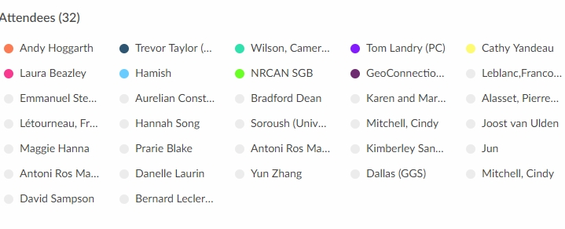
Links to presentation and recording of the meeting are on the Wiki, under the meetings section;

https://external.opengeospatial.org/twiki_public/CanadaForum/WebHome

Work Plan Discussion

Innovation Show Case - Banff | Volunteers to design and plan this event.  Interest; Dallas (Global Grid Systems)
Communications Support | Resources to support and maintain
Sandbox | Volunteers to scope and check feasibility  Interest Dallas – has something similar
Outreach | Volunteers to support
Government Standards Community of Practice | Develop network of geomatics open standards practitioners and policy leads  Cindy Mitchell – to FGP lists, content, connect with CCOG
Data Stacks for Indigenous Communities | Contribute to other “Stacks”  Interest : Dallas, Surveyor General Branch (SGB), Cathy Yandeau, Ocean networks Canada
Indigenous Leadership Group | Volunteers to help scope and establish, Interest: SGB, WindView GIS (Hamish Rogers*)
Trade Mission | Volunteers to assist in refining the concept  Interest: GGS, CARIS others?
Joint Canadian offering | Volunteers to scope and check feasibility
Increased activation of the University and Research communities | Volunteers to help scope a potential work plan items  Interest GGS, Ocean networks Canada  CRIM AI/ML
Reminder from CW- all standards related to geo, ( e.g. OGC, IHO, ISO) wtih the possibility of the Forum driving requirements for a Pilot in the future.

CW notes: Use Banff as comms event. Video, sponsorship etc. Leverage Arctic Data Committee, SAON, Indigenous include Firelight group. Gaps could be funded by NRCan. Maintain Data Stacks momentum (Hatfield to present in Banff CW to confirm).

2019 Calendar Review

- Open Government Partnership (OGP) Global Summit, Ottawa, May 29-31 (TL)
- 40th Canadian Symposium on Remote Sensing & Geomatics Atlantics 2019, Fredericton, June, 4 to 6(AH)
- GeoIgnite/ Standards Policy Workshop side event (TBC) – Ottawa, June 18/19 ( Nadine , TT)
- International Geoscience and Remote Sensing Symposium, Yokohama, Japan, July 28 to August 2nd (TL or , Ingo or George from OGC staff)
- Indigenous Mapping Workshop, August (BD
- 112th OGC meetings, Banff, AB, September 9-12th, Host U of Calgary and SensorUp (plus others TBC)
- Canada SDI Summit and CCOG - October 15, Quebec City (TT)
- Geomatics Alberta, Red Deer, November 13 -14 (TT)
- 2020 – 115th OGC Meetings, Montreal, QC, June, Sponsored by CAE Inc ( AC)

Consider other types of opportunities - City meetings, energy, utilities...etc

Open Discussion and Next Steps

- Email to Canada Forum to drive people to the Wiki - meeting presentation and recording, with a request for additional volunteers (TT)
- Agenda Building for Sept - data stacks, Uni work re: Arctic, ½ day to start, extra evening event ? Tuesday for the Forum - breakouts related to work tasks - intro - break out - conclusions - practical outcome /tasks,focussed versus informational session, Large SDI project - inclusive of the tasks from work plan - connect all communities local to National- urgent issue based - climate /arctic - middle power = punch above our weight = leverage global data sources - Theme for the Forum - GIS difference v SDI , relevant to non-traditional - ie get out of own camp
- Trade mission , theme related - build out show me narative - use as a trade mission with a common story
- Theme - polar, water, small island, coastal , inundation ? leverage Machine Learning threads - strong story that relates to all countries - in-land waterways - dynamic not charted - change frequency - Hydrology
- Indig. Leadership group ? Virtual ? Action - separate meeting - Open ? Suggestions BD to publish to his Bulletin Board

Next Steps:

- Planning Meeting for Banff as the Anchor event for 2019, covering the most popular work items above

