DRAFT OGC Discussion Paper

July 20, 2016

Author: Lance McKee
lmckee76@gmail.com
Cell: +1 508-868-2295
Office: +1 508-752-0108
Worcester, MA USA
Skype name: lancemckee

Access: This draft discussion paper is available for download from the OGC website. The author invites comments.

Proposed: an open standard electromagnetic field data model and derived encodings

About the author:

For many years as the Open Geospatial Consortium (OGC)’s staff writer, the author of this paper wrote about OGC’s collaborative standards development process for making complex spatial and temporal digital data easier to share and integrate. In 2013, he began studying the question of whether an open standard conceptual data model and derived digital encoding(s) for electromagnetic field (EMF) data could benefit domains focused on the electromagnetic spectrum. Conversations with experts in EMF application domains encouraged him to continue. He resigned in March 2016 from his OGC staff position and now works as a consultant. The author is submitting this paper as an OGC member for review by the OGC membership.

About this paper:

This is not an official OGC document, but a draft discussion paper to inform discussion at a “SpectrumML ad hoc” session to be held in Dublin, Ireland, Thursday 23 June 2016, 09:00 to 09:55 during the week of the OGC Technical Committee Meeting. The author invites interested persons to attend or dial in to the ad hoc session. Experts are also invited to contribute as co-authors of this paper and to participate in the proposed standards development activity. See http://www.opengeospatial.org/event/1606tc for more information about the Technical Committee Meeting, including registration details.

What the proposed standard is and is not:

What is proposed is NOT a mathematical model. The behavior of electrical fields, magnetic fields and electromagnetic fields is already described by Maxwell's equations. Basic measurement methods, too, are well documented and widely used. However, there is no standard data model or digital encoding derived from that model for sharing and communicating data produced by those measurements. Such data models and derived encodings are necessary for efficient publishing, sharing, evaluation, aggregation, access, analysis and visualization of digital data from diverse sources.

What is proposed is NOT a communications protocol like GSM, CDMA, WiMAX or Bluetooth.

What is proposed is NOT a regulatory standard, nor is it a biological exposure limitation recommendation or electromagnetic compatibility recommendation for radio frequency EMF. The proposed standard would, however, enable clear, consistent and detailed definition of electromagnetic field properties in such recommendations.

What is proposed is a formal and standard way of communicating data about environmental electrical fields, magnetic fields and radio frequency (also perhaps optical frequency) electromagnetic fields as measured in the environment or as provided by emitting devices. That is, what is proposed is a conceptual data model, and a digital encoding(s) derived from that data model, for the sharing, communication and exploitation of a particular kind of environmental data. It would be a standard similar to OGC’s WaterML 2.0 standard for hydrological data or the GeoSciML standard for geological data. Unlike those two examples, however, which provide XML (eXtensible Markup Language (XML) encodings, the most useful digital encoding language will probably not be XML, but instead a more compact encoding.

1. Purpose

The purpose of this OGC discussion paper is to vet these two propositions:

- A consensus-derived international standard conceptual model and derived digital encoding (or encodings) for electromagnetic spectrum features and phenomena—referred to here, for convenience, as “Spectrum Model Language”, or “SpectrumML”— would be useful in applications in many domains that use the spectrum or study its environmental effects. Such applications include, perhaps among others:

- Detection and mitigation of interference between wireless communications and both active and passive remote sensing operations. Also, improvements in remote sensing data integration and analysis.
- Cognitive Radio, and other methodologies to maximize efficiency in use of the radio-frequency (RF) spectrum.
- Improved management of Electromagnetic Compatibility (EMC), the branch of electrical engineering concerned with mitigating electromagnetic interference (EMI) and physical damage caused by electromagnetic fields. Spatial environmental data is important in this work.

- The Open Geospatial Consortium (OGC) is the appropriate organization in which to develop such a standard, because electromagnetic fields are inherently spatial/temporal phenomena that interact in complex ways with spatial/temporal features and phenomena. OGC members have developed a widely used standards development process and a comprehensive international standards platform for modeling and encoding spatial/temporal features and phenomena (including the OGC SensorML and Observations & Measurements standards).
The proposed SpectrumML DWG would contact other standards development organizations (SDOs), such as ISO, ITU, BIPM and IEEE, to determine whether they have similar standards efforts ongoing or under consideration. The OGC is arguably more agile, and if the standard were seen to meet its purpose, it is likely that it would be endorsed or specified by one or more of these other SDOs.

If these propositions are seen to have merit and if there is support from 3 or more OGC members, this discussion paper would provide the basis for a charter for either an OGC SpectrumML Domain Working Group (DWG) that would review interoperability requirements, or, if there is early consensus on requirements, a charter for a SpectrumML Standards Working Group (SWG).

In an OGC Standards Working Group, participants would define scope, contribute domain requirements, review applicability of the OGC SensorML and Observations & Measurements standards and other standards, and work together to develop a conceptual data model, using UML. An example of such an UML model is illustrated in Figure 1.

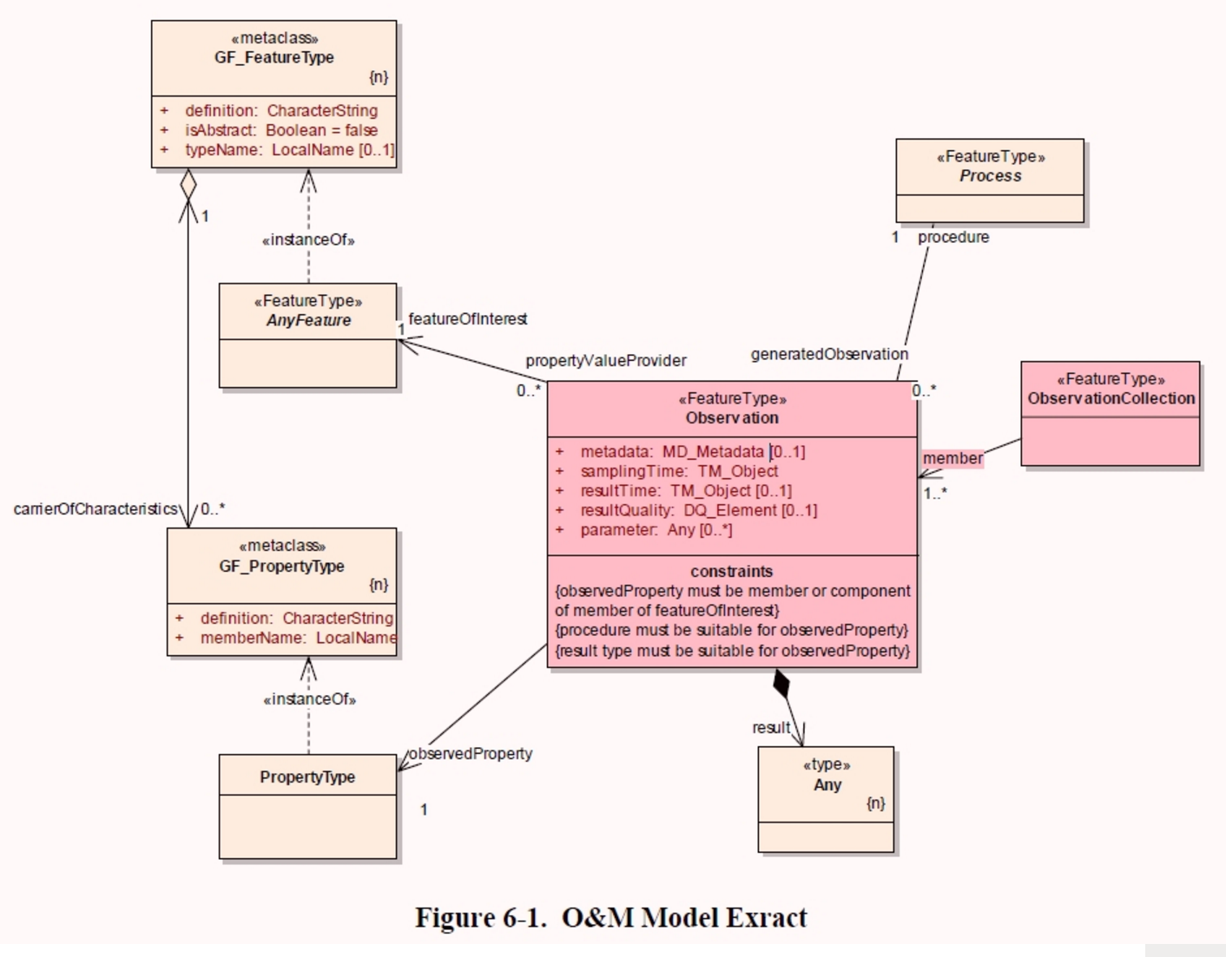
Figure 1: Example UML diagram: The basic UML diagram for the OGC and ISO Observations and Measurements (O&M) conceptual model. (OGC Observations and Measurements v2.0 is also published as ISO 19156:2011). The O&M model would provide a basis for the SpectrumML standard.

One or more digital encoding standards derived from that conceptual model could be implemented, like other OGC encoding standards, in the XML encoding language (human readable and machine readable in the Web environment, but verbose). Because of the high data rates and volume necessary to accurately sample EMF, however, a more compact encoding language such as the Binary Point File (BPF) might be appropriate. Working Group participants would discuss introducing a draft encoding standard into one of the OGC’s testbeds for rapid prototyping in the development of the standard.

2. The current situation

Marconi’s wireless telegraph in 1894 sparked an arc of increasing research, application and investment in applications of the electromagnetic spectrum. Rapid acceleration of this progress was driven by unprecedented levels of government and private investment in wireless communication and optics beginning in the late 20th century, bringing extraordinary new understanding and applications.

In recent decades, civilization has become utterly dependent on wireless and fiber-optic communication, imaging systems, GPS navigation, remote sensing, solar power, plasma deposition in semiconductor fabrication and other technologies that apply our knowledge of the electromagnetic spectrum as illustrated in Figure 2.
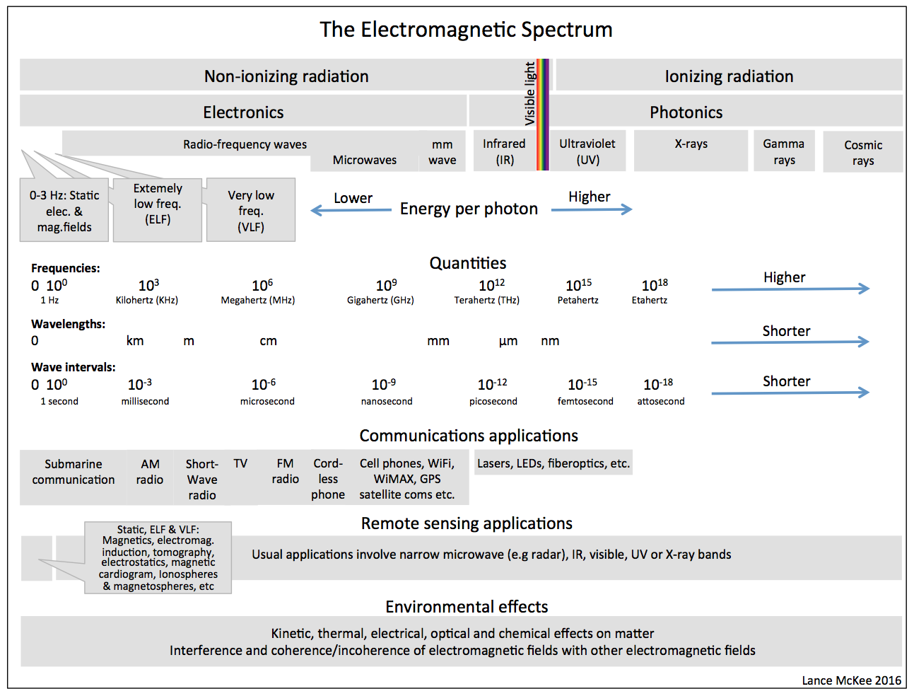
Figure 2. Overview of the electromagnetic spectrum, its uses and its environmental effects.

Radio frequencies used for wireless communication, remote sensing and location determination are NOT an endlessly renewable resource, because interference between simultaneous uses makes each narrow frequency band a limited resource within a specific region. To avoid interference, frequency bands are allotted to public and private uses and users by the ITU and other international, national and regional agencies. See Figure 3. Demand for bandwidth and competition for these narrow frequency band allotments drives up radio-frequency spectrum prices. Competition also drives wireless companies to find novel ways of increasing the number of channels within their allotments and increasing the bits per second that can be sent along those channels.

Interference between wireless communications and remote sensing activities is a growing issue as both domains expand. In some domains, including electromagnetic compatibility (EMC), plasma and chemical deposition, and antenna engineering, research communities are focused not on interference between emissions but on interactions of EMF and matter.
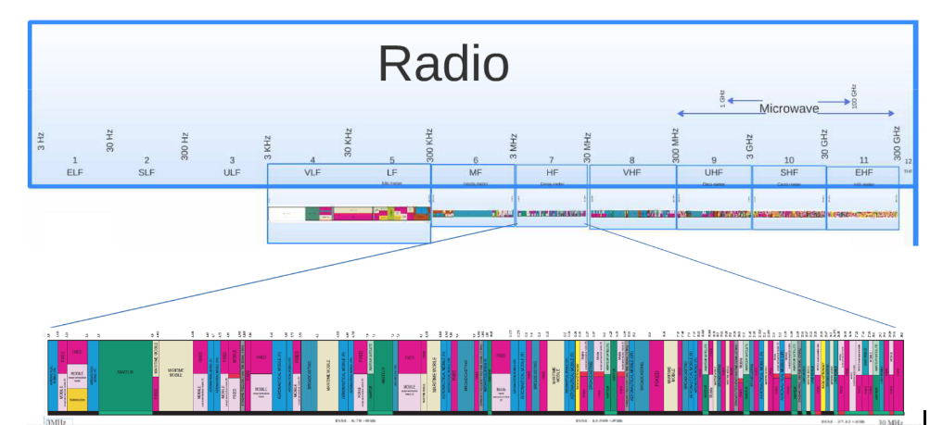
Image adapted from High Tech Forum image (http://hightechforum.org/low-versus-high-radio-spectrum/
Figure 3. The electromagnetic spectrum, showing in detail the large number of spectral band allocations in just one region of the spectrum, the High Frequency microwave region.

Despite all this research in all of these domains, and perhaps because there are so many different application domains, there is no international standard data model for the electromagnetic spectrum. That is, there is no specific agreed-upon conceptual schema, with semantics, for attributes and attribute relationships of data collected in observing specific EMF instances. There is also no standard schema to describe in detail the attributes of EMF emissions reported at points in time by an EMF emitting device such as a cell phone or wireless smart meter.

In the absence of a standard data model, different records of EMF data that need to be compared or aggregated for digital analysis must be converted so that the attributes of the emissions are named and ordered in the same way, using consistent names of properties and units of measure. Classes and subclasses of properties may need to be re-represented in a consistent way. Such data conversion is time consuming and error-prone, requiring case-by-case manual intervention and repeated development of special conversion routines. Such conversion would be unnecessary if a common data model were used in creating and storing data, or if a “lingua franca” existed that could be implemented in digital interfaces for on-the-fly automated conversion in communication between diverse data stores, devices and processing resources.

A standard data model would provide the structure for such interfaces and for the standard encodings recognized by those interfaces. Different emitting devices, receiving devices, sensors and databases that provide data through software interfaces that use a common encoding could interoperate much more easily. For example, functions such as data comparison and aggregation could become fully automated steps in digital workflows involving network-connected resources. With a standard encoding, it would potentially be possible for devices, databases, cloud-resident analytics etc. developed for any of the electromagnetic domains to become useful in any of the other domains. The standard would provide market scale to stimulate investment in development of hardware, software and services that would accelerate research and implementation in multiple domains. Because EMF instances often must be sampled at very high rates, and because new technologies enable sampling at ever-higher rates, many EMF-focused domains could benefit from the latest Big Data processing methodologies and services. Big Data is about finding patterns in data characterized by “volume, velocity, and variety”, adjectives that accurately describe EMF data.

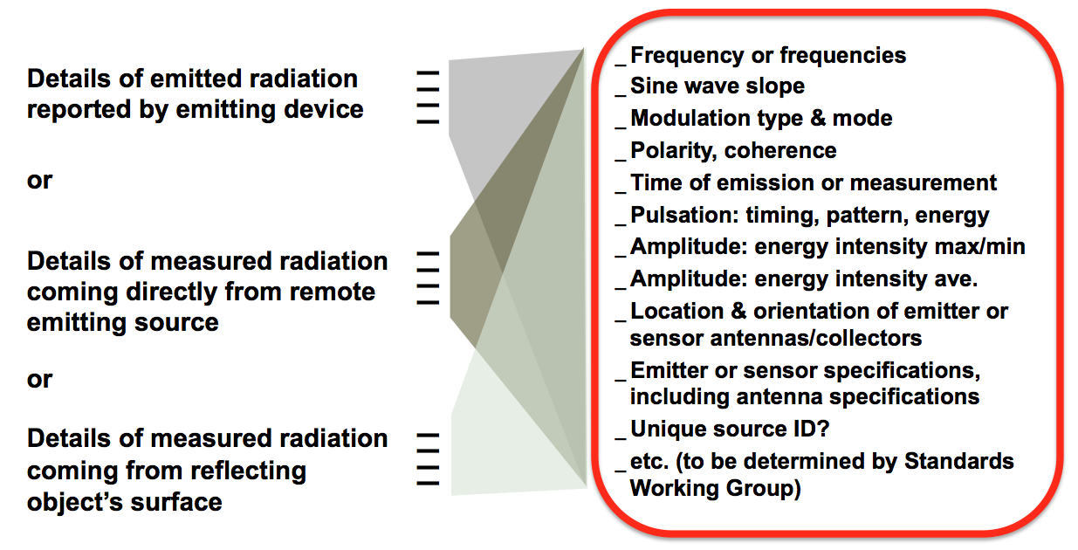
Figure by Lance McKee
Figure 4: On the right are some of the EMF properties that might be included in the proposed standard EMF conceptual data model. On the left are three general classes of use cases that would all use the same model or profiles or application schemas of that model.

At first glance, one might imagine that the reason for the lack of a standard data model is that the basic properties we measure to describe an actual electromagnetic field are few: frequency, amplitude, and polarity. (Photon spin is sometimes measured, but not usually.) Because of this apparent simplicity, converting data from different data models might be assumed to be trivial, obviating the need for a standard data model.

However, electromagnetic fields exhibit great complexity. Phase and coherence need to be included with polarity, and they are related to each other in complex ways. There is complexity in the mathematics used to describe relationships among the properties, in the various radiometry units (most of which are SI derived units) relevant to different applications, and in the time domain/frequency domain mathematics used to represent and analyze time-series data. There is complexity in the permutations of varied values for the properties’ parameters.

Environmental interactions with radiation, shown in Figure 4, multiply the complexity of electromagnetic fields in the environment. These effects include, for example, Fresnel zones, regions along a transmission path where reflective surfaces cause phase shifts that reduce and/or increase the power of a received signal at a point in space. Interference between fields of the same frequency results in peaks and valleys of intensity. At almost any particular time in a particular place, multiple electromagnetic fields at various frequencies (including static electrical and magnetic fields, in which frequency=0), from the same source or different sources, are present simultaneously. The energy of static electric, static magnetic, and oscillating electromagnetic fields decreases rapidly with distance from source (though not always by the same “inverse square law” rule), so in most environments most of the fields are very weak. High levels of electromagnetic white noise result from multiple emissions, many mobile, undergoing attenuation, reflection, scattering and resonance in complex material environments. The properties of transmitting media as well as the properties of and spatial relationship to physical obstacles (see Figure 4) add complexity.

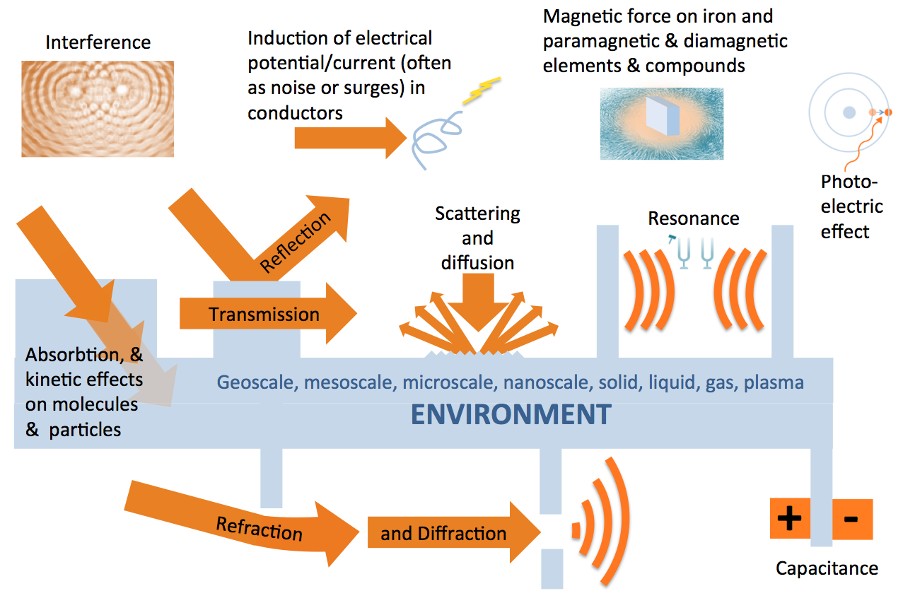
Figure by Lance McKee
Figure 5. Electromagnetic waves and fields interact with the physical environment and each other in many ways.

The main reason that there is no international standard data model for the electromagnetic spectrum may be that different EMF research, utilization and management domains have been independently developing science and technology around the electromagnetic spectrum, and their data models and encodings are tailored for the particular things they doing. The SI (metric system) units provide sufficient consistency and interoperability for these domains’ purposes. Also, in high performance applications with limited requirements for interoperability, use of a comprehensive data model might unnecessarily introduce data that would require additional storage, bandwidth and/or processing power.

The commonality provided by SI units was essential and sufficient for progress in the last century, but we argue that SI units alone do not provide the interoperability necessary for progress in this century. Sharing of data within domains and between domains is important now and it will become increasingly important, because “connection” is the hallmark of our age. Often EMF data include only application-relevant derived units, typically SI derived units, such as radiant flux or watts per square meter. Derived units are computed from basic measures that might or might not be recorded or reported separately. Depending on what data is available in the data sets, the basic measures might or might not be computable from the derived units.

We argue that in many of the fields that use or could use the electromagnetic spectrum, a standard data model and derived encodings would enable:

- Open data regimes, that is, infrastructure—policies, standards, registries, data stores, collaborative sensor development, collaborative data collection programs etc.— for efficient in-domain and cross-domain publishing, discovery, sharing and reuse, assessment, verification, comparison, access, analysis and visualization of electromagnetic spectrum data.

- End-to-end processing architectures that eliminate most manual intervention in steps such as: data reduction; data conversion; metadata collection; integration of data from different devices, spreadsheets, and databases; chaining of analysis models; etc. In most spectrum applications, the data rates for measurements are extremely high compared to typical data rates for sampling most physical phenomena. Many areas of spectrum related research and practice therefore need high performance digital systems. Progress in research and practice will depend to a great extent on these domains’ ability to continually upgrade their systems to take advantage of both new and faster sampling technologies and new and faster data collection, transmission, and processing technologies. An open standard data model and derived encoding(s) would contribute to efficient integration of the latest “best of breed” technologies and tools, which might be hosted as cloud services. The standard would support integration of such services into processing workflows.

- Consideration of multiple environmental effects, both to obtain desired effects and to avoid undesired effects. Wireless communications systems sometimes impact remote sensing, wireless communication devices sometimes impact power system components’ inadvertent emissions sometimes damage sensitive electronics. Mitigation of unwanted impacts requires researchers, developers, engineers, practitioners and regulators to draw on different knowledge domains and different kinds of data. As long as the data and processing resources in those different domains lack common standards for efficiently modeling and communicating spectrum information (including spatial properties), technical barriers will continue to obstruct efficient and effective communication, analysis and action.

- Efficient and safe exploitation of spectrum (including exploitation within enclosed spaces) may eventually in some cases require emitters that adapt to, rather than ignore, physical surroundings.

- Early discovery of new opportunities for technology transfer and technology convergence. For example, a capability for producing impulses of briefer duration in communication signals might enable improved remote sensing or more rapid measurement of fleeting chemical phenomena. Standards tend to increase opportunities for such technology transfer and convergence. There would perhaps also be new markets for products such as signal generators, radiometers and Big Data analysis resources, and more innovation in those markets.

4. Use cases

3.1 Remote Sensing

“Owing to advances realized in the past decade in the technology used in cellular mobile phone applications, opportunities for improving coexistence with radio-frequency interference (RFI) have improved significantly. However, these benefits offer more to the world of communications than to sensing applications.”
Committee on a Survey of the Active Sensing Uses of the Radio Spectrum, Board on Physics and Astronomy, National Academies of Sciences, Engineering, and Medicine. (NAS) 2015. “A Strategy for Active Remote Sensing Amid Increased Demand for Radio Spectrum (2015)”, National Academies Press.

Spectrum competition increases with our growing dependence on the electromagnetic spectrum for both communication and remote sensing. ITU and other international organizations work collaboratively and with great effectiveness to achieve international agreement on particular uses for particular bands, so that active remote sensing and wireless communications, for example, don’t conflict in countries that have different spectrum band assignments. Industry standards such as GSM, TDMA and CDMA play an important role in enabling interoperability between devices operating on specified frequencies so that the devices can use the same network. ISO recognition and adoption plays an important role in stabilizing these industry standards, which are critical to the world’s communication network. Nevertheless, evolving technologies and different and evolving national and market needs prevent perfect agreement. The need to resolve conflicts is ongoing and dynamic.

In response to these challenges, according to the NAS study:
“Regulators are using reallocation, spectrum sharing, and higher spectral efficiency to try to make the desired spectrum available. … Wireless communication systems have already demonstrated the ability to share the spectrum. While it has not yet occurred, it should be possible for Earth active remote sensing systems to operate in existing communication bands, although limitations exist, to provide scientists with access to improved observations and thus an improved understanding of Earth.”

We argue that an international standard EMF data model will very likely be necessary to first learn how communication signals and imaging beams can share spectral bands and then to implement this sharing. The NAS study suggests this:
“It should also be noted that one of the difficulties with characterizing the impact of RFI on active remote sensing space instruments is the incompleteness of information regarding current emitters world-wide, as well as the evolving nature of the RFI environment over time. There is currently a lack of good metrics for quantifying the degradation of science measurements for the full variety of active instrument types (e.g., scatterometers, altimeters, SARs, interferometers, and sounders). This makes it very difficult to accurately quantify how a given active sensor might be impacted by RFI, how the RFI might be mitigated, and how the spectrum might be shared.”

Recommendation 8.1 in the section in the NAS study titled “Actions by Federal Agencies”, states:
“NASA should lead an effort to significantly improve characterization of the RFI environment that affects active science measurements. This effort should also involve other agencies involved in active remote sensing, including NOAA, NSF, and perhaps DOD, as well as the agencies regulating these activities—the FCC and the NTIA—and include the use of (1) modeling, (2) dedicated ground-based and airborne characterization campaigns, and (3) data mining of currently operating science sensors. To the extent possible, this effort should be a collaborative one with other space and science agencies of the world.”

Certain wavelengths of electromagnetic radiation are emitted by the earth’s surface and the atmosphere and its various constituents, wuch as water vapour, pollutants, dust or volcanic ash. These are observed by ‘passive’ remote sensing, usually from space, but also using other platforms such as balloons, It is important that these ‘windows’ into the earth system are not polluted by man-made emissions so that the state of the earth system can continue to be monitored.

The proposed OGC SpectrumML standard development activity would provide space and science agencies with an efficient international forum and testbed for development of a basic EMF model. Many, perhaps most, of the space and science agencies of the world who would be interested in participating are already members of OGC. It is likely that the new standard would play a role in “characterization campaigns” and in data mining of currently operating science sensors and their data collections.

Beyond the applications focused on mitigation of RFI between communications signals and Earth remote sensing campaigns, other remote sensing use cases might well emerge. The data model might provide opportunities for innovative integration and Big Data analysis of diverse Earth Observation data sets, leading to discovery of useful and previously unnoticed correspondences and patterns. Also, advances in indoor location systems, smart cars, smart cities and smart UAVs will undoubtedly bring rapid increases in near-field remote sensing and near-field communications, with attendant interference similar to the interference between wireless communications and Earth imaging.

It would be useful to have technical representatives from the wireless industry, the radiometry industry and the signal generator industries in this standards activity.

A robust international standard EMF data model and associated encoding(s) would, in remote sensing as in other fields that use EMF, enable better sharing, reuse and exploration of data, increase the value of the data, and stimulate product and service innovation. The electromagnetic environment is complex, just as DNA, climate, weather, hydrology and geology are complex. In all of these fields, open data models and encoding standards are having or are expected to have beneficial effects. These standards are key elements in the cyberinfrastructures being developed for these domains.

3.3 Radio communication and telecommunication

As mentioned above, demand for bandwidth and competition for frequency band allotments drives up radio-frequency spectrum prices and drives wireless companies to find novel ways of increasing the number of channels within their allotments and increasing the bits per second that can be sent along those channels. The proposed open standard EMF data model and encoding(s) would likely be useful in some scenarios for using software to maximize the amount of data that can be transmitted over limited spectral bands.

Software-defined radio (SDR) applications are applications in which functions that have traditionally been implemented in hardware components can now, thanks to improvements in semiconductor performance, be implemented in software. Radio protocols can be described as complex waveform patterns. These patterns could be characterized and specified using the proposed standard data model. This “what protocol?” information could be communicated as necessary between transmitters or between transmitters and software services that serve as spectrum managers that adjust band allocation in real time. In many of these scenarios, transmitter location needs to be communicated. The location data section in the data model could adhere to the standard point profile of the OGC Geography Markup Language (GML). This profile is embedded in Internet protocols, emergency and disaster response communications systems and other information infrastructure. Interoperability with these information infrastructure elements would be critical in some scenarios.

In some cases dynamic transmitter power adjustment based on transmitter and receiver location might be served by implementations of the proposed standard. This would likely be useful in wireless mesh networks.

The proposed data model and encoding could perhaps be adapted to provide a method for signal generation and signal manipulation that would provide capabilities similar to what MIDI (Musical Instrument Digital Interface) provides for music generation and editing. MIDI data files are smaller than recorded audio files and digitally sampled audio can be converted to MIDI. MIDI implementations can separate sampled music into separate channels for each instrument. Perhaps the proposed SpectrumML standard configured as an “EMF Digital Interface” standard would help separate electrosmog data into profiles of the strongest individual transmissions.

The proposed standard could be implemented in monitoring systems employed by wireless regulatory agencies such as the FCC.

The proposed standard might also be useful in signals intelligence (SIGINT), communications intelligence (COMINT) and electronic intelligence (ELINT).

3.4 Electromagnetic compatibility (EMC)

In this paper we have discussed interference between radio signals and between radio signals and active remote sensing beams. There are other problematic kinds of radiofrequency interference, and the proposed standard might be useful in characterizing and mitigating these emissions.

The EPRI Electric and Magnetic Field Management Reference Bookis a standard reference for EMC engineers whose goal is to provide electrical protection. The book describes common sources of unintended electrical, magnetic and electromagnetic fields and recommends strategies for measuring and then eliminating or reducing these fields in homes, schools, and industrial and commercial buildings. New sources of incidental interference are entering the environment, including LEDs’ switching power circuits, solar arrays’ power inverters, emerging wireless charging systems, and medical imaging devices’ powerful magnetics.

The need for improved characterization and mitigation of incidental EMF increases as
Sources of EMF hazards increase with the smart grid, distributed generation, electric vehicles and inductive charging,

EMC becomes more important as the Internet of Things (IoT) emerges and brings with it more vulnerable miniature electronic devices as well as more emitting devices. It also becomes more important as “healthy buildings” get more attention. Presumably, these trends will give rise to efforts to gather and share data about EMF, and there will be mitigation initiatives that will require EMF data to move through digital workflows. The proposed standard would support such efforts.

5. Conclusion

In this paper we have proposed the development of “SpectrumML”, an open standard data model and data encoding(s) for data about environmental electromagnetic fields. We have provided reasons why institutions in four of the domains working with electromagnetic fields—remote sensing, telecommunications, and electromagnetic compatibility (EMC)—might be interested in collaborating to develop this standard. The applications that would benefit from the standard all involve creating, publishing, discovering, assessing, verifying, sharing, accessing, aggregating, analyzing and/or visualizing data about static electric and magnetic fields and oscillating electromagnetic fields. We have noted various trends that point to an increasing need for such a standard.

Static electric and magnetic fields and oscillating electromagnetic fields are spatial/temporal phenomena that interact with the spatial environment at all spatial scales. Because of these phenomenas' spatial/temporal nature, and because all of the domains listed above have various requirements to model physical environments in their operations, we propose developing the SpectrumML standard in the Open Geospatial Consortium (OGC). OGC, working with many other standards organizations, provides the dominant international standards used in modeling the spatial/temporal environment. OGC standards include, among others, standard models for sensors, observations & measurements, and urban 3D environments. Development of SpectrumML would thus benefit from previous work in the OGC and from expertise in the OGC Technical Committee. Implementations of the standard would provide interoperability with implementations of other spatial standards in OGC’s standards baseline.

We invite your comments.

https://portal.opengeospatial.org/files/?artifact_id=68630&version=1 on the OGC Pending Documents page.
Open Geospatial Consortium (OGC) (http://www.opengeospatial.org)
A conceptual data model is an abstract model, using natural language (such as English) and diagrams, that organizes elements of data and standardizes how they relate to one another and to properties of the real world. (Adapted from Wikipedia (https://en.wikipedia.org/wiki/Data_model). See also “Semantic spectrum” in Wikipedia (https://en.wikipedia.org/wiki/Semantic_spectrum ).
A conceptual data model must be translated into a digital encoding before it can be used in computer programs.
See, for example, EPRI 2009. Electrical and Magnetic Field Management Reference Book http://www.epri.com/search/Pages/results.aspx?k=Electric%20and%20Magnetic%20Field%20Management%20Reference%20Book:%20First%20Edition
OGC WaterML 2.0. (http://www.opengeospatial.org/standards/waterml)
GeoSciML (http://www.geosciml.org/). Developed by the IUGS Commission for the Management and Application of GeoScience Information
XML : A World Wide Web standard (https://www.w3.org/XML/) implemented in virtually all Web browsers.
“A cognitive radio is an intelligent radio that can be programmed and configured dynamically.” Wikipedia (https://en.wikipedia.org/wiki/Cognitive_radio ). See “Cognitive Radio Techniques - Spectrum Sensing, Interference Mitigation, and Localization”, 2012. By Kandeepan Sithamparanathan and Andrea Giorgetti, Artech House.
OGC Sensor Model Language ( SensorML) Standard (http://www.opengeospatial.org/standards/sensorml)
OGC Observations & Measurements (O&M) Standard (http://www.opengeospatial.org/standards/om)
International Organization for Standardization (ISO)
International Telecommunications Union (ITU)
International Bureau of Weights and Measures (BIPM)
Institute of Electrical and Electronic Engineers (IEEE)
Unified Model Language (UML), an OMG standard (http://www.uml.org/)
Binary Point File (BPF) (https://nsgreg.nga.mil/doc/view?i=4202)
International Telecommunications Union (http://www.itu.int/en/about/Pages/default.aspx)
See for example the single-photon avalanche diode (SPAD), which can signal the arrival times of photons with a jitter of a few tens of picoseconds. (picosecond = 1 trillionth of a second). Described in Wikipia: https://en.wikipedia.org/wiki/Single-photon_avalanche_diode
Committee on a Survey of the Active Sensing Uses of the Radio Spectrum, Board on Physics and Astronomy, National Academies of Sciences, Engineering, and Medicine. (NAS) 2015. “A Strategy for Active Remote Sensing Amid Increased Demand for Radio Spectrum (2015)”, National Academies Press. Chapter 11, page 1. (http://www.nap.edu/read/21729/chapter/11)
See for example the WMO Position on the ITU WRC-15 conference, 28 September 2015 (http://wis.wmo.int/file=965)
Ibid page 2.
Ibid. page 5.
Ibid, page 7.
MIDI Association (https://www.midi.org/ )
EPRI 2009. Electrical and Magnetic Field Management Reference Book http://www.epri.com/search/Pages/results.aspx?k=Electric%20and%20Magnetic%20Field%20Management%20Reference%20Book:%20First%20Edition
OGC Alliance Partners (http://www.opengeospatial.org/ogc/alliancepartners )
OGC standards (http://www.opengeospatial.org/standards )

