OGC Project Document 18-018r1
TITLE: OGC Interoperable Simulation and Gaming Domain Working Group (ISG DWG) Charter

Author (s) Name: David Graham
Organization(s): CAE Inc.
Email(s):david.graham@cae.com

Date: 07/13/2018

CATEGORY: Domain Working Group

Introduction
This Domain Working Group charter defines the role for OGC activities within the Interoperable Simulation and Gaming community and to provide an open forum for the discussion and presentation of interoperability requirements, use cases, pilots, and implementations of OGC standards in this domain. This Charter is to be presented to the OGC’s Technical and Planning committees for consideration.

Working Group
Operation of OGC Domain Working Group follows the policies and procedures of the Technical Committee. The following definitions from the Technical Policies and Procedures apply to this DWG Charter.

Definition of a Domain Working Group: A group (organizationally, a subgroup of the TC) of individuals composed of members of the TC and invited guests, with the specific intent of solving some particular interoperability problem or problems in a particular technology domain for recommendation to the Technical Committee.
Functions of a Domain Working Group:
- Provide a forum for discussion and documentation of interoperability requirements for a given information or user community,
- Provide a forum to discuss and recommend document actions related to Interoperability Program Reports,
- Develop Change Requests Proposals (CRPs) for existing OGC Standards,
- Develop engineering reports with the intent of seeking approval by the TC for release of these documents as OGC White Papers, Discussion Papers or Best Practices Papers,
- Informational presentations and discussions about the market use of adopted OGC Standards,
- Have a formal approved charter that defines the DWGs Scope of Work and estimated timeline for completion of the work,
- have all-member voting policies (unless otherwise stated), and
- Have missions and goals defined by the TC.

A DWG Does Not work on RFC submissions, candidate standards, or revisions to existing OGC Standards. However, a DWG can develop change requests as documented interoperability requirements that can then be submitted as work items to a SWG.

A DWG may determine that they wish to have public collaboration, such as in teleconference, email discussions, or a public twiki. In this case, the DWG shall make a motion to the TC to approve public participation in the DWG. Voting in DWGs is by simple majority of OGC Members present at the WG meeting, not just Voting TC Members, with the caveat that no OGC Member organization may cast more than one vote in a WG vote.

Purpose of Working Group
This Domain Working Group (DWG) will provide a forum for the discussion of requirements and use cases for standards and the registration of implementations related to use and re-use of geospatial data within the Interoperable Simulation and Gaming (ISG) community. The working group will provide a forum for broad discussion of ISG topics and research activities that are of relevance to various geospatial and modeling, simulation, and gaming communities and that may potentially impact on existing, or new, geospatial standards. The working group will aim to increase awareness of the advantages of ISG in general, to define the qualities of ISG systems, to enhance their interoperability, and to support activities to standardize operations within and among them related to the use and re-use of geospatial data. This DWG is not intended to be a forum for scientific modeling and simulation.

Problem Statement

Gaming systems and technologies have been developed, originally for entertainment, that are increasingly also being used for training and rehearsal as a mechanism for interoperable simulation. Such gaming systems traditionally relied upon fictitious or highly-simplified representations of the world for their geographic environment, However, in recent years there has been more widespread use of realistic depictions of real-world environments and capabilities of gaming systems to represent large areas of the Earth.

Computer generated simulations are in wide use for training and rehearsal. The fidelity and usefulness of simulations is frequently enhanced by the creation of a virtual rendering of a 3D environment within which entities in the environment operate.. Most computer-based gaming systems have technical architectures that are different from more traditional simulation systems, and considerable innovation and enhancements in virtual environment fidelity (and reductions in system costs) are expected to result from increased use of computer game based technical architectures. This DWG will assess how gaming systems might be leveraged for geospatial use cases.

Geospatial data are increasingly used as a primary source of information from which to generate virtual simulation environments. High performance and high fidelity simulations have generally required that geospatial source data be converted to optimized, and frequently proprietary, formats in order to support fast and deterministic storing, retrieval and rendering of high quality 3D virtual environments.

Training and rehearsal capabilities for individual vehicle and system operations may be significantly enhanced by interoperation of traditional and game-based simulations.

The interoperability problem is that differences in the rendering and perception of 3D virtual environments within systems that have chosen to interoperate are sometimes major obstacles to the effective use of these systems. In defense terms, 3D environments within systems need to be similar enough to support the concept of a “fair fight”. A specific example is two or more simulation and gaming systems operating with 3D environments with different terrain resolution renderings. High level of detail terrain in one system might introduce interruptions in the line-of-sight between viewpoints. Lower level of detail terrain representations in interoperating systems in the same area might not perceive the same interruption in line-of-sight, resulting in an “unfair” advantage or disadvantage based on the 3D environment that would not be present in real vehicles operating in real terrain.

Charter
The following constitutes the general scope of work for the ISG DWG.
- Discuss emerging issues and topics related to ISG technologies and standards,
- Govern the discussion of requirements and use cases that impact the OGC standards baseline, and task the existing SWGs where appropriate, or recommend new SWGs, to draft specific implementation standards and protocols/best practice documents,
- Engage with the OGC Compliance Program, and other TC Working Groups as necessary, to establish, manage and publish an OGC registry of ISG specifications and their implementations,
- Engage with other OGC working groups on cross-cutting issues related to ISG,
- Engage with other Standards bodies, as necessary, including specifically the Simulation Interoperability Standards Organization (SISO), on ISG related matters (including the establishment of external and/or joint workings groups to draft ISG relevant standards), and
- Advocate the adoption of standardized ISG technologies through the public, private and academic sectors.

Charter Members.
The initial membership of the DOMAIN WG will consist of the following members and individuals with extensive education and experience in DOMAIN issues, namely:

Name | Affiliation
David Graham | CAE Inc., SISO Inc.
Sara Saeedi | University of Calgary
Susan Raymie | US SOCOM
Lance Marrou | LEIDOS
Roy Rathbun | NGA
Chris Little | UK Met Office
Don Sullivan | NASA
Hermann Brassard | Presagis
Matt Purss | Geoscience Australia
Stefan Strobel | DGIWG
Brian Ford | FlightSafety International Visual Systems
Glen Johnson | VATC
Colin George | Real Factors
David Ronnfeldt | Department of Defence (Australia)
Glen Quesenberry | U.S. Army Geospatial Center
Ron Moore | Leidos

Key Activities.

The ISG DWG shall perform the following general activities:
- Administer the discussion of requirements and use cases that impact the ISG standards baseline,
- Engage with the OGC Compliance Program, and other TC Working Groups as necessary (as shown in Figure 1), to establish and administer a registry of conformant ISG specifications and their implementations and to govern the registry’s content,
- Discuss current and future trends in ISG research, development and implementation,
- Discuss and identify gaps in the ISG and wider OGC standards baselines where specific interoperable protocols need to be specified,
- Develop examples demonstrating the implementation of the ISG standards baseline, and
- Organize, promote, and support test-bed and pilot project activity while it is active to exemplify the value of the standard to content-providers and end-user communities.
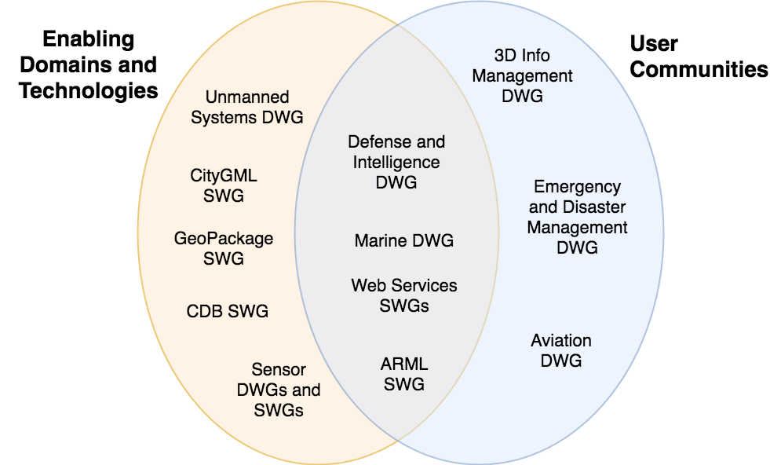
Figure 1 Some of the OGC Working Groups that should cooperate with the ISG DWG

Business Case

Solving issues that limit the effectiveness of interoperating simulations and gaming systems will benefit end-users by reducing the cost and increasing the effectiveness of use of real-world geospatial data in a synthetic environment.

Use of open standards, including OGC standards for use of geospatial data in 3D environments offers opportunity to end-users and system providers to achieve higher levels of effective usage of interoperating simulations.

The OGC’s open consensus based standards development processes and OGC participation by international government, industry, and academia has been proven to be effective. Standards developed and maintained by OGC have been demonstrated to achieve the balance between the benefits of standardization and critical preservation of technical discriminators necessary for competitive markets.

Organizational Approach and Scope of Work

ISG DWG Business Goals
The ISG DWG will establish a set of business goals that form the basis for determining the nature and type of recommendations made to the OGC, framed around the above mentioned business issues. Some of these business goals include:
1) Efforts should focus on addressing ISG issues and problems that result in a net gain for the community,
2) Minimize incompatible technical distinctions between different ISG implementations – particularly associated with data interoperability, as this can lead to artificial barriers that limit the potential of all segments of the community to come together and fully prosper,
3) Avoid placing artificial technical barriers on use of ISG hosted geospatial data,
4) Establish the means by which OGC can achieve interoperability and yet preserve the proprietary discriminators of ISG implementers, and
5) Define the supporting infrastructure for the community to achieve these goals.

ISG DWG: Mission and Role
The mission and role of the ISGDWG will be to:
- Serve as the forum for discussion of requirements and use cases for further development of the ISG standards suite,
- Recommend to the CDB SWG and other OGC SWGS to create or change specific ISG standards documents as required, and
- Provide a forum for discussion of topics and issues relevant to ISG technologies and how they may impact on geospatial standards.

Activities planned for ISGDWG
Activities currently planned for the ISGDWG include:
- Conduct one or more summits during OGC TC meetings to gather requirements and use cases;
- Engage with the OGC Compliance Program, and other TC Working Groups as necessary, to establish a registration system for ISG specifications and their implementations ,
- Investigate the elaboration of extensions to the core OGC ISG Standards to define additional functional algorithms and/or schemas that will support interoperability protocols. Investigate potential additions to the OGC ISG Standards and Best Practices additions to other OGC standards,

