OGC®

Open Geospatial Consortium (OGC)

Request for Quotations (RFQ)

and

Call for Participation (CFP)

for

OGC Testbed 10

OGC Web Services Initiative - Phase 10 (OWS-10)

Annex B

OGC Testbed 10 Architecture

RFQ Issuance Date: 15 July 2013

**Proposal Due Date: 26 August 2013**

TABLE OF CONTENTS

1 OGC Testbed 10 Introduction 5

2 OGC Testbed 10 Thread Summaries 6

2.1 Cross-Community Interoperability (CCI) Thread 6

2.2 Open Mobility Thread 6

2.3 Aviation 7

2.4 Types of Deliverables 7

3 OGC Testbed 10 Baseline 9

3.1 OGC Reference Model 9

3.2 OGC Standards Baseline 9

4 Cross-Community Interoperability (CCI) Thread 11

4.1 CCI Thread Scope 11

4.2 CCI Thread Requirements 11

4.3 CCI Thread Deliverables 28

4.4 CCI Enterprise Viewpoint 31

4.5 CCI Information Viewpoint 33

4.6 CCI Computational Viewpoint 34

4.7 CCI Engineering Viewpoint 35

5 Open Mobility Thread 37

5.1 Open Mobility Thread Scope 37

5.2 Open Mobility Thread Requirements 37

5.3 Open Mobility Thread Deliverables 41

5.4 Open Mobility Enterprise Viewpoint 43

5.5 Open Mobility Information Viewpoint 44

5.6 Open Mobility Computational Viewpoint 45

5.7 Open Mobility Engineering Viewpoint 45

6 Aviation Thread 48

6.1 Aviation Thread Scope 48

6.2 Aviation Thread Requirements 49

6.3 Aviation Thread Deliverables 59

6.4 Aviation Enterprise Viewpoint 65

6.5 Aviation Information Viewpoint 69

6.6 Aviation Computational Viewpoint 72

6.7 Aviation Engineering Viewpoint 74

7 Appendix A Integrated Client Enhancement Description 75

LIST OF FIGURES

Figure 4‑1 Ontology Architecture 13

Figure 4‑2 VGI Context Architecture 14

Figure 4‑3 Sample Tabular Output 16

Figure 4‑4 Geographic names in New Brunswick, Canada. 18

Figure 4‑5 Matches Between Two Gazetteer Services/Databases 19

Figure 4‑6 Map Display Showing Updated Names from Source Data 19

Figure 4‑7 Map Display Showing Updated Source Data and Other Target Data 20

Figure 4‑8 Map Display Showing Updated Source Data and Other Target Data 20

Figure 4‑9 Sample Match Display 21

Figure 4‑10 Task Console 22

Figure 4‑11 High Level Architecture from Sections 3.2.5 & 3.2.5 26

Figure 4‑12 Hydro Model Concept 27

Figure 6‑1 Towards a New Aeronautical Information Management Paradigm 66

Figure 6‑2 Information Exchange Models (red) for ATM domains (blue) - ATM Information Management enablers 66

Figure 6‑3 globally connected SWIM environments 67

Figure 6‑4 Interoperable dissemination of ATM information from multiple SWIM environments facilitated by OGC service interfaces 67

Figure 6‑5 Building blocks for interoperable ATM Information Management 68

Figure 6‑6 Aviation Thread Engineering Viewpoint 74

LIST OF TABLES

Table 1 – CCI Thread Deliverables Summary 28

Table 2 – Open Mobility Thread Deliverables Summary 41

Table 3 – Aviation Thread Deliverables Summary 59

# OGC Testbed 10 Introduction

A significant part of the OGC standards development process is the Interoperability Program (IP), which conducts international interoperability initiatives such as Testbeds, Pilot Projects, Interoperability Experiments, and Interoperability Expert Services. These activities are designed to encourage rapid development, testing, validation, demonstration and adoption of open, consensus based standards and best practices. Descriptions of these various initiatives can be found here:

<http://www.opengeospatial.org/ogc/programs/ip>

The OGC Testbed 10 is a Testbed within the Interoperability Program. OGC Testbed 10 is a global, hands-on and collaborative prototyping activity designed for rapid agile development and delivery of components and services, as well as experience leading to documented best practices. The results of OGC Testbed 10 will be documented as Engineering Reports and submitted to OGC’s Technical Committee for consideration for release as public documents. In the future, some of the Engineering Reports, upon formal adoption within the OGC Standards Program may lead to new standards, revisions to existing standards, or best practices.

An index to the policies and procedures governing OGC can be found here:

[http://www.opengeospatial.org/ogc/policies](http://www.opengeospatial.org/ogc/policies/)

The policies and procedures that define the OGC Interoperability Program are available here:

<http://www.opengeospatial.org/ogc/policies/ippp>

The purpose of Annex B is to describe the detailed context and requirements for OGC Testbed 10 development, which involves multiple interdependent activity threads. The requirements and architectures presented here are based upon a collaborative effort between OGC Testbed 10 Sponsors and OGC’s IP program and project management staff, collectively referred to as the IP Team. The OGC Testbed 10 architecture builds on the results from previous and ongoing OGC IP initiatives, existing OGC discussion papers and specifications, OGC Technical Committee activities, and publicly available documentation from related standards organizations including ISO, W3C, OASIS, and others.

Section 2 provides an overview of the OGC Testbed 10 development threads.

Section 3 discusses the architectural approach and technical baseline for OGC Testbed 10.

Sections 4 through 6 provide the requirements, deliverables, architectural approaches and issues for each of the OGC Testbed 10 development threads.

The OGC public website provides a Glossary of Terms at the following URL that may be useful to aid in understanding and interpretation of terms and abbreviations contained throughout this RFQ:

<http://www.opengeospatial.org/ogc/glossary>

# OGC Testbed 10 Thread Summaries

## Cross-Community Interoperability (CCI) Thread

The Cross-Community Interoperability (CCI) thread seeks to build on interoperability within communities sharing geospatial data and advance semantic mediation approaches for data discovery, access and use of heterogeneous data models and heterogeneous metadata models. This thread will explore the creation of domain ontologies and tools to create, assemble, and disseminate geographic data provided voluntarily by individuals. In addition to build integration across all OGC web services with the intent to provide a better understanding of service content and the relationships or associations that exist between OGC services and resources/content. The work to be performed in this thread includes the following:

* **Ontology –** Creation of an ontology that renders shared [vocabulary](http://en.wikipedia.org/wiki/Vocabulary) and [taxonomy](http://en.wikipedia.org/wiki/Taxonomy_(general)) which models a domain with the definition of objects/concepts, as well as their properties and relations.
* **Volunteered Geographic Information (VGI) –** The VGI effort continues on OWS-9 work to expand the use of OGC services and standards for VGI access, data linking, and rule-based conflation.
* **Gazetteer -** The Virtual Global Gazetteer effort extends the Single Point of Entry Global Gazetteer (SPEGG) work from OWS-9, building on the framework established in the earlier testbed and expanding gazetteer functionality to include gazetteer conflation and semantic gazetteer linking.
* **WPS conflation and provenance –** The WPS effort will advance data and service discovery. It will also investigate new and/or existing services the benefit of semantic mediation approaches to support discovery of pertinent services or data collections.
* **Linked WPS and Decision Rules** – This effort willdevelop a framework for WPS to investigate diverse data sets and build relational linkages and, when appropriate, invoke other services (e.g. WPS Conflation).
* **Profiles –** This effort will ensure that implementations developed in this thread are based on the latest versions of the DGIWG and NSG profiles of OGC Web Services.
* **Hydro Model Interoperability –** This effort will demonstrate interoperability among hydrographic and hydrologic data sources.

## Open Mobility Thread

Client applications are mobile. They can be found in enterprise desktop environments, workhorse tablets, or phone platforms. Information services are mobile. They are distributed across clouds, internal servers and even individual users. And they consist of raw data and just-in-time processing capabilities. With such an adaptive, open environment, security is a must. The Open Mobility thread of OGC Testbed 10 explores the geospatial standards requirements to implement these concepts.

Topics in this thread include:

* **Cloud Computing** – Exploitation and service performance enhancement
* **Mobile Data** – GeoPackages and GeoPackaging services
* **OWS Context** – JSON encoding and KML annotations
* **Security** – GeoXACML, PEPs, and PDPs
* **Linked OWS** – Augmenting the OGC architecture to facilitate linking related data across services

## Aviation

The Aviation Thread of OGC Testbed 10 seeks to develop and demonstrate the use of the Aeronautical Information Exchange Model (AIXM) and especially the Flight Information Exchange Model (FIXM) in an OGC Web Services environment.

The work to be performed in this thread includes the following:

* **Advance interoperable management of aeronautical and flight information** – Test, validate and demonstrate the use of FIXM, AIXM and Digital NOTAM in a service oriented architecture including Web Feature Service, Event Service, and CSW ebRIM Registry.
* **Develop recommendations for exchange of terrain data** – Assess and investigate suitable formats and approaches for the interoperable exchange of terrain data, and satisfying Aviation domain the requirements.
* **Advance human factor based portrayal of Digital NOTAMs** – Improve the way that aeronautical information, especially NOTAMs, is visualized.
* **Advance compliance** – Advance the capability to test the conformance of geometry types contained in AIXM datasets and improve the documentation of the WFS extension to handle dynamic feature data.
* **Advance support of AIXM in development tools (J2EE, .NET)** – Investigate and test ways to improve AIXM software development.

## Types of Deliverables

The OGC Testbed 10 threads require several types of deliverables in each Thread:

* **Documents - Engineering Reports (ER), Information Models (IM), Encodings (EN), Change Requests (CR):** will be prepared in accordance with OGC published templates. Engineering Reports will be delivered by posting on the OGC Portal Pending Documents list when complete and the document has achieved a satisfactory level of consensus among interested participants, contributors and editors. Engineering Reports are the formal mechanism used to deliver results of the Interoperability Program to sponsors and to the OGC Specification Program Domain and Specification Working Groups for consideration.
* **Implementations - Services, Clients, Datasets and Tools:** will be provided by methods suitable to its type and stated requirements. For example, services and components (ex. WFS) are delivered by deployment of the service or component for use in the testbed via an accessible URL. A Client software application or component may be used during the testbed to exercise services and components to test and demonstrate interoperability; however, it is most often not delivered as a license for follow-on usage. Implementations of services, clients and data instances will be developed and deployed in the Aviation thread for integration and interoperability testing, in support of the agreed-up thread scenario(s) and technical architecture. The services, clients and tools may be invoked for cross-thread scenarios in demonstration events.

**Note that certain draft deliverables may have to be completed by the Preliminary Design and Deliverables milestone to support cross-thread development. These early deliverables are designated and handled on a thread-by-thread basis.**

# OGC Testbed 10 Baseline

## OGC Reference Model

Reference: OGC Reference Model version 2.1, document OGC 08-062r7

<http://www.opengeospatial.org/standards/orm>

The OGC Reference Model (ORM) provides an architecture framework for the ongoing work of the OGC. Further, the ORM provides a framework for the OGC Standards Baseline. The OGC Standards Baseline consists of the member-approved Implementation/Abstract Specifications as well as for a number of candidate specifications that are currently in progress.

The ORM is a living document that is revised on a regular basis to continually and accurately reflect the ongoing work of the Consortium. We encourage respondents to this RFQ to learn and understand the concepts that are presented in the ORM.

The structure of the ORM is based on the Reference Model for Open Distributed Processing (RM-ODP), also identified as ISO 10746. This is a multi-dimensional approach well suited to describing complex information systems. This Annex of the OGC Testbed 10 RFQ will use one or more of the upper four viewpoints of RM-ODP: Enterprise, Information, Computational, and Engineering, as shown in the figure below, for discussing the context for each activity thread in OGC Testbed 10.

RM-ODP_slide

## OGC Standards Baseline

The OGC Standards Baseline is comprised of all member-approved Implementation Standards, Abstract Standards, and Best Practices documents. These standards and related documents are freely available to the public at this website:

<http://www.opengeospatial.org/standards>

Each major section of the thread descriptions below identifies the relevant standards and other useful references, both normative and informative. The context of the description will make it clear whether a standard is normative (normally expressed as “will” or “shall” be used) or informative (“may” or “should”).

# Cross-Community Interoperability (CCI) Thread

## CCI Thread Scope

The Cross-Community Interoperability (CCI) thread seeks to build on interoperability within communities sharing geospatial data and advance semantic mediation approaches for data discovery, access and use of heterogeneous data models and heterogeneous metadata models. This thread will explore the creation of domain ontologies and tools to create, assemble, and disseminate geographic data provided voluntarily by individuals. In addition to build integration across all OGC web services with the intent to provide a better understanding of service content and the relationships or associations that exist between OGC services and resources/content. The work to be performed in this thread includes the following:

* **Ontology –** Creation of an ontology that renders shared [vocabulary](http://en.wikipedia.org/wiki/Vocabulary) and [taxonomy](http://en.wikipedia.org/wiki/Taxonomy_(general)) which models a domain with the definition of objects/concepts, as well as their properties and relations.
* **Volunteered Geographic Information (VGI) –** The VGI effort continues on OWS-9 work to expand the use of OGC services and standards for VGI access, data linking, and rule-based conflation.
* **Gazetteer -** The Virtual Global Gazetteer effort extends the Single Point of Entry Global Gazetteer (SPEGG) work from OWS-9, building on the framework established in the earlier testbed and expanding gazetteer functionality to include gazetteer conflation and semantic gazetteer linking.
* **WPS conflation and provenance –** The WPS effort will advance data and service discovery. It will also investigate new and/or existing services the benefit of semantic mediation approaches to support discovery of pertinent services or data collections.
* **Linked WPS and Decision Rules** – This effort willdevelop a framework for WPS to investigate diverse data sets and build relational linkages and, when appropriate, invoke other services (e.g. WPS Conflation).
* **Profiles –** This effort will ensure that implementations developed in this thread are based on the latest versions of the DGIWG and NSG profiles of OGC Web Services.
* **Hydro Model Interoperability –** This effort will demonstrate interoperability among hydrographic and hydrologic data sources.

## CCI Thread Requirements

**References**

* OWS-9 CCI Engineering Reports <http://www.opengeospatial.org/pub/www/ows9/cci.html?slide=5>
* CSW – OpenGIS Catalogue Service Implementation Specification (2.0.2) 07-006r1 <http://www.opengeospatial.org/standards/cat>
* FGDC-STD-001-1998 - The Content Standard for Digital Geospatial Metadata (CSDGM) version 2 <http://www.fgdc.gov/metadata/geospatial-metadata-standards#csdgm>
* ISO 19115:2003 Geographic information Metadata <http://www.iso.org/iso/catalogue_detail.htm?csnumber=26020>
* ISO 19115-2:2009 - Geographic information -- Metadata -- Part 2: Extensions for imagery and gridded data
* ISO 19157 Geographic information — Data quality
* <http://www.iso.org/iso/catalogue_detail.htm?csnumber=39229>
* NSG Metadata Foundation (NMF) 2.1 – NMF Metadata Implementation Specification (NMIS)
* NMF – Part 2 Quality Metadata
* OpenStreetMap - Wikiguide <http://wiki.openstreetmap.org/wiki/Beginners_Guide_1.1>
* NITF version 2 - National Imagery Transmission Format <http://www.globalsecurity.org/intell/systems/nitfs.htm>
* OGC GeoSPARQL – A Geographic Query Language for RDF Data (11-52r4)
* OWS-8 CCI Semantic Mediation ER (11-063r6) <https://portal.opengeospatial.org/files/?artifact_id=46342>
* SPARQL Query Language for RDF. W3C Recommendation 15 January 2008. <http://www.w3.org/TR/rdf-sparql-query/>
* TDS – NSG Topographic Data Store - Content Spec V3.0: <https://nsgreg.nga.mil/as/view?i=82045>
* The Specification Model - A Standard for Modular specifications (08-131r3) <https://portal.opengeospatial.org/files/?artifact_id=34762>
* TNM - USGS The USGS National Map. <http://nationalmap.gov/>

### Ontology

Currently there is no standard data model within communities of interest. For example amongst fire and rescue different local, federal or international agencies use different symbols and terminology for the same event, location or building. This makes the sharing of data difficult. The participant shall identify the standard model for the Emergency and Disaster Management community and provide a component (preferably a web service) that will translate between different local, federal or international sources. The current suggestion is utilizing the homeland security symbology found at: [www.fgdc.gov/HSWG/index.html](http://www.fgdc.gov/HSWG/index.html) as the basis for the standard model. This needs to be evaluated, and other recommendation noted in the ER along with missing items and or issues with using this as the overall standard model. Other areas to explore are if there are defined subsets of feature classes, what types of subsets should be defined and what features relate to those subsets. Finally the participants shall propose a mapping of features to the symbol in the Homeland Security Symbology.

In terms of harmonizing vocabulary / ontology support the participant shall prioritize the effort at the national level and then international as follows:

1. Police – Fire – Ambulance
2. Emergency Services – Military (for joint ops / events)
3. National Police – Interpol – other international police organizations
4. National Emergency Services – UN, Disaster Relief organizations

The participants shall create a component, either a tool or service that can map between a dataset and the selected standard model. This tool should be able to allow for the data exchange between different communities of practice, for example between NGA model and the DGIWG.

The participants shall report all findings in an Ontology Engineering report which should include potentially missing symbols, events that are un-mappable, and optimization ideas.

An example of possible output of this activity is a tool that would take Source A and Source B inputs and translate them to the Common Standard as depicted below:

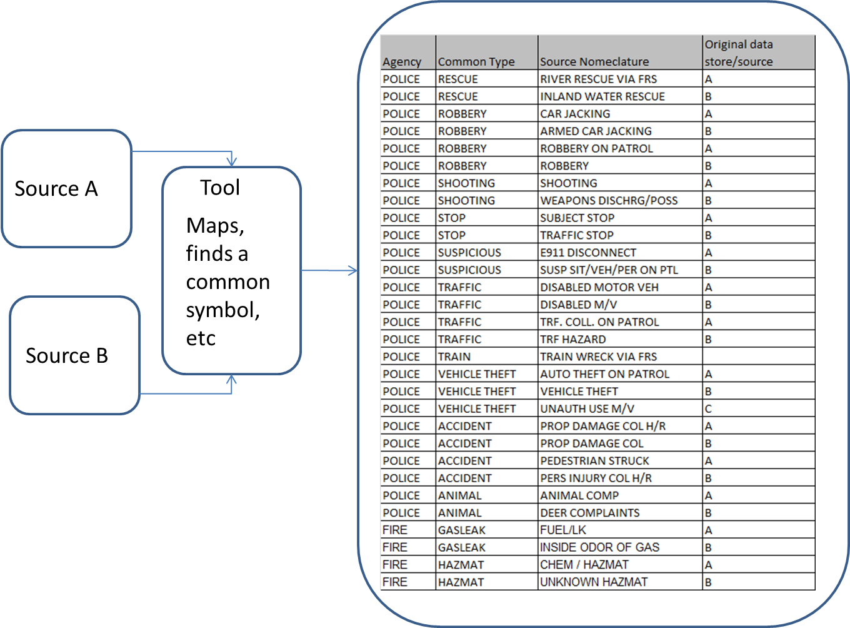

**Figure 4‑1 Ontology Architecture**

### Volunteered Geographic Information (VGI)

Volunteered geographic information (VGI) is the harnessing of tools to create, assemble, and disseminate geographic data provided voluntarily by individuals. Some examples of this phenomenon are [WikiMapia](http://en.wikipedia.org/wiki/WikiMapia), [OpenStreetMap](http://en.wikipedia.org/wiki/OpenStreetMap), and [Google Map Maker](http://en.wikipedia.org/wiki/Google_Map_Maker). These sites provide general base map information and allow users to create their own content by marking locations where various events occurred or certain features exist, but aren’t already shown on the base map. VGI is a special case of the larger Web phenomenon known as [user-generated content](http://en.wikipedia.org/wiki/User-generated_content).

The ability to render, share and exploit VGI data in a meaningful way needs to be further explored. The participant shall demonstrate expanded use of OGC services and standards for VGI access, data linking, and rule-based conflation to include:

a. Link VGI from Twitter or other sources to point features, POI, and gazetteer data (must expand use of VGI beyond Twitter)

b. Link other unstructured open-source/crowd-source information to existing point features, POI, and gazetteer data

c. Address cross-domain semantic mediation to support feature and attribute matching for conflation and data linkage

d. Semantic mediation should expand beyond feature class and name to enable rule-based conflation of selective attributes. For example: status, construction material, height, relation to other features, other identifying designators, etc

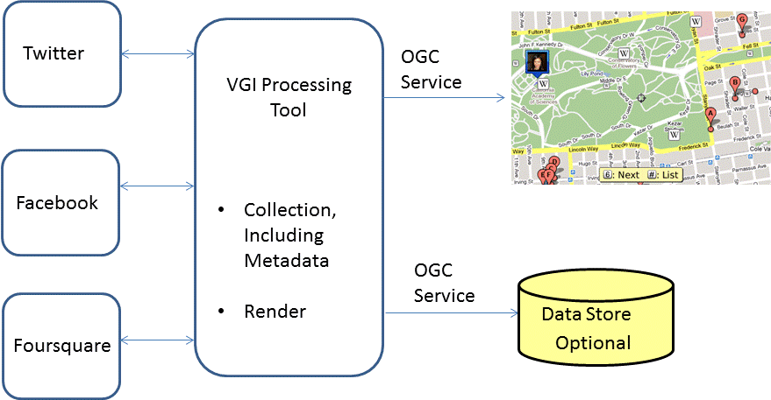

**Figure 4‑2 VGI Context Architecture**

### Gazetteer

During OWS-9, the basic components for a standards-based system for querying multiple gazetteers from a single query were demonstrated under the SPEGG. Participants demonstrated access to two gazetteers, with non-overlapping geographic coverage, using a single query with Web Feature Services – Gazetteer (WFS-G) best practices, cascading web servers, and semantic mediation.

This SPEGG research forms the foundation for the Virtual Global Gazetteer Client and Enhancements task of the current effort, which will focus on developing a Virtual Global Gazetteer that includes a gazetteer-specific client, develops advanced fault-tolerant capabilities, and opens the service to the wider community for comment.

The second task, Gazetteer Conflation addresses the issue of gazetteers with overlapping geographic coverage. The assumption for this Web Processing Service task will be that gazetteer features that represent the same geographic feature may differ in location and spelling. This standards-based task builds on the OWS-9 conflation research, but focuses on gazetteer-based point conflation. This task will require semantic linking to filter the features and conflation to match the features and transfer attribute and positional information. The output from this process will either be a map display or a concordance (link table) of matched features.

Gazetteer Linking will build on the semantic web, RDF standards, SPARQL, and concordances to rapidly move across gazetteers and other crowdsourced data, giving researchers access to information beyond the limited descriptions in gazetteers. This task will involve encoding gazetteer information in RDF and linking information from other sources. A concordance or data internal to the services or databases will be used to walk across information sources, so no conflation or geometric/attribute matching is required. With this approach, a user of an NGA gazetteer will be able to link to the Geonames.org gazetteer and move from there to other information, such as weather, climate, population, and government descriptions.

The standards-based work in this thread will enhance the capabilities of current gazetteers, further interoperability among gazetteers, and demonstrate the potential of conflation and linking gazetteers as key elements of the semantic web.

The three research tasks outlined in this thread are all standards-based efforts intended to implement, test, and evaluate and extend the state-of-the-art for geographic names analysis and management.

#### Virtual Global Gazetteer Client and Enhancements

The first task will focus on the development of a Virtual Global Gazetteer capability that tests the suitability of a standards-based approach for addressing geographic names customer requirements. During OWS-9, a generic client for handling names requests served ably to demonstrate the basic functionality of the overall architecture.

The first task in OGC Testbed 10 will develop a customized gazetteer client so that users can generate queries and access services without understanding the underlying technologies and receive responses that are similar to those from non-standards-based systems. The underlying architecture will be similar to the Single Point of Entry Global Gazetteer using the NGA and USGS gazetteers, but contain enhancements identified in OWS-9.

##### Client Development

OGC Testbed 10 should demonstrate a client that allows a user to formulate a query that includes the name, a name string filter for the name, a feature description, country, and a spatial constraint. The results that are returned should be in tabular form, with the ability to search for additional results if a subset of the search results is returned by the query.

##### Queries

The user should be able to query by name, feature description, country, and spatial constraint.

###### Name

The user should be able to enter a name, including diacritics if appropriate.

###### Name String Filter

The user should be able to select how the name is utilized in the query. Filters may include:

* Starts With
* Ends with
* Contains
* Fuzzy Match

###### Feature Description

The user should be able to filter queries by the feature description (also known as the feature designation). This description could reflect the terminology of either agency, i.e., the user should be able to query on USGS feature descriptions or NGA feature designations. These should be expanded to common language descriptions rather than codes. As an example, a user should be able to select USGS feature descriptions and pick a term like ‘summit.’ This term would access information from related NGA feature classes, such as ‘mountain’, ‘hill’, ‘peak’, ‘rock’, etc. The user should also be able to filter features based on the use of NGA terms. In this case, picking a term like ‘hill’ would return USGS ‘summit’ features. These mappings should be displayed to the user on the query form.

###### Country

The user should be able to filter queries by country, i.e., show only names in Afghanistan. Country names should be expanded to common language descriptions rather than codes.

###### Spatial Constraint

The user should be able to filter the query using a bounding box, radial search, or near query that will sort the results from closest to furthest away from a given coordinate.

##### Results

###### Tabular Format

Results should be returned in a tabular format. If the number of records returned is fewer than the total number of records identified by the query, then the user will have the option of seeing the total number of results and paging through the results until all the records are displayed. (See Figure 4-3) Figure 4-3, like all figures in this Statement of Work, is provided for illustration purposes only and the exact content and design may vary. Any processing errors should be identified as well if the results of the query are incomplete due to lack of WFS-G support by any of the servers.

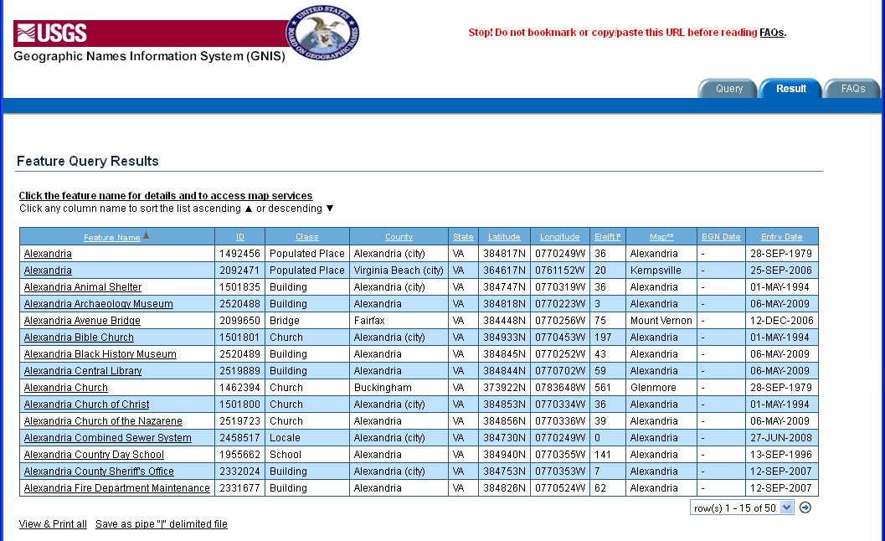

Figure 4‑3 Sample Tabular Output

##### Sorting Records

The user shall have the ability to sort the results by name or feature description. In addition, the user shall have the option of sorting the records from nearest to furthest away, based on a near spatial query.

##### Architecture Enhancements

Based on the feedback from OWS-9, the basic architecture underlying the Virtual Global Gazetteer shall be improved and where necessary developed.

###### Thick Mediator Semantic Mediation Approach

Because of limitations between the versions of the WFS-G servers, a ‘thick mediator’ approach may be most practical for the underlying architecture. This will allow differences in capabilities and versions to be addressed by the mediator/cascading service. The research should evaluate the complexity of this approach versus the costs and effort to configure multiple WFS-G services identically.

###### Fault Tolerance

Due to lack of capabilities and potential problems in service, the addition of fault tolerant functionality needs to be addressed to assure consistent service and provide the user with an understanding of the results returned.

###### Use of Complete Data Sets

The Virtual Global Gazetteer should be designed to access and deliver results from the complete NGA and USGS servers (or simulated servers). Performance for the system should be recorded to insure that results are timely. Note: performance is not normally a part of OGC testbeds, but is needed to determine the viability of the solution.

#### Gazetteer Conflation

Gazetteer conflation is the process of matching entries from multiple names sources, sharing or replacing attribute information, and presenting the fused results to users. This task is becoming more important with the proliferation of international, national, state, and crowdsourced gazetteers. This matching process enables a gazetteer producer to identify common features across sources as well as update and enhance existing sources. Gazetteer Conflation uses point-to-point conflation of data sets with limited attribution … basically a name and feature description.

Matching will occur between a source service that contains the original names and a target service that contains the names to be matched to the source. Typically, matches are based on proximity, closeness of name spelling, and agreement of feature designation. The conflation process needs to be sensitive to the nuances of name matching, including the ability to match names which may 1) be spelled slightly differently (Minch Harbor versus Minche Harbor), 2) be spelled using different word orders(Lake Utopia versus Utopia Lake), 3) incorporate abbreviations (Saint George and St. George), 4) incorporate numbers which are indicated by numerals or spelled out (Dike 1 versus Dike One), 5) include special symbols as word replacements (Dike # 1 versus Dike Number 1 or Chesapeake & Ohio Canal versus Chesapeake and Ohio Canal), and 6) be missing the generic portion of the name (Minch Harbor versus Minch) . These differences may occur singly or in combination.

Conflation algorithms also need to be able to match names using variant names as well as official names. For example, if the name Peking is found in a source service and associated with the name Beijing, the conflation algorithm should recognize this relationship and match the name Peking from a target service with Beijing in the source service.

Matching feature designations requires semantic matching as differing gazetteers may use differing terminology. This step is essential for reducing the search space of candidate names. For example, the NGA feature description, Populated Place, is equivalent to the Canadian Geographical Names Database (CGND) of Town, Hamlet, or Unincorporated Area.

Gazetteer matches are typically scored based on measures of proximity and closeness of spelling. A name that is spelled the same and located at the same position would get a perfect score. Scores would be reduced as differences in position and spelling increase. Users would specify a threshold at which two point features are considered to match and the highest scoring feature from the target database exceeding the threshold would be selected as the matched feature.

The goal of this task is to demonstrate a standards-based approach to gazetteer conflation using Web Feature Servers (WFS), Web Processing Standards (WPS), and Web Feature Services Transactional (WFS-T). It will address two specific use cases: 1) Automated Gazetteer Conflation where one source is known to contain better information than a second source, and 2) Transactional Gazetteer Conflation based on user interaction.

##### Automated Gazetteer Conflation

In the first use case, the goal is to take a WFS-G gazetteer service (referred to as A) and match it with a data from another service (WFS-G or WFS) (referred to as B) that contains more accurate and/or more current information, displaying the conflated results. The assumption is that the information in A is inferior to the data in B and will be replaced by the information from B in cases where a match is found.

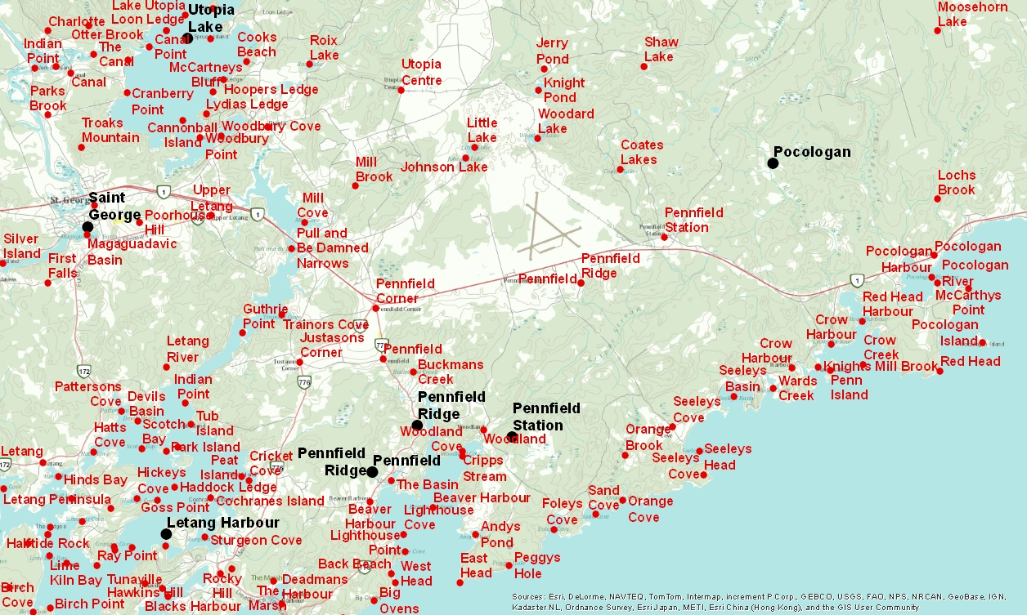

Figure 4‑4 Geographic names in New Brunswick, Canada.

In Figure 4-4, NGA source names are shown in black and New Brunswick target provincial names are shown in red. This illustrates a typical situation, where a locally produced gazetteer contains information that differs from the NGA gazetteer in terms of the positional accuracy of names, as well as the current local spelling. For the purposes of this task, it is assumed that the information in the New Brunswick gazetteer is more accurate than the NGA gazetteer in every respect and will replace the NGA data when matched.

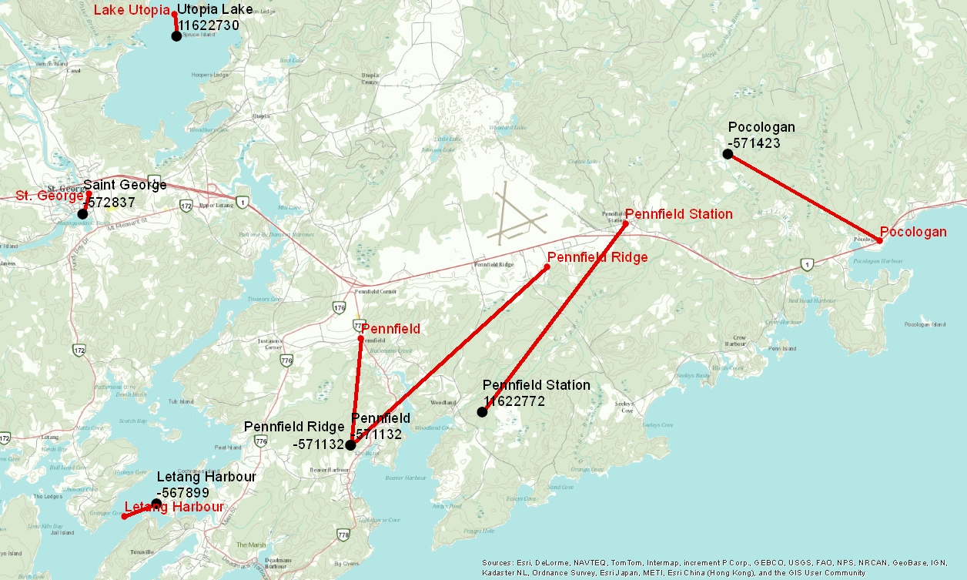

Figure 4‑5 Matches Between Two Gazetteer Services/Databases

In Figure 4-5, the named features from NGA are shown in black and the named features from New Brunswick are shown in red. The locations of the identical features are connected using red lines, highlighting the positional differences in the two databases.

###### Map Display

The conflation results should be displayed on a map. The user should be able to select the type of map display, either 1) an updated version showing the updated source service names or 2) an updated version showing all the names from the source and target services.

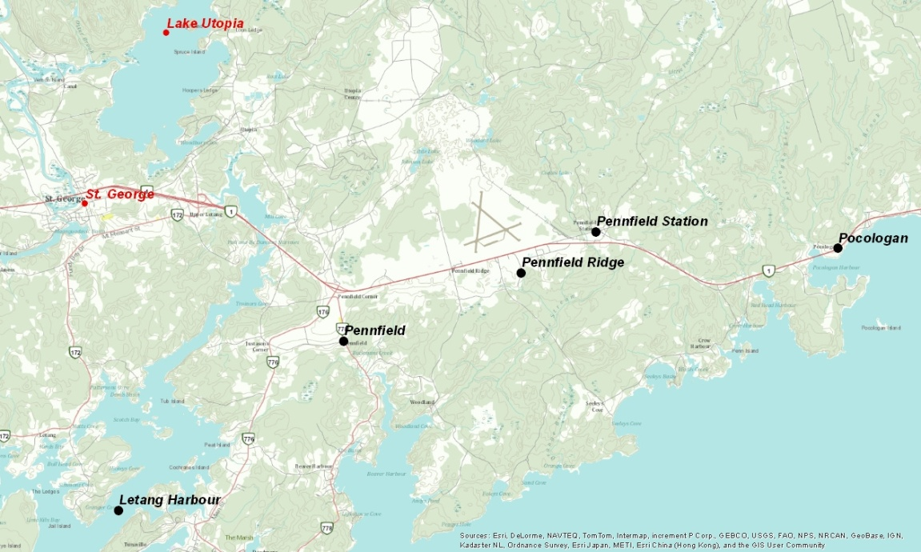

Figure 4‑6 Map Display Showing Updated Names from Source Data

The updated NGA data is shown in Figure 4-6. In this case, the names are symbolized to reflect the changes as a result of conflation. Names in black retain the original NGA spelling. Names in red adopt the New Brunswick spelling. Names in italics represent features whose positions have changed from the NGA source. Names not in italics (none in this example) would represent names where the original NGA positional information is retained. The specific changes need to be noted in the map display, although the specific graphic design shown in Figure 4-7 is not required.

***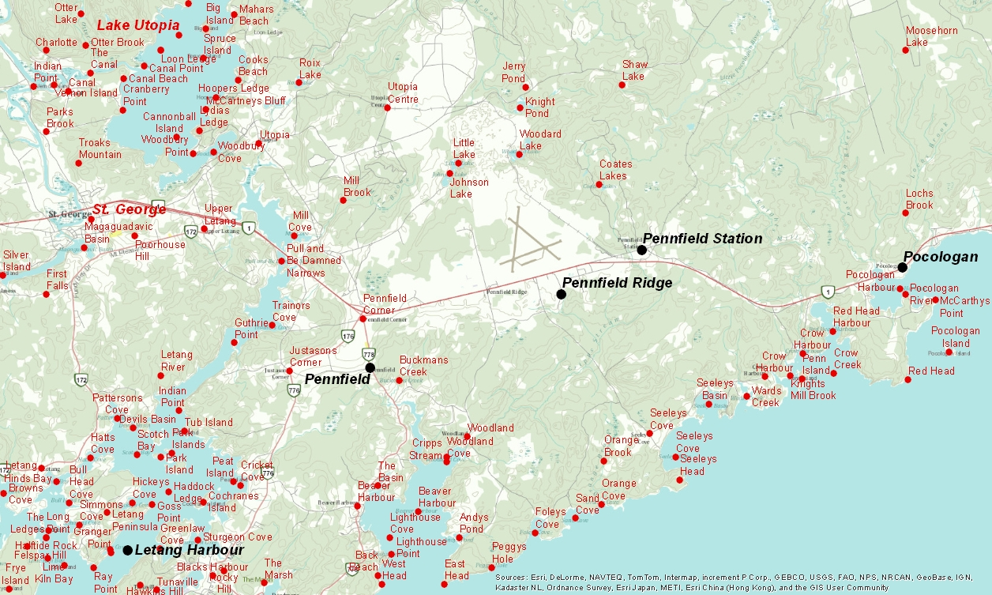***

Figure 4‑7 Map Display Showing Updated Source Data and Other Target Data

The updated NGA data from Figure 4-6 is combined with the other New Brunswick names data in Figure 4-7. This would form a layer containing all the names information from both sources, symbolized to indicate how the source was modified.

###### Tabular Results

In addition to a map display, the automated conflation process should produce a match table, similar to Figure 4-8, showing the feature identifier from the source, the feature identifier from the target, and highest match score if there is a match.

|  |  |  |  |  |
| --- | --- | --- | --- | --- |
| **NGA Name** | **New Brunswick Name** | **NGA UFI** | **New Brunswick UUID** | **Match Score** |
| Pocologan | Pocologan | -571423 | 0c7dd088849c20c342494509894eb04d | 96.25 |
| Saint George | St. George | -572837 | 0c7a15ea849c20c3bdef246bf504e09e | 92.50 |
| Utopia Lake | Lake Utopia | 11622730 | ad9d92b7c6cd11d892e2080020a0f4c9 | 93.60 |
|  | Lorneville |  | 0c7df9a1849c20c34832386c5d2ab4fd |  |
| Kedron Lakes |  | 11622794 |  |  |

Figure 4‑8 Map Display Showing Updated Source Data and Other Target Data

##### Transactional Gazetteer Conflation

Automated Gazetteer Conflation is optimistic, assuming that one data service is superior to another in every respect and can be used to replace the information without inspection. A more realistic scenario, Transactional Gazetteer Conflation, evaluates names one at a time, puts an analyst in the loop, and lets the analyst determine which positional and attribute information is transferred from the target service to the source service. In this use case, the analyst extracts a series of records for conflation and then steps through the set of records.

###### Workflow

The Interactive Gazetteer Conflation workflow uses the following steps:

1. Extract source data from service to be used for analysis
2. Individual source record extracted from source data
3. Source feature matched against target data set using WPS
4. Source feature and target matches displayed on match display
5. Analyst selects correct match and determines which attributes to update in source data
6. Update to source data performed using WFS-T
7. Update source data set for Task Console
8. Go to Step 2 and extract next record

###### Match Display

The Match Display should display a map showing the location of the source name and the candidate matches. The source name and information should be displayed, along with a table of candidate matches listing at a minimum the name, distance from the original feature, and spelling score match. The user should be able to select a match record and update the position or name fields and commit the record to the database using WFS-T. Once a record is committed, it should be marked as a ‘Match’. If no record matches, the user should mark the name as having ‘No Match’. Any record which is not committed or matched will have a status of ‘Not Evaluated.’

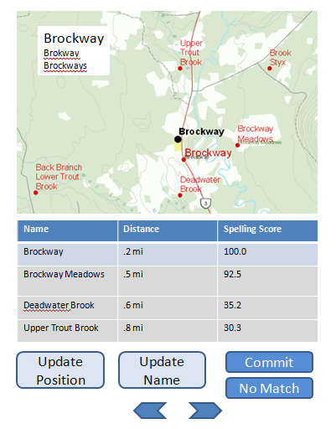

Figure 4‑9 Sample Match Display

###### Task Console

The Task Console shows the overall progress of the matching process for the selected source data. It will provide an overview of the progress for the selected data being matched, as well as the status of the individual records.

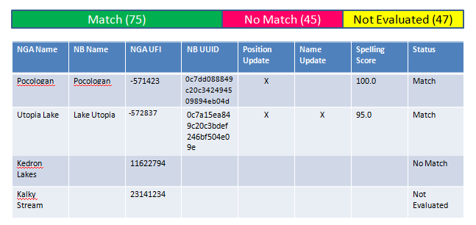

Figure 4‑10 Task Console

###### Export Results

The analyst should be able to export the results of the conflation process to create a concordance table containing the match information and linkages between the sources. This table can be used in the Gazetteer Linking process.

#### Gazetteer Linking

Gazetteer Linking is based on the premise that features in a gazetteer and other sources of information have already been matched and the match between identifiers is stored in a concordance or is embedded in a data source. The former is known as a concordance link and the latter as an embedded link. To take full advantage of the semantic web and ability to quickly move across links, the data sets should be encoded in an RDF.

The power of linking may be demonstrated through a simple example. Moncton is a city in New Brunswick, Canada. NGA stores this feature with a Unique Feature Identifier (UFI) of -569498. Geonames.org, a crowdsourced gazetteer, provides a concordance that links NGA features to Geonames.org features, based on unique identifiers, so there is a record with the IDs -569498 (NGA) and 6076211 (Geonames.org). If you know the NGA identifier, you can use this to access the related Geonames.org record, which contains information not found in the NGA gazetteer, such as alternate names, the time zone, a link to the Wikipedia article, and a link to the DBpedia database. The link to the DBpedia article, <http://dbpedia.org/page/Moncton>, provides access to a the DBpedia semantic description with a variety of other information, such as the population, climate, government, time zone, city home page, and such non-traditional data as a list of famous people who were born, currently live, or died there. Thus, by simply knowing the NGA UFI, you can obtain a tremendous amount of additional context that simply isn’t possible using a single data source.

The goal of this task is to encode NGA gazetteer information in RDF, demonstrate a capability to list new information available from related resources (obtaining information from sources at least two sources distant from the original source), query and select the information of interest, and return the information in a query. This will be done using common links and the OGC GeoSPARQL query language and technology.

##### Encoding Gazetteer Data in RDF

The NGA gazetteer information will be encoded in RDF in a form suitable for linking to the Geonames.org RDF and DBpedia RDF using common identifiers.

##### Describing Information Content of Linked Resources

The initial step in the linking process is the identification of information provided in the linked resource. This information shall be listed in a form that lists the code for the resource as well as a textual description if available. For example, the DBpedia data for Moncton lists information for the property ‘foaf:nick’. This information is the “nickname - A short informal nickname characterising an agent (includes login identifiers, IRC and other chat nicknames)” and in the case of Moncton is Hub City. This set of information will be used to build the query for extracting the information.

##### Querying and Extracting Information

Once the linkages between semantic data and the available information are known, the analyst can prepare the query to extract the information. The developer will design an interface that lets the analyst select a gazetteer record of interest, establish the links to the related semantic databases, select the information of interest, query the data, and see the results. This should be done as generically as possible, so that any number of linked databases can participate in the query. As an example, the user should be able to select Moncton from the NGA gazetteer service and see that its nickname is Hub City using information from DBpedia that was accessed using a link from Geonames.org.

#### Government Furnished Equipment

The Government will provide copies of the following databases for testing:

* Geographic Names Information System (GNIS)
* Geographic Names Data Base (GNDB)

USACE will provide geographic names support for oversight and testing of the proposed solutions.

### WPS Conflation and Provenance

In OGC Testbed 10, the CCI thread will utilize a Web Processing Service (WPS) to advance data and service discovery and investigate, evaluate, and demonstrate through OGC new and/or existing services the benefit of semantic mediation approaches to support discovery of pertinent services or data collections providing semantically equivalent or relevant data.

The participants shall begin with the architecture results from OWS-9 and evolve them to:

* + - Allow metadata semantic equivalency for the purpose of content discovery
    - Develop a client and web services to allow consumers to submit general search requests.
    - Provide the ability to apply a minimum set of metadata to be used to reference/link data to geographic area, event, timeline and other data holdings.
    - Investigate and implement mechanism to allow catalogs to express SPARQL server capabilities.
    - Investigate how to make SPARQL servers compatible with OGC web services. For example: Can a WFS provide a SPARQL end point?
    - Incorporate Volunteered Geographic Information (VGI) into the decision and workflow process.

The participants shall advance the management of data provenance in OGC Web Services by properly capturing and propagating that information through OGC services:

* + - Investigate how data quality and provenance information, using ISO 19115 can be exposed in OGC services and encodings.
    - Provide approach for maintaining data provenance of processed data in metadata of combined datasets.

The participants shall implement more complex conflation cases:

* + - Demonstrate cross-domain conflation (e.g. names (gazetteer entries), POI, points or aeronautical, topographic and maritime features). This includes updating of attributes from one domain to the other.
    - Demonstrate conflation of 3 or more multiple datasets.
    - Demonstrate conflation or linking of points, lines, and polygons.

The participants shall mature and extend the attribute matching concepts of OWS-9:

* + - Current mediation is primarily used for feature class and feature name only
    - Apply semantic mediation to the feature matching process to determine matches based on descriptive feature class, name, and attribute similarity.
    - Apply semantic mediation to additional attributes as part of decision rules to conflate or link data.
    - Apply semantic mediation to additional attributes as part of conflation business rules to enrich target attribution.
    - Use the best available open source or participant provided conflation tools in the WPS, which is not necessarily continuation from OWS-9 tools, other options may be explored.

The participants shall conduct an engineering study to investigate alternatives and provide provenance strategy. The study should include the following:

* Assess and apply multiple standards (e.g. ISO and W3C) at specified levels (layer, feature, attribute).
* Review and vet candidate geospatial quality indicators.
* Identify processes to support provenance queries, provide visual flags of changes and provide alerts on quality issues.
* Summarize results and recommendations.

The participants shall implement an expanded provenance processes to include:

* Build on OWS-9 ISO approach and add W3C, implement data quality indicators and flags, and provide alerts to meaningful and measurable change.
* Apply appropriate provenance to the Linked WPS and Conflation WPS.
* Include provenance in cases where decision and business rules lead to full or partial feature/attribute update.
  + Maintain link/context to reach back to sources of change.
  + Capture provenance at the dataset, feature, or attribute level metadata.

### Linked WPS and Decision Rules

The CCI thread will develop a framework for WPS to investigate diverse data sets and build relational linkages.

The participants shall:

* Utilize OWS Context, GeoSPARQL, and RDF to provide means to capture linkages and relationships between different datasets and objects.
* Enable data access, discovery of spatial and semantic relationships, linking related date.
* Provide improved visualization and context for situational awareness, conflation, analysis, and several other applications.
* Apply decision rules on whether data should be linked and referenced or whether features should be conflated. Some items to be considered are:
  + Are objects the same as each other or only related to each other? Features linked geospatially or thematically but essentially different.
  + When data is related but conflation is not warranted, provide means to capture linkage in both datasets.
  + When data relationship warrants conflation, invoke conflation WPS.

Linked data should provide initial access to expanded set of VGI and crowd-sourced data of semantic or spatial relevance.

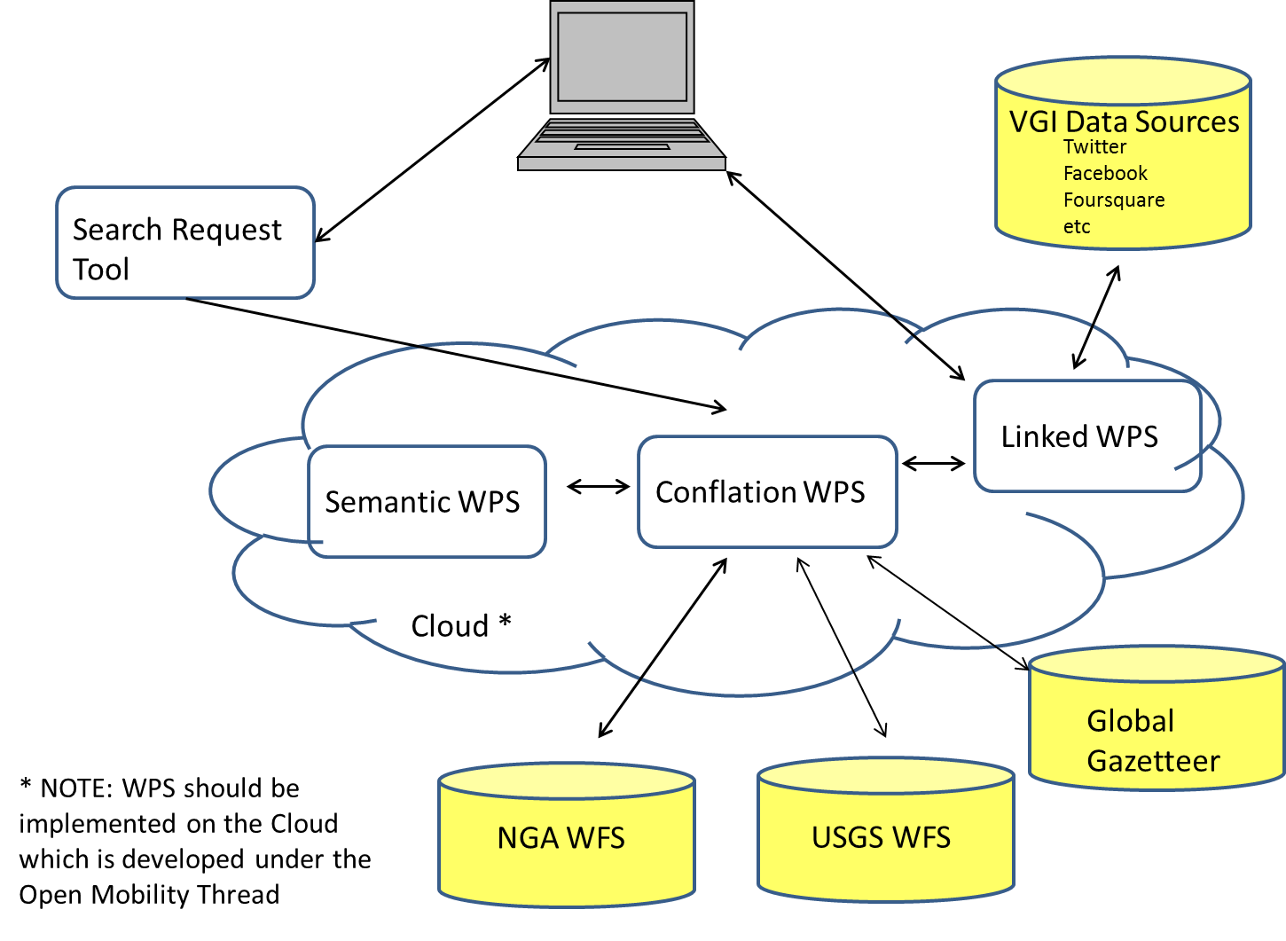

Figure 4‑11 High Level Architecture from Sections 3.2.5 & 3.2.5

### Profiles

All Web Service Implementations developed in response to the scenario shall be based on the following:

* DGIWG Web Feature Service Profiles (WFS 2.0) Basic
* DGIWG Web Feature Service Profiles (WFS 2.0) Transactional (Locking)
* DGIWG Web Map Service Profile (WMS 1.3)
* NSG Web Map Service Profile (WMS 1.3)
* DGIWG draft Web Coverage Service 2.0 Profiles Terrain/Image (unfunded)
* DGIWG draft Web Coverage Service 2.0 Profiles METOC (WCS 2.0) (unfunded)

### Hydro Model Interoperability

Hydrographic and hydrologic data have been collected by numerous agencies using specific conceptual models to fulfill specific needs. For example, Canada and the United States have each a specific conceptual feature models, the National Hydrographic Network and the National Hydrographic Dataset Plus (NHD+), respectively. Even if efforts were undertaken to spatially harmonize the data, the semantic, quality and data structure are still distinct. As a result, the access, query, and use of multiple hydro data sources together are still an issue.

The World Meteorological Organization has developed and proposed to OGC a hydro model that is called the HY\_Features model. The HY\_Features model is available as an OGC Discussion paper at: <http://www.opengis.net/doc/DP/hy-features>. This Meta model addresses most of the requirements that represent cross domain hydro concepts and has been implemented within the Australian Hydrological Geospatial Fabric (Geofabric). However, there is a need to demonstrate how it should be used as part of hydro data infrastructure to support interoperability among such data and services.

Consequently, this part of the CCI thread aims to answer questions that include:

* How can the HY\_Features model enable access to hydro data from multiple sources?
* How can the HY\_Features model help the mediation between multiple hydro conceptual feature models?
* Would a HY\_Features profile be required for each data sources?
* The test bed would demonstrate how to engineer a hydrographic and hydrologic data source mediation system based on the HY\_Features model to support interoperability across jurisdictions, between various data models, and data structures.

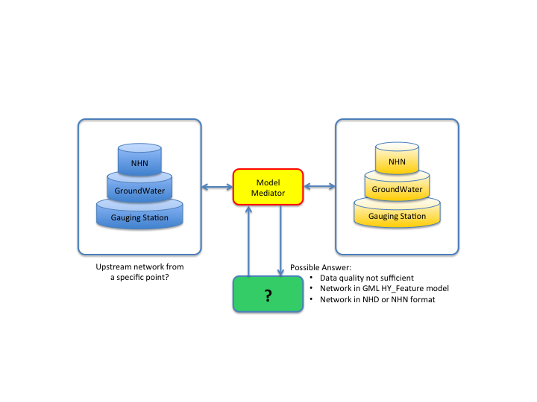

**Figure 4‑12 Hydro Model Concept**

The test bed would demonstrate how to engineer specific hydrographic and hydrologic data sources along with the HY\_Features model to support their interoperability across jurisdictions, between various data models and data structures.

Based on the Canada NHN, the US NHD, the Australian Geofabric and other specific hydro feature models available, the participant shall develop a Web-based mediation service using the HY\_Features meta-model to link hydrographic, hydrologic, and societal features. Queries should be formed in terms of the HY\_Features or particular hydro feature model, returning linked data types and or applicable OGC Web Service payloads. The results can be a GML file, a file in the format supported by the specific source, a WFS, etc.

The test bed shall also demonstrate the use of GeoSPARQL to query hydro data and to provide results that support the Semantic Web and Linked Data, for example using an implementation of the Linked Data API (http://code.google.com/p/elda/).

OGC Testbed 10 Hydro modeling will provide support services to demonstrate the use of linked data to provide feature identity and representation linking services for a set of societally-defined features. Linked representations of the features and the features’ attributes should include but not be limited to Web Feature Services and Sensor Observations Services. Linked data types and relationships should be based on appropriate domain information models such as HY\_Features, CityGML, etc.

In addition to the service, the participant shall make recommendations for the development of new hydro models and identify strengths and weaknesses of hydro models used during the test bed. This shall be documented in the ER along with any other findings identified during the test bed. Also, best practices shall be elaborated to support agencies that aim to interoperate with others with respect to their specific hydro data in conjunction with the HY\_Features model.

## CCI Thread Deliverables

The Deliverables are summarized in the Table with descriptions of the Deliverables in paragraphs following the table.

Table 1 – CCI Thread Deliverables Summary

|  |
| --- |
| 1. Profile Interoperability Engineering Report |
| 1. CCI Change Requests – to OGC standards (as needed) |
| 1. Virtual Global Gazetteer Client |
| 1. Virtual Global Gazetteer Service |
| 1. NGA WFS-G |
| 1. USGS WFS-G |
| 1. Local WFS |
| 1. WFS for VGI |
| 1. Virtual Global Gazetteer Engineering Report |
| 1. CCI OGC Web Services |
| 1. Provenance Engineering Report |
| 1. CCI OGC Client Applications |
| 1. CCI WPS 2.0 Conflation Service |
| 1. VGI Component |
| 1. Semantic Mediation Service |
| 1. Ontology Engineering Report |
| 1. Ontology Mapping Component |
| 1. VGI Engineering Report |
| 1. Hydro Engineering Report |
| 1. Hydro Mediation Service |
| 1. Hydro Model Services |
| 1. WPS Profiles Engineering Report (Added Aug 15, 2013) |

### Profile Interoperability Engineering Report

This Engineering Report will include description of the work performed and analysis of DGIWG and NSG profiles for interoperability. Highlight any issues which may be cause for interoperability concerns with standard OGC services or between DGIWG and NSG profiles.

### CCI Change Requests – to OGC standards

Change Requests to OGC specifications as required. Modifications or enhancements to the OGC suite of standards as needed to support the concept and implementation of Semantic Mediation capabilities.

### Virtual Global Gazetteer Client

A client as described in detail in section 4.2.3.

### Virtual Global Gazetteer Service

This component is a thick mediator that will be able to cascade different gazetteers as described in detail in section 4.2.3.

### NGA WFS-G

WFS-G service for the GNS or GeoNET Names Server that provides access to the Geographic Names Data Base (GNDB). It serves names for areas outside the United States and its dependent areas, as well as names for undersea features, as described in detail in section 4.2.3.

### USGS WFS-G

The GNIS or Geographic Names Information System, managed by USGS. It contains information about domestic and Antarctic names as described in detail in section 4.2.3.

### Local WFS

Other gazetteers from any part of the world that might be available via WFS or WFS-G (e.g. New Brunswick gazetteer) for use in the conflation work as mentioned in section 4.2.3.

### WFS for VGI

A WFS Service that provides Point of Interest data from Volunteered Geographic Information (VGI) sources, as for example Open Street Map for use in the conflation work as mentioned in section 4.2.2.

### Virtual Global Gazetteer Engineering Report

This Engineering Report shall be written in compliance with OGC standards and Policies and Procedures. It should include summary, recommendations and lessons learned and future work of the activity. The report will include sections about client development, queries and results, architecture enhancements, gazetteer conflation, and gazetteer linking.

### CCI OGC Web Services

Enhancements to the WFS, CSW, Semantic Mediator, SPARQL server, as needed to test the architecture. These are described in more detail in the CCI Requirements Section 4.2. WMS/WFS/WCS should follow the DGIWG profiles as defined in Section 4.2.6.

### Provenance Engineering Report

This Engineering Report shall be written in compliance with OGC standards and include optimization ideas, Service change recommendations, and lessons learned.

### CCI OGC Client Applications

### A GIS application to support to all WPS/WCPS processes to include visualization of the results, as described in section 4.2.4 & 4.2.5

### WPS 2.0 Conflation Service

A WPS or WPSs that satisfy the requirements as described in section 4.2.4

### VGI Component

A VGI software component as described in section 4.2.2.

### Semantic Mediation Service

A WPS that satisfies the requirements as described in section 4.2.4.

### Ontology Engineering Report

The report summaries findings about the encoding of ontologies and models. It should include optimization ideas an potential issues, such as missing symbols, events that are un-mappable,.

### Ontology Mapping Component

A component that can map between a dataset and the selected standard model. This component should be able to allow for the data exchange between different communities of practice, for example between NGA model and the DGIWG.

### VGI Engineering Report

The report summarizes findings about the advancements using VGI resources. The report shall include optimization ideas, service change recommendations, and lessons learned.

### Hydro Model Engineering Report

The report includes recommendations for the development of new hydro models and identifies strengths and weaknesses of hydro models used during the test bed. This report shall also capture best practices to support agencies that aim to interoperate with others with respect to their specific hydro data in conjunction with the HY\_Features model.

### Hydro Mediation Service

A mediation service on the Web that can accept query according to the specific conceptual models and the HY\_Features model and returns results according to one of the conceptual model that would be identified in the query.

### Hydro Model Services

### Service or services enabling Gauging station selection that triggers the calculation and returns the upstream network across US-Can border as a GML file following the NHD or NHN model.

### WPS Profiles Engineering Report

### To include

* + 1. Analysis of WPS 2.0 core ability to support multiple profiles
    2. Clear definition of opportunities for commonality between OGC Testbed 10 WPS profiles
    3. Description of unique requirements to support conflation as described in the RFQ

## CCI Enterprise Viewpoint

### Ontology

An ontology represents knowledge as a set of concepts within a [domain](http://en.wikipedia.org/wiki/Domain_of_discourse), and the relationships between pairs of concepts which can be used to model a domain and support [reasoning](http://en.wikipedia.org/wiki/Reasoning) about entities. An ontology renders shared [vocabulary](http://en.wikipedia.org/wiki/Vocabulary) and [taxonomy](http://en.wikipedia.org/wiki/Taxonomy_(general)) which models a domain with the definition of objects/concepts, as well as their properties and relations. The creation of domain ontologies is fundamental to the definition and use of an [enterprise architecture framework](http://en.wikipedia.org/wiki/Enterprise_architecture_framework).

### Integration with Crowd-sourced data

The objective in OGC Testbed 10 for the VGI is to continue work integration of the emerging flow of less structure data provided by citizens that are becoming more and more important, and that requires to be integrated with structured data sources. OWS-9 developed a process to geocode the twitter feeds. The process is available as a service over the web and uses gazetteer on the backend to resolve place names. These services over the web, are also based on WPS.

Example of crowd-sourced data includes:

* http://en.wikipedia.org/wiki/Volunteered\_geographic\_information
* http://www.gfdrr.org/gfdrr/volunteer-technology-communities-open-development
* http://giscorps.org/
* http://www.openstreetmap.org/
* http://www.disasterscharter.org/home
* http://crisiscommons.org/
* http://crisismappers.net/
* http://wiki.openstreetmap.org/wiki/Humanitarian\_OSM\_Team
* http://tomnod.com/
* http://wiki.crisiscommons.org/wiki/COD\_101
* http://cod.humanitarianresponse.info/
* http://www.napsgfoundation.org/
* http://www.hifldwg.org/

### Gazetteer Interoperability

The objective in OGC Testbed 10 for the Gazetteer is to continue work on a Single Point of Entry (SPEGG), as defined in the OWS-9 RFQ Annex B.

### WPS Conflation and Provenance

The objective in OGC Testbed 10 for the WPS Conflation and Provenance is to support additional data and service discovery.

### Linked WPS and Decision Rules

The objective in OGC Testbed 10 for the Linked WPS and Decision Rules is to identify linkages between multiple and diverse data sets.

### Hydro Model Interoperability

The objective in OGC Testbed 10 of Hydro Modeling is to demonstrate how it should be used has part of hydro data infrastructure to support interoperability among the following data and services:

Initial models and data sources for the test bed:

* Hydro Network and Hydrography packages from the NHN data model (<http://www.geobase.ca/doc/specs/pdf/GeoBase_NHNC1_Data_Model_UML_EN.pdf>)
  + The related Feature catalogue (<http://www.geobase.ca/doc/catalogue/GeoBase_NHN_Catalogue_1.0_EN.html>)
* NHD or NHD Plus

Data sources:

* A specific crossborder (US-Can) watershed should be select as the targeted area. NHN (on Canadian side) and a NHD (on US side) dataset will be used as the base hydrodata for selected watershed
* Gauging stations information will complete the test dataset on both side of the border
  + Hydat gauging station data from Environment Canada (<http://ec.gc.ca/rhc-wsc/default.asp?lang=En&n=9018B5EC-1>)
  + US gauging station data from EPA

Existing services:

* NRCan WMS (<http://www.geobase.ca/geobase/en/wms/index.html>)
  + Note : display data on both side of the border for sub-sub watershed on the border
* NRCan WPS – Upstream service (<http://ows.geobase.ca/wps/geobase?Service=WPS&Request=DescribeProcess&Version=1.0.0&identifier=NHNUpstream>)
  + Note : Return GML file of the network upstream. The return network is limited to the sub-sub watershed selected and return network for both side of the border.
* US services description
  + The National Map NHD services: <http://services.nationalmap.gov/ArcGIS/rest/services/nhd/MapServer>
  + The USGS Framework WFS: http://frameworkwfs.usgs.gov/
  + Additionally, OGC WMS/WFS and ESRI REST services may be provided by the StreamStats program and/or the Office of Water Information Center for Integrated Data Analytics.
  + The USGS National Water Information system is available from: US gauging station data from USGS (http://waterservices.usgs.gov/)

## CCI Information Viewpoint

The Information Viewpoint considers the information models and encodings that will make up the content of the services and exchanges to be extended or developed to support this thread.

Many items within the OGC Testbed 10 CCI thread are enhancing work performed in the OWS-9 CCI Thread. The following ERs will be helpful to understand how the technology has been enhanced.

|  |  |
| --- | --- |
| **Title** | **OGC Doc Number** |
| OWS-9 Single Point of Entry Global Gazetteer ER | 12-104 |
| OWS-9 Semantic Mediation ER | 12-103r3 |
| OWS-9 Conflation with Provenance ER | 12-159 |
| OWS-9 Context Evaluation ER | 12-105 |

Below is a listing of the specifications and how they are utilized within the OGC Testbed 10 CCI thread. More information, links and details refer to the annotated online bibliography of this RFQ/CFP.

* GML- The GML specification will be used to satisfy the Hydro Model component as described in Section 4.2.7
* GNIS – The US Geological Survey will be used as described to accomplish the Gazetteer activities as described in Section 4.2.3.
* GNS - GEoNet Names Server may be utilized while implementing Gazetteer capability.
* RDF – Resource Description Framework will be used as described to accomplish the Gazetteer activities as described in Section 4.2.3
* NGA Topographic Data Store (TDS) Model will be utilized as a data source for the functional mission scenario.
* USGS National Map Data Model will be utilized as a data source for the functional mission scenario.

The following Geospatial related ISO specifications are included for general informational purposes, as all implementation must be ISO standard compliant:

* ISO 19139 Metadata XML Schema Implementation
* ISO 19115:2003
* ISO 19115-2:2009
* ISO 19157

## CCI Computational Viewpoint

The computational viewpoint is concerned with the functional decomposition of this thread architecture into a set of services that interact at interfaces. It reflects the components, interfaces, interactions and constraints of the service architecture without regard to their distribution. For more information about each of the elements listed here, please refer to the online annotated bibliography of this RFQ/CFP

### Web Feature Service / Filter Encoding

The Web Feature Service and Filter Encodings will be implemented while satisfying the Gazetteer requirements.

WFS 2.0 and FES 1.1 will be used to serve and query data from the different data models.

### Web Feature Service – Gazetteer

The Web Feature Service and Filter Encodings will be implemented while satisfying the Gazetteer requirements.

### Web Processing Service

The Web Processing Service (WPS) will be implemented while satisfying the WPS requirements.

### OpenSearch

OpenSearch may be used to find VGI data to aid in satisfying those requirements.

### OWS Context

OWS Context will be utilized in the Linked WPS section to provide means to capture linkages and relationships between different datasets and objects.

### Web Map Service (WMS)

The WMS specification will be utilized while working with profile interoperability. In addition the Hydro Model capability will be demonstrated utilizing a WMS.

### OGC GeoSPARQL

The GeoSPARQL specification will be utilized throughout the CCI thread to perform Gazetteer, WPS linkage and Hydro modeling implementations.

## CCI Engineering Viewpoint

The Enterprise, Information, and Computation viewpoints describe a system in terms of its purposes, its content, and its functions. The Engineering viewpoint identifies component types in order to support distributed interaction between the components of the system. Those components interact based upon the services identified and described in the Computational viewpoint. Described below in the Engineering viewpoint is a basic notional scenario to understand how the components would interoperate in normal anticipated usage.

The following scenario is an initial engineering viewpoint and will be refined and modified as needed during the implementation stages by the CCI and Mobility thread participants. It is provide here for perspective and context of the thread requirements and mission.

Any of the databases and WPS/WCPS processes above should make use of cloud integration from Open Mobility Thread.

**Event**:

Nuclear dirty bomb takes out an oil platform off of Monterey.

**Triggers**:

* Alert message to first responders and National Guard identifying event and location.
* Catalogue 3.0 (ebRIM/ISO 19115) used to discover data including open search for VGI, social media
* First responders analysts start data collection:
  + data includes USGS map data (OGC WMS),
  + USGS vector data (implements OGC WFS),
  + NGA Digital Nautical Chart (VPF).
  + terrain data,
  + twitter, open street map, VGI)
* Utilize Ontology tool to map data and names and symbols from multiple sources into one single display.
* Generates OWS Context (GeoServices REST encoding) – Implemented in Open Mobility Thread
* National Guard analysts start data collection data includes:
  + Digital Nautical Chart (implements DGIWG WFS Basic Profile),
  + Monterey TDS (implements DGIWG WFS Transactional Profile)
* Linkage WPS process initiated to identify and capture relational linkages across datasets and apply decision rules to send to Conflation WPS when appropriate conditions met.
* Generates OWS Context (JSON encoding). Context provides references as "Data Views" – Implemented in Open Mobility Thread
* Both OWS Context documents viewed/displayed, inconsistencies found in data alignment of coastlines, roads, emergency shelters (ArcGIS and Browser products) – Implemented in Open Mobility Thread
* Conflation (WPS) process required to align coastline, roads, add VGI/social media reports, and link/conflate Gazetteer names, POI, points
* Conflation completed results sent back out as NIEM RFI with OWS Context embedded (GeoJSON encoded)
* Lead Agency receives NIEM RFI evaluates OWS Context document adds weather and determines (using WPS) need to evacuate Monterey as nuclear fallout is being projected to reach land.
* Lead Agency determines evacuation routes heading east. Determination that some routes will require use of cross country temporary roads.
* WPS generates slope polygons from matrix terrain data (DGIWG WCS 2.0 Geo Profile).
* WCPS used to generate suitable cross country routes (soil types, slope polygons and weather data (DGIWG WCS 2.0 METOC Profile))
* Lead Agency determines all possible evacuation routes generates NIEM wrapped OWS Context (HTML 5) with KML annotated evacuation routes.
* National Guard initiates GeoPackage Service to pull data from Monterey TDS WFS, and map/tiles data (not sure yet where to get this as I'd like to see two WMS one DGIWG and one OGC) - generates GeoPackage – Implemented in Open Mobility Thread
* Handhelds are updated with GeoPackage along with Security Policy specifying data access to specific Role. e.g. First Responders get evacuation routes along roads, National Guard gets cross country evacuation routes, (need to figure out how to fit Water Marking into this part). Username/login followed by Mobile PEP/PDP app to execute policy access rights to specific data. – Implemented in Open Mobility Thread
* GeoPackage vectors, maps/tiles, image displayed with OWS Context provided KML evacuation routes overlaid. – Implemented in Open Mobility Thread
* Lead Agency receives multiple NIEM messages stating evacuation route closed (accidents, unusable Cross Country Route). GeoXACML policy analysis determines GPS location is inconsistent with GSM tower. Messages determined to be attempt at sabotage of evacuation. Messages not forwarded.
* Hydro Agency uses Hydro mediation service to query and Hydro Service to perform network calculations. Data results to are evaluated and determined no issues have occurred due to blast
* First Responders / National Guard collect "road/route all clear" updates and send back to the Monterey TDS (DGIWG WFS Transactional Profile).

# Open Mobility Thread

## Open Mobility Thread Scope

Client applications are mobile. They can be found in enterprise desktop environments, workhorse tablets, or phone platforms. Information services are mobile. They are distributed across clouds, internal servers and even individual users. And they consist of raw data and just-in-time processing capabilities. With such an adaptive, open environment, security is a must. The Open Mobility thread of OGC Testbed 10 explores the geospatial standards requirements to implement these concepts.

Topics in this thread include:

* Cloud Computing: Exploitation and service performance enhancement
* Mobile Data: GeoPackages and GeoPackaging services
* OWS Context: JSON encoding and KML annotations
* Security: GeoXACML, PEPs, and PDPs
* Linked OWS: Augmenting the OGC architecture to facilitate linking related data across services

## Open Mobility Thread Requirements

References:

* *OWS-9* *OGC Mobile Apps: Definition, Requirements, and Information Architecture* (OGC 12-119r1) <https://portal.opengeospatial.org/files/?artifact_id=52272>
* *OWS 7 Engineering Report -- Geosynchronization service* (OGC 10-069) <http://portal.opengeospatial.org/files/?artifact_id=39476>
* *OWS-9 Engineering Report – SSI - Bulk Data Transfer (GML Streaming)* (OGC 12-097) <https://portal.opengeospatial.org/files/?artifact_id=51998>
* *OWS-8 Bulk Data Transfer Using GML Engineering Report* (OGC 11-085r1) <https://portal.opengeospatial.org/files/?artifact_id=46679>
* *OWS-8 Bulk Geodata Transfer with File Geodatabase* (OGC 11-114) <https://portal.opengeospatial.org/files/?artifact_id=45754>
* *OWS-9 Security Engineering Report* (OGC 12-151) <https://portal.opengeospatial.org/files/?artifact_id=51806>
* *OWS-9 Security Rules Service Engineering Report* (OGC 12-139) <https://portal.opengeospatial.org/files/?artifact_id=51833>

### Cloud Computing

Cloud computing is the use of resources (hardware and software) that are delivered as a service over a network. Cloud computing provides remote services with a user’s data, software and computation. Users access cloud-based applications through a web browser or mobile app. Cloud computing allows enterprises to get their applications up and running faster, with improved manageability and less maintenance, and enables IT to more rapidly adjust resources to meet fluctuating and unpredictable demand.

Cloud computing relies on sharing of resources to achieve coherence and the ability to scale over a network. A cloud computing environment can support multiple tenants in the same physical environment. An enterprise performing large-scale geospatial data production could manage work between multiple producers in a shared cloud environment by partitioning production responsibilities, for example by geography or by scale. In such an environment, the data produced needs to be consistent between each tenant performing production.

In this testbed the objective is to explore the state of the art in geospatial cloud computing, starting with existing geospatial cloud services in current use, and add an interoperability layer. Of particular interest are those cloud services that already implement OGC services such as WMS, WMTS, WCS, WFS and WPS. Of particular interest is in how these scale, and how they can be augmented with processing services and used in workflows.

### Mobile Data: Geopackage

Mobile device users who require map/geospatial application services and operate in disconnected or limited network connectivity environments are challenged by limited storage capacity and the lack of open format geospatial data to support these applications. The current situation is that each map/geospatial application requires its own potentially proprietary geospatial data store. These separate application-specific data stores may contain the same geospatial data, wasting the limited storage available, and requiring custom applications for data translation, replication, and synchronization to enable different applications to share the same world view.

In addition, many existing geospatial data stores are platform-specific, which means that users with different platforms must translate data to share it. An open, standards-based, application-independent, platform-independent, portable, interoperable, self-describing, GeoPackage (GPKG) data container, API and manifest are needed to overcome these challenges and to effectively support multiple map/geospatial applications such as fixed product distribution, local data collection, and geospatially enabled analytics.  
  
In addition to exercising the GeoPackage format, this thread will develop services for creating and synchronizing GeoPackages with themselves, and with complementary OGC services. Synchronization should be bi-directional, with a GeoPackage being able to update a geodata service, and a geodata service being able to update a GeoPackage. There is particular interest in solutions which utilize Cloud storage capabilities for the source geodata.

### OWS Context: JSON encoding and KML annotations

The OGC Web Services Context Document (OWS Context) was created to allow a set of configured information resources (service set) to be passed between applications — primarily as a collection of services, but it supports in-line content as well. The goal is to support use cases such as the distribution of search results, the exchange of a set of geospatial data resources such as OGC Web Feature Service (WFS), Web Map Service (WMS), Web Map Tile Service (WMTS), Web Coverage Service (WCS) and others in a ‘common operating picture’. Additionally OWS Context can deliver a set of configured Web Processing Service (WPS) parameters to allow the processing to be reproduced on different nodes.

A conceptual model and an Atom XML encoding exist for OWS Context. OGC Testbed 10 develops a JSON encoding and explores the use of KML to create annotations on OWS Context resources.

OWS Context can be a useful situational awareness tool when embedded in other data formats. Of interest in OGC Testbed 10 is how OWS Context can be used with a NIEM-based Request for Information (RFI) IEPD, which wraps an OWS Context document to provide links to relevant data as well as annotations highlighting a feature of interest. This should be encoded in Atom and JSON formats.

As an option to exercise this information encoding, a Web browser-based client is required, which will accept the NIEM RFI IEPD, and open and view the embedded OWS Context information. It should also be able to update the OWS Context as well as the NEIM RFI IEPD, and distribute the updated document.

### NIEM with OWS Context

New NIEM tools are imperative to keeping pace with the demand for NIEM. Across the Federal, State, local, private industry, and international communities, organizations are seeking better ways to rapidly rollout new NIEM-based information-sharing services. And increasingly, these organizations are struggling to create new and more efficient ways to keep pace with the growing demand for NIEM information exchanges.

NIEM breaks down barriers to information sharing by establishing a standard for information sharing between Communities of Interest (COIs) at all levels of government. This effort shall:

a. Develop a NIEM based Request for Information (RFI) IEPD which wraps an OWS Context document providing links to relevant data as well as annotations highlighting the feature of interest.

b. Develop a Browser based client solution to ingest an RFI IEPD then process and display the OWS Context. Furthermore, the client and associated processes shall include the ability to:

i. Add additional Information to the IEPD content including the OWS Context content

ii. Update NIEM RFI IEPD

iii. Distribute the updated RFI IEPD

c. Develop ATOM, JSON, GeoJSON, GeoServices REST JSON, and HTML5 representations of NIEM for the OWS Context

The RFI IEPD shall contain an OWS Context document wrapped inside it. The OWS Context document may contain a wide variety of valuable data that provides a rich and much more complete picture for situational awareness. The NIEM IEPD format shall be maintained so that a consumer application expecting to receive a conformant NIEM IEPD would be able to ingest and process the NIEM-related content. The Context Document content contained within the RFI exchange document shall be able to be processed and displayed in the browser client.

The participants shall provide necessary alerting and data sharing tools required to accomplish the scenario described in the CCI Thread.

### Security: GeoXACML, PEPs, and PDPs

Security has been explored in many OWS Testbeds. In this Testbed, the focus is on aspects of security unique to mobile devices. For instance, it is critically important that a device truthfully reports its location. The GPS location, for example, can be spoofed by a malicious user. However, they can not fake the location of the cell tower their device is nearest to. Therefore, a useful way to add security to mobile device positioning is to validate that the GPS location reported makes sense relative to the cell tower in use.

It may also make sense to digitally sign location reporting information so that the receiver can link the location report with the user who is supposed to have the device. This can form the basis of further security actions, such as providing access to GeoPackages on the device, or allowing a camera or other sensing device to be used. Authentication and authorization will include role-based and attribute-based rules indicating where a user and consumer is authorized access to particular services or GeoPackages, and whether they have read-only or modification privileges.

### Integrated Client Enhancement Study

The ability to discover the association between a data set in one service and that in another can be important to exploit OGC services in the most efficient manner. For example, knowing that a WMS layer has a specific WFS feature as its data set is important to apply the proper style to render the layer and access the feature’s vector representation if analysis is needed. Another example links WMTS and WCS. A linked OWS-aware client could quickly navigate a global WMTS, drilling down to a specific area of interest, then access the WCS for high-resolution, multi-band imagery in that area.

It is impossible to discover this type of association using the current OGC Web Services architecture. Additional capabilities metadata may be needed, as well as additional service operations. This study seeks to determine what changes are required to the OWS stack in order to realize the integrated client vision.

See Appendix A: Integrated Client Enhancement Description of this Annex for more information.

## Open Mobility Thread Deliverables

The Deliverables are summarized in the Table with descriptions of the Deliverables in paragraphs following the table.

Table 2 – Open Mobility Thread Deliverables Summary

|  |
| --- |
| 1. OWS Context JSON Interoperability Engineering Report |
| 1. OWS Context Change Requests |
| 1. OWS Context in NIEM (unfunded) |
| 1. NIEM / OWS Context Client (unfunded) |
| 1. Performance Enhancement through Cloud Computing Engineering Report |
| 1. Cloud infrastructure for services (unfunded) |
| 1. Cloud services (unfunded) |
| 1. Geopackaging Engineering Report |
| 1. GeoPackaging Service Reference Implementation |
| 1. Mobile GeoPackage and OWS Context Client |
| 1. GeoPackage Change Requests |
| 1. Mobile Device Security Engineering Report (unfunded) |
| 1. Mobile App Policy Enforcement Point and Policy Decision Point (unfunded) |
| 1. Integrated Client Enhancement Study and Change Requests (funded) |

### OWS Context JSON Interoperability Engineering Report

This report shall describe the ability to encode an interoperable OWS Context document whether encoded using GeoJSON, JSON or GeoServices (Esri) JSON.

### OWS Context Change Requests

Formal OGC change requests based on gaps identified during the Testbed.

### OWS Context with NIEM Engineering Report

This report shall describe the ability to encode a NIEM RFI IEPD with an OWS Context document embedded. It should include exemplary ATOM and JSON representations of NIEM with OWS Context.

### NIEM Client (unfunded)

Develop browser-based client solution NIEM based Request for Information (RFI) IEPD which wraps an OWS Context document providing links to relevant data as well as annotations highlighting the feature of interest. This client should:

* Add additional Information to the IEPD content, including OWS Context content.
* Update the NIEM RFI IEPD
* Distribute updated RFI IEPD

### Performance Enhancement through Cloud Computing Engineering Report

This report shall analyze the impact of Cloud Computing on the performance of OGC Web Services, specifically processing services and access to large amounts of data.

### Cloud Infrastructure for Services (unfunded: Bring-your-own-component)

OGC Testbed 10 requires cloud services in which to deploy OGC services. Infrastructure is needed to provision computing resources, such as multiple virtual machines, on-demand. Cloud based data holdings – image data, tile or vector data – are sought.

### Cloud services (unfunded: Bring-your-own-component)

OGC services, such as WFS, WMS, WMTS, and WPS, that are located in cloud computing environments that scale beyond a single virtual machine.

### GeoPackaging Engineering Report

Analysis of service development and implementation of the GeoPackage draft standard supporting vectors and tiles. Highlight any issues or concerns with implementing GeoPackage as a data container for a mobile device.

### GeoPackaging Service Reference Implementation

Prototype GeoPackage Service as an open source Reference Implementation. This service shall be capable of generating a GeoPackage for vector data from a Web Feature Service, Image/Terrain from a Web Coverage Service and Tiles from a Web Map Service / Web Map Tile Service. It should also be able to create an OWS Context document in JSON or Atom format referencing the data in the GeoPackage.

### Mobile GeoPackage and OWS Context Client

This client application will deploy on mobile devices and support disconnected use. It may target any of the following platforms: HTML5 (platform-agnostic), iOS, Android, Windows 8.

The client will support direct use of GeoPackages, update GeoPackages by modifying feature data, and serve as a client to the GeoPackaging service developed in this thread, sending requests to a WFS for updating the original data source. It will also support OWS Context and any new features developed for OWS Context in this thread, such as JSON formats and the KML annotation capabilities.

### GeoPackage Change Requests

Formal OGC change requests based on gaps identified during the Testbed.

### Mobile Device Security Engineering Report (unfunded)

This report shall describe the ability to provide a “mobile” GeoXACML 3.0 policy which can be executed via mobile application Policy Enforcement Point and Policy Decision Point. The report shall document the use of these mobile apps with policy on a GeoPackage container.

### Mobile App Policy Enforcement Point and Policy Decision Point (unfunded)

PEP and PDP that can be utilized on a mobile device to grant access to the device’s hardware such as the GPS or camera, on-device files, and/or remote services.

### Integrated Client Enhancement Study Engineering Report and Change Requests (funded)

Analysis of the recommendations made to support better integration across all OGC web services. Highlight any issues or concerns. Identify steps which are required to implement these suggestions across the board. Submit Change Requests as required to support integration of Integrated Client Enhancement Study ER recommendations.

## Open Mobility Enterprise Viewpoint

The Open Mobility thread is fundamentally about blurring the traditional boundaries between client, server, and network environments, as well as client-server computing in general. For example, one requirement is for a mobile client application that exercises the GeoPackage draft specification. Unlike traditional client-server architecture, where the client application is supposed to interact with a service for all data requests, here we strive to create a client application that, to the user, “feels” as if the data it needs is completely local. While the user’s experience is simplified, the client must be much more sophisticated. The client application must cache data locally for performance benefits and so that the application can disconnect from the network and still function seamlessly. A GeoPackage can accomplish this by acting as a cache of geospatial information from a larger data store. We also strive to eliminate the complexities of information updating from the user by developing services around the GeoPackage such that it transparently synchronizes changes when connected. This allows users to not worry about mobility or networks.

### Scenarios

In all these scenarios, the value of Open Mobility is that humans are freed from repetitive, error-prone tasks at which software excels. Subsetting data sets, synchronizing changes, deciding who can make changes, and keeping track of what changed when on what computer is computational bureaucracy, and it should be handled by computer systems whenever possible.

The enterprise requirements of this thread are described in the scenarios that follow. The scenarios may be modified/augmented by the Open Mobility OGC Testbed 10 team (participants, sponsors and IP Team) as needed throughout the initiative.

#### Scenario A: Field Trip

A group requires a common set of geospatial information to take in the field, disconnected from all networks. The geo office uses an area of interest to export data to a GeoPackage. These data come from all the foundational OGC web services – Web Feature Services, Web Coverage Services, Web Mapping and Web Map Tile Services. An OGC Web Context document is generated that contains references to the original services and their companion data sets in the GeoPackage.

#### Scenario B: Treasure Hunt

This scenario continues where Scenario A leaves off. It adds the requirement for field data collection, updating the GeoPackage with information gathered while disconnected from the network. The user returns to the geo office with a GeoPackage slightly different from the one they left with. The geo office is able to update their data holdings using this modified GeoPackage through standards-based service interfaces, but only after the user is authorized to make updates.

#### Scenario C: Cloud Processing

A user wants to run a computing-intensive computation, so a cloud-based processing service is used for this purpose.

## Open Mobility Information Viewpoint

The information viewpoint is concerned with the semantics of information and information processing. Listed here are various information modeling and encoding standards that have direct relevance to the requirements of the thread. For details, refer to the annotated online bibliography of this RFQ/CFP.

* GeoPackage
* Geography Markup Language (GML)
* KML
* OWS Context
* XACML and GeoXACML

## Open Mobility Computational Viewpoint

The computational viewpoint is concerned with the functional decomposition of the system into a set of services that interact at interfaces. Listed here are various service interface standards that have direct relevance to the requirements of the thread. For details, refer to the annotated online bibliography of this RFQ/CF Geosynchronization Service (GSS)

* Appendix A: Integrated Client Enhancement Description
* OGC Web Service Common Implementation Specification (OWS Common)
* Policy Enforcement Point (PEP)
* Policy Decision Point (PDP)
* Web Coverage Service (WCS)
* Web Feature Service / Filter Encoding (WFS / FE)
* Web Mapping Service (WMS)
* Web Map Tile Service (WMTS)
* Web Processing Service (WPS)

## Open Mobility Engineering Viewpoint

The engineering viewpoint defines a set of components that form the basis for deployment in a distributed environment. Initial consideration for identification of Engineering is to consider the requirements identified in the *Enterprise Viewpoint*. Engineering components are accessed through services. Engineering Components handle data. The services and data that are used to define engineering components are defined in the previous viewpoints.

### GeoPackaging Component

A GeoPackaging component retrieves geodata from OGC services and writes it to a GeoPackage. This may be accomplished by designing one or more new services, or extending existing OGC services. GeoPackage formats supported shall be GeoPackage Features and GeoPackage Tiles. WFS data shall be translated to GeoPackage Features. WMS, WMTS and WCS data shall be translated to GeoPackage Tiles. There is special interest in solutions which utilize Cloud storage capabilities.

Additionally, WCS data may be translated into a prototype GeoPackage Raster format to be designed by participants. The current GeoPackage specification does not define a raster format, so this would be experimental work.

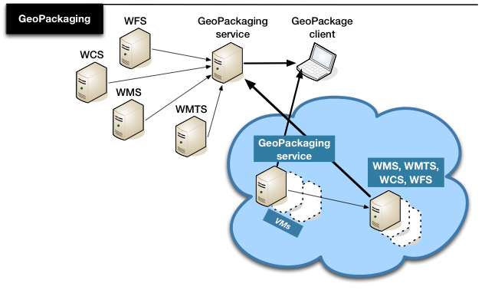

### WFS update from GeoPackage

A mobile client may participate in field data collection and update activities, including feature editing, vector annotation/map markup, and map annotation with photographs. These updates should be stored in the GeoPackage, and when the client returns “home”, these updates should be synchronized via a component to be developed in the thread.

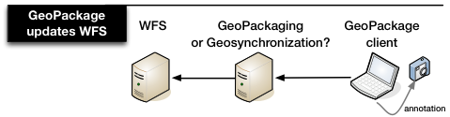

### Cloud Processing

This thread investigates the ability of the cloud paradigm to provide on-demand scaling to improve the performance of OGC Web Services. Two areas are of special interest: rapid analytics, integrating Web Processing Services with WCS and WFS; and rapid data packaging, integrating the GeoPackaging service with WMS, WMTS, WFS and WCS.

Changes to the traditional service access paradigm may be necessary to best support cloud processing. For example, the WPS interface may require modification to allow the client to specify the computing resources and/or virtual machines required to run the analysis. Another approach may be to have the client specify the desired response time, and the service would decide how much processing power was required to satisfy the response time parameter.

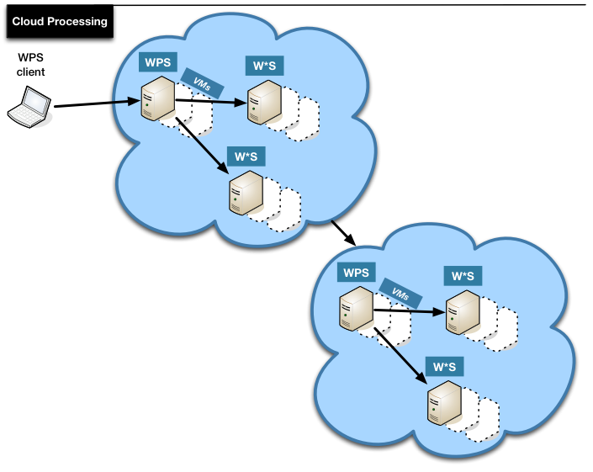

# Aviation Thread

## Aviation Thread Scope

The Aviation Thread of OGC Testbed 10 is concerned with the following tasks:

• Advance interoperable management of aeronautical and flight information

• Develop recommendations for exchange of terrain data

• Explore new sources for weather information

• Advance human factor based portrayal of Digital NOTAMs

• Advance compliance

• Advance support of AIXM in development tools (J2EE, .NET)

To test and demonstrate work performed under the above tasks, one or more scenarios will be developed, refined and used as high-level objectives for organizing the work in the Aviation Thread and as the basis for the final demonstrations of the results. The scenario(s) will exercise a variety of web services utilizing the AIXM and FIXM encodings. With respect to data sources:

* Existing data sources should be used to the extent possible to test the requirements and support the thread scenarios.
  + Note: in previous testbeds, participants contributed data sources to the Aviation Thread activities. If you can contribute data to OGC Testbed 10 Aviation in-kind, indicate this in your proposal – providing details about:
    - Availability (publicly usable, non-disclosure agreement required, usage instructions to be noted – for example “for non-operational purposes”, etc.),
    - Content (static and/or dynamic aeronautical feature data, weather data),
    - Format (e.g. AIXM 5.1, FIXM v1/v2) and
    - Extent (e.g. airports in Europe).
* As needed, FAA and EUROCONTROL may provide access to:
  + AIXM files that contain sample aeronautical data (static and dynamic).
    - A list of (contact information / downloads for) available AIXM 5.1 data is maintained by EUROCONTROL at: <https://extranet.eurocontrol.int/http://webprisme.cfmu.eurocontrol.int/aixmwiki_public/bin/view/Main/XML_Tags> - one or more of these data sources may be used in OGC Testbed 10, this will be decided early on in the testbed.
    - The thread participants may need to convert existing source data into AIXM compliant formats.
  + FIXM test data created based on operational data
  + Potentially also terrain data sets
* For testing purposes – especially conformance tests – the thread participants may need to create ad-hoc AIXM 5.1 data based on the data provided by the sponsors.

## Aviation Thread Requirements

The following sections define the requirements for the OGC Testbed 10 Aviation Thread.

Note: a general requirement for all service components used in OGC Testbed 10 Aviation is that the service provider shall deliver a WSDL description of the deployed service instance(s), for subsequent publication in the SESAR SWIM Registry.

### Getting Access to Non-Public Reference Material

Several documents referenced in the Aviation Thread are not publicly available, but available upon request. To receive these documents, send an email to [techdesk@opengeospatial.org](mailto:techdesk@opengeospatial.org) and the documents will be sent along with direction that the receiving organization is not permitted to send the document to any third parties without prior approval. Additionally, the receiving organization must abide by the Intellectual Property Requirements listed in the documents.

### Advance interoperable management of aeronautical and flight information

**References**

* Documents available upon request (to access these references follow the instructions in section 6.2.8):
  + Draft FIXM 2.0 model, XML schema, and additional documentation
* FIXM homepage: <http://www.fixm.aero> (especially the [documents page](http://www.fixm.aero/documents))

**Background**

The Federal Aviation Administration (FAA) and EUROCONTROL, in conjunction with multiple other international partners as well, are currently in the process of developing the Flight Information Exchange Model (FIXM). FIXM is an exchange model capturing Flight and Flow information that is globally standardized. The need for FIXM was identified by the International Civil Aviation Organization (ICAO) Air Traffic Management Requirements and Performance Panel (ATMRPP) in order to support the exchange of flight information as prescribed in Flight and Flow Information for a Collaborative Environment (FF-ICE).

FIXM is the equivalent, for the Flight domain, of AIXM (Aeronautical Information Exchange Model) and WXXM (Weather Information Exchange Model), both of which were developed in order to achieve global interoperability for, respectively, AIS and MET information exchange. FIXM is therefore part of a family of technology independent, harmonized and interoperable information exchange models designed to cover the information needs of Air Traffic Management.

Previous OGC IP initiatives developed an architecture that supports the exchange of AIXM and WXXM data. It is time to test and validate the exchange of flight information based upon the emerging FIXM standard within this architecture.

**OGC Testbed 10 Requirements**

The Aviation Thread of OGC Testbed 10 will advance the interoperable management and dissemination of aeronautical and flight information within the system.

More specifically, the Aviation Thread of OGC Testbed 10 will:

* Manage aeronautical and flight information via WFS-T 2.0, more specifically:
  + Import available datasets and provide them as AIXM 5.1 and FIXM 2.0.
    - Note: the first FIXM version deemed to be sufficiently mature enough and complete enough for global use is FIXM v3.0. Since FIXM v3.0 will not be available until Aug 2014, OGC Testbed 10 may need to modify (improve and/or fix) FIXM v2.0 so that the version of FIXM used in the testbed is sufficient to support OGC Testbed 10 use cases and scenario(s). Drafts of FIXM v3.0 may be made available to OGC Testbed 10 during the testbed, which can be used for testing and development if all relevant participants and the Thread Architect agree to do so.
  + Support queries for AIXM and FIXM feature data.
  + Support creation, update and – if possible – deletion of AIXM and FIXM data.
    - Note: the most relevant FIXM feature type for OGC Testbed 10 probably is the Flight.
* Publish aeronautical and flight information updates (formatted as Digital NOTAM and FIXM) via the Event Service, more specifically:
  + Automatically generate a notification at WFS-T when aeronautical and flight information changed at the service (created, updated, deleted), and send this notification to the Event Service. Which events need to be detected will be determined and agreed during the testbed. It is expected that a limited set of events will be needed to support the demonstration scenario.
  + Manage subscriptions (support functionality to at least create and delete them).
  + Support filtering of AIXM 5.1 information updates, especially encoded as Digital NOTAM version 2.0, and FIXM 2.0 information updates.
    - The exact encoding of FIXM updates will be determined during the testbed.
    - Basic filtering functionality defined by the Event Service (more specifically WS-Notification - see 6.6.2) is achieved via XPath based filtering of the XML encoded message. More advanced filtering supporting the OGC Filter Encoding Specification has been realized in previous OGC IP initiatives (for example OWS-8 and OWS-9). Support for XPath filtering is required. More advanced filtering functionality is of interest but not required.
  + Notification of clients (for any message with AIXM/FIXM data that matches their subscription criteria).
* Support discovery of flight and other metadata via the CSW ebRIM Registry, more specifically:
  + Develop ebRIM models required to capture service and dataset (AIXM, FIXM) metadata relevant for the demonstration.
  + Harvest and load relevant metadata, as required to support the demonstration
* Verify and validate (through tests and demonstrations) 1) the FIXM design and 2) the capability of the OGC Aviation Architecture to support interoperable exchange of FIXM data, and document the results (especially any improvements for FIXM).
* Document potential enhancements and identified issues for relevant documents and references. For OGC documents, change requests (especially for Standard and Best Practice documents) will be created.

### Develop recommendations for exchange of terrain data

**References**

* Documents available upon request (to access these references follow the instructions in section 6.2.8):
  + SESAR Aeronautical Information Domain Model Requirements - Annex B - Terrain Model (edition 03.01.00)
* EUROCONTROL Tender No 10-110288-E - Pilot Study Evaluating Guidance Material on the Provision of Terrain and Obstacle Data (TOD) in Accordance with ICAO Annex 15 (<http://www.eurocontrol.int/sites/default/files/content/documents/information-management/20110824-etod-pilot-study-rev1.pdf>)
* EUROCONTROL homepage on Terrain and Obstacle Data (<http://www.eurocontrol.int/services/terrain-and-obstacle-data>)
* Terrain and Obstacle Data (TOD) Manual (<http://www.eurocontrol.int/sites/default/files/content/documents/information-management/20120305-etodguidance_-v2.pdf>)
* Terrain and Obstacle Data Working Group (TODWG):
  + eTOD Metadata Profile (<https://portal.opengeospatial.org/files/?artifact_id=54481>)
  + Action paper on “Terrain Formats” from the sixteenth meeting of the TODWG (<https://portal.opengeospatial.org/files/?artifact_id=54480>)
* TICM/TIXM: Terrain Data Model Primer ed. 0.5 (<https://portal.opengeospatial.org/files/?artifact_id=54479>; includes TICM UML model and TIXM XML Schema)
* ICAO Annex 15 (Aeronautical Information Services), chapter 10 and Appendix 8
* INSPIRE Data Specification on Elevation – Draft Technical Guidelines (v3.0rc3 <http://inspire.jrc.ec.europa.eu/documents/Data_Specifications/INSPIRE_DataSpecification_EL_v3.0rc3.pdf>,or later versions)
  + This is the most prominent example of potentially relevant INSPIRE documents.
  + Apparently this version is newer than the one used in the SESAR document.
* ADQ Implementing Rule: Commission Regulation (EU) No 73/2010 of 26 January 2010 laying down requirements on the quality of aeronautical data and aeronautical information for the single European sky (online at <http://eur-lex.europa.eu/LexUriServ/LexUriServ.do?uri=CELEX:32010R0073:EN:NOT>)

**Background**

ICAO SARPS require the States to provide their electronic terrain and obstacle data (eTOD) in digital datasets. The datasets should provide eTOD with different numerical requirements defined by ICAO Annex 15 for 4 specific areas:

* Area 1 - the territory of State
* Area 2 - around the aerodrome up to 45 km, subdivided in 4 areas
* Area 3 - around aerodrome movement area
* Area 4 - strip before CAT II/III RWY

More information is available on the EUROCONTROL homepage (Terrain and Obstacle Data).

The ADQ defines additional requirements related to terrain data.

Currently there are many different formats to represent obstacle and terrain data. Obstacles are represented using AIXM. For terrain, however, there are a multitude of formats widely used today that do not completely satisfy ICAO and ADQ requirements (in particular for metadata - ISO 19115). EUROCONTROL has analyzed user and data originator preferred formats for terrain data in order to establish a list of commonly preferred terrain formats (see references from the TODWG).

It is of interest to the aviation community to have seamless terrain data throughout the region and not the terrain datasets ending at national borders. At present, due to the different national geodetic systems, there are issues with seamless integration of cross-border terrain data for Area 1 (sometimes Area 2 if an aerodrome is located close to the border).

As more and more states start providing their eTOD data there is also a growing interest in the possibility for web-based access to eTOD data in an INSPIRE compliant way.

**OGC Testbed 10 Requirements**

The Aviation Thread of OGC Testbed 10 will perform an assessment of the exchange of terrain data between states, including but not limited to:

* Identification of possible formats - that are compliant with ICAO Annex 15 and ADQ requirements - for the exchange of terrain data.
* Identification of possible ways to overcome the cross-border differences in terrain data due to differences in national geodetic systems and provision of seamless terrain data.
* Investigation of possibilities for web-based access to eTOD data in an INSPIRE compliant way.
* Documentation of potential enhancements and identified issues for relevant documents and references. For OGC documents, change requests (especially for Standard and Best Practice documents) will be created.

Note: the realization of an actual service infrastructure for and demonstration of terrain data exchange is not required. However, the Aviation sponsors welcome prototype implementations that realize (parts or all of) the recommendations for exchange of terrain data resulting from the assessment.

### Explore new sources for weather information

**References**

* Presentation on Web Gridded Document Service (WGDS), December 2012
* OGC WCS 2.0 Interface Standard – Core (<http://www.opengeospatial.org/standards/wcs>)
* OGC GML Application Schema – Coverages (<https://portal.opengeospatial.org/files/?artifact_id=48553>)

**Background**

In 2004, the NOAA's National Weather Service (NWS) created its Digital Services Program to meet their customers’ increasing need for digital weather, water, and climate services. The foundation of this program is the National Digital Forecast Database (NDFD). NDFD is a set of gridded forecasts of sensible weather elements. It contains a seamless mosaic of digital forecasts from NWS field offices working in collaboration with the National Centers for Environmental Prediction (NCEP). A companion to NDFD is the National Digital Guidance Database (NDGD) which contains guidance forecasts in gridded formats that are interoperable with NDFD.

NDFD and NDGD have offered an unprecedented opportunity for the NWS to automate, modernize, and improve products and services to meet the needs of their customers and partners. Users can download forecast grids that are encoded in the WMO's FM-92 GRIB Edition 2 (GRIB2). Customers and partners can also access NDFD/NDGD data that have been formatted in Digital Weather Markup Language (DWML), an NWS-specific dialect of XML, via a web service that supports Simple Object Access Protocol (SOAP) and Representational State Transfer (REST).

This NDFD web service services millions of hits each day. Unfortunately, it is not OGC compliant. None of the established service models appears to fully support the functional requirements. The closest match seems to be Web Coverage Service (WCS). In response to this gap, the NWS has developed the Web Gridded Document Service (WGDS).

The WGDS implements a service model that is reminiscent of the Web Coverage Service (WCS). i.e., the WGDS responds to operations similar to getCapabilities, describeCoverage, and getCoverage. The following differences are noted between WGDS and WCS:

* The response from a WGDS getCapabilities request includes a list of available products.
* A WGDS describeCoverage request identifies a product and also a (list of) point location(s), instead of a (list of) coverage identifier(s). The describeCoverage response contains a list of available weather elements, time constraints, and a list of supported output representations/formats (WXXM, DWML).
* The user chooses the weather elements as well as point locations he is interested in and provides them as parameter in the WGDS getCoverage request, along with time constraints, the desired product and representation/format. The response contains

**OGC Testbed 10 Requirements**

OGC Testbed 10 will analyze the WGDS and incorporate it in the Aviation architecture. More specifically, OGC Testbed 10 will:

* Analyze to which extent WGDS functionality, models and operation parameters map to elements of the WCS 2.0 model and the GML Application Schema for Coverages. This includes, but is not limited to:
  + Available, planned and/or new WCS extensions, for example for coverage processing, range subsetting, interpolation and format conversions.
  + An assessment if WXXM data served by WGDS needs to be adapted to comply with the coverage model, and if improvements can be achieved through other adaptations.
  + An assessment and evaluation of:
    - the WGDS WSDL,
    - the usability and suitability of WGDS schema and encoded documents,
    - WGDS in comparison to established OGC standards (including, but not limited to, WCS 2.0).
      * Note: The legacy web service (NDFD) provides a simple interface to NWS users and partners. The WGDS maintains much of that simplicity. The analysis should try to determine if the same simplicity can be achieved with OGC standards, especially WCS.
* Develop, test and demonstrate an adaptation of the WGDS to demonstrate the feasibility of wrapping certain aspects of WGDS in OGC web services:
  + The adapter is envisioned to be a service that is based on the WCS 2.0 model and the GML Application Schema for Coverages, extended as necessary.
  + An adaptation of the WXXM data served by WGDS may be required, in case it does not comply with the coverage model, or if improvements can be made. This will be determined during the assessment of WGDS.
  + The adapter should provide all functionality and data required for the air ambulance scenario (see chapter 6.4.1.1), which may be revised during OGC Testbed 10.
* Document potential enhancements and identified issues for relevant documents and references. For OGC documents, change requests (especially for Standard and Best Practice documents) will be created.

### Advance human factor based portrayal of Digital NOTAMs

**References**

* SAE-G10 Human Factors Minimum Requirements and Recommendations for the Flight Deck Display of Data Linked Notices to Airmen (NOTAMs) ARP 6467
* Digital NOTAM Event Specification – see section 6.5.2 for further details
* ICAO Annex 4 to the Convention on International Civil Aviation, Aeronautical Charts, Edition 11, July 2009
* OWS-8 Engineering Report - Guidelines for International Civil Aviation Organization (ICAO) portrayal using SLD/SE
  + available on the OGC homepage at: <https://portal.opengeospatial.org/files/?artifact_id=46228>

**Background**

An Aeronautical Information Working Group was formed within the SAE-G10 Aerospace Behavioral Engineering Technology Committee. This group establishes recommended practices with regards to the graphical display of NOTAM information on on-board systems (EFB, flight deck navigation displays…). The goal is to make it easy for users – such as the pilot – to process the information correctly and hard to do it wrong. As such, the work from SAE-G10 is also relevant for the graphical display of digital NOTAMs in ePIBs (Digitally Enhanced Pre-Flight Information Bulletin), such as maps of the departure and arrival airports. The recommendations from SAE-G10 are intended to complement existing portrayal requirements, for example from ICAO Annex 15.

**OGC Testbed 10 Requirements**

OGC Testbed 10 will advance the work from previous testbeds in portrayal of digital NOTAM information, focusing on test and development of recommendations for human factor based portrayal of aeronautical information updates.

More specifically, the Aviation Thread of OGC Testbed 10 will:

* Analyze the human factors guidance from the SAE-G10 document, both the general guidance (chapter 4 in the SAE-G10 document) and the specific guidance for display of selected NOTAMs (chapter 5 in the SAE-G10 document), and:
  + Realize client-support for portrayal of selected DNOTAMs (like Runway Closed NOTAM, Displaced Threshold Runway NOTAM, Taxiway Closed NOTAM and Temporary Flight Restriction NOTAM) following the SAE-G10 requirements and recommendations.
    - Using DNOTAM v2.0
  + Develop potential guidance for SLD and symbol libraries that realize requirements and recommendations from SAE-G10, with special emphasis on how this would change/extend the symbology defined by ICAO Annex 4.
  + Assess if the SAE-G10 requirements and recommendations can be realized using SLD/SE – which would be relevant input for (future) ePIB work.
  + Document the according results.
* Document potential enhancements and identified issues for relevant documents and references. For OGC documents, change requests (especially for Standard and Best Practice documents) will be created.

### Advance compliance

**References**

* Guidance and Profile of GML for use with Aviation Data (see chapter 6.5.3)
* OGC Compliance Testing Program – general information online at: <http://cite.opengeospatial.org/>; more specifically:
  + GML 3.2 test suite (further information on <http://cite.opengeospatial.org/te2/about/gml/3.2.1-r3/web/overview.html>)
  + TestNG: <http://testng.org>
  + CITE SVN repository with TestNG source code: <https://svn.opengeospatial.org/ogc-projects/cite/ets/testng/>
* OGC WFS Temporality Extension (see chapter 6.6.1)
* AIXM Temporality Model (see chapter 6.5.1)
* The Specification Model — A Standard for Modular specifications, OGC document 08-131r3 (<https://portal.opengeospatial.org/files/?artifact_id=34762>)

**Background**

The OWS-9 CITE thread has developed tests that check the conformance of a GML application schema and adherence of a given GML instance document to that schema.

Note: the GML test suite developed in OWS-9 covers the tests described in clauses A.3.1 to A.3.4 of the GML 3.2.1 standard. Clause A.3.5 is not yet covered, because it simply states to “verify that the GML document complies with all other constraints specified by this International Standard”. Apparently the abstract test suite in the GML 3.2.1 standard is lacking more specific coverage of additional rules and constraints defined for GML geometry types.

In other words, the GML application schema itself is tested against the rules for application schema defined by the GML standard. Testing of an instance document at the moment is rather only a validation against its GML application schema. A general capability exists to perform schematron constraint checking. There are no “standard” schematron tests to check further GML requirements. Consequently, there is room for improving the existing GML test suite to check additional GML rules/constraints. Within the Aviation domain, the geometry types defined in the “Guidance and Profile of GML for use with Aviation Data” OGC Discussion Paper are of particular interest.

The OWS Aviation Threads conducted over the past four years have demonstrated the successful use of WFS technology for on demand access to AIXM 5.1 data. However, a number of outstanding issues have also been identified when it comes to handling the AIXM 5.1 Temporality Model. During OWS-8 and OWS-9, the OGC WFS Temporality Extension specification was developed, to address these issues. The specification defines an extension of the WFS and FES 2.0 models, specifically designed to support dynamic feature data following the AIXM Temporality Model. It is available as an OGC Discussion Paper. Further work is required, though. On the one hand, the specification does not yet explicitly define requirements following the OGC Specification Model. On the other hand, it does not yet define an abstract conformance test suite.

**OGC Testbed 10 Requirements**

The Aviation Thread of OGC Testbed 10 shall advance compliance of GML in Aviation data as well as the WFS capability to manage AIXM dynamic feature data, through development of test suites and documentation.

More specifically, the Aviation Thread of OGC Testbed 10 will:

* Develop an executable compliance test suite to check compliance of geometry types in Aviation data. This includes:
  + Developing a test suite to check rules and constraints defined by the GML 3.2.1 standard for geometry types that are contained in the GML profile defined by the *“Guidance and Profile of GML for use with Aviation Data”*.   
    In order to improve the overall capability of CITE testing for GML data, additional tests to check rules and constraints for GML geometry types (as referenced by the abstract test in clause A.3.5 of the GML 3.2.1 standard) shall be developed.   
    Test development shall focus on the geometry types defined in the GML profile for Aviation data. This has a direct benefit for the Aviation domain but will also benefit other domains that use GML geometry types in their data.
  + The test suite should extend the GML 3.2.1 test suite developed in OWS-9.
  + The test suite shall be integrated with the OGC Team Engine.
  + At the end of OGC Testbed 10 the compliance of geometry types contained in AIXM datasets shall be tested using the OGC Team Engine. The test data shall be suited to cover the developed test cases and be taken from available data sources and/or created as necessary.
  + The test results shall be documented.
* Revise and enhance the OGC WFS Temporality Extension. This includes:
  + Documenting the functional requirements of the WFS Temporality Extension following the OGC Specification Model and revising the WFS Temporality Extension accordingly.
  + Writing an abstract test suite for the WFS Temporality Extension and adding it to the WFS Temporality Extension document.
* Document potential enhancements and identified issues for relevant documents and references as well as the CITE test environment (existing test suites and the test engine). For OGC documents and the CITE test environment, change requests (especially for Standard and Best Practice documents) will be created.

### Advance support of AIXM in development tools (J2EE, .NET)

**References**

* GlassFish – Metro, online at <https://metro.java.net/> (main focus on XML binding features)
* Microsoft .NET Framework, online at <http://www.microsoft.com/net> (main focus on XML Schema Definition Tool: xsd.exe)

**Background**

It is perceived by the community implementing applications based on ATM information exchange models that the binding of AIXM to development tools is not easy, due to the complexity/verbosity of GML and in particular the metadata schema.

Automated code generation in today’s popular development environments (e.g. Java: Glassfish/Metro, Microsoft: .NET with XSD.EXE) fails at the code generation itself, or produces code with poor quality/usability (e.g. generated code does not contain the required equivalence of some elements and attributes).

The W3C states that XSD schema can be used for code generation: *"Since XSD supports associating data types with element and attribute content, it is also used for data binding, that is, for software components that read and write XML representations of computer programming-language objects."* (source: <http://www.w3.org/standards/xml/schema>)

**OGC Testbed 10 Requirements**

In order to improve the efficiency of AIXM component development, OGC Testbed 10 will investigate and document recommendations for improving the binding of AIXM XSDs to development tools.

More specifically, the Aviation Thread of OGC Testbed 10 will:

* Investigate, test and document the creation and use of XML Schema bindings for AIXM in different development environments.
  + The goal is to auto-generate program code from the AIXM XML Schema and use this code in a software component to perform a complete round-trip (serialization/deserialization) of AIXM data.
  + Factors to take into account in the investigations and developments of AIXM binding code can include: code quality, usability, completeness, performance, etc.
  + Development environments to be investigated include, but are not limited to:
    - Java – Glassfish/Metro
    - Microsoft .NET with XSD.EXE
* Document potential enhancements and identified issues for relevant documents and references. For OGC documents, change requests (especially for Standard and Best Practice documents) will be created.

Note: the focus of this task is in XML (Schema) binding technologies. However, investigations and testing could go further and analyze solutions that facilitate development of components that use AIXM. For example, it could include software libraries/APIs – preferably based on open source – that defines (via open interfaces) or supports (as actual code) more functional tasks related to AIXM data: evaluation of feature state (with or without schedule evaluation), geometry computations, change management, etc.

## Aviation Thread Deliverables

The Deliverables are summarized in the Table with descriptions of the Deliverables in paragraphs following the table.

Table 3 – Aviation Thread Deliverables Summary

|  |
| --- |
| 1. Aviation Architecture Engineering Report |
| 1. Aviation Recommendations for the Exchange of Terrain Data Engineering Report |
| 1. Aviation Binding AIXM to Dev Tools Engineering Report |
| 1. Aviation Human Factor Based Portrayal of Digital NOTAMs Engineering Report |
| 1. Aviation Dissemination of Weather Data Engineering Report |
| 1. GML for Aviation Compliance Test Suite + GML for Aviation Conformance Testing Engineering Report |
| 1. WFS Temporality Extension Discussion Paper Revision |
| 1. Change Requests (as needed) |
| 1. Web Feature Service |
| 1. Web Coverage Service Adapter for WGDS |
| 1. Event Service |
| 1. CSW ebRIM Registry (unfunded) |
| 1. Aviation Client |

### Aviation Architecture ER

The report shall document:

1. The Web Services Architecture established in OGC Testbed 10 Aviation, including:
   1. General workflows
   2. Descriptions of the service and client components (provided by the respective participants)
2. The final OGC Testbed 10 Aviation scenario(s)
3. The results of verifying and validating 1) the FIXM design and 2) the capability of the OGC Aviation Architecture to support interoperable exchange of FIXM data.
4. Identified issues, lessons learned, recommendations, future work items and accomplishments – all from the overall OGC Testbed 10 Aviation Architecture perspective

This deliverable realizes (parts of) the following requirement(s):

* Advance interoperable management of aeronautical and flight information

### Aviation Recommendations for the Exchange of Terrain Data ER

The participants responsible for this deliverable shall:

1. Perform an assessment to:
   1. Identify possible formats for the exchange of terrain datasets compliant with ICAO Annex 15 and ADQ requirements.
   2. Identify possible ways to overcome the cross-border differences in terrain data due to differences in national geodetic systems and provision of seamless terrain data.
   3. Identify possibilities for web-based access to eTOD data in an INSPIRE compliant way.
2. Document the results of the assessment.
3. Document identified issues, lessons learned, recommendations, future work items and accomplishments that result from the work on developing recommendations for the exchange of terrain data.

This deliverable realizes (parts of) the following requirement(s):

* Develop recommendations for exchange of terrain data

### Aviation Binding AIXM to Development Tools ER

The participants responsible for this deliverable shall:

1. Investigate, test and document the creation and use of XML Schema bindings for AIXM in different development environments.
   1. An expected outcome is to auto-generate program code from the AIXM XML Schema and use this code in a software component to perform a complete round-trip (serialization/deserialization) of AIXM data.
   2. Development environments to be investigated include, but are not limited to:
      1. Java – Glassfish/Metro
      2. Microsoft .NET with XSD.EXE
2. Document identified issues, lessons learned, recommendations, future work items and accomplishments that result from the work on advancing support of AIXM in development tools.

This deliverable realizes (parts of) the following requirement(s):

* Advance support of AIXM in development tools (J2EE, .NET)

### Aviation Human Factor Based Portrayal of Digital NOTAMs ER

The participants responsible for this deliverable shall:

1. Analyze the human factors guidance from the SAE-G10 document.
2. Together with the participant responsible for the deliverable described in section 6.3.13:
   * Develop potential guidance for SLD and symbol libraries that realize requirements and recommendations from SAE-G10, with special emphasis on how this would change/extend the symbology defined by ICAO Annex 4.
   * Assess if the SAE-G10 requirements and recommendations can be realized using SLD/SE.

The report shall document:

1. The results of the work performed in OGC Testbed 10 on analysis as well as testing and development of the guidance from the SAE-G10 group including but not limited to:
   1. Potential guidance for SLD and symbol libraries that realize requirements and recommendations from SAE-G10.
   2. The results of the assessment if the SAE-G10 requirements and recommendations can be realized using SLD/SE.
2. Identified issues, lessons learned, recommendations, future work items and accomplishments that result from the work on advancing human factor based portrayal of Digital NOTAMs.

This deliverable realizes (parts of) the following requirement(s):

* Advance interoperable management of aeronautical and flight information

### Aviation Dissemination of Weather Data ER

The participants responsible for this deliverable shall:

1. Analyze to which extent WGDS functionality, models and operation parameters map to elements of the WCS 2.0 model and the GML Application Schema for Coverages. This includes, but is not limited to:
   * Available, planned and/or new WCS extensions, for example for coverage processing, range subsetting, interpolation and format conversions.
   * An assessment if WXXM data served by WGDS needs to be adapted to comply with the coverage model, and if improvements can be achieved through other adaptations.
   * An assessment and evaluation of:
     + the WGDS WSDL,
     + the usability and suitability of WGDS schema and encoded documents,
     + WGDS in comparison to established OGC standards (including, but not limited to, WCS 2.0).
       - Note: The legacy web service (NDFD) provides a simple interface to NWS users and partners. The WGDS maintains much of that simplicity. The analysis should try to determine if the same simplicity can be achieved with OGC standards, especially WCS.

The report shall document:

1. The results of the work performed in OGC Testbed 10 to incorporate WGDS in the OGC – especially the OGC Aviation - architecture (analysis, testing and development).
2. Identified issues, lessons learned, recommendations, future work items and accomplishments that result from the work on exploring WGDS as a new source of weather information.

This deliverable realizes (parts of) the following requirement(s):

* Explore new sources for weather information

### GML for Aviation Compliance Test Suite + GML for Aviation Conformance Testing ER

The participants shall:

1. Develop a test suite to check rules and constraints defined by the GML 3.2.1 standard for geometry types that are contained in the GML profile defined by the “Guidance and Profile of GML for use with Aviation Data”.
   1. The test suite should extend the GML 3.2.1 test suite developed in OWS-9.
2. Integrate the test suite with the OGC Team Engine.
3. Identify and/or (if necessary) create AIXM test data suited to cover the developed test cases.
4. Using the OGC Team Engine, test the compliance of geometry types contained in the AIXM test data.

Note: it is understood that it would require considerable efforts to create a test suite that covers all relevant rules and constraints for the geometry types defined by the GML Profile for Aviation data. RFQ responses addressing this deliverable should therefore clearly document which aspects of the GML standard will be covered by the test suite that is proposed to be developed in OGC Testbed 10.

The report shall document:

1. A brief overview of the test system (OGC TEAM Engine) and testing process – focusing on the test suite developed in OGC Testbed 10 Aviation.
2. The results of the GML for Aviation Compliance Test Suite development.
3. Identified issues, lessons learned, recommendations, future work items and accomplishments that result from the work on advancing compliance.

This deliverable realizes (parts of) the following requirement(s):

* Advance compliance

### WFS Temporality Extension Discussion Paper Revision

The participant responsible for this deliverable shall:

1. Document the functional requirements of the specification following the OGC Specification Model and revise the WFS Temporality Extension accordingly.
2. Write an abstract test suite for the WFS Temporality Extension and add it to the specification.

This deliverable realizes (parts of) the following requirement(s):

* Advance compliance

### Change Requests (as needed)

This deliverable covers the documentation of identified potential enhancements and issues in change requests against relevant OGC documents (like Standard and Best Practice documents) as well as the CITE test environment (existing test suites and the test engine).

This deliverable is related to all requirements stated in 6.2.

### Web Feature Service - Transactional

The realization of this component deliverable shall include:

1. Realization of WFS 2.0 Transactional functionality.
2. Import and provision of aeronautical and flight information (as AIXM 5.1 and FIXM 2.0) for test/demo purposes.
   1. Note: this may require transformation of the data from a previous version to the required version.
3. Supporting the creation, update and – if possible – deletion of AIXM and FIXM data.
4. Publication of aeronautical and flight information updates to the Event Service.
5. Documentation of the component including, but not limited to:
   1. Appropriate documentation of the requests that were used in support of the demo scenario(s) to retrieve data.
   2. A description of the component for inclusion in the Aviation Architecture ER (see 6.3.1).
   3. A WSDL file describing the service instance, for subsequent publication in the SESAR SWIM Registry.

This deliverable realizes (parts of) the following requirement(s):

* Advance interoperable management of aeronautical and flight information

### Web Coverage Service Adapter for WGDS

The realization of this component deliverable shall include:

* An analysis to which extent Web Gridded Document Service (WGDS) functionality, models and operation parameters map to elements of the WCS 2.0 model and the GML Application Schema for Coverages.
* Supporting the documentation tasks of the participant responsible for the  *Aviation Dissemination of Weather Data ER* deliverable (see chapter 6.3.6).
* Test and development of a service adapter for the WGDS that is based on the WCS 2.0 model and the GML Application Schema for Coverages, extended as necessary.
  + An adaptation of the WXXM data served by WGDS may be required, in case it does not comply with the coverage model, or if improvements can be made. This will be determined during the assessment of WGDS.
  + The adapter should provide all functionality and data required for the air ambulance scenario (see chapter 6.4.1.1), which may be revised during OGC Testbed 10.
* Documentation of the component including, but not limited to:
  + Appropriate documentation of the requests that were used in support of the demo scenario(s) to retrieve data.
  + A description of the component for inclusion in the Aviation Architecture ER (see 6.3.1).
  + A WSDL file describing the service instance, for subsequent publication in the SESAR SWIM Registry.

This deliverable realizes (parts of) the following requirement(s):

* Explore new sources for weather information

### Event Service

The realization of this component deliverable shall include:

* Support filtering of AIXM 5.1 information updates, especially encoded as Digital NOTAM version 2.0, and FIXM 2.0 information updates.
  + NOTE: at least XPath based filtering shall be supported. More advanced filtering functionality, for example based on OGC FES (see 6.5.6) is of interest, but not required.
* Support for subscription management and notification of clients (for any message with AIXM/FIXM data that matches their subscription criteria)
* Documentation of the component including, but not limited to:
  + Appropriate documentation of the events and subscriptions that were used in support of the demo scenario(s).
  + A description of the component for inclusion in the Aviation Architecture ER (see 6.3.1).
  + A WSDL file describing the service instance, for subsequent publication in the SESAR SWIM Registry.

NOTE: in previous OGC IPs the Event Service was a standalone component that realized brokered notification functionality. However, basic Event Service functionality can also be realized by WFS components – they only need to implement the Publish/Subscribe interface.

This deliverable realizes (parts of) the following requirement(s):

* Advance interoperable management of aeronautical and flight information

### CSW ebRIM Registry (UNFUNDED)

The realization of this component deliverable shall include:

* Realization of OGC CSW-ebRIM Registry functionality.
* Development of ebRIM models required to capture service and dataset (AIXM, FIXM) metadata relevant for the demonstration.
* Harvesting and loading of relevant metadata, as required to support the demonstration.
* Documentation of the component including, but not limited to:
  + Appropriate documentation of the ebRIM models and requests that were used in support of the demo scenario(s), to retrieve metadata from the registry.
  + A description of the component for inclusion in the Aviation Architecture ER (see 6.3.1).
  + A WSDL file describing the service instance, for subsequent publication in the SESAR SWIM Registry.

This deliverable realizes (parts of) the following requirement(s):

* Advance interoperable management of aeronautical and flight information

The realization of this component deliverable will include interfacing with all OGC Testbed 10 Aviation service components, for testing and demonstrating the relevant service functionality. The client shall support the OGC Testbed 10 Aviation demonstration(s) based upon the OGC Testbed 10 Aviation scenario(s). Emphasis is on supporting and demonstrating new client and service functionality developed by the participants in the OGC Testbed 10 Aviation Thread.

In addition to this general requirement, the participant responsible for this deliverable shall especially also:

1. Analyze the human factors guidance from the SAE-G10 document.
2. Together with the participant responsible for the deliverable described in section 6.3.4:
   * Develop potential guidance for SLD and symbol libraries that realize requirements and recommendations from SAE-G10, with special emphasis on how this would change/extend the symbology defined by ICAO Annex 4.
   * Assess if the SAE-G10 requirements and recommendations can be realized using SLD/SE.
3. Realize client-support for portrayal of selected DNOTAMs (like Runway Closed NOTAM, Displaced Threshold Runway NOTAM, Taxiway Closed NOTAM and Temporary Flight Restriction NOTAM) following the SAE-G10 requirements and recommendations.
   * DNOTAM instances (in version 2.0) for testing and demonstration shall be identified and if necessary created by the participant.

This deliverable realizes (parts of) the following requirement(s):

* Advance interoperable management of aeronautical and flight information
* Advance human factor based portrayal of Digital NOTAM
* Explore new sources for weather information

## Aviation Enterprise Viewpoint

According to the FAA website, the air transportation system is stretched thin with forecasts indicating increases in passenger demand ranging from a factor of two to three by 2025. The current system is already straining with ever-increasing levels of congestion, declining on-time arrivals, increasing delays (and customer frustration) as well as increasing costs and environmental impacts. At the same time, according to EUROCONTROL, the European Airspace is fragmented and will become more and more congested, as traffic is forecast to grow steadily over the next 15 years. The legacy Air navigation services and their supporting systems are not fully integrated and are based on technologies that are already running at maximum. AirServices Australia (ASA) has acknowledged similar issues in the Commonwealth, as have other nations in the Pacific Rim and in economically emerging nations. In order to accommodate future Air Traffic needs, a “paradigm shift”, supported by state-of-the-art and innovative technologies, is required.

To realize this paradigm shift, the Aviation industry is working on a framework built extensively on standards, digital data exchange and process automation.

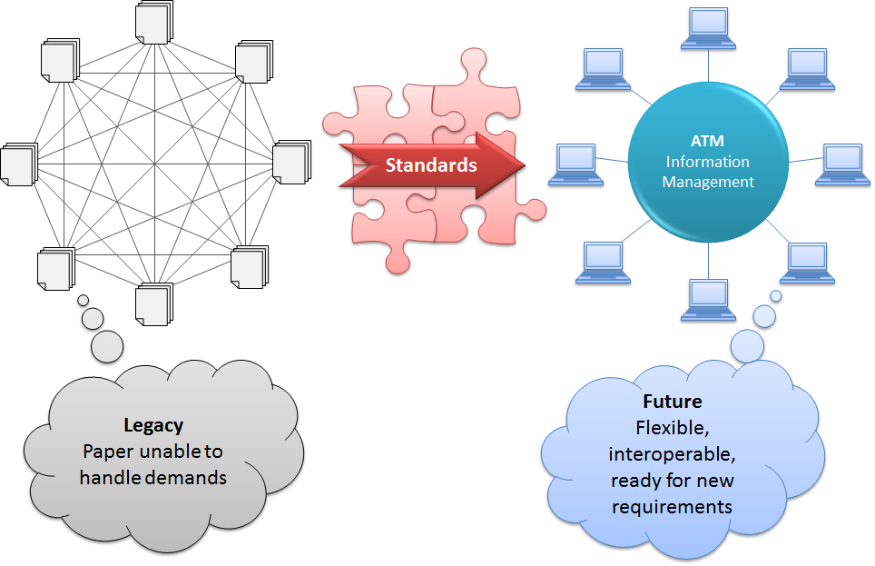

**Figure 6‑1 Towards a New Aeronautical Information Management Paradigm**

At the heart of this new ATM Information Management paradigm are standardized Information Exchange Models.

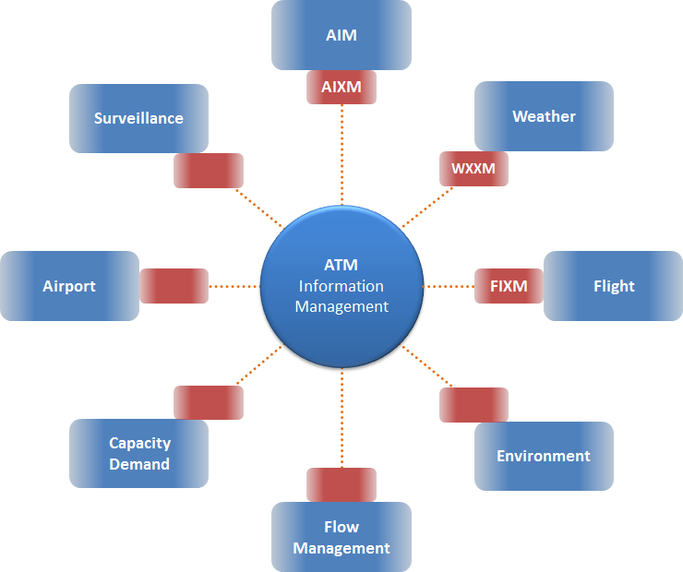

**Figure 6‑2 Information Exchange Models (red) for ATM domains (blue) - ATM Information Management enablers**

These models cover relevant information from ATM domains. Information encoded according to the models will be exchanged via standardized, reusable, and loosely coupled service interfaces. These services will enable System Wide Information Management (SWIM), on an international scale.

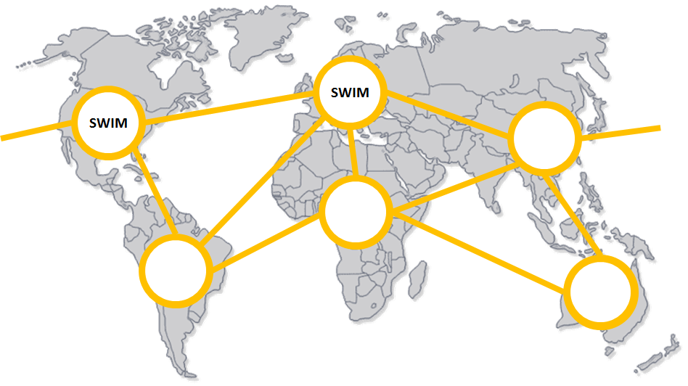

**Figure 6‑3 globally connected SWIM environments**

Even though the general term “SWIM” as well as the general concept is the same, SWIM environments (for example developed by NextGen and SESAR) currently do not use exactly the same service interfaces. OGC web service interfaces can be used to adapt SWIM service interfaces and to disseminate ATM information from multiple SWIM environments in an interoperable way.

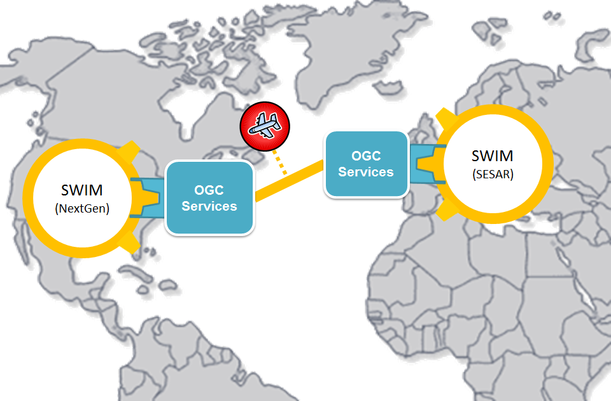

**Figure 6‑4 Interoperable dissemination of ATM information from multiple SWIM environments facilitated by OGC service interfaces**

The Aviation domain is actively pursuing the goal of establishing a global, interoperable ATM Information Management system. Through projects and ongoing efforts by the community, a number of building blocks for this system have already been established: models to exchange aeronautical and weather information, services to discover, access and publish such information, as well as a number of supporting studies, analyses and assessments, to name but a few.

Additional building blocks are required to ensure system compliance, facilitation of software development, exchange of flight and terrain information, as well as portrayal and display of ATM information for human users. OGC Testbed 10 will address these tasks.



**Figure 6‑5 Building blocks for interoperable ATM Information Management**

### Aviation Thread Scenarios and Use Cases

Aviation Thread scenarios provide a fictitious, but realistic context for a demonstration of the functionality that will be developed in the Aviation Thread of OGC Testbed 10, and for the interaction with other OWS components. The scenarios are intended to prompt the exercising of interfaces, components, tools and services as well as the use of encodings that will be developed or enhanced within OGC Testbed 10. This includes exercising a variety of web services and encodings.

Within the OGC Testbed 10Aviation thread, the scenarios will revolve around the following theme(s):

* Exchange of FIXM datasets as well as static and dynamic aeronautical information.
* Portrayal of AIXM, FIXM, weather and potentially also terrain data.

Initial scenario(s) and use cases will be discussed and developed during the OGC Testbed 10 kickoff. They are subject to change as determined by various factors, most notably availability of suitable data*.* The scenarios and use cases will be revised and enhanced during OGC Testbed 10, as required.

#### Air Ambulance Scenario

Background

The National Transportation Safety Board (NTSB) continues to be concerned with Air Ambulance safety, and for good reason. Emergency helicopter flights can be risky, often operating at night in low altitudes and in uncertain weather conditions. The International Civil Aviation Organization (ICAO) Annex 3, the Meteorological Services for International Air Navigation, provides standards and recommended practices covering Meteorological Terminal Aviation Routine Weather Report (METAR), SPECI (Special), Terminal Aerodrome Forecast (TAF) and Significant Meteorological Information (SIGMET), and the communication and dissemination of Meteorological information to pilots. Much of this meteorological information is available today at aerodrome locations (e.g. airports) only. What makes Air Ambulance missions so hard, is that weather information is not typically available in-flight and at the destination location.

The National Weather Service (NWS) issues operational gridded forecasts of sensible weather elements like clouds, temperature, dew point, relative humidity, probability of precipitation, wind direction, wind speed via the National Digital Forecast Database (NDFD). The NDFD also contains experimental gridded forecasts of ceiling height and visibility at a limited portion of the Contiguous United States (CONUS). NDFD weather data is available to the public to use in creating text, graphic, gridded and image products of their own, and is the type of weather information that is currently available for pilots. The NWS also has a Localized Aviation Model Output Statistics (MOS) Program (LAMP) statistical system that provides forecast guidance for sensible weather elements. An important feature of LAMP guidance is its probabilistic nature. LAMP forecasts for many weather elements are created as categorical probabilities. These guidance forecasts offer valuable information that can be used as a decision support tool in addition to the TAF. The NWS has developed a prototype probabilistic TAF product from LAMP that can be used as guidance.

Scenario

Winter night in north central Massachusetts. A coastal low pressure system has spread low clouds and snow across coastal Massachusetts. Traffic accident on US-202 near Gardiner, Massachusetts. Air ambulance pilots check official TAFs and METARs. Bedford, Massachusetts (KBED) METAR observation shows ceiling and visibility in the category named Low Instrument Flight Rules (LIFR) and the Terminal Aerodrome Forecast (TAF) shows poor conditions persisting for the next 3 hours. Fitchburg, Massachusetts (KFIT) METAR is a little better. No TAF is available, however, for KFIT. Air ambulance pilots access a time series forecast of wind, weather, ceiling height, and visibility for the gridpoint nearest the accident site. This gridded aviation forecast indicates that the accident site is far enough west to be out of the worst of the coastal storm’s weather. Conditions are flyable, and air ambulance completes its mission.

## Aviation Information Viewpoint

The Information Viewpoint describes the information models and encodings that will make up the content of the services and exchanges to be extended or developed to support the Aviation thread activities.

### AIXM

#### Relevant Specifications and Documents

See <bibliography.rst#aeronautical-information-exchange-model-aixm>

#### Relevance for OGC Testbed 10

AIXM will be used for conformance testing work and within the Aviation Architecture that will be tested and demonstrated. Conformance tests will require standalone AIXM data (sets). In the demonstration, a client will access AIXM data from WFS and display it.

NOTE: the AIXM model is based on the concept of dynamic features. The AIXM Temporality Model defines rules for the handling of dynamic features in AIXM and is an integral part of AIXM. Applications and services managing and using AIXM data usually need to be able to take the specifics of dynamic feature data into account. Clients, for example, need to be able to compute the state of a dynamic feature for a given point in time from the time slices available in the representation of that feature. For more information, please refer to the AIXM Temporality Model specification.

### Digital NOTAM Event Specification

#### Relevant Specifications and Documents

See <bibliography.rst#digital-notam-event-specification>

#### Relevance for OGC Testbed 10

DNOTAM v2.0 will be published in July 2013 and will be the basis for developments in OGC Testbed 10. This major revision primarily documents additional publication scenarios. Some of the DNOTAM scenarios are relevant for the human factor based portrayal work.

### GML Application Schema - Coverages

#### Relevant Specifications and Documents

See <bibliography.rst#gml-application-schema---coverages>

#### Relevance for OGC Testbed 10

Web Coverage Service (WCS) 2.0 is based on the GML Application Schema (AS) for Coverages. OGC Testbed 10 shall assess and test how the NWS Web Gridded Document Service (WGDS) can be incorporated into the OGC Aviation Architecture, ideally through suitable adaptation via a WCS. As such, the Coverages GML AS is a crucial part of this work. An important aspect is to assess if the (WXXM) data served by the WGDS complies with the Coverages GML AS, and if any adaptations of the data and format(s) are necessary.

### Guidance and Profile of GML for use with Aviation Data

#### Relevant Specifications and Documents

See <bibliography.rst#guidance-and-profile-of-gml-for-use-with-aviation-data>

#### Relevance for OGC Testbed 10

Service and client components should support the GML profile defined in the “Guidance and Profile of GML for use with Aviation Data”. The geometry types covered by this profile also define the scope for the GML conformance test development: the rules and constraints defined by the GML standard for the geometry types of the profile have priority for test development.

### TICM / TIXM

#### Relevant Specifications and Documents

See <bibliography.rst#ticm--tixm>

#### Relevance for OGC Testbed 10

OGC Testbed 10 will perform an assessment of the exchange of terrain data. TICM and TIXM are designed to support the interoperable exchange of terrain data. As such, they should be considered in the assessment.

### FIXM

#### Relevant Specifications and Documents

See <bibliography.rst#flight-information-exchange-model>

#### Relevance for OGC Testbed 10

The Aviation Thread will verify and validate the current design of FIXM version 2.0.

OGC Web Feature Service(s) will be used to manage and disseminate FIXM data, while Aviation client component(s) will access and display FIXM data.

NOTE: the first FIXM version deemed to be sufficiently mature enough and complete enough for global use is FIXM v3.0. Since FIXM v3.0 will not be available until Aug 2014, OGC Testbed 10 may need to modify (improve and/or fix) FIXM v2.0 so that the version of FIXM used in the testbed is sufficient to support OGC Testbed 10 use cases and scenario(s). Drafts of FIXM v3.0 may be made available to OGC Testbed 10 during the testbed, which can be used for testing and development if all relevant participants and the Thread Architect agree to do so.

### Filter Encoding

#### Relevant Specifications and Documents

See <bibliography.rst#filter-encoding>

#### Relevance for OGC Testbed 10

FE 2.0 will be used in the Aviation Thread to support filtering of AIXM and FIXM datasets.

### SLD/SE

#### Relevant Specifications and Documents

See <bibliography.rst#styled-layer-descriptor-sld--symbology-encoding-se>

#### Relevance for OGC Testbed 10

The OGC Testbed 10 Aviation Thread will analyze and test the implementation of requirements and recommendations from SAE-G10 for human factor based portrayal of NOTAMs. One important part of this work is to assess if the requirements and recommendations can be realized using SLD/SE, and to develop potential guidance for SLD (and symbol libraries) with special emphasis on changes/extensions to the symbology defined by ICAO Annex 4.

### TestNG

#### Relevant Specification and Documents

See <bibliography.rst#testng>

#### Relevance for OGC Testbed 10

The executable conformance test suites for GML 3.2.1 developed in OWS-9 is realized with TestNG. The “GML for Aviation Compliance Test Suite” to be developed in the OGC Testbed 10 Aviation thread should extend the existing GML 3.2.1 test suite.

## Aviation Computational Viewpoint

The computational viewpoint is concerned with the functional decomposition of the Aviation architecture into a set of services that interact at interfaces. It reflects the components, interfaces, interactions and constraints of the Service Architecture without regard to their distribution. For the Aviation thread of OGC Testbed 10, those components are:

* Web Feature Service (WFS) for access to aeronautical and flight information.
* Event Service (based on OASIS Web Services Notification) for the automatic delivery of information updates to interested clients
* Catalog Service for the Web (CSW) ebRIM for managing metadata on services as well as aeronautical and especially flight information available in the system.
* Aviation Clients.

### Web Feature Service

#### Relevant Specifications and Documents

See <bibliography.rst#web-feature-service-wfs>

#### Relevance for OGC Testbed 10

WFS 2.0 will be used in the Aviation thread to serve and query AIXM 5.1 aeronautical features as well as FIXM data. The WFS shall support transactions (for updates of feature data and combined automatic publication of according event information).

### Event Service

#### Relevant Specification and Documents

See <bibliography.rst#event-service>

#### Relevance for OGC Testbed 10

The Aviation Thread of OGC Testbed 10 will use the Event Service component developed in previous OGC IPs to enable information producers to publish notifications/events (such as Digital NOTAMs and updates of FIXM data) and to notify information consumers (Clients) of events that match their subscription criteria. An Event Service in OGC Testbed 10 Aviation needs to support filtering of AIXM and FIXM data.

### Web Coverage Service

#### Relevant Specifications and Documents

See <bibliography.rst#web-coverage-service-wcs>

#### Relevance for OGC Testbed 10

OGC Testbed 10 shall assess and test how the NWS Web Gridded Document Service (WGDS) can be incorporated into the OGC Aviation Architecture, ideally through suitable adaptation via a Web Coverage Service.

### CSW ebRIM

#### Relevant Specifications and Documents

See <bibliography.rst#csw-ebrim>

#### Relevance for OGC Testbed 10

The CSW ebRIM Registry service will be used to manage and provide metadata about the services as well as the (AIXM and especially FIXM) data available in the OGC Testbed 10 Aviation architecture.

NOTE: a CSW ebRIM service usually is a cross-thread component, supporting the catalog requirements of multiple threads.

### Client

The Aviation Clients in the Aviation Thread of OGC Testbed 10 are critical to demonstrating interoperability of the web services used in the thread as well as highlighting the potential value of interoperable access, filtering, integration and portrayal of AIXM/FIXM data and events.

The Aviation Clients can be developed as either thin or thick clients, and can act as proxies for EFB/handheld applications, avionic system applications, flight dispatch/airline operations applications, or any other applications that can benefit from the combination of functionality developed during the thread.

## Aviation Engineering Viewpoint

The Enterprise, Information, and Computation viewpoints describe a system in terms of its purposes, its content, and its functions. The Engineering viewpoint identifies component types in order to support distributed interaction between the components of the system. Those components interact based upon the services identified and described in the Computational viewpoint.

The Figure below provides an overview of the components of the Aviation thread, organized based on the ISO 3-tier model with the top tier dealing with clients, the middle tier embodying the business processes required to respond to requests issued by clients, and a lower tier focusing on provision of data. Note that in order to minimize the complexity of the engineering viewpoint, the figure does not show all possible interactions amongst the identified components.

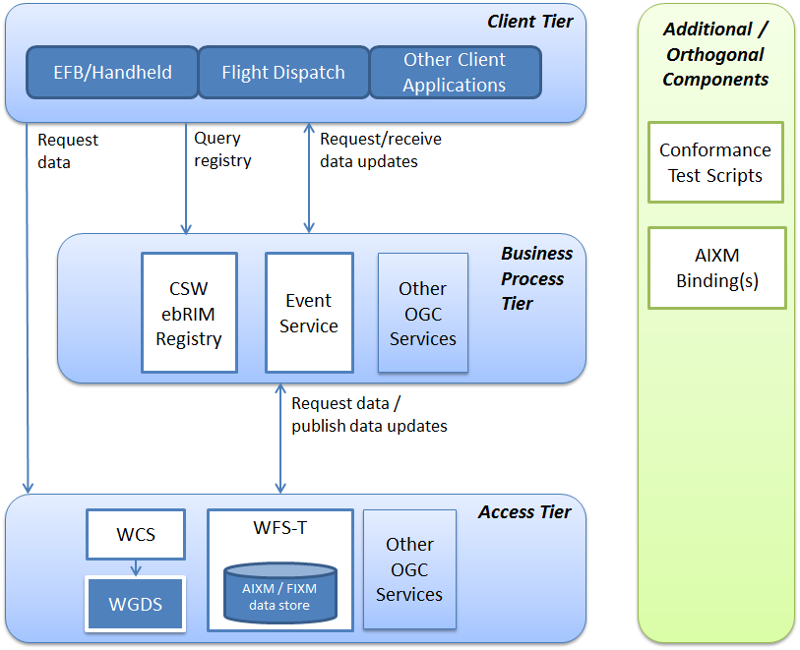

**Figure 6‑6 Aviation Thread Engineering Viewpoint**

# Appendix A Integrated Client Enhancement Description

*Originally from an email by Peter Vretanos*

What does an OGC web service need to provide in its capabilities document and perhaps what additional operations OGC services need to implement so that a catalogue can harvest that information, create the associations between services and the data they offer, and make all that information transparently discoverable and usable without prior knowledge of each OGC service when requirements call for the use of more than one OGC service (i.e. WMS and WFS)?

In the example above, the ability to discover the association between a WMS layer and the underlying features (from a WFS) is important to apply the proper style to render the layer and access the feature (its vector representation) if an analysis on that data is needed . Once that association is created and is discoverable, a client can navigate around using a WMS or WMTS, find something of interest, click a DOWNLOAD button and have the data assembled and downloaded to his/her machine in a format that they like (GBT, zipped up SHAPE files, whatever) from a WFS.

This can happen automagically and transparently because a portal application can use a catalogue to find the associations between WMS layers and the WFS feature types. Once the association is found, the portal can follow the association to the WFS (for example) that offers the underlying data and then make a WFS request to get (i.e. download) the data!

This concept can be generically applied to all OGC services and offer a level of integration not currently available in OGC specifications. This work would require catalogue work – not so much changes to the API or the information model – but to define the standard association identifiers that need to exist for all this to hang together.

This work would also require changes at the service level. Among the changes required would be (a) making a serviceId element mandatory in the capabilities document so that a catalogue can unambiguously identify a specific service, (b) have rendering services implement a request (we call it GetAccessibility) that explicitly advertises which source data a WMS is using to render the layers it is offering, etc...

Right now, all this is done in monolithic systems where all the data is centrally located – a decidedly UNDISTRIBUTED and proprietary architecture. However, it does not need to be so! OGC has all the Web services required, and with a little bit of tweaking OGC can define how to loosely couple these services together to achieve the same thing the monolithic systems do but in an open, distributed and standard way.