The Criticality of Consistent Standards
A Joint White Paper Describing a Way Ahead

US Geospatial Intelligence Foundation (USGIF)
Simulation Interoperability Standards Organization (SISO)
Open Geospatial Consortium (OGC)

Introduction
Geospatial and georeferenced data are being collected at continually increasing rates. Daily growth in data volume comes from diverse sources related to global initiatives like Smart Cities, the organic emergence of the Internet of Things (IOT), and imagery coming from hand-held devices in building interiors to smallsats circling the globe. Advances in technology support the possibility of increased interoperability among systems that have the potential to use these data, including simulations. Increased Interoperability among simulations, and between simulations and other information systems is becoming possible. Imagine the improvements in military and disaster response performance that are possible with systems that are informed by all these data. Or consider an urban planning simulation with the ease of use of a video game but informed by current authoritative geospatial data and forecasting models that can leverage that data.

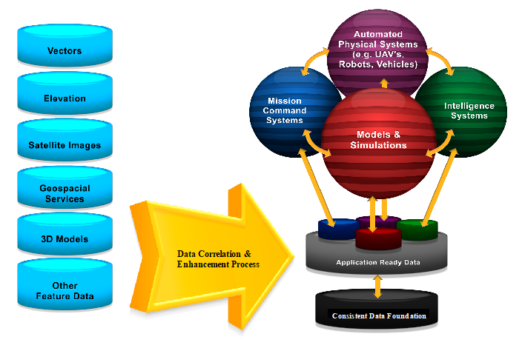
Figure 1 Vision of Interoperable Future for M&S

There is often the mistaken belief among less technically-inclined leaders that these capabilities largely already exist and are ready to mobilize seamlessly to meet mission needs. Further, to achieve these capabilities, one must also consider if source data is consistent, timely, and has known provenance. Unfortunately, the data and technologies we are attempting to integrate originate in different communities, for different purposes, of differing quality, and using different data formats and standards. Compounding these technical challenges are organizational biases and friction that inhibit collaboration. Failure to find ways to effectively automate these data and technology processes will at best result in continued systemic inefficiencies and latency, and at worst lead to catastrophic outcomes like unnecessary casualties due to poor situational awareness. The consistent application of open standards is a necessary step toward preventing these outcomes through improved interoperability.

A Call to Action
This white paper represents a call to action for the M&S and standards communities to work in partnership with the combined resources, knowledge, experience and processes of key standards organizations and associations to advance interoperability of technologies and data for improved mission responsiveness. Key goals include the development of a common conceptual open systems architecture for M&S and the conduct of cooperative testing and prototyping initiatives to attain rapid, incremental standards-based improvements in the flexibility and responsiveness of M&S processes.

A Vision of Future interoperability
This paper presents a vision of a higher level of interoperability for the entire M&S community – and beyond.
- Where any tool, any data source, any process, any database can be leveraged quickly and seamlessly to address mission needs.
- Where proposed process enhancements can be tested, validated and deployed with minimal time, effort and cost.
- Where the fruits of the community’s processes can be mobilized rapidly and deployed broadly for a range of yet unimagined mission needs.
- Where an open systems architecture based on a common standards framework unites and aligns the data generating and data consuming communities toward vastly improved information exchange and processing, and technology tool interoperability.

Responding to the vision
Several years ago, the leadership of the US Geospatial Intelligence Foundation (USGIF) raised concern regarding the need for the M&S community to establish a higher level of interoperability to better leverage a growing diversity of geospatial information. In its view, the lack of open standards-based interoperability was hampering critical information exchange, delaying the rapid deployment of new capabilities, and risking unreasonably high costs of system maintenance and expansion. Addressing these challenges would require a well-coordinated focus between the user community on requirements and priorities, and the information and technology community through cross organizational collaboration with Standards Development Organizations (SDO) and relevant associations.

The USGIF established a Modeling & Simulation Working Group to unite its members in discussion, and soon thereafter reached out to the Open Geospatial Consortium (OGC) to join in dialog. As a first action in this partnership, a live demonstration was conducted for the GEOINT 2013* conference to demonstrate the ability of OGC Web Services standards to support interoperable ingest of geospatial data into M&S processing workflows, and to support distribution of M&S products to an array of users. The success of this effort, which united the M&S and the broader GEOINT community to demonstrate interoperable capabilities in just a few weeks, led to additional summits and meetings to mature the understanding of interoperability “pain points” and to formalize a collaborative process to align the community to address them. From these events, a 3D Geospatial M&S Collaborative Project was formed.

Accomplishments to date
Since the formation of this informal collaborative, a number of accomplishments have helped to move us toward this vision:
- Formal collaborative alliances have been forged between the OGC, the Simulation Interoperability Standards Organization (SISO) and the USGIF as the 3D Geospatial M&S Collaborative Project. Other SDOs and associations are being encouraged to join.
- The OGC has advanced CDB as an open standard, and has included CDB in its 2017 Interoperability Testbed as part of its broader roadmap for modeling, forecasting, 3D visualization/rendering, indoor navigation and sensor/IoT enablement.
- SISO is continuing to develop the Reuse and Interoperation of Environmental Data & Processes (RIEDP) products, with comment resolution currently in progress for the RIEDP Data Model Foundation. SISO continues to maintain and improve the foundation simulation interoperability networking standards (IEEE Std 1278TM Series – Distributed Interactive Simulation (DIS), IEEE Std 1516TM Series – High Level Architecture for M&S (HLA), and SISO REF 010 2016: Reference for Enumerations for Simulation Interoperability.
- A draft 3D Geospatial M&S Roadmap has been developed as a starting point to help guide work of the project going forward
- The 3D Geospatial M&S Collaborative Project is investigating ways to advance joint testbeds, pilots and experiments to achieve enhanced standards-based best practices to ease time and effort related to data ingest, terrain generation and data distribution processes. This includes assessment of how we can support I/ITSEC’s Operation Blended Warrior with useful standards best practice.
- USGIF is providing insight from this process back into the geospatial tradecraft regarding the critical role that GEOINT plays in the generation of geospatial data, analysis, and associated technologies.

What we still need
With an informal process and resources bootstrapped from existing organizations, we have achieved measured success in moving toward this vision. While we recognize that the grassroots support has successfully created advancements, such support is insufficient to achieve the momentum and technical depth necessary to sustain this process. To advance further, the community must create greater strength and commitment in the following areas:

Sustained Commitment, Coordination and Communication
There are devils in the details of this kind of effort. As a community of common interest, a key need will be to sustain organized and detailed technical discussions within and between cooperating organizations to identify and prioritize “pain points” for action based on direct conversations with stakeholders across the community: from data sources to end-users of simulation systems. Project participants will work to leverage current and planned committees, working groups, and outreach functions of cooperating partners -- USGIF, SISO and OGC to support this work.

A Common Open Systems Architecture

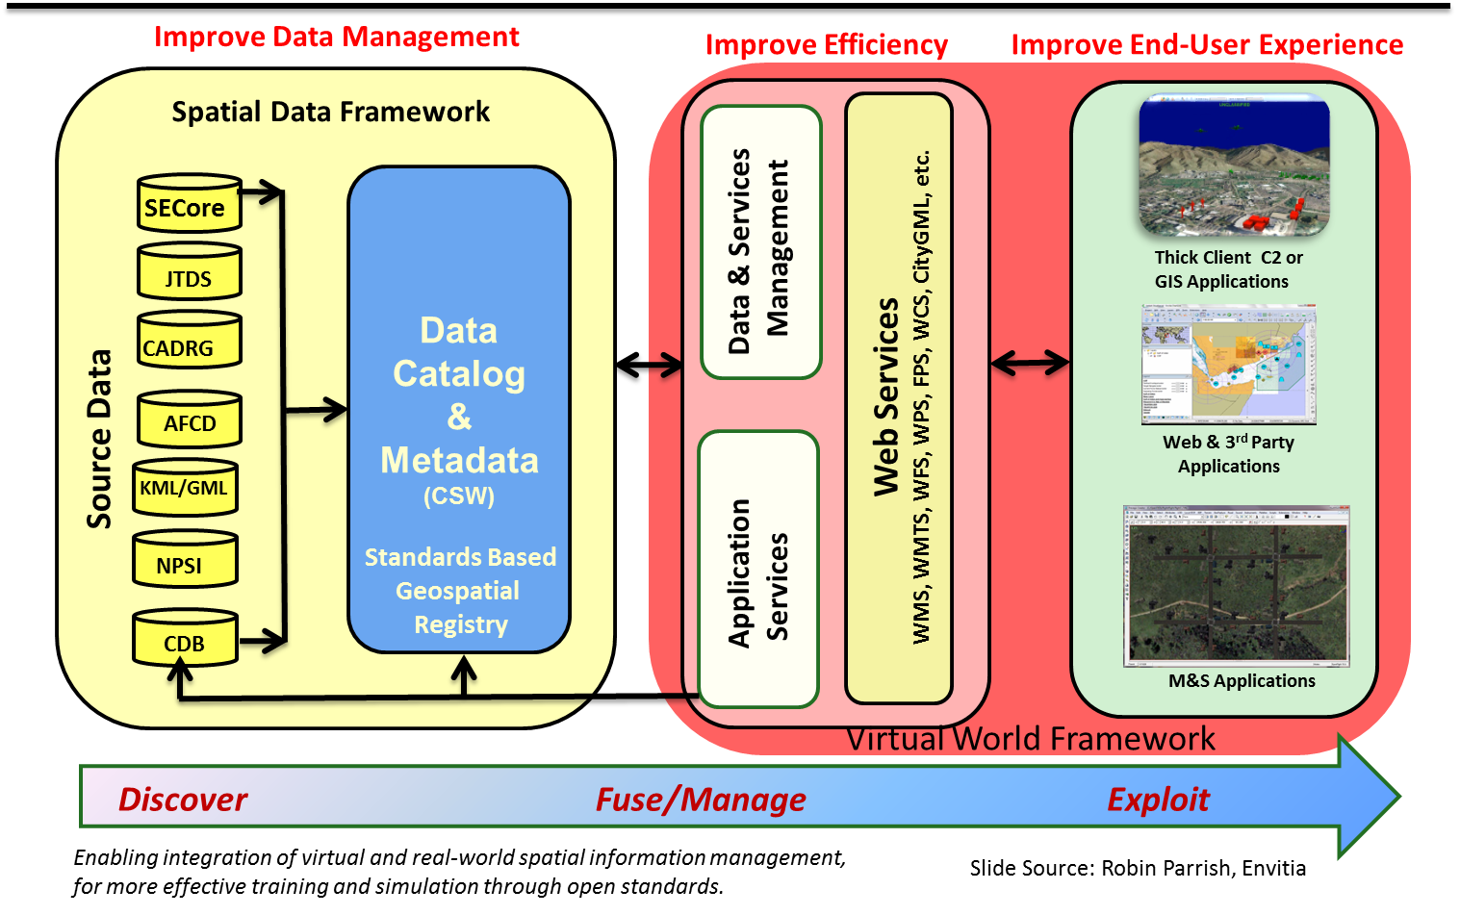
The M&S community should consider rallying around an overarching open systems architecture based on an agreed upon set of open international standards. Much like the emphasis on standardization in the automotive industry, creating pre-formed modular parts allows for the generation, integration, and broad use of better and emerging capabilities as they are developed. Maintaining control of this overarching architecture allows systems engineers the ability to define the intended use and content of their systems, and to adapt quickly to new, disruptive technologies.

This modularization allows for a more focused approach to systems development and deployment, further enriching the community as a whole. Authority and Accreditation can be defined on a more focused level. This ensures that systems are performing the correct roles, in a uniform and repeatable manner.

Once constructed, this standards-based common open architecture will allow for increasingly complex and agile interaction among processes to create higher-level service capability that can answer the growing demands of the user community. For example, current GIS applications excel at performing line of site analysis at a fixed-point, albeit not necessarily at a processing speed or parallel nature suitable for M&S use. As these technologies mature and with M&S community insight, these and other applications may become viable service components for use within the M&S environment. The open standards already embraced by the geospatial community will enable rapid mobilization into M&S workflows. Combining these systems will allow for the creation of a service that can perform line of sight analysis through a specific time of day or phenomenon that could obstruct vision (e.g. a smoke plume).

While much more work is needed to reach our vision, essential standards exist today to enable key aspects of the conceptual architecture noted above. A range of existing open international standards form a foundation for improved data management, processing efficiency, and end user activities.

It is important to develop a conceptual Common standards-based Architecture to articulate recommended and relevant open international standards, and to guide our future work is a key milestone for this Project in 2018

Architecture Components
A common open system architecture addresses the M&S system environment, but also must include standards-based access to source data and services to deliver M&S data to other users. Many of the components necessary for the envisioned architecture already exist. Key to success is ensuring interoperability amongst these standards and extending or profiling the standards as necessary to meet end user needs. The description of the current landscape of architecture components is divided into two categories: (1) the elements that provide the foundational data to source M&S content and (2) the elements necessary to operate M&S systems and deliver from those systems to a wider community.

Foundation architectural components
A myriad of traditional and non-traditional data sources is available for consumption by M&S systems. These data are often made available via standards to provide the following capabilities:

- Discovery, Access, Ingest and Management – to improve source data cataloging, discovery, access, and ingest of geospatial information (imagery, terrain, hydrology, bathymetry, 3D / Urban models, etc.). Complementing these sources are open standards to task, access, process and exploit the expanse of information coming fixed and mobile sensors and IoT devices in the outdoor and indoor environments. Relevant standards include:
  - OGC: Catalogue Services for the Web (CSW), CDB, Web Map Service (WMS), Web Feature Service (WFS), Web Coverage Service (WCS), Geography Markup Language, KML, netCDF, CityGML, IndoorGML, SensorML, Sensor Observation Service, Sensor Planning Service and many others
  - IETF: JSON, GeoJSON
  - MilSpec: CADRG, CIB, NTIF
- Improved Fusion and Exploitation Efficiency – OGC Web Services standards, which include standards such as the Web Processing Service, also allow for processing of source data and the modularization of key processing and visualization capabilities in the M&S workflow.
  - OGC: WMS, WFS, WCS, GML as mentioned above, plus Web Processing Services and others
- Dissemination and Broad End User Experience
  - OGC: standards as mentioned above, plus GeoPackage

Much of the foundation data necessary for M&S consumption is already stored in or served by the standards referenced above across a range of traditional commercial and open source technology solutions. Critical to streamlining the compilation time for M&S datasets is direct access to source content through native service parameters or in standardized exchangeable formats.

The M&S Database / Processing Environment
The goal of this common architecture approach is to achieve a level of common interoperability between various M&S technologies. Central to this goal is understanding and supporting available database environments, along with the capability to interoperate between these environments when necessary.

CDB is currently an approved OGC standard and is under active revision to better integrate the use of international standards for source data and distribution to a broader array of applications. Such work requires deft consideration of the requirements from the existing user community in ensuring a viable upgrade path. The approach to revision of any standard always considers issues of backward compatibility, known mechanisms for conversion of content, and forecast end user requirements.

Data compiled and consumed in the M&S environment also has value for other end users. In some cases, data accuracy and currency have been improved via the M&S process and can be returned to the originator for update. In other cases non-M&S users can benefit from access to M&S content for their own missions. As with the standards identified to support data ingest / management, open web service standards can be “bolted onto” the M&S infrastructure to allow service of M&S content to more traditional GIS and geospatial clients. Use of the OGC WMS and WFS services satisfies many of these use cases.

Driving Progress Step by Step: Spiral Development, Testing, and Validation
A key component of this cooperative is to drive incremental advancements through development, testing and demonstration of new, standards-based interoperable solutions by leveraging existing capabilities of its contributing organizations. Major focus will be placed on planning and conducting cooperative, cross-organizational interoperability experiments, testbeds, pilots, demonstrations and related initiatives to generate incremental advancements that can be quickly implemented and scaled across the community.

Uniting and Aligning
This project enables likeminded organizations to pool resources and benefit from scales of economy that could not be achieved in isolation. Dedicated resources to support the above- both intellectual resources and funding, will be required to help drive alignment of industry and users on a clear open standards vision, and to roadmap the establishment of a common standards architecture framework. OGC, SISO and USGIF are committed to work with its members to identify and align resources to continue this project.

In the coming months, project participants will place emphasis on:
- Formalizing a detailed Common Interoperability Architecture to guide the work of this Project
- Sustaining discussion and advancement of interoperability across the community through:
  - Continuous virtual connectivity. A wiki and project email list have been established to support continuous dialog.
  - Face to Face meetings / events to stimulate alignment and action. Future events include:
    - November 29, 2017, 3D Geospatial M&S Summit II, I/ITSEC (Orlando)
    - 21-26 January 2018, Simulation Innovation Workshop (rescheduled), Orlando
    - 3D Geospatial M&S Domain Working Group Workshop, April 2018, GEOINT 2018 (Tampa, FL)
    - OGC Technical Committee Meetings, March 2018 (Orleans, France), and June 2018 (Ft Collins, CO)
- Identification and allocation of priority interoperability requirements for work within appropriate SDOs and supporting organizations.
- Planning and conduct of interoperability experiments, testbeds and pilots to test, validate new interoperable capabilities
- Expanding collaboration with other organizations as required
- Periodic interoperability capability demonstrations to illustrate the value and power of open standards and best practice to benefit the community.

Commitment and involvement of the geospatial and M&S communities will be vital to the success in achieving these goals.

What you can do
This effort, properly supported and resourced, has the potential to deliver better, faster, and cheaper capabilities for the M&S community. It can significantly improve the interoperability of simulations as well as interoperability between simulations and other information systems. It will allow for the affordable management of the continuously exploding volume and velocity of data. It will allow for easier integration of new data, new algorithms, and new technology. In short, it will provide the agility that allows us to meet the expectations of a broad and growing customer base.

Please join this effort by visiting the 3D Geospatial M&S Project Wiki and joining the project email list to be notified of upcoming events and initiatives. While USGIF, SISO, or OGC membership is not required to join in on the public discussion, please consider taking a membership in one or more of these organizations to deepen your involvement, commitment and impact to achieving this vision.

Project Points of Contact:
Dan Maxwell, USGIF M&S WG Chair
David Graham, SISO President
Scott Simmons, OGC Executive Director Standards

