BRGM’s answer to Underground CDS RFI
March 15th, 2017

Description of responding organization
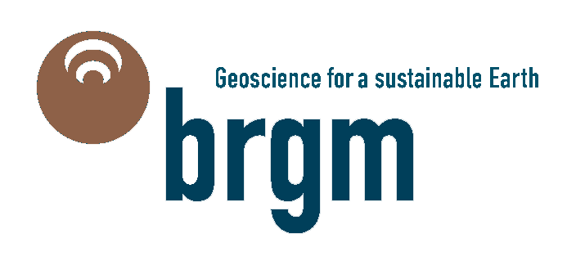The Bureau de Recherches Géologiques et Minières (BRGM) is the French Geological Survey and France’s leading public institution for Earth Science applications applied in the management of surface/subsurface resources and geoscience information exchange. BRGM is an interdisciplinary institution that delivers policy development support to public authorities and carries out research activities to bring innovative technologies and practical responses to major challenges such as climate change, new energy needs, and land degradation. BRGM is a major player in the collection and delivery of georeferenced data and has been a pioneering organisation in conceptual work on interoperability as a principle of distributed information systems.
BRGM ensures the quality of the undergoing research projects being ISO 9001:2008 and ISO 14001:2004 certified for all of its activities. It manages projects on commercial basis for international funding agencies like European Commission or World Bank. BRGM has an international expertise in information systems, being part of drafting teams of the INSPIRE directive and now its maintenance. Under Inspire, BRGM is in charge of the French Inspire catalogue (French Government’s Geoportail) and codelist repository. Voting Member of the Open Geospatial Consortium (OGC), it is involved in several OGC working groups such as the GeoSciML SWG and Hydrology Domain Working group standardising a suite of international standards for the geology and water communities.
BRGM is also actively involved in the International Union of Geological Sciences (IUGS) Commission for the Management and Application of Geoscience Application (CGI) setting up international standards such as GeoSciML, EarthResourceML. BRGM has a strong expertise and experience in EU and national-funded collaborative projects. For the OneGeology Consortium (118 countries) BRGM is in charge of the portal development and operation. It is also a workpackage leader in the European Plate Observing System (EPOS).
BRGM implements research programmes and decision-support tools designed to anticipate and prevent surface and subsurface risks. BRGM is closely involved in furthering knowledge on coastal risks and their management in the context of climate change. It is also involved in monitoring coastline change, through the Coastline Observatories in mainland and overseas France.

Interests in Underground CDS and opportunities of collaboration
As a geological survey, BRGM is deeply involved in natural underground mapping and modeling. From BRGM point of view and interest, the underground CDS initiative may offer the opportunity to undertake two major challenges:

Towards a complete subsurface modelling…
Underground is not only composed of natural elements, especially in urban environment. Then a complete subsurface modeling shall include both natural elements and manmade objects.
Beside the OGC initiatives, the Building Smart International (BSI) community works on standard definition for the description of buildings and infrastructure. The Building Information Modeling (BIM) process aims to create a “living”model of the building or infrastructure it represents that would be fulfilled and enhanced all along the life of the project. For this purpose, BIM community supports the IFC standard to describe building parts.
As BIM is becoming more and more used and even defined as requirements in some new building and infrastructure construction, interactions with IFC standards shall be studied.
In France, the MINND initiative aims to extend BIM processes to infrastructure. This work lead to recommendations about the definition of new IFC classes, dedicated to bridge for example.
The MINND project is now also concerned with underground infrastructure modeling. A very upcoming project with the French national radioactive waste management agency (ANDRA), should specially focuses on definition of IFC classes dedicated with Underground Infrastructure (IST).
In this project, BRGM is about to work with the BIM community on the necessary connections and interactions between natural subsurface and infrastructure description.
Expected results are identification of data workflow during an underground infrastructure creation, definition of a data dictionary, mapping with existing classes (especially IFC and OGC standards) and purposes of enhancements.
BRGM especially aim to define standardized solutions to access geological and geotechnical data from BIM models through OGC standards.

…to facilitate risk assessment and support tools developement
A building or an infrastructure is a living object, and then its environment may evolve leading to new effects on the buildings structure and components. For those reasons, building and more especially infrastructure shall be monitored during their construction until its destruction (or major conversion). This can be partly achieved by pertinent sensors implementations. Then sensors combined to subsurface modelling data shall facilitate risk assessment and help building tools to support decision making in new projects.
Risks can arise from natural phenomena (such as earth tremors, eruptions, tsunamis, marine submersion, cavity collapse, slope movements and erosion, clay shrinking and swelling and coastline retreat) and from human activities, as well as the impacts of climate change on these risks.
Those topics are studied in BRGM, and in order to assess risks, scientists use to combine several data. Having those data interoperable would considerably help data discovery and combination. Thus data fusion processes or algorithms built to be based on interoperable data can be more easily reused and adapted for other problematics and/or partners needs.

Linked initiatives

Harmonization of natural underground knowledge and representations
Geological modeling is mostly based on interpolation processes. Knowledge of the complexity of geology as well as density of boreholes used can considerably change geological modeling accuracy.
This lead to the production of several deliverables: 2d maps and 3d geological models provided at various and not necessarily compatible scales. Harmonization between geological knowledge and representations is required and BRGM is working on several projects to make it happen.
At country scale, BRGM is currently working on the creation of a 3D harmonized system of information about its geology, named the Référentiel Géologique de la France (RGF).
BRGM is also involved in international projects, such as the European Geological Data Infrastructure (EGDI) and the European Plate Observing System (EPOS) to organize geoscience data exposure in the EU, especially borehole information and representation.
For those purposes, standards from IUCS-CGI, that are recognized by the OGC, such as GeoSciML and EarthResourceML are used and adaptations or enhancements are proposed.

Definition of a GeoScience DWG
The existing collaboration between CGI-IUGS and OGC is currently growing and getting formalized by the creation of a GeoScience DWG.
GeoScience DWG will offer the platform necessary to create links between initiatives and works contributing in the promotion of interoperability in geoscience data exchange.
Works from GeoScience DWG will be done with links to other DWG and SWG, especially those working more or less on smart cities problematics, such as LandInfra, CityGML.
Deep connections with Underground CDS may fully enter the GeoScience DWG scope and shall be defined soon to be formalized in the DWG charter.

