Open Geospatial Consortium
Submission Date: <2017-06-30>
Approval Date: <yyyy-mm-dd>
Publication Date: <yyyy-mm-dd>
External identifier of this OGC® document: <http://www.opengis.net/doc/bp/qoe/0.1>
Internal reference number of this OGC® document: 17-049
Version: 0.1.0
Category: OGC® Discussion Paper
Editors: C. Mitchell, M. Gordon, M. Anthony, T. Kralidis

Ensuring Quality of User Experience with OGC Web Services – Discussion Paper

Copyright notice
Copyright © 2017 Open Geospatial Consortium
To obtain additional rights of use, visit http://www.opengeospatial.org/legal/.

Warning
This document is not an OGC Standard. This document is distributed for review and comment. This document is subject to change without notice and may not be referred to as an OGC Standard.
Document type: OGC® Discussion Paper
Document subtype: N/A
Document stage: Draft
Document language: English
Recipients of this document are invited to submit, with their comments, notification of any relevant patent rights of which they are aware that might be infringed by any implementation of any idea set forth in this document and to provide supporting documentation.
License Agreement
Permission is hereby granted by the Open Geospatial Consortium, ("Licensor"), free of charge and subject to the terms set forth below, to any person obtaining a copy of this Intellectual Property and any associated documentation, to deal in the Intellectual Property without restriction (except as set forth below), including without limitation the rights to implement, use, copy, modify, merge, publish, distribute, and/or sublicense copies of the Intellectual Property, and to permit persons to whom the Intellectual Property is furnished to do so, provided that all copyright notices on the intellectual property are retained intact and that each person to whom the Intellectual Property is furnished agrees to the terms of this Agreement.
If you modify the Intellectual Property, all copies of the modified Intellectual Property must include, in addition to the above copyright notice, a notice that the Intellectual Property includes modifications that have not been approved or adopted by LICENSOR.
THIS LICENSE IS A COPYRIGHT LICENSE ONLY, AND DOES NOT CONVEY ANY RIGHTS UNDER ANY PATENTS THAT MAY BE IN FORCE ANYWHERE IN THE WORLD.
THE INTELLECTUAL PROPERTY IS PROVIDED "AS IS", WITHOUT WARRANTY OF ANY KIND, EXPRESS OR IMPLIED, INCLUDING BUT NOT LIMITED TO THE WARRANTIES OF MERCHANTABILITY, FITNESS FOR A PARTICULAR PURPOSE, AND NONINFRINGEMENT OF THIRD PARTY RIGHTS. THE COPYRIGHT HOLDER OR HOLDERS INCLUDED IN THIS NOTICE DO NOT WARRANT THAT THE FUNCTIONS CONTAINED IN THE INTELLECTUAL PROPERTY WILL MEET YOUR REQUIREMENTS OR THAT THE OPERATION OF THE INTELLECTUAL PROPERTY WILL BE UNINTERRUPTED OR ERROR FREE. ANY USE OF THE INTELLECTUAL PROPERTY SHALL BE MADE ENTIRELY AT THE USER’S OWN RISK. IN NO EVENT SHALL THE COPYRIGHT HOLDER OR ANY CONTRIBUTOR OF INTELLECTUAL PROPERTY RIGHTS TO THE INTELLECTUAL PROPERTY BE LIABLE FOR ANY CLAIM, OR ANY DIRECT, SPECIAL, INDIRECT OR CONSEQUENTIAL DAMAGES, OR ANY DAMAGES WHATSOEVER RESULTING FROM ANY ALLEGED INFRINGEMENT OR ANY LOSS OF USE, DATA OR PROFITS, WHETHER IN AN ACTION OF CONTRACT, NEGLIGENCE OR UNDER ANY OTHER LEGAL THEORY, ARISING OUT OF OR IN CONNECTION WITH THE IMPLEMENTATION, USE, COMMERCIALIZATION OR PERFORMANCE OF THIS INTELLECTUAL PROPERTY.
This license is effective until terminated. You may terminate it at any time by destroying the Intellectual Property together with all copies in any form. The license will also terminate if you fail to comply with any term or condition of this Agreement. Except as provided in the following sentence, no such termination of this license shall require the termination of any third party end-user sublicense to the Intellectual Property which is in force as of the date of notice of such termination. In addition, should the Intellectual Property, or the operation of the Intellectual Property, infringe, or in LICENSOR’s sole opinion be likely to infringe, any patent, copyright, trademark or other right of a third party, you agree that LICENSOR, in its sole discretion, may terminate this license without any compensation or liability to you, your licensees or any other party. You agree upon termination of any kind to destroy or cause to be destroyed the Intellectual Property together with all copies in any form, whether held by you or by any third party.
Except as contained in this notice, the name of LICENSOR or of any other holder of a copyright in all or part of the Intellectual Property shall not be used in advertising or otherwise to promote the sale, use or other dealings in this Intellectual Property without prior written authorization of LICENSOR or such copyright holder. LICENSOR is and shall at all times be the sole entity that may authorize you or any third party to use certification marks, trademarks or other special designations to indicate compliance with any LICENSOR standards or specifications. This Agreement is governed by the laws of the Commonwealth of Massachusetts. The application to this Agreement of the United Nations Convention on Contracts for the International Sale of Goods is hereby expressly excluded. In the event any provision of this Agreement shall be deemed unenforceable, void or invalid, such provision shall be modified so as to make it valid and enforceable, and as so modified the entire Agreement shall remain in full force and effect. No decision, action or inaction by LICENSOR shall be construed to be a waiver of any rights or remedies available to it.

Contents
1. Scope 6
2. Audience 6
3. References 6
4. Terms and Definitions 6
5. Use Cases 6
6. Topics to Discuss 6

- Abstract
This paper is intended to identify usability issues associated with use of OGC web services that affect the quality of experience a user may have when accessing and using OGC web service, and discuss potential solutions and guidance to address these issues. Additionally, guidance on evaluating and self-assessing the Quality of Experience of Spatial Data Services will also be discussed and addressed with a proposal for common assessment criteria and common practices for improving the user experience when viewing, layering or querying an OGC web mapping services.

- Keywords
The following are keywords to be used by search engines and document catalogues.
ogcdoc, OGC document, quality, web services, best practices,
- Background
The notion of a Quality of Service activity was initially raised in the Opening Plenary of the June 2016 TC/PC meeting in Dublin, Ireland. A survey was released shortly thereafter to canvass OGC members on expectations for the proposed activity; eight ad-hoc meetings of the group convened between July and December of 2016, culminating in a draft Charter for a Quality of Service Experience Domain Working Group, which was approved by the OGC TC Taichung meeting in December 2016.
During the development of the Charter, the scope of the QoSE DWG evolved to include considerations of the Quality of Experience, particularly around the experience of the end-user and the general usability of OGC web services by non-expert users (those unfamiliar with OGC web services and what they offer). While no standards-setting activity is anticipated to result from discussion of Quality of Experience, it is expected that a Best Practices document supporting all conditions to ensure a positive and fruitful experience when using OGC web services will result.
The assessment framework and criteria and best practices suggested in this discussion paper are the result of a web service quality study based on an inventory of Government of Canada web map services available on the Canadian Federal Geospatial Platform. Natural Resources Canada worked with Refractions Research to construct an assessment framework and use it to assess the quality of 160 web mapping services. The results of the assessment clearly showed that the quality and usability of web mapping services is strongly dependent on a number of relatively simple, straightforward considerations, such as:
- Use of meaningful, jargon-free titles and attribute names
- A clear, readable and easy to understand legend
- An appealing cartographic representation that is easy to view and interpret
- Adequately detailed metadata
- Inclusion of relevant and easy to understand data dictionaries and other supporting documentation
These relatively simple considerations are often overlooked when constructing web services.

- Submitting organizations
The following organizations submitted this Document to the Open Geospatial Consortium (OGC):
CCMEO - Canada Centre for Mapping and Earth Observation, Natural Resources Canada
OS - Ordnance Survey, Great Britain
USGS – United States Geological Survey, United States of America
MSC - Meteorological Service of Canada, Environment and Climate Change Canada
- Submitters
All questions regarding this submission will be directed to the editors or the submitters:
Name | Affiliation
Cindy Mitchell | Canada Centre for Mapping and Earth Observation, Canada
Michael Gordon | Ordnance Survey, Great Britain
Michelle Anthony | United States Geological Survey, US
Tom Kralidis | Meteorological Service of Canada, Canada

Scope
This paper explores means of ensuring that persons using OGC web mapping services consistently experience and achieve a positive interaction between themselves, any web services being accessed, and the data they represent.
Organizations that provide open web mapping services generally do so with the intent of allowing end users to view one or more datasets as a map in any OGC-compliant web mapping client or application. OGC web services are open and interoperable by design, are normative and can be tested for full compliance according to its OCG specification. Standing up an OGC web mapping service involves following the specification and results is an open, interoperable service that makes it possible to visualize geospatial data as a map.
In theory, this approach sounds simple. In practice, challenges abound. The Quality of Service Experience Domain Working Group (QoSE DWG) has found that a reasonable quality of experience (QoE) for the end user when using OGC-OWS is not always assured. Web mapping services can comply perfectly with the OGC specification and still be perceived by the user as poorly documented or poorly presented. Through interaction and support of its end users, the Federal Geospatial Platform has found that geospatial web services are not always easy or intuitive to navigate, combine or understand, especially for new or non-expert users. Ongoing user testing has shown that OGC web mapping services can leave many end users unable to fully understand or make use of results. A non-expert user that cannot interpret or make sense of information presented by a web service will not feel confident in using that information to help build a policy position or make a decision, and are likely to seek other sources of information to inform their decisions. This lack of usability for non-expert users seriously weakens the business case for provision of OGC web services.
A study of the usability of web services by the Canada Centre for Mapping and Earth Observation and Refractions Research in 2016 suggested that an optimal end user experience with OGC web mapping services is hindered by a current lack of documented good practices to guide web service providers when creating OGC web services. The QoSE DWG has taken on the task of providing documented good practices and guidance for providers of web services to fill this gap.
This discussion paper is the first step in identifying quality and usability issues and suggesting solutions for improving these qualities for OGC web services; ideas presented in this discussion paper are candidates for inclusion in a possible OGC Best Practices document on this topic. Topics to be considered in this paper include:
- Proposed service quality indicators and assessment framework
- Recommendations and discussion of practices to improve service quality

Audience
The primary audience for this discussion paper are geospatial data practitioners who prepare and make OGC web services available.

This report specifically targets how to make OGC web services, with particular emphasis on the OGC WMS, more usable and more effective for light users. By better meeting the needs of this group, the quality and usability of OGC web services should increase for all.

References
There are no normative references.

Terms and Definitions
For the purposes of this document, the following additional terms and definitions apply.

- Quality of Service (QoS): Technical reliability and performance of a network service. Typically measured using metrics like error rates, throughput, availability and delay or request response time.
- Quality of (User) Experience (QoE): A holistic, qualitative measure of the customers' experience of the application or service. It encompasses both the user experience and the customer support experience of the evaluated applications and/or services.
- Spatial Data Service (SDS): a standardised technical communication interface containing operations to be invoked by a computer application to view, extract and spatial-temporally query a collection or stream of geospatial information and its metadata, to append new information or metadata to such a collection or stream, or to process geospatial information in such collection or stream. An SDS may be a Web Service operating over a request-response protocol such as HTTP, or it may be operating in some other paradigm and protocol, such as an event or publish-subscribe based model. An SDS may be exposed to its client applications or other services over the Internet, a closed IP-based network or some other networking protocol.
- OGC Spatial Data Service: A Spatial Data Service implementing one or more OGC Standards defining its operations and service description.

Use Cases

Goal 1: Inform a policy decision using a map view
Primary Actor: Economic policy analyst Jan is a federal government employee responsible for policy recommendations to the Minister of Economic Development. Jan has a strong background in applied economics and creation of public policies, but does not have much experience in data analysis, data visualizations or mapping.
Scope: Jan finds and views a web map service in a simple web map visualization client.
Level: OWS - Quality of Experience
Preconditions for success:
- The web map service is discoverable. There is metadata describing the service published online.
- The metadata describing the service contains sufficient detail to allow a person to understand its purpose and content.
- The language used in the metadata is simple and easy for a person to understand. It does not contain jargon, technical or esoteric terms, acronyms, etc.
- The title of the service is human readable.
- The title of the service is meaningful. It is informative and indicative of the data content that the service provides.
- There is a legend provided with the web map service.
- The content of the legend is human readable.
- The content in the legend is simple and easy for a person to understand and use.
- The legend is meaningful. It provides sufficient detail to allow a person to understand what is displayed on the map, without having to refer to other material.
Story: Jan opens a catalogue application that contains metadata records for all government datasets. She enters the terms "education indigenous population Canada" in the free text search field. The search yields two results: a dataset called General Population Education and another dataset called Indigenous Persons Education. Jan selects both records and opens the metadata for the datasets. Both contain a link to a web map service. Jan chooses to view both web map services in the web map client provided by the catalogue application. Jan is able to successfully view and understand the content the web service makes available. The legend provides a clear indication of information presented in the map. The titles of the datasets and all map attributes and queries provide clear, simple, human readable information. Jan is satisfied with the information presented. She does not need to search further to make sense of the data and information presented to her by the service.

Goal 2: Create a web map service optimized for public consumption
Primary Actor: Dan, a GIS data manager.
Scope: Dan, a GIS data manager working in a science-based federal department, is preparing a web map service for general publication on the web. The service will be accessible to the public.
Level: OWS – Quality of Experience
Preconditions:
- Consideration and effort expended to ensure a responsive, usable client-side map rendering, legend, symbology, attributes and metadata.
- Complex datasets are optimized (e.g. minimally generalized) to ensure:
  - Service is responsive and does not appear to fail to load
  - Service renders and returns information quickly
  - Load on server is reduced
- Dataset attributes essential to understanding and using the web map service are made available; attributes of marginal interest are excluded.
- Titles, attribute names, legends included in the web mapping service are human-readable, meaningful and do not include jargon, overly technical or esoteric terms, or acronyms.
Story: Dan is tasked with making simple feature information associated with a new and exciting dataset available to the public using an OGC:WMS. Dan has set up several OGC:WMS before, but has never considered the needs of potential users of the service before. Because this dataset is so topical, the web service is sure to be very popular and used for many different purposes. This causes Dan to think carefully about how the web service will be perceived, from both a performance perspective (response time, speed of rendering, availability, managing load on the server) and from a quality-of-content perspective (what attributes of the data are most interesting and which are less interesting, titles, attributes, legend content are provided in simple, human readable terms that contain a sufficient amount of meaningful intelligence). Dan references a best practices guide from a trusted agency to ensure that he provides the web mapping service in a way to make it responsive, clearly rendered, understandable and usable to a wide range of end-users.

Topics to Discuss

6.1 Service Quality Indicator Criteria:

As stated above, evaluating, comparing and improving the QoE of Spatial Data Services is difficult without commonly agreed and well-defined metrics for measuring the Quality of Experience. A set of service quality indicator criteria has been developed for consideration as a potential OGC endorsed best practice for assessing the quality of OGC web mapping services.
The fourteen criteria described below are all aimed at assessing the quality of a web service in terms of the degree to which it conveys clearly understood information to the user. As noted earlier, the user is assumed to be a non-expert, but in most cases the criteria are equally valid for all classes of users.

1. Title - Meaningfulness

Definition

How meaningful a title is assessed to be is evaluated against the
following categories:

● Meaningful; Informative and clearly indicates content
● Less meaningful; somewhat ambivalent; some use of
jargon (overly technical, esoteric or organization-specific
terms) or acronyms; could be improved
● Not meaningful; insufficient to convey content; use of
jargon (overly technical, esoteric or organization-specific
terms) or acronyms; vague; missing information

Rationale

The title may be the only information a user makes use of in order to determine whether a service is appropriate for their task. It is important to convey as much meaning as possible in a relatively short title.

2. Consistency between Title and Map Content

Definition

This criterion is used to assess the degree to which the title and map content are consistent with one another. A simple three category evaluation is used:

● Map displays what title states
● Some inconsistency between what map displays and
what title states
● Mismatch between map and title

Rationale

To identify services which may have been misnamed in error or otherwise.

3. Legend Appearance

Definition

The appearance of a legend includes the legibility of any symbols used, the legibility of the explanatory text, the three values are as follows:

● Clearly legible
● Poor legibility
● Missing

Rationale

An initial survey of services identified that some services provided legend images that were difficult to read. The intent was to determine the extent of this problem.

4. Legend Content

Definition

The degree to which the legend conveys meaningful content is assessed against four categories:

● Not applicable, a legend is not provided (in some cases
because it is not necessary, eg. satellite imagery)
● Meaningful; provides sufficient detail to allow user to
easily and immediately understand map display
● Less meaningful - lacks some context, could be improved
by adding units of measure, other information, but still
allows for some comprehension of content
● Not meaningful; a user must seek further information to
understand content of legend

Rationale

To evaluate the actual content of the legend, regardless of its legibility (evaluated above). Is there an appropriate number of categories and is it clear what each of them mean?

5. Feature Attribution

Definition

The number and relevance of the attributes provided for each feature.

● Not applicable, no attributes (typically a raster service)
● Sufficient attribution; attributes of essential interest to the
dataset are included
● Minimal attribution; sparse information; could be improved
● Excessive attribution; contains unnecessary content

Rationale

To identify outlying cases of excessive or insufficient attribution.

6. Feature Attribute Names

Definition

The understandability of the attribute names themselves.

● Not applicable, no attributes (typically a raster service)
● Meaningful; informative and clearly identifies attribute
● Less meaningful; somewhat ambivalent, some use of
jargon or acronyms, could be improved
● Not meaningful; insufficient to convey meaning of attribute; use of jargon (overly technical, esoteric or organization-specific terms) or acronyms; vague, missing information

Rationale

To identify issues with the naming of attributes.

7. Feature Attribute Completeness

Definition

The completeness of attribute values.

● Not applicable, no attributes (typically a raster service)
● Appears complete - data not missing
● Does not appear complete - empty fields; should be examined

Rationale

To identify cases where a service provides attribute(s) that rarely or never have values, possibly due to an error, or otherwise. Only cases of missing attribute values that were apparent from the assessment of the attribute values themselves have been identified. A thorough review of all features in all services is out of the scope of this assessment.

8. Feature Attribute Values

Definition

The understandability of the attribute values.

● Not applicable, no attributes (typically a raster service)
● Conveys information/meaning effectively
● Does not convey information/meaning effectively (excessive precision, code given but unclear as to what it means, vague); should be examine

Rationale

To identify issues with understanding the meaning of attribute values, as they are important for analysis of the data.

9. Map Visualization

Definition

An overall measure of the quality and understandability of the map.

● Clearly rendered map; quality of visualization is high,
quickly and easily understood at appropriate scale

● Poorly rendered map; quality of visualization is lacking; not easy to view or understand at appropriate scale

Rationale

To identify any of various issues that make it difficult to interpret the map. These include potential technical issues to do with re-projection or rendering, as well as issues with the data representation and cartography.

10. Map Cartography

Definition

How well colour and symbols (if used) are used to add information and clarity to the map.

● Use of colour/colour ramp and symbols effective
● Use of colour/symbols less effective, could be improved
● Poor or ineffective use of colour/colour ramp or symbols, should be improved

Rationale

To identify cases where the use of colour could or should be improved to enhance the usability of the service. While this assessment is somewhat subjective, some colours are
objectively poor when displayed against the default basemap provided in the RAMP viewer.

11. Map Scaling - Consistency

Definition

Whether or not the data is consistent at different zoom levels.

● Consistent between scales; no rendering issues when
zooming
● Inconsistencies apparent between scales; missing areas,
jumbled areas, etc.

Rationale

To identify services where, due to technical reasons or other, only a semi-random subset of the data is displayed at smaller zoom levels, while displaying more or all of the data at larger zooms. This can cause confusion for a user who doesn’t understand why it might be happening.

12. Map Scaling Visibility

Definition

Whether or not the data is scale-dependent, as apparent from viewing the data in the web mapping client.

● Can be viewed at all zoom levels
● Cannot be viewed at all zoom levels; i.e., scale dependencies exist

Rationale

To identify layers which have scale dependencies, as they can be more difficult for users to make use of or understand.

13. Supporting Docs

Definition

The availability and understandability of supporting documentation for the service.

● Available; complete and easy to understand
● Available, incomplete or difficult to understand
● Broken link
● No supporting docs

Rationale

To identify missing or broken links, or a lack of supporting documentation for a service. Note that the supporting document(s) were only given cursory viewing; only in cases of
complete jargon or otherwise expert-only readability were they assessed to be difficult to understand. A complete review of the supporting documentation is out of the scope of this assessment.

14. Service Metadata

Definition

The service abstract and other information made available from the “Metadata” link displayed in the web mapping client.

● Available and easy to understand
● Available, not easily understood or not meaningful
● Does not exist

Rationale

To determine the extent to which the metadata abstract is used to good effect. The service abstract is the most accessible description of the service’s data. It can provide some explanation of otherwise complex or technical data and/or provide insight into
the methodology of the creation or capture of the data.

In addition to the fourteen criteria above, three further criteria are included that, although they are more subjective, still provide value in assessing the overall quality of the web services from a quality/usability perspective:

Loading / Response Time

Definition

This criterion refers to how quickly the service performs. Normal means that it either loaded immediately or quickly by requesting a reload. Frustrating implies that a number of tries were required or that the response time appeared excessive. Failed to load means the service would not load, regardless of multiple attempts and long wait times.

● Normal
● Frustrating
● Failed to load

Rationale

To identify services where the response time caused problems in using the service. While this might seem to be subjective, the difference in usability between the “slowest” service assessed as normal and the “fastest/best” service assessed as frustrating can be quite significant; in the FGP assessment, the “frustrating” cases were all clear outliers.

User Level Suitability

Definition

Suitable simply means easy to understand, not-confusing. It does not imply that the service cannot be improved or that it cannot be made easier to use. For simplicity, users are placed into just two categories, expert or non-expert.

● Suitable for a light user, a non-expert
● Suitable only for a moderate to heavy user, an expert

Rationale

To determine the target audience for the service.

Overall Evaluation of Quality

Definition

The services can be compared against one another. Among the best does not mean that it cannot be improved, but it does suggest that it may serve as a worthwhile example.

● Among the best
● Not among the best

6.2 Proposed practices to alleviate usability issues:

In this section, quality and usability issues are reviewed and and recommended solutions proposed. The issues and solutions are grouped using the assessment criteria described in section 6.1.

3.1 Title

3.1.1 Discussion
Titles are expected to be human readable and comprehensible, and contain little or no jargon, abbreviations, acronyms, etc.. Titles should also be well-formed: short, specific, relevant, providing a user with the ability to readily grasp the content of the service.
A common issue with naming is having very general information, such as an organization name or a data series precedes the name of a specific data subject, pushing the main data subject further to the right and making it harder to read and assess, in various situations.
In other cases this additional name would follow the data subject, making the title excessively long or pushing other information in the title (location, date, scale) further to the right and out of view.
Another issue is the use of unnecessary words in the title, such as “Geographic Distribution” or “Location”. These are generally implied by the fact that the data is being shown on a map.
A common best practice on the web is to limit any title to 70 characters or less, to avoid truncation. Abiding by this rule can also keep titles relatively crisp and relevant. Shorter, simpler names with the most specific information at the front can be beneficial in situations where there is not enough room to display the entire title. It is also important that the title is not overly general. For example, Fisheries and Oceans Canada provides a service titled “Critical Habitat of Species at Risk”, which by name would appear to be a roll-up of all Critical Habitat layers - but it in fact only represents the critical habitat of aquatic species at risk. This is not clear until the product specification is downloaded and read. This title is therefore too general and can be misleading - “Aquatic Species at Risk - Critical Habitat” might be a better choice of title.
3.1.2 Recommendations
Title-1: Use human-readable language as titles and attribute names. Do not use program or other jargon, codes or other alphanumeric strings, and avoid using acronyms and abbreviations.
Title-2: Keep service title length to 70 characters or less, starting with the most unique or important aspect of the data first.
Title-3 : Include enough specificity in the title to clearly identify the subject of the data, avoid also being overly general, suggesting the inclusion of data which is not included.

3.x Fees and Access Constraints
3.x.1 Discussion
OWS services allow for the advertisement of ‘Fees’ and ‘AccessConstraints’ elements which identify whether there are costs or limitations on access against the entire OWS. While the content model for both of these elements is freetext, OGC standards recommend using the term ‘None’ (case insensitive) if no fees or access constraints exist and the server wishes to advertise them as such.
3.x.2 Recommendations
Fees-AccessConstraints-1: OWS servers should explicitly advertise Fees and Access Constraints as ‘None’ in lieu of not declaring these elements in a GetCapabilities response.

3.x Bounding Boxes
3.x.1 Discussion
OGC Web Services typically support a ‘GetCapabilities’ operation designed to provide a high-level overview (or ‘table of contents’) of a given OWS which includes a list of layers, feature types, coverages, or other data resource types. A given OWS data resource includes support for advertising a bounding box which represents a minimum bounding rectangle or geospatial extent that represents the OWS data record’s geospatial area of interest.
Below are some observations on how OWS server implementations handle this capability:
- auto-calculation: the OWS server generates the bounding box value ‘on the fly’ or automagically. While precise, this could bear a performance cost and overall Quality of Service
- global as default: the OWS server provides a default “-180, -90, 180, 90” type value which is representative of the entire globe. This could result in poor search/discovery workflow when assessing the area of interest of an OWS data resource (data encompasses a very small, but important, area of interest)
- omission: the OWS server provides no bounding value for an OWS data resource. This results in the user having no knowledge of the spatial characteristics of the OWS data resource
3.x.2 Recommendations
BoundingBox-1: the bounding box should always represent the accurate area of interest of a given resource
BoundingBox-2: if an OWS data resource’s bounding box is truly global, the OWS server should advertise as such
3.x Attribution
3.x.1 Discussion
OGC:WMS (via GetCapabilities) provides a wms:Attribution construct for any given Layer definition. wms:Attribution provides references to the content provider (URL, Title, LogoURL). wms:Attribution provides value for organizational branding (authoritative source) that OGC:WMS clients can use when building a user interface/client.
3.x.2 Recommendations
- Attribution-1: WMS server implementations should implement wms:Attribution for the root Layer to provide overall attribution of the WMS server.
- Attribution-2: WMS server implementations may implement wms:Attribution for any or all child Layers
- Attribution-3: WMS server implementations should ensure wms::Attribution/wms:LogoURL points to a web friendly graphic (PNG, JPEG, etc.), providing an image of smaller dimensions so as to display as a thumbnail by clients
3.2 Legend
3.2.1 Discussion
The legend is perhaps the most intuitive way for the service provider to give the user useful information about the layer.
Depending on the configuration of the service and the type of data being displayed, the legend could be displayed in two different ways: either as a single image including all of the “colour swatches” and all of the text descriptions, or as individual images for each colour swatch accompanied by actual text. When the legend is displayed as a single image, the text descriptions are often difficult to read.
Another problem encountered with some of the legends is that they are too large (i.e. too long, too many attributes or categories) to be displayed in the layer list, without scrolling. Realistically even when the user scrolls down, the large number of categories could compromise their understanding of the display, depending upon the details. Excessively long legend descriptions can also cause the legend to be too wide to be easily viewable.
When the legend includes numeric values, it should also include the appropriate units in the text description of each legend item. Standard International System of Units (SI) abbreviations (i.e. units) should be used in legend descriptions.
Unexplained codes or jargon are not appropriate for a general audience but may be acceptable for expert use.
3.2.2 Recommendations
Legend-1 : The legend should accurately reflect the content of the map.
Legend-2 : A legend should not be provided if the content is not categorized or otherwise has no need of a legend.
Legend-3 : Units, following SI conventions, should be included in the legend descriptive text when measurements are used.
Legend-4 : Codes, contractions or abbreviations should not be used in the legend descriptions if possible, with the exception of SI measurement units and map indexes.
Legend-5 : The legend should be legible. Ensure that method of constructing legend produces a clear, sharp image and easy to read text.
3.3 Feature Attributes
3.3.1 Discussion
The assessment of the feature attributes is mostly about readability and understandability.
The most common problem is the use of codes or jargon in either the attribute names or the attribute values.
A minor concern is that floating-point numeric attribute values are often represented at their maximum precision, which can make the numbers difficult to read and falsely represents the actual accuracy of the underlying data.
In some cases point features included the latitude and longitude as attribute values. While this is commonly done as separate attributes, in at least one case the two values were stored in a single attribute as text, separated by a space, which is not as readable for humans or computers. If the data is already being supplied with point geometry, provision of coordinates as attributes really is not necessary.
3.3.2 Recommendations
FeatureAttributes-1 : The use of space-separated words or short phrases for feature attribute names should be used, as opposed to contractions, camelCase or underscores.
FeatureAttributes-2 : The unit of measure in the feature attribute name for measured values should be specified as a separate attribute using SI recognized units. The units used should relate to accuracy and common usage (e.g., the value for the area of a wetlands polygon of 2.34 km 2 should not be given as 2,338,062 m 2 ).
FeatureAttributes-3 : Numerical precision (i.e., the number of digits) should be given to correspond to and reflect actual accuracy level of the dataset and not to the maximum, machine generated values.
FeatureAttributes-4 : Feature attributes not be included unless they normally have values.
FeatureAttributes-5 : Longitude and latitude should not be given as feature attributes of point data, since equivalent information is contained in the geometry.
3.4 Cartographic Representation
3.4.1 Discussion
In the example below from the Pelagic Seabird Atlas - Average Grid Cell Density layer, each grid location may have multiple “stacked” polygons in the same location, each storing observation data for a different species. The user has no way to control which species or which polygon’s attributes are displayed when clicking on any grid cell, so making use of this data is difficult.
Alternatively or additionally, a single heat map could be produced showing the number of species found in each grid cell. For many casual users this might be much more useful.
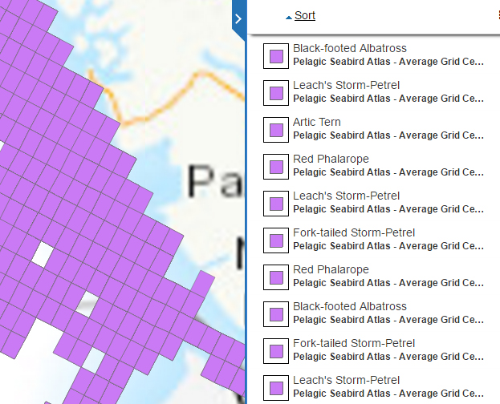
3.4.1.1 Colour
Here is an example of a layer from the Critical Habitat for Species at Risk series of data.
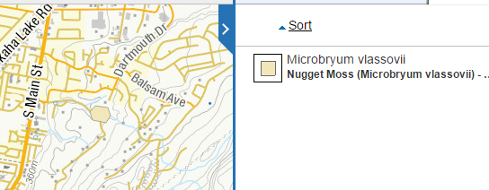
It is initially difficult to recognize any of the subject features on the map because of the small size of the polygons. Even after zooming in on a specific polygon, it remains difficult to see due to the use of a muted yellowish colour that is similar to both the yellow background and the yellow used for the streets. This colour may have been chosen to differentiate this species from the other species in the series or perhaps simply to avoid garish colours; however, against the default basemap the contrast is much too low.
While the opportunity for colour clashes always exists, one approach might be to use less saturated colours for the basemap, and more saturated colours for the layers of interest. This should at least help increase the visibility a single data layer shown over the basemap. What if the same layer might be used as part of a different basemap? This approach also increases the likelihood of interlayer colour conflicts, because it reduces the colour space available to the non-basemap data layers. These issues will be discussed further in the Service Interoperability section.
3.4.1.2 Symbology
The “Carbon monoxide emissions by facility” map shown below displays very effective symbology. The colours are very clear and meaning is enhanced by the different sizes employed. The colours on the legend and map are of different hues, which helps with the user experience. As well, no confusion exists with the background colours or basemap details, although a brighter yellow for 100 to <500 would provide greater contrast with the background. The one real deficiency is the of gray for No Recordings; it is difficult to see. If No Recordings were symbolized by a gray circle with a heavy black boundary it would work better. The legend could be improved by specifying the time period to which the number of tonnes applies.
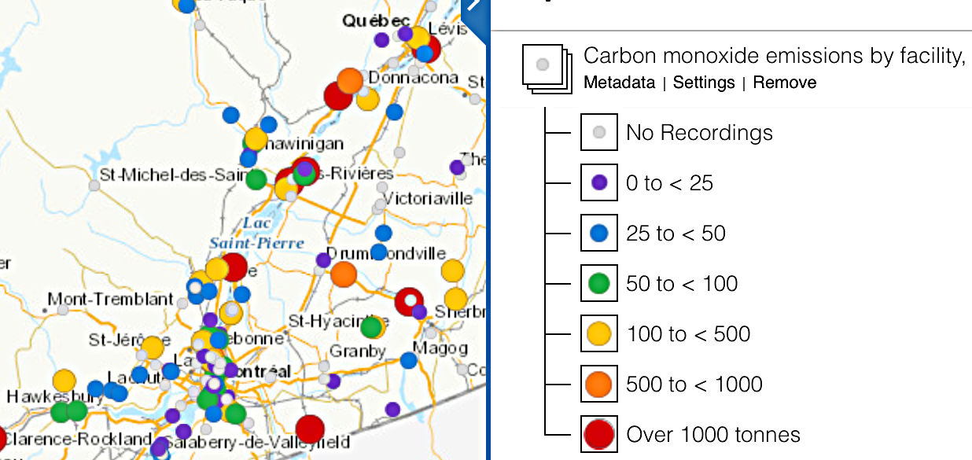
“The Major Projects Inventory - Point Geometry” shown below uses circles, squares, and triangles for different kinds of projects, as shown in the large image below. The colours are sufficiently different to aid recognition as are the different sizes of the symbols. Also note that the darker tones in all three cases are used for Planned, whereas lighter tones are employed for Under Construction. The black boundary used to indicate the largest planned and under construction sites is used on only a single site across the country (shown on the map snippet on the left).
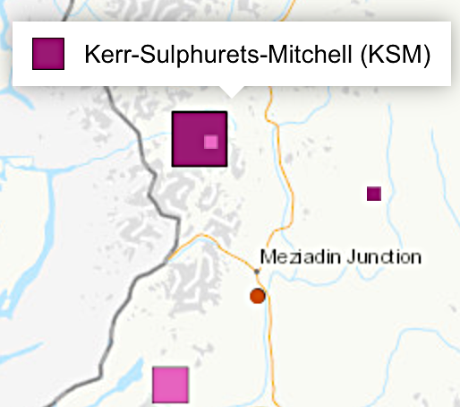
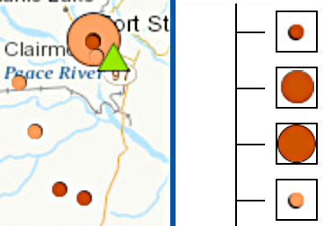
This raises the question of whether the legend should contain symbols that cannot be found anywhere in the country, as is the case with Mining, More than 5 billion, Under Construction. On the other hand, by including the category it is clear in this case that nothing has been forgotten.
A very minor inconsistency is that the shadow effect used on the two smallest energy symbols is on the lower left in the legend but the upper right on the map, as shown in the second small image above. The legend should also indicate the units used, which will differ depending upon the subject.
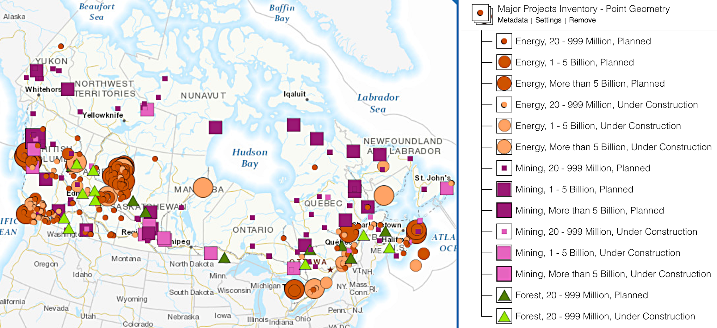
The “Metal Mines - Producing Mines” map below shows symbols with a flat design, characterized by no use of gradients, textures or drop shadows. Not only is this in line with modern design, as used on smartphones for example, but it also makes displaying the symbols more compatible with different map rendering technologies.
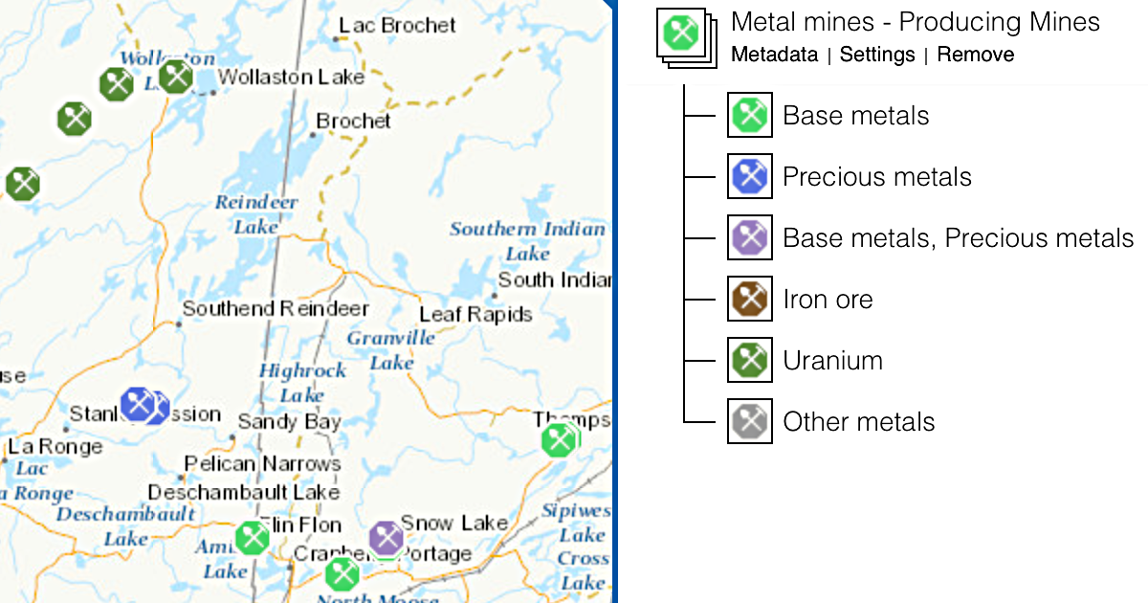
3.4.1.3 Labelling
Relatively few layers had any labelling of features. Below is an example of a good use of labelling. On the left are the NTS 1:250 000 blocks shown with labels and 1:50 000 subdivisions. Zooming in further (on the right) shows the labels for the 1:50 0000 mapsheets. The labels are clear and the overlay against the basemap is quite well done in both cases. Zooming further (not shown) shows the blocks and the labels for the 1:20 000 NTS grid.
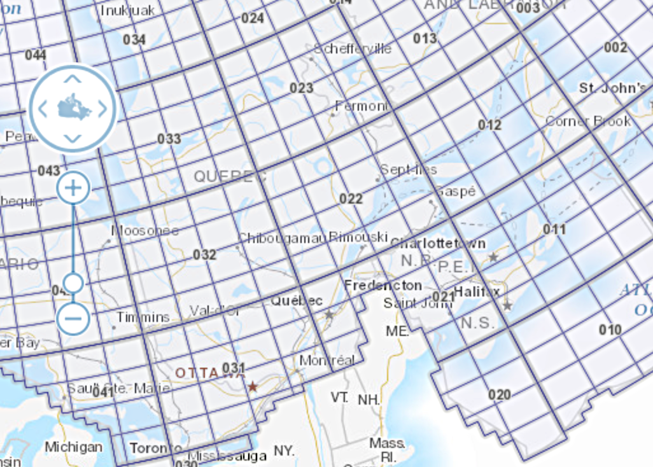
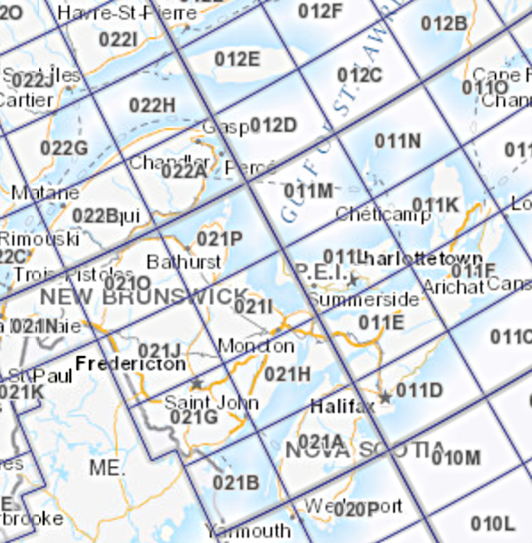
In the Historic Treaties map below, labels and different colours would do much to improve the useful information content of this map. The various green colours are difficult to identify with certainty with the listing in the legend. So this service has issues with labels, colours, legend content, and legend length.
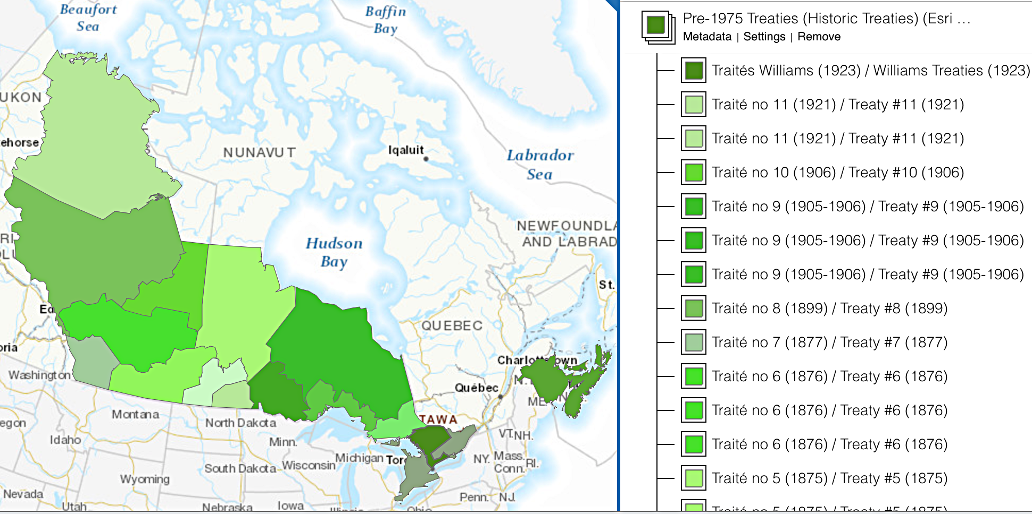
In the case of feature level services, some viewers display a feature “name” when a feature is hovered-over with the mouse cursor. It’s not uncommon to find when a feature “name” is displayed when hovering, it is a code or jargon of some sort, where a long-form name is actually available in the data. Since this form of labeling does not take up permanent space on the map image, it seems there is no reason not to use the most descriptive name.
3.4.1.4 Scaling
For a general use web service, it is important that something be clearly visible on the map at all resolutions. In the case of small polygon data, or small raster areas, it is often invisible on the map at a smaller (i.e. national or provincial) zoom level, and would better be represented as point symbols or a polygon area to help a user navigate to where the data is and zoom in on it.
Conversely, it should not be possible to request more data than can be returned in a reasonable period of time; when zoomed out, either more general data should be displayed or a point symbol used. For feature-level services, expert users should still be able to access the full detail data.
3.4.1.5 Imagery
This example from the “Swift Current LiDAR Project 2009 - Orthos” layer shows some edge artifacts likely caused by re-tiling or re-projecting the ortho image tiles. This sort of problem may affect the usability of the data from an analytical perspective. Of more importance here is that it is an assault on the viewer’s sensibilities and should be easily avoidable with due care taken in processing the data.
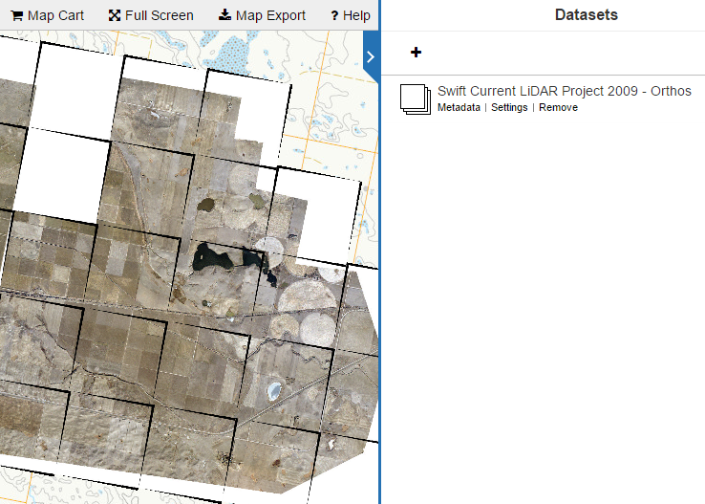
Another point about lidar imagery (next page) concerns their meaning to the typical user. Such imagery is often shown as shades of gray with the darker sections showing lower elevations and the lighter sections displaying higher elevations. This should be indicated through the legend preferably and otherwise by the metadata. Even more useful would be to show the range of elevation in the area of question. The experienced user may realize that the the dark shades represent lower areas, but will not necessarily know if the difference between these lower areas and the higher elevation areas is centimetres, metres, tens of metres, etc.
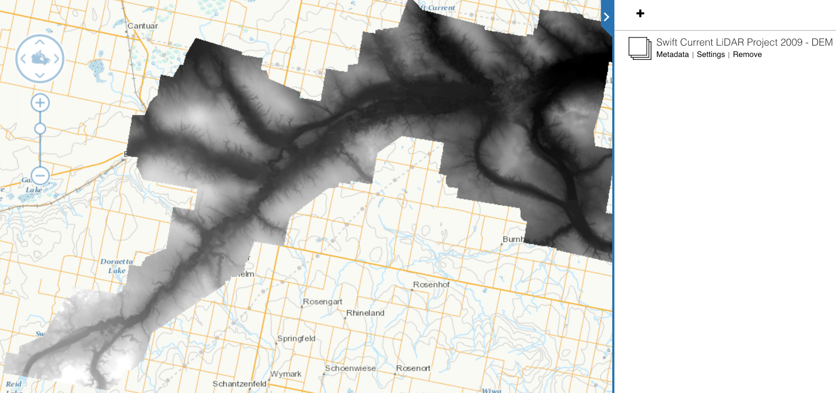
3.4.2 Recommendations
CartographyColour-1 : Colours for features/layers should be chosen that are in clear contrast with those on the basemap.
CartographyColour-2 : Colours appearing on individual layers should be readily distinguishable from one another, unless by intention they are of the same colour.
CartographyColour-3 : If it is known that certain layers are likely to be used in combination with one another, then care should be taken to ensure that similar colours are not used on the different layers.
CartographySymbology-1 : Symbols should have colours that contrast sufficiently with the basemap details and with one another. Subdued or pastel colours should be avoided.
CartographySymbology-2 : If the symbols include contrasting boundaries used to distinguish symbols from one another, then the boundaries should be comparatively thick so that they are easily discerned on different devices and screens of differing qualities.
CartographySymbology-3 : The use of different sizes and colours in combination is recommended for rendering different numeric categories.
CartographySymbology-4 : The use of different shapes, such as triangles, squares, and circles, is recommended for portraying different series on the same map.
CartographySymbology-5 : Connotative symbols with varying shapes or internal icons can be used so long as colour is also used to distinguish them.
CartographySymbology-6 : All symbols should have a flat design, without the use of gradients, textures, or drop shadows.
CartographyLabelling-1 : If used, labels should be short and readily understood directly or from the legend, with the exception of the label as a map index, in which case it is acceptable if the explanation is found in the metadata.
CartographyLabelling-2 : Where large polygonal features are displayed, labels are recommended if practical to implement. For small features on the map, care must be taken that the label does not conflict with other labels or with boundaries.
CartographyLabelling-3: In cases where feature name is configured to display when hovered over, avoid providing codes, acronyms or other cryptic text if a long-form name is available in the data.
CartographyScaling-1 : Services should not allow requests for excessive amounts of data that would cause the server or connection to timeout. If a service provides only high-resolution data, it should only be available at large scales.
CartographyScaling-2 : Wherever possible, lower resolution data or alternative representations (e.g. a point symbol instead of a set of lines or polygons) should be provided at smaller scales to enable the user to navigate the map to the data of interest.
CartographyImagery-1 : Quality assurance should be carried out so that a proper orthomosaic is available, without obvious artifacts.
CartographyImagery-2 : When a color gradient is used to visualize the data, such as a greyscale map of elevation data, the legend should indicate the values associated with key colors in the gradient, eg. that the lighter and darker areas represent higher and lower elevations, respectively.
3.5 Metadata, Series and Supporting Documents
3.5.1 Discussion
The service “abstract” should contain at least a short overview describing the dataset. In some cases, the provided abstract provides no more information than the title of service.
Ideally a link to a “product specification” or similar document should be provided if one exists. A suggested standard for the minimum information that should be provided in such a document could be:
● A data dictionary for codes or terminology
● Description of the methodology for the creation/capture of the data
● Reference to any related laws or standards
The name of the “data series” that a service belongs to should be recorded in the service metadata, searchable and displayed to the user through the map viewer interface. The map viewer’s “metadata” display should include the name of the data series, links to view the metadata of the other layers in the same series, and links to add some or all of those other layers to the map.
3.5.2 Recommendation
MetadataSeries&SupportingDocs-1 : Every service should include an abstract with meaningful content. The content should include more detail than the title, so that in a few sentences the reader has a fair idea as to what the service provides.
MetadataSeries&SupportingDocs-2 : Any documents intended for a general audience should minimize the use of jargon and abbreviations. If such terms are commonplace or judged to be unavoidable, they should be briefly defined.
MetadataSeries&SupportingDocs-3 : It is strongly encouraged that service metadata include a link to a “product specification” or similar document. Such document(s) should include as a minimum a data dictionary, a description of the creation/capture methodology, and references to any related laws or standards.
MetadataSeries&SupportingDocs-4 : Ensure support for the concept of “data series” in metadata records.
3.6 Service Interoperability
3.6.1 Discussion
Through reviewing and assessing 160 web map services, various issues involving service interoperability were identified. In particular, there are difficulties with:
● Visualization of a service displayed over a basemap
● Visualization of multiple services when displayed together
● Querying two similar services
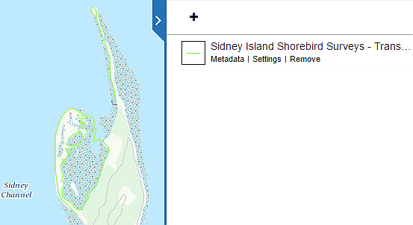
An example of poor visualization of a service over a basemap is shown below, from the service “Sidney Island Shorebird Surveys - Transects Line”.

The thin light green line is almost invisible against the background. Visibility would be improved with a thicker line of a more contrasting colour. With so much green on the basemap, the colour of the line should have a different hue altogether. In the current case the line is so thin and light that even tested against a different coloured basemap, such as a shaded relief option, its rendering needs improvement.
The following example shows the difficulty in visualizing and querying two services together. In this case, several layers in a related series of data (Canadian Environmental Sustainability Indicators (CESI)) were displayed on the map together. These layers use the same symbology of coloured points: increasing in size and tending toward red as they get larger (worse). This results in a very readable map, individually. However, when multiple CESI layers are loaded at the same time, it is impossible to determine which symbol relates to which dataset, just by viewing the map. Furthermore, querying the map shows that the two data sets have nearly identical attributes. It is difficult to recognize which layer’s feature has been selected, because the map client used in this case did not identify from which layer the results were returned. Looking carefully at the attributes of the feature helps in this case because the attribute name “Sox” corresponds to the name of the pollutant. In a worse case, it is possible that multiple datasets could share identical attribution and styling, and be indifferentiable when queried.
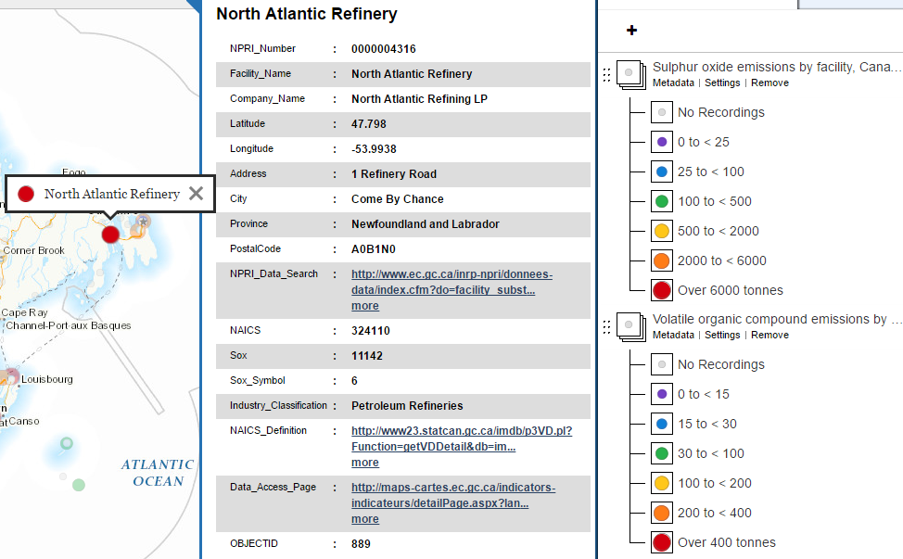
The way around these problems is to be able change the styling of a service (colors, linetypes, and/or symbols) dynamically, depending on the situation. Three relevant solutions to this problem are recognized:
● WMS Named styles
● WMS Styled Layer Descriptor (SLD) support
● Client-side style definition and rendering of ESRI REST layers
The WMS specification (all versions since 1.0.0) allows for each layer to support zero or more named styles, with the names of the styles (and other descriptive information) specified in the layer’s capabilities in the WMS server’s capabilities document. This allows the service provider to provide more than one style for a given layer, and requires only minimal support on the client side (allowing the user to select from a list of style names).
The WMS specification also provides for optional support of the SLD specification, which includes the ability for the client to provide an SLD document describing how to style the layer, with a getMap request. This allows the client to specify the style information in the SLD, and have the server render the map according to that SLD. This implies a sophisticated client application, which provides a user interface to define the style, generates the appropriate SLD XML, and makes use of an XML-based HTTP POST getMap request to send the SLD to the server (instead of the typical HTTP GET getMap request). While this provides excellent flexibility and configurability, supporting it on the server side allows the user to specify arbitrarily complex styling that could cause excessive workload for the server. To reduce the level of sophistication required in the client, another approach is for the service provider to provide additionally, alternate SLDs. These alternate SLDs would work similarly to named styles, except instead of being defined in the server configuration, and referenced by name, they would be defined by a separate SLD file and reference using a URL. It is even possible for a third party to define and provide the SLD, a job that could be filled potentially by an FGP styling team. This requires some basic support in the client and a way to communicate the availability of the alternate SLDs to the client, likely through some sort of metadata.
The ESRI REST interface sends feature-level data, not map images, and the client renders them to a map image using the styling suggested by the service. ArcMap (ArcGIS for Desktop) supports complete restyling of the data on the client-side, and so could a sufficiently sophisticated web-map client. This provides the greatest flexibility, but requires that both the server and the client handle the individual features and coordinates being rendered on the map, which in some cases is a significant overhead, even preventing some layers from loading or displaying properly because of the volume of data.
3.6.2 Recommendations
ServiceInteroperability-1 : Implement support in web-mapping clients for WMS named styles, and recommend that WMS services offer more than one named style. In the case of data series, one style should be visually distinguishable from other data in the series, and another style should be similar or identical to other data in the series.
ServiceInteroperability-2 : Investigate the compatibility of different services with SLD. It should be determined if a single SLD can be published and used correctly by WMS servers from different vendors (Mapserver, Geoserver, ArcGIS Server). Further investigation will be required to determine who should be responsible for producing and maintaining such SLDs, and how they can be discovered and used.

Endnote
Recommendations for web service quality found in this discussion paper were prepared by Mark Sondheim and Chris Hodgson of Refractions Research for Cindy Mitchell and Joost Van Ulden of the Federal Geospatial Platform Initiative, Canada Centre for Remote Sensing and Earth Observation, Earth Sciences Sector, Natural Resource Canada. Based on a quality assessment of 160 web map services offered by ten Canadian federal government departments in November 2016.

User persona development for the Federal Geospatial Platform identified four classes of users - Light - little to no familiarity with mapping: i.e. government policy analysts, economists, others with limited to no GIS experience - Moderate - some familiarity or expertise with mapping and mapping data: data managers and data analysts - Heavy - expert in geospatial analysis and development: GIS/geomatics practitioners, other power users - Web and application developers

