OPEN GEOSPATIAL CONSORTIUM (OGC)
In partnership with
INTERNATIONAL HYDROGRAPHIC ORGANIZATION (IHO)

REPORT: Development of Spatial Data Infrastructures for Marine Data Management
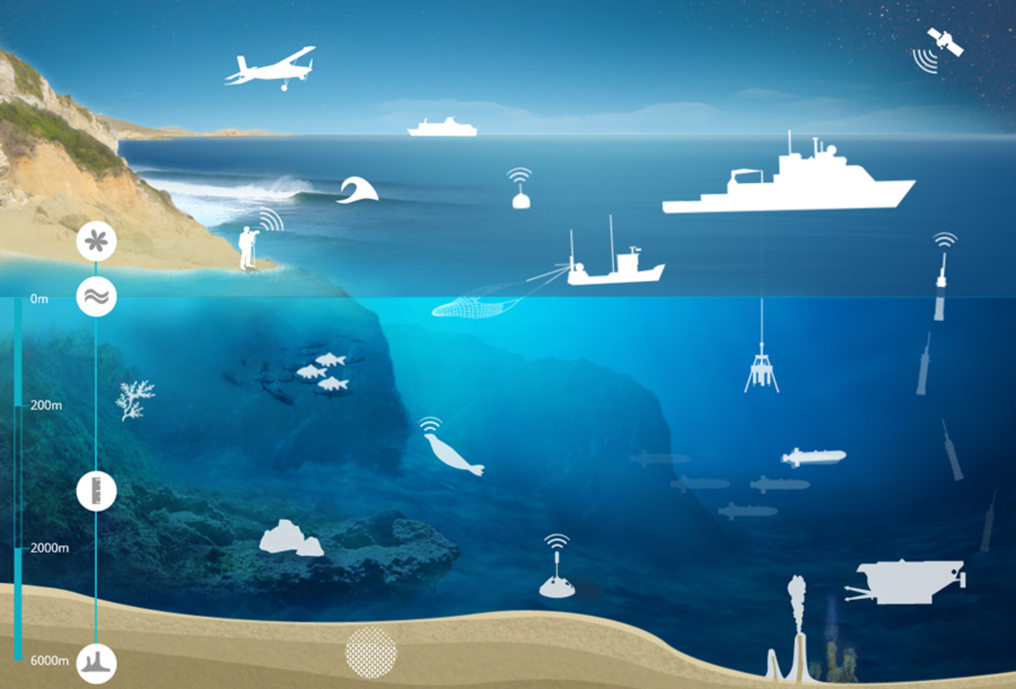
OGC - IHO Marine SDI Concept Development Study

Ocean Data Information and Services
- France

Open Geospatial Consortium
Submission Date: 2019-05-06
Approval Date: 2019-06-27
Publication Date: YYYY-MM-DD
External identifier of this OGC® document: http://www.opengis.net/doc/per/XXX
Internal reference number of this OGC® document: 19-025r1
Category: OGC® Engineering Report
Editors: Robert Thomas, Terry Idol

Development of Spatial Data Infrastructures for Marine Data Management

Copyright notice
Copyright © 2019 Open Geospatial Consortium
To obtain additional rights of use, visit http://www.opengeospatial.org/legal/.

Warning
This document is not an OGC or an IHO Standard. This document is an OGC-IHO Public Engineering Report created as a deliverable in an OGC-IHO Interoperability Initiative and is not an official position of the OGC or IHO membership. It is distributed for review and comment. It is subject to change without notice and may not be referred to as an OGC or an IHO Standard. Further, any OGC or IHO Engineering Report should not be referenced as required or mandatory technology in procurements. However, the discussions in this document could very well lead to the definition of an OGC or an IHO Standard, or a joint Standard.
Document type: OGC® Engineering Report
Document subtype:
Document stage: Approved for Public Release
Document language: English

License Agreement
Permission is hereby granted by the Open Geospatial Consortium and by the International Hydrographic Organization, ("Licensor"), free of charge and subject to the terms set forth below, to any person obtaining a copy of this Intellectual Property and any associated documentation, to deal in the Intellectual Property without restriction (except as set forth below), including without limitation the rights to implement, use, copy, modify, merge, publish, distribute, and/or sublicense copies of the Intellectual Property, and to permit persons to whom the Intellectual Property is furnished to do so, provided that all copyright notices on the intellectual property are retained intact and that each person to whom the Intellectual Property is furnished agrees to the terms of this Agreement.
If you modify the Intellectual Property, all copies of the modified Intellectual Property must include, in addition to the above copyright notice, a notice that the Intellectual Property includes modifications that have not been approved or adopted by LICENSOR.
THIS LICENSE IS A COPYRIGHT LICENSE ONLY, AND DOES NOT CONVEY ANY RIGHTS UNDER ANY PATENTS THAT MAY BE IN FORCE ANYWHERE IN THE WORLD.
THE INTELLECTUAL PROPERTY IS PROVIDED "AS IS", WITHOUT WARRANTY OF ANY KIND, EXPRESS OR IMPLIED, INCLUDING BUT NOT LIMITED TO THE WARRANTIES OF MERCHANTABILITY, FITNESS FOR A PARTICULAR PURPOSE, AND NONINFRINGEMENT OF THIRD PARTY RIGHTS. THE COPYRIGHT HOLDER OR HOLDERS INCLUDED IN THIS NOTICE DO NOT WARRANT THAT THE FUNCTIONS CONTAINED IN THE INTELLECTUAL PROPERTY WILL MEET YOUR REQUIREMENTS OR THAT THE OPERATION OF THE INTELLECTUAL PROPERTY WILL BE UNINTERRUPTED OR ERROR FREE. ANY USE OF THE INTELLECTUAL PROPERTY SHALL BE MADE ENTIRELY AT THE USER’S OWN RISK. IN NO EVENT SHALL THE COPYRIGHT HOLDER OR ANY CONTRIBUTOR OF INTELLECTUAL PROPERTY RIGHTS TO THE INTELLECTUAL PROPERTY BE LIABLE FOR ANY CLAIM, OR ANY DIRECT, SPECIAL, INDIRECT OR CONSEQUENTIAL DAMAGES, OR ANY DAMAGES WHATSOEVER RESULTING FROM ANY ALLEGED INFRINGEMENT OR ANY LOSS OF USE, DATA OR PROFITS, WHETHER IN AN ACTION OF CONTRACT, NEGLIGENCE OR UNDER ANY OTHER LEGAL THEORY, ARISING OUT OF OR IN CONNECTION WITH THE IMPLEMENTATION, USE, COMMERCIALIZATION OR PERFORMANCE OF THIS INTELLECTUAL PROPERTY.
This license is effective until terminated. You may terminate it at any time by destroying the Intellectual Property together with all copies in any form. The license will also terminate if you fail to comply with any term or condition of this Agreement. Except as provided in the following sentence, no such termination of this license shall require the termination of any third party end-user sublicense to the Intellectual Property which is in force as of the date of notice of such termination. In addition, should the Intellectual Property, or the operation of the Intellectual Property, infringe, or in LICENSOR’s sole opinion be likely to infringe, any patent, copyright, trademark or other right of a third party, you agree that LICENSOR, in its sole discretion, may terminate this license without any compensation or liability to you, your licensees or any other party. You agree upon termination of any kind to destroy or cause to be destroyed the Intellectual Property together with all copies in any form, whether held by you or by any third party.
Except as contained in this notice, the name of LICENSOR or of any other holder of a copyright in all or part of the Intellectual Property shall not be used in advertising or otherwise to promote the sale, use or other dealings in this Intellectual Property without prior written authorization of LICENSOR or such copyright holder. LICENSOR is and shall at all times be the sole entity that may authorize you or any third party to use certification marks, trademarks or other special designations to indicate compliance with any LICENSOR standards or specifications. This Agreement is governed by the laws of the Commonwealth of Massachusetts. The application to this Agreement of the United Nations Convention on Contracts for the International Sale of Goods is hereby expressly excluded. In the event any provision of this Agreement shall be deemed unenforceable, void or invalid, such provision shall be modified so as to make it valid and enforceable, and as so modified the entire Agreement shall remain in full force and effect. No decision, action or inaction by LICENSOR shall be construed to be a waiver of any rights or remedies available to it.

Acknowledgements
The OGC expresses its gratitude to its sponsor National Geospatial-Intelligence Agency (NGA), Maritime Safety Office (MSO) for supporting this work on behalf of the International Hydrographic Organization (IHO) and the IHO MSDI Working Group (MSDIWG). In addition, OGC wishes to thank the U.S. Committee on the Marine Transportation System (CMTS), Office of the Executive Secretariat, at the U.S. Department of Transportation (DOT), for hosting the MSDI Workshop and the National Oceanic and Atmospheric Administration (NOAA), Office of Coast Survey (OCS), for hosting the MSDI Roundtable. OGC further wishes to express its gratitude to the following companies and organizations, who provided excellent contributions that have been used in excerpts in this report.

Organization / Company

National Geospatial-Intelligence Agency (sponsor)
Arctic Spatial Data Infrastructure (Arctic SDI)
Brazilian Navy Hydrographic Center (CHM)
British Oceanographic Data Centre (BODC)
Canadian Hydrographic Service (CHS)
Cooperative Institute for Research in Environmental Sciences (CIRES)
Danish Geodata Agency (DGA), Danish Hydrographic Office
Directorate of Hydrography and Navigation (DHN), Brazilian Hydrographic Office
Esri
Geographic Information System Service (GISS)
Geoscience Australia - Marine Geoscience Group
The HDF Group
Helyx Secure Information Systems Ltd
Hexagon Geospatial
IIC Technologies
International Hydrographic Organization (IHO)
IHO Marine Spatial Data Infrastructures Working Group (MSDIWG)
Italian Hydrographic Institute (IIM)
Land Information New Zealand (LINZ)
Marine Environmental Data and Information Network (MEDIN)
National Geospatial-Intelligence Agency (NGA), Maritime Safety Office (MSO)
National Oceanic & Atmospheric Administration (NOAA), Office of Coast Survey (OCS)
National Technical University of Athens (NTUA)
Natural Resources Canada: GeoConnections and Fisheries and Oceans Canada (DFO)
Naval Research Laboratory (NRL)
Netherlands Hydrographic Service
Norwegian Mapping Authority (NMA)
OceanWise Limited
OGC Marine Domain Working Group (OGC Marine DWG)
Portuguese Hydrographic Institute
Sounding Science LLC & Geopoint Solutions
Teledyne CARIS
UK Hydrographic Office (UKHO)
U.S. Army Engineer Research and Development Center (ERDC)
U.S. Coast Guard Navigation Center (NAVCEN)
U.S. Committee on the Marine Transportation System (CMTS)
U.S. Department of Transportation (DOT)
U.S. Energy Information Administration (EIA)
University Of Colorado Boulder
University of Southern Mississippi (USM)
White House Office of Science and Technology Policy (OSTP)

Table 1: Organizations and companies contributing to this report
OPEN GEOSPATIAL CONSORTIUM (OGC)

Abstract
Report: Development of Spatial Data Infrastructures for Marine Data Management
OGC - IHO Marine SDI Concept Development Study (CDS)
This engineering report presents the results of a concept development study on a Marine Spatial Data Infrastructure (SDI), sponsored by the National Geospatial-Intelligence Agency (NGA) - Maritime Safety Office (MSO), on behalf of the International Hydrographic Organization (IHO) and the IHO MSDI Working Group (MSDIWG), and executed by the Open Geospatial Consortium (OGC). The goal of this study was to demonstrate to stakeholders the diversity, richness and value of a Marine SDI – specifically data, analysis, interoperability and associated IT services - including web services - in addressing needs of the marine domain.
The study included an open Request for Information (RFI) with the objective to gather additional information to better support governments, agencies, non-governmental organizations and citizens, unlocking the full societal and economic potential of the wealth of marine data at local, national, regional or international levels. The RFI results also provide information and insight on the current state of the Marine SDI. In addition to the RFI, a MSDI workshop and roundtable were held to gather additional information from both expert panel members and the audience.
This engineering report presents an analysis of RFI, workshop and roundtable responses and interactions which provided in depth information on requirements and issues related to stakeholders, architecture, data, standards of current and a possible future Marine SDI. In addition, this report will serve as the basis for improvement of SDIs’ to support the marine domain. The responses will also be discussed with potential sponsoring organizations that would provide funding opportunities for possible Marine SDI Pilot(s) initiatives proposed for later this year, and in subsequent years. All RFI, workshop and roundtable responses will contribute to Marine SDI(s) moving forward. It will help to achieve greater interoperability, availability and usability of geospatial Web services and tools across different types of marine spatial data uses. In addition, these responses will provide identification of gaps, and definition of core components of an SDI to be referenced by IHO MSDIWG and used to define reference use-cases and scenarios for use in future pilot activities.

Table of Contents
Acknowledgements 5
Abstract 8
Table of Contents 10
List of Figures 14
List of Tables 14
List of Abbreviations 15
Chapter 1 Introduction 17
1.1 Goals, Sponsor, and Participants of this Initiative 19
1.2 Marine SDI CDS Activity 21
1.3 Profile and Role of RFI Responses 22
1.3.1 Profile of RFI Respondents 23
1.3.2 Role of RFI Respondents 24
Chapter 2: MSDI Definition and Stakeholders 26
2.1 What is a Marine Spatial Data Infrastructure? 26
2.2 Marine SDI Stakeholders 28
2.3 Needs of Stakeholders 32
2.3.1 Integration and Presentation 36
2.4 Coordination and Communications 37
2.4.1 Outreach and Awareness 37
Chapter 3: Currently Used and Emerging Standards 40
3.1 Existing Standards and Organizations 41
3.1.1 International Hydrographic Organization (IHO) 42
3.1.2 International Organization for Standardization (ISO) 43
3.1.3 The Open Geospatial Consortium (OGC) 43
3.1.3.1 OGC Standards in Marine Use 44
3.1.4 World Wide Web Consortium (W3C) 45
3.2 Emerging Community Standards 46
3.2.1 3D Standards 47
3.2.2 Linking to IoT Technologies 48
3.2.3 Push based communication flows 48
3.2.4 Web processing services 49
Chapter 4: Marine Data Themes in a MSDI 50
4.1 Marine Data Ontology 50
4.2 Examples of Marine Data Themes 51
Chapter 5: Data and Governance 53
5.1 Data and Tool Usage of RFI Respondents 53
5.2 Data Requirements 54
5.3 Metadata and Catalogs 58
5.4 Data Identified 59
5.5 Governance 59
5.5.1 High Level Governance Goals 60
5.5.2 Recommendations for Collaboration 63
Chapter 6: MSDI Interoperability Reference Architecture 65
6.1 Architecture of RFI Respondents 65
6.2 Requirements 66
6.2.1 Open Data & Data Sharing 67
6.2.2 Standards and Interoperability 68
6.2.3 Funding and Investments 68
6.2.4 Integration with Existing Systems 69
6.2.5 Architecture and Platforms 70
6.2.6 Security, Privacy and Safety 71
6.3 SDI Technology Approaches 72
6.3.1 Closely Architected Approach 72
6.3.2 Federated Approach 74
6.4 MSDI Reference Architecture 76
Chapter 7: Portals, Applications and Scenarios 80
7.1 Portals and Software Applications 80
7.1.1 Marine Portals 81
7.2 Potential MSDI Scenarios 81
7.2.1 Offshore Wind Power Site Selection in the Caribbean 81
7.2.2 Land / Sea boundary 82
7.2.2 Other Scenario Aspects 84
Chapter 8: Other Factors and Conclusion 86
8.1 Other Factors 86
8.2 Conclusion 87
Appendix A: Data Identified 90
Arctic Spatial Data Infrastructure (Arctic SDI) 91
Brazilian Navy Hydrographic Center (CHM), within the Directorate of Hydrography and Navigation 92
British Oceanographic Data Centre (BODC) 92
Canadian Hydrographic Service (CHS) 92
Cooperative Institute for Research in Environmental Sciences (CIRES) - University of Colorado Boulder 93
Danish Geodata Agency, Danish Hydrographic Office 93
Geoscience Australia - Marine Geoscience Group 94
Land Information New Zealand (LINZ) 94
Marine Environmental Data and Information Network (MEDIN) 94
NGA / NOAA 95
Portuguese Hydrographic Institute
Geographic Information System Service (GISS) 96
U.S. Committee on the Marine Transportation System (CMTS) 96
Appendix B: Marine Data Portals 99
Appendix C: Workshop and Roundtable Summaries 104
C.1 MSDI-CDS Workshop 104
Agenda 104
Key Points 106
C.2 MSDI Roundtable 110
Participants 110
Agenda 110
Summary 111
Bibliography 112

List of Figures
1.1 | Aspects of an SDI. . . . . . . . . . . . . . . . . . . . . . . . . . . . . . . . . . . . . . . . . . | 17
1.2 | Profile of RFI Respondents. . . . . . . . . . . . . . . . . . . . . . . . . . . . . . . . . . . | 21
1.3 | Organization Type of RFI Respondents. . . . . . . . . . . . . . . . . . . . . . . . . . | 22
1.4 | Role of RFI Respondents. . . . . . . . . . . . . . . . . . . . . . . . . . . . . . . . . . . . . | 23
2.1 | Four Pillars of an MSDI . . . . . . . . . . . . . . . . . . . . . . . . . . . . . . . . . . . . . | 25
2.2 | Classes of Stakeholders. . . . . . . . . . . . . . . . . . . . . . . . . . . . . . . . . . . . | 27
3.1 | Point Cloud Shipwreck . . . . . . . . . . . . . . . . . . . . . . . . . . . . . . . . . . . . | 46
5.1 | Data and Tool Usage of RFI Respondents. . . . . . . . . . . . . . . . . . . . . . . . | 53
5.2 | High Level Governance Goals . . . . . . . . . . . . . . . . . . . . . . . . . . . . . . . . | 60
5.3 | National Spatial Data Infrastructure Model . . . . . . . . . . . . . . . . . . . . . . . | 62
6.1 | Architectural aspects that need consideration . . . . . . . . . . . . . . . . . . . . | 64
6.2 | Architecture and Standards of RFI Respondents . . . . . . . . . . . . . . . . . . | 65
6.3 | High level requirement categories . . . . . . . . . . . . . . . . . . . . . . . . . . . . . . | 66
6.4 | Closely Architected Approach . . . . . . . . . . . . . . . . . . . . . . . . . . . . . . . . | 72
6.5 | Federated Approach . . . . . . . . . . . . . . . . . . . . . . . . . . . . . . . . . . . . . . . . | 74
6.6 | Aspects of openness . . . . . . . . . . . . . . . . . . . . . . . . . . . . . . . . . . . . . . . . . | 76

List of Tables
1 Organizations and companies contributing to this report . . . . . 4
2.1 Abbreviated List of the Marine SDI Stakeholders . . . . . …. . . . . . . . . 28
2.2 Application Requirements Across Stakeholders and Marine Themes . . 31
5.1 Examples of scientific activities that drive information requirements . . 54
5.2 Examples of operational activities that drive information requirements . 55
A.1 Data Identified within Different Marine Themes . . . . . …. . . . . . . . . . . . 91

List of Abbreviations
API | Application Programming Interface
ASPRS | American Society for Photogrammetry & Remote Sensing
BIM | Building Information Modeling
BODC | British Oceanographic Data Centre
CAAS | Communication as a Service
CAD | Computer-aided design
CDS | Concept Development Study
CGDI | Canadian Geospatial Data Infrastructure
CGNDB | Canadian Geographical Names Database
CGSB | Canadian General Standards Board
CHM  CHS | Brazilian Navy Hydrographic Center  Canadian Hydrographic Service
CIRES | Cooperative Institute for Research in Environmental Sciences
CMTS  CSV | U.S. Committee on the Marine Transportation System  Comma Separated Values
CSW | Catalog Service Web
DaaS | Data as a Service
DAP | Data Access Protocol
DAB | Data Access Broker
DCAT  DGA  DHN | Data Catalog Vocabulary  Danish Geodata Agency  Directorate of Hydrography and Navigation
DOT | Department of Transportation
EO | Earth Observation
EOWCS | Earth Observation Profile Web Coverage Service
FGDC | Federal Geographic Data Committee
GEO  GEOINT | Group on Earth Observation  Geospatial Intelligence
GEOSS | Global Earth Observation System of Systems
GeoXACML | Geospatial XACML
GIS | Geographic Information System
GISS | Geographic Information System Service
GML | Geography Markup Language
HDF | Hierarchical Data Format
HTTP | Hypertext Transfer Protocol
IHO | International Hydrographic Organization
IIM | Italian Hydrographic Institute
InaaS | Information as a Service
IoT | Internet of Things
ISO | International Organization for Standardization
ICT | Information and Communication Technology
IT | Information Technology
JSON | JavaScript Object Notation
JSON-LD | JSON Linked Data
KML | Keyhole Markup Language
LINZ | Land Information New Zealand
MEDIN | Marine Environmental Data and Information Network
MSDI  MSDIWG  NSDI | Marine Spatial Data Infrastructure  IHO Marine Spatial Data Infrastructures Working Group  National Spatial Data Infrastructure
MOU  MPA | Memorandum of Understanding  Marine Protected Area
NASA | National Aeronautics and Space Administration
netCDF | network Common Data Form
NGA | National Geospatial-Intelligence Agency
NGDA | FGDC National Geospatial Data Assets
NMA | Norwegian Mapping Authority
NOAA | U.S. National Oceanic and Atmospheric Administration
NRCan | Natural Resources Canada
NSDI | National Spatial Data Infrastructure
OGC | Open Geospatial Consortium
OoT | Oceans of Tomorrow
OPeNDAP | Open-source Project for a Network Data Access Protocol
OSM | OpenStreetMap
PaaS | Platform as a Service
POI | Points-of-interest
RDF | Resource Description Framework
RFI | Request For Information
RFQ  RHC | Request For Quotation  Regional Hydrographic Commission
SaaS | Software as a Service
SDI  SDK  SDO  SoN | Spatial Data Infrastructure  Software Development Kit  Standards Developing Organization  Safety of Navigation
SOS | Sensor Observation Service
SPARQL | SPARQL Protocol and RDF Query Language
SWE | Sensor Web Enablement
SWG | Standards Working Group
UN-GGIM | United Nations Committee of Experts on Global Geospatial Information Management
U.S. | United States
USGS | U.S. Geological Survey
W3C | World Wide Web Consortium
WCPS | Web Coverage Processing Service
WCS | Web Catalog Service
WFS | Web Feature Service
WMS | Web Mapping Service
WMTS | Web Mapping Tile Service
WPS | Web Processing Service
WS | Web Service
WSDL | Web Services Description Language
WxS | Web <whatever> Service
XACML | eXtensible Access Control Markup Language

Chapter 1 Introduction
Ocean and marine data are recognized as valuable resources that tend to have a high cost of acquisition. Large quantities of this data are collected and stored all over the world for a wide variety of purposes and by diverse groups of public and private entities. Due to its importance and value, this data should be well managed and made as widely available to end users as possible for a variety of uses including planning, policy and decision making; marine management; Marine Spatial Planning (MSP); scientific research, and economic activities.
The collection, protection and sharing of marine data provides significant societal benefits. Data and information on the state and variability of the marine environment is crucial for understanding changes that may result from human activity, including the effects of human-induced climate change and ocean acidification. In addition, there is an urgent need to develop and provide improved emergency planning and response in the world’s sea space. This has been highlighted by several high profile events in recent years including:
- BP oil spill in Gulf of Mexico;
- 2011 Tōhoku earthquake and tsunami in Japan;
- 2014 sinking of MV Sewol in Korea; and
- the loss of Malaysia Airlines flight MH370.
Reaction to each of these, and numerous other events, requires a multi-disciplinary approach including emergency response, environmental protection and longer term regional planning.
Currently government agencies, research institutions, and the private sector provide a considerable investment in marine monitoring and observation, data sharing and assembly, as well as downstream services. As a result, significant progress has been made to collect, aggregate and make publicly available the data and information derived from monitoring and observing our marine environment.
However, data-sharing initiatives still face common challenges in their efforts to unlock the full societal and economic potential of the wealth of marine data and observations at local, national, regional and international levels. The landscape remains highly fragmented and complex and the need for a better integrated, end-to-end and sustained Marine SDI remains high.
The ability to effectively share, use, and re-use geospatial information and applications across, and between, the diverse groups of marine stakeholders is dependent upon having an effective Marine SDI already in-place.
Figure 1.1 below, from Natural Resources Canada, presents an example that shows the key aspects of an SDI. It illustrates common aspects of SDIs that are also applicable to the marine domain.
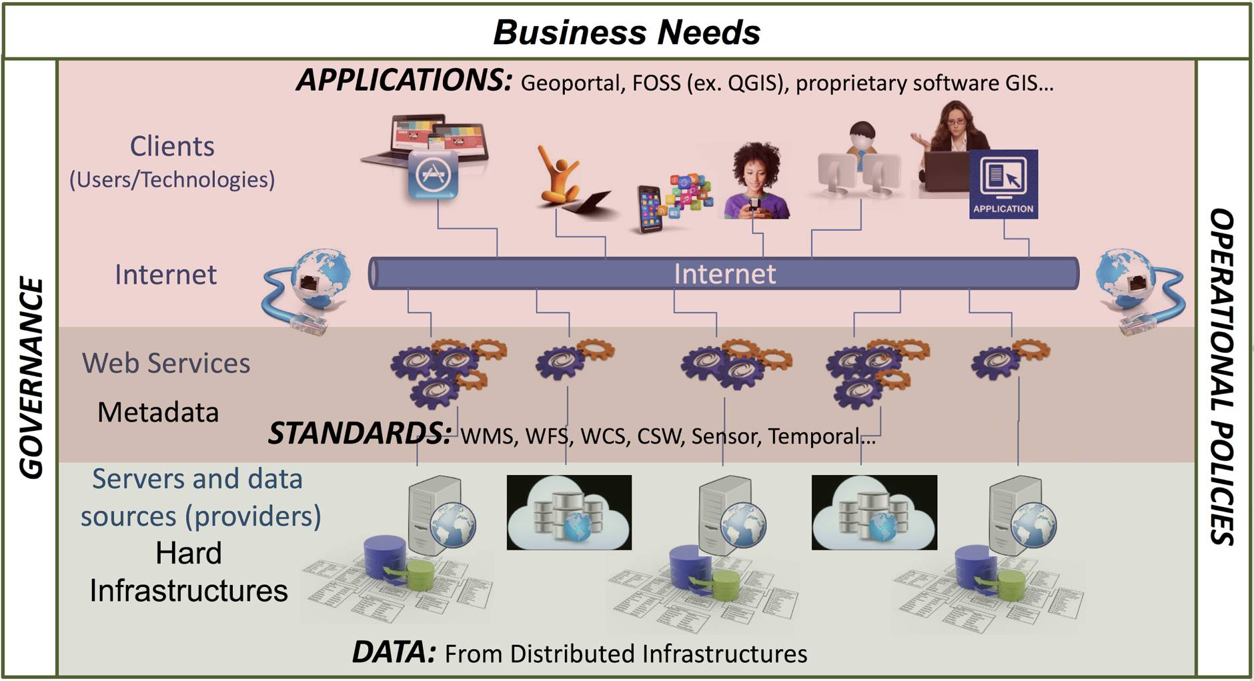
Figure 1.1: Aspects of an SDI (Source: Natural Resources Canada)
This report discusses the various classes and types of stakeholders of a Marine SDI examining their specific needs (chapter 2) and then looks into currently used and emerging standards within the marine domain (chapter 3). The report then explores marine data themes and ontologies within a SDI (chapter 4) and discusses possible SDI architecture models, data, standards and interoperability including aspects to optimize discovery, usage, and processing of data in a highly heterogeneous network of SDI data and service providers (chapter 5). This then leads to an interoperability reference architecture based on RFI responses (chapter 6). The report finally discusses technologies, portals and scenarios (chapter 7). The report concludes with a discussion of other factors received from the RFI responses, workshop and round-table that may be considered when building an effective Marine SDI (chapter 8). Finally, conclusions from the report are summarized.

1.1 Goals, Sponsor, and Participants of this Initiative
The ability to effectively share, use, and re-use geospatial information and applications across and between public and private sector organizations in support of the marine domain is dependent upon having an effective SDI already in-place. This CDS, and possible resulting pilots, are expected to assess the current state of data and product exchange practices and technologies as used in the marine domain. The information gained in the CDS will aid in developing a series of possible future pilots that may, in turn, advance the state of SDIs that support effective marine data usage across the globe. The CDS project brought together diverse stakeholders from the global marine community to assess the current state of SDI components. The study documented data interoperability technologies and standards, developed an inventory of available geospatial Web services across different marine sub-domains, defined the core components of a Marine SDI architecture, and presented conclusions that may be implemented in future Marine SDI pilot(s).
This engineering report provides an analysis of RFI, workshop and round-table responses from marine domain stakeholders and contributors. In addition to the analysis contained within the report, a detailed agenda and key points taken away from both the workshop and roundtable are provided in Appendix C. Future Pilot(s), if activated, will be organized and executed by OGC’s Innovation Program as a structured initiative with active involvement by several OGC members and potentially larger, partner organizations (e.g., IHO).
Organization managing the CDS
The Open Geospatial Consortium (OGC) is an international consortium of more than 500 companies, government agencies, research organizations, and universities participating in a consensus process to develop publicly available geospatial standards. OGC standards support interoperable solutions that "geo-enable" the Web, wireless and location-based services, and mainstream IT. OGC standards empower technology developers to make geospatial information and services accessible and useful with any application that needs to be geospatially enabled.
Partner Organizations
The International Hydrographic Organization (IHO) is an intergovernmental consultative and technical organization that was established in 1921 to support safety of navigation and the protection of the marine environment.
The object of the Organization is to bring about:
- The coordination of the activities of national hydrographic offices;
- The greatest possible uniformity in nautical charts and documents;
- The adoption of reliable and efficient methods of carrying out and exploiting hydrographic surveys; and
- The development of the sciences in the field of hydrography and the techniques employed in descriptive oceanography.
In 2016, both IHO and OGC entered in to a formal Memorandum of Understanding (MoU). Two of their subordinate working groups have been closely collaborating for a number of years: the IHO MSDI Working Group (MSDIWG) and the OGC Marine Domain Working Group (Marine DWG).
The IHO MSDIWG is established within the IHO’s Inter-Regional Coordination Committee (IRCC) and supports the activities of the IHO related to Spatial Data Infrastructures (SDI) and/or Marine Spatial Data Infrastructures (MSDI). During its annual meeting. In 2017, the MSDIWG discussed the possibility to create a structured OGC study that could establish the framework for future development of MSDI. In 2018, NGA, representing the United States alongside NOAA in the MSDIWG, began support of the Marine SDI CDS on behalf of the MSDIWG and its work program tasks.
The OGC Marine DWG is motivated by the widening use of marine data for purposes other than safe navigation, which can be captured loosely under the term MSDI. The Marine DWG also ensures that evolving IHO standards (e.g., S-100) are brought to the attention of the OGC members and evolving OGC standards are brought to the attention of IHO members in an effort to ensure best practices are being used and the latest technical approaches considered. The Marine DWG works closely with the IHO MSDIWG and its adjacent groups/commissions/committees under the IHO IRCC, the IHO Hydrographic Services and Standards Committee (HSSC), and other related organizations. The Marine DWG has been an active participant and champion of this Marine SDI CDS activity and has assisted the MSDIWG with furthering this activity through OGC.
This Marine SDI CDS activity furthers the collaboration and common interests of IHO and OGC, established in their MoU, and contributes to the development of a foundational report for the development of MSDIs worldwide.
Sponsor
The National Geospatial-Intelligence Agency (NGA) delivers world-class geospatial intelligence that provides a decisive advantage to policymakers, warfighters, intelligence professionals and first responders. NGA is a unique combination of intelligence agency and combat support agency. It is the world leader in timely, relevant, accurate and actionable GEOINT. NGA enables the U.S. intelligence community and the Department of Defense (DOD) to fulfill the president’s national security priorities to protect the nation. NGA also anticipates its partners’ future needs and advances the GEOINT discipline to meet them.

1.2 Marine SDI CDS Activity
The Marine SDI Concept Development Study was sponsored by NGA on behalf of the International Hydrographic Organization (IHO) and the IHO Marine SDI Working Group (MSDIWG), a primary organization involved in this study. Kicked-off on July 7, 2018, the goal was to demonstrate the diversity, richness and value of Marine Web services to marine stakeholders. The diversity of data available via OGC specifications was assessed within the context of domestic, regional/multi-national and international requirements.
The project is being executed in two phases. The first phase was organized as an OGC concept development study. The second phase, if initiated, will be an OGC pilot initiative with active involvement of a number of OGC member organizations. Funding and sponsorship is required for the pilot phase.

Both the OGC Concept Development Study and Pilot are conducted in accordance with the OGC Interoperability Program Policy and Procedures. Phase one develops an overall assessment of geospatial Web services across the marine domain, defines the core components of the National SDI architecture for marine environment (Marine SDI), and define use cases and scenarios for future implementations as part of Phase two. These activities are complemented by the request for information (RFI) and workshops in order to capture the various perspectives, requirements, and opinions by marine stakeholders and contributors.
The goal of future pilot activities is to articulate the value of interoperability and to demonstrate the usefulness of standards. This will be done by implementing the recommended Marine SDI architecture and developing demonstrations that will tell the story of the scenario(s) and showcase incorporation of the services into Marine SDI and other applications.
Several ways identified during the Concept Development Study that a future pilot(s) can support MSDI enhancements are:
- Gathering requirements on different portions of a common SDI architecture to support the marine domain.;
- Explaining an SDI architecture concept, technology and its application to support marine domain stakeholders;
- Making more data available;
- Analyzing consistent and long term retainability practices for marine domain material; and
- Complementing it with clients, tools, and applications that allow efficient use of Marine SDI data, processing resources and long-term storage capabilities.

1.3 Profile and Role of RFI Responses
The Marine SDI RFI consisted of a set of questions divided into 8 clusters. These 8 clusters were:
- Stakeholders
- Architecture and Data Governance Models
- Data
- Requirements
- Scenarios and Use Cases
- Operation & Organization
- Technologies & Applications
- Other Factors
Respondents were invited to answer any or all questions and take as much space as they felt required to provide a thorough response.

1.3.1 Profile of RFI Respondents
A total of 27 responses to the RFI were received representing contributions from 11 different countries. As Figure 1.2 shows, over two thirds of the responses (72%) were a coordinated response from single institutions/companies (spanning national institutes, agencies, private companies and other single entities); 20% from ‘umbrella’ organizations or projects (from people working in the marine and maritime sectors) and 8% were individual responses.
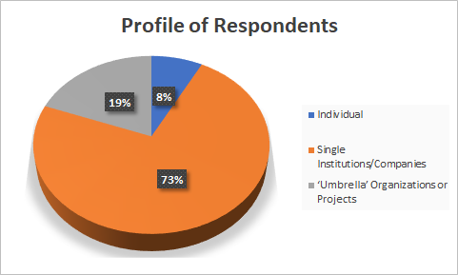
Figure 1.2: Profile of RFI Respondents (Source: OGC)

Figure 1.3 shows that most of the respondents replied that their organization was scientific or environmentally based (44%), including private and public research performers, such as universities, research institutes, and agencies. Contributions from hydrographic offices represented 30% while 26% were received from commercial organizations.
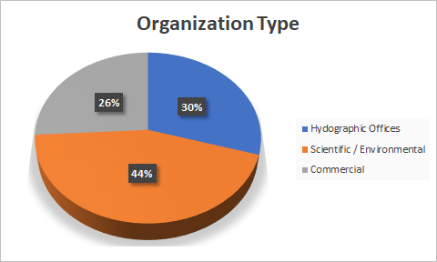
Figure 1.3: Organization Type of RFI Respondents (Source: OGC)
These results represent a fairly even distribution of responses across different organization types.

1.3.2 Role of RFI Respondents
There were three polar (yes/no) questions about the role of the respondent or their organization. The first question determines whether the respondent was a data provider and/or data owner (e.g. data, tools, applications, services). The next question determined if the respondent was primarily a marine data user (e.g., science, research, commercial) and finally the third question determined if the respondent was a data enabler (e.g., help provide access to the data, software company, data standards organization, app developer).
As shown in figure 1.4, over three quarters (78%), of those that responded to the question, indicated they were a marine data provider or owner while less then one quarter (22%), of those that responded to the question, indicated that they were marine data users. However, almost all respondents (96%) indicated that they considered themselves data enablers.
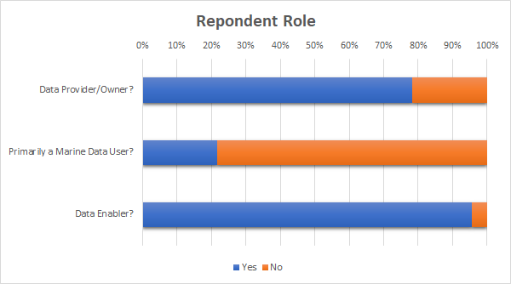
Figure 1.4: Role of RFI Respondents (Source: OGC)
These results indicate that respondents either considered themselves to be marine data providers or marine data users but not both. There are very few overlapping stakeholders with regards to producers and users of data within the marine domain.

Chapter 2: MSDI Definition and Stakeholders
This chapter looks at the definition of a Marine SDI and examines the four traditional SDI pillars as they relate to the marine domain. Once this definition has been established, the chapter will examine and analyze the various levels of stakeholders and how they interact. This will aid in determining their needs and requirements as they relate to a Marine SDI.

2.1 What is a Marine Spatial Data Infrastructure?
A definition by the International Hydrographic Organization provides a succinct interpretation:
“A Marine SDI is the component of an SDI that encompasses marine and coastal geographic and business information in its widest sense and would typically include information on seabed bathymetry (elevation), geology, infrastructure (e.g. wrecks, offshore installations, pipelines, cables); administrative and legal boundaries, areas of conservation and marine habitats and oceanography.''
A Marine Spatial Data Infrastructure (MSDI) is that element of an SDI that focuses on the marine input in terms of governance, standards, ICT and content. The concept of MSDI is now gaining wider appreciation in terms of the way a variety of data types might be combined for efficient analysis by a wide range of disciplines, such as spatial planning, environmental management and emergency response. This requires the data to be held in a generic way, rather than for a particular product for a limited user group or for a specific purpose. An MSDI is not a collection of hydrographic products, but an infrastructure that promote interoperability of data at all levels.

The four basic components, or pillars, of a Marine SDI are shown in the following diagram:
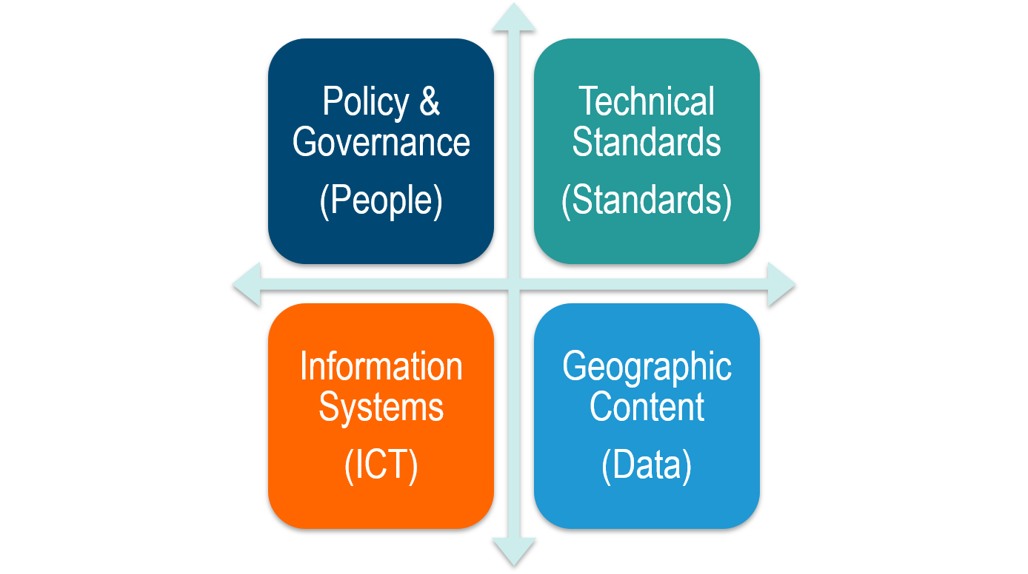
Figure 2.1. Four Pillars of an MSDI (Source: IHO Publication C-17, Spatial Data Infrastructures: “The Marine Dimension”)
These pillars are defined as follows.
- Data and Metadata - comprise the marine data and information to be made accessible.
- Information System/Technology - encompasses the hardware, software and system component.
- Standards - which emphasizes the “unlocking” of geospatial data. This is usually accomplished through enablers.
- Policy and Governance - which dictates the structural relationships of all those involved.
As was described in the MSDI Workshop, the MSDI includes all aspects related to spatial information including the structure of the data and all of the interfaces to the systems that disseminate or present the information. At a more granular level, these fundamental components can include:
- Data structure/schema (Application Schema);
- Data description/semantics (Feature Catalogue);
- Metadata;
- Data and metadata capture operations;
- Data (the data elements);
- Data management;
- Discovery;
- Access; and
- Transformation.
Based on RFI responses and MSDI Workshop discussions, there appears to be several challenges in engaging a Marine SDI, as follows.
- Lack of an integrated policy and operational framework to facilitate rapid acceptance, qualification, ingest and use of relevant geospatial information from a range of government, commercial providers and citizens.
- The current focus on products supporting a single customer group such as those of Hydrographic Offices. Without diminishing their relevance and importance, their traditional business model may not be compatible with MSDI principles of data sharing and collaboration, due to the critical nature of chart production and Safety of Navigation (SoN).
- Inability, with existing metadata approaches, to quickly discover and understand which information sources are most useful in the context of a user’s need.
- Inability to properly fuse and synthesize multiple data sources.
- The need for a persistent platform to organize and manage marine information and tools necessary for collaborating organizations to fully utilize the variety of marine data.
A goal of this CDS was to determine the current state of these challenges.

2.2 Marine SDI Stakeholders
The number and types of stakeholders is evolving with the changing marine domain environment. As an example, increased vessel traffic above the Arctic Circle, increased surveying and research work, increased resource exploration and extraction work, or increased tourism among other things are significant contributors to these changes. With increasing human activity, chances of disasters and emergencies also increase, making emergency response organizations a key user group of a Marine SDI.
The responses from the RFI, workshop and roundtable have differentiated the range of stakeholders into five classes. The stakeholders summarized under each class often have some influence on each other, illustrated by the circular arrows.
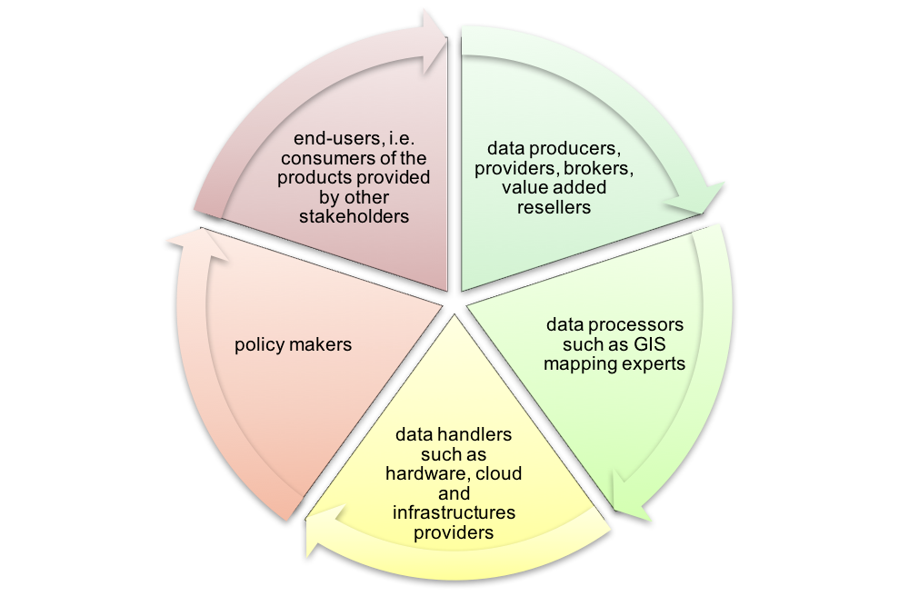
Figure 2.2: Classes of Stakeholders
Using Figure 2.2 and beginning in the upper left, the wide class of end-users includes all consumers of products provided by the other classes, e.g., data and services, products in the form of reports and statistics, policies and regulations etc. Following the arrows clockwise, the next class aggregates all data producers or creators, data providers, data brokers, and value-added resellers. This large group is of particular relevance, as it is responsible for one of the main products of the Marine SDI, the data. The third class covers data processors such as GIS professionals, data scientists, data modelers, mapping experts, or others in the high end supercomputing environment who are addressing the complexity of near or real-time analytics / forecasting geospatial products. These experts create products such as analyses, reports, statistics, or maps using data provided by the previous group. The fourth class, data handlers, somewhat intersects the previous three, and includes the hardware, storage and computing service providers that provide the necessary infrastructure for data exchange and processing. The last class, Policy makers, tends to intersect the classes described before. It lays out the necessary rules and guidelines for a successful operation and governance of Marine SDIs.
Identified stakeholders from RFI responses classified in one or many of these five levels come from a wide range of organizations. An already long, though still non-exclusive, list is provided in table 2.1.
Stakeholders
Data Producers, Providers, Brokers, Value-added Resellers
Federal, state, provincial, local, or territorial governments
Marine and Oceanographic boards and groups
GIS and Information Technology: 311 System, Internet and Social Media
Federal, state, provincial, local, or territorial government agencies
Military Organizations
Authorities: Port Authority, others
Utility companies/organizations: Oil & Gas, Power
Academic and educational institutions
Commercial data / analytic providers
Insurance companies
The General Public (Crowd Sourced)
Data Processors
Commercial data / analytic providers
Federal, state, provincial, local, or territorial government agencies
Software developers
Mapping and GIS experts
Marine and Oceanographic boards and groups
Military Organizations
Transportation
Insurance companies
Academic and educational institutions
Data Handlers, Infrastructure Providers
Federal, state, provincial, local, or territorial government agencies
Local Government Agencies
Internet and Social Media Providers
Military Organizations
Authorities: Port Authority, Marine Transportation Authority, others
Marine and Oceanographic boards and groups
Academic and educational institutions
Policy Makers
Federal, state, provincial, local, or territorial government agencies
Environmental Protection Agencies
Public Authorities
Local Government Agencies
Military Organizations
Authorities: Port Authority, Marine Transportation Authority, others
Public Works
Standards Developing Organizations
Diplomatic and national security officials
Marine and Oceanographic boards and groups
Insurance companies
International and Regional Intergovernmental Organizations
End Users
Federal, state, provincial, local, or territorial government agencies
Shipping and cruise ship companies
Search and rescue officials
Transportation
Military Organizations
Authorities: Port Authority, Marine Transportation Authority, others
Fishing companies
Port managers and harbormasters
Public Works
Utility companies/organizations: Oil & Gas, Power
Mining companies
Researchers from various fields such as climate, conservation
Archaeology, marine, hydrology, ecology, and geological science
Academic and educational institutions
Insurance companies
NGO Service Providers
Academic and educational institutions
Diplomatic and national security officials
International and Regional Intergovernmental Organizations
The General Public
Table 2.1: Abbreviated List of the Marine SDI Stakeholders
Many of the organizations included in this list have been emphasized as particularly relevant by respondents to the Marine SDI CDS RFI. The editors of the Engineering Report continue to welcome the involvement and contributions of anyone involved in marine data management willing to support the goals and objectives of a future pilot.

2.3 Needs of Stakeholders
Though the stakeholders vary considerably, there are substantial overlap in terms of needs among most stakeholders. Generally speaking, needs for the data consumers or end users, include the aspects of easy discovery, access, download and analysis of marine spatial data. For the data producer, provider and processor, needs include the ability to publish, integrate, aggregate and analyze geospatial data and related non-geospatial data. Focus should be on ease-of-use and effectiveness. Integrated systems, possibly in a system-of-systems or network-of-networks approach, with the ability to harvest data from existing solutions in a secure, reliable manner, should be supported.
In addition, there is a need for further requirements on real-time or archived availability, data and system Intellectual Property Rights (IPR), reuse and indemnification rules and regulations, security and privacy settings, as well as financial costs.
On the system side, it is essential that systems are operational and reliable with clear life cycle costs to providers and users. Stakeholders require robust, but intuitive, easy-to-use tools, to access, visualize and contribute data in a manner that allows for ingestion into organizations supporting policy development and decision making. The underlying systems have to cater to various types of consumer capacities. While some of the stakeholders may have very limited internal geospatial capacity or solutions, others are far more advanced.
In terms of data sets, a detailed analysis of both provided and required data sets are discussed in chapter 5.
From an analysis of the RFI responses, and information discussed and presented at the workshop and roundtable, the stakeholder needs relevant to a Marine SDI can be distilled and summarized as follows.
- The Marine SDI should foster data integrity and provide stakeholders with security-based, appropriate access to the spatial data they need. These data can be static as well as dynamic.
- The Marine SDI should allow access of data on a variety of devices and platforms including mobile, e.g., smartphones and tablets.
- The Marine SDI should allow different stakeholders, at different locations, to access the SDI.
- The Marine SDI should allow for data exchange, especially the dynamic data, in an interoperable, appropriate, efficient and secure way.
These four overarching needs are a simplification of the wide variety of needs facing stakeholders. However, keeping these four requirements top-of-mind during implementation will lead to a more effective, sustainable, useful and dynamic Marine SDI for all stakeholders.
Table 2.2 illustrates the interlocking of marine theme, stakeholder and data/applications. Even though the table represents a small subset of the themes, stakeholders, and applications, the table still provides a valuable insight into the richness of applications in the marine domain. The table does not provide an exhaustive list of data and all its possible applications.
Marine Theme | Stakeholder | Required Data/Application
Hydrography  Hydrography  (continued) | Federal, state, provincial, local, or territorial government agencies | - Nautical charting for navigation safety  - National defense  - Emergency response  - Infrastructure planning/development  - Fisheries management  - Legal boundary determinations  - Flood planning  - Baseline habitat mapping  - Environmental baseline monitoring  - Sovereignty
 | Oil and gas companies | - Safe navigation  - Engineering activities during exploration, development, and production  - Environmental responsibilities related to sustainable development and protection of biodiversity
 | Mining companies | - Safe navigation  - Engineering activities during exploration, development, and production  - Environmental responsibilities related to  sustainable development and protection of biodiversity
 | Utility companies | - Engineering activities during exploration, development, and production  - Environmental responsibilities related to  sustainable development and protection of biodiversity
 | Shipping and cruise ship companies | - Safe navigation  - Trip planning  - Route planning
 | Commercial fishing companies | - Safe navigation  - Fishing sources geolocation
 | Geospatial community | - Survey methodologies, technology manufacturing, software development
 | General public | - Safe navigation, subsistence activities, recreational boating and recreational fishing
 | Insurance companies | - Safe navigation  - Route planning  - Environmental baseline monitoring
Coastal Mapping | Federal, state, provincial, local, or territorial government agencies | - Maritime safety  - Emergency response (natural disasters,  etc.)  - Offshore development regulation  - Scientific research  - Coastal monitoring (change analysis)  - Coastal flooding modeling, analysis,  mitigation  - Earthquake/tsunami assessment,  mitigation  - Regional sediment management  - Infrastructure development/maintenance  - Fisheries management  - Environmental baseline monitoring
 | Engineers | - Infrastructure development/maintenance  - Flood planning  - Environmental baseline monitoring  - Coastal monitoring (change analysis)
 | Insurance companies, real estate companies, lenders | - Flood risk information  - Tsunami inundation  - Erosion studies
 | General public | - Flood risk information  - Erosion studies
 | Geospatial community | - Survey methodologies, technology manufacturing, software development
Ice thickness  mapping  (sea ice) | Federal, state, provincial, local, or territorial government agencies | - Navigation safety during in-ice operations  - Ice load information for infrastructure  design/engineering  - Establishment of shipping lanes
 | Oil and gas companies | - Navigation safety during in-ice operations  - Environmental protection during in-ice operations  - Ice load information for infrastructure design/engineering
 | Commercial shipping companies  Cruise ship companies | - Navigation safety during in-ice operations
 | Insurance companies | - Risk assessment for vessel operations in  Arctic waters
 | Researchers | - Tracking icefields over time as a measure of climate change  - Correlation to ice gouge mapping and monitoring
 | Geospatial community | - Survey methodologies, technology  manufacturing, software development
Ocean  current imaging | Federal, state, provincial, local, or territorial government agencies | - Maritime safety  - Search and rescue  - Environmental protection  - Coastal monitoring (change analysis)  - Erosion studies
 | Oil and gas companies | - Engineering design and large structure  building projects  - Search and rescue  - Environmental protection  - Spill management planning
Table 2.2: Application Requirements Across Stakeholders and Marine Themes
The challenge is to manage both the data/analytic contributions, and the data/analytical needs of the many marine domain organizations, during the present period, when an overload of new data is pouring into the marine community on a regular basis. Preparedness and planning phases are critical to make management and ease of access to the data a reality. The computer and telecommunications infrastructure must be designed to scale up in order to handle the ever increasing demands for data and analysis of the data.
From the Marine SDI CDS RFI responses there was a unanimous “Yes” to the question, “Are there unique needs that need to be considered at various levels of marine operations (local, state, regional, national, international levels), and by various players (government, commercial, NGO, academia/research)?” It is apparent that the marine domain has unique requirements.
The engagement of stakeholders and the awareness raising of the Marine SDI among potential stakeholders are key goals of the Marine SDI CDS. First and foremost, the best way to get stakeholders involved and well served is to meet their needs. This requires making data easy to find, use, and understand. During the Marine SDI Workshop the following three simple questions directly targeted the usefulness of any Marine SDI.
- Can I find it? - Can an individual or organization find the data and information they are looking for (highly metadata dependent). The better the metadata usually the easier it is to discover the data that meets user requirements.
- Can I get it? - Once discovered, can the data actually be accessed or retrieved. Are there ways to easily download or access the data.
- Can I use it? - The data is accessible but is it in a format that can be used.
For any Marine SDI to be considered successful, then ‘yes’ must be the answer to these questions. The more we dive into these three simple questions the more complex things tend to get. It must also be kept in mind that a particular Marine SDI does not have to provide everything to everyone.
This report reflects guidelines and experiences from a significant number of marine domain and data management experts to identify the best way to achieve these essential requirements. In addition, ease of use, reliability, and completeness, are further dimensions that can be actively pursued. The following subsection identifies aspects that need to be addressed in order to improve the participation and integration of stakeholders.

2.3.1 Integration and Presentation
Another aspect that needs to be investigated is the integration of a Marine SDI with existing regional and National Spatial Data Infrastructures (NSDI), such as the U.S. NSDI advanced by the Federal Geographic Data Committee (FGDC). Further attention shall be given to the integration of marine data and apps (applications that use the data) into widely deployed and used platforms. This is in addition to any stand-alone Marine SDI Portals. Simply put, some stakeholders are better served by integrating data and apps into the tools they use. For geospatial scientists, it means being tightly integrated into their GIS; for policy stakeholders, it would mean simple story maps, creating dashboard using marine statistical and geospatial data tied to policy questions; and for scientists, it would mean integration of marine datasets with analytical tools. Additionally, stand-alone Marine Portals must be designed for ease of use, must be interoperable with each other, and be both reliably available and secure. To achieve this level of integration, standards defining generic data containers or Web service interfaces for easy data access are of overall importance.

2.4 Coordination and Communications
Coordination of SDI related activities and collaboration among the various organizations involved is a critical success factor for a Marine SDI. A successfully shared SDI would be a stepping stone to other collaboration activities that could focus on increased data collection, introduction of robust monitoring programs, and ideally reduced duplication of effort. Additional coordinating activities include fostering early coordination and planning, encouraging transparency within the public sector so that collection priorities and data requirements are clearly stated and that the most efficient approach can be applied to ensure end user needs are met. In particular, the following aspects shall be considered.
- Work closely with marine, oceanographic and hydrographic organizations such as the International Hydrographic Organization (IHO), that supports the development of MSDIs and through its MSDI Working Group (MSDIWG), aims to identify and promote national and regional best practices, assesses existing and new standards in the provision of marine components of spatial data infrastructures, promotes MSDI training and education, and facilitates (external) MSDI communication.
- Involve the Government Agencies at all levels of the marine domain.
- Integrate multiple technologies during offshore data collection to speed the pace of acquisition, increase safety, and benefit multiple stakeholders with a variety of datasets meeting a varied level of needs.

2.4.1 Outreach and Awareness
Outreach and awareness activities help attract new stakeholders and raise awareness of the importance of MSDI among stakeholders already involved or at least aware of the relevance of a MSDI. Combined with early coordination activities, outreach and awareness activities across stakeholders help to maximize efficiency and transparency, which are crucial components leading to acceptance and eventual success of a MSDI. From the RFI responses, workshop, and roundtable discussions, the following activities and mechanisms are suggested.
- Outreach, including the utilization of social media, story maps, press releases, conference presentations, websites, online and in-classroom training classes, books, etc. All of the above are important for an SDI community to thrive.
- Promote the idea of crowd-sourced data.
- Consider developing a White Paper for discussion and comment at both ministerial and senior management level across all stakeholders.
- Publicize projects to help make the average citizen care more about the marine domain and its global impact.
- Improve collaboration between the public and private sectors to share lessons learned, establish best practices, and keep abreast of technology advancements.
- Participate in the marine related trade shows, symposiums, and conferences.
- Share Case Studies to demonstrate the wide range of uses of Marine Spatial Data.
Technology ease of use, coupled with reliability, greatly impacts stakeholder adoption rates as well as ensuring users are successful. Thus, the best outreach is probably achieved by word of mouth, triggered by an excellent implementation of a MSDI serving all stakeholders needs. Another approach to improve outreach is to implement it embedded in the exchange technologies. In this case, outreach material is shipped with software or directly part of Web portals. Further on, outreach embedded in technology can provide a base set of data in tools out-of-the-box without requiring substantial download of data at start-up time; an approach that simplifies the usage of software components.
It is a goal of a future pilot to demonstrate the value of MSDI to stakeholders through the use of multiple case studies that would demonstrate the capabilities of MSDI. This case study demonstration would overcome the currently existing paradox: potential stakeholders are not aware of the capabilities of a MSDI and therefore not using it; meanwhile, the data providers are not able to adapt to the users’ needs, as they are neither formulated nor expressed.

Chapter 3: Currently Used and Emerging Standards
The value of standards is clearly demonstrable and is one of the key pillars of any SDI including a Marine SDI. The OGC defines an open standard as having the following characteristics.
- Is created in an open, international, participatory industry process. The standard is thus non-proprietary, that is, owned in common. It will continue to be revised in that open process, in which any company, agency or organization can participate.
- Has free rights of distribution: An "open" license shall not restrict any party from selling or giving away the specification as part of a software distribution. The "open" license shall not require a royalty or other fee.
- Has open specification access: An "open" environment must include free, public, and open access to all interface specifications. Developers are allowed to distribute the specifications.
- Does not discriminate against persons or groups: "Open" specification licenses must not discriminate against any person or group of persons.
- Ensures that the specification and the license must be technology neutral: No provision of the license may be predicated on any individual technology or style of interface.
Open standards are key for the quality and development of interoperable geographic information and geospatial software during the entire life cycle of any data set. Standards define how data is created, archived, used, discovered and exchanged between components within a system. They address different aspects of interoperability such as syntax, semantics, services, profiles, or cultural and organizational interoperability. There are excellent publications which discuss the value of standards and the role of standards in geospatial information management (OGC/ISO TC211/IHO, 2014) or the usage of standards within SDIs (United Nations, 2013). This report focuses on the experiences of the SDI developers and users community along with input from RFI responders, workshop attendees and roundtable participants gathered during the course of the project. It will also refer to external literature for further details on the various standards. A good starting point to learn more about existing standards relevant to the marine domain is the website of the International Organization for Standardization, the Open Geospatial Consortium and the International Hydrographic Organization.
An approach often used by various SDI cookbooks that exist for the development and operation of an SDI (New Zealand Geospatial Office, 2011; United Nations, 2013) appears to be quite suitable here. This approach classifies standards, in the context of an SDI, into three categories.
- Content Standards - For understanding the contents of different data themes by providing a data model of spatial features, attributes, relationships, and a data dictionary.
- Management Standards - For handling spatial data involving actions such as discovery of data through metadata, spatial referencing of data, collection of data from the field, submission of data by contractors to stakeholders, and tiling of image-based maps.
- Portrayal Standards - For structured visual portrayal of spatial data.
The following sections will briefly discuss more details on the various categories to ensure a robust baseline for the development of a MSDI reference architecture as discussed in chapter 6.

3.1 Existing Standards and Organizations
One approach, to understanding the status of MSDI implementations, is to characterize the development of their individual technology and standards elements. RFI Responses described four primary standards bodies, the International Hydrographic Organization (IHO), International Organization for Standardization (ISO), the Open Geospatial Consortium (OGC) and the World Wide Web Consortium (W3C). It should be noted that these organizations do not work in isolation and significant efforts are underway to better integrate OGC and IHO activities and increase dialog with ISO and W3C, especially within the marine domain.
Standards and Interoperability address mechanisms and agreements to ensure that components which are part of, or that are loosely connected to, an MSDI can communicate with each other. The following underlying principles govern the implementation of standards within an MSDI.
- Interoperability of SDI components across platforms is of overall importance.
- Data shall be served at standardized Web interfaces using standardized encodings.
- Standards-based Web GIS integrates and leverages all the investments that have already been made in GIS standards, data, and technologies. Any MSDI should benefit from these investments and should be based on Web GIS patterns.
- Detailed compliance tests shall be available to ensure interoperability across components.

3.1.1 International Hydrographic Organization (IHO)
The IHO is a domain specific standards organization. It is a high level international intergovernmental organization, often represented by their national hydrographic offices, from which a significant portion of the RFI responses were provided. The IHO initially developed unique stand-alone standards, such as the IHO Transfer Standard for Digital Hydrographic Data S-57, but is in the process of replacing these standards with standards based on the ISO Geographic information/Geomatics standards (i.e., ISO/TC 211). The transition to the new IHO Universal Hydrographic Data Model (S-100) is in progress, and much of hydrographic data currently in use is built to S-57 and is therefore only partially suitable for use with many of the Web Services standards available from ISO and OGC.
The IHO has published the Universal Hydrographic Data Model - S-100 standard which “will use and extend the ISO 19100 series of geographic standards for hydrographic, maritime and related issues.” Still in development, the S-101 Electronic Nautical Chart (ENC) product specification, is based on the S-100 framework and is aimed at replacing the existing IHO S-57 standard. Standards to support state discharge of International Maritime Organization (IMO) obligations under the Safety of Life At Sea (SOLAS) convention are a priority for IHO members and standards for ENC (S-57 and, in time, S-101) are endorsed and used by the IMO community to provide type approved data and marine navigational equipment. Alongside SOLAS-specific requirements the IHO community promotes MSDI through its MSDI Working Group (MSDIWG). and activities in Regional Hydrographic Commissions (RHCs). IHO S-100 is fully capable of supporting MSDI activities and standards as well as those serving SOLAS needs.
The IHO has already published or is developing several other product specifications based on S-100. This includes, but not limited to, IHO S-102 Bathymetric Surface Product Specification, S-111 Surface Current Product Specification, S-121 Maritime Limits and Boundaries, S-122 Marine Protected Areas (MPAs), and several others.
The IHO standards are in alignment with the ISO and OGC standards necessary to establish a Spatial Data Infrastructure, but some of the IHO standards are not yet implemented on a broad scale.

3.1.2 International Organization for Standardization (ISO)
The International Organization for Standardization (ISO) Technical Committee on Geographic Information TC211 has developed a large repertoire of standards to describe many aspects of geographic information. A number of its standards are abstract high level reference models and abstract schemas. The ISO standards are intended to be guides upon which other groups, such as IHO or national bodies or industry would develop more specific profiles and product specifications.
The ISO standards are widely adopted and many of the standards are of great importance such as the general feature model, metadata, spatial referencing, spatial schema, coverage geometry and register standards. They already form the basis of the IHO S-100 standard.
The ISO standards also support services and define encodings that are used in a Web Service. The “neutral” encoding defined in ISO is XML and the namespace for geographic information in XML is the Geography Markup Language (GML) an XML grammar defined by the Open Geospatial Consortium (OGC). GML has also been defined in ISO as standard ISO 19136 Geographic information -- Geography Markup Language (GML). Both ISO and OGC also define standards for other aspects of Web Services.
The ISO standards are mature and support the development of an MSDI; but to use them, profiles and product specifications need to be developed.

3.1.3 The Open Geospatial Consortium (OGC)
The Open Geospatial Consortium (OGC) is an industry standards group that primarily develops service standards that support Web Services. They work closely with ISO and provide the implementation level standards that are used in services. The OGC have a wide repertoire of standards, and their standards evolved quickly to keep-up with technology.
OGC has defined a set of services and compliance tests that essentially make-up the interface to a Spatial Data Infrastructure. This is a hierarchical structure.
OGC standards are in place and sufficient to implement a full suite of Web Services, although the standards are fluid and are in active development. A Web Service is not something one just builds and lets stand. It needs active maintenance and evolution.

3.1.3.1 OGC Standards in Marine Use
Current OGC Standards used in marine community include the following.
- Observations & Measurements (O&M) – The general models and XML encodings for observations and measurements.
- PUCK Protocol Standard – Defines a protocol to retrieve a SensorML description, sensor "driver" code, and other information from the device itself, thus enabling automatic sensor installation, configuration and operation.
- Web Map Service (WMS) - It provides a simple HTTP interface for requesting geo-registered map images from one or more distributed geospatial databases.
- Web Feature Service (WFS) - It provides an interface allowing requests for geographical features across the web using platform-independent calls.
- Web Coverage Service (WCS) - It defines Web-based retrieval of multi-dimensional coverages – that is, digital geospatial information representing space/time-varying phenomena.
- Catalogue Service - It supports the ability to publish and search collections of descriptive information (metadata) for data, services, and related information objects and present results for evaluation and further processing by both humans and software.
- Sensor Model Language (SensorML) – Standard models and XML Schema for describing the processes within sensor and observation processing systems.
- Sensor Observation Service (SOS) – Open interface for a web service to obtain observations and sensor and platform descriptions from one or more sensors attached to a platform.
- Sensor Planning Service (SPS) – An open interface for a web service by which a client can 1) determine the feasibility of collecting data from one or more sensors and 2) submit collection requests.
- Sensor Alert Service (SAS) - Provides notification of events such as measurements, sensor anomalies, observation actions

3.1.4 World Wide Web Consortium (W3C)
The World Wide Web Consortium (W3C) is an international community where Member organizations, a full-time staff, and the public work together to develop Web standards. The W3C's mission is to lead the Web to its full potential.
W3C standards define an Open Web Platform for application development that has the unprecedented potential to enable developers to build rich interactive experiences, powered by vast data stores, that are available on any device.
W3C develops these technical specifications and guidelines through a process designed to maximize consensus about the content of a technical report, to ensure high technical and editorial quality, and to earn endorsement by W3C and the broader community.
Current W3C Standards used in marine community include the following.
- Semantic Sensor Network (SSN) – Ontology for describing sensors and their observations. This standard is published jointly with OGC.
- Resource Description Framework (RDF) - Standard model for data interchange on the Web.
- SPARQL Protocol and RDF Query Language (SPARQL) - An RDF query language, that is, a semantic query language for databases, able to retrieve and manipulate data stored in RDF format.

3.2 Emerging Community Standards
RFI, workshop and roundtable responses described new or emerging OGC and other community standards and protocols that may be used within an MSDI. Many within the community are beginning to use the following standards and protocols.
- GeoPackage - An open, standards-based, platform-independent, portable, self-describing, compact format for transferring geospatial information. The GeoPackage Encoding Standard describes a set of conventions for storing the following within an SQLite database: vector features; tile matrix sets of imagery and raster maps at various scales; attributes (non-spatial data); and
extensions. Since a GeoPackage is a database, it supports direct use, meaning that its data can be accessed and updated in a "native" storage format without intermediate format translations. GeoPackages are interoperable across all enterprise and personal computing environments, and are particularly useful on mobile devices like cell phones and tablets in communications environments with limited connectivity and bandwidth.
- SWE Common Data Model – Defines low-level data models for exchanging sensor related data between nodes of the OGC Sensor Web Enablement (SWE) framework.
- SWE Service Model ­– Defines data types for common use across OGC Sensor Web Enablement (SWE) services including operation request and response types.
- SensorThings API (http://ogc-iot.github.io/ogc-iot-api/) - OGC standard specification for providing an open and unified way to interconnect IoT devices, data, and applications over the Web. Existing Sensor Web implementations (e.g. those using OGC Sensor Observation Service) may be enhanced with additional SensorThings API support as well as support of regular REST- and JSON-bindings of the OGC Sensor Observation Service and ISO/OGC Observations and Measurements standards. The availability of both types of implementation would be the basis for a scientifically sound comparison and implementation.
- MQ Telemetry Transport (MQTT) - It is a publish/subscribe, extremely simple and lightweight messaging protocol, designed for constrained devices and low-bandwidth, high-latency or unreliable networks.

3.2.1 3D Standards
3D data standards for the marine domain are emerging as an important interoperability technology. The ability to discover, access and share these datasets has increased in importance in recent years. These 3D Data Standards support activities such as inundation and storm surge modeling, hydrodynamic modeling, shoreline mapping, emergency response, infrastructure inspection, hydrographic surveying, and coastal vulnerability analysis.
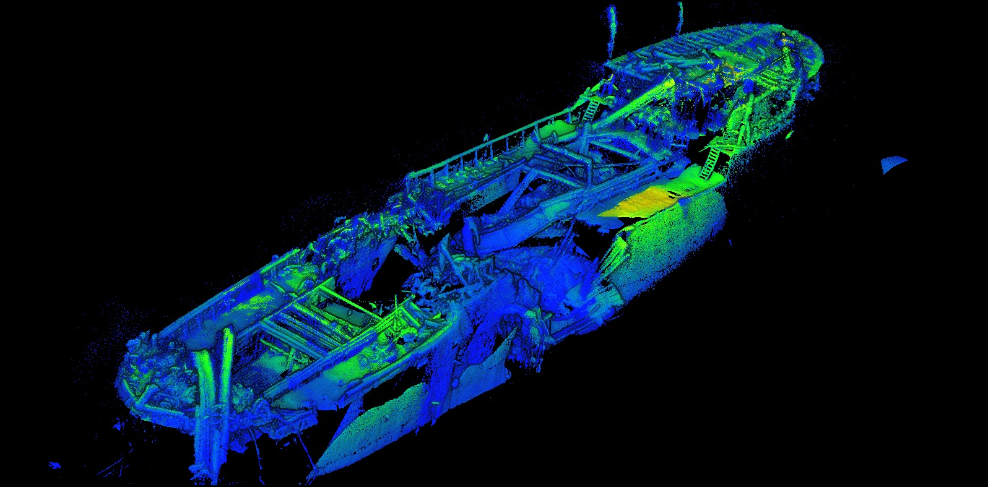
Figure 3.1: Point Cloud Shipwreck (Source: 2G Robotics Inc.)
The following are a few of the standards that are currently being used by RFI respondents, workshop and roundtable attendees.
- 3D Portrayal Service (3DPS) - The 3DPS standard describes how a client and service negotiate what is to be delivered and in which manner, to enable interoperable 3D portrayal. It provides the ability to view, analyze and combine 3D geoinformation from diverse sources in a single view. This is a joint standard between the OGC and the W3D consortium.
- Indexed 3D Scene Layer (I3S) - The I3S format is an open 3D content delivery format used to rapidly stream and distribute large volumes of 3D GIS data to mobile, web and desktop clients. I3S content can be shared across enterprise systems using both physical and cloud servers. Developed by ESRI, along with numerous endorsing organizations. This is an OGC Community standard.
- LAS File Format - The LAS file format is a public file format for the interchange of 3-dimensional point cloud data between data users. The LAS file is intended to contain lidar (or other) point cloud data records. The data is used to derive images and 3D surface models. The American Society for Photogrammetry & Remote Sensing (ASPRS) is the owner of the LAS Specification and was recognized by the OGC as an OGC Community standard.

3.2.2 Linking to IoT Technologies
There are currently several activities in the Internet of Things (IoT) community that may be considered as complementary enhancements of the established Sensor Web architectures within the marine community, specifically:
- Applicability of IoT protocols (e.g. MQTT, AMQP, COAP, LoRaWAN, etc.) to marine applications: the complexity of this topic may require dedicated work items/work packages as part of new research projects;
- OGC SensorThings API - As described in the previous section;
- W3C Web of Things for IoT (https://www.w3.org/WoT/); and
- Marine Sensor Web Profiles with Internet of Things technology as dedicated chapters of the Marine Sensor Web Profiles Best Practice documentation.

3.2.3 Push based communication flows
Push technology, or server push, is a style of Internet-based communication where the request for a given transaction is initiated by the publisher or central server as opposed to pull/get, where the request for the transmission of information is initiated by the receiver or client such as the SOS protocol used in the IoT projects.
- A profile for the OGC Publish/Subscribe standard that is tailored to the needs of marine Sensor Web applications.
- Push based communication patterns through bandwidth constrained links.
- Event stream processing tools for marine application scenarios and develop exemplary implementations for selected use cases.
- Publish/Subscribe extensions for existing OGC SOS servers.

3.2.4 Web processing services
Investigate the coupling of marine Sensor Web services (e.g. SOS servers complying to the Marine SWE Profiles recommendations) to OGC Web Processing Service instance. This should be realized as a set of demonstrators showing the dynamic integration of different observation data sources and process types. The SWE service model, common data model provides a framework for such aggregation.

Chapter 4: Marine Data Themes in a MSDI
Marine data themes represent the features and characteristics of seas, oceans, and inland water bodies (i.e., depths, tides, tidal waves, coastal information, reefs) and features and characteristics that represent the intersection of the land with the water surface (i.e., shorelines), the lines from which the territorial sea and other maritime zones are measured (i.e., baseline maritime) and lands covered by water at any stage of the tide (i.e., Outer Continental Shelf), as distinguished from tidelands, which are attached to the mainland or an island and cover and uncover with the tide.
Today, a steadily growing wealth of marine data from a wide range of disciplines acquired in real-time, near-real time and delayed mode, are available from online information systems around the world. While substantial achievements have been made in reaching consensus on standards for data and metadata formats, system protocols and exchange mechanisms by standardization organizations such as the OGC, ISO, IHO and the W3C, there are still a number of gaps prohibiting full interoperability between marine information systems.

4.1 Marine Data Ontology
To develop an interoperable Marine SDI, a detailed definition of the semantics of the data being requested and the services being called is required. A major goal of a MSDI is to develop a multi-domain and multilingual ontology of marine data and services to provide semantic interoperability within the system.
There are already a considerable number of marine data themes and controlled vocabularies for marine data available on the Internet through portals and other SDI that vary considerably in function, scope, capability, and content. An approach to building an effective marine ontology may be by; analyzing existing semantic resources and provide mappings between them, and, gluing together the definitions and workflows of the OGC WxS (Web <whatever> Services). Tools for the development and population of ontologies may also be needed in the semantic infrastructure.

4.2 Examples of Marine Data Themes
From the RFI responses, workshop and roundtable, there were many themes and data categories identified. These have been classified and summarized into the following nine possible themes:
- Hydrography - bathymetry and elevation, topography of submarine, geology, coastline, rocks and reefs, substrate, sea areas and boundaries;
- Oceanography - tides, ocean currents, winds, nutrients and oxygen, sea temperature, salinity and density, water column features, meteorology, MetOcean;
- Marine Biology / Scientific - phytoplankton and zooplankton, marine ecosystems, biodiversity, marine species and populations, seabirds, habitats and geomorphology, toxic elements, water-quality parameters;
- Ecology, Environmental - nature protection, pollution, sewage discharge, ocean dumping, seawater intake, ecological functions and services;
- Maritime Governance - Marine Protected Areas (MPAs), maritime routes, commercial leases, jurisdictional boundaries, tribally governed areas, regulatory use restrictions;
- Transportation - commercial shipping, cruise ships, military vessels, AIS Systems, navigational aids - charts, lighthouses, buoys, fog signals and day beacons, other navigation services;
- Infrastructure - orientation facilities, ports and harbor facilities, underwater transmission cables, pipelines, power grids, and other structures;
- Industrial, Commercial - energy production including wind, wave, tidal, current, thermal, oil & gas; fisheries, aquaculture, seaweed harvesting, mining and mineral extraction; and
- Tourism, Recreational, Cultural Use - facilities and services for small boats, tourist information, diving/snorkeling/swimming areas, wildlife viewing at sea, archaeological sites, shipwrecks, shore use, nature parks and protected reserves, beaches and recreation areas, recreational fishing.
With the large number of marine data themes, controlled vocabularies and ontologies for marine data available, an approach to integrating these may be by analyzing existing semantic resources and provide mappings between them. The previous nine themes may act as a starting point for this integration that may greatly improve the discoverability of data within the Marine SDI.
Existing ontologies can be used as reference:
- MarineTLO, http://aims.fao.org/activity/blog/marinetlo-top-level-ontology-marine-domain;
- GEMET, http://www.eionet.europa.eu/gemet (also applicable to INSPIRE); and
- NETMAR, https://netmar.nersc.no/.

Chapter 5: Data and Governance
The marine domain provides a unique environment when it comes to data acquisition and collection. Much of the data collected is not observable directly and have to be captured through the use of specialized marine sensors. More than eighty percent of our ocean is unmapped, unobserved, and unexplored. Given the high degree of difficulty and cost in exploring our ocean, researchers have long relied on technologies such as sonar to generate maps of the seafloor. It is estimated that less than ten percent of the global ocean is mapped using modern sonar technology and that most of the seafloor that has been mapped thoroughly is close to shore.
Marine data collecting also needs to handle extreme weather conditions in harsh environments, which requires sophisticated health, safety, and environment (HSE) training and expertise. This chapter addresses data aspects from two perspectives. The first (5.1) is from the data consumer side, who has particular needs on the type and format of the data; with further requirements on update rates, reliability, quality and other characteristics. The second (5.2) part addresses data sets that are already available. This part only highlights a number of data sets that were suggested by RFI, workshop, and roundtable respondents, and are ideally available at standardized interfaces. A more complete inventory of available data sets shall be developed in the course of a possible future pilot project. The chapter continues to address Governance (5.3) as it relates to a Marine SDI.

5.1 Data and Tool Usage of RFI Respondents
There were four polar (yes/no) questions about data and tool usage that were included in the RFI. The first question determines whether the respondent relied on any global, regional, national or local datasets in the marine domain. The next question determined if the respondent felt there were adequate tools for analysis of marine data. The third question determined if the respondent thought their data or tools were only accessible to limited, experienced people or general populations. The last question attempted to determine if the respondents used data models. It should be noted that there was an approximate 60% response rate to questions one, two and four, while question three had a response rate of 84%.

Figure 5.1: Data and Tool Usage of RFI Respondents (Source: OGC)
As shown in Figure 5.1, all (100%), of those that responded to the question, indicated that there were datasets in the marine domain that they relied upon. Over 90 percent (93%), of those that responded to the question, indicated that there were adequate tools for marine data analysis and the same percentage (93%) indicated that they used data models. However, one third (33%), of those that responded to the question, indicated that the marine tools or data were only accessible to limited, or experienced people.
One of the key takeaways from these responses is that approximately two thirds of respondents felt that marine data and tools are accessible to the general public. This fact was also brought forward in the workshop and it is recommended that a future pilot may try and achieve even greater public accessibility.

5.2 Data Requirements
The requirements for data and information in the marine domain are being driven by a broad range of societal, operational, and scientific imperatives. The world's oceans greatly affect changes taking place across many domains, including climate, atmosphere, and ecosystems, which have significant impacts in the regions and, through complex earth system connections, worldwide. The drivers include both national and international science policies, strategies, and programmes that contribute to an understanding of the changes taking place in the marine domain and shape policy responses. To better understand the following requirements on data sets, table 5.1 provide some examples of marine science activities.
Research Theme | Examples of Scientific Activities
Atmosphere, Climate  and Weather Change  Research | - Research on how interactions between the atmosphere and ocean control the rate of climate change  - Increasing knowledge of how lake ice cover affects energy and water budgets to improve ability to forecast weather  - Research on landfast sea ice distribution as a sensitive indicator of climate variability and change, especially in Antarctica
Land Surface and  Use Change  Research | - Research on structural and functional characteristics of land use  systems to sustainably manage food, water and energy supplies  - Research on the impacts of human activities on the oceans
Ocean Status and Coastal Zone Change Research | - Monitoring and understanding extremes such as coastal sea level  surges and ocean waves  - Study of how the melting of landfast sea ice is causing increasing coastal erosion that is impacting coastal infrastructure and local populations  - Study of the role of the ocean in the stability of the Antarctic ice sheet and its contribution to sea-level rise
Ecosystem and  Organism Change  Research | - Effects of ocean acidification on marine biodiversity and ecosystem function  - Research on the effects of temperature upon the toxicity of chemicals to aquatic organisms  - Research on tipping points, thresholds and the keystone role of physiology in marine climate change
Table 5.1: Examples of marine scientific activities that drive information
requirements
Operations in the marine environment take place in some of the most difficult conditions on Earth. Those involved in these operations, such as shipping and fisheries companies, offshore oil and gas operators, research organizations, coast guards, and local communities, require access to reliable and often near real-time information to plan and undertake their activities. Drivers of information requirements include a range of regulations, standards, and policies aimed at ensuring the safety of life and mitigating negative environmental impacts. Examples of polar operational activities are contained in table 5.2. Of course, these activities are not solely exclusive to polar areas.
Theme | Examples of Operational Activities
Environmental Impact Assessment | - Supporting the responsible development of major offshore infrastructure or resource development projects  - Assessing and mitigating the operation of such projects
Engineering Design | - Design of buildings and structures for installation in changing marine conditions  - Design of offshore drilling and production platforms for safe and effective deployment in ice-covered waters
Safe Navigation and  Operations | - Navigation of vessels through hazardous waters  - Avoiding collisions with the operation of offshore oil and gas exploration and production platforms
Emergency Response | - Developing and maintaining a common operating picture (COP) between response organizations  - Expeditious movement of responders and their equipment from bases of operation to the emergency site
Weather Forecasting | - Observing and modelling weather patterns to improve short-term weather predictions in support of operations in marine environment
Climate Change  Adaptation | - Establishing new regulations and standards, investing in new infrastructure, and enhancing operational capabilities in reaction to changes in the marine climate and its impact  - Expeditious movement of responders and their equipment from bases of operation to the emergency site
Table 5.2: Examples of marine operational activities that drive
information requirements
There are a number of general requirements that apply to many data types, such as real-time data availability, or data quality, coverage and resolution. Based on an analysis of the RFI responses, datasets for the following key data categories have been identified to be required within an effective Marine SDI at minimum. Some of the categories tend to be cross cutting, meaning that they may use data from other categories within the list. This is not an exhaustive list and the list is in no particular order.
- Hydrographic data
  - Hydrographic data should be the foundation of any Marine SDI as it relates to the measurement and description of the physical features of oceans, seas, coastal areas, lakes and rivers within a given country or region. This would typically include seabed topography (bathymetry), marine infrastructure (e.g., offshore installations, pipelines, and cables), hazards (e.g., wrecks, rocks, and obstructions), aids to navigation, administrative and legal boundaries, and areas of conservation, marine habitats and oceanography.
  - Nautical charting and seabed data.
  - Possible crowdsourced hydrographic data as collected by shipping, cruise ship companies and other stakeholders.
  - Horizontal and vertical datum, maritime baseline, seabed characteristics, marine boundaries, shoreline.

- Oceanographic data
  - Ocean currents, waves and tides.
  - Water properties including water temperature, salinity, fluorescence, turbidity, dissolved oxygen, chlorophyll, suspended material, chromophoric dissolved organic matter.
  - Geology, offshore minerals, oceanographic features.
  - Sea ice and iceberg presence, density, and velocity.
- Land and coast data
  - Topographic base maps (high and medium resolution DEM) and coastal mapping.
  - Land cover, offshore cadaster, land ownership, flood hazards, and gazetteer.
  - Optical and radar imagery with long term historic imagery to provide valuable insights into changes and near real-time imagery to monitor the region.

- Vessel Tracking. Continual near real-time monitoring of traffic via AIS or remote sensing together with historic data on vessels’ voyages. Data should include vessel position, velocity, voyage, and historical track and position information.
- Port information and data.
- Meteorology and Climate including wind velocity and direction, air temperature, humidity, and atmospheric pressure as well as climate parameters and indices.
- Cryosphere Data such as areas of snow, ice and frozen ground to support research on warming permafrost, reduction in snow cover extent and duration, reduction in summer sea ice, increased loss of glaciers and the break-up of ice shelves.
- Historical Data: such as data used for Marine spatial planning (MSP), a process that brings together multiple users of the marine environment to make informed and coordinated decisions.
- Real-time Sensor Data: This data category includes data received in real time from available marine sensor systems.
- Crowd-Sourced Data: Advances in technologies and communications, coupled with the rapid rise and adoption of social media applications have created a new category of data in the marine environment. This has now enabled citizens to generate real-time, georeferenced data that may be useful within a Marine SDI.
It was stated in many of the RFI responses and the workshop discussions, that in general, all data should be available in, or transformable to, different projections using different datums for efficient map productions or integrated processing and analysis operations.
Globally, the marine domain has very valuable data that can be leveraged in ways that cannot be foreseen. It has traditionally been a challenge to integrate this data from the many established digital data centers however efforts to do so tend to be limited to a particular region or theme. As part of a future pilot project the ability to deploy a wider integration of this data would be pursued:
- Identify marine domain data repositories and portals; and
- Test standards and Web services, as well as best practices of data management to achieve this integration.

5.3 Metadata and Catalogs
Many catalogs and registries make use of OGC Services and their corresponding ISO TC211 documents. For example, the IHO S-100 provides the data framework for the development of the next generation of Electronic Navigational Charts (ENC), as well as other related digital products required by the hydrographic, maritime and GIS communities. S-100 is based on the ISO 19100 series of geographic standards. This means that S-100 based data is compatible with data created according to the relevant ISO standards. An S-100 online registry based on the ISO 19135 standard (Procedures for Registration of Geographical Information Items), has been established for the registration, management and maintenance of the various dictionaries of items recognized under the S-100 framework. The registry contains the following principal subordinate registers:
- Feature Concept Dictionary (FCD) register
- Portrayal register
- Metadata register
- Product Specifications register
- Data Producer Code register
It has been recommended that metadata (or a subset of metadata) follow the ISO 19115 (Geographic Information - Metadata) and corresponding ISO 19139 (Geographic Information - Metadata XML schema implementation), or their respective profiles, CSDGM (FGDC Content Standard for Geospatial Metadata), the Dublin Core, or INSPIRE guidelines and implementation rules. In addition, the emerging DCAT standard may be analyzed in more detail for its applicability in SDIs. This is an idea that could be explored further as part of a future pilot.

5.4 Data Identified
Despite many areas still lacking sufficient data coverage (or available data is of coarse resolution or low quality), quite a number of data sets are already available. Appendix A provides an overview of data sets that have been identified in the MSDI workshop, RFI responses, MSDI roundtable or referenced in literature. In addition, there is a list of data portals online (see Appendix B for details).

5.5 Governance
This section will concentrate on high level governance goals instead of the collective decision making process that may often get blurred by the large number of stakeholders that participate in a SDI and may implement very little in an overlapping, collective decision making processes. For an optimal performance of any SDI, it is highly recommended to study the lessons learned as documented, for example, in Box and Rajabifard, 2009, which groups the most pertinent governance lessons learned into institutional, business, data and service categories and ranks them based on a number of case studies’ results. Additionally, the United Nations Committee of Experts on Global Geospatial Information Management (UN-GGIM) has created The Statement of Shared Guiding Principles for Geospatial Information Management that are exemplified by “a strong, successful and relevant geospatial information organization.” Innovation, Governance, and Compliance are the section in which all the Shared Guiding Principles, are organized, with Governance containing the majority of the Principles.

5.5.1 High Level Governance Goals
In the following section, a number of high level governance goals are briefly introduced that are of significant importance in any collaborative decision support system that focuses on the marine domain. These goals are shown in figure 5.2.
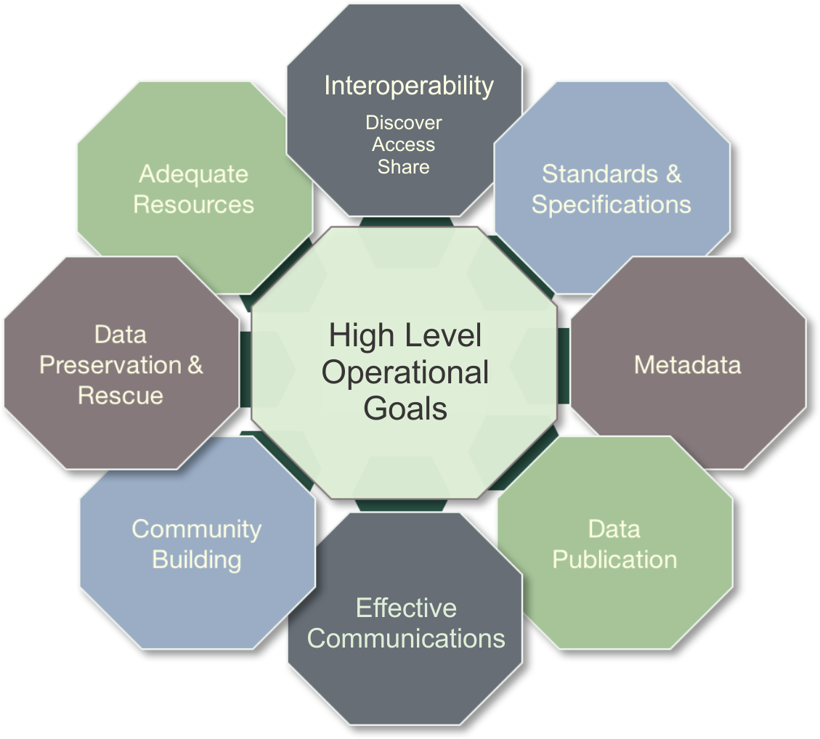
Figure 5.2: High Level Governance Goals
- Interoperability - Interoperability, the ability to easily discover, access and share data across systems and users, is one of the most important priorities identified by RFI responders and workshop attendees. An interoperable system must enable data accessibility that can support many different users. This may require visualization or other mediation such as translating vocabularies to make data usable by different communities. Achieving interoperability will require adequate resources, a certain level of standardization, and a connected community.
- Standards and Specifications - The overarching purpose of many in the marine community is to promote and facilitate international collaboration towards the goal of free, ethically open, sustained, and timely access to marine data through useful, usable, and interoperable systems. This includes facilitating the adoption, implementation and development (where necessary) of standards that will enable free, open and timely access to data.
- Metadata - The objective of this activity is to develop recommendations on a common set of metadata elements relevant across the marine domain, that facilitate discovery, interoperability and sharing between data repositories and online portals. To start, this effort should focus on identifying initiatives that have established a metadata template, schema, or profile. Initially, a limited set of disciplines or focus areas will be identified to make the scope manageable. Wherever possible and practical, the effort will build on and/or contribute to other related initiatives.
- Data Publication - The objective of this activity is to provide a report and guide on data publication and citation for marine data providers and enablers. This would provide the marine community with a resource to help them to understand developments in this area, including assignment of DOIs (Digital Object Identifiers) to published data sets.
- Effective Communications - Through the established bodies of the marine community, improved communication, outreach, and coordination is needed to provide improved stakeholder engagement.
- Community Building - Improved data sharing, that is part of a broader global system, requires community building, collaboration, and coordination of efforts. To achieve this, a better understanding of the nature of the marine community (who is doing the work, where, and the systems and processing workflows, etc.) across many scales, and what is collectively trying to be achieved is required. It is also important to recognize engaging with broader global initiatives ongoing in the marine domain.
- Data Preservation and Rescue - Continuous reuse and re-purpose of past observations is key to increase current understanding. Therefore, data and all the necessary descriptive information must be preserved. Too often, preservation is forgotten, and data managers must pursue costly and time intensive data rescue activities. Even current data are at risk of loss. Strategic data rescue programs must be developed, and preservation must be prioritized as a long-term investment and cost-saving measure.
- Adequate Resources - Making progress will require adequate financial, technical, and human resources. More focus is needed on the training of early career scientists and youth to ensure that they have the necessary data literacy to engage in intensive research while contributing to and benefiting from an open, interoperable system.
In Norway, a national governmental geospatial strategy was developed in 2017 with a vision to improve the overall value and usefulness of geospatial information to its society. This framework tended to concentrate on the high level governance goals, discussed above, merged with the four pillars of a SDI discussed in chapter 2. The main goals for this strategy is to:
- Establish a national platform of knowledge through geospatial information, in accordance to user priorities;
- Incorporate technological tools and interoperability to increase efficiency and improve innovation;
- Improve and further develop cross-sectorial cooperation and collaboration arenas; and
- Adapt policies and framework conditions to meet the challenges within geospatial infrastructure, e-Governmental services and the digital society in general.
Figure 5.3 illustrates this SDI strategy.
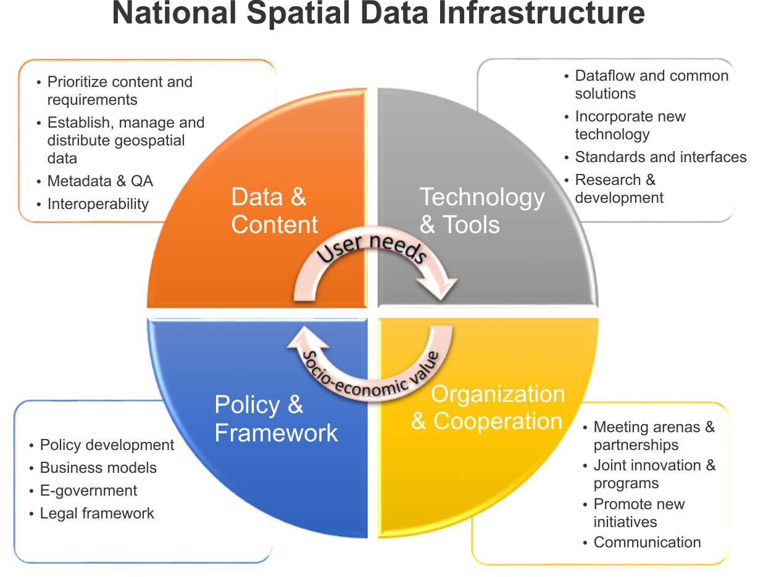
Figure 5.3: National Spatial Data Infrastructure Model, source: Norwegian Mapping Authority (modified)

5.5.2 Recommendations for Collaboration
Collaboration through effective communications and community building are key components of high level governance goals. To emphasize these components, two items shall be further discussed. The first is to help attract additional stakeholders by enabling data access from other contributors and the second is to have starting points for further collaboration on the organizational level. This list serves as a starting point and does not make any claims of being complete.
It is recommended that a prospective pilot reaches out to, and collaborates with the following.
- the International Hydrographic Organization’s Marine Spatial Data Infrastructure Working Group (IHO MSDIWG).
- National Oceanography Centre (NOC) – British Oceanographic Data Centre (BODC) and the Natural Environment Research Council (NERC) designated data center for marine environmental data.
- International Oceanographic Data and Information Exchange (IODE) of the Intergovernmental Oceanographic Commission" (IOC) of UNESCO.
- UN Committee of Experts on Global Geospatial Information Management (UN-GGIM) Working Group on Marine Geospatial Information (WG-MGI).
- The United Nations (UN) Integrated Geospatial Information Framework - A UN endorsed initiative built upon the work of the UN Committee of Experts on Global Geospatial Information Management (UN-GGIM) and the World Bank. It is providing a roadmap to help countries develop, manage, and use vital geospatial data to address development challenges.
- Infrastructure for Spatial Information in Europe (INSPIRE) - This legislative Directive of the European Parliament established an infrastructure for spatial information in Europe to support policies or activities which may have an impact on the environment.
Global interaction at this level cannot be over-emphasized.

Chapter 6: MSDI Interoperability Reference Architecture
The architecture of an SDI is a multi-dimensional concept, including software, hardware, deployments, networks, operations, federations and many others. Figure 6.1 identifies a large number of aspects that play a role in architecture design and definition.
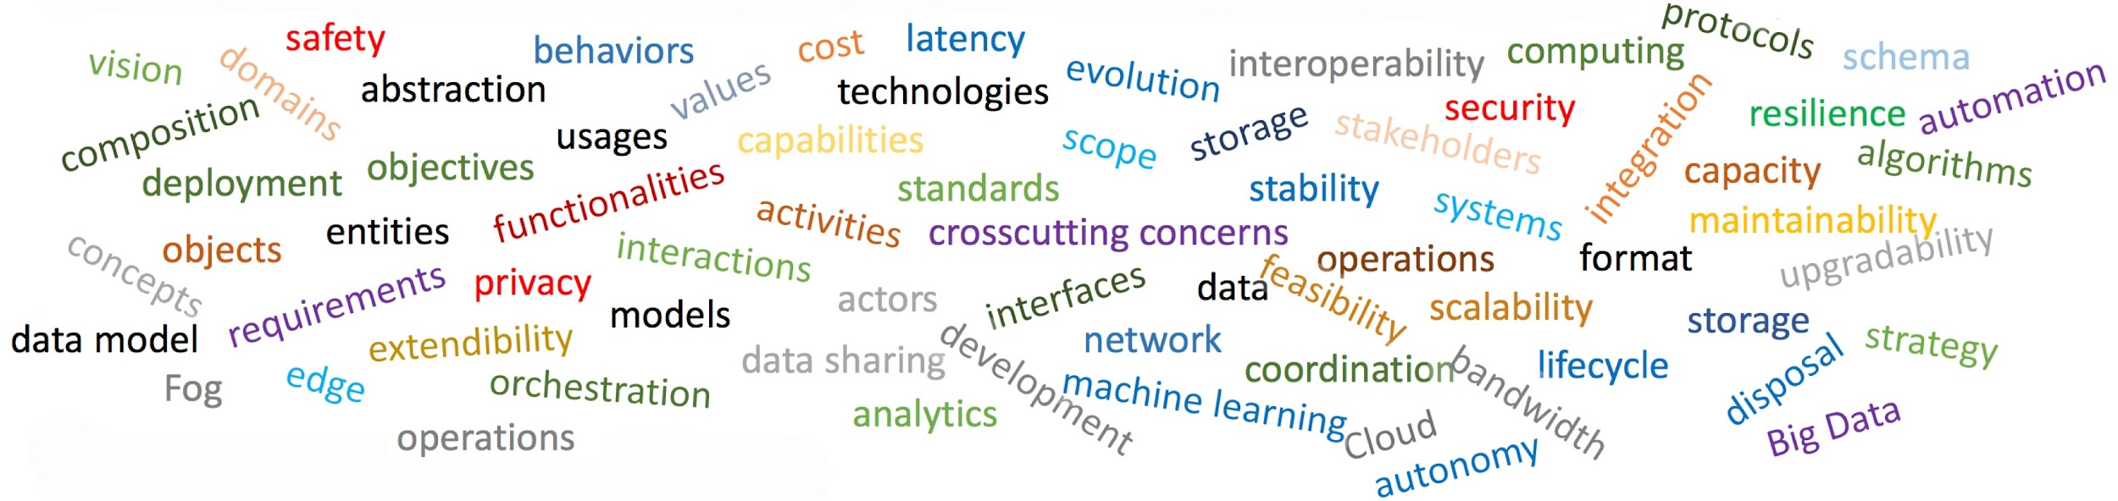
Figure 6.1: Architectural aspects that need consideration
The goal of any future pilot would be to demonstrate the value of an integrated SDI for Marine Data Management. It has been agreed that one of the best approaches to demonstrate value and increase stakeholders’ adoption rates is a careful and well planned implementation of a Marine SDI serving all stakeholders needs. The following sections discuss architecture requirements, perspectives, and concentrates on a number of key aspects to support the future development of a possible MSDI Interoperability Reference Architecture as a starting point for a future Pilot.

6.1 Architecture of RFI Respondents
There were two polar (yes/no) questions that were linked to architecture and a Marine SDI. The first question determined whether the respondent had or provided a marine data management system and the second question determined if the respondent used geospatial standards to access data and services. It should be noted that there was an 84% response rate to these questions.
As shown in figure 6.2, 81% of those that responded to the question, indicated they had a marine data management system and 90% of those that responded to the question, indicated they used geospatial standards to access data and services.
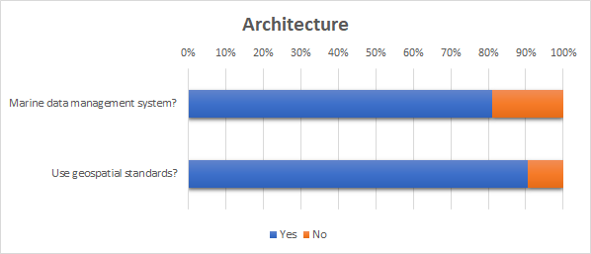
Figure 6.2: Architecture and Standards of RFI Respondents (Source: OGC)
These results indicate that the vast majority of those in the marine domain use geospatial standards. However there are still some who do not.

6.2 Requirements
To address stakeholder needs outlined in chapter 2, there are a number of overarching requirements for an optimal Marine SDI architecture. These are described in terms of data sharing, standards and interoperability, funding and investment, integration with existing systems, agility and adaptability, and security, privacy and safety. Figure 6.2 illustrates these categories.
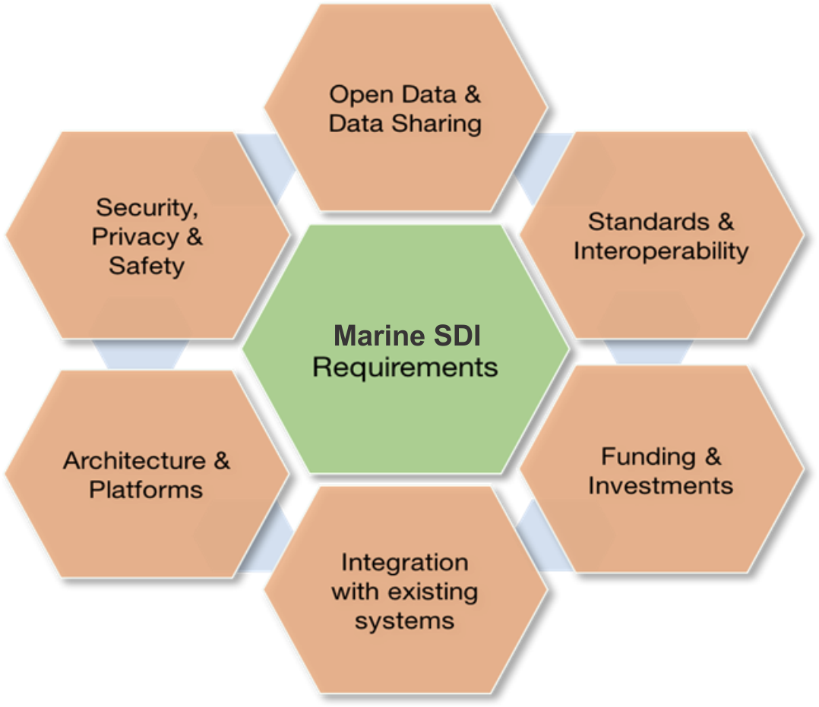
Figure 6.3: High level requirement categories
The following sections will briefly examine more details on the various categories that ensure a robust baseline for the development of a Marine SDI architecture.

6.2.1 Open Data & Data Sharing
Open Data & Data Sharing addresses both legal as well as technical aspects such as how to enable data sharing among disparate and heterogeneous endpoints and systems using common data models and schemas. Open data is the idea that some data should be freely available to everyone to use and re-publish as they wish, without restrictions from copyright, patents or other mechanisms of control. Open Data & Data Sharing further addresses organizational aspects such as how to encourage data sharing with social or economic incentives and enforcement of rules.
- Any Marine SDI shall broker the delivery of government and non-governmental marine observations.
- The architecture shall support real time observations. Traditionally, this has been difficult to achieve due to the proprietary nature of the sensor interfaces used for real time observations. New technologies such as SensorThings API should can be implemented to help reduce this difficulty.
- The architecture shall support creation and exchange of research-oriented synthesized data sets (i.e. simulation model outputs).
- All data shall be accompanied by metadata. Exploration into minimizing the need for manually generated metadata should be continued.
- The architecture should consider bandwidth flexibility, for situations such as sudden surge in users during or right after an extraordinary event (e.g., hurricane/typhoon, earthquake-tsunami, etc.), when the need of updated and authoritative information is paramount for first responders.

6.2.2 Standards and Interoperability
Standards and Interoperability addresses mechanisms and agreements to ensure that components being part of or that are loosely connected to a Marine SDI can communicate with each other.
- Interoperability of SDI components across platforms is of overall importance.
- Data in open, standardized formats should be served by Web interfaces using standardized encodings.
- Standards-based Web GIS integrates and leverages all the investments that have already been made in GIS and hydrographic standards, data, and technologies. Any Marine SDI should benefit from these investments and should be based on these standards.
- Detailed compliance tests shall be available to ensure interoperability across components.
- Unstructured data feeds should be analyzed to determine the best format to enable sharing with other users for further process in the marine domain workflow.

6.2.3 Funding and Investments
The operation and maintenance of a successful Marine SDI generates substantial costs that need to be covered by funding agencies or invested by companies with the goal to generate proportionate profit in the future. In terms of business needs, the following aspects need to be considered.
- Adequate funding from the various public sectors; at least initially.
- Funding issues may arise if the benefits to be gained from a Marine SDI are not sufficiently understood by funding bodies within the marine domain and beyond.
- Development of relevant applications in the private sector to generate desirable return on investment.
- Recognition of marine data as an investment rather than a cost, which is possible through geospatial consortia making the data interoperable between different users to be utilized in an interoperable manner for business purposes, to support sustainable economic development, and prevent and recover from disasters quickly.
- Any Marine SDI shall consider not only one-time costs associated with implementing the solution but the ongoing requirements to support, maintain and enhance the solution over its lifecycle to ensure it continues to deliver value and meet stakeholder needs.
- Individual management objectives, priorities, planning cycles and investment capacity are all constraints that will affect an organization's ability to participate in the development of a Marine SDI.
- Cost efficiency is key and any Marine SDI should be implemented as much as possible out-of-the-box - meaning using existing cloud hosting and server based geospatial solutions and without the added expense of in-house software development.

6.2.4 Integration with Existing Systems
Integration with existing systems is a critical aspect to ensure neat integration of data hosted in external systems and the protection of investments in other SDIs or platforms that shall be conserved. Therefore, a Marine SDI must:
- Coordinate with national and international Marine, Hydrographic and Oceanographic authorities that provide data for the marine domain;
- Coordinate with international, national and regional SDIs and MSDIs;
- Integrate with national and regional SDIs without replicating already available resources;
- Integrate with and support widely deployed geographic information systems (GIS);
- Not be perceived as a competitor to local, regional, or national SDIs;
- Integrate data platforms operated by national space agencies or other organizations providing satellite-derived data products; and
- Connect (as practical) with any possible marine data provider (industry, academia, research entities).

6.2.5 Architecture and Platforms
Architecture and Platform aspects play a key role in distributed spatial data collection, exploration, and processing environments; and need to ensure that the targeted Marine SDI can keep pace with changing technologies and Internet trends. The following high-level requirements have been identified.
- Development efforts for any SDI could be constrained by how prescriptive the architectural design is at the outset. To benefit from rapidly improving technology, a Marine SDI needs to remain flexible and agile. Architectural decisions affect costs and the ability to benefit as technology changes. Early architectural decision can translate into constraints if they are too rigid in their approach. Therefore, questions such as these must be addressed.
  - Will the Marine SDI be a loose federation of portals and platforms discoverable by open specifications and standards allowing as-is communities to participate?
  - Or will the Marine SDI be highly architected and all data and apps services be available as hosted/re-hosted services (cloud and/or on-premise)?
  - Or any combination of the above two approaches?
- Technical knowledge and availability of skills is often a limiting factor in stakeholders adopting technical solutions, or in continuing efforts to maintain solutions already in place. The architecture has to cater for greatly varying paces at which organizations adapt new technology and will have to bridge a wide variety of technical solutions of differing ages and platforms.
- A Marine SDI shall be very dynamic and flexible because change is occurring at a very high rate. New data sets are continually added and a huge number of monitoring data sets are updated constantly.
- A Marine SDI should consider low-bandwidth and offline capabilities for where Internet connectivity is limited or non-existent for users operating far offshore. Marine SDI designers must decide if they will provide infrastructure as well as data and apps. Examples of using data appliances that are loaded with data, software, and apps, such as GeoPackage, shall be explored.
- Intuitively designed user interfaces and website structure/navigation best practices to lower the entry barrier and provide ease of access to a Marine SDI.
- Efficient search functionality and fast or flexible download rates.
- Preservation of the national language, support for multilingualism, and technical language requirements should be taken into account.
- The architecture shall allow for future extensions and allow the integration of upcoming new patterns to handle e.g., Big Data or semantic annotation.

6.2.6 Security, Privacy and Safety
Security, Privacy and Safety includes aspects such as vulnerability to attacks, acceptance and assurance of privacy concerns, secure and reliable access, protection of intellectual property rights, and assurance of system availability in critical situations, e.g. emergency responses or major crises. Additionally, Data Integrity is crucial in secure infrastructures where the maintenance and the assurance of the accuracy and consistency of data persists over its entire life-cycle (Boritz, 2004). Users need to identify the source of the data and to be sure that the data was not modified in the process. Additional items mentioned in RFI responses include the following.
- Many data sets are access-protected for good reasons (e.g. security implications or commercial or government interests). Though these reasons are fully acknowledged, Marine SDI design should provide for obtaining information about how to access datasets that are not open but may be accessed through some other means. For example, industrial stakeholders who procure their own data collection programs often are protective of the data set but are willing to share them under certain circumstances. The necessary brokering has to be addressed.
- Foundational data shall be provided as license-free data (public sector) for ease of reuse during crisis support.
- Individual logins, firewall protection and a secure server connections capable of transferring and storing highly sensitive data need to be available.

6.3 SDI Technology Approaches
When it comes to SDI design reflected in the RFI responses, two important approaches must be differentiated. They are not mutually exclusive and a chosen approach can still be complemented by the other. In fact, both approaches represent the two extremes of a given continuum, with most implementations, including a Marine SDI, will feature some level of middle course. Nevertheless, the architecture design differs depending on the preferred approach. The first approach focuses on a closely architected infrastructure that provides data and apps as services. Thus, the defined architecture caters for a defined set of services (includes rehosted services) that are operated and maintained by a SDI control board, i.e., a group with control over the individual components. The second approach focuses on infrastructures, platforms, and geoportals as they currently exist and emphasizes their integration into a federation of systems. Here, emphasis is on discoverability and integration based on open standards. The first approach puts more control into the hands of the control board, whereas the second approach provides more flexibility and distributed responsibilities. Key to both approaches is the strong adherence to standards to avoid vendor lock-in with limited flexibility and extensibility. It should be emphasized that both approaches can complement each other, i.e., they do not necessarily act in isolation, but support interfaces to allow mutual usage.

6.3.1 Closely Architected Approach
The first, closely architected approach is illustrated in figure 6.4. The platform itself consists of the infrastructure, the content, any number of Application Programming Interfaces (APIs) and Software Development Kits (SDKs), and application and content management tools. The actual applications are usually provided as external components or as web-based thin clients. The key here is the fact that the entire system focuses on the single platform concept, which means that the individual layers and implemented aspects are not particular characteristics of the closely architected approach. It is the way they are implemented and linked with each other.
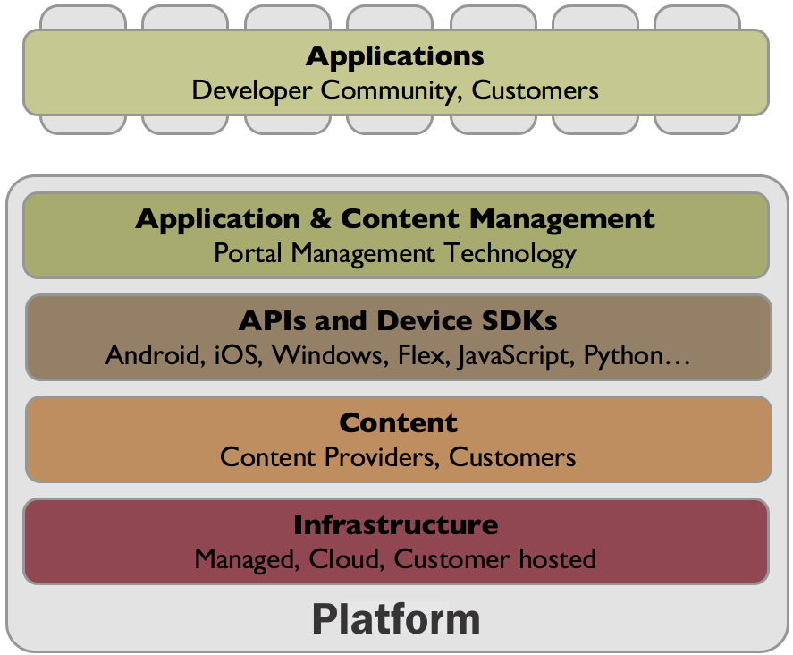
Figure 6.4: Closely Architected Approach, source: ESRI (modified)
The infrastructure includes the hardware and software needed to operate a Marine SDI. The infrastructure design will need to take into consideration the different user scenarios, data sources (either managed by the SDI or coming from third party sources), appropriateness of cloud technologies, current and future IT policies, and existing hosting capacity. The Marine SDI will need to account for offline or restricted bandwidth situations. To mitigate these, the SDI could consider using data appliances, container formats such as GeoPackage.
The content aspect of the Marine SDI can be broken down into the following.
- Geospatial data management - this includes the technologies and workflows for managing vector and raster data that will be managed and used in the Marine SDI. Following the best practices defined by INSPIRE and/or the Federal Geographic Data Committee (FGDC) for the National Spatial Data Infrastructure (NSDI), the Marine SDI would define the key spatial and nonspatial data layers that support the needs of the use cases of the Marine SDI. For these data layers, data management and portfolio management policies and procedures need to be defined. This includes, but is not limited to, data models, data update frequencies, conflation of multi-source data, data quality assurance, and availability assurances.
- Real-time data management - this includes the technologies and workflows for ingesting and using real-time data feeds such as sensor feeds, vessel tracking, news feeds, and feeds from other systems relevant for the Marine SDI.
- Data integration with 3rd-party systems - this allows the feeding (push) or consuming (pull) data from the Marine SDI. For this, a Web services approach using common service interface specifications that build on international standards from the OGC, W3C, IHO, and others are recommended.
APIs and SDKs: If data is the fuel of an SDI, APIs and SDKs form the engine that powers the applications and integration with 3rd-party components. Whatever platform is selected, it needs to offer an effective way to create and manage geospatial applications to developers. The offered APIs and SDKs shall support building web, mobile, and desktop apps that incorporate mapping, visualization, analysis, and more.
Application and Content Management: This component provides the tools and concepts that allow for organizing the content in the Marine SDI in logical and easy to understand groups of thematic or organizational structures. In many cases Content Management is performed through portals.
Applications: The entire platform will be accessed through a number of applications that are tailored to the specific user audiences of the SDI. This component may include map applications for viewing, editing, analyzing, and collecting content. The applications may vary, from templates that are used to tell stories around specific issues in the marine domain, to advanced desktop GIS that connects to the metadata catalog and discovers web services and other content to consume. The important realization and consideration is that not all users will engage with a Marine SDI through the portal or through the applications managed as part of the SDI.

6.3.2 Federated Approach
The second approach is illustrated in Figure 6.5. This approach, shown here with focus on service interfaces and encodings, identifies four main components, visualized using different background colors. The dark components at the bottom represent data sources such as geospatial feature data, geospatial raster data, map, sensor, and other data. This data is served by a number of services that belong to different classes, such as data access services, processing services, sensor web services, discovery services, or other services. These services make use of standardized data models and encodings. Visualization and decision support tools and applications make use of the data provided by the various services in standardized formats.
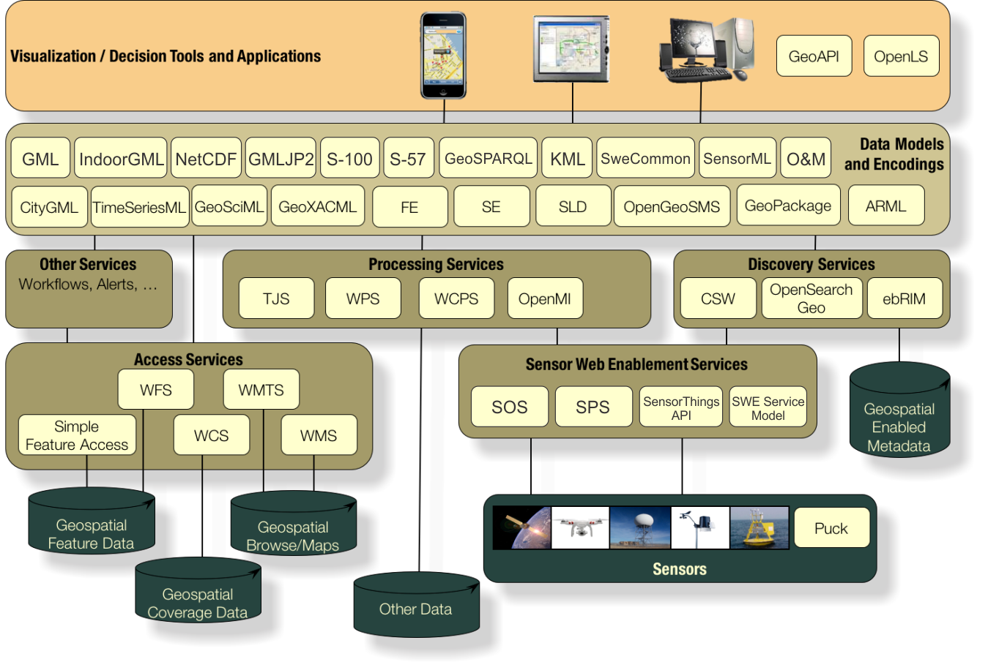
Figure 6.5: Federated Approach, source: OGC
This approach concentrates on service interfaces and encodings. It allows an entirely decoupled and loosely federated infrastructure with minimized, necessary, a-priori knowledge required to interact with the various components. This approach leaves aspects such as maintenance, service configuration etc. to the service operators, i.e., this functionality is not part of the architecture view, as it is irrelevant for the actual SDI. This contrasts with the closely architected SDI concept, where management tools and content tools allow control over more than a single SDI component. The environment illustrated here needs to be enriched with security settings, which usually require some sort of higher level organization if features such as single-sign on shall be supported (otherwise service consumer would need to register with every service, which works in principle, but is not very practical).

6.4 MSDI Reference Architecture
The MSDI Reference Architecture must find the right balance between being prescriptive while remaining agile to allow for easy integration of upcoming technologies. This requires the Marine SDI to be implemented as a loose federation of portals and platforms, a federated systems of systems, discoverable by open specifications and standards rather than being a highly architected infrastructure with data and applications being available as hosted/re-hosted services.
Independent of the chosen approach, a number of additional aspects have been repeatedly identified by RFI respondents and workshop attendees as being relevant for a successful Marine SDI. These aspects are usually complemented with the standing request for openness as illustrated in figure 6.6. Openness usually refers to a number of aspects that describe an element that is openly (in the sense of publicly and royalty free) available and reusable, developed in an open process, and accessible at minimum costs (in terms of data pure reproduction costs or even no costs).
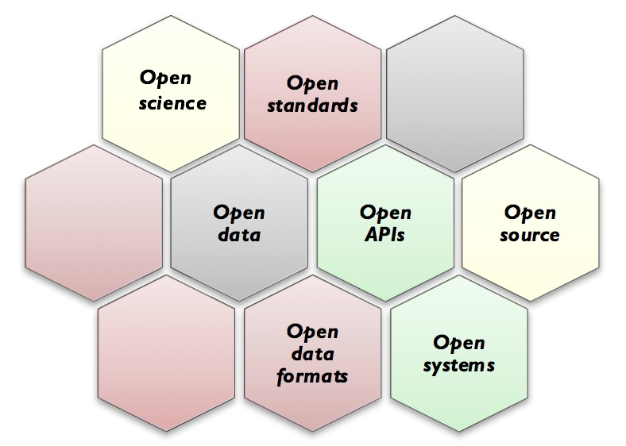
Figure 6.6: Aspects of openness
Open science is the movement to make scientific research, data and dissemination accessible to all levels of an inquiring society, amateur or professional. Open systems includes open source work and GitHub resources, choices in hardware, operating systems, Cloud, databases, developer tools, direct links to non-GIS systems such as CAD and BIM, etc.. Open standards include standards as provided by OGC, IHO, ISO TC/211, CGSB, FGDC, OASIS, W3C, ASPRS, etc.) and open specifications (widely used but not yet adopted by Standards Developing Organizations (SDOs) and openly published technology such as GeoJSON, Geoservices REST API, etc.)
In addition to these general ‘Open’ requirements, many individual Marine SDI architectural requirements were described in the RFI responses and workshop. From this valuable input, an ideal Marine SDI architecture shall be designed to provide for the following.
- Registry and Discovery
  - Rapidly discover and access information, products and data.
  - Architecture shall support search mechanisms that go beyond metadata based keyword search, as metadata is almost never complete and often hard to maintain.
  - Auto-registry system for sensors (both remote and in-situ).
  - Search engine for finding and browsing data, services, and metadata. It should be adaptable to allow for a range of search types from basic quick searches through detailed searches using multiple criteria including: geography, time, organization, physical parameter, etc.
  - Users able to discover (search), view, assemble and obtain desired data and services for a particular area of interest without needing to know the details of how the data and services are stored and maintained by independent agencies, organizations and data custodians.
  - Non-mapped search results (e.g. technical reports, multimedia) should be associated with mapped search results and viewable in the web browser.
- New Functionality and Extension
  - Easily publish/reference information, products and data into the Marine SDI.
  - Integration of new functionality.
  - A Marine SDI is, by nature, federated. It should be as transparent as reasonable to an end-user as to where the information being accessed is sourced from within the federation.
  - Consideration may be given to adding an online information network with an ontology-based interface on top to visualize databases and information sources content. The ontology-based approach would allow for efficient searches once all data and operation concepts are annotated. The ontology-based approach would allow for illustration and processing of stakeholder-data relationships, or stakeholder-processing relationships, which could provide valuable insight for other stakeholders with similar requirements, as process could be copied or adapted more easily.
- Low Bandwidth and Offline Usage
  - Due to the nature of the marine environment, where access to high speed data infrastructures are limited, there tends to be low or no bandwidth available. Applications should consider the support of both online and offline use of data.
  - One of its key uses, within a Marine SDI, is the ability to exploit low cost mobile devices, such as Android tablets, in the marine environment for monitoring, gathering and updating data in areas that have no, or poor data communications. Workers in the marine environment preload data they may need on to their mobile device using a GeoPackager application. They can then go into the field and add or update current data on the device. When they return to an area with data communication, the GeoPackage will synchronize with the original data.
  - Should allow for proxies that optimize data for transport over limited bandwidth connections or other specific purpose tools.
  - Large datasets need to be made available in very efficient ways to support low bandwidth situations. One method suggested would be to create a ‘Marine GeoPackage’ that could be pre-loaded with large relevant datasets.
  - Transferring of data via non-internet mechanisms, such as shipping hard drives/thumb drives to customers with very limited internet connectivity. These drive-deployed datasets shall be made available as being directly served from a standards-based Web service, i.e., data storage is transparent to the end user. Again, this can be accomplished using a Marine GeoPackage.
  - Downloadable datasets in standard formats.
- External Systems and Formats
  - Content may be disseminated to other global, national or regional networks. This increases the visibility of Marine SDI data and information products.
  - Provide connectivity to legacy/heritage systems.
  - Support for scanned documents that provide valuable historic data sets, including charts, maps, forms, other tabular data (both machine and hand written), or hand-drawn sketches.
  - Support for documentary videos, oral histories, and other sources beyond purely numerical data.
  - Enable e-visualization of information in a geospatial, data analysis presentation environment and temporal context.
- Tailoring
  - Support both the desktop and mobile environments.
  - Support multi-lingualism and appropriate character sets.
  - Support targeted users from a diversity of backgrounds. The efficacy of the portal to access information by the uninitiated, the man-of-the-street, has been proven is key to a successful, i.e., well-used SDI.
- Key Service Functionality
  - A mapping interface showing search results. The map portrayal should be interactive: pannable, zoomable, changeable projection. Mapped items should be interactive: obtain metadata by clicking/hovering, get data values by clicking/hovering.
  - Basic analysis and visualization tools, e.g., navigating long time series, statistical analysis on selected data sets or subsets.

Chapter 7: Portals, Applications and Scenarios
The feedback on current technologies and portals used in marine management, type of services that should be available as part of a MSDI, or type of applications shall be developed that make use of MSDI was quite varied.
To the RFI question: “Are there other national, regional or topical portals that can be used to support the marine domain that are currently available and serve your needs?” all but one respondent said yes. The general view from RFI respondents and workshop attendees was that there were many portals available, but no method for easily determining what was available in each.
Finally, this chapter looks at possible scenarios and use cases that could be exercised if a Marine SDI Pilot were to be launched.

7.1 Portals and Software Applications
From the RFI responses, workshop, and roundtable discussions, the following list of current applications includes, on the abstract level, items such as:
- geospatial portal development
- mobile platform integration and cross platform mobile app development
- data warehouse management
- Internet mapping
- metadata management
- gateway creation
- comprehensive data connectivity
More detailed applications include:
- water license management and water quality and quantity flow analysis, visualization and modeling
- Infrastructure monitoring and planning
- Decision Support Systems
- Climate change research
A list of possible key applications that could be made available as part of an MSDI include:
- Dashboard for marine monitoring
- Metadata harvester/broker
- MSDI Portal for non-technical users
- MSDI portal for scientists
- Oil spill tracker/forecaster
The wide range of potential services shall support the following aspects:
- Ease of discovery and use
- Possibility of using in no- or low-bandwidth environments
- Use of geospatial standards
- Service level agreements to address business and contractual agreements.

7.1.1 Marine Portals
Many regions including Europe, East Asia, the USA, Australia, and Canada are making significant progress in facilitating the discovery, access, and long-term stewardship of marine data through the development, implementation, and operation of national, regional, or international distributed ocean observing and data management infrastructures commonly referred to as portals. A comprehensive list of marine related portals that were received from RFI respondents, workshop and roundtable attendees has been included in Appendix B.

7.2 Potential MSDI Scenarios
One of the goals of the study is to identify scenarios and use cases to drive possible follow on pilots. It has been agreed that this could best be done by the implementation and description of a number of use cases and scenarios that make use of a number of data sets discovered and served by the Marine SDI and visualized by Marine SDI client components. The following overview is intended as a starting point for the Pilot.

7.2.1 Offshore Wind Power Site Selection in the Caribbean
The Caribbean has the potential for a significant increase in wind-powered electricity production. A number of wind farm projects have implemented, making wind potentially the fastest growing renewable energy technology in the region over the next two decades.
For this scenario, a MSDI will be exercised to aid the decision making process to determine a site selection for a wind farm being deployed offshore. The following list provides a sample of MSDI data that would possibly be required for this scenario.
- Bathymetry Data (Crowdsourced, Multibeam, Singlebeam, etc.)
- Major Maritime Transportation Routes
- Coastline Data
- Continental Shelf Boundary
- Digital Elevation Models
- Marine Geology and Geophysical Data
- Seafloor and Water Column Backscatter Data
- Marine Meteorological Data
- Ocean Current Data
- Sea State Observation Data
- Sea State Forecast Data
- Sea Level Data
- Tide Forecast Data
- Marine Species and Habitats Data
- Marine Ecosystems
- Fisheries Data
- Geographical Regions (Marine Names / Gazetteer)
- Maritime Limits and Boundaries
- Aids to Navigation
- Pipelines
- Ports and Harbour Facilities
- Power Grids, and Other Structures
- Shoreline Constructions (E.G. Tide Gauges, Jetties)
- Underwater Transmission Cables
A specific nation or region within the Caribbean has not been identified and would be determined during future pilot activities.

7.2.2 Land / Sea boundary
A land / sea boundary scenario would exercise a MSDI for coastal protection and shoreline management. In this context, coastal protection would include protection of land and property from erosion or encroachment by the sea, and sea/tidal defense in estuaries (prevention of temporary flooding events over land). Shoreline management would be a long term, strategic approach to managing risk from land instability, coastal erosion and tidal flooding.
The last two decades have seen a significant increase in coastal hazards such as storms, tsunamis, typhoons, flooding and their impact is more serious now than it would have been 50 years ago, not only because the events are bigger than before, but also because there are more people living in the coastal zones. According to the United Nations, about 40% of the world's population lives within 100 kilometers of a coast.
According to the Intergovernmental Panel on Climate Change (IPCC), over the 1901-2010 period, the global mean sea level rose by approximately 19 cm (7.5 inches). The rate of sea-level rise since the mid-19th century has been larger than the mean rate during the previous two millennia.
These factors have increased the importance of coastal protection and shoreline management for many nations.
For this scenario, a MSDI will be exercised to aid the development of a shoreline management plan and coastal protection and mitigation. The following list provides a sample of MSDI data that would possibly be required for this scenario.
- Bathymetry Data (Crowdsourced, Multibeam, Singlebeam, Etc)
- Historic Marine Environment Data
- Coastline Data
- Continental Shelf Boundary
- Digital Elevation Models
- Seafloor and Water Column Backscatter Data
- Marine Meteorological Data
- Ocean Current Data
- Sea State Observation Data
- Sea State Forecast Data
- Sea Level Data
- Tide Forecast Data
- Marine Ecosystems
- Fisheries Data
- Geographical Regions (Marine Names / Gazetteer)
- Maritime Limits and Boundaries
- Aids to Navigation
- Pipelines
- Ports and Harbour Facilities
- Shoreline Constructions (e.g., Tide Gauges, Jetties)
A specific nation or region has not been identified and would be determined during future pilot activities. However, suggested regions would be Netherlands, Denmark, Belgium area or Vietnam, Cambodia, Thailand, Myanmar region. This last region could also be expanded to include Bangladesh to the west, Indonesia to the east and Malaysia to the south. The entire southeast Asia region contains a population of over 50 million that may be directly exposed and affected by sea conditions due to climate change.

7.2.2 Other Scenario Aspects
There are a number of aspects that are independent on the specific scenario. Instead, they are applicable to almost all scenarios. One very important aspect, in this context, are typical issues caused by cross-boundary events, e.g., a stranded cruise ship in the Arctic near an international border, such as between the United States and Canada or the effects of sea level rise as described in the land / sea boundary scenario. This requires bringing together a wide variety of disparate data and cross border interoperability.
Another aspect addresses the reality of dealing with low to no Internet bandwidth in some areas. This aspect, that was mentioned several times by respondents, should be addressed in at least one pilot implementation scenario.
A Marine SDI scenario should include at least one use-case involving both public and private sector entities sharing a diverse array of marine data.
The scenario should focus on integrating multiple types of data together (coverages, imagery, vector, sensor feeds) over a large scale to fully appreciate the value of a unified map service with shared semantics and a shared tiling approach.
Crowdsourcing marine data through Mobile applications that provide real time geolocated visual or other sensor data should be investigated.
Specific scenarios or use cases for future pilots will be selected by the Sponsors during the Pilot Collaboration Phase for each of the pilots. The scenarios or use cases may be chosen from the previous topics described in this report or developed independently by the participants. The Sponsors will decide what possible Marine SDI issues or shortcomings they wish to address during the particular pilot.

Chapter 8: Other Factors and Conclusion

8.1 Other Factors
RFI respondents, workshop participants, and roundtable attendees discussed other success factors or considerations seen as needed for a successful Marine SDI.
It was noted that a successful, international, Marine SDI may require some, or all of the following.
- Well documented APIs. Support for OGC-based standards and those that use emerging standards like the OpenAPI specification, JSON-LD and schema.org.
- Consistent access to, management of, and analysis of AIS data tends to be challenging.
- The primary vulnerability of any MSDI is its reliance on internet and other interconnected computer networks. Therefore, the MSDI must be set up with high availability but it must also be built on technology that supports disconnected workflows and information security must also be considered.
- Due to its complexity and scope, a future global MSDI project must be divided into several manageable subprojects, and develop each MSDI element “brick by brick.”
- Maintenance of an MSDI in the long term (more than five years) may be a challenge. There are many dead web portals, not maintained and outdated, but still online.
- Interoperability and harmonization of various datasets.
- Awareness that MSDI exists and a clear vision of its added value.
- A clear way to communicate and receive feedback from core users and stakeholders.
- Agreement between data owners regarding all aspects of the MSDI (management, availability of data, frequency of data updates, standardization progress, etc.).
- careful attention should be paid to address issues such as, information technology security, privacy and confidentiality, liability, legal interoperability of data and services, and resource allocation.
Many of the factors described in the following section were discussed in previous chapters.

8.2 Conclusion
This consultation process, the RFI workshop, and the roundtable were critical to collect the views of the marine community and wider stakeholders on Marine SDI development, governance and future directions.
The results form an important step in the evolution of a MSDI. Almost all contributors agree on the following conclusions. These are summarized as follows in no particular order.
- Coordination of SDI related activities and collaboration among the various organizations involved is a critical success factor for a Marine SDI. A successful shared SDI would be a stepping stone to other collaboration activities that could focus on increased data collection, introduction of robust monitoring programs and ideally reduced duplication of effort. Fostering early coordination and planning and encouraging transparency within the public sector so that collection priorities and data requirements are clearly stated and the most efficient approach can be applied to ensure that end user needs are met.
- It was found that a MSDI Reference Architecture must find the right balance between being prescriptive while remaining agile to allow for easy integration of upcoming technologies. This requires the Marine SDI to be implemented as a federation of portals and platforms discoverable by open specifications and standards rather than being a highly architected infrastructure with data and applications being available as hosted/re-hosted services.
- The majority of respondents considered that an MSDI should be community-driven, fostering links across existing IHO, ocean observing and other data initiatives, and gaining commitment and support from the marine community, and regional, national and international governments and umbrella organizations. MSDI development in the medium-term should be facilitated by the OGC and other sponsors, building on existing initiatives and support for longer-term coordination.
- Building on the CDS results and the suggestions for future MSDI development, e.g., pilot actions, the OGC will produce a strategy to achieve this goal. As an ongoing activity, the OGC will seek the support from potential sponsors and the community by building a communications strategy to inform MSDI developments.
- From all the needs presented, they can be best summarized into four, high level, overarching requirements of any Marine SDI.
1. Provide stakeholders with appropriate access to the spatial data they need.
2. Allow different stakeholders, at different locations, to access the SDI.
3. Allow for data exchange, especially the dynamic data, in an appropriate, efficient and secure way.
4. To achieve one, two and three above, will require the continued and increasing use of OGC and other open standards.
- In the future, integration of near real-time observations from both satellites and in-situ sensors will be of increasing importance in the marine environment. Traditionally, this has not been easily achieved due to the proprietary nature of the sensor interfaces. New technologies such as SensorThings API should be considered to ease introduction and use the latest sensor / observation technology.
- To help in remediating issues due to limited bandwidth in much of the marine environment, a significant portion of the base or core data can be prepared in advance and pre-loaded on mobile devices for field use. This can be accomplished by leveraging the GeoPackage standard.
- All data should be accompanied by metadata. Exploration into minimizing the need for manually generated metadata should be continued.
The above conclusions should not be regarded as a definitive list. Instead, these conclusions listed here may provide a focus for a future Marine SDI and a possible pilot phase of the CDS.

Appendix A: Data Identified
The following table lists data sets that were identified as necessary by RFI responders, Workshop attendees and MSDI Roundtable attendees. This non-exhaustive list is displayed based on Marine Themes described in chapter 4.
Marine Theme | Data Identified
Hydrography | - Bathymetry Data (Crowdsourced, Multibeam, Singlebeam, etc.)  - Coastline Data  - Continental Shelf Boundary  - Digital Elevation Models  - High Resolution Bathymetric Attributed Grids (BAG) Files  - Marine Geology And Geophysical Data  - Multibeam Bathymetry Database (MBBDB)  - Ocean-Based Acoustic Data  - Ocean-Based Video Data  - Surface Sediments Of The Portuguese Continental Shelf  - Seafloor And Water Column Backscatter Data  - Seafloor Type  - Water Level Data
Oceanography | - Conductivity, Temperature And Depth (CTD) Data  - Ocean Current Data  - Sea Level Data  - Tide Forecast Data  - Water Column Oceanography Data
Meteorology and Climate | - Climatology Data  - Meteorological Observations Data  - Marine Meteorological Data  - Sea State Observations Data  - Sea State Forecast Data  - Weather Warning  - Wave Forecast Data
Marine Biology / Scientific | - Habitat Mapping Data  - Habitats and Geomorphology,  - Marine Species and Habitats Data  - Marine Ecosystems,  - Marine Species and Populations,  - Phytoplankton and Zooplankton,  - Seabirds,  - Water-Quality Parameters
Ecology, Environmental | - Data of Metal Contaminants In Sediments  - Environmental Protected Area.  - Historic Marine Environment Data.  - Nature Protection Data  - Ocean Dumping Data  - Pollution Data  - Seawater Intake Data  - Sewage Discharge Data,  - Toxic Elements Data
Maritime Governance | - Administrative Limits,  - Geographical Names  - Geographical Regions (Marine Names / Gazetteer)  - Maritime Limits and Boundaries  - Major Maritime Transportation Routes  - Outer Continental Shelf Submerged Lands Act Boundaries  - Practice and Exercise and /or Restricted Areas  - Revenue Zone Boundaries  - Underwater Feature Names  - U.S. Marine Protected Areas Boundaries: MPA Inventory
Transportation | - AIS Data and Information  - Aids to Navigation (E.G. Lights, Landmarks, Buoys)  - Commercial Shipping Data  - Cruise Ship Data  - Harbor Pilots  - Major Transportation Routes  - Obstructions and Wrecks  - Raster Nautical Charts  - Traffic Separation Schemes
Infrastructure | - Orientation Facilities  - Pipelines  - Ports and Harbour Facilities  - Power Grids, and Other Structures  - Shoreline Constructions (E.G. Tide Gauges, Jetties)  - Underwater Transmission Cables
Industrial, Commercial | - Aquaculture Data  - Constructions At Sea (E.G. Wind Farms, Oil Platforms)  - Energy Production & Exploration Data (Wind, Wave, Tidal, Current,Thermal, Oil & Gas)  - Fisheries Data  - Industrial Facilities  - Mining and Mineral Extraction
Tourism, Recreational, Cultural | - Archaeological Sites  - Beaches and Recreation Areas  - Diving/Snorkeling/Swimming Areas  - Facilities and Services for Small Boats  - Nature Parks and Protected Reserves  - Recreational Fishing  - Sailing Directions and Nautical Publications  - Shipwrecks  - Tourist Information
Table A.1: Data Identified within Different Marine Themes
In addition to desired data, several RFI responders have offered the following data to be included in an MSDI. The following table provides a listing of data sets and the organizations that have offered them.
The following organizations, listed in alphabetical order, have been identified in RFI responses, the Workshop and MSDI Roundtable willing to offer a wide variety of datasets and/or services.

Arctic Spatial Data Infrastructure (Arctic SDI)
Raster data includes satellite derived products, including time-series, from Arctic Council, National Science Foundation via Polar Geospatial Centre and each National Mapping Agency. While the focus has been on optical products, further efforts can be done with active and passive radar (e.g., ice thickness and salinity).

Brazilian Navy Hydrographic Center (CHM), within the Directorate of Hydrography and Navigation
The following datasets are available to an MSDI:
- National Boundary Limits
- depth metadata
- raster nautical charts
- tidal station locations
- geological samples
- buoys
- weather warning
- synoptic charts
- oceanographic data
- geophysics data.

British Oceanographic Data Centre (BODC)
The following datasets are available to an MSDI:
- Core BODC holdings (scientific data curated from NERC projects)
- GEBCO/Seabed 2030 data
- Sea level data
- MERMAN data
- Data from autonomous oceanographic observation platforms

Canadian Hydrographic Service (CHS)
The following datasets are available to an MSDI.
- CHS has recently released the NONNA-100 (Non-Navigational 100m resolution bathymetry).
- We are also currently working towards the IWLS (Integrated Water Level System) service, which will provide tides, currents and water level information on multiple platforms to the public.
- CHS has multiple additional datasets that should become part of a MSDI, but because of the current CHS business model and legal framework in Canada that governs these products, we must issue licenses for use.
- CHS is also working towards making its catalogue of backscatter data available, which could be a useful addition to MSDI.

Cooperative Institute for Research in Environmental Sciences (CIRES) - University of Colorado Boulder
The following datasets are available to an MSDI:
- Bathymetry data (crowdsourced, multibeam, singlebeam, etc)
- Digital elevation models
- Ocean-based acoustic data
- Ocean-based video data
- Marine geophysical data
- Water level data
- World Ocean Atlas data

Danish Geodata Agency, Danish Hydrographic Office
The following datasets are available to an MSDI:
- Bathymetry
- Underwater Feature Names
- Marine Boundaries
- Sea Level Data
- Marine historic environment data
- Coastline Datasets

Geoscience Australia - Marine Geoscience Group
The following datasets are available to an MSDI:
- Multibeam bathymetry and ancillaries
- backscatter
- side scan sonar
- multibeam water column
- sub-bottom profiles
- seabed sediments
- marine imagery and video

Land Information New Zealand (LINZ)
The following datasets are available to an MSDI:
- Bathymetry
- Seafloor and Water Column Backscatter Data
- Underwater Feature Names
- Marine Boundaries
- Sea Level Data
- Coastline Datasets.
We expect more datasets will be identified by the NZ National Marine Working Group in the near future.

Marine Environmental Data and Information Network (MEDIN)
For the past decade, MEDIN has been working with hundreds of organizations to make marine geospatial data openly and easily available. MEDIN currently provides access to over 220 TB of marine geospatial data via its network of specialist data centers. The marine data types covered by MEDIN are all important as part of an SDI to support the marine environment.
- Bathymetry data
- Water column oceanography data
- Marine geology and geophysics data
- Marine meteorological data
- Marine species and habitats data
- Fisheries data
- Marine historic environment data

NGA / NOAA
National Geospatial-Intelligence Agency (NGA), Maritime Safety Office (MSO) and the National Oceanic & Atmospheric Administration (NOAA), Office of Coast Survey (OCS) have made the following datasets available to a MSDI.
- Continental Shelf Boundary - Gulf of Mexico Region NAD27
- Maritime Limits and Boundaries of the United States of America
- NOAA Coastal Mapping Shoreline Products
- NOAA Electronic Navigational Charts (ENC)
- NOAA Raster Navigational Charts (RNC)
- OCSLA Sec. 8(g) Revenue Zone Boundaries (4 zones)
- ODIN: Observational Data Interactive Navigation, an interactive map of all CO-OPS active stations
- Outer Continental Shelf Submerged Lands Act Boundaries (4 zones)
- Sea Levels Online: Sea Level Variations of the United States Derived from National Water Level Observation Network Stations
- U.S. Marine Protected Areas Boundaries: MPA Inventory
- Multibeam Bathymetry Database (MBBDB)
- NOS Hydrographic Surveys Collection
NGA MSO along with OCS also produces a variety of Nautical Publications available to the public, some of which are queryable via the Maritime Safety Information website (e.g., List of Lights, Radio Navigational Aids, World Port Index). Nautical Publications such as the U.S. Coast Pilot which should be incorporated in an SDI for the marine domain. In addition, other Nautical publications could be developed in a way that they are accessible via web service and be part of a National SDI.

Portuguese Hydrographic Institute
Geographic Information System Service (GISS)
The following datasets are available to an MSDI.
- Surface Sediments of the Portuguese Continental Shelf
- Data of metal contaminants in sediments
- Hydrographic Surveys
- Bathymetric models
- Conductivity, Temperature and Depth (CTD) Data
- Sea state observations data (Buoys Network, every 2 hours)
- Meteo observations data (Weather Stations Network)
- Tide forecast
- Sea state forecast models (Regional, National and Local) up to 6 days, Daily predictions available online
- Aids to Navigation
- Climatology data
- Ocean currents (Coastal radar observations)
- Wave forecast

U.S. Committee on the Marine Transportation System (CMTS)
AIS data and information is of utmost importance to the maritime community and should be included in any MSDI. Directly related to accessibility of AIS information, the following Federal data platforms/portals provide access to AIS data.
U.S. Coast Guard (USCG) Navigation Center (NAVCEN)
The USCG is the national competent authority for AIS and operates the Nationwide AIS (NAIS) system, which provides AIS coverage for the coastal continental U.S., inland rivers, Alaska, Hawaii, and Guam for monitoring vessel traffic for safety and security, providing vessel traffic services, and communicating navigation safety information to vessels.
USCG NAVCEN provides two core services to internal and external stakeholders, Data Distribution and AIS Enforcement. NAVCEN provides NAIS data in several formats. In 2018, NAVCEN maintained 97 ‘live’ or ‘streaming’ data feeds offering government partners, USCG Programs, Vessel Traffic Services, port partners and other stakeholders near real-time AIS data fed directly from NAIS production servers. Federal and non-federal stakeholders can access NAIS information dating back three years through Historical Data Requests to re-create events, view trends and norms, and inform marine spatial planning.
Marine Cadastre (https://marinecadastre.gov/)
The National Ocean and Atmospheric Administration and the Bureau of Ocean Energy Management jointly manage the Marine Cadastre, a GIS-based marine data viewer and repository that provides decision support tools for siting of offshore renewable energy, mineral extraction, aquaculture, and other activities. Since 2009, the Marine Cadastre has operated as a distributor of USCG NAIS in open and GIS formats, storing and providing access to coastal NAIS information from 2009-2017. The Marine Cadastre has also developed end-user AIS products like track lines, density plots, transit counts, web map services, tutorials and software for desktop GIS users. These data, tools, and support material are available to the public for a wide range of coastal and ocean management, planning, research, industry, and academic purposes.
Maritime Safety & Security Information System (MSSIS)
MSSIS is a government-to-government AIS data sharing network, developed and operated by the U.S. DOT Volpe Center and funded by the U.S. Navy. Through secure Internet-based servers, MSSIS combines AIS data from 74 participating nations (including USCG-NAIS as the U.S. contribution) into a single raw-AIS NMEA data stream which amounts to over 150 million vessel position reports per day for as many as 60,000 vessels or more. Through MSSIS, participating governments can upload their local real-time AIS data and receive back the entire combined stream. Two AIS data platforms are available for display and conversion of AIS data: Transview and SeaVision.
Users of AIS information range from “General Users” to “Power Users” and everything in between. General users are those who are seeking to use limited AIS fields over shortened time periods and smaller regions. General users may be interested in standard analysis products, such as track lines or vessel density maps. General users also include new users entering this space who may not be familiar with, or have the capabilities for, technical AIS data analysis. In contrast, “Power Users” are those with advanced existing AIS data management capabilities and familiarity working with raw data, and likely have policy and technical requirements. These data identities can be broadly applied to all marine data users as they directly influence data capacity.

Appendix B: Marine Data Portals
The following summarizes a selection of marine data portals and initiatives that are relevant to a Marine SDI.
Admiralty Marine Data Portal: The Admiralty Marine Data Portal provides access to marine data sets held by the UK Hydrographic Office (UKHO) within the UK Exclusive Economic Zone (EEZ). The ADMIRALTY Marine Data Portal replaces the INSPIRE Portal as the place to search and download data sets regarding Maritime Limits and Boundaries, Ships’ Routing Measures and Bathymetry.
https://data.admiralty.co.uk/portal/apps/sites/#/marine-data-portal
Arctic SDI Geoportal: The Arctic SDI Geoportal allows data visualization, access to a searchable Metadata Catalogue, the Arctic Topographic Basemap, authoritative thematic Arctic map data and standardized services – e.g., place name search, embedded maps to use in own web sites.
https://geoportal.arctic-sdi.org/
British Oceanographic Data Centre (BODC): The British Oceanographic Data Centre (BODC) is a national facility for looking after and distributing data concerning the marine environment. The BODC consists of current holdings for biological, chemical, physical and geophysical data. Our databases contain measurements of nearly 22,000 different variables. Many of our staff have direct experience of marine data collection and analysis. They work alongside information technology specialists to ensure that data are documented and stored for current and future use.
https://www.bodc.ac.uk
CHS Digital Data Portal: Canadian Hydrographic Service (CHS) has regional and national portals that we use to support the marine domain. For example, the CHS Digital Data Portal is currently being used for the distribution of digital products to end users. It could be improved by adapting to the cloud technology. Currently, CHS is looking to migrate the platform to the cloud in order to optimize performance.
https://inter-j01.dfo-mpo.gc.ca/registry-registre/spa-pea
European Marine Observation and Data Network (EMODnet): The European Marine Observation and Data Network (EMODnet) consists of more than 160 organizations that together work on assembling, harmonizing and making marine data, products and metadata more available to public and private users. This Data Ingestion portal facilitates additional data managers to ingest their marine datasets for further processing, publishing as open data and contributing to applications for society.
http://www.emodnet.eu
Global Earth Observation System of Systems (GEOSS): The Group on Earth Observations (GEO) is an intergovernmental organization working to improve the availability, access to and use of Earth observations by building a Global Earth Observation System of Systems (GEOSS), which provides decision-support tools to a wide variety of users. As with the Internet, GEOSS will be a global and flexible network of content providers allowing decision makers to access an extraordinary range of information at their desk. The GEOSS Portal is the main entry point to Earth Observation data from all over the world. It's putting users at the center by focusing on simplification of the guided user interface and making it more intuitive and easy to use.
http://www.geoportal.org/
Global Oceans Observing System (GOOS): The Global Ocean Observing System (GOOS) is a sustained collaborative system of ocean observations, encompassing in situ networks, satellite systems, governments, UN agencies and individual scientists. We are organized around a series of components undertaking requirements assessment, observing implementation, innovation through projects, and a core team.
http://goosocean.org
IHO Data Centre for Digital Bathymetry Viewer: NCEI hosts the IHO Data Centre for Digital Bathymetry Data Viewer which allows for the discovery and access of various types of bathymetry (including crowdsourced bathymetry) archived at NCEI and at other international repositories.
https://maps.ngdc.noaa.gov/viewers/iho_dcdb/
Instituto Hidrográfico: The Instituto Hidrográfico provides marine data and information around Portugal.
http://www.hidrografico.pt/
IODE Ocean Data Portal (ODP): The International Oceanographic Data and Information Exchange (IODE) of the Intergovernmental Oceanographic Commission (IOC) of UNESCO was established in 1961. Its purpose is to enhance marine research, exploitation and development, by facilitating the exchange of oceanographic data and information between participating Member States, and by meeting the needs of users for data and information products.
IODE established the establishing the Ocean Data Portal (ODP) to facilitate seamless access to marine data/services and to promote the exchange and dissemination of marine data and services.
http://www.oceandataportal.org
MarineCadastre.gov: MarineCadastre.gov was developed through a partnership between the U.S. Department of Commerce’s National Oceanic and Atmospheric Administration (NOAA) Office for Coastal Management and the U.S. Department of the Interior’s Bureau of Ocean Energy Management (BOEM). MarineCadastre.gov is an integrated marine information system that provides data, tools, and technical support for ocean and Great Lakes planning. MarineCadastre.gov was designed specifically to support renewable energy siting on the U.S. Outer Continental Shelf but also is being used for other ocean-related efforts. The MarineCadastre.gov team is continually working to increase access to data through data and map services. The services are designed to deliver data without replication and directly from the source. MarineCadastre.gov supports a number of complementary efforts, including Digital Coast, Data.gov, and Geoplatform.gov.
https://marinecadastre.gov
MEDIN Portal: The Marine Environmental Data and Information Network (MEDIN) promotes sharing of, and improved access to, these data. It is an open partnership and its partners represent government departments, research institutions and private companies. The MEDIN portal contains information about 14,776 marine datasets from over 400 UK organizations.
http://portal.oceannet.org/portal/start.php
Natural Resources Canada: GeoConnections and Fisheries and Oceans Canada (DFO): The Government Canada open data portal. Query the Government Canada open data portal with keyword “Marine” there a 119 records are found as of Feb 6, 2019.
Marine Environmental Data Section (MEDS)- The Marine Environmental Data Section (MEDS) provides real-time/near real-time and historical ocean monitoring data collected by DFO or by outside organizations and systems.
http://www.meds-sdmm.dfo-mpo.gc.ca/isdm-gdsi/index-eng.html
The Canadian Geographical Name Database contains attributes for Sea, Sea Features, Undersea Features and other Marine features.
NOAA’s National Centers for Environmental Information (NCEI): NOAA’s National Centers for Environmental Information (NCEI) hosts and provides access to one of the most significant archives on earth, with comprehensive oceanic, atmospheric, and geophysical data. From the depths of the ocean to the surface of the sun and from million-year-old ice core records to near-real-time satellite images, NCEI is the Nation’s leading authority for environmental information. The demand for high-value environmental data and information has dramatically increased in recent years. NCEI is designed to improve NOAA’s ability to meet that demand. NCEI is the result of the consolidation of NOAA’s existing three National Data Centers: the National Climatic Data Center, the National Geophysical Data Center, and the National Oceanographic Data Center into the National Centers for Environmental Information.
https://www.ncei.noaa.gov
NOAA OneStop: NOAA OneStop provides marine domain datasets discoverable through a generic search and discovery. The OneStop Project is designed to improve NOAA's data discovery and access framework. Focusing on all layers of the framework and not just the user interface, OneStop is addressing data format and metadata best practices, ensuring more data are available through modern web services, working to improve the relevance of dataset searches, and advancing both collection-level metadata management and granule-level metadata systems to accommodate the wide variety and vast scale of NOAA's data. This portal could be enhanced by providing greater marine domain specific features by leveraging the portal’s application programming interface (API), but such an effort has not been pursued yet.
https://data.noaa.gov/onestop/
Ocean Biogeographic Information System (OBIS): OBIS is a global open-access data and information clearing-house on marine biodiversity for science, conservation and sustainable development. Its vision is to be the most comprehensive gateway to the world’s ocean biodiversity and biogeographic data and information required to address pressing coastal and world ocean concerns. It currently has more than 20 OBIS nodes around the world connecting 500 institutions from 56 countries. Collectively, they have provided over 45 million observations of nearly 120 000 marine species, from Bacteria to Whales, from the surface to 10,900 meters depth, and from the Tropics to the Poles. The datasets are integrated so you can search and map them all seamlessly by species name, higher taxonomic level, geographic area, depth, time and environmental parameters.
https://obis.org.
SeaDataNet: SeaDataNet is a distributed Marine Data Infrastructure for the management of large and diverse sets of data deriving from in-situ of the seas and oceans. SeaDataNet has federated open digital repositories to manage, access and share data, information, products and knowledge originating from oceanographic fleets, new automatic observation systems and space sensors. The online access to in-situ data, meta-data and products is provided through a unique portal interconnecting the interoperable node platforms constituted by the SeaDataNet data centers.
https://www.seadatanet.org
Scientific Information Systems for the Sea (SISMER): SISMER (Scientific Information Systems for the Sea) is French Research Institute for Exploitation of the Sea's (Ifremer) service in charge of managing numerous marine databases and information systems which Ifremer is responsible for implementing. The information systems managed by SISMER range from CATDS (SMOS satellite data) to geoscience data (bathymetry, seismic, geological samples), not forgetting water column data (physics and chemistry, data for operational oceanography – Coriolis - Copernicus CMEMS), fisheries data (Harmonie), coastal environment data (Quadrige 2) and deep-sea environment data (Archimède).
http://en.data.ifremer.fr

Appendix C: Workshop and Roundtable Summaries
The following are brief summaries of a MSDI Workshop held on October 23, 2018 and a MSDI Roundtable held on March 27, 2019.
These events have been conducted to further the issues and knowledge around the implementation of a MSDI.

C.1 MSDI-CDS Workshop
Marine Spatial Data Infrastructure Concept Development Study Workshop (MSDI-CDS)
DATE: October 23, 2018
LOCATION: USDOT, Washington, D.C.

Agenda
8:00 - 8:30 AM | Registration at New Jersey AVE SE entrance
8:30 - 8:45 AM | Welcome: Helen Brohl - Executive Director, U.S. Committee on the Marine Transportation System (CMTS)
8:45 - 9:15 AM | Introduction to MSDI-CDS  Sebastian Carisio - NGA | Vice-Chair, IHO MSDIWG | Chair, ARMSDIWG | Co-Chair, OGC Marine DWG  Dr. Terry Idol - Director, OGC
9:15 - 9:45 AM | Keynote Speaker 1: Jens Peter Hartmann - Danish Geodata Agency International Coordinator | Chair, IHO MSDIWG | Chair, BS-NSMSDIWG
9:45 - 10:00 AM | Break
10:00 - 11:30 AM | Panel: Marine Uses of Spatial Data Infrastructures  Moderator: Dr. Luis Bermudez - Executive Director, OGC Innovation Program  ● Patrick Keown - NOAA Office of Coast Survey (OCS)  ● Jim Rogers - NGA | Chair, MACHC MEIP  ● Tim Battista - NOAA National Centers for Coastal Ocean Science (NCCOS)  ● Ellen Vos - Hydrographic Office - Royal Netherlands Navy
11:30 AM - 12:00 PM | Keynote Speaker 2: John Lowell - NGA Senior GEOINT Authority - Maritime
12:00 - 1:00 PM | Lunch
1:00 - 2:30 PM | Panel: Meeting U.S. Government Needs for Marine Spatial Data  Moderator: Supriti Jaya Ghosh - Senior Maritime Policy Advisor - CMTS  ● Mr. Brian Tetreault - USACE Engineer Research and Development Center  ● LCDR Brock Eckel - White House Office of Science and Technology Policy  ● Mr. Matt Chambers - USDOT Bureau of Transportation Statistics  ● LCDR Marlon Heron - USCG Navigation Center
2:30 - 2:45 PM | Break
2:45 - 4:15 PM | Panel: MSDI Geospatial Technology, Standards and Services  Moderator: Sebastian Carisio - NGA | Vice-Chair, IHO MSDIWG | Chair, ARMSDIWG | Co-Chair, OGC Marine DWG  ● Rafael Ponce - Esri  ● Karen Hart - Teledyne CARIS  ● Jonathan Pritchard - IIC Technologies  ● John Nystrom - Esri
4:15 - 4:30 PM | Closing Comments and Conclusion

Key Points
The following key points were discussed during the MSDI CDS workshop.
- U.S. Committee on the Marine Transportation System (CMTS) - Integrate all waterway data one of the larger jobs. Interoperability is key.
- Arctic MSDI is also involved in the CDS
- Data Discovery:
  - Can we find data
  - Can we understand certainty behind data
  - If you don’t know where the data is you can’t find it. What do you do to make data more discoverable?
  - Still have to think about the public accessibility and discoverability of data.
  - Still a lot of sneaker work.
  - Still very people centric.
  - Still difficult.
- MSDI cannot operate on it’s own. It will cross domains.
- Builds a sustainable infrastructure
- Importance of Authoritative Data - How do we trust the data we find - Web trust and identification. Digitally signing ENC charts. There is a certification of identity. Crucial that data is authoritative and from authoritative agency. Whose data do you use?
- Different communities with different policies and communications systems ontologies, dictionaries connect the personal world and technical world
- Ensure data can have multiple uses. Try to understand what / how public is going to use the data and the need to track usage
- Start using AI to distill large amounts of data to better define an outcome.
  - EG: Distribution of deep sea corals Using machine learning to help explain the distribution of corals
  - Marine and weather data to fishing companies and aquaculture
- Ontologies and semantics.
  - Use ontologies to make data more discoverable?
    - WC3 approach
    - ISO 191XX approach.
  - We can do a better job of describing the data.
  - An international forum – the interoperability model NSG has been using has been converted into an ontology and maybe extremely useful to actually integrate within the MSDI.
- Three big Questions for any MSDI
  - Can I find it?
  - Can I get it?
  - Can I use it?
The more we dive into these 3 questions the more complex things get.
Keep in mind - Don’t have to provide everything to everyone.
- Find a new more accessible way to use sensor data on a global scale.
- Open data means it’s findable
- Collect data so it’s usable to a broader audience. Think multiple uses.
Many datasets are being used for purposes that they were not necessarily envisioned. Data is in high demand. Other users find numerous ways in which to use this data.
  - Make the connection between multiple datasets from multiple agencies.
  - Planning data usage across borders.
  - 3rd or 4th degree users of AIS. Using it ways now that were never envisioned.
  - Distinct agencies have different diverse missions. Collect different data for different purposes. It may be useful for other purposes. When it makes sense to facilitate alternate uses do it. Find areas of common interest.
- How to ensure stakeholders know you have the data? - Challenge is not necessarily knowing what users need but need to know end state users are trying to achieve.
  - Communicate with users first hand. Talk to stakeholders what the need how the use data. Having different things for different types of users.
  - Make sure data is the community standard format - interoperable!
  - Try to move entry level users closer to power users.
  - Be aware of data gaps that may exist.
- Use a centralized data model. A MSDI data model that covers every facet of marine data.
- 2000 years of tradition unimpeded by progress.
- Moving a lot of the data from flat files to dashboards and API tools. Allows users to manipulate data in a variety of ways.
- Offshore oil and gas data collected by companies not currently available and is a source of untapped data not available to us.
- S-100 product specification . Need to drive the adoption of this standard faster. Today S-57 is quite restrictive so it is more difficult to disseminate. Not friendly with other applications. S-101 is a step forward. Using cloud services to allow users to access S-102 data and ENC through APIs.
- Making data available one of the key goals of a MSDI
- MSDI needs to be a more data centric approach
- MSDI expanding into ports and harbours. Port infrastructure security important. Smart Cities / Smart Ports. 3D visualizations extending into smart ports. Limits and Boundaries products allow hooks into cadastral management.
- Goal is to make more of this data available to a broader audience. The tech appears to be available for this.
- Europe is looking to harmonise catalogs, data etc. Marine Spatial Planning Directive (European) may influence. Standards a big driver. Semantic web will change how we do discovery.
- Enabling data and services is the key to MSDI. Cloud environments may play a key role.
- MSDI may need aid of AI to process and create future products. There will be much more machine-to-machine interaction.
- Foundational data for a MSDI?
  - Bathymetry first foundation. From product makers to authoritative data providers. User creates product from different sources of information and merge them together. MSDI provide logically organized datasets.
  - Raw data may work for power users but Apps will be more available to average users. Combine sources of information without having to be an expert.
  - Keep in mind ships have limited bandwidth. I3S format for large amount datasets.
  - Foundation depends on application for different users. How easy to interpret and manage datasets.
- Three Primary categories of MSDI Users
  - Owners - Gov agencies, etc.
  - Enablers – common global standards necessary, encodings, validation, catalogs
  - Users - trust is a big thing for users
- Other user areas for MSDI
  - Undersea cables represent several domains. International Cable Protection Committee - Something that should be included in MSDI
  - Navigation and deep-sea mining.
  - Marine protected areas.
  - Energy domain.
- Google Dataset Search. May make getting to geospatial datasets easier. Makes it easier to Find the data.

C.2 MSDI Roundtable
Marine Spatial Data Infrastructure Concept Development Study (MSDI-CDS) Roundtable
DATE: March 27, 2019
LOCATION: NOAA, Silver Spring, Maryland

Participants
There were fifteen participants in the MSDI roundtable split between in-person attendees and those that attended online. These attendees represented a good cross section of stakeholders in the marine domain. These included:
- ESRI
- Geoscience Australia
- IIC Technologies
- International Hydrographic Organization (IHO)
- Land Information New Zealand (LINZ)
- National Geospatial-Intelligence Agency (NGA)
- National Oceanic and Atmospheric Administration (NOAA)
- Norwegian Mapping Authority (Kartverket)
- Open Geospatial Consortium
- Teledyne CARIS
- United Kingdom Hydrographic Office (UKHO)

Agenda
To make the most of the limited time available, each attendee was asked to focus their comments, and/or suggestions, to an assigned section of the draft document. There were seven sections of focus:
- MSDI Assessment for Various Levels (Stakeholders)
- Currently Used and Emerging Standards
- Marine Data Themes in a MSDI
- Data and Governance
- MSDI Interoperability Reference Architecture
- Consumer Feedback and Applications
- Scenarios, Use Cases and Other Questions
This format better facilitated the discussion and provided useful feedback.
The meeting started at 8:30 AM and continued until 12:30 PM. Approximately 20-30 minutes was allotted to each section of focus. The following is a summary of the key points of the roundtable.

Summary
As the roundtable was focused on a draft version of the report, the feedback, observations and recommendations concentrated on changes and additions to the reports content. The majority of these changes and additions were integrated into the final report.

Bibliography
Arctic SDI Secretariat. (2015). Arctic Spatial Data Infrastructure Governance Document. Arctic SDI.
Boritz, J (2004). "IS Practitioners' Views on Core Concepts of Information Integrity". In: International Journal of Accounting Information Systems. Elsevier.
Box, Paul (2013). “The Governance of Spatial Data Infrastructure: A Registry Based Model”. Ph. D. thesis. The University of Melbourne. http://www.csdila.unimelb.edu.au/publication/theses/Paul_Box_Thesis.pdf.
Box, Paul and Abbas Rajabifard (2009). “SDI governance: bridging the gap between people and geospatial resources”. In: Proceedings of GSDI 11 Conference, 15 - 19 June, 2009, Rotterdam, The Netherlands. Vol. Rotterdam, pp. URL: https://minerva-access.unimelb.edu.au/bitstream/handle/11343/26692/117554_SDI_governance.pdf?sequence=1&isAllowed=y
GeoConnections. (2012). Canadian Geospatial Data Infrastructure - Overview. GeoConnections, Natural Resources Canada. GeoConnections.
Global Spatial Data Infrastructure Association. (2009). The SDI Cookbook. Global Spatial Data Infrastructure, Global Spatial Data Infrastructure. Global Spatial Data Infrastructure.
International Hydrographic Organization (2017). Spatial Data Infrastructures "The Marine Dimension" Guidance for Hydrographic Offices. DRAFT Publication C-17, Second Edition, Version 2.0.0
Leadbetter, A., Hamre, T., Lowry, R., Lassoued, Y., and Dunne, D. (2010): “Ontologies and Ontology Extension for Marine Environmental Information Systems”. In: Proceedings of the Workshop Environmental Information Systems and Services – Infrastructures and Platforms (ENVIP’2010), October 7-8, 2010, in conjunction with the ENVIROINFO 2010, Bonn, Germany. URL: http://ceur-ws.org/Vol-679/paper11.pdf
New Zealand Geospatial Office (2011). Spatial Data Infrastructure Cookbook. v1.1. November. New Zealand Geospatial Office. ISBN: 9780473192181. URL: http://gsdiassociation.org/images/publications/cookbooks/SDI_Cookbook_New_Zealand_v1-1_17Nov2011.pdf
OGC / ISO TC211 / IHO (2014). A Guide to the Role of Standards in Geospatial Information Management. Tech. rep. August. New York, NY, USA: OGC/ISO
TC211/IHO, pp. 1–27.
Open Geospatial Consortium. (2011). OGC Reference Model (ORM) - version 2.1. Open Geospatial Consortium
Open Geospatial Consortium. (2016). OGC Arctic Spatial Data Pilot - Phase 1 Report: Spatial Data Sharing for the Arctic. Open Geospatial Consortium
Tavra, M.; Jajac, N.; Cetl, V. Marine Spatial Data Infrastructure Development Framework: Croatia Case Study. ISPRS Int. J. Geo-Inf. 2017, 6, 117.
United Nations (2013). Spatial Data Infrastructure ( SDI ) Manual for the Americas.
Tech. rep. New York, NY, USA: United Nations, p. 205. URL: https://unstats.un.org/unsd/geoinfo/rcc/docs/rcca10/E_Conf_103_14_PCIDEA_SDI%20Manual_ING_Final.pdf.
U.S. Department of the Interior, U.S. Geological Survey (2015). Data Categories for Marine Planning. Open-File Report March 2015–1046. URL: https://pubs.usgs.gov/of/2015/1046/pdf/ofr2015-1046.pdf

To avoid an overload with references, in particular as paragraphs often include parts provided by different companies or organizations, this report does not include local references other than for images.
IHO MSDI Working Group, C-17. Spatial Data Infrastructures: “The Marine Dimension” - Guidance for Hydrographic Offices, Edition 2.0.0, January 2017
National Ocean Service, NOAA
United Nations, Factsheet: People and Oceans, Oceans Conference, 2017.
Carbon Brief, What the IPCC report says about sea level rise, October 3. 2013.

