Open Geospatial Consortium
Submission Date: 2018-10-02
Approval Date: 2018-11-14
Publication Date: YYYY-MM-DD
External identifier of this OGC® document: http://www.opengis.net/doc/per/XXX
Internal reference number of this OGC® document: 18-087r5
Category: OGC® Engineering Report
Editors: Terry Idol, Robert Thomas

OGC Development of Disaster Spatial Data Infrastructures for Disaster Resilience

Copyright notice
Copyright © 2018 Open Geospatial Consortium
To obtain additional rights of use, visit http://www.opengeospatial.org/legal/.

Warning
This document is not an OGC Standard. This document presents a discussion of technology issues considered in an initiative of the OGC Innovation Program. This document does not represent an official position of the OGC. It is subject to change without notice and may not be referred to as an OGC Standard. However, the discussions in this document could very well lead to the definition of an OGC Standard.
Document type: OGC® Engineering Report
Document subtype:
Document stage: Approved for Public Release
Document language: English

License Agreement
Permission is hereby granted by the Open Geospatial Consortium, ("Licensor"), free of charge and subject to the terms set forth below, to any person obtaining a copy of this Intellectual Property and any associated documentation, to deal in the Intellectual Property without restriction (except as set forth below), including without limitation the rights to implement, use, copy, modify, merge, publish, distribute, and/or sublicense copies of the Intellectual Property, and to permit persons to whom the Intellectual Property is furnished to do so, provided that all copyright notices on the intellectual property are retained intact and that each person to whom the Intellectual Property is furnished agrees to the terms of this Agreement.
If you modify the Intellectual Property, all copies of the modified Intellectual Property must include, in addition to the above copyright notice, a notice that the Intellectual Property includes modifications that have not been approved or adopted by LICENSOR.
THIS LICENSE IS A COPYRIGHT LICENSE ONLY, AND DOES NOT CONVEY ANY RIGHTS UNDER ANY PATENTS THAT MAY BE IN FORCE ANYWHERE IN THE WORLD.
THE INTELLECTUAL PROPERTY IS PROVIDED "AS IS", WITHOUT WARRANTY OF ANY KIND, EXPRESS OR IMPLIED, INCLUDING BUT NOT LIMITED TO THE WARRANTIES OF MERCHANTABILITY, FITNESS FOR A PARTICULAR PURPOSE, AND NONINFRINGEMENT OF THIRD PARTY RIGHTS. THE COPYRIGHT HOLDER OR HOLDERS INCLUDED IN THIS NOTICE DO NOT WARRANT THAT THE FUNCTIONS CONTAINED IN THE INTELLECTUAL PROPERTY WILL MEET YOUR REQUIREMENTS OR THAT THE OPERATION OF THE INTELLECTUAL PROPERTY WILL BE UNINTERRUPTED OR ERROR FREE. ANY USE OF THE INTELLECTUAL PROPERTY SHALL BE MADE ENTIRELY AT THE USER’S OWN RISK. IN NO EVENT SHALL THE COPYRIGHT HOLDER OR ANY CONTRIBUTOR OF INTELLECTUAL PROPERTY RIGHTS TO THE INTELLECTUAL PROPERTY BE LIABLE FOR ANY CLAIM, OR ANY DIRECT, SPECIAL, INDIRECT OR CONSEQUENTIAL DAMAGES, OR ANY DAMAGES WHATSOEVER RESULTING FROM ANY ALLEGED INFRINGEMENT OR ANY LOSS OF USE, DATA OR PROFITS, WHETHER IN AN ACTION OF CONTRACT, NEGLIGENCE OR UNDER ANY OTHER LEGAL THEORY, ARISING OUT OF OR IN CONNECTION WITH THE IMPLEMENTATION, USE, COMMERCIALIZATION OR PERFORMANCE OF THIS INTELLECTUAL PROPERTY.
This license is effective until terminated. You may terminate it at any time by destroying the Intellectual Property together with all copies in any form. The license will also terminate if you fail to comply with any term or condition of this Agreement. Except as provided in the following sentence, no such termination of this license shall require the termination of any third party end-user sublicense to the Intellectual Property which is in force as of the date of notice of such termination. In addition, should the Intellectual Property, or the operation of the Intellectual Property, infringe, or in LICENSOR’s sole opinion be likely to infringe, any patent, copyright, trademark or other right of a third party, you agree that LICENSOR, in its sole discretion, may terminate this license without any compensation or liability to you, your licensees or any other party. You agree upon termination of any kind to destroy or cause to be destroyed the Intellectual Property together with all copies in any form, whether held by you or by any third party.
Except as contained in this notice, the name of LICENSOR or of any other holder of a copyright in all or part of the Intellectual Property shall not be used in advertising or otherwise to promote the sale, use or other dealings in this Intellectual Property without prior written authorization of LICENSOR or such copyright holder. LICENSOR is and shall at all times be the sole entity that may authorize you or any third party to use certification marks, trademarks or other special designations to indicate compliance with any LICENSOR standards or specifications. This Agreement is governed by the laws of the Commonwealth of Massachusetts. The application to this Agreement of the United Nations Convention on Contracts for the International Sale of Goods is hereby expressly excluded. In the event any provision of this Agreement shall be deemed unenforceable, void or invalid, such provision shall be modified so as to make it valid and enforceable, and as so modified the entire Agreement shall remain in full force and effect. No decision, action or inaction by LICENSOR shall be construed to be a waiver of any rights or remedies available to it.

OPEN GEOSPATIAL CONSORTIUM (OGC)

REPORT: Development of Disaster Spatial Data Infrastructures for Disaster Resilience
OGC Disasters Interoperability Concept Development Study
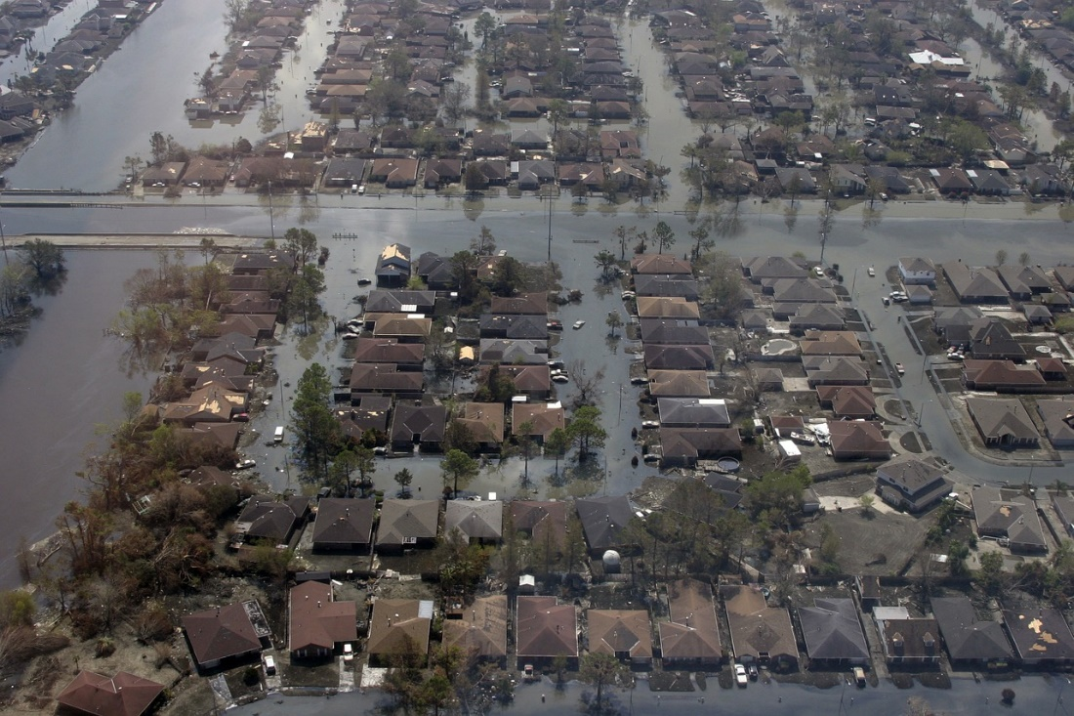
release: September 30, 2018

The Open Geospatial Consortium (OGC)
35 Main Street, Suite 5 Wayland, MA 01778 Telephone: +1-508-655-5858

Acknowledgements
The OGC expresses its gratefulness to its sponsors; US Geological Survey, Federal Geographic Data Committee and the Department of Homeland Security, for supporting this work. In addition, OGC wishes to thank the National Aeronautics and Space Administration (NASA) and the National Oceanic and Atmospheric Administration (NOAA) for hosting the two Disasters Workshops. OGC further wishes to express its gratitude to the following companies and organizations, who provided excellent contributions that have been cited this report.

Organization / Company
Department of Homeland Security (sponsor)
US Geological Survey (sponsor)
Federal Geographic Data Committee (sponsor)
AmericaView
Ardent
Canadian Armed Services
CIESIN, Columbia University
Columbia University
Croatian Crisis Management Association
CubeWerx
DigitalGlobe
Ecere
Envitia
Esri
European Union Satellite Centre
Fund for New York City
GeoScience Australia
GeoThings
German Weather Service (DWD)
Group on Earth Observations (GEO)
HazardHub
Humanitarian OpenStreetMap Team (HOT)
Hunter College of Geography
ImageMatters
Land Information New Zealand
MappingSupport
MetSafe
National Aeronautics and Space Administration (NASA)
National Oceanic and Atmospheric Administration (NOAA)
National Park Service:
Cultural Resource GIS Facility
National Center for Preservation Technology and Training (NCPTT)
Natural Resources Canada (eight groups)
New Light Technologies
New York City
New York Geospatial Catalysts
Remote Sensing Solutions Inc.
StormCenter Communications, Inc.
The W3C Maps for HTML Community Group
United States Geologic Survey
USDA Operations Center/Emergency Programs Division
xentity corporation

TABLE 1: Organizations and companies contributing to this report through the RFI
OPEN GEOSPATIAL CONSORTIUM (OGC)

Abstract
CDS Report: Development of Disaster Spatial Data Infrastructures for Disaster Resilience

OGC Disasters Interoperability Concept Development Study (CDS)
by OGC
This report presents the results of a concept development study on Disasters Interoperability, sponsored by US Geological Survey (USGS) and Federal Geographic Data Committee (FGDC), and Department of Homeland Security (DHS), and executed by the Open Geospatial Consortium (OGC). The focus of this study was to understand how to best support the development of, or combination of SDI(s) for the use in disasters, to advance the understanding of stakeholder issues, and serve stakeholders’ needs. The study included stakeholder engagements, workshops and open Request for Information (RFI) that gathered external international positions and opinions on the optimal setup and design of an SDI for disasters. The outflow of this report will guide a series of interoperability pilots to address priority challenges identified by the community in this study. The report follows the format and document of the OGC Arctic Spatial Data Pilot; Phase 1 Report: Spatial Data Sharing for the Arctic.
The report gathered the information from the RFI responses, workshops led by OGC, the Subcommittee on Disaster Reduction (SDR) a Federal interagency body of the U.S. National Science and Technology Council under the Committee on Environment, Natural Resources and Sustainability that brought together domain experts. It discusses the various types of stakeholders of an SDI for disasters with their specific needs and requirements on aspects such as data sharing, standards & interoperability, funding and investment, integration with existing systems, architecture and platform as well as security, privacy, and safety. The report further discusses various architecture models with a focus on standards required to optimize discovery, usage, and processing of data in a highly heterogeneous network of SDI data and service providers. The report concludes with several demonstration scenarios that could be used in subsequent pilots to demonstrate the value of an SDI for disasters to a broad range of stakeholders in different types of disasters. Appendix C provides a summary of the two workshops.

Contents

Acknowledgements i
Abstract iii
OGC Disasters Interoperability Concept Development Study (CDS) iii
Contents iv
List of Figures vi
List of Tables vii
List of Abbreviations viii
Chapter 1: Introduction 1
1.1 Goals, Sponsors, and Participants of this Initiative 4
1.2 Disasters SDI Linkages 6
1.3 Disasters Spatial Data Pilot Activity 6
Chapter 2: Stakeholders 8
2.1 Types of Stakeholders 8
Stakeholders 9
2.2 Needs of Stakeholders 11
2.3 Analysis of Stakeholders 12
2.3.1 Coordination and Planning of activities 12
2.3.2 Outreach and Awareness 13
2.3.3 Technology Ease of Use and Data Availability 13
Chapter 3: Requirements and Constraints 16
3.1 Open Data & Data Sharing 17
3.2 Standards and Interoperability 18
3.3 Funding and Investments 18
3.4 Integration with existing systems 19
3.5 Architecture and Platforms 20
3.6 Security, Privacy, Safety 21
Chapter 4: Architecture 22
4.1 Data Infrastructure Evolution 23
4.2 SDI Architecture Concepts 24
4.2.1 Key Infrastructure Components 24
4.2.2 Knowledge Chain Perspective 26
4.2.3 Classical SDI Technology Perspective 26
4.2.4 Architecture Requirements 30
Chapter 5: Data 34
5.1 Standards 34
5.1.1 Data Format & Access Standards 35
5.1.2 Metadata and Catalogs 36
5.1.3 Geodata Integration 37
5.1.4 Complementary Standards 38
5.2 Data Requirements 38
5.3 Data Identified in RFI Responses 40
Chapter 6: Scenarios and Use Cases 41
6.1 Exercise the Life Cycle 41
6.2 Disaster Scenario Planning for Future Pilots 42
6.3 Other Scenario Aspects 43
6.4 Pilot Development 44
Chapter 7: Operation & Organization 45
7.1 High Level Operational Goals 45
Chapter 8: Technologies & Applications 48
Chapter 9: Other Factors / Conclusion 51
Other Factors 51
Conclusion 52
Appendix A: Data Identified in RFI Responses 54
AmericaView 54
Center for International Earth Science Information Network (CIESIN) 54
DigitalGlobe 55
Group on Earth Observations (GEO) 55
Geoscience Australia 56
HazardHub Data/Models 56
Humanitarian OpenStreetMap Team (HOT) 56
Land Information New Zealand (LINZ) 57
National Park Service 57
Natural Resources Canada (NRCan) 57
Remote Sensing Solutions Inc. 58
USGS National Geospatial Program (NGP) 58
Appendix B: Disaster Management Data and Information Portals 61
Appendix C: Workshop Summaries 64
C.1 Workshop 1 64
C.2 Workshop 2 68
Appendix D: HazardHub Data/Models 72
Appendix E: NYC Public Engagement 74
Bibliography 76

List of Figures
1.1 | Disasters Geospatial Concept of Operations. . . . . . . . . . . . . . . . . . . . | 2
1.2 | Aspects of an SDI. . . . . . . . . . . . . . . . . . . . . . . . . . | 2
1.3 | US National Spatial Data Infrastructure – GeoPlatform Architecture. . . . | 3
2.1 | Types of stakeholders . . . . . . . . . . . . . . . . . . . . . . . . . . | 9
3.1 | High Level Requirements Categories | 17
4.1 | Architecture . . . . . . . . . . . . . . . . . . . . . . . . . . . . . . . | 22
4.2 | Components of a modern data platform . . . . . . . . . . . . . . . | 25
4.3 | Aspects of an SDI | 28
4.4 | Loose confederation approach | 30
4.5 | Aspects of openness | 31
5.1 | Discrete Global Grid System | 39
7.1 | High Level Operational Goals | 52

List of Tables
1 Organizations and companies contributing to this report . . . . . ii
2.1 Abbreviated List of the Disasters SDI Stakeholders . . . . . . . . . . . . . . 12

List of Abbreviations
API | Application Programming Interface
CAAS | Communication as a Service
CDS | Concept Development Study
CGDI | Canadian Geospatial Data Infrastructure
CGNDB | Canadian Geographical Names Data Base
CSV | Comma Separated Values
CSW | Catalog Service Web
DaaS | Data as a Service
DAP | Data Access Protocol
DCAT | Data Catalog Vocabulary
DHS | Department of Homeland Security
EO | Earth Observation
EOWCS | Earth Observation Profile Web Coverage Service
FGDC | Federal Geographic Data Committee
FEMA | Federal Emergency Management Agency
GEO | Group on Earth Observation
GEOSS | Global Earth Observation System of Systems
GeoXACML | Geospatial XACML
GIS | Geographic Information System
GML | Geography Markup Language
HDF | Hierarchical Data Format
HOT | Humanitarian OpenStreetMap Team
HTTP | Hypertext Transfer Protocol
IHO | International Hydrographic Organization
InaaS | Information as a Service
ISO | International Organization for Standardization
ICT | Information and Communication Technology
IT | Information Technology
JSON | JavaScript Object Notation
JSON-LD | JSON Linked Data
KML | Keyhole Markup Language
MOU | Memorandum of Understanding
NASA | National Aeronautics and Space Administration
netCDF | network Common Data Form
NGDA | FGDC National Geospatial Data Assets
NOAA | U.S. National Oceanic and Atmospheric Administration
NRCan | Natural Resources Canada
NSDI | National Spatial Data Infrastructure
OGC | Open Geospatial Consortium
OPeNDAP | Open-source Project for a Network Data Access Protocol
OSM | OpenStreetMap
PaaS | Platform as a Service
POI | Points-of-interest
RDF | Resource Description Framework
RFI | Request For Information
RFQ | Request For Quotation
SaaS | Software as a Service
SDI | Spatial Data Infrastructure
SOS | Sensor Observation Service
SPARQL | SPARQL Protocol and RDF Query Language
SWE | Sensor Web Enablement
SWG | Standards Working Group
UN-GGIM | United Nations Committee of Experts on Global Geospatial Information Ma
U.S. | United States
USGS | U.S. Geological Survey
W3C | World Wide Web Consortium
WCPS | Web Coverage Processing Service
WCS | Web Catalog Service
WFS  WMO | Web Feature Service  World Meteorological Organization
WMS | Web Mapping Service
WMTS | Web Mapping Tile Service
WPS | Web Processing Service
WS | Web Service
WSDL | Web Services Description Language
XACML | eXtensible Access Control Markup Language

Chapter 1: Introduction
Multiple jurisdictions across expansive regions are spending increasing time and resources to assist communities and citizens to prepare, respond and recover from major disaster events including hurricanes, earthquakes, flooding, disease outbreaks, extended drought, and wildfires to name a few. Globally, in the last ten years, there have been an average of 370 natural disasters and over 70,000 fatalities a year. In the U.S. alone, the cumulative cost of 16 separate billion-dollar weather events was $306.2 billion.
To avoid or minimize disaster impacts, effective coordination policies and practices as well as the efficient gathering of current and often near real-time data of known quality from a range of sources. Many local, national, and regional jurisdictions have adopted common Spatial Data Infrastructure (SDI) policies and best practices to support the sharing and exploitation of important location and condition information, and to support rapid adoption of new geoinformation sources and technologies. However, in many cases, as described in the RFI responses, these policies and practices may be inconsistently implemented and coordinated which has limited the ability of valuable information and tools to be shared and used to address disaster management.
It was noted that the NSDI has become a critical vehicle for facilitating seamless data development, information sharing, and collaborative decision-making across multiple sectors of the economy.
Geospatial information has been proven effective in supporting both the understanding of, and response to, disasters. The supported activities include identifying at-risk areas by building scientific models and analyzing historical data, assessing damage, and coordinating response teams using near real-time data.
The ability to effectively share, use, and re-use geospatial information and applications across and between public and private sector organizations in support of disaster preparation, response and resilience is dependent upon having a SDI already in-place when disaster strikes. Figure 1.1 presents an example of a U.S. Geospatial CONOPS for Disaster preparedness. This CDS and resulting pilots are expected to connect Geospatial communities across all operational tiers to bring together requirements for data, tools and services required for effective disaster management. Figure 1.2 from Natural Resources Canada, below, presents an example that shows the key aspects of an SDI. Figure 1.3 from U.S. FGDC shows the National SDI ––GeoPlatform architecture, which is a resource that can be used in natural disasters.

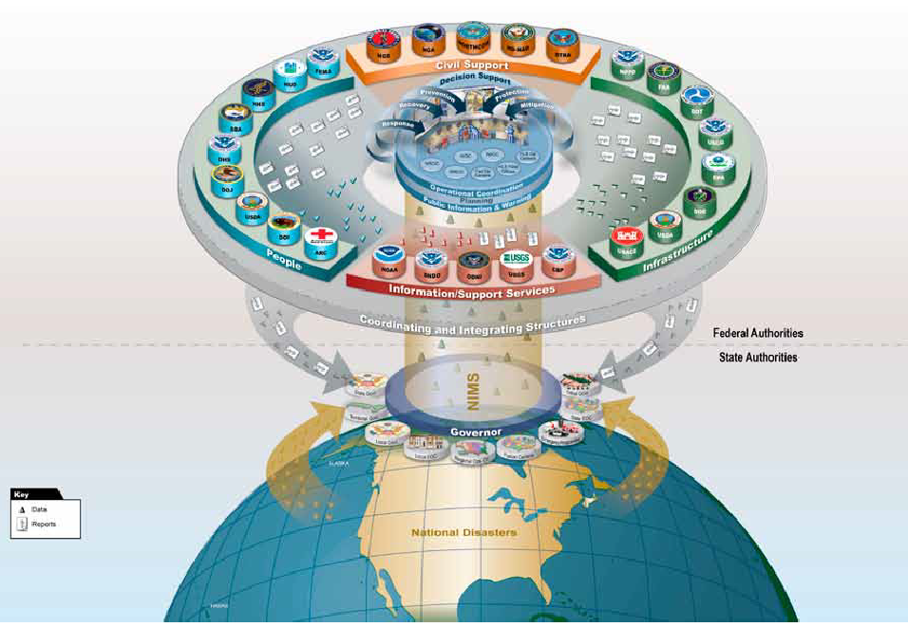
Figure 1.1: Disasters Geospatial Concept of Operations: Department of Homeland Security, USA

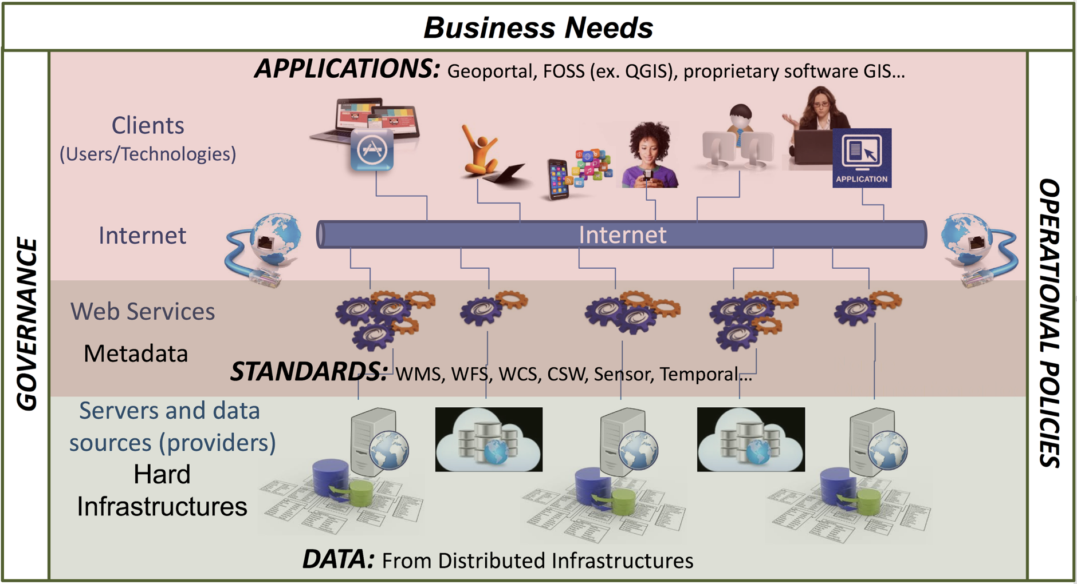
Figure 1.2: Aspects of an SDI (Source: Natural Resources Canada)

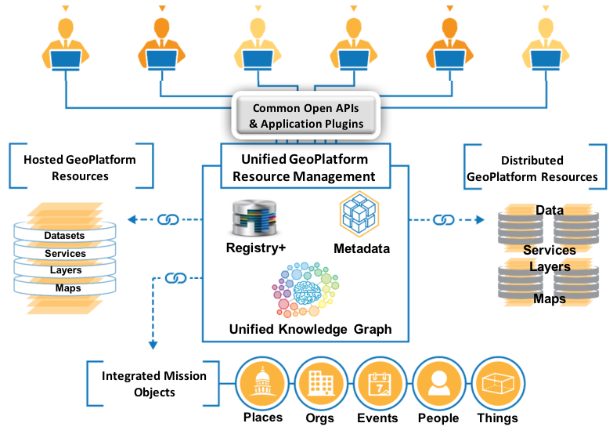
Figure 1.3: US National Spatial Data Infrastructure –– GeoPlatform Architecture

Several recurring challenges are common in disaster events.
- Lack of an integrated policy and operational framework to facilitate rapid acceptance, qualification, gestation and use of relevant geospatial information from a range of government, commercial providers and citizens.
- Inability with existing metadata approaches to quickly discover and understand which information sources are most useful in the context of a user’s need.
- Inability to properly fuse and synthesize multiple data sources locally to derive knowledge necessary for rapid disaster response decisions.
- The need for a persistent platform to organize and manage disaster related geospatial information and tools necessary for collaborating organizations to address the full disaster lifecycle – preparedness, response and recovery.
Interoperability and open standards are core to any spatial data infrastructure for disasters, as they enable the exchange of geospatial data and the use of data in the processing, visualization, and representation services in distributed systems most efficiently. The economic benefits of building systems based on standards has been shown in many studies (e.g., DIN 2011).
The focus of this study was to understand how to best support the development of an SDI for disasters and how to make existing implementations i) better known to stakeholders, and ii) better in serving the needs of stakeholders. The study included an open Request for Information (RFI) with the objective to gather community positions and opinions on the optimal setup and design of an SDI for disasters. Responses to this RFI and information gathered during two workshops have been integrated into this report. The varied responses to the RFI demonstrate the value of standards in an environment that is principally built as a system of systems, i.e., a Disaster Spatial Data Infrastructure that integrates a number of existing systems as well as individual services, data repositories and near real-time sensor data access.
The report discusses the various types of stakeholders of an SDI for disasters examining their specific needs (Chapter 2) and then examines requirements and constraints on aspects such as data sharing, standards and interoperability, funding and investment, integration with existing systems, architecture and platform as well as security, privacy, and safety (Chapter 3), The report then explores possible SDI architecture models (Chapter 4), data, standards and interoperability, including aspects to optimize discovery, usage, and processing of data in a highly heterogeneous network of SDI data and service providers (Chapter 5). This then leads to an outline of various use cases and scenarios that could be used in a series of pilots to demonstrate the value of a Disasters SDI to a broad range of stakeholders (Chapter 6). The report discusses operational and organizational requirements and goals (Chapter 7) and concludes with a discussion of applications and technologies (Chapter 8) along with other factors received from the RFI responses that may be considered when building an effective Disasters SDI (Chapter 9).

Goals, Sponsors, and Participants of this Initiative
The Disasters Interoperability CDS is sponsored with a North American focus yet is scalable to the entire geospatial community. The project supports the evolution of the GeoPlatform, developed by FGDC. To be successful, the Disasters Interoperability CDS must take particular requirements into account, including responding to priorities of First Responders, working in zero/low bandwidth regions and considering the realities of quickly changing circumstances.
The future follow on pilots that result from the work in the Disasters Interoperability CDS will play a key role in addressing a range of complex issues where geospatial data are necessary, such as responsible disaster planning, response and recovery, and security. Any Disasters SDI aims to make geospatial information available in a standardized way to the First Responders, public, academic institutions, the private sector, and stakeholders who are involved in conducting disaster response, research, or produce value-added products and applications, driving innovation and stimulating economic development. Geospatial data, services and applications accessed through the GeoPlatform and similar platforms will help agencies understand the lifecycle of disasters, facilitating monitoring, management, mitigation, emergency preparedness, and decision making.
Organization managing the RFI
The Open Geospatial Consortium (OGC) is an international consortium of more than 500 companies, government agencies, research organizations, and universities participating in a consensus process to develop publicly available geospatial standards. OGC standards support interoperable solutions that "geo-enable" the Web, wireless and location-based services, and mainstream IT. OGC standards empower technology developers to make geospatial information and services accessible and useful with any application that needs to be geospatially enabled.
Sponsors
The Department of Homeland Security (DHS) provides the coordinated, comprehensive federal response in the event of a terrorist attack, natural disaster or other large-scale emergency while working with federal, state, local, and private sector partners to ensure a swift and effective recovery effort.
US Federal Geographic Data Committee (FGDC) is an interagency committee that promotes the coordinated use, sharing, and dissemination of geospatial data on a national basis. The FGDC is composed of representatives from 32 Cabinet-level and independent Federal agencies. The FGDC is an organized structure of Federal geospatial professionals and constituents that provide executive, managerial, and advisory direction and oversight for geospatial management and policy across the Federal government.
As the largest water, earth, and biological science and civilian mapping agency of the United States, the U.S. Geological Survey (USGS) collects, monitors, and analyzes data and information, and provides scientific understanding about natural resource conditions, issues, and problems. The diversity of its scientific expertise enables USGS to carry out large-scale, multi-disciplinary investigations and provide impartial scientific information to resource managers, planners, and other customers.
The National Aeronautics and Space Administration (NASA) AMES Research Center and National Oceanic and Atmospheric Administration (NOAA) hosted the two Disasters Workshops. Both agencies have provided long term commitment to the Open Geospatial Consortium and open standards, as well as supported an open data policy.

1.2 Disasters SDI Linkages
There are a number of SDI initiatives addressing disasters, such as the US National Spatial Data Infrastructure (NSDI).
"The NSDI has come to be seen as the technology, policies, criteria, standards and people necessary to promote geospatial data sharing throughout all levels of government, the private and non-profit sectors, and academia. It provides a base or structure of practices and relationships among data producers and users that facilitates data sharing and use. It is a set of actions and new ways of accessing, sharing and using geographic data that enables far more comprehensive analysis of data to help decision-makers choose the best course(s) of action." FGDC
The vision of the NSDI is to leverage investments in people, technology, data, and procedures to create and provide the geospatial knowledge required to understand, protect, and promote national and global interests.

1.3 Disasters Spatial Data Pilot Activity
The Disasters Concept Development is the first phase activity that helped capture the requirements, gaps and priorities to advance SDIs in the use of disasters. The second phase will be a series of OGC pilot initiatives with active involvement of several OGC member organizations.
Both the OGC Concept Development Study and Pilot leverage using OGC’s proven Innovation Program rapid prototyping and engineering process. The Innovation Program unites technology providers and users in hands on collaborative initiative to identify and address significant interoperability challenges.
The CDS phase develops an overall assessment of geospatial Web services across the disaster domain, defines the core components of the National SDI architecture for disasters (Disasters SDI), and defines use cases and scenarios for future implementations as part of the follow-on pilot phase. These activities were complemented by the request for information (RFI) and two workshops to capture the various perspectives, requirements, and opinions by disaster stakeholders and contributors.
The goal of the pilot phase is to illustrate and demonstrate the value and usefulness of standards-based interoperability in the context of addressing specific challenges identified in the CDS phase. This will be done by implementing the recommended Disasters SDI architecture and developing a demonstration video that will tell the story of the scenario(s) and showcase incorporation of the services into GeoPortal SDI and other applications.

Chapter 2: Stakeholders

2.1 Types of Stakeholders
Through the analysis of the RFI responses and information gathered from Workshops, there emerges multiple, orthogonal ways to describe relevant stakeholders in the context of a Disasters SDI. The range of stakeholders have been differentiated into five classes (See Figure 2.1): End-users, data producers, data providers, data processors, data handlers, and policy makers. The classes are not mutually exclusive, and many organizations or individuals are members of more than one class. Each class has some level of influence on each other, illustrated by the circular arrows connecting the classes.
The wide class of end-users includes all consumers of products provided by the other classes such as data and services, products in the form of reports and statistics, policies and regulations, etc. The second class aggregates all data producers or creators, data providers, data brokers, and value-added re-sellers. This large group is of particular relevance, as it is responsible for one of the main products of the Disasters SDI: the data. The third group covers data processors such as GIS, data scientists, data modelers, mapping experts, or others in the high-end supercomputing environment who are addressing the complexity of near or real-time analytics / forecasting geospatial products. These experts create products such as analyses, reports, statistics, or maps using data provided by the previous group. The fourth group, data handlers is somewhat orthogonal to the previous three, and includes the hardware, storage, and computing service providers that provide the necessary infrastructure for data exchange and processing. The last group, Policy makers, is orthogonal to the ones described before. It lays out the necessary rules and guidelines for a successful operation and governance of a Disasters SDI.
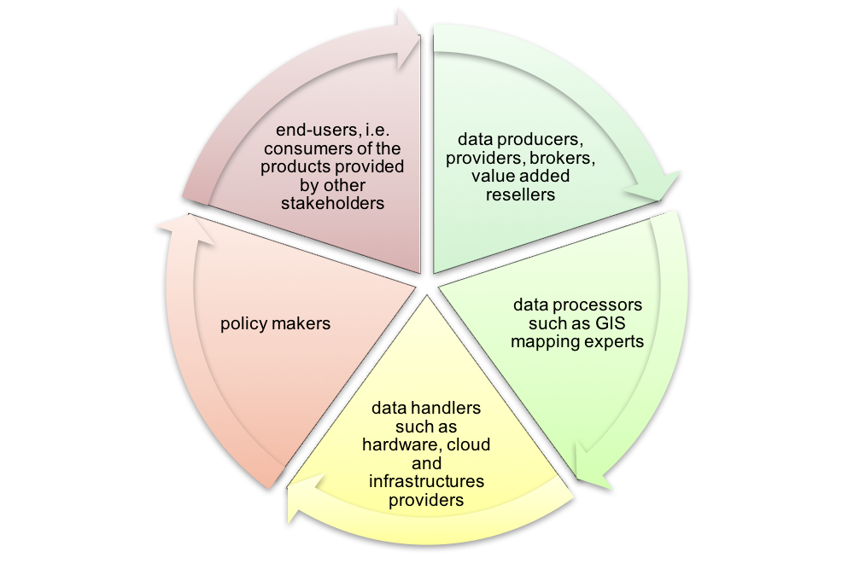
F
IGURE
2.1:
Types of Stakeholders
The stakeholders classified in one or many of these five classes come from a wide range of organizations. An already long, though still non-exclusive, list is provided in table 2.1.

Stakeholders

Data Producers, Providers, Brokers, Value-added Resellers
First Responders: Police, Fire, EMS including 911 Systems
Public Works
Transportation
GIS and Information Technology: 311 System, Internet and Social Media
Federal FEMA, DoD/NGA, DOT, DHS, USGS, Coast Guard, NOAA, U.S. Census, etc., Search and rescue officials
Note: The DHS GeoCONOPS details dozens of Federal capabilities.
State EM, Police, DOT, DEP, etc.
Authorities: Port Authority, Metropolitan Transportation Authority, others
Utility companies/organizations: Water and Sewer, Gas, Electric
Academic and educational institutions
Commercial data / analytic providers
Insurance companies
The General Public

Data Processors
Commercial data / analytic providers
Federal FEMA, DoD/NGA, DOT, DHS, USGS, Coast Guard, NOAA, U.S. Census, etc.,
Software developers
Mapping and GIS experts
Disaster Management boards and groups
Public Works
Insurance companies
Transportation
Academic and educational institutions

Data Handlers, Infrastructure Providers
Federal FEMA, DoD/NGA, DOT, DHS, USGS, Coast Guard, NOAA, U.S. Census, etc.,
Local Government Agencies
Internet and Social Media
State EM, Police, DOT, DEP, etc.
Authorities: Port Authority, Metropolitan Transportation Authority, others
Disaster Management boards and groups
NGO Service Providers such as the Red Cross and other helping organizations
Academic and educational institutions

Policy Makers
First Responders: Police, Fire, EMS
Environmental Protection
State and Federal Agencies, Public Authorities
Local Government Agencies
State EM, Police, DOT, DEP, etc.
Authorities: Port Authority, Metropolitan Transportation Authority, others
First Responders: Police, Fire, EMS including 911 Systems for each
Health and Hospitals
Environmental Protection
Public Works
Standards Developing Organizations
Disaster Management boards and groups
Insurance companies

End Users
First Responders: Police, Fire, EMS including 911 Systems
Public Works
Transportation
GIS and Information Technology: 311 System, Internet and Social Media
Federal FEMA, DoD/NGA, DOT, DHS, USGS, Coast Guard, NOAA, U.S. Census, etc., Search and rescue officials
Note: The DHS GeoCONOPS details dozens of Federal capabilities.
State EM, Police, DOT, DEP, etc.
Authorities: Port Authority, Metropolitan Transportation Authority, others
Utility companies/organizations: Water and Sewer, Gas, Electric
Academic and educational institutions
Insurance companies
Human Services
Fuel providers including gasoline stations, shipping depots, storage facilities
Providers of fuel, bottled water, food and other vital supplies
Contractors for a wide range of construction and repair services, also providing heavy equipment.
NGO Service Providers such as the Red Cross and other helping organizations
Property owners and building managers
Academic and educational institutions
The General Public

TABLE 2.1: Abbreviated List of the Disasters SDI Stakeholders
Many of the organizations included in this long list have been emphasized as particularly relevant by respondents to the Disasters CDS RFI. The editors of the Engineering Report continue to welcome the involvement and contributions of anyone involved in disaster management willing to support the goals and objectives of this pilot. These include a list of individuals that can help facilitate contact and engagement of a number of organizations as provided in Appendix A.

2.2 Needs of Stakeholders
From an analysis of the RFI responses, and information discussed and presented at workshops, the stakeholder needs relevant to a Disasters SDI can be distilled and summarized as follows.
- The Disasters SDI should provide stakeholders with appropriate access to the spatial data they need. These data can be static as well as dynamic data that arise before, during and after the disaster.
- The Disasters SDI should allow different stakeholders at different locations to access the SDI.
- The Disasters SDI should allow for data exchange, especially the dynamic data, in an appropriate, efficient and secure way.
These three needs are a simplification of the wide variety of needs facing stakeholders. However, keeping these three requirements top-of-mind when during implementation will lead to a more effective, useful and dynamic Disasters SDI for all stakeholders.
A more detailed analysis of stakeholders is described in the remaining sections of this chapter and a further examination of stakeholder needs is described in Chapter 3: Requirements and Constraints.

2.3 Analysis of Stakeholders
The challenge is to manage both the data/analytic contributions, and the data/analytical needs of the many organizations responding to a major disaster during a period when an overload of new data is pouring into the response community on a minute by minute basis. Obviously, preparedness and planning phases are critical to make things work right during an incident. The computer and telecommunications infrastructure leveraged during a response must be designed to scale up in order to handle the largest imaginable disaster loads.
The engagement of stakeholders and the awareness raising of the Disasters SDI among potential stakeholders are key goals of the Disasters Interoperability CDS. First and foremost, the best way to get stakeholders involved and well served is to meet their needs. This requires making data easy to find, use, and understand. This report covers guidelines and experiences from a significant number of disaster data management experts to identify the best way to achieve these essential requirements. In addition, ease of use, reliability, and completeness, are further dimensions that can be actively pursued. The following three subsections identify aspects that need to be addressed in order to improve the participation and integration of stakeholders.

2.3.1 Coordination and Planning of activities
Coordination of SDI related activities and collaboration among the various organizations involved is a critical success factor for a Disasters SDI. A successful shared SDI would be a stepping stone to other collaboration activities that could focus on increased data collection, introduction of robust monitoring programs and ideally reduced duplication of effort. Fostering early coordination and planning and encouraging transparency within the public sector so that collection priorities and data requirements are clearly stated and the most efficient approach can be applied ensure that end user needs are met.

2.3.2 Outreach and Awareness
Outreach and awareness activities help to attract new stakeholders and to reassure the importance of the Disasters SDI among stakeholders already involved or at least aware of the relevance of a Disasters SDI. Combined with early coordination activities, outreach and awareness activities across stakeholders help to maximize efficiency and transparency, which are crucial components leading to acceptance and eventually success of a Disasters SDI. The following is a guideline related to outreach activities.
- Perform outreach activities including social media, story maps, press releases, conference presentations, websites, on-line and in-classroom training classes, books, etc.
- Promote the use of crowdsourcing and resultant information in the disaster lifecycle.
- Consider developing a White Paper to guide discussion and comment at both ministerial and senior management level across all stakeholders.
- Improve collaboration between the public and private sectors to share lessons learned, establish best practices, and keep abreast of technology advancements.
- Participate in the trade shows, symposiums, workshops and conferences.

2.3.3 Technology Ease of Use and Data Availability
Technology ease of use, coupled with reliability, greatly impacts stakeholder adoption rates as well as ensuring users are successful. Thus, the best outreach is probably achieved by word of mouth, triggered by an excellent implementation of a Disasters SDI serving all stakeholders needs.
Another aspect that needs to be carefully revisited is the integration of a Disasters SDI with existing regional and national Spatial Data Infrastructures, such as US NSDI. Further attention shall be given to the integration of data and apps (applications that use the data) into widely deployed and used platforms. Simply put, some stakeholders are better served by integrating data and apps into the tools they use. For geospatial scientists it means being tightly integrated into their GIS; for policy stakeholders it would mean simple story maps, creating dashboard using statistical and geospatial data tied to policy questions; and for scientist it would mean integration of datasets with a variety of tools. Additionally, stand-alone Disaster Portals must be designed for ease of use and must be interoperable with each other and be reliably available and secure. To achieve this level of integration, standards defining generic data containers or Web service interfaces for easy data access are of overall importance.
Any successful Disasters SDI needs to take into account the particular disaster situation. The SDI needs to find ways to incorporate static knowledge together with dynamic, fast changing information.

Chapter 3: Requirements and Constraints
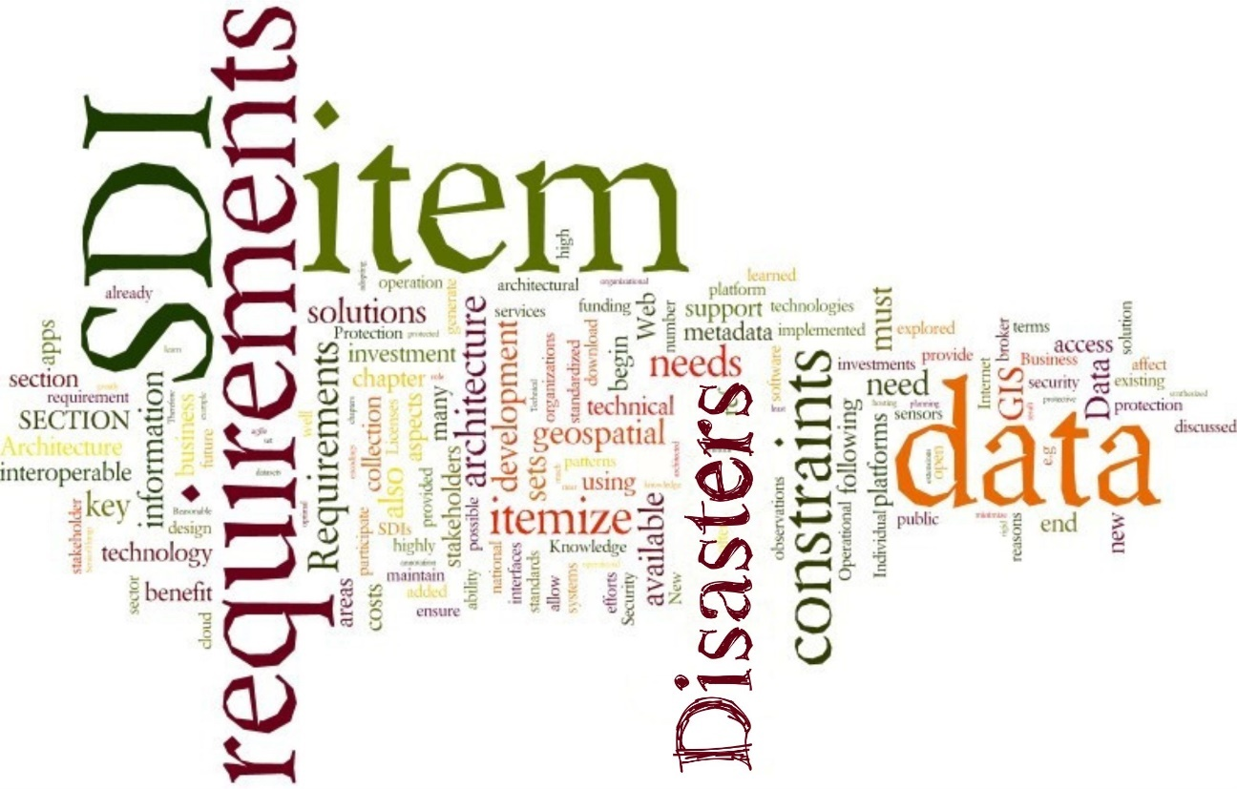
The stakeholder needs discussed in Chapter 2 result in a number of requirements and constraints on an optimal Disasters SDI that will be expanded upon in in this chapter. Requirements and constraints will be explored in terms of data sharing, standards and interoperability, funding and investment, integration with existing systems, agility and adaptability, and security, privacy and safety. Figure 3.1 illustrates these categories.
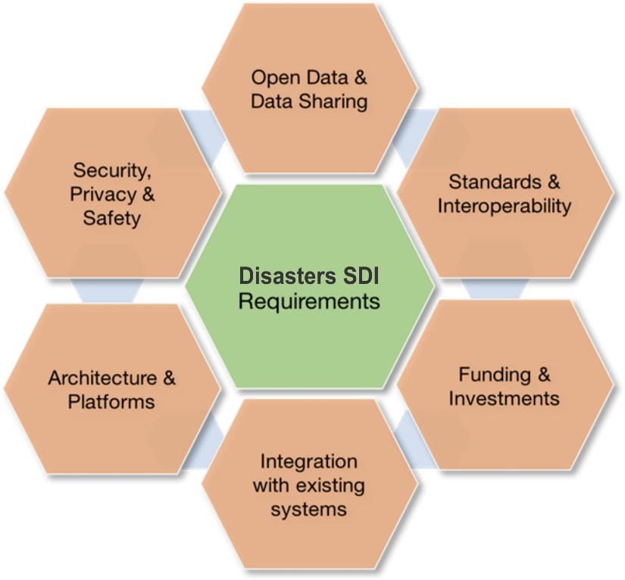
FIGURE 3.1: High level requirement categories
The following sections will briefly discuss more details on the various categories to ensure a robust baseline for the development of a Disasters SDI architecture and operations as discussed in Chapters 4 and 7.

3.1 Open Data & Data Sharing
Open Data & Data sharing addresses both legal as well as technical aspects such as how to enable data sharing among disparate and heterogeneous endpoints and systems using common data models and schemas. Open data is the idea that some data should be freely available to everyone to use and republish as they wish, without restrictions from copyright, patents or other mechanisms of control. Open Data & Data Sharing further addresses organizational aspects such as how to encourage data sharing with social or economic incentives and enforcement of rules.
- Any Disasters SDI shall broker both the delivery of government and non-governmental information or data.
- Integration of near real-time observations from both satellites and in-situ sensors is key. Traditionally, this has not been easily achieved due to the proprietary nature of the sensor interfaces. New technologies such as SensorThings API shall be implemented. Also, auto-registry of sensors is a key requirement.
- The architecture shall support creation and exchange of research-oriented synthesized data sets (i.e., simulation model outputs).
- All data shall be accompanied by metadata. As this requirement is extremely tough to implement, new ways shall be explored to minimize the need for manually generated metadata.

3.2 Standards and Interoperability
Standards and Interoperability addresses mechanisms and agreements to ensure that components being part of or that are loosely connected to a Disasters SDI can communicate with each other.
- Interoperability of SDI components across platforms is of overall importance.
- Data in standardized formats should be served by Web interfaces using standardized encodings.
- Standards-based Web GIS integrates and leverages all the investments that have already been made in GIS standards, data, and technologies. Any Disasters SDI should benefit from these investments and should be based on Web GIS patterns.
- Detailed compliance tests shall be available to ensure interoperability across components.
- Unstructured data feeds should be analyzed to determine the best format to enable sharing with other users for further process in the disaster workflow.

3.3 Funding and Investments
The operation and maintenance of a successful Disasters SDI generates substantial costs that need to be covered by funding agencies or invested by companies with the goal to generate proportionate profit in the future. In terms of business needs, the following aspects need to be considered.
- Adequate funding from the various organizations; at least initially.
- Development of relevant applications in the private sector to generate desirable return on investment.
- Recognition of geospatial data as an investment rather than a cost, which is possible through geospatial consortia making the data interoperable between different users to be utilized in an interoperable manner.
- Any Disasters SDI shall consider not only one-time costs associated with implementing the solution but the ongoing requirements to support, maintain, and enhance the solution over its lifecycle to ensure it continues to deliver value and meet stakeholder needs.
- Individual management objectives, priorities, planning cycles, and investment capacity are all constraints that will affect an organizations ability to participate in the development of an SDI.
- Any Disasters SDI shall be prepared for eroding national or organizational technical infrastructures.
- Cost efficiency is key and provided as much as possible out-of-the-box meaning using existing cloud hosting and geospatial solutions and without the added expense of in-house software development.

3.4 Integration with existing systems
Integration with existing systems is a critical aspect to ensure neat integration of data hosted in external systems and the protection of investments in other SDIs or platforms that shall be conserved. Therefore, the Disasters SDI shall:
- Coordinate with National Mapping authorities that provide data;
- Coordinate with international SDIs such as INSPIRE or GEOSS;
- Integrate with national and regional SDIs such as US NSDI, CGSI, without replicating already available resources;
- Integrate with and support widely deployed geographic information systems (GIS);
- Not be perceived as a competitor to local, regional, or national SDIs; and
- Integrate data platforms operated by national space agencies or other organizations providing satellite-derived data products.

3.5 Architecture and Platforms
Architecture and Platform aspects play a key role in distributed spatial data collection, exploration, and processing environments; and need to ensure that the targeted Disasters SDI can keep pace with changing technologies and Internet trends. The following high-level requirements have been identified.
- Development efforts for any SDI could be constrained by how prescriptive the architectural design is at the outset. To benefit from rapidly improving technology, a Disasters SDI needs to remain agile. Architectural decisions affect costs to the participants and the ability to benefit as technology changes. Early architectural decision can translate into constraints if they are too rigid in their approach. Therefore, questions such as these must be addressed:
  - Will the Disasters SDI be a closely architected approach where the platform itself consists of the infrastructure, the content, any number of APIs and SDKs, and application and content management tools, or
  - Will the Disasters SDI be a loose confederation of portals and platforms discoverable by open specifications and standards allowing as-is communities to participate, or
  - Will the Disasters SDI be a combination of the two approaches?
- Multi-linguism and technical language requirements should be considered.
- Technical knowledge and availability of skills is often a limiting factor in stakeholders adopting technical solutions, or in continuing efforts to maintain solutions already in place. The architecture has to cater for greatly varying paces at which organizations adapt new technology and will have to bridge a wide variety of technical solutions of differing ages and platforms.
- A Disasters SDI shall be very dynamic (in contrast to many other SDIs, that tend to be static), because change is occurring at a very high rate. New data sets are constantly being added and the huge number of monitoring data sets are updated constantly.
- A Disasters SDI should be also designed for no- or low-bandwidth areas where the Internet may not be readily available due to damaged infrastructure from the disaster event. Disasters SDI designers must decide if they will provide infrastructure as well as data and apps. Examples of using data appliances that are loaded with data, software, and apps shall be explored.
- Intuitive site structure/navigation with best practices to lower the entry barrier to SDIs.
- Efficient search functionality and fast download rates.
- The architecture shall allow for future extensions and allow the integration of upcoming new patterns to handle e.g., Big Data or semantic annotation.

3.6 Security, Privacy, Safety
Security, Privacy and Safety includes aspects such as vulnerability to attacks, acceptance and assurance of privacy concerns, secure and reliable access, protection of intellectual property rights, and assurance of system availability in critical situations, e.g. emergency responses or major crises. Additional items mentioned in RFI responses include the following.
- Many data-sets are access-protected for good reasons (e.g., security implications or commercial or government interests). Though these reasons are fully acknowledged, SDI design should provide for obtaining information about how to access datasets that are not open but may be accessed through some other means. For example, industrial stakeholders who procure their own data collection programs often are protective of the data set but are willing to share them under certain circumstances. The necessary brokering, including dealing with protected datasets, must be addressed.
- Foundational data should be provided as license-free data by the public sector during disasters.
- Individual logins, firewall protection, and a secure server connection capable of transferring and storing highly sensitive data need to be available.

Chapter 4: Architecture
The architecture of an SDI is a multi-dimensional concept, including software, hardware, deployments, networks, operations, federations and many others. Figure 4.1 identifies many aspects that play a role in architecture design and definition.

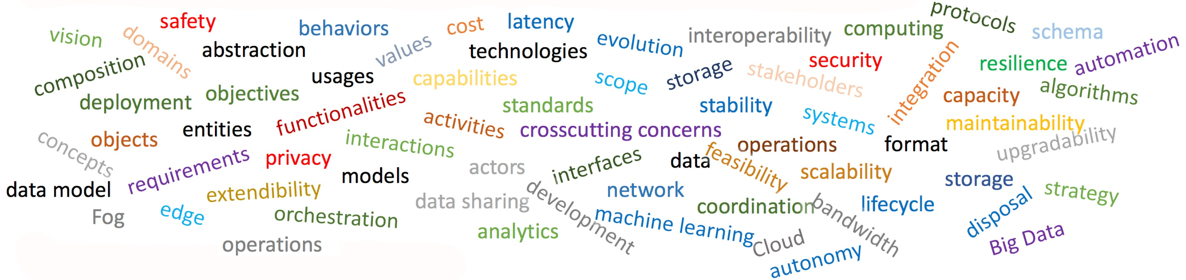
FIGURE 4.1: Architectural Aspects that Need Consideration
The main goal of this Disasters Interoperability CDS and the follow-on pilots is to demonstrate the value of an SDI for Disasters to a broad range of stakeholders. As discussed in chapter 2.3.3, one of the best approaches to demonstrate value and increase stakeholders’ adoption rates is an excellent implementation of a Disasters SDI serving all stakeholders needs. In the simplest terms, as described in section chapter 2, these needs were summarized as follows.
- The Disasters SDI should provide stakeholders with appropriate access to the spatial data they need. These data can be static as well as dynamic data that arise before, during and after the disaster.
- The Disasters SDI should allow different stakeholders at different locations to access the SDI.
- The Disasters SDI should allow for data exchange, especially the dynamic data, in an appropriate, efficient and secure way.
A further discussion of requirements was conducted in Chapter 3 covering areas such as open data & data sharing, standards and interoperability, funding and investments, integration with existing systems, architecture and platforms, security, privacy, and safety. This chapter discusses architecture perspectives and concentrates on a number of key aspects to support the future development and extension of any Disasters SDI without necessarily being a blueprint ready for implementation.

4.1 Data Infrastructure Evolution
There is already a considerable data available on the Internet through portals and other SDIs that vary considerably in function, scope, capability, and content. Appendix B provides an overview of some of these existing data sources. The disaster management community and responders to this RFI are well aware that there are many opportunities for improvement in how data to be used in disaster management are stored, managed, discovered, and delivered to users, and RFI respondents and workshop attendees are tending to work collaboratively with, at time, limited resources, to improve the situation.
The development of disasters SDI is occurring within a context of rapid growth in the provision of data and change in user expectations about access to and use of such data. The data available, that can be brought to bear on any disaster scenario, is growing in volume, velocity, variety, precision, and value. This is increasing the complexity of scenarios for data exploitation, as well as the resources required by the communities using the data. A number of groups and RFI respondents are developing innovative approaches to the creation of data platforms. These approaches share some common characteristics, as follow.
- Individual parameters by themselves are not nearly as valuable as integrated data sets. Therefore, the trend is to provide data platform users with access to a wide range of data types that they can be exploited together.
- Data dissemination to first responders can be very challenging due to limited bandwidth availability during disaster scenarios.
- With the explosion of the data that are available, data discovery and analysis is becoming increasingly challenging. As a result, the trend is to include sophisticated data visualization tools to enable data platform users to easily see and understand both the data they can utilize and the results of their analysis of that data. Future pilots and perhaps testbeds will need to consider recommendations for including artificial intelligence and machine learning. An emphasis for the pilots could be focusing heavily on these methodologies, including complex data preprocessing to provide first responders with “decision ready” information for use.
- For any given disaster, much of the data is very dynamic. That is to say that the information is changing rapidly and needs to be accessed in near real-time.
- The quantity of data available, especially earth observation (EO) data, means that it is often not practical for each user to download the data they need to their local environment. Rather, the trend is to bring the algorithms to the data and only download the results of their calculations.
- Working with large data sets is often computationally intensive. This means that modern data platforms need to provide users with highly capable information and communication (ICT) technology infrastructure for data processing, storage, and networking.
- The increasing diversity of data sources and the need for operational communities to access data unfamiliar to them makes it essential that usable data quality information is available for all products.
- There is an aversion to lock-in with any one technology or supplier.

4.2 SDI Architecture Concepts
The ideal Disasters SDI architecture includes many facets that will need to be addressed in detail in the next phase of a Disasters CDS Pilot. To avoid restricting the exploration activities planned for the pilot, this document will concentrate here on several rather high-level views on the architecture, including key components of a future ideal SDI architecture, knowledge generation views, and technical perspectives demonstrating the current state of the art in terms of existing SDI components and installations to reflect real world component renewing cycles and operational realities.

4.2.1 Key Infrastructure Components
Taking the characteristics discussed in chapter 3.1 into account, it can be summarized that modern spatial data platforms are going far beyond traditional data portals by combining multiple functionalities and making them available (often in the cloud). The components of a modern data platform are shown in Figure 4.2, representing an ideal high-level architecture of an integrated Disasters information system for Disaster Mitigation, Preparedness, Response, and Recovery.
This high-level architecture contains the following major components.
- Community as a Service (CaaS): Collaborative tools for users to publish, share and discuss their results, information, data and software/code on the platform. Social networking makes a new level of online collaboration among communities of practice possible.

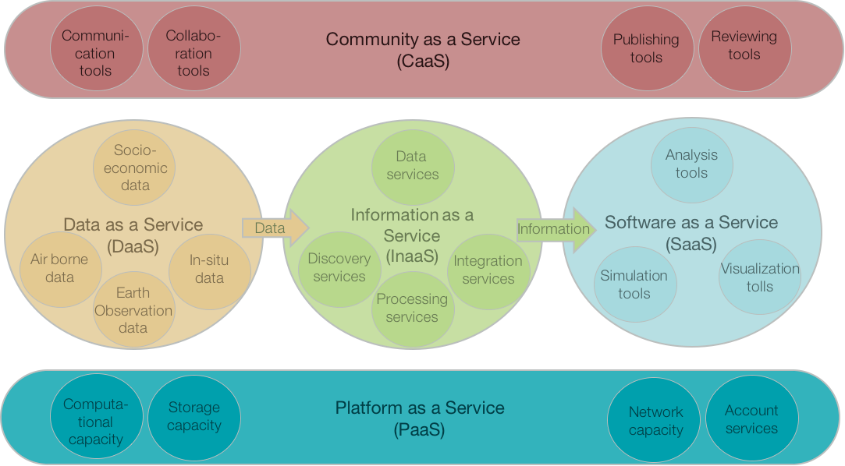
FIGURE 4.2: Components of a modern data platform
- Data as a Service (DaaS): On-demand data sharing through discovery, access, and transportation. Data sets can cover earth observation, air-borne and in-situ sensors, as well as other socio-economic data. The emergence of service-oriented architecture has rendered the actual platform on which the data resides less relevant.
- Information as a Service (InaaS): The ability to provide standardized and secure methods to create, manage, exchange, and extract meaningful information from all available data in the right format at the right time.
- Software as a Service (SaaS): Delivery and management of applications and tools by the platform or its users that are used remotely on the platform. Provides users with the capability to deploy user-created or acquired applications.
- Infrastructure as a Service (IaaS): The provision of computing resources, complemented by storage and networking capabilities, as shared resources, scalable on-demand, and enabling cost efficiencies.
Systems implementing these components integrate a number of functionalities that are crucial for modern spatial data infrastructures. Almost all elements are provided by services, which allows to serve the full spectrum from raw data access to highly customer-tailored products. This approach improves the ease of use for a large group of heterogeneous stakeholders using different platforms, including First Responders with almost no Internet connectivity to scientists with fiber optics and supercomputers, or infrastructure novices to data processing experts. They reflect the growing complexity of research and analysis situations and provide the necessary communication infrastructure to connect distributed stakeholders. They take into account that data cannot be transferred to customers in all situations but needs to be processed close to the physical data stores to minimize transport issues, which are either caused by limited physical bandwidth or by sheer amount of data that needs to be transferred. Cloud technologies support further evolvement of the infrastructure as resources can be added on demand.

4.2.2 Knowledge Chain Perspective
The first perspective discussed in 4.2.1 above illustrated a high-level future architecture. A different position is taken in this chapter to bridge to the technical architecture as it can be realistically implemented within the next few years, while at the same time being extended step-wise and evolutionary with modern concepts as they reach production level maturity.
From a knowledge generation perspective, an SDI for disasters should ideally consider the full data value chain that includes connecting to earth observation and in-situ sensor networks, providing mechanisms for storing and hosting data (when hosting is not possible at the data source), make the data discoverable and enable use of the data in different media and accounting for both online and offline use. From a Disasters SDI, content may be disseminated to or retrieved from other global or national networks such as GEOSS, United States Geospatial Platform, WMO, and others. This increases visibility of the Disaster Management data and information products.
At the same time, data might be served from storage and server components being part of other SDIs or data portal APIs. A large number of data providers, portals and access points exist and will remain active in the future and new ones will appear. It is one of the goals of a future pilot to demonstrate the value of an SDI as being part of an application scenario that involves data registered and served at other SDI or portal API instances.

4.2.3 Classical SDI Technology Perspective
When it comes to SDI design reflected in the RFI responses, two important approaches must be differentiated. They are not mutually exclusive and a chosen approach can still be complemented by the other. In fact, both approaches represent the two extremes of a given continuum, with most implementations featuring some level of middle course. Nevertheless, the architecture design differs depending on the preferred approach. The first approach focuses on the Disasters SDI as a closely architected infrastructure that provides data and apps as services. Thus, the defined architecture caters for a defined set of services (includes rehosted services) that are operated and maintained by an SDI control board, i.e., a group with control over the individual components. The second approach focuses on infrastructures, platforms, and geoportals as they currently exist and emphasizes their integration into a loose confederation. Here, emphasis is on discoverability and integration based on open standards. The first puts more control into the hands of the control board, whereas the second provides more flexibility and distributed responsibilities. Key to both approaches is the strong adherence to standards to avoid vendor lock-in with limited flexibility and extensibility. It should be emphasized that both approaches can complement each other, i.e., they do not necessarily act in isolation, but support interfaces to allow mutual usage.

Closely Architected Approach
The first, closely architected approach is illustrated in figure 4.3. The platform itself consists of the infrastructure, the content, any number of APIs and SDKs, and application and content management tools. The actual applications or usually provided as external components or as web-based thin clients. Key here is the fact that the entire system focuses on the single platform concept, which means that the individual layers and implemented aspects are not particular characteristics of the closely architected approach. It is the way they are implemented and linked with each other.
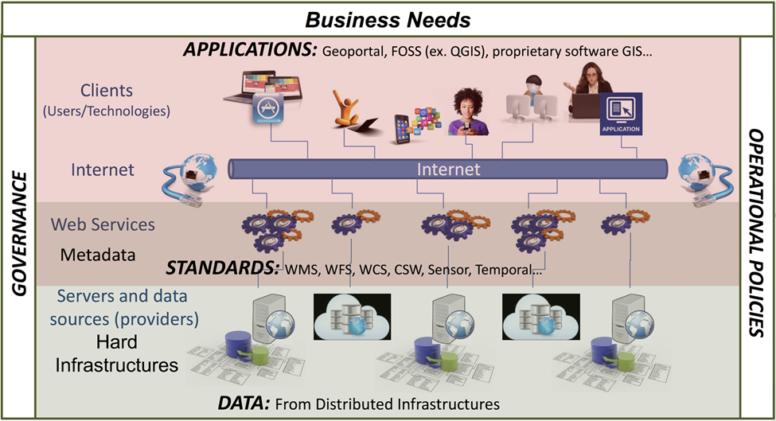
FIGURE 4.3: Aspects of an SDI (Source: Natural Resources Canada) Modified)

The infrastructure includes the hardware and software needed to operate a Disasters SDI. The infrastructure design will need to take into consideration the different user scenarios, data sources (either managed by the SDI or coming from third party sources), appropriateness of cloud technologies, current and future IT policies, and existing hosting capacity. The SDI will need to account for offline use situations. To mitigate these, the SDI could consider using data appliances, container formats such as GeoPackage, or programs such as Geonetcast.
The content aspect of the Disasters SDI can be broken down into the following.
- The geospatial data management includes the technologies and workflows for managing vector and raster data that will be managed and used in the Disasters SDI. Following the best practices defined by the Federal Geographic Data Committee (FGDC) for the National Spatial Data Infrastructure (NSDI), the Disasters SDI would define the key spatial and nonspatial data layers that support the needs of the use cases of the Disasters SDI. For these data layers, data management and portfolio management policies and procedures need to be defined. This includes but is not limited to data models, data update frequencies, conflation of multi-source data, data quality assurance, and availability assurances.
- The real-time data management includes the technologies and workflows for ingesting and using real-time data feeds such as sensor feeds, personnel tracking, news feeds, and feeds from other systems relevant for the Disasters SDI.
- Data integration with 3rd-party systems allows to feed or consume data from the Disasters SDI. For this, a Web services approach using common service interface specifications that build on international standards from the World Wide Web Consortium (W3C), the OGC, and others are recommended.
APIs and SDKs: If data is the fuel of an SDI, Application Programming Interfaces (API) and Software Development Kits (SDK) form the engine that powers the applications and integration with 3rd-party components. Whatever platform is selected, it needs to offer an effective way to create and manage geospatial applications to developers. The offered APIs and SDKs shall support building web, mobile, and desktop apps that incorporate mapping, visualization, analysis, and more.
The Application and Content Management component provides the tools and concepts that allow for organizing the content in the Disasters SDI in logical and easy to understand groups of thematic or organizational structures. Content Management is typically done through portals.
Applications: The entire platform will be accessed through a number of applications that are tailored to the specific user audiences of the SDI. This component may include map applications for viewing, editing, analyzing, and collecting content. The applications may vary from templates that are used to tell stories around specific issues Disaster Management to advanced desktop GIS that connects to the metadata catalog and discovers web services and other content to consume. The important realization is that not all users will engage with an SDI for Disaster Management through the portal or through the applications managed as part of the SDI.
Loose Confederation Approach
The second approach is illustrated in Figure 4.4. This approach, shown here with focus on service interfaces and encodings, identifies four main components, visualized using different background colors. The dark components at the bottom represent data sources such as geospatial feature data, geospatial raster data, map, sensor, and other data. This data is served by a number of services that belong to different classes, such as data access services, processing services, sensor web services, discovery services, or other services. These services make use of standardized data models and encodings. Visualization and decision support tools and applications make use the data provided by the various services in standardized formats.
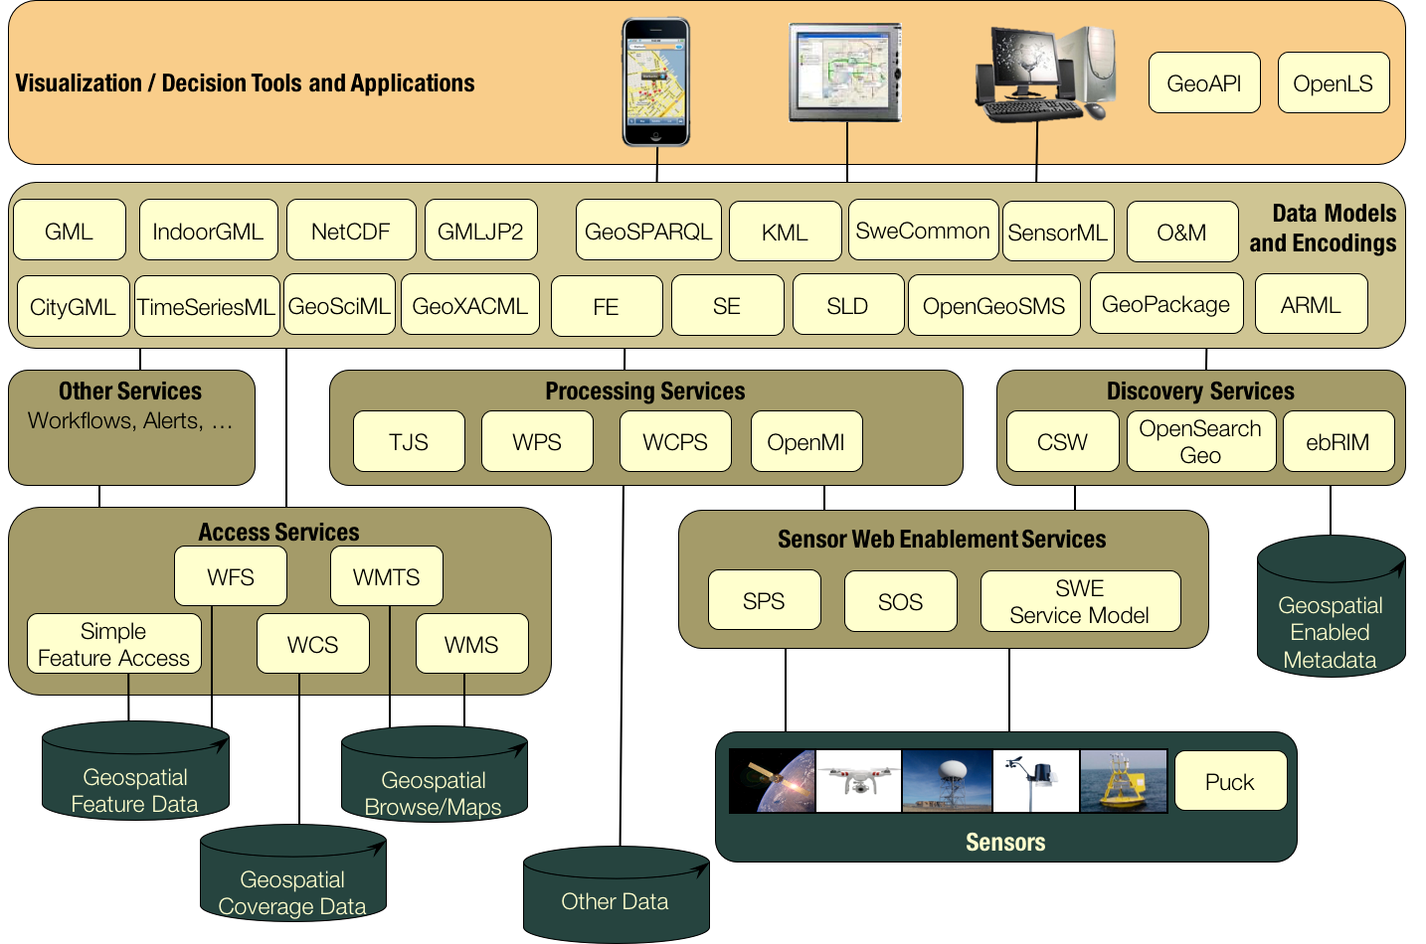
FIGURE 4.4: Loose confederation approach, source: OGC
This approach concentrates on service interfaces and encodings. It allows an entirely decoupled and loosely federated infrastructure with minimized necessary a-priori knowledge required to interact with the various components. This approach leaves aspects such as maintenance, service configuration etc. to the service operators, i.e., this functionality is not part of the architecture view, as it is irrelevant for the actual SDI. This contrasts with the closely architected SDI concept, where management tools and content tools allow control over more than a single SDI component. The environment illustrated here needs to be enriched with security settings, which usually require some sort of higher-level organization if features such as single-sign on shall be supported (otherwise service consumer would need to register with every service, which works in principle, but is not very practical).

4.2.4 Architecture Requirements
Independent of the chosen approach, a number of aspects have been repeatedly identified as being relevant for a successful SDI. These are usually complemented with the standing request for openness as illustrated in figure 4.5. Openness usually refers a number of aspects that circle around the fact that an element is openly (in the sense of publicly and royalty free) available and reusable, developed in an open process, accessible at minimum costs (in terms of data pure reproduction costs or even no costs).
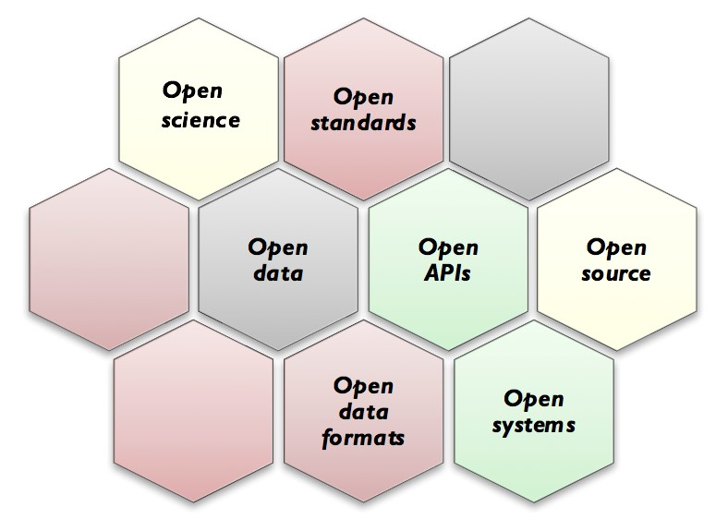
F
IGURE
4.5:
Aspects of openness
Open science is the movement to make scientific research, data and dissemination accessible to all levels of an inquiring society, amateur or professional. Open systems includes open source work and Github resources, choices in hardware, operating systems, Cloud, databases, developer tools, direct links to non-GIS systems such as CAD and BIM, etc.. Open standards include standards as provided by OGC, IHO, ISO TC/211, DGIWG, GWG, CGSB, FGDC, OASIS, W3C, ASPRS, etc.) and open specification (widely used but not yet adopted by SDOs openly published technology such as GeoJSON, Geoservices REST API, etc.).
In addition to these general requirements (that are purely stated here, not judged, as it is fully acknowledged that some data cannot not be openly available but needs to be protected to ensure privacy constraints), an ideal SDI architecture shall allow the following.
- Registry and discovery
    - rapidly discover and access information, products and data.
    - A search mechanism that goes beyond metadata-based key-word search, as metadata is never complete and often hard to maintain.
    - Auto-registry for sensors (both remote and in-situ).;
    - Search engines for finding and browsing data, services, and metadata which should be adaptable to allow for basic quick searches through detailed searches using multiple criteria including: geography, time, organization, physical parameter.
    - Users to discover (search), view, assemble and obtain desired data and services for a particular area of interest without needing to know the details of how the data and services are stored and maintained by independent agencies, organizations and data custodians.
    - Non-mapped search results (e.g. technical reports, multimedia) should be associated with mapped search results and viewable in the web browser.
- New functionality and extension
    - Easily publish/reference information, products and data into the SDI.
    - Integration of new functionality.
    - Implementation as a loose confederation of portals and platforms discoverable by open specifications and standards. The implementation should allow easy integration of upcoming technologies. This is particular important as the Disasters SDI needs to allow for restricted bandwidth stakeholders.
    - Transparency.
    - A Disasters SDI is by nature federated. It should be as transparent as reasonable to an end-user as to where the information being accessed is sourced from within the federation.
    - Provide illustration and processing of stakeholder data relationships, or stakeholder-processing relationships, which could provide valuable insight for other stakeholders with similar requirements, as process could be copied or adapted more easily. Consideration could be given to adding an online information network with an ontology-based interface on top to visualize databases and information sources content. This ontology-based approach would allow for efficient searches once all data and operation concepts are annotated.
- Low bandwidth and offline usage
  - Support for both online and offline use.
  - Support for low cost mobile devices, such as Android tablets, in the field for monitoring, gathering and updating data in areas that have no, or poor data communications, using Bluetooth and standards such as GeoPackage.
  - Support for proxies that optimize data for transport over limited bandwidth connections or other specific purpose tools.
  - Publishing of large datasets in very efficient ways to support low bandwidth situations.
  - Transferring of data via non-internet mechanisms, such as shipping hard drives to customers with very limited internet connectivity. These hard drive deployed datasets shall be made available as being directly served from a standards-based Web service, i.e. data storage is transparent to the end user. At least end user experiences shall differ minimally.
  - Downloading datasets in standard formats.
- External systems and formats
  - Disseminating of metadata and geospatial content to other global or national networks such as the Group on Earth Observations, United States Geospatial Platform, and others. This increases visibility of the Disasters SDI data and information products.
  - Providing connectivity to legacy/heritage systems.
  - Support for scanned hardcopy documents that provide valuable historic data sets, including maps, forms, other tabular data (both machine and hand-written), or hand-drawn sketches.
  - Support for documentary videos, oral histories, and other sources beyond purely numerical data.
  - Enabling e-visualization of information in a geospatial, data analysis presentation environment and temporal context.
- Tailoring
  - Support both the desktop and mobile environments.
  - Support multi-linguism and appropriate character sets.
  - Support targeted users from a diversity of backgrounds. The efficacy of the portal to accessing information by the uninitiated, the man-of-the-street has been proven is key to a successful, i.e., well-used SDI.
- Key service functionality
  - Mapping interface showing search results. Map should be interactive: pannable, zoomable, changeable projection. Mapped items should be interactive: obtain metadata by clicking/hovering, get data values by clicking/hovering.
  - Basic analysis and visualization tools, e.g., navigating long timeseries, statistical analysis on selected data sets or subsets.

Chapter 5: Data
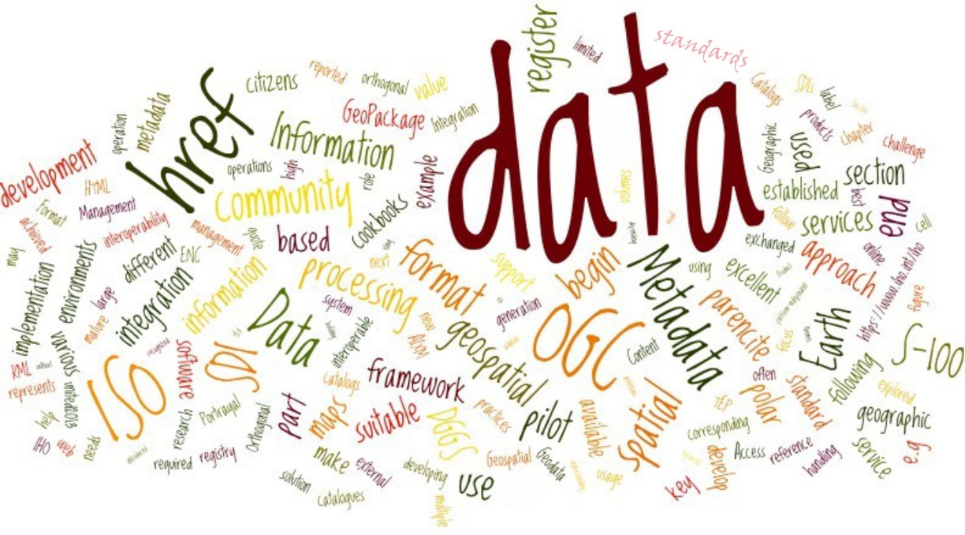
The Disasters Management community provides a unique environment when it comes to data acquisition and management.
This chapter addresses the data required for an effective Disasters SDI. In Section 5.1 data standards are examined. Data standards was a consistent priority within the RFI responses. Section 5.2 looks at data requirements. What data did respondents feel were necessary for an effective Disasters SDI.
Finally, a third section addresses data sets that are available from the responders to the RFI. This part can only highlight a number of data sets that are ideally available at standardized interfaces. A more complete inventory of available data sets shall be developed during this project, with catalog services being used as service and data registries that become integral part of the planned demonstrations.

5.1 Standards
Standards are one of the key pillars of any SDI. They are key for the quality and development of interoperable geographic information and geospatial software during the entire life cycle of any data set. Standards define how data is created, archived, used, and discovered at and exchanged between components. They address different levels of interoperability such as syntax, semantics, services, profiles, or cultural and organizational interoperability. There are excellent publications available discussing the value of standards and role of standards in geospatial information management (OGC/ISO TC211/IHO, 2014) or the usage of standards in SDIs (United Nations, 2013). This report will concentrate here on experiences made by the SDI developers and users community and refer to external literature for further details on the various standards. A good starting point to learn more about important standards is the website of the OGC.
An approach often used by cookbooks is to classify standards in the context of SDI following three categories as introduced by GPC Group.
- Data Content Standards For understanding the contents of different data themes by providing a data model of spatial features, attributes, relationships, and a data dictionary.
- Data Management Standards For handling spatial data involving actions such as discovery of data through metadata, spatial referencing of data, collection of data from the field, submission of data by contractors to stakeholders, and tiling of image-based maps.
- Data Portrayal Standards For visual portrayal of spatial data using cartographic feature symbology.
This approach is often used by the various cookbooks that exist for the development and operation of an SDI (New Zealand Geospatial Office, 2011; United Nations, 2013). Here, a different approach and the report discusses standards depending on their functionality domain, i.e., data format & access standards, metadata and catalogs, geodata integration, and orthogonal standards.

5.1.1 Data Format & Access Standards
Many in the disaster management community has adopted OGC standards. However, there were organizations responding to the RFI that were continuing to use proprietary systems. Most of the respondents use OGC standards to make data and maps available for inclusion in external sites and applications. Additionally, many organizations have been instructed to use OGC standards when available and develop best practices for implementation of the standards. The use of OGC standards will include resource catalogues, processing service execution, processing service packaging, and processing containers. The major challenge in developing increased usage of the OGC approach will be in community building, adequate support (e.g., cookbooks and, easily deployed stacks), and a clear value proposition. The focus should be on mature OGC standards that are core OGC services: GML, JSON, GeoJSON, WMS, WMTS, WCS, WFS, WPS, SOS, and CSW.
The Disasters SDI pilot will provide an excellent laboratory environment to experiment with new, less mature standards in conjunction with established technology.
Examples of standards that may be further explored as part of the pilot are provided below.
- KML: KML is a file format used to display geographic data in an Earth browser such as Google Earth.
- GeoPackage: GeoPackage is an open, standards-based, platform-independent, portable, self-describing, compact format for transferring geospatial information. Since a GeoPackage is a database, it supports direct use, meaning that its data can be accessed and updated in a "native" storage format without intermediate format translations. GeoPackages are interoperable across all enterprise and personal computing environments and are particularly useful on mobile devices like cell phones and tablets in communications environments with limited connectivity and bandwidth.
- SensorThings API: SensorThings API provides an open, geospatial-enabled, unified and simple way to interconnect the Internet of Things (IoT) devices, sensors, data, and applications over the Web. It provides a standard way to manage and retrieve observations and metadata from heterogeneous sensor systems.
- AIXM: Aeronautical Information Exchange Model (AIXM): AIXM enables the provision, in digital format, of the aeronautical information that is in the scope of Aeronautical Information Services (AIS). It takes advantages of established information engineering standards and supports current and future aeronautical information system requirements.

5.1.2 Metadata and Catalogs
Many catalogs and registries make use of OGC Services and their corresponding ISO TC211 documents.
It is recommended that metadata follow the ISO 19115 (Geographic Information - Metadata) and corresponding ISO 19139 (Geographic Information - Metadata XML schema implementation), or their respective profiles, CSDGM (FGDC Content Standard for Geospatial Metadata), the Dublin Core, or INSPIRE guidelines and implementation rules. In addition, the emerging DCAT standard may be analyzed in more detail for its applicability in SDIs.
One issue that has been reported is today’s focus of spatial data infrastructure metadata standards, which are suitable for business-to-business integration, but not suitable for consumption by ordinary citizens (e.g., elementary school students). There is a need to develop standards which make maps and spatial data suitable for re-use by citizens of limited experience and resources. Communities such as the W3C Maps for the HTML community have the objective to develop the concepts, software and community associated to the needs of developing a standard for maps suitable for adoption by browsers, and thereby for citizens who produce and consume HTML. As such, a Disasters Pilot would serve as an excellent initiative which could help stimulate development of the standards and software of Map Markup Language (MapML) and the <web-map>/<MAP> element; an idea that could be experimented with as part of a pilot.

5.1.3 Geodata Integration
Combining multiple sources of geospatial information - a necessary key step in the geospatial knowledge generation cycle or geospatial data integration in near real-time - is still a challenge if it comes to high volumes of data or extremely high update frequencies. A solution can only be achieved through the conversion of traditional data archives into standardized data architectures that support parallel processing in distributed and/or high-performance computing environments as well as complex stream processing. A common framework is required that will link very large multi-resolution and multi-domain datasets together and to enable the next generation of analytic processes to be applied. A solution must be capable of handling multiple data streams rather than being explicitly linked to a sensor or data type.
One successful approach for integration of data is using a discrete global grid system (DGGS). A DGGS is a form of Earth reference that, unlike its established counterpart the coordinate reference system that represents the Earth as a continual lattice of points, represents the Earth with a tessellation of nested cells [6]. Generally, a DGGS will exhaustively partition the globe in closely packed hierarchical tessellations, each cell representing a homogenous value, with a unique identifier or indexing that allows for linear ordering, parent-child operations, and nearest neighbor algebraic operations. Further experiments with DGGS and service support should be part of this pilot to gain new insights into large data volumes processing and integration.
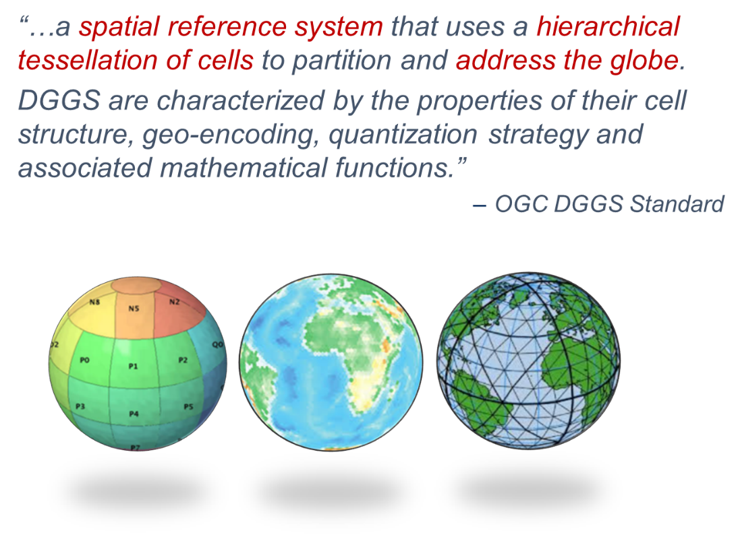
FIGURE 5.1.: Discrete Global Grid System, source: OGC

5.1.4 Complementary Standards
There are a number of complementary standards that may play a role in SDI setup and operation and should be explored further as part of this pilot, for example ISO 27001 (Information Security) and ISO 20000 (IT Service Management).

5.2 Data Requirements
A Disasters SDI will play an important role in decision-making in all aspects of disaster management. This is a multidisciplinary activity and a spatial data infrastructure is expected to facilitate and coordinate the exchange and sharing of static and dynamic spatial data between all stakeholders.
There are several general requirements that apply to many data types, such as real-time data availability, integration of local, on-the-scene knowledge with physical environmental data, or data quality, coverage and resolution. Based on an analysis of the RFI responses, datasets for the following key data categories have been identified to be required within an effective Disasters SDI at minimum. Some of the categories tend to be cross cutting, meaning that they may use data from other categories within the list. This is not an exhaustive list and is in no particular order.
- Earth Observation: These data category includes satellite and airborne collected multispectral and hyperspectral imagery, radar data, airborne and surface collected LiDAR data, and unmanned aerial systems (UAS) imagery and derivatives.
- Topographic: This data category includes standard GIS layers such as Roads, Buildings, Elevation (including Digital Elevation Models), Terrain, Basic Landuse/Landcover (water, rivers, soil, man-made, vegetation), Flood Plains, near shore bathymetry, etc.
- Critical Infrastructure: This data category includes road networks, dams and reservoirs, power plants, power distribution, oil pipelines, etc.
- Land Use: This data category includes data property and address, land use, geology, land stability, etc.
- Demographic and Socioeconomic: This data category includes population location, density, demographic characteristics, and cultural and heritage assets etc. These data sets are useful for assessing disaster vulnerability, potential communication demand during disasters, response time for disaster services, prioritization of mitigation and response efforts.
- Meteorological: This data category includes wind velocity and direction, air temperature, humidity, and atmospheric pressure, as well as, climate parameters and indices. Observations (synoptical measurement, as well as remote sensing such as radar) are vital to assess the current state. Forecasts are used in planning an appropriate response.
- Real-time Sensor Data: This data category includes data received in real time from available sensor systems such as direct data devices, audio sensors, video cameras and CBRN sensors.
- Crowd-Sourced Data: Advances in technologies and communications, coupled with the rapid rise and adoption of the social media applications have created a new category of data for emergency and disaster response systems. This has now enabled citizens to generate real-time, georeferenced data that may be useful within a Disasters SDI.
- Disaster Prediction and Planning: This data category includes data such as flood predictions, flood depth grid data, seismic site conditions, hurricane predictions, etc. This category may also include vulnerability models, structures, and social vulnerability.
It was stated in many responses that, in general, all data should be available in, or transformable to, different projections using different datums for efficient map productions or integrated processing and analysis operations. It was also stated that the use of Web Mercator (Auxiliary Sphere) WGS84, though often used in Web applications, has some serious precision implications and should be used with caution in applications that have FIPS Moderate or High categorizations.

5.3 Data Identified in RFI Responses
Despite the very long list of data categories and types, quite a number of data sets are available. Appendix A provides an overview of data sets that have been identified in RFI responses, and Workshops. In addition, there is a list of data portals online (see Appendix B for details).

Chapter 6: Scenarios and Use Cases
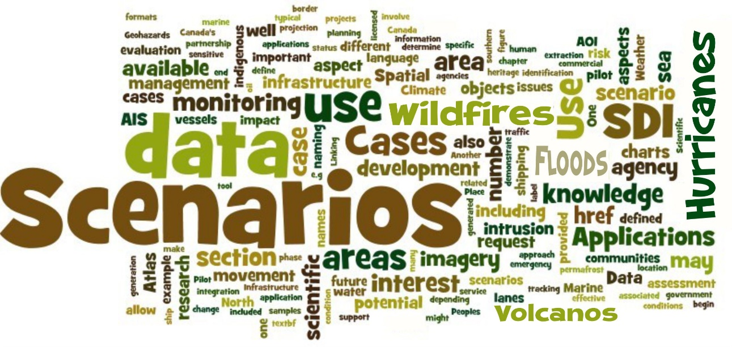
The goal of this study is to identify requirements and use cases to drive follow on pilots that address these requirements and use cases. It has been agreed that this could best be done by the implementation and description of a number of use cases and scenarios that make use of a number of data sets discovered and served by the Disasters SDI and visualized by Disasters SDI client components. The following overview is intended as a starting point for the Pilot.

6.1 Exercise the Life Cycle
Many of the RFI responses stated that scenarios should not only include disaster response situations, but also the current state of data and product exchange practices and technologies throughout the disaster life cycle, including disaster planning, response, and recovery.
It was noted that pilot activities could include multi-hazard risk management decision making and projections to assess the implications of climate change on future disaster risk
In multi-hazard risk management decision making, it is necessary to combine spatial data for multiple natural and technological hazards with appropriate exposure and vulnerability data. The integration of data will help compare risks and assess potential interactions (e.g., Fukishima-type risks resulting from a natural hazard event).
Another pilot activity is to provide predictive model-based projections to assess the implications of future disaster risk and adaptation options.
Response scenarios should include at least one use-case involving both public and private sector entities sharing disaster impact, response, and recovery data to support more effective and timely coordination during the response and recovery phases.

6.2 Disaster Scenario Planning for Future Pilots
A review of responses indicates that Hurricanes, Earthquakes, Floods and Wildfires were, by far, the most popular scenarios that respondents would like to see as a scenario. A variety of other disaster scenarios were proposed related to single events and multiple event triggers and responses.
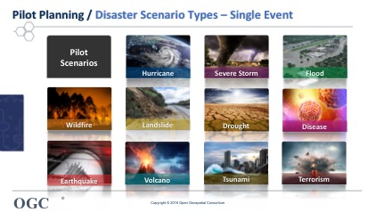
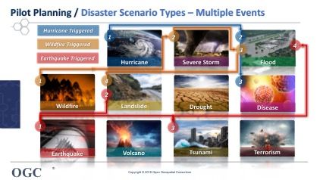

6.3 Other Scenario Aspects
There are a number of aspects that are independent on the specific scenario. Instead, they are applicable to almost all scenarios. One very important aspect in this context is the reality of dealing with low to no Internet bandwidth in some areas. This aspect that was mentioned several times should be addressed in at least one pilot implementation scenario.
Another aspect addresses typical issues caused by cross-boundary events, e.g., a downed aircraft near an international border such as between United States and Canada. This requires bringing together a wide variety of disparate data and cross border interoperability.
Focus on integrating multiple types of data together (coverages, imagery, vector, sensor feeds) over a large scale to fully appreciate the value of a unified map service with shared semantics and a shared tiling approach. This can be demonstrated by 'plume' related disasters, whether nuclear accidents or volcanic ash at an international level, or widespread downwind pollution from wildfires and chemical incidents, usually at the more local level. It should be noted that plume events are intrinsically 3 or 4D and may be satisfactorily represented by existing (2D) spatial data infrastructures.
Crowdsourcing Mobile application that provides real time geolocated visual information (photographic and survey).

6.4 Pilot Development
The follow-on pilot(s) initiative implemented as a result of this CDS will not attempt to develop a different, new operational professional grade Disasters SDI. Instead, it will support the existing suite of Disasters SDIs by demonstrating their value to stakeholders, and by reinforcing / devising interoperability arrangements to address key Stakeholder challenges. Nevertheless, the following topics shall be considered during the development of the pilot(s), even though they usually apply to the development of a professional-grade SDI.
- Prepare Inventory and Assessment of Existing Disaster Systems, Portals, Applications, Data Sets and Databases. This involves assessing key existing geospatial systems and imagery. Inventory should cover formats, datums, metadata, standards used, etc.
- Development of a V1.0 Disasters Reference Architecture working with participants and the Domain Working Group and Technical Committee agreement.
- Improve Disasters SDI based on feedback and technology evolution.
- OGC Pilot to improve interoperability arrangements between providers and users testing that OGC services are discoverable in heterogeneous (or homogeneous) global community of providers.
- Outreach and adoption of standards and specifications.
- Leverage the U.S. GeoPlatform and a variety of geospatial community resources to support disasters.
The specific themes or use cases for the pilots will be selected by the Sponsors during the Pilot Collaboration Phase for each of the pilots. The themes or use cases may be chosen from the previous topics reported above in this report. The Sponsors will decide what Disasters issues or shortcoming they wish to address during the particular pilot.

Chapter 7: Operation & Organization
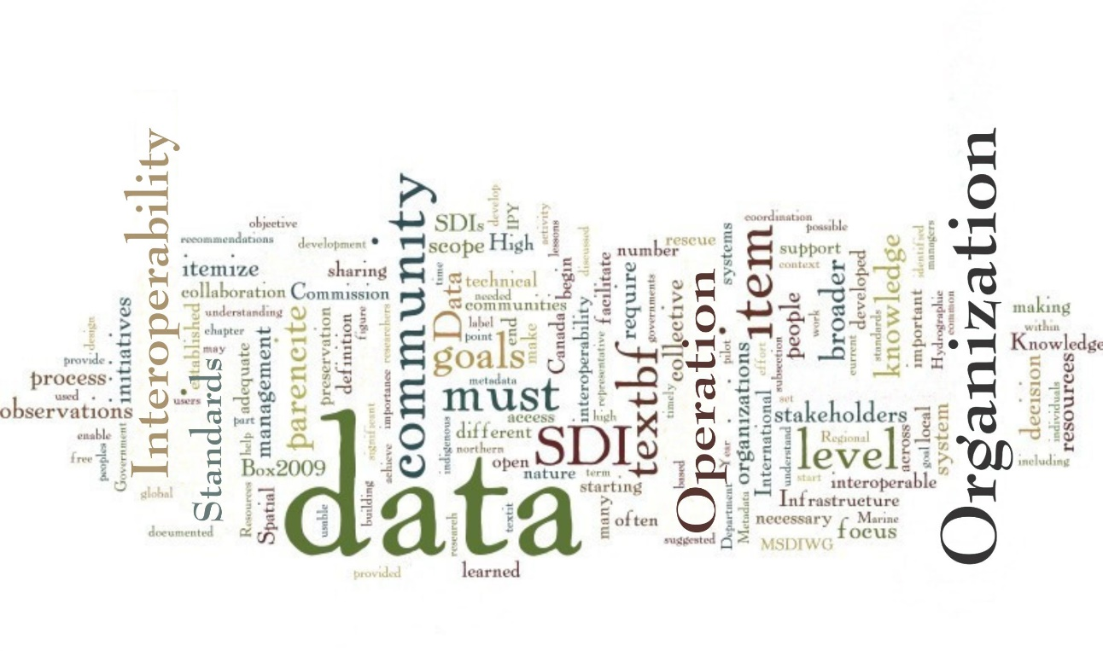
The collective decision-making process often gets blurred by the large number of stakeholders that participate in an SDI and may implement very little overlapping and thus collective decision-making processes. Given that the goals of this CDS and follow on Pilot are to demonstrate the usability of a Disasters SDI for a large range or stakeholders, rather than defining a fully featured SDI from scratch, stakeholders can concentrate on high level operational goals instead. Several high-level operational goals were stated by many of the respondents in the responses to the RFI and these reflect, to some extent, established best practices.

7.1 High Level Operational Goals
In the following sections several high level operational goals are mentioned that were discussed in the RFI responses and are of ample importance in any collaborative decision support system that focus on disaster management.
- Interoperability: The ability to easily share data across systems and users, is one of the most important priorities identified by the
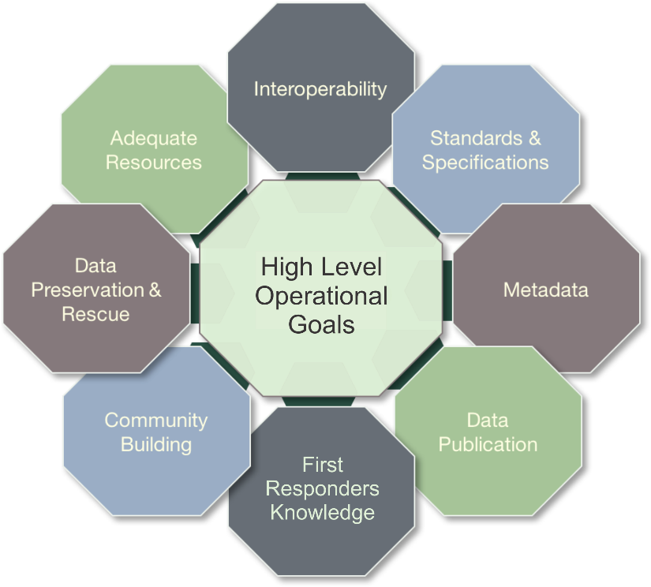
F
IGURE
7.1:
High Level Operational Goals
RFI respondents. An interoperable system must enable data access that can support many different users. This may require visualization or other mediation such as translating vocabularies to make data usable by different communities. Achieving interoperability will require adequate resources, a certain level of standardization, and a connected community.
- Standards and Specifications: The overarching purpose of the disaster management community is to promote and facilitate collaboration towards the goal of sustained, and timely access to disaster data through useful, usable, and interoperable systems. This includes facilitating the adoption, implementation and development (where necessary) of standards that will enable free, open, and timely access to data.
- Metadata: The objective of this activity is to develop recommendations on a common set of metadata elements relevant across disaster management, to facilitate discovery, interoperability, and sharing between data repositories and online portals. To start, this effort will focus on identifying initiatives that have established a metadata template, schema, or profile. Initially, a limited set of disciplines or focus areas will be identified to make the scope manageable. Wherever possible and practical, the effort will build on and/or contribute to other related initiatives.
- Data Publication: The objective of this activity is to provide a guide on data publication and citation for the Disaster Management community. This would provide a resource to help them to publish data sets.
- Including First Responder’s Perspectives, Knowledge and Information: There is probably no other group that can bring the practical perspectives, knowledge and information to get the most out of a Disasters SDI then First Responders. This knowledge is being increasingly utilized, but in many instances, it is still being overlooked or considered as an afterthought. The perspectives of First Responders must be heard directly. This will enhance understanding of how this knowledge can be used appropriately.
- Community Building: Improved data sharing that is part of a broader global system requiring community building, collaboration, and coordination of efforts. To achieve this, a better understanding of the nature of the disasters data community (who is doing the work, where, and the systems and processing workflows, etc.) across many scales and what is collectively trying to be achieved is required. It is also important to recognize engaging with broader global initiatives ongoing in the disaster management.
- Data Preservation and Rescue: Continuous re-use and re-purpose of past observations is key to increase current understanding. Therefore, data and all the necessary descriptive information must be preserved. Too often, preservation is forgotten, and data managers must pursue costly and time intensive data rescue activities. Even current data are at risk of loss. Strategic data rescue programs must be developed, and preservation must be prioritized as a long-term investment and cost-saving measure.
- Adequate Resources: Making progress will require adequate financial, technical, and human resources. More focus is needed on the training of early career scientists and youth to ensure that they have the necessary data literacy to engage in intensive research while contributing to and benefiting from an open, interoperable system.

Chapter 8: Technologies & Applications
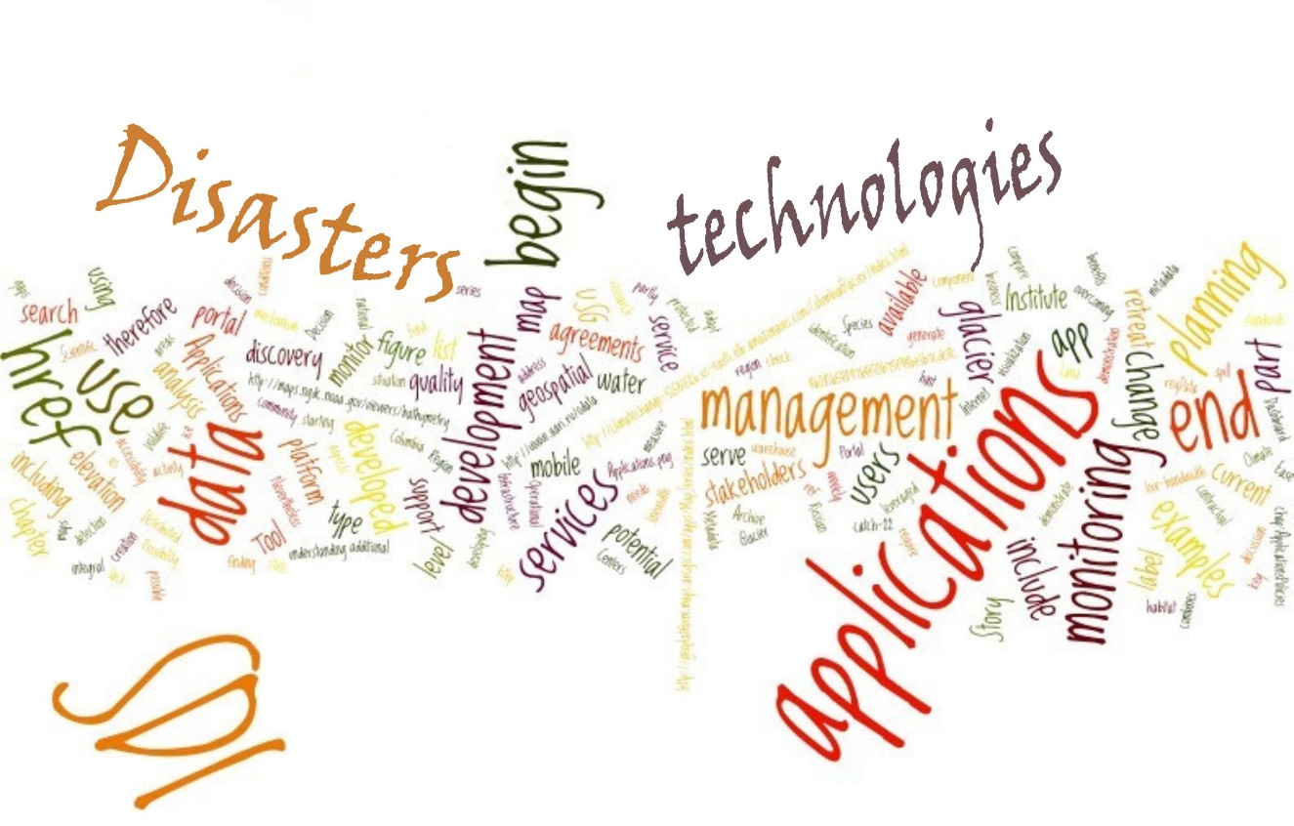
The feedback on current portals, applications and technologies used in disaster management, type of services that should be available as part of a Disasters SDI, or type of applications shall be developed that make use of Disasters SDI was quite varied.
The general view was that there were many portals available but no method for easily determining what was available in each. There were a few respondents that described the NSDI as a great mechanism that can be leveraged. There was also the mention of possibly using the GEOSS platform as a resource to coordinate some disaster efforts.
However, many respondents noted that there are many portals stakeholders could access to gain the information they need to respond to a disaster events; however, understanding which portals are most relevant, which subsets of relevant information might be contained in each, and particulars of the user interface with each multiply the complexity of getting any usable information at all. This tends to provide a massive barrier to user engagement. In particular, if experts in the geospatial field are finding it inordinately complex to use many portals to acquire all data required for a task, then there is no chance responders in an emergency situation will be able to do so.
One of the RFI respondents was so frustrated trying to determine what public facing layers were available, and where they were located, that he produced his own lists showing the ‘top’ internet address for over 200 public-facing ArcGIS servers with open data.
The small number of specific portals for Disaster Management indicates possible gaps between stakeholders such as data providers, SDI component operators, and SDI consumers that require further investigation. The major the goal of the pilots is to demonstrate the value of Disasters SDI to stakeholders, and therefore overcoming the Catch-22 situation that potential stakeholders are not aware of the capabilities of a Disasters SDI and therefore not using it; and the provider side not being able to better adapt to users’ needs, as they are not formulated and expressed.
The list of current applications includes on the abstract level items such as:
- geospatial portal development
- incident and event management and decision support applications
- mobile platform integration and cross platform mobile app development
- data warehouse management
- Internet mapping
- metadata management
- gateway creation
- comprehensive data connectivity
More detailed applications include:
- water license management and water quality and quantity flow analysis, visualization and modeling
- Infrastructure monitoring and planning
- Decision Support Systems
- Climate change research
A list of possible key applications that could be made available as part of a Disasters SDI include:
- Dashboard for disaster monitoring/response
- Metadata harvester/broker
- SDI Portal for non-technical users
- SDI portal for scientists
- Oil spill tracker/forecaster
The wide gamut of potential services shall support the following aspects:
- Ease of discovery and use
- First Responder community emphasis
- Possibility of using in non or low-bandwidth environments
- Use of relevant open standards
- Service level agreements to address business and contractual agreements
- Additional SDI applications could include more general applications like search and rescue; and social and demographic applications.
A few future applications were also described as follows.
- Predictive Services: modeling and other predictive services that could be shared as part of the common operating picture could be very valuable.
- Artificial Intelligence (AI) Assisted Mapping: this field is growing, after some initial failures at road mapping with AI generated data in OpenStreetMap, it is now part of the HOT project at OSM.
- Disaster Routing

Chapter 9: Other Factors / Conclusion

Other Factors
Workshop participants and RFI respondents discussed other success factors or considerations seen as needed for a successful National SDI architecture for disasters.
It was noted that a successful National SDI architecture for disasters will require careful coordination between the system design and architecture and organizational policies, responsibilities, roles, and incentives, considering both public and private sector needs and constraints, different time horizons and scales of operation, different stakeholder mixes across sectors, varied levels of government and community sizes, and challenging data integration issues. Careful attention will be needed to address issues such as information technology security, privacy and confidentiality, liability, legal interoperability of data and services, and resource allocation. Many of these factors were discussed in previous chapters.
It was also noted that cooperation among federal agencies acquiring and producing data to the local responders was a priority and it was critical to be able to add data to the architecture quickly and without downtime or disruption.
When dealing with the public, the NYC response included an addendum to their submission entitled, “Towards Comprehensive Engagement with the Public During All Disaster Phases”. This document has been included as Appendix E.
It should also be noted that a respondent concluded with the following; “OGC can provide a useful role in bringing information, technology and people together. We believe encouraging government to establish persistent experimental infrastructure and funding on-going experimentation (a persistent sandbox environment) on-line would be a valuable way to encourage innovation and maximize value and would be essential strides in prioritizing Prevention and Preparedness alongside Response. If such an infrastructure was there and could be depended on, it would make each experiment cheaper to execute. This does though require commitment from many agencies and government research institutions.”

Conclusion
There were common threads that weaved their way through many of the RFI responses and represent key conclusions based on the variety of responses. These conclusions are summarized as follows in no particular order.
- From all the needs presented, they can be summarized into four, high level, overarching requirements of any Disasters SDI.
  - Provide stakeholders with appropriate access to the spatial data they need. These data can be static as well as dynamic data that arise before, during and after the disaster.
  - Allow different stakeholders at different locations to access the SDI.
  - Allow for data exchange, especially the dynamic data, in an appropriate, efficient, and secure way.
  - To achieve one, two and three will require the continued and increasing use of OGC and other open standards.
- There appeared to be under serviced stakeholders with regards to a Disasters SDI. These were First Responders and the General Public. First responders need a more streamlined approach to discovering, accessing, processing, and applying data. They tend to have very focused requirements: needing specific data in a streamlined, easy to use interface within the confines of a narrow bandwidth environment.
For the public, availability and simplicity appear to be key attributes. To achieve this within the Disasters SDI, improved outreach and more tailored interfaces need to be implemented. Moving forward more effort may have to be made to include these stakeholders.
- Many responses described several new data sources that should be included in a Disasters SDI such as observations from UAVs and crowd-sourced data. It needs to be determined what other new data and standards can be used and are there other new tools that can be utilized to integrate these new data sources.
- Integration of near real-time observations from both satellites and in-situ sensors is key. Traditionally, this has not been easily achieved due to the proprietary nature of the sensor interfaces. New technologies such as SensorThings API should be considered to ease introduction and use the latest sensor / observation technology. Also, auto-registry of sensors is a key requirement.
- Going forward many respondents described the need to exercise a Disasters SDI in all phases the ‘life cycle’ of disaster management: 1) mitigation; 2) preparedness; 3) response; and 4) recovery. Any scenarios or use cases should attempt to address all four phases.
- Need to determine what data is key in different disaster types; Hurricanes, earth quakes, tsunamis, floods, wild fires, tornados, and pandemics. Each type has different needs depending on the stakeholder. For example, data used in hurricane response for a first responder would be quite different then that required for a wild fire.
- To help in remediating issues due to limited bandwidth during a disaster event much of the base or core data can be prepared in advance any loaded on mobile device for first responder / field use. This can be accomplished by leveraging the GeoPackage standard.
- All data must be accompanied by metadata. As this can be extremely tough to implement, new ways should be explored to minimize the need for manually generated metadata.
The above conclusions should not be regarded as a definitive list to be taken away from this report. Instead, these conclusions listed here may provide a focus for a future Disasters SDI and the pilot phase of the CDS.

Appendix A: Data Identified in RFI Responses
The following sections provide an overview of data sets that have been identified in RFI responses, and Workshops in alphabetical order.

AmericaView
A national consortium, AmericaView has access, to and the ability to process and interpret, a large and growing number of diverse Earth Observation data sets. These data include satellite- and airborne- collected multispectral and hyperspectral imagery, radar data, airborne and surface collected LiDAR data, and unmanned aerial systems (UAS) imagery and derivatives that could become part of the Disasters SDI. Examples of imagery sources include, but are not limited to, Landsat, MODIS, RadarSat, and the ESA Copernicus Programme.
AmericaView should be viewed as a national and international resource with the ability to mobilize with short notice to support local, regional, or national disaster response needs.

Center for International Earth Science Information Network (CIESIN)
CIESIN operates the Socioeconomic Data and Applications Center (SEDAC) providing a range of disaster-related data, services, and tools, including:
- Spatial data on human settlements, infrastructure, population, and hazard risks, including settlement points, road networks, reservoirs and dams, nuclear power plants, impervious surfaces, demographic characteristics, historic/current/projected estimates of population counts and density, urban land use change, and global natural disaster hotspots. See: http://sedac.ciesin.columbia.edu/data/sets/browse.
- OGC-compliant web services for many of the above data sets, including WMS, WFS, and WCS as appropriate. See: http://sedac.ciesin.columbia.edu/maps/services.
- The Population Estimation Service, which returns total population estimates for a user-defined circle or polygon (WPS or REST compliant). See: http://sedac.ciesin.columbia.edu/data/collection/gpw-v4/population-estimation-service. A version which provides totals by selected age categories and sex is under development.
- The SEDAC Hazard Mapper and HazPop mobile app for iOS, which provide integrated access to a range of both SEDAC and external hazard-related datasets and support spatial queries against the Population Estimation Service. The HazPop mobile app utilizes location-based services for selected functions. See: http://sedac.ciesin.columbia.edu/mapping/hazards/ and https://itunes.apple.com/us/app/hazards-population-mapper/id1092168898?mt=8.
CIESIN also provides additional data and resources useful to the disaster community, including:
- High Resolution Settlement Layer (HRSL) data, developed in collaboration with the Connectivity Lab at Facebook, which provides estimated population distribution at a resolution of 1 arc-second (~30 meters) for more than 20 countries and Puerto Rico in 2015 based on 0.5-m resolution DigitalGlobe imagery. See: http://www.ciesin.columbia.edu/data/hrsl/.
- Hudson River Flood Mapper, a decision support system for flood mapping designed to support municipal planning decisions. See: http://www.ciesin.columbia.edu/hudson-river-flood-map/.
- AdaptMap, an online mapping tool that demonstrates how sea level rise will worsen storm-driven flooding in Jamaica Bay, New York. See: http://adaptmap.info/jamaicabay/.

DigitalGlobe
Imagery, Elevation derived from imagery (good for remote areas of globe), Landuse/Landcover (LULC) (water, soil, man-made, vegetation).

Group on Earth Observations (GEO)
Data from many EO satellites are available free of charge for many different types of applications for example Landsat, Copernicus, Sentinel. In addition, data from several missions with a more restrictive data policy, e.g., missions from the commercial sector can be accessed at no cost in certain circumstances, for instance for as part of a disaster response phase. https://www.earthobservations.org.

Geoscience Australia
Geoscience Australia (GA) provides spatial data, web services, earth observations, GIS analysis, and natural hazard, impact and risk modeling. Data that could be provided by GA includes:
- National scale hazard assessments and their supporting scenarios for earthquake, offshore tsunami and tropical cyclone
- Earthquake event catalogue
- National Exposure Information System (NEXIS)
- Vulnerability models (for selected building types for selected hazards)
- Seismic Site Conditions Map (as an input to provide situational awareness for earthquake impact)
- Wind Multipliers (as an input to determine local wind impact assessments)
- Neotectonics database
- Australian Flood Risk Information Portal (AFRIP)

HazardHub Data/Models
HazardHub covers all types of disasters and has information on most natural and manmade disaster types. All these pieces are critical to knowing the total impact of a disaster. The data is available to the public via www.freehomerisk.com and a list of data and models is shown in Appendix D.

Humanitarian OpenStreetMap Team (HOT)
The global, all inclusive, database of OpenStreetMap provides a base map. It includes roads and buildings, infrastructure, sometimes waterways, land use or really any geospatial data that can be digitized from aerial imagery.
The Activation Protocol is licensed cc-by-sa 4.0 and can be viewed or downloaded here: https://www.hotosm.org/sites/default/files/HOTActivationProtocol_0.pdf

Land Information New Zealand (LINZ)
LINZ can access and/or provide the following data for New Zealand.
Demographics, topography, aerial imagery, transport networks, critical infrastructure, lifelines and utilities, cultural and heritage assets, property and address, land use, rivers, near shore bathymetry, geology, land stability etc.
Topo 50 maps, Aerial Photography, Historic Aerial Photography, Address, Cadastral boundaries, Buildings, Survey Marks, Geographic Names, Residential Areas, Historic Areas, Coastline, Rivers, Dams, Canals, Pipelines, Marine Charts, Tide Stations, Roads, Tunnels, Railways, Airports, Contours, 8m Digital Elevation Model, LiDAR.
The catalog is located here: https://catalogue.data.govt.nz/dataset?q=linz

National Park Service
The National Park Service makes the unrestricted National Register of Historic Places spatial data set available through the NSDI to support disaster response among many other uses.

Natural Resources Canada (NRCan)
Hydrological features (rivers, lakes, drainage areas for each) supporting mitigation of flood events, the location of historical floodplain mapping locations as well as the floodplain delineations; critical infrastructure, hydrography, DEM, associated elevation data, floodplain mapping.
Building stock; critical infrastructure; demographics;
Active fire locations, fire situation reports.
In addition, the fallowing datasets are available:
• The 1 to 50 000 scale topographic datasets
• The Canadian Base Map for Transportation should become part of an SDI
• Radarsat-2 and Radarsat Constellation Mission imagery
• Sentinel-1 and 2 imagery
• MODIS imagery
• Landsat-8 imagery
• SRTM digital elevation models
NRCan provides Flood extent polygons (.shp, REST, WMS) and River Ice State products (.tif, REST, WMS) that could be of use to an SDI. Also available is Seismic hazard model, hazard scenarios.
Satellite detected hotspots, Fire weather and fire behavior estimates.

Remote Sensing Solutions Inc.
Remote Sensing Solutions, Inc. (RSS) that includes an affiliation to the Dartmouth Flood Observatory (DFO) (http://floodobservatory.colorado.edu).
The DFO is a data and information producer and provider during disasters and these are free to use (with some rare restrictions to large, commercial for-profit usage). Many of the organizations with a stake in the (National) Spatial Data Infrastructure ((N)SDI) and those issuing this RFI, such as DHS (here in particular FEMA), USGS, and also OGC, use and work with DFO data sets on a regular basis during disasters.
The DFO uses conventional HTML. GIS formats (shp, tiff), and jpeg image format as well as Excel spreadsheet files to provide the various data. Recently though, the DFO has adopted OGC standards and protocols to increase data interoperability between various systems and users. For now, the primary OGC standard used is WMS. For a demonstration of this, see the DFO web portal at http://floodobservatory.colorado.edu/WebMapServerDataLinks.html.

USGS National Geospatial Program (NGP)
US Topo, is a primary product supplied by NGP to support disaster response. In addition to the US Topo maps, the geographic information available from The National Map includes orthoimagery (aerial photographs), elevation, geographic names, hydrography, boundaries, transportation, structures, and land cover. The National Map publishes over 50 map services providing topographic information on the US. These services consist of tile cached raster base maps, as well as dynamic vector and raster overlay services. The National Maps vector data sets consist of millions of features consisting of points, lines and polygons. The National Map also provides high resolution Lidar data through its 3DEP program and is working on achieve National coverage over the next 8 years.
The map services from the National Map are primarily ESRI ArcGIS REST services that also enable WMS and WFS interfaces. A web coverage service (WCS) exists for Land Cover data as well as a prototype elevation service. A list of the existing map and data services is provided below.
Map and Data Services APIs: https://viewer.nationalmap.gov/services/
Search and Discovery - ScienceBase API
- ScienceBase (https://www.sciencebase.gov):
Catalog:
https://www.sciencebase.gov/catalog/
API Documentation:
https://my.usgs.gov/confluence/display/sciencebase/ScienceBase
ScienceBase is a collaborative environment for communities to document and host their own scientific content. The ScienceBase Catalog provides a fast and flexible data cataloging and discovery mechanism for over 8 million records. It is backed by a REST API for search and update activities.
- The National Map uses the ScienceBase Catalog to store metadata for all of it's publically available data products. This FGDC metadata includes thesaurus-driven keywords defined by the National Map to aid query and filtering based on: dataset, product extent and product format. By leveraging the existing ScienceBase API, search and filtering capabilities were realized without the need to duplicate these capabilities for the National Map.
National Map API:
    - https://viewer.nationalmap.gov/help/documents/TNMAccessAPIDocumentation/TNMAccessAPIDocumentation.pdf
    - Datasets https://viewer.nationalmap.gov/datasets/
    - Products https://viewer.nationalmap.gov/datasets/
    - Services https://viewer.nationalmap.gov/services/
    - Notifications https://viewer.nationalmap.gov/tnmaccess/api/notificationsForm
    - https://viewer.nationalmap.gov/tnmaccess/
Metadata is also discoverable through data.gov and Geoplatform APIs.
National Map client applications use Map APIs that include: Leaflet, ESRI Javascript API, and OpenLayers.
MapBox Vector Tile services are being explored as a way of capitalizing on the efficiencies realized with cached tiles while providing the flexibility of caching once and styling often. While the data content is standardized the adoption within web and desktop clients is still maturing.
Data access APIs for Big Data (such as Lidar) are being investigated in an effort to lessen the necessity for downloading data. Investigation of the Entwine (https://entwine.io/) and Greyhound (https://github.com/hobu/greyhound) APIs are being investigated to provide 3D visualization of point clouds through a web browser.

Appendix B: Disaster Management Data and Information Portals
The following summarizes a selection of data portals and initiatives that are relevant to disaster information.
GeoPlatform: GeoPlatform.gov was created to enhance geospatial resource sharing across the U.S. Government and the world, and to allow users like you to participate in an online geospatial services experience. Whether you want to discover and use up-to-date National Geospatial Data Assets (NGDAs), make a shared gallery of maps for your website, integrate quality National data into your web applications, or more, GeoPlatform.gov is a place to stay connected to a fast evolving geospatial service ecosystem. The GeoPlatform includes a number of disaster related resources https://communities.geoplatform.gov/geoconops/
USGS Natural Hazards: Every year in the United States, natural hazards threaten lives and livelihoods and result in billions of dollars in damage. The USGS work s with many partners to monitor, assess, and conduct targeted research on a wide range of natural hazards so that policymakers and the public have the understanding they need to enhance preparedness, response, and resilience. The USGS provides a topical directory of hazards related resources related to this topic. https://www.usgs.gov/science/science-explorer/Natural+Hazards

Ready.gov: Launched in February 2003, Ready is a National public service campaign designed to educate and empower the American people to prepare for, respond to and mitigate emergencies, including natural and man-made disasters. The goal of the campaign is to promote preparedness through public involvement Ready, and its Spanish language version Listo, ask individuals to do four key things: (1) stay informed about the different types of emergencies that could occur and their appropriate responses (2) make a family emergency plan and (3) build an emergency supply kit, and (4) get involved in your community by taking action to prepare for emergencies. https://www.ready.gov/
OpenFEMA: OpenFEMA delivers mission data to the public in machine readable formats. https://www.fema.gov/openfema
Australian Flood Risk Information Portal (AFRIP): The Australian Flood Risk Information Portal (the portal) enables flood information, currently held by different sources, to be accessible from a single online location. The portal includes a database of flood study information and metadata (the Australian Flood Studies Database). The portal provides access to authoritative flood maps and flood studies, as well as information about surface water observations derived from the analysis of satellite imagery. http://www.ga.gov.au/scientific-topics/hazards/flood/afrip
Land Information New Zealand Portal: Data.govt.nz helps people discover and use open data easily; empowering, enabling informed decision making, and problem-solving for citizens and business alike. Tagging datasets as being relevant to emergency management and natural hazards in this portal. https://data.govt.nz/
Global Earth Observation System of Systems (GEOSS): The Group on Earth Observations (GEO) is an intergovernmental organization working to improve the availability, access to and use of Earth observations by building a Global Earth Observation System of Systems (GEOSS), which provides decision-support tools to a wide variety of users. As with the Internet, GEOSS will be a global and flexible network of content providers allowing decision makers to access an extraordinary range of information at their desk. The GEOSS Portal is the main entry point to Earth Observation data from all over the world. It's putting users at the centre by focusing on simplification of the guided user interface and making it more intuitive and easy to use. http://www.geoportal.org/
Copernicus Data and Information Access Services (DIAS): The European Commission has launched an initiative to develop DIAS to facilitate access to Copernicus data and information access alongside processing resources, tools, and other relevant data. Copernicus offers added value products such as the Emergency Management Service (EMS) supports players in the field of crisis management. It addresses disasters caused by natural hazards as well as man-made hazards and humanitarian crisis. Only authorized users can trigger the service, but everybody can assess maps. http://emergency.copernicus.eu/
NASA Disasters Mapping Portal: The NASA Disasters Program promotes the use of Earth observations to improve prediction of, preparation for, response to, and recovery from natural and technological disasters. The Disasters Mapping Portal helps communicate relevant NASA disaster science data products and services to the broader disaster management community to help inform decision making before, during and after disasters. It serves as an aggregate for all available NASA data related to the Disaster lifecycle and serves out both Near-Real-Time data, as well as disaster event specific products. The portal also helps to bridge the gap between the research science community and those who can utilize this information to make better decisions. https://disasters.nasa.gov/
CEOS Open Data Cube Initiative: CEOS has started the ODC initiative to provide a data architecture solution that has value to its global users and increases the impact of EO satellite data. https://www.opendatacube.org/ceos
The Dartmouth Flood Observatory (DFO) GIS portal: The DFO uses conventional HTML. GIS formats (shp, tiff), and jpeg image format as well as Excel spreadsheet files to provide the various data. Recently though, the DFO has adopted OGC standards and protocols to increase data interoperability between various systems and users. For now, the primary OGC standard used is WMS. For a demonstration of this, see the DFO GIS web portal at http://floodobservatory.colorado.edu/WebMapServerDataLinks.html.
URL: http://floodobservatory.colorado.edu

Appendix C: Workshop Summaries
The following are brief summaries of two Workshops that have been conducted to further the issues and knowledge around the implementation of a Disasters SDI.

C.1 Workshop 1
Disaster CDS Workshop at NASA Ames
Thursday, 17 May, 2018
Agenda:
Day 1 - May 17, 2018
Time
8:30 - 9:00 | Registration
9:00 - 9:15 | Opening Remarks - Michael Tubbs, Deputy Director Center Operations, NASA AMES
9:15 - 9:45 | OGC Disaster Activities - Terry Idol - OGC IP Director
9:45 - 10:05 | Keynote Speaker - Ivan DeLoatch
10:05 - 10:30 | Break
10:30 - 12:00 | Panel 1 - Disasters Planning (Flooding, Hurricane, Fires, Earthquakes, Pandemics)  Moderator - Ivan DeLoatch, Executive Director FGDC  - Paul Steblein - Wildland Fire Science Coordinator,USGS  - Ken Hudnut - Science Advisor for Risk Reduction, USGS  - Alan Leidner - Center for Geospatial Innovation for the Fund for the City of New York  - Vincent Seaman - Sr. Program Officer, Bill and Melinda Gates Foundation.
12:00 - 1:15 | Lunch
1:15 - 1:45 | Keynote Speaker - Kumar Navulur, Director of Next Generation Products, DigitalGlobe
1:45 - 3:00 | Panel 2 - Disasters Response (Flooding, Hurricane, Fires, Earthquakes, Pandemics)  Moderator - Caroline Thomas Jacobs  - Vincent Ambrosia - California State University Monterey Bay, NASA  - Ryan Lash - Health Scientist, Disease Classifications & Recommendations, CDC  - Marie Peppler - Flood Coordinator, USGS  - Russell Deffner - Humanitarian Open Street Maps  - Jenn Hughey - Esri
3:00 - 3:30 | Break
3:30 - 4:45 | Panel 3 - Disasters Response (Flooding, Hurricane, Fires, Earthquakes, Pandemics)  Moderator - Caroline Thomas Jacobs, Emergency Management Executive, California Governor's Office  - Brittany Zajic - Senior Coordinator, Disaster Response Operations at Planet  - Sophia Liu - Citizen-Centered Innovation Theme Lead, USGS  - Ken Hudnut - Science Advisor for Risk Reduction, USGS  - Robert Munro - Chief Technology Officer, Figure Eight  - Kevin Dobbs - NGA
4:45 - 5:00 | Wrap-up

Day 2 - May 18, 2018
Time
8:30 - 9:00 | Registration
9:00 - 9:15 | Opening Remarks - Susan Benjamin, Menlo Park Center Director, USGS
9:15 - 9:45 | Keynote Speaker - Mike Sena - Director of the Northern California Regional Intelligence Center (NCRIC)
9:45 - 11:00 | Panel 4 - Disasters Recovery (Flooding, Hurricane, Fires, Earthquakes, Pandemics)  Moderator: Tod Dabolt, Geographic Information Officer, Department of Interior  - Caroline Thomas Jacobs - Emergency Management Executive, California Governor's Office  - Paul Steblein - Wildland Fire Science Coordinator, USGS  - Ryan Lash - Health Scientist, Disease Classifications and Recommendations, CDC  - Joseph “Nate” Workman - Geospatial Advisor, FEMA  - Russell Deffner - Humanitarian Open Street Maps
11:00-11:30 | Moderators Summary of Discussions
11:30 - 11:45 | Wrap up and Closing

Key Points
- Orchestration (Capacity Building) in advance very important
- Outreach, coordination, communication, education
- Needs and gaps addressed
- Timely, discoverable, accessible, scaled, curated, trusted and digestible data
- Tools and services that are interoperable and intuitive)
Key Takeaways
- Common standards based operating environment for information sharing, co-creation, product and services development
- Audience based intuitive fit-for-use data tools and services that are stakeholder responsive (Linked to Value Chain)
- Improve collection and consumption by leveraging emerging technologies mobile, crowdsourcing, advanced remote sensing, AI, machine learning, cloud, video, sensors etc.
- Strengthen value-based understanding of the need for the data and capabilities when engaging decision makers (Cost value analysis)
Need to develop pilots that address these challenges and others

Pilot Planning
- Include a diverse group of stakeholders
  - Local, State, National, Global, Commercial Sector, NGOs, Academia
  - Responders, decision makers, policy makers, resource managers, scientist, citizens
- Cross-cutting engagement in disaster pilots
  - Hurricane → Floods → Pandemic
  - Fire → Landslide
  - Earthquake → Fire → Landslide
- Topical elements to include - Social elements (ex. public health), Economic, Environmental
- Communication, coordination, education, outreach
- Interoperability
  - Data and information metadata, symbology→ discovery, access, workflow, use
  - Leverage diverse technology

Next Steps
- Compile input from the workshop
- Share outcomes with the community
- Share outcomes with Sub Committee on Disaster Resilience (May 30) https://www.sdr.gov/
- Additional Workshop planned for DC (Tentative: July)
- Publish results of RFI, Workshops etc.
- Work with sponsors on pilot scenarios
- Publish RFQ for 2018 pilots

What can you do to help
- Stay engaged
- Review notes and send feedback to us
- Let your leaders know of this activity
- Encourage participation
- Provide feedback via the RFI send to tidol@opengeospatial.org
- Get on our mailing list?
- Participate in the DC workshop
- OGC Disaster Domain Working group great way to stay engaged

C.2 Workshop 2
NOAA Auditorium, Silver Spring, Maryland
July 24-25, 2018
Agenda:
Day 1 - July 24, 2018
Time | Activity
8:00 - 8:30 | Registration at front entrance
8:30 - 8:45 | Welcome - Mary Erickson, Deputy Director, National Weather Service, National Oceanic and Atmospheric Administration (NOAA)
8:45 - 9:00 | OGC Initiative Program and Disaster Initiative - Luis Bermudez, Executive Director Innovation, Open Geospatial Consortium (OGC)
9:00 - 9:25 | Keynote Speaker - David Applegate, Associate Director for Natural Hazards, US Geological Survey (USGS)
9:25 - 10:35 | Executive Panel - Disaster Resilience  Moderator - Luis Bermudez, Executive Director OGC Innovation Program, Open Geospatial Consortium (OGC)  - Ivan DeLoatch, Executive Director, Federal Geographic Data Committee (FGDC)  - Jacqueline Meszaros, Senior Policy Advisor and Assistant Director for Natural Disaster Resilience, Office of Science and Technology Policy, Executive Office of the President  - Kshemendra Paul, Deputy Director, Mission and Strategy, Information Sharing and Services Office, Department of Homeland Security (DHS)  - Mark Reichardt, President and Chief Executive Officer, Open Geospatial Consortium, Inc. (OGC)  - Kari Sheets, Geographic Information Systems Lead, Office of Dissemination, National Weather Service, National Oceanic and Atmospheric Administration (NOAA)  - David Green, Program Manager for Disaster Applications, National Aeronautics and Space Administration (NASA)  - Lorant Czaran, Program Officer at United Nations, United Nations Office of Outer Space Affairs (UNOOSA)
10:35 - 10:50 | Break
10:50 - 12:15 | Panel 1 - Disasters Planning (Flooding, Hurricane, Fires, Earthquakes, Diseases)  Moderator - Luis Bermudez, Executive Director OGC Innovation Program, Open Geospatial Consortium  - Michael Blanpied, Associate Coordinator of the USGS Earthquake Hazards Program, USGS  - Christopher Penney, Program Manager National Hurricane Program, Federal Emergency Management Agency (FEMA)  - Paul Steblein - Wildland Fire Science Coordinator, USGS  - Leremy Colf, Director, Disaster Science, U.S. Department of Health and Human Services (HHS)  - Julie Waters, Ph.D., Director, Enterprise Analytics Division, FEMA  - Philip Ashlock, Director of Data & Analytics, GSA Technology Transformation Services, General Services Administration
12:15 - 1:30 | Lunch
1:30 - 2:00 | Keynote Speaker - Michael Hinson, Deputy Director Office of Emergency Management, Howard County, Maryland and Phil Nichols, Assistant Chief Administrative Officer, Howard County, Maryland
2:00 - 3:15 | Panel 2 - Disasters Response/Recovery (Flooding, Hurricane, Fires, Earthquakes, Diseases)  Moderator - Chris Vaughn, Geospatial Information Officer, FEMA  - Norman Levine, Director of the South Carolina Earthquake Education and Preparedness Program, College of Charleston, SC  - Erin Sutton, Director, Office of Emergency Management, City of Virginia Beach, VA  - Tom Moran, Executive Director, All Hazards Consortium  - Christopher Algiere, Director, Federal and National Programs, First Responder Network Authority  - Tari Martin, National Alliance for Public Safety GIS Foundation (NAPSG), Baltimore, Maryland  - Kevin Dobbs, National Geospatial-Intelligence Agency (NGA)
3:15 - 3:30 | Break
3:30 - 4:45 | Panel 3 - Disaster Capabilities and Services to Support Responses/Recovery  Moderator - Tod Dabolt, Geographic Information Officer, Department of Interior  - Marie Peppler - Acting Emergency Manager, USGS  - Sophia B Liu - Innovation Specialist and Crowdsourcing Coordinator, USGS  - Ryan Lanclos, Director of Public Safety Industries, Esri Houston, Texas  - Kumar Navulur, Director of Next Generation Products, DigitalGlobe  - Jeff Sloan, National Unmanned Aircraft Systems, USGS  - Kuo-Yu “Slayer” Chuang, GeoThings, the Humanitarian ICT
4:45 - 5:00 | Day Summary and Wrap-up - Ivan DeLoatch, Executive Director, FGDC

Day 2 - July 25, 2018
Time
8:30 - 8:45 | Registration
8:45 - 9:00 | Day 2 Opening and Remarks - Julie Waters, Ph.D., Director, Enterprise Analytics Division, FEMA
9:00 - 9:30 | Keynote Speaker - Ted Okada, Chief Technology Officer, FEMA
9:30 - 11:00 | Panel 4 - Disasters Response/Recovery (Flooding, Hurricane, Fires, Earthquakes, Diseases) Moderator - George Percivall, Chief Technology Officer and Chief Engineer, Open Geospatial Consortium, Inc. (OGC)  - Brian Solis, Transportation and Transit Planning Manager, City of Virginia Beach, VA  - Vivien Deparday, Disaster Risk Management, World Bank  - Walter Dykas, Program Manager for Energy Sector Situational Awareness, Department of Energy  - Joe Flasher, Open Geospatial Data Lead, Amazon Web Services  - Rob Agee, Vice President, Geospatial Intelligence Center, National Insurance Crime Bureau
11:00 - 11:30 | Break
11:30 - 12:15 | Summary of panel discussions and feedback - Presented by Moderators
12:15 - 1:15 | Lunch
1:15 - 1:40 | Keynote Speaker - Mark Reichardt, President and Chief Executive Officer, Open Geospatial Consortium, Inc. (OGC)
1:40 - 2:10 | Disaster Grant Opportunity  Doug Lynott, Director, Economic Development Integration, U.S. Economic Development Administration (EDA)  EDA has approximately $587 million in FY18 supplemental appropriations available for disaster recovery grants (see Bipartisan Budget Act of 2018, P.L.115-123). Subject to the availability of funds.  Economic Development Agency will provide a special presentation regarding disaster supplemental funding, such as applicant eligibility, eligible activities, and application preparation and submission requirements.
2:10 - 3:00 | OGC Presentation - Terry Idol, PhD Director Innovation Program, OGC  Innovation program pilot process overview  - Pilot planning and discussion –– Informational & Q/A  - Pilot Sponsorship  - RFQ
3:00 - 3:30 | Break
3:30 - 4:00 | Workshop Feedback, Summary and Next steps - Terry Idol, PhD Director Innovation Program, OGC and Eldrich “Rich” Frazier, Technical Advisor, FGDC
4:00 - 4:30 | Workshop Closing Remarks - Kshemendra Paul, Deputy Director, Mission and Strategy, Information Sharing and Services Office, Department of Homeland Security (DHS)

Appendix D: HazardHub Data/Models
1. Tsunami Risk
2. Distance to Coast
3. Coastal Storm Surge Risk
4. Proprietary Flood Risk
5. FEMA Flood Risk
6. Fire Protection Class (distance to nearest fire station and/or available water)
7. Fire Stations (Straight Line/Drive Distance, Drive Time)
8. Fire Hydrants (6,000,000+ Records)
9. Wildfire Risk
10. Drought
11. Earthquake Shake & Damage
12. Distance to Nearest Known Earthquake Fault
13. Earthquake Risk from Fracking
14. Landslide Susceptibility
15. Distance to nearest Superfund site
16. Distance to nearest Brownfield site
17. Florida Sinkhole Risk
18. Mine Subsidence Risk
19. Radon Score
20. Convective Storm Frequency/Risk
21. Straight Line Wind Frequency/Risk
22. Damaging Hail (1") Frequency/Risk
23. Tornado Frequency/Risk
24. Lightning Ground Strike Frequency/Risk
25. Average Annual Precipitation
26. Average Annual Snowfall
27. Average Annual Temperature Max
28. Average Annual Temperature Min
29. Average Winter Snowfall
30. Cooling Degree Days
31. Average Number of Days Below 32 Degrees
32. Average Days Snowfall Greater Than 1 Inch
33. Average Days Snow Depth Greater Than 10 Inches
34. Heating Degree Days
35. Average Number of Winter Days Below 32 Degrees
36. Hurricane Frequency/Risk
37. Murder
38. Forcible Rape
39. Forcible Robbery
40. Aggravated Assault
41. Burglary
42. Larceny
43. Motor Vehicle Theft
44. Total Crime
45. Distance to nearest Volcano
46. Distance to nearest Nuclear Facility
47. AK Wildfire Risk
48. HI Wildfire Risk
49. Drug & Alcohol Deaths
50. Distance to nearest Underground Storage Tank Facility
51. Distance to Nearest Toxic Release Facility

Appendix E: NYC Public Engagement
Towards Comprehensive Engagement with the Public During All Disaster Phases
- Public Organizations and Social Entities With Possible Roles in Disaster Preparedness and Response
  - Community Emergency Response Teams (NYC-CERT): Trained volunteers with emergency preparedness and response training. CERT teams are found in all 59 NYC Community Boards.
  - Community Groups: The Existing Organized Social Structure
    - Building Associations including Tenants Associations, Coop and Condo Boards
    - Block Associations
    - Neighborhood Associations
    - Community Boards
    - Social and Single-Issue Organizations
    - Local offices of elected officials
- Systems that connect citizens with government first responders and with private utilities
  - 911 Emergency Response: Often overwhelmed in a disaster. However, Police, Fire and EMS services are all locally based. If responders can be given up to date prioritized information about who needs help in a disaster, many problems can be avoided and lives saved by better deployment of field units.
  - 311 Service Requests: Often overwhelmed in a disaster. But if information flows about outages and damage can be properly managed and prioritized, disaster response would be more effective because the field teams from responding agencies would be better directed.
  - Utility Services Hotlines: Often overwhelmed in a disaster. See b. above.
  - Social Media including Twitter, Facebook, and Crowd Sourced Applications (like the Google Crisis Response Team): Fragmented, generally disconnected from government responders, non-standardized data, etc.
- Types of Solutions to Solve the Responder/Citizen Synapse
  - Registries: Applications that utilize information about citizens who are disabled, frail, sick and depend upon services (electricity, nursing aid, food and medicine delivery) that may not be available during an emergency. Registries identify people who cannot self- evacuate. Registries can also include information about individuals who are located in particularly vulnerable areas where mandatory evacuation may be ordered.
  - Trained Community Informants: In addition to ad hoc and unstructured social media methods, a network of community liaisons drawn from neighborhood organizations can be trained to provided structured information about local conditions. Inputs can be mapped and flagged for the most threatening conditions. This can be an extension of the CERT program.
- Social Media: Standards must be established so that collected data obeys a common structure for easy synthesis, mapping and analysis. Social media must be drawn into the structured disaster response system.
- Preparedness: Resilience starts at home and the workplace. Smart strategies need to be designed so that residences and businesses, residents and workers have a level of resources and strategies that will get them through the acute phase of a disaster event. The Federally sponsored “All Together Now” Program attempted to do this. www.empowermentinstitute.net/index.php/community/resilient-community FEMA has extensive information on preparedness actions. But for the most part, individual preparedness programs have not been very successful. What would it take to improve them?

Bibliography
Atkinson, R and P Box (2008). United Nations Spatial Data Infrastructure (UNSDI) Proposed Technical Governance Framework - Preliminary Report Version 1.1. Tech. rep. UNSDI, pp. 1–52.
Box, Paul (2013). “The Governance of Spatial Data Infrastructure: A Registry Based Model”. Ph. D. thesis. The University of Melbourne. URL: http:// www.csdila.unimelb.edu.au/publication/theses/Paul%7B%5C_
%7DBox%7B%5C_%7DThesis.pdf.
Box, Paul and Abbas Rajabifard (2009). “SDI governance: bridging the gap between people and geospatial resources”. In: Proceedings of GSDI 11 Conference, 15 - 19 June, 2009, Rotterdam, The Netherlands. Vol. Rotterdam, pp. -–-. URL: http://www.gsdi.orgwww.gsdi.org/gsdiconf/gsdi11/papers/ pdf/151.pdf.
Commission on Global Governance (1995). Our Global Neighborhood: The Report of the Commission on Global Governance. Oxford: Oxford University Press.
New Zealand Geospatial Office (2011). Spatial Data Infrastructure Cookbook. v1.1.
November. New Zealand Geospatial Office. ISBN: 9780473192181. URL: http:
//gsdiassociation.org/images/publications/cookbooks/SDI%
7B%5C_%7DCookbook%7B%5C_%7DNew%7B%5C_%7DZealand%7B%5C_
%7Dv1-1%7B%5C_%7D17Nov2011.pdf.
OGC/ISO TC211/IHO (2014). A Guide to the Role of Standards in Geospatial Information Management. Tech. rep. August. New York, NY, USA: OGC/ISO TC211/IHO, pp. 1–27.
United Nations (2013). Spatial Data Infrastructure ( SDI ) Manual for the Americas. Tech. rep. New York, NY, USA: United Nations, p. 205. URL: http:
//unstats.un.org/unsd/geoinfo/RCC/docs/rcca10/E%7B%
5C_%7DConf%7B%5C_%7D103%7B%5C_%7D14%7B%5C_%7DPCIDEA%7B% 5C_%7DSDI%20Manual%7B%5C_%7DING%7B%5C_%7DFinal.pdf.

To avoid an overload with references, in particular as paragraphs often include parts provided by different companies or organizations, this report does not include local references other than for images.
Source: NOAA, Disasters CDS Workshop 2
Federal ArcGIS servers https://mappingsupport.com/p/surf_gis/list-federal-GIS-servers.pdf State ArcGIS servers https://mappingsupport.com/p/surf_gis/list-state-GIS-servers.pdf
OGC RFI Respondent
Some utility companies keep a critical customer list like people on dialysis machines.

