Open Geospatial Consortium
Submission Date: 2016-04-04
Approval Date: yyyy-dd-mm
Publication Date: yyyy-dd-mm
External identifier for OGC® document: http://www.opengis.net/doc/BP/CDB-core-annexes/x.x
Internal reference number of this OGC® document: 16-005
Version: 1.0
Category: OGC® Best Practice
Editor: Carl Reed

Volume 2.0: OGC CDB Core: Model and Physical Structure: Informative Annexes

Copyright notice
Copyright © 2016 Open Geospatial Consortium
To obtain additional rights of use, visit http://www.opengeospatial.org/legal/.

Warning
This document is not an OGC Standard. This document is distributed for review and comment. This document is subject to change without notice and may not be referred to as an OGC Standard. Recipients of this document are invited to submit, with their comments, notification of any relevant patent rights of which they are aware and to provide supporting documentation.
Document type: OGC® Best Practice
Document subtype: if applicable
Document stage: Draft
Document language: English

License Agreement
Permission is hereby granted by the Open Geospatial Consortium, ("Licensor"), free of charge and subject to the terms set forth below, to any person obtaining a copy of this Intellectual Property and any associated documentation, to deal in the Intellectual Property without restriction (except as set forth below), including without limitation the rights to implement, use, copy, modify, merge, publish, distribute, and/or sublicense copies of the Intellectual Property, and to permit persons to whom the Intellectual Property is furnished to do so, provided that all copyright notices on the intellectual property are retained intact and that each person to whom the Intellectual Property is furnished agrees to the terms of this Agreement.
If you modify the Intellectual Property, all copies of the modified Intellectual Property must include, in addition to the above copyright notice, a notice that the Intellectual Property includes modifications that have not been approved or adopted by LICENSOR.
THIS LICENSE IS A COPYRIGHT LICENSE ONLY, AND DOES NOT CONVEY ANY RIGHTS UNDER ANY PATENTS THAT MAY BE IN FORCE ANYWHERE IN THE WORLD.
THE INTELLECTUAL PROPERTY IS PROVIDED "AS IS", WITHOUT WARRANTY OF ANY KIND, EXPRESS OR IMPLIED, INCLUDING BUT NOT LIMITED TO THE WARRANTIES OF MERCHANTABILITY, FITNESS FOR A PARTICULAR PURPOSE, AND NONINFRINGEMENT OF THIRD PARTY RIGHTS. THE COPYRIGHT HOLDER OR HOLDERS INCLUDED IN THIS NOTICE DO NOT WARRANT THAT THE FUNCTIONS CONTAINED IN THE INTELLECTUAL PROPERTY WILL MEET YOUR REQUIREMENTS OR THAT THE OPERATION OF THE INTELLECTUAL PROPERTY WILL BE UNINTERRUPTED OR ERROR FREE. ANY USE OF THE INTELLECTUAL PROPERTY SHALL BE MADE ENTIRELY AT THE USER’S OWN RISK. IN NO EVENT SHALL THE COPYRIGHT HOLDER OR ANY CONTRIBUTOR OF INTELLECTUAL PROPERTY RIGHTS TO THE INTELLECTUAL PROPERTY BE LIABLE FOR ANY CLAIM, OR ANY DIRECT, SPECIAL, INDIRECT OR CONSEQUENTIAL DAMAGES, OR ANY DAMAGES WHATSOEVER RESULTING FROM ANY ALLEGED INFRINGEMENT OR ANY LOSS OF USE, DATA OR PROFITS, WHETHER IN AN ACTION OF CONTRACT, NEGLIGENCE OR UNDER ANY OTHER LEGAL THEORY, ARISING OUT OF OR IN CONNECTION WITH THE IMPLEMENTATION, USE, COMMERCIALIZATION OR PERFORMANCE OF THIS INTELLECTUAL PROPERTY.
This license is effective until terminated. You may terminate it at any time by destroying the Intellectual Property together with all copies in any form. The license will also terminate if you fail to comply with any term or condition of this Agreement. Except as provided in the following sentence, no such termination of this license shall require the termination of any third party end-user sublicense to the Intellectual Property which is in force as of the date of notice of such termination. In addition, should the Intellectual Property, or the operation of the Intellectual Property, infringe, or in LICENSOR’s sole opinion be likely to infringe, any patent, copyright, trademark or other right of a third party, you agree that LICENSOR, in its sole discretion, may terminate this license without any compensation or liability to you, your licensees or any other party. You agree upon termination of any kind to destroy or cause to be destroyed the Intellectual Property together with all copies in any form, whether held by you or by any third party.
Except as contained in this notice, the name of LICENSOR or of any other holder of a copyright in all or part of the Intellectual Property shall not be used in advertising or otherwise to promote the sale, use or other dealings in this Intellectual Property without prior written authorization of LICENSOR or such copyright holder. LICENSOR is and shall at all times be the sole entity that may authorize you or any third party to use certification marks, trademarks or other special designations to indicate compliance with any LICENSOR standards or specifications. This Agreement is governed by the laws of the Commonwealth of Massachusetts. The application to this Agreement of the United Nations Convention on Contracts for the International Sale of Goods is hereby expressly excluded. In the event any provision of this Agreement shall be deemed unenforceable, void or invalid, such provision shall be modified so as to make it valid and enforceable, and as so modified the entire Agreement shall remain in full force and effect. No decision, action or inaction by LICENSOR shall be construed to be a waiver of any rights or remedies available to it.

Contents
1. Scope 5
2. Conformance 7
3. References 7
4. Terms and Definitions 7
5. Conventions 7
5.1 Identifiers 7
6. Annex A: Conformance Class Abstract Test Suite (Normative) 9
7. Annex B Rationale: Sensor Simulation - Achieving Device-Independence 10
8. Annex C: Reasons for Using Jpeg 12
9. Annex F Rationale: Partitioning the Earth into Tiles 14
10. Annex G Rationale: Importance of Level of Detail 18
11. Annex H Informative: JPEG 20
12. Annex I Informative: ZipFile Format Notes 22
13. Annex J: Light Names and Hierarchy 24
14. M: CDB Directory Naming and Structure 36
15. O: List of Texture Component Selectors 37
16. Annex Q: Table of Dataset Codes 45
17. Annex R: Derived Datasets within the CDB 48
18. Annex S: Default Read and Write values for Simulator Client-Devices 51

- Abstract
This document provides the Annexes for the CDB Core: Model and Physical Structure standard. The only exception is Annex A, Abstract Test Suite. The CDB ATS Annex is in Volume 1: Core document.
- Keywords
The following are keywords to be used by search engines and document catalogues.
ogcdoc, OGC document, CDB, annexes
- Preface
Attention is drawn to the possibility that some of the elements of this document may be the subject of patent rights. The Open Geospatial Consortium shall not be held responsible for identifying any or all such patent rights.
Recipients of this document are requested to submit, with their comments, notification of any relevant patent claims or other intellectual property rights of which they may be aware that might be infringed by any implementation of the standard set forth in this document, and to provide supporting documentation.
- Submitting organizations
The following organizations submitted this Document to the Open Geospatial Consortium (OGC):
CAE Inc.
Carl Reed, OGC Individual Member
Envitia, Ltd
Glen Johnson, OGC Individual Member
KaDSci, LLC
Laval University
Open Site Plan
University of Calgary
UK Met Office
The OGC CDB standard is based on and derived from an industry developed and maintained specification, which has been approved and published as OGC Document 15-003: OGC Common DataBase Volume 1 Main Body. An extensive listing of contributors to the legacy industry-led CDB specification is at Chapter 11, pp 475-476 in that OGC Best Practices Document (https://portal.opengeospatial.org/files/?artifact_id=61935).

- Submitters
All questions regarding this submission should be directed to the editor or the submitters:

Name | Affiliation
Carl Reed | Carl Reed & Associates
David Graham | CAE Inc.

Scope
This document contains a number of annexes related to the OGC CDB Core standard.
For the purposes of being able to cross reference this OGC standard with the previous versions of the CDB standard, the following annex “crosswalk” is provided.

OGC Best Practice and CDB 3.2 | OGC CDB Standard Version 1.0
Formerly Annex A10 in Volume 2 | Annex B Rationale: Sensor Simulation - Achieving Device-Independence
Main Body: Rationale for using JPEG | Annex C Reasons for Using JPEG
Formerly Annex B in Volume 2 | Annex D: TIFF Implementation Requirements
Formerly Annex D in Volume 2 | Annex E: ShapeFile dBASE III Guidance
Formerly Annex A.11 in Volume 2 | Annex F: Annex F Rationale: Partitioning the Earth into Tiles
Formerly Annex A.12 | Annex G Rationale: Importance of Level of Detail
Formerly Annex A.17 Volume 2 | Annex H: JPEG Informative annex
Was Annex U, Volume 2 | Annex I ZIPFile Informative annex
Formerly Annex E, Volume 2 | Annex J: Light Hierarchy
Formerly Annex M, Volume 2 | Annex M: CDB Directory Naming and Structure
Formerly Annex O, Volume 2 | Annex O: List of Texture Component Selectors
Formerly Annex Q, Volume 2 | Annex Q: Table of Dataset Codes
Formerly Annex R, Volume 2 | Annex R: Derived Datasets within the CDB
Formerly Annex S, Volume 2 | Annex S: Default Read and Write values to be used by Simulator Client-Devices

For ease of editing and review, the standard has been separated into 12 Volumes, one of which is a schema repository.
- Volume 0: OGC CDB Companion Primer for the CDB standard. (Best Practice)
- Volume 1: OGC CDB Core Standard: Model and Physical Data Store Structure.
The main body (core) of the CBD standard (Normative).
- Volume 2: OGC CDB Core Model and Physical Structure Annexes (Best Practice).
- Volume 3: OGC CDB Terms and Definitions (Normative).
- Volume 4: OGC CDB Use of Shapefiles for Vector Data Storage (Best Practice).
- Volume 5: OGC CDB Radar Cross Section (RCS) Models (Best Practice).
- Volume 6: OGC CDB Rules for Encoding Data using OpenFlight (Best Practice).
- Volume 7: OGC CDB Data Model Guidance (Best Practice).
- Volume 8: OGC CDB Spatial Reference System Guidance (Best Practice).
- Volume 9: OGC CDB Schema Package: provides the normative schemas for key features types required in the synthetic modelling environment. Essentially, these schemas are designed to enable semantic interoperability within the simulation context. (Normative)
- Volume 10: OGC CDB Implementation Guidance (Best Practice).
- Volume 11: OGC CDB Core Standard Conceptual Model (Normative)
- Volume 12: OGC CDB Navaids Attribution and Navaids Attribution Enumeration Values (Best Practice)

Conformance
This section is not applicable to this document.

References
The following normative documents contain provisions that, through reference in this text, constitute provisions of this document. For dated references, subsequent amendments to, or revisions of, any of these publications do not apply. For undated references, the latest edition of the normative document referred to applies.

Terms and Definitions
This document uses the terms defined in Sub-clause 5.3 of [OGC 06-121r8], which is based on the ISO/IEC Directives, Part 2, Rules for the structure and drafting of International Standards. In particular, the word “shall” (not “must”) is the verb form used to indicate a requirement to be strictly followed to conform to this standard.
Other Terms and Definitions may be found in Volume 3: OGC CDB Terms and Definitions (normative) of this standard.

Conventions
This sections provides details and examples for any conventions used in the document. Examples of conventions are symbols, abbreviations, use of XML schema, or special notes regarding how to read the document.

Identifiers
The normative provisions in this standard are denoted by the URI
http://www.opengis.net/spec/CDB/1.0/annexes
All requirements and conformance tests that appear in this document are denoted by partial URIs which are relative to this base.

Annex A: Conformance Class Abstract Test Suite (Normative)
Not applicable for this document.

Annex B Rationale: Sensor Simulation - Achieving Device-Independence
Formerly Annex A10 in Volume 2
One of the primary objectives of the CDB Standard is to provide and integrate all of the data required by all sensor devices, not just Image Generators producing the OTW scenes. The purpose of this integration, among other things, is to achieve and maintain a high level of correlation among the many client-devices (subsystems) within a simulator. Furthermore, this integration must be done independently of the client-device or the sensor type, with little or no duplication of data amongst clients. In addition to the OTW, many simulator client-devices are required to simulate the synthetic environment over different portions of the electromagnetic spectrum, infrared (e.g. FLIR, NVG), microwaves (e.g. radar), audio (e.g. sonar), etc. Up to now, the current state of the art approaches to the simulation of sensors has typically been quite proprietary to the client-device implementation of the various vendors. There have been no universally accepted simulation models suitable for use in simulation.
Sensor simulation typically requires a simulation of the device itself, supplemented by a complete simulation of the synthetic environment over the portion of the electromagnetic spectrum that is relevant to this device. The former simulation is referred to as the Sensor Simulation Model (SSM) while the latter is called the Sensor Environmental Model (SEM). In the past, the SEM relied heavily on environmental database whose content was designed to match the functionality, fidelity, structure and format requirements of the SEM. The level of realism possible by the SEM depended heavily on the quality, quantity and completeness of the data available. The environmental database was highly device-specific and could not be readily ported to other platforms.
A SEM is usually based on mathematical model of the environment for the portion of the electromagnetic spectrum of interest. The SEM acts much as a black box that produces a response in accordance to input data. A significant portion of this data must come from the CDB; however, the key is to segregate all device-dependent data and all SEM-dependent data from the modeling data that represents the synthetic environment. In order to accommodate the most different kind of sensors possible, a common denominator must be chosen. In the CDB standard, this common denominator is called a material. This is the subject of this annex.
One of the fundamental issues of sensor simulation involves the handling of material properties. As discussed earlier, the determination of which material properties should be supported heavily depends on:
- the sensor types to be supported.
- the vendors’ sensor simulation implementations to be supported.
- the level of fidelity, functionality and precision of the SEMs to be supported.

Clearly, the task of determining a definitive list of material properties that would accommodate all of the above requirements for the today’s sensor types, vendor implementations and SEMs would be a significant challenge. Furthermore, once released, the materials properties would limit any SEM innovation by the industry. As a result, the CDB Standard limits its jurisdiction over the material properties.
Instead, the CDB standard defines and publicly defines a list of materials that can be used in a CDB. It is the responsibility of each vendor to define the properties (that satisfies the sensor type) for these CDB materials. As a result, vendors are totally free to select material properties that satisfy the fidelity, functionality and precision requirements of the SEM for the sensor type of interest. Alternately, if the vendors have their own list of materials, they can create a mapping between CDB materials and their internally supported list of materials. This approach allows client-devices to retain their SEMs as well as their own sets of material properties.

The materials.xsd and materials.xml schema in the CDB schema package enumerates the base materials supported by this standard.

Annex C: Reasons for Using Jpeg
(Formerly from body of Best Practice Volume 1)
The CDB Standard prescribes the use of an industry standard compression algorithm for its storage intensive raster imagery datasets. This not only provides a substantial reduction in storage, but also reduces the data transmission bandwidths associated with simulator’s access to the synthetic environment database at runtime. As a result of its storage efficiency, the CDB Standard relies on relatively few data formats for storing its datasets. There is no benefit (other than storage efficiency) to be gained in supporting any other specialized data formats whose underlying objective is only for storage efficiency. The CDB Standard embodies the JPEG 2000 industry standard format for raster imagery because it has comparable storage efficiency to all of these image formats without sacrificing any generality. JPEG 2000 has been chosen by the CDB Standard as a format for the storage of OTW raster imagery because of the following characteristics:
1. High compression efficiency: Compression better than 0.25 bits per pixels. Virtually indiscernible loss in image quality for 10:1 – 20:1 compression.
2. Lossless and lossy compression: Lossless compression ratios approx. 1.7:1
3. Perceptual color space internal coding: Allow dark images to be reconstructed without banding artifacts.
4. High dynamic range: Compress and decompress images with various dynamic ranges (e.g., 1-bit to 16-bit) for each color component.
5. Large images sizes: Up to (2^32 - 1)
There are other characteristics of the JPEG 2000 that are worth mentioning but are not directly beneficial to the CDB Specification. Those are:
1. Progressive image reconstruction: Allow images to be reconstructed with increasing pixel accuracy and resolution.
2. Region of interest coding: Permits certain Region of Interest (ROI’s) in the image to be coded and transmitted with better quality and less distortion than the rest of the image.
3. Seamless quality and resolution scalability: Without having to download the entire file
4. Error resilience during transfers.
JPEG 2000 will be solely targeted at Raster Imagery data only. The reason is simply because of its highly efficient compression scheme that fits well with the goal of reducing the huge datasets associated with Imagery. Other raster-based datasets defined in the CDB will solely be using the TIFF format due to their more manageable size.

Annex F Rationale: Partitioning the Earth into Tiles
Formerly Appendix A11 in Volume 2 of the CDB Best Practice.
This section provides rationale for partitioning the world into tiles.
The design of the CDB standard tile representation is centered on three primary considerations:
- A tile representation comprehensive enough to accommodate the entire earth.
- A tile representation that lends itself to real-time implementation by a CDB system and all of its attached simulator client-devices.
A numerically straightforward mapping (such as a simple scaling) to map lat-long coordinates into CDB coordinates and vice versa is highly desirable for real-time implementation considerations.
- A tile representation with a system of units that conforms as much as possible to geographic standards.
One of the underlying motivations driving the CDB tile representation is the need for a system that will remain as close to the raw source data as possible which currently is DTED and GeoTIFF; DTED uses a geographic coordinate system defined by latitudes and longitudes. The basic unit in DTED is a geo-cell, which always has a height and width of one degree. In order to maintain a density of data that does not increase inordinately when moving towards the poles, the grid post intervals (measured in degrees or arc-sec) along the longitudinal axis are increased at specific latitudes; for instance, at DTED level 2, the latitude interval is always one second of arc but the longitude interval is one second of arc at latitudes from 0 to 50 degrees, from latitudes 50 to 70 the interval is two arc seconds and so on as shown in Table A-3. INTERVALS FOR DTED LEVEL 2.

Table A-3. INTERVALS FOR DTED LEVEL 2
DTED  Zone | Latitude Range  (Degrees) | Latitude Interval  (Arc seconds) | Longitude Interval  (Arc seconds)
I | 0 – 50 N-S | 1 | 1
II | 50 – 70 N-S | 1 | 2
III | 70 – 75 N-S | 1 | 3
IV | 75 – 80 N-S | 1 | 4
V | 80 – 90 N-S | 1 | 6

Before going into the detailed design of the CDB tile representation, it is worth stating the guiding principles that constrain the approach used by the CDB tile representation:

- The earth model is divided (in latitude) into slices.
- The slice’s x-axis is aligned to WGS-84 lines of latitude.
- The slice’s y-axis is aligned to WGS-84 lines of longitude.
- The number of units along the slice’s y-axis for a given level of detail is the same for all slices.
The earth surface geodetic dimension in arc-second of y-axis units within an earth slice and in all earth slices is exactly the same, regardless of latitude.
- The geodetic dimension of an x-axis unit in arc-second is constant within a zone, but is re-defined at pre-selected latitudes to achieve a greater level of spatial sampling uniformity in all tiles; this overcomes the narrowing effect of increased latitudes on longitudinal distances. The definition of zones in the CDB is the same as those in DTED (with the exception of the poles).
- The number of units along the slice’s x-axis for a given level of detail is the same within each zone.
- The number of units along the slice’s y-axis is constrained to a 2^{n}-multiple in all slices.
Many simulator client devices impose constraints related to the run-time use of binary pyramidal structures (such as mip-maps, quadtrees, etc.). A binary pyramidal structure is simply a collection of two-dimensional arrays; each array represents the same content but at successively finer levels of resolution.
- The number of units along the slice’s x-axis will vary depending on which zone the latitude of the slice belongs. At this point we introduce the concept of a CDBGeocell, which differs slightly from a DTED Geocell. A DTED cell is always 1 × 1 degrees. In contrast, a CDBGeocell always has a height of 1 degree but has a varying width depending on its latitude. Table A-4. Size of CDB Geocell per zone shows the dimensions of a CDB Geocell per zones of latitude. For instance, in latitude zone 5, which goes from –50 to 50 degrees latitude, a CDBGeocell is 1 × 1 degree, in zone 4 and 6 which goes from latitude 50 to 70 degrees the cell size is 1 × 2 degrees. The main reason to introduce this concept is to maintain a reasonable eccentricity between the sides by trying to keep them as close to a square as possible. Two criteria are used to define the size of a CDB Geocell:

- A CDBGeocell must contain a whole number of DTED Geocells; in other words a CDBGeocell must start and end on a whole degree along the longitudinal axis. This is done so as to facilitate mapping from CDBGeocells to DTED Geocells.
- The length of the CDBGeocell must be a whole factor of 180, in other words length of 1, 2, 3, 4, 6 and 12 degrees are legal but lengths of 7 and 8 degrees would not be since these are not exact factors of 180.
Table A-4. Size of CDB Geocell per zone
CDB  Zone | Latitude Range  (Degrees) | CDBGeocell size  (deg Lat × deg Lon)) | Number of DTED  Geocells
0 | –90 ≤ lat < –89 | 1 X 12 | 12
1 | –89 ≤ lat < –80 | 1 X 6 | 6
2 | –80 ≤ lat < –75 | 1 X 4 | 4
3 | –75 ≤ lat < –70 | 1 X 3 | 3
4 | –70 ≤ lat < –50 | 1 X 2 | 2
5 | –50 ≤ lat < +50 | 1 X 1 | 1
6 | +50 ≤ lat < +70 | 1 x 2 | 2
7 | +70 ≤ lat < +75 | 1 x 3 | 3
8 | +75 ≤ lat < +80 | 1 x 4 | 4
9 | +80 ≤ lat < +89 | 1 x 6 | 6
10 | +89 ≤ lat < +90 | 1 x 12 | 12

The variable CDB Geocell size in the CDB standard has the following benefits:

- Reduces the simulator client processing overheads associated with the switching from one zone to another. (Due to the small number of zones across the earth.)
- Reduces the variation of longitudinal dimensions (in meters) to a maximum of 50%.
- Improves storage efficiency.

Annex G Rationale: Importance of Level of Detail
Formerly Appendix A-12 of Volume 2 of the OGC CDB Best Practice.
The availability of LODs for most datasets is critical for real-time performance. Many simulator client-devices can readily take advantage of an LOD structure because many clients naturally require less detail with increasing distance away from the simulated ownship position. For example, the projection of screen pixels (i.e. pixels in an IG image plane) onto near-field terrain subtends much less area than the projection of screen pixel onto far-field terrain near the horizon; as a result, much less detail is required at far range. In addition, clients may need to revert to an alternate coarser representation if they cannot cope with the paging bandwidths, memory footprint or computational requirements of finer LODs. This provides a solid basis on which client-devices can build paging managers, load management and memory management algorithms.
The following example illustrates the important performance considerations and the inherent performance advantage that can be achieved with an LOD structure. Consider a simulator client-device, with a capability to display terrain imagery out to 128 km; the imagery is 1m at its finest available resolution and the simulated ownship is flying at 100 m/s. Under these conditions, and without the benefit of an LOD organization (as illustrated in Figure A-15: Paging of Terrain Imagery without an LOD Structure), the client-device would require access to the imagery at a rate of ~100 Mpixels/sec. Consider on the other hand the same operating conditions but with the client-device accessing LOD-organized imagery (as illustrated in Figure A-14: Paging of Terrain Imagery with an LOD Structure). Furthermore, assume that the client-device only requires 1m imagery for ranges less than 1/2 km, 2m for ranges less than 1km, 4m for ranges less than 2km, and so on. With the benefit of an LOD structure, the client-device would require access to the imagery at a much lower rate of ~1 Mpixels/sec, reducing access bandwidth by a factor of ~100x over the non-LOD approach. Clearly, such performance gains cannot be ignored for real-time applications such as flight simulators, especially when one realizes that access bandwidth increases as the square of the imagery resolution.
In addition to a reduction in access bandwidth, the LOD structure also benefits simulator client-devices that have a requirement to dynamically filter the data to control aliasing. In effect, part of the client-device filtering process is relegated to an off-line process.
The CDB standard does not enforce, nor does it specify the type of filter used to compute the data element values of raster-organized or list-organized datasets. Yet, it is clear that inadequate off-line filter may affect the rendering quality of the affected client-devices. As a result, the CDB standard provides guidelines to govern the quality of the off-line LOD process; these guidelines are provided with each of the raster-organized dataset (or list-organized datasets in future releases of the CDB standard).
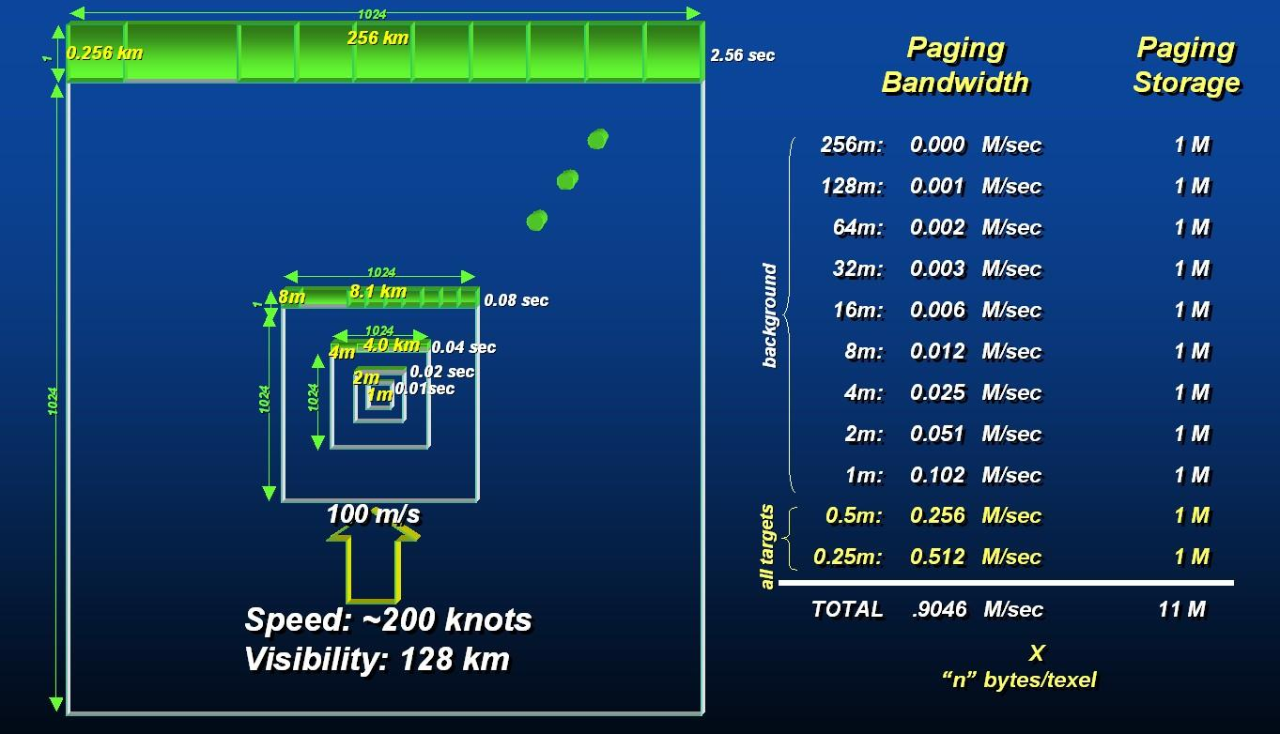
Figure A-14: Paging of Terrain Imagery with an LOD Structure
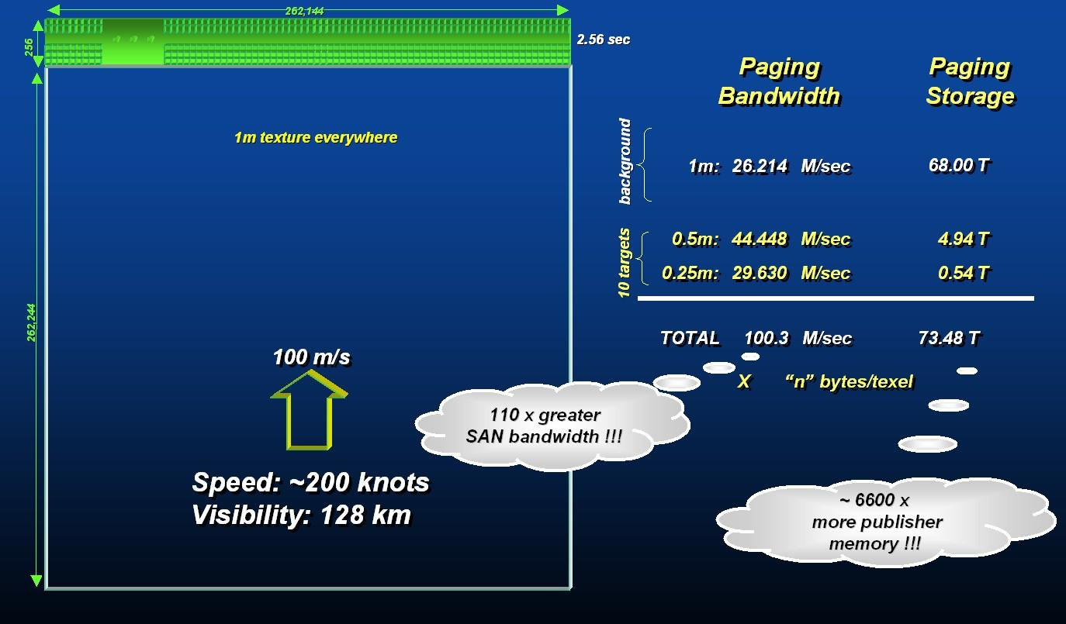
Figure A-15: Paging of Terrain Imagery without an LOD Structure

Annex H Informative: JPEG
Formerly Appendix A.17 in Volume 2 of the OGC CDB Best Practice
The CDB standard supports JPEG2000 for both VSTI and VSTLM component data.
As a result of the high rates of compression there are no real advantages to be gained in supporting a broad range of alternate color representations (such as single channel representations, indexed color representations, RGB-triplet color encoding such as 5-6-5, etc.). The underlying motivation behind all such schemes is driven by a desire to reduce storage and transmission bandwidths. JPEG-2000 achieves these goals and many others, refer to Table A-8 JPEG 2000 Features.

Table A-8 JPEG 2000 Features
High compression efficiency:  Compression better than 0.25 bits per pixels, 20% compression efficiency improvement over JPEG. | High dynamic range:  Compress images with various dynamic ranges (e.g. 1-16 bit) for each color component.
Lossless and lossy compression:  Lossless compression ratios approx. 1.7:1. | Seamless quality / resolution scalability:  Without having to download the entire file.
Progressive image reconstruction:  Allows images to be reconstructed with increasing pixel accuracy and resolution. | Large images sizes - up to (2³² - 1).
Perceptual color space internal coding. | Single decompression architecture.
Region of interest coding:  Permits certain ROI’s in the image to be coded and transmitted with better quality and less distortion than the rest of the image. | Error resilience during transfers.

Annex I Informative: ZipFile Format Notes
Formerly Annex U in Volume 2 of the OGC CDB Best Practice
The archive zip format used in the CDB standard is based on
APPNOTE.TXT - .ZIP File Format Specification
URL: http://www.pkware.com/documents/APPNOTE/APPNOTE-6.3.1.TXT
Version: 6.3.1
Revised: April 11, 2007
Copyright (c) 1989 - 2007 PKWARE Inc., All Rights Reserved.
The use of certain technological aspects disclosed in the currentAPPNOTE is available pursuant to the below section entitled "Incorporating PKWARE Proprietary Technology into Your Product".

CDB zip compliant reader is required to support as a minimum the following features defined in APPNOTE.TXT:
- Local file header (Note: Extra field can be inserted but not required to be read)
- File data
- Data descriptor:
- Central directory structure (Note: Digital signature is supported but will not be read)
- End of central directory record: (Note: ZIP file comments are supported but will not be read)

The compression methods supported:
- No compression
- Deflate (Enhanced Deflate is not required to be supported)

The following features are not required to be supported thus are optional and left to the implementation
- Archive decryption header:
- Archive extra data record.
- Zip64 end of central directory record
- Zip64 end of central directory locator
- Splitting and Spanning ZIP files
- Encryptions of any type

Note that anything not listed in this section is by default assumed not to be supported.

Annex J: Light Names and Hierarchy

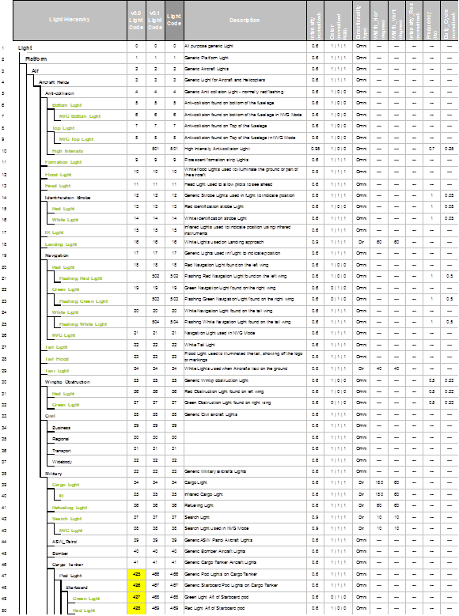
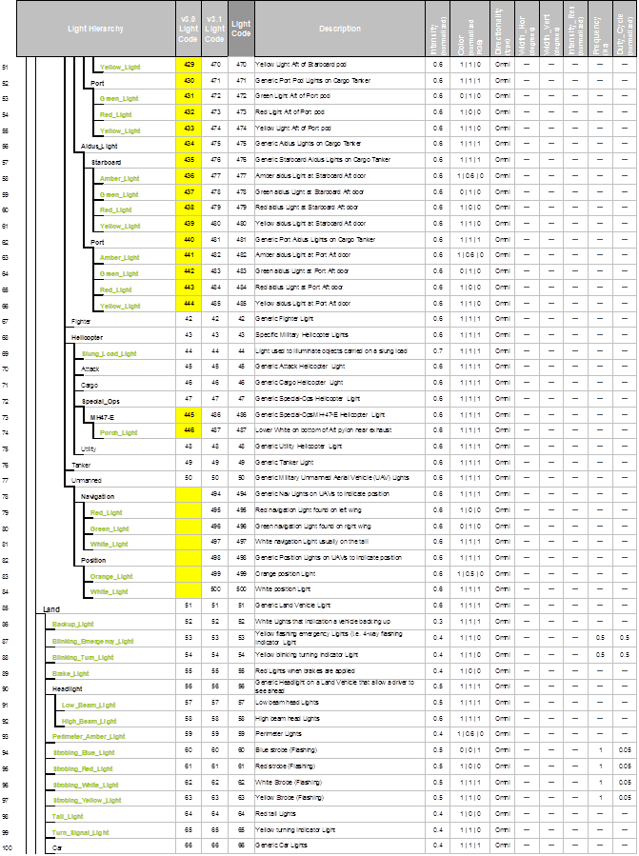
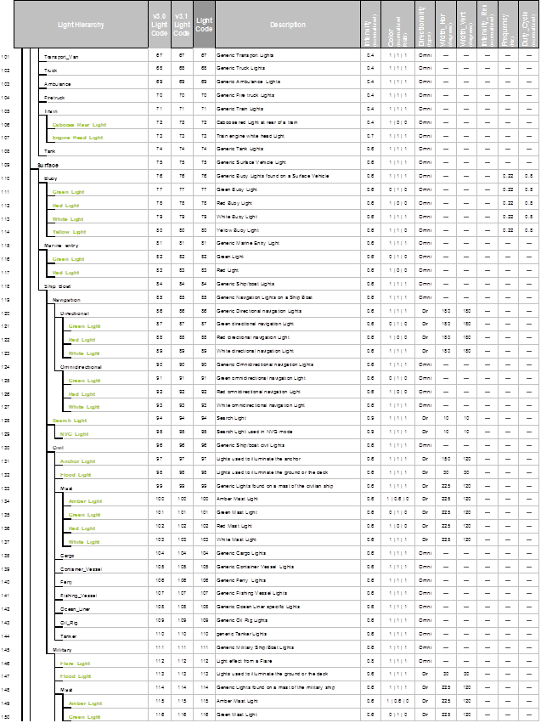
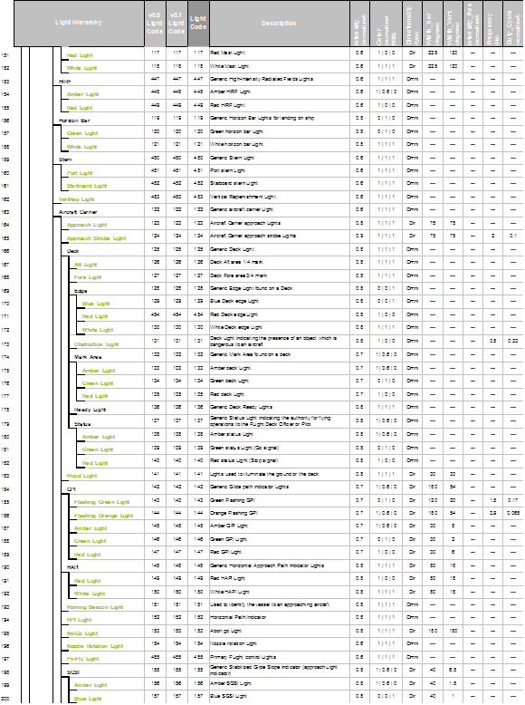
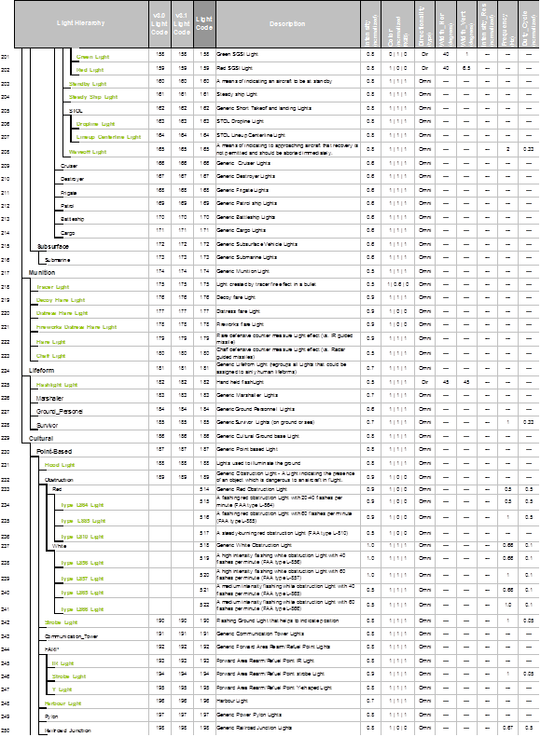
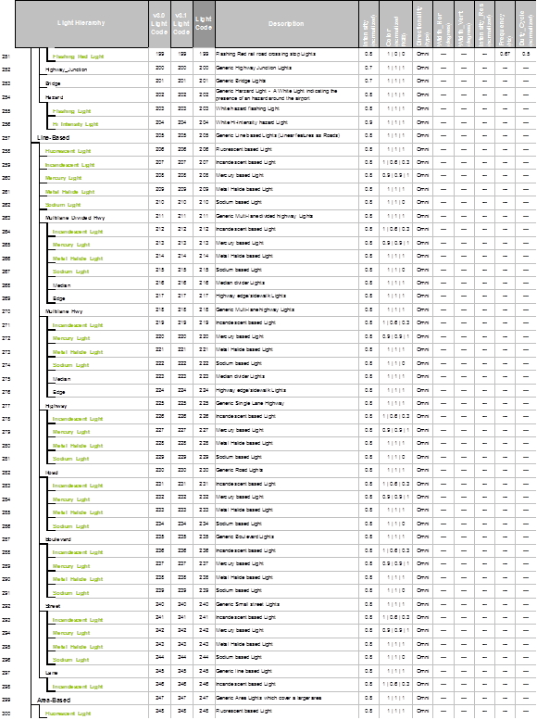
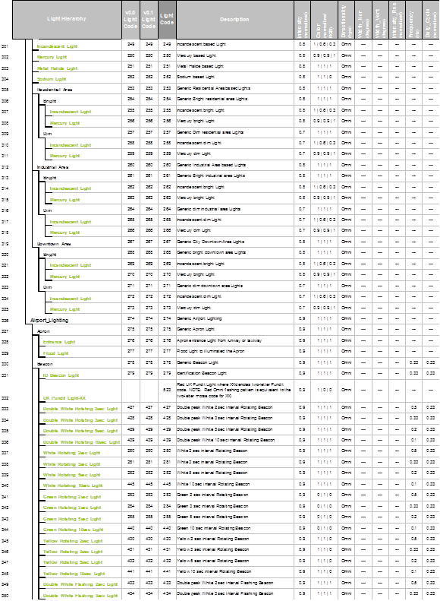
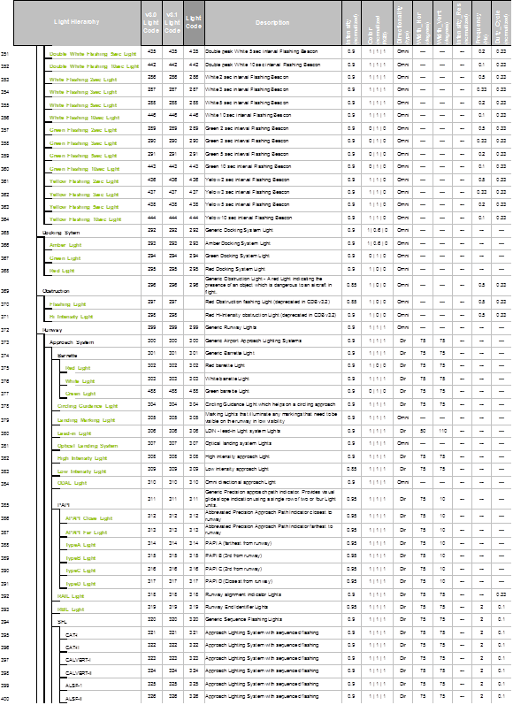
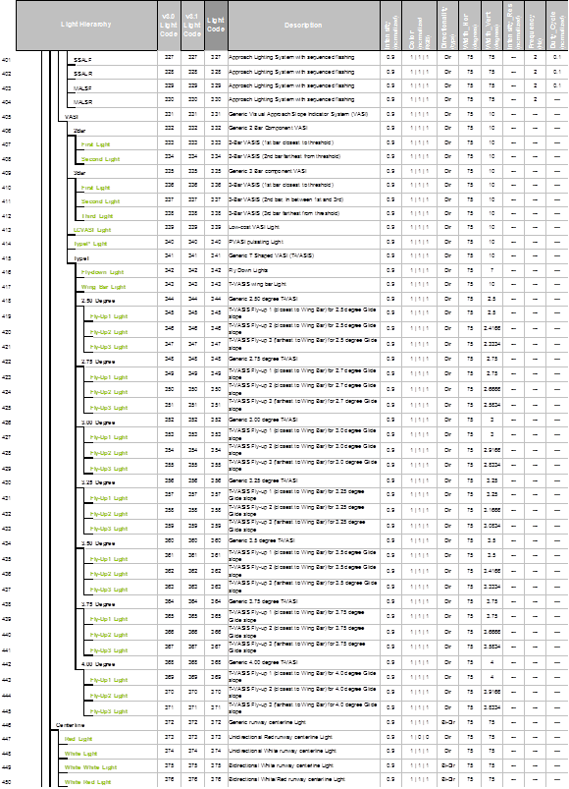
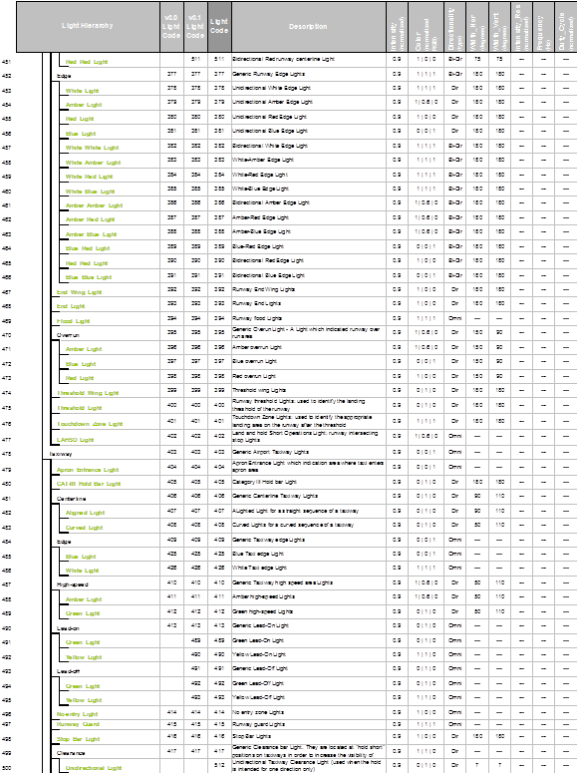
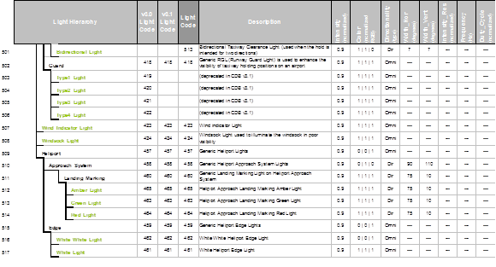

M: CDB Directory Naming and Structure
Formerly Appendix M, Volume 2 of the OGC CDB Best Practice
In previous versions of the CDB specification, Appendix M was used to present the complete list of names allowed to construct the directories of the CDB. As of version 3.2, the appendix has been replaced by a combination of folder hierarchy and metadata files delivered with the CDB Distribution Package.
The /CDB folder hierarchy provides a complete list of directory and file name patterns of the CDB; it summarizes the structure of the CDB presented in chapter 3, Volume 1: Core. The following files are necessary to expand the patterns:
- /CDB/Metadata/Feature_Data_Dictionary.xml provides the list of directory names associated with FACC codes.
- /CDB/Metadata/Moving_Model_Codes.xml provides the list of names for DIS Entity Kinds, Domains, and Categories.
- /CDB/Metadata/DIS_Country_Codes.xml contains the list of DIS Country Names.

Together, these files provide all the information required to build the names of all directories permitted by the CDB standard.

O: List of Texture Component Selectors

Formerly Appendix O, Volume 2 of the OGC CDB Best Practice

The following table provides the list of codes to use to build CDB model texture filenames.

Texture Kind CS1 (Sxxx) | Texture Index CS2 (Txxx) | Description
002 – Month | 001 | January
 | 002 | February
 | 003 | March
 | 004 | April
 | 005 | May
 | 006 | June
 | 007 | July
 | 008 | August
 | 009 | September
 | 010 | October
 | 011 | November
 | 012 | December
003 – Season | 001 | Spring
 | 002 | Summer
 | 003 | Autumn
 | 004 | Winter
004 – Uniform Paint Scheme | 001 | Grey
 | 002 | White
 | 003 | Green
 | 004 | Black
 | 005 | Beige
 | 006 | Blue
 | 007 | Red
 | 008 | Yellow
 | 009 | Brown
 | 010 | Pink
 | 011 | Purple
 | 012 | Burgundy
 | 013 | Orange
 | 014 | Light Blue
 | 015 | Khaki
 | 016 | Dark Grey
 | 017 | Amber
 | 018 | Gold
 | 019 | Silver
 | 020 | Copper
005 – Camouflage Paint Scheme | 001 | Desert
 | 002 | Winter
 | 003 | Forest
 | 004 | Generic
 | 005 | Urban
006 – Airline Paint Scheme | 001 | AAH Aloha Airlines Inc.
 | 002 | AAL American Airlines Inc.
 | 003 | AAR Asiana Airlines Inc.
 | 004 | AAW Afriqiyah Airways
 | 005 | ABR Air Contractors (UK) Limited
 | 006 | ACA Air Canada
 | 007 | ACI Air Caledonie International
 | 008 | ADR Adria Airways - The Airline of Slovenia
 | 009 | AEA Air Europa Lineas Aereas, S.A.
 | 010 | AEE Aegean Airlines S.A.
 | 011 | AEW Aerosvit Airlines
 | 012 | AFG Ariana Afghan Airlines
 | 013 | AFL Aeroflot Russian Airlines
 | 014 | AFR Air France
 | 015 | AGN Air Gabon
 | 016 | AHY Azerbaijan Hava Yollary
 | 017 | AIC Air-India Limited
 | 018 | AIZ Arkia - Israeli Airlines Ltd
 | 019 | AJM Air Jamaica
 | 020 | ALK SriLankan Airlines Limited
 | 021 | AMC Air Malta p.l.c.
 | 022 | AML Air Malawi Limited
 | 023 | AMU Air Macau Company Limited
 | 024 | AMX Aeromexico
 | 025 | ANA All Nippon Airways Co. Ltd.
 | 026 | ANG Air Niugini Pty Limited
 | 027 | ANS Air Nostrum L.A.M.S.A.
 | 028 | ANZ Air New Zealand Limited
 | 029 | ARG Aerolineas Argentinas
 | 030 | ASA Alaska Airlines Inc.
 | 031 | ATC Air Tanzania Company Ltd.
 | 032 | AUA Austrian Airlines, Osterreichische
 | 033 | AUI Ukraine International Airlines
 | 034 | AUT Cielos del Sur S.A.
 | 035 | AVA Aerovias del Continente Americano – Avianca
 | 036 | AVN Air Vanuatu (Operations) Limited
 | 037 | AWE America West Airlines Inc.
 | 038 | AZA Alitalia - Linee Aeree Italiane
 | 039 | AZW Air Zimbabwe (Pvt) Ltd.
 | 040 | BAG dba Luftfahrtgesellschaft mbH
 | 041 | BAW British Airways p.l.c.
 | 042 | BBC Biman Bangladesh Airlines
 | 043 | BCS European Air Transport
 | 044 | BCY Cityjet
 | 045 | BEE Jersey European Airways Limited
 | 046 | BER Air Berlin GmbH & Co. Luftverkehrs KG
 | 047 | BKP Bangkok Airways Co. Ltd.
 | 048 | BLF Blue1 Oy
 | 049 | BLV Bellview Airlines Ltd.
 | 050 | BMA British Midland Airways Ltd.
 | 051 | BOT Air Botswana Corporation
 | 052 | BPA Blue Panorama Airlines S.p.A.
 | 053 | BRA SAS Braathens AS
 | 054 | BRU Belavia
 | 055 | BRZ Samara Airlines
 | 056 | BWA BWIA West Indies Airways Limited
 | 057 | CAL China Airlines
 | 058 | CAW Comair Ltd.
 | 059 | CCA Air China Limited
 | 060 | CDG Shandong Airlines
 | 061 | CES China Eastern Airlines
 | 062 | CHH Hainan Airlines Company Limited
 | 063 | CLH Lufthansa CityLine GmbH
 | 064 | CLX Cargolux Airlines International S.A.
 | 065 | CMI Continental Micronesia, Inc.
 | 066 | CMP Compania Panamena de Aviacion, S.A.
 | 067 | CNW China Northwest Airlines
 | 068 | COA Continental Airlines, Inc.
 | 069 | CPA Cathay Pacific Airways Ltd.
 | 070 | CPN Caspian Airlines Service Company Ltd.
 | 071 | CRL CORSAIR
 | 072 | CSA Czech Airlines a.s., CSA
 | 073 | CSN China Southern Airlines
 | 074 | CTN Croatia Airlines
 | 075 | CUB Cubana de Aviacion S.A.
 | 076 | CXA Xiamen Airlines
 | 077 | CYH China Yunnan Airlines
 | 078 | CYP Cyprus Airways Limited
 | 079 | DAH Air Algerie
 | 080 | DAL Delta Air Lines Inc.
 | 081 | DAN Maersk Air A.S.
 | 082 | DAT Delta Air Transport N.V.
 | 083 | DHK DHL Air Limited
 | 084 | DHX DHL International E.C.
 | 085 | DLH Deutsche Lufthansa AG
 | 086 | DNM Denim Air
 | 087 | DTA TAAG - Linhas Aereas de Angola
 | 088 | EIN Aer Lingus Limited
 | 089 | ELG ALPI Eagles S.p.A.
 | 090 | ELL Estonian Air
 | 091 | ELY El Al Israel Airlines Ltd.
 | 092 | ETD Etihad Airways
 | 093 | ETH Ethiopian Airlines Enterprise
 | 094 | EVA EVA Airways Corporation
 | 095 | EWG Eurowings AG
 | 096 | FCN Falcon Air AB
 | 097 | FDX FedEx
 | 098 | FIN Finnair Oyj
 | 099 | FJI Air Pacific Ltd.
 | 100 | GBL GB Airways Ltd.
 | 101 | GEC Lufthansa Cargo AG
 | 102 | GFA Gulf Air Company G.S.C.
 | 103 | GHA Ghana Airways Corp.
 | 104 | GIA Garuda Indonesia
 | 105 | HCY Helios Airways
 | 106 | HDA Hong Kong Dragon Airlines Limited
 | 107 | HEJ Hellas Jet S.A.
 | 108 | HHN Hahn Air Lines
 | 109 | HLF Hapag Lloyd Fluggesellschaft
 | 110 | HZL Hazelton Airlines dba Regional Express
 | 111 | IAC Indian Airlines
 | 112 | IAW Iraqi Airways
 | 113 | IBB Binter Canarias
 | 114 | IBE Iberia - Lineas Aereas de Espana
 | 115 | ICE Icelandair
 | 116 | ICL C.A.L. Cargo Airlines Ltd.
 | 117 | IRA Iran Air
 | 118 | IRC Iran Aseman Airlines
 | 119 | IRM Mahan Airlines
 | 120 | ISR Israir Airlines and Tourism Ltd.
 | 121 | ISS Meridiana S.p.A.
 | 122 | IYE Yemenia - Yemen Airways
 | 123 | JAI Jet Airways (India) Limited
 | 124 | JAL Japan Airlines International Co., Ltd.
 | 125 | JAT Jat Airways
 | 126 | JAZ JALways Co. Ltd.
 | 127 | JKK Spanair S.A.
 | 128 | KAC Kuwait Airways
 | 129 | KAL Korean Air Lines Co. Ltd.
 | 130 | KHA Kitty Hawk Aircargo, Inc.
 | 131 | KLM KLM Royal Dutch Airlines
 | 132 | KOR Air Koryo
 | 133 | KQA Kenya Airways
 | 134 | KRP Carpatair S.A.
 | 135 | LAA Libyan Arab Airlines
 | 136 | LAM LAM - Linhas Aereas de Mocambique
 | 137 | LAN Lan Airlines S.A.
 | 138 | LAP TAM - Transportes Aereos del
 | 139 | LBC Albanian Airlines MAK S.H.P.K.
 | 140 | LBH Laker Airways (Bahamas) Limited
 | 141 | LCO Lan Chile Cargo S.A.
 | 142 | LDA Lauda Air Luftfahrt AG
 | 143 | LDI Lauda Air S.p.A.
 | 144 | LGL Luxair
 | 145 | LIL Lithuanian Airlines
 | 146 | LLB Lloyd Aereo Boliviano S.A. (LAB)
 | 147 | LOT LOT - Polish Airlines
 | 148 | LPE Lan Peru S.A.
 | 149 | LRC Lineas Aereas Costarricenses S.A.
 | 150 | LTU LTU International Airways
 | 151 | LXR Air Luxor, S.A.
 | 152 | MAH Malev Hungarian Airlines Limited
 | 153 | MAK Macedonian Airlines
 | 154 | MAS Malaysia Airline System Berhad
 | 155 | MAU Air Mauritius
 | 156 | MAZ Zambian Airways
 | 157 | MDG Air Madagascar
 | 158 | MEA Middle East Airlines AirLiban
 | 159 | MGL MIAT - Mongolian Airlines
 | 160 | MGX Montenegro Airlines
 | 161 | MLD Air Moldova
 | 162 | MPX Aeromexpress S.A. de C.V.
 | 163 | MRS Air Marshall Islands, Inc.
 | 164 | MSR Egyptair
 | 165 | MXA Compania Mexicana de Aviacion
 | 166 | NBK Albarka Air Services Ltd.
 | 167 | NCA Nippon Cargo Airlines
 | 168 | NMB Air Namibia
 | 169 | NTW Nationwide Airlines (Pty) Ltd.
 | 170 | NWA Northwest Airlines, Inc.
 | 171 | OAL Olympic Airlines
 | 172 | OAS Oman Aviation Services Co. (SAOG)
 | 173 | PAL Philippine Airlines, Inc.
 | 174 | PAO Polynesian Limited
 | 175 | PGA Portugalia - Companhia Portuguesa de
 | 176 | PIA Pakistan International Airlines
 | 177 | PLK Pulkovo Aviation Enterprise
 | 178 | PNW Palestinian Airlines
 | 179 | PUA Pluna Lineas Aereas Uruguayas S.A.
 | 180 | QFA Qantas Airways Ltd.
 | 181 | QTR Qatar Airways(Q.C.S.C)
 | 182 | RAM Royal Air Maroc
 | 183 | RBA Royal Brunei Airlines Sdn. Bhd.
 | 184 | REU Air Austral
 | 185 | RJA Royal Jordanian
 | 186 | ROT TAROM - Transporturile Aeriene Romane
 | 187 | RSN Royal Swazi National Airways Corp.
 | 188 | RWD Rwandair Express
 | 189 | SAA South African Airways
 | 190 | SAS Scandinavian Airlines System (SAS)
 | 191 | SAT SATA - Air Acores
 | 192 | SBI Siberia Airlines
 | 193 | SER Aero California
 | 194 | SEY Air Seychelles Limited
 | 195 | SFR Safair (Proprietary) Ltd.
 | 196 | SIA Singapore Airlines Limited
 | 197 | SKX Skyways AB
 | 198 | SLA Sierra National Airlines
 | 199 | SLK SilkAir (S) Pte. Ltd.
 | 200 | SLM Surinam Airways Ltd.
 | 201 | SNG Air Senegal International
 | 202 | SOL Solomon Airlines
 | 203 | SQC Singapore Airlines Cargo Pte. Ltd.
 | 204 | SUD Sudan Airways Co. Ltd.
 | 205 | SVA Saudi Arabian Airlines
 | 206 | SWD Southern Winds S.A.
 | 207 | SWR SWISS International Air Lines Ltd
 | 208 | SYR Syrian Arab Airlines
 | 209 | TAI Taca International Airlines, S.A.
 | 210 | TAM TAM Linhas Aereas S.A.
 | 211 | TAP TAP - Air Portugal
 | 212 | TAR Tunisair
 | 213 | TAY TNT Airways S.A.
 | 214 | THA Thai Airways International Public
 | 215 | THT Air Tahiti Nui
 | 216 | THY Turkish Airlines Inc.
 | 217 | TMA Trans-Mediterranean Airways
 | 218 | TNA TransAsia Airways Corporation
 | 219 | TSO Transaero Airlines
 | 220 | TUA Turkmenistan Airlines
 | 221 | UAE Emirates
 | 222 | UAL United Airlines, Inc.
 | 223 | UPS UPS
 | 224 | USA US Airways, Inc.
 | 225 | UYC Cameroon Airlines
 | 226 | VAP Phuket Airlines Co., Ltd.
 | 227 | VDA Volga-Dnepr Airline Joint Stock
 | 228 | VIR Virgin Atlantic Airways Limited
 | 229 | VLE Volare Airlines S.p.A.
 | 230 | VLK Vladivostok Air JSC
 | 231 | VRG Varig S.A.
 | 232 | VSP Viacao Aerea Sao Paulo, S.A. (VASP)
 | 233 | VTA Air Tahiti
 | 234 | WIF Wideroe's Flyveselskap A.S.
 | 235 | WNT Cargojet Airways Ltd.
 | 236 | CRX Crossair
 | 237 | WJA WestJet Airlines Ltd.
 | 238 | JAS Japan Air System
 | 239 | NWW North West Airlines
 | 240 | MEP Midwest Express Airlines
 | 241 | TWA Trans World Airlines
 | 242 | SAB Sabena
 | 243 | TUI Tuninter
 | 244 | SRT Trans Asian Airlines
 | 245 | JBU JetBlue Airways
 | 246 | TSC Air Transat
 | 247 | SWG Sunwing Airlines
 | 248 | FFM Firefly
 | 249 | BVT Berjaya Air
 | 250 | VLG Vueling Airlines
 | 251 | SKY Skymark Airlines
 | 252 | JST Jetstar Airways
 | 253 | ABX ABX Air
 | 254 | CQH Spring Airlines
 | 255 | POE Porter Airlines
 | 256 | EAQ Eastern Australia
 | 257 | EZY EasyJet
 | 258 | NLY Niki
 | 259 | VOZ Virgin Australia
 | 260 | KNA Kunming Airlines
 | 261 | CSC Sichuan Airlines
 | 262 | VRD Virgin America
 | 263 | DKH Juneyao Airlines
 | 264 | KEN Kenmore Air
 | 265 | XAK Air Kenya
 | 266 | NZM Mount Cook Airline
 | 267 | FDA Fuji Dream Airlines
 | 268 | TAE TAME (Línea Aérea del Ecuador)
 | 269 | CFE BA CityFlyer
 | 270 | JZA Jazz Aviation
 | 271 | CSH Shanghai Airlines
 | 272 | BEE Flybe
 | 273 | TYR Tyrolean Airways
 | 274 | SWA Southwest Airlines
 | 275 | XME Australian Air Express
 | 276 | BEL Brussels Airlines
 | 277 | GCR Tianjin Airlines
 | 278 | VOI Volaris
 | 279 | ARA Arik Air
 | 280 | LNI Lion Air
 | 281 | RYR Ryanair
 | 282 | SHU Aurora
 | 283 | NIG Aero Contractors
 | 284 | SCW Malmö Aviation
 | 285 | NAX Norwegian Air Shuttle
 | 286 | RAR Air Rarotonga
009 – Quarter | 001 | First quarter of the year
 | 002 | Second quarter of the year
 | 003 | Third quarter of the year
 | 004 | Fourth quarter of the year
054 – Contaminant | 001 | Wet Surface
 | 002 | Snowy Surface
 | 003 | Icy Surface
 | 004 | Slushy Surface
 | 005 | Patchy Wet Surface
 | 006 | Patchy Snowy Surface
 | 007 | Patchy Icy Surface
 | 008 | Patchy Sandy Surface
 | 009 | Patchy Dirty Surface
 | 010 | Volcanic Ash
 | 011 | Patchy Volcanic Ash
055 – Skid Mark | 001 | Tire Mark

Examples:
- A geospecific City Hall especially decorated for the Halloween during the month (S002) of October (T010) could have a texture named Geocell_D301_S002_T010_LOD_UREF_RREF_City-Hall.rgb.
- The texture of a geotypical house used during the first (T001) quarter (S009) of the year could be named D501_S009_T001_Wxx_House.rgb.
- Similarly, the uniform (S004) grey (T001) texture used with a Cobra helicopter could be named D601_S004_T001_Wxx_Cobra.rgb.
- A 1024 by 1024 (W10) texture representing an M1A2 tank desert (T001) camouflage (S005) could be stored in a file named D601_S005_T001_W10_M1A2.rgb.
- An Airbus 380 model 800 operated by the Emirates (T221) Airlines (S006) could be stored in a file named D601_S006_T221_Wxx_A380-800.rgb.

Notes:
- Texture Kind 002 and 009 are complete; the number of months and quarters will not change.
- Texture Kind 004 will expand as new colors are added. Color names are defined here: http://en.wiktionary.org/wiki/Appendix:Colors.
- Texture Kind 005, the Camouflage Paint Scheme, follows a similar numbering scheme as the HLA’s RPR-FOM Version 2 Draft 17. The list will expand as new camouflages are needed or new values added to the RPR-FOM.
- Texture Kind 006 will expand as ICAO assigns new airline acronyms.
- Texture Kind 054 and 055 will expand as new contaminants and skid marks are deemed necessary.

Annex Q: Table of Dataset Codes
Formerly Appendix Q in Volume 2 of the OGC CDB Best Practice.

The table below summarizes the CDB dataset codes along with their names and their applicability to the three active versions of the CDB standard.

Dataset |  | Specification
Name | Code | 3.0 | 3.2
Elevation | 001 | √ | √
MinMaxElevation | 002 | √ | √
MaxCulture | 003 | √ | √
Imagery | 004 | √ | √
RMTexture | 005 | √ | √
RMDescriptor | 006 | √ | √
Reserved | 007
Reserved | 008
Reserved | 020
GSFeature | 100 | √ | √
GTFeature | 101 | √ | √
GeoPolitical | 102 | √ | √
VectorMaterial | 200 | √ | √
RoadNetwork | 201 | √ | √
RailRoadNetwork | 202 | √ | √
PowerLineNetwork | 203 | √ | √
HydrographyNetwork | 204 | √ | √
GSModelGeometry | 300 | √ | √
GSModelTexture | 301 | √ | √
GSModelSignature | 302 | √ | √
GSModelDescriptor | 303 | √ | √
GSModelMaterial | 304 |  | √
GSModelInteriorGeometry | 305 |  | √
GSModelInteriorTexture | 306 |  | √
GSModelInteriorDescriptor | 307 |  | √
GSModelInteriorMaterial | 308 |  | √
GSModelCMT | 309 |  | √
T2DModelGeometry | 310 |  | √
NavData | 400 | √ | √
Navigation | 401 | √ | √
GTModelGeometry | 500 | √ | √
 | 510 |  | √
GTModelTexture | 501 | √
 | 511 |  | √
GTModelSignature | 502 | √
 | 512 |  | √
GTModelDescriptor | 503 | √ | √
GTModelMaterial | 504 |  | √
GTModelCMT | 505 |  | √
GTModelInteriorGeometry | 506 |  | √
GTModelInteriorTexture | 507 |  | √
GTModelInteriorDescriptor | 508 |  | √
GTModelInteriorMaterial | 509 |  | √
GTModelInteriorCMT | 513 |  | √
MModelGeometry | 600 | √ | √
MModelTexture | 601 | √ | √
MModelSignature | 602 | √
 | 606 |  | √
MModelDescriptor | 603 | √ | √
MModelMaterial | 604 |  | √
MModelCMT | 605 |  | √
Metadata | 700 |  | √
ClientSpecific | 701 |  | √
Reserved for CDB Extensions | 9xx

 | Dataset Code is not used
√ | Dataset Code is in use
 | Dataset Code is deprecated
 | Dataset Code is reserved

Annex R: Derived Datasets within the CDB
As seen throughout this document, the CDB Specification provides all the means and mechanisms to populate all the simulation datasets without involving data duplication by using Industry Standards. However, there are situations where a specific dataset information type needs to be derived from another existing one in order to specialize further the information into another dataset type or form.
This consideration becomes a grey area where the off-line tools’ capability and the run-time simulation clients’ performance levels enforces this data derivation.
It is such a case with the Mip-Map data, Min-Max Elevation datat, Tile Presence data, RCS data, and Raster Material data for example.

Source Dataset | Data Manipulation  Description | Resulting Dataset(s)
Elevation Dataset | In order to produce the various Level Of Details within the Elevation Dataset, it is often necessary to over-sample or sub-sample a primary set of data values. Since those values within the LOD hierarchy may come from a single data source, the LODs can be seen as derived information which can better accommodate the client needs based on their performance level. | Elevation LODs
Elevation Dataset | For clients that need to compute line of sights (LOS) between simulation entities spread across a vast terrain area, it is imperative to have a fast way of knowing the minimum and maximum elevations within a tile without loading the entire elevation data grid. The min/max elevation dataset can be used to ensure a fast pre-determination of entities occultation state with the terrain. The min/max data is stored in the form of a quad-tree pyramid and is based on the area covered at the given depth level of the quad-tree. For example, for the maximum dataset the top will contain the maximum for the whole of the geocell, the next pyramid level contains maximum data for each the quarter geocells and so on. Similarly for the minimum the top represents the minimum for the whole of the geocell going down as for maximums. Currently the pyramid size is fixed and goes down to level 9 which covers areas that are approximately 256x256 meters square; note that the depth level can be modified to a finer or coarser level but level 9 is suggested as a reasonable compromise of performance vs. storage. A tool will pre-determine the minimum and maximum elevations within a geocell’s elevations and generate the quad-trees described previously; note that the tool will use all of the elevation data that is present in the elevation dataset to determine the maximums or minimums in a given area. The tool will provide Min-Max values to client devices through the Min-Max Elevation datasets in the CDB. | Min-Max Elevation
Vector Datasets (Point, Lineal and Areal Features) | The Max Culture Height data is produced for clients that need to compute line of sights (LOS) between simulation entities spread across a vast terrain area that take into account the maximum cultural feature heights. The dataset helps rapidly assess an intersection status of line-of-sight with cultural features. This dataset is derived from the Vector Datasets of the CDB for corresponding tiles. The storage is done via a quad-tree similar to that of the min/max elevation the top of the pyramid represents the height of the highest cultural feature in the dataset going down to a suggested depth level of 9. | Max Culture Height
3D Model (GT, GS, MM) Datasets | The polar diagram data (covering all aspect angles) of the RCS dataset for Geotypical, Geospecific or Moving Models cannot readily be computed at run-time due to the complex mathematical computing algorithms and resources required to determine the Electro-Magnetic Energy absorption levels by the model’s materials, the corner reflections, the multi-path reflections, EM parameters (frequency, polarization) effects, and so on. Therefore, off-line COTS tools are used to analyze the 3D model geometry and its materials in order to produce the RCS dataset specifically for different frequencies and polarizations. | RCS (Radar Cross Section)
Vector Datasets (Point, Lineal and Areal Features) | Since the material attribution is normally done in the vector data, a rasterization operation among all features is required to come up with a raster grid of attributed materials. | Raster Material

Annex S: Default Read and Write values for Simulator Client-Devices
As seen throughout this document, the CDB standard provides guidelines with respect to default values in cases where no data could be read from the CDB for requested datasets. Those default parameters are captured in a Metadata file within the CDB. The Table below summarizes all the Default Parameters Names and the suggested initial values to be used by client-devices. In cases where the default parameter would be missing altogether from \CDB\Metadata\Defaults.xml, Client-Devices shall use the “Default Value” found in the fourth column. A “Read” default refers to the value being assumed while reading the CDB data. A “Write” default refers to the value being written to the file when content-generation tools have partial source data.

Parameter Name | Dataset | Type | Default Value | R/W
Default_Elevation-1 | 001_Elevation | float | 0 m | R
Default_Elevation-[2-99] | 001_Elevation | float | 0 m | R
Default_Primary_Elevation_Control | 001_Elevation | integer | INSIDE (1) | R
Default_Subordinate_Elevation_Control | 001_Elevation | integer | NO_ELEVATION (0) | R
Default_Bathymetry | 001_Elevation | float | 0 m | R
Default_Tide | 001_Elevation | float | 2.5 m | R
Default_MinElevation_CaseI | 002_MinMaxElevation | float | Default_Elevation-1 | R
Default_MaxElevation_CaseI | 002_MinMaxElevation | float | Default_Elevation-1 | R
Default_MinElevation_CaseII | 002_MinMaxElevation | float | -400 m | R
Default_MaxElevation_CaseII | 002_MinMaxElevation | float | 8846 m | R
Default_MinElevation_CaseIII | 002_MinMaxElevation | float | 8846 m | W
Default_MaxElevation_CaseIII | 002_MinMaxElevation | float | -400 m | W
Default_MaxCulture_CaseI | 003_MaxCulture | float | 600 m | R
Default_MaxCulture_CaseII | 003_MaxCulture | float | 0 m | R
Default_VSTI_Y_Mono | 004_Imagery | float | 0.5 | R
Default_VSTI_Y_Red | 004_Imagery | float | 0.5 | R
Default_VSTI_Y_Green | 004_Imagery | float | 0.5 | R
Default_VSTI_Y_Blue | 004_Imagery | float | 0.5 | R
Default_VSTLM_Mono | 004_Imagery | float | 0.0 | R
Default_VSTLM_Red | 004_Imagery | float | 0.0 | R
Default_VSTLM_Green | 004_Imagery | float | 0.0 | R
Default_VSTLM_Blue | 004_Imagery | float | 0.0 | R
Default_Imagery_Gamma | 004_Imagery | float | 1.0 | R
Default_RoadNetwork_LTN | 201_RoadNetwork | integer | 2 | R
Default_RailRoadNetwork_LTN | 202_RailRoadNetwork | integer | 1 | R
Default_GSModelTexture_Gamma | 301_GSModelTexture | float | 1.0 | R
Default_GSModelInteriorTexture_Gamma | 306_GSModelInteriorTexture | float | 1.0 | R
Default_GTModelTexture_Gamma | 511_GTModelTexture | float | 1.0 | R
Default_GTModelInteriorTexture_Gamma | 507_GTModelInteriorTexture | float | 1.0 | R
Default_MModelTexture_Gamma | 601_MModelTexture | float | 1.0 | R
Default_Base_Material |  | string | BM_LAND-MOOR | R
Default_Material_Layer |  | integer | 0 | R
Default_AO1 |  | float | 0.0 | R
Default_SCAL[x,y,z] |  | float | 1.0 | R
Default_TRF |  | integer | 4 | R

