Open Geospatial Consortium
Submission Date: 2016-04-04
Approval Date: 2016-dd-mm
Publication Date: 2016-dd-mm
External identifier of this OGC® document: http://www.opengis.net/doc/IS/CDB-core-model/1.0
Internal reference number of this OGC® document: 16-007r1
Version: 1.0
Category: OGC® Implementation
Editor: Sara Saeedi

Volume 11: OGC CDB Core Standard Conceptual Model

Copyright notice
Copyright © 2016 Open Geospatial Consortium
To obtain additional rights of use, visit http://www.opengeospatial.org/legal/.

Warning
This document is not an OGC Standard. This document is distributed for review and comment. This document is subject to change without notice and may not be referred to as an OGC Standard. Recipients of this document are invited to submit, with their comments, notification of any relevant patent rights of which they are aware and to provide supporting documentation.

Document type: OGC® Candidate Standard
Document subtype: if applicable
Document stage: Draft
Document language: English

License Agreement
Permission is hereby granted by the Open Geospatial Consortium, ("Licensor"), free of charge and subject to the terms set forth below, to any person obtaining a copy of this Intellectual Property and any associated documentation, to deal in the Intellectual Property without restriction (except as set forth below), including without limitation the rights to implement, use, copy, modify, merge, publish, distribute, and/or sublicense copies of the Intellectual Property, and to permit persons to whom the Intellectual Property is furnished to do so, provided that all copyright notices on the intellectual property are retained intact and that each person to whom the Intellectual Property is furnished agrees to the terms of this Agreement.
If you modify the Intellectual Property, all copies of the modified Intellectual Property must include, in addition to the above copyright notice, a notice that the Intellectual Property includes modifications that have not been approved or adopted by LICENSOR.
THIS LICENSE IS A COPYRIGHT LICENSE ONLY, AND DOES NOT CONVEY ANY RIGHTS UNDER ANY PATENTS THAT MAY BE IN FORCE ANYWHERE IN THE WORLD.
THE INTELLECTUAL PROPERTY IS PROVIDED "AS IS", WITHOUT WARRANTY OF ANY KIND, EXPRESS OR IMPLIED, INCLUDING BUT NOT LIMITED TO THE WARRANTIES OF MERCHANTABILITY, FITNESS FOR A PARTICULAR PURPOSE, AND NONINFRINGEMENT OF THIRD PARTY RIGHTS. THE COPYRIGHT HOLDER OR HOLDERS INCLUDED IN THIS NOTICE DO NOT WARRANT THAT THE FUNCTIONS CONTAINED IN THE INTELLECTUAL PROPERTY WILL MEET YOUR REQUIREMENTS OR THAT THE OPERATION OF THE INTELLECTUAL PROPERTY WILL BE UNINTERRUPTED OR ERROR FREE. ANY USE OF THE INTELLECTUAL PROPERTY SHALL BE MADE ENTIRELY AT THE USER’S OWN RISK. IN NO EVENT SHALL THE COPYRIGHT HOLDER OR ANY CONTRIBUTOR OF INTELLECTUAL PROPERTY RIGHTS TO THE INTELLECTUAL PROPERTY BE LIABLE FOR ANY CLAIM, OR ANY DIRECT, SPECIAL, INDIRECT OR CONSEQUENTIAL DAMAGES, OR ANY DAMAGES WHATSOEVER RESULTING FROM ANY ALLEGED INFRINGEMENT OR ANY LOSS OF USE, DATA OR PROFITS, WHETHER IN AN ACTION OF CONTRACT, NEGLIGENCE OR UNDER ANY OTHER LEGAL THEORY, ARISING OUT OF OR IN CONNECTION WITH THE IMPLEMENTATION, USE, COMMERCIALIZATION OR PERFORMANCE OF THIS INTELLECTUAL PROPERTY.
This license is effective until terminated. You may terminate it at any time by destroying the Intellectual Property together with all copies in any form. The license will also terminate if you fail to comply with any term or condition of this Agreement. Except as provided in the following sentence, no such termination of this license shall require the termination of any third party end-user sublicense to the Intellectual Property which is in force as of the date of notice of such termination. In addition, should the Intellectual Property, or the operation of the Intellectual Property, infringe, or in LICENSOR’s sole opinion be likely to infringe, any patent, copyright, trademark or other right of a third party, you agree that LICENSOR, in its sole discretion, may terminate this license without any compensation or liability to you, your licensees or any other party. You agree upon termination of any kind to destroy or cause to be destroyed the Intellectual Property together with all copies in any form, whether held by you or by any third party.
Except as contained in this notice, the name of LICENSOR or of any other holder of a copyright in all or part of the Intellectual Property shall not be used in advertising or otherwise to promote the sale, use or other dealings in this Intellectual Property without prior written authorization of LICENSOR or such copyright holder. LICENSOR is and shall at all times be the sole entity that may authorize you or any third party to use certification marks, trademarks or other special designations to indicate compliance with any LICENSOR standards or specifications. This Agreement is governed by the laws of the Commonwealth of Massachusetts. The application to this Agreement of the United Nations Convention on Contracts for the International Sale of Goods is hereby expressly excluded. In the event any provision of this Agreement shall be deemed unenforceable, void or invalid, such provision shall be modified so as to make it valid and enforceable, and as so modified the entire Agreement shall remain in full force and effect. No decision, action or inaction by LICENSOR shall be construed to be a waiver of any rights or remedies available to it.

Table of Contents
Contents
Abstract 5
i. Keywords 5
ii. Preface 5
iii. Submitting organizations 6
iv. Submitters 6
v. Future Work 6
vi. CDB Document Guide 6
1- Overview of the OGC CDB Conceptual Model 8
2- CDB General Data Organization 11
2-1- LOD and Geocell 13
2-2- CDB File System 14
2-3- Model Type 17
2-3-1 3D Moving Model 18
2-4- Vector Data Model 19
3- Metadata Schema 20
3-1- Light Names Hierarchy 20
3-2- Client Specific Lights Definition 21
3-3- Model Components Definition 21
3-4- Base Materials Table 22
3-5- Composite Material Tables 23
3-6- Default Values Definition Table 24
3-7- Version 25
3-8- Configuration 26
3-9- CDB Vector Attributes 28
3-10- 3D Model Metadata 29
4- 3D Model Extensions 32
5- Feature Data Dictionary 32
Annex A: 35
A.1. CDB Overall Conceptual Model 35
Annex B: 36
B.1 Class Diagrams Notation 36

Abstract
This OGC standard defines the conceptual model for the OGC CDB 1.0 Standard. The objective of this document is to provide an abstract core conceptual model. The model is represented using UML (unified modeling language). The conceptual model is comprised of concepts, schema, classes and categories as well as their relationships, which are used to understand, and/or represent an OGC CDB data store. This enables a comparison and description of the CDB data store structure on a more detailed level. This document was created by reverse-engineering a UML model and documentation from the OGC CDB standard as a basis for supporting OGC interoperability. One of the important roles of this conceptual model is to provide a UML model that is consistent with the other OGC standards and to identify functional gaps between the current CDB data store and the OGC standards baseline. This document references sections of Volume 1: OGC CDB Core Standard: Model and Physical Database Structure [OGC 15-113].

NOTE: The simulation community uses the term “synthetic environment data” to mean all the digital data stored in some database or structured data store that is required for use by simulation clients. From the geospatial community perspective, these data are essentially the same as GIS data but with, in some cases, special attributes, such as radar reflectivity.

Keywords
The following are keywords to be used by search engines and document catalogues.
ogcdoc, UML, conceptual model, raster, tiles, vector, CDB, simulation, visualization, synthetic environment

Preface
The industry-maintained CDB model and data store structure has been discussed and demonstrated at OGC Technical Committee meetings since September, 2013. This document, the first UML conceptual model for OGC CDB standard, is one of the 12 documents that comprise the OGC CDB modular standard. The UML conceptual model establishes a single set of consistent concepts that could be also implemented using other encoding mechanisms.
The CDB standard is originally based on the OGC CDB Best Practice documents, which were submitted to the OGC by CAE Inc. on behalf of the CDB implementation community and user group. CDB is currently widely implemented in the DoD and aviation simulation communities. The intent is that this initial OGC version of the CDB standard be backwards compatible with existing implementations but that terminology and concepts be aligned as appropriate with the OGC technical baseline. Future work is planned to align the standard with other OGC standards and to provide Best Practices focused on how to use CDB with the existing OGC standards baseline, such as OGC WMS, WFS, and WCS.
Attention is drawn to the possibility that some of the elements of this document may be the subject of patent rights. The Open Geospatial Consortium shall not be held responsible for identifying any or all such patent rights.
Recipients of this document are requested to submit, with their comments, notification of any relevant patent claims or other intellectual property rights of which they may be aware that might be infringed by any implementation of the standard set forth in this document, and to provide supporting documentation.

Submitting organizations
The following organizations submitted this Document to the Open Geospatial Consortium (OGC):
CAE Inc.
Carl Reed, OGC Individual Member
Envitia, Ltd
Glen Johnson, OGC Individual Member
KaDSci, LLC
Laval University
Open Site Plan
University of Calgary
UK Met Office
The OGC CDB standard is based on and derived from an industry developed and maintained specification, which has been approved and published as OGC Document 15-003: OGC Common DataBase Volume 1 Main Body. An extensive listing of contributors to the legacy industry-led CDB specification is at Chapter 11, pp 475-476 in that OGC Best Practices Document (https://portal.opengeospatial.org/files/?artifact_id=61935).

Submitters
All questions regarding this submission should be directed to the editor or the submitters:
Name | Affiliation
Sara Saeedi | University of Calgary
Steve Liang | University of Calgary
Carl Reed | Carl Reed & Associates
David Graham | CAE Inc.

Future Work
The CDB community anticipates that additional standardization will be required to prescribe content appropriate to targeted simulation applications. The CDB SWG understands there is opportunity of increased alignment of the CDB standard with the OGC/ISO Standards baselines such as the details of using WMS, WFS, and WCS to access existing CDB data stores; and including the use of GeoPackage, GML, or other commonly used industry formats in a CDB data store.

CDB Document Guide
For ease of editing and review, the standard has been separated into 12 Volumes and a schema repository.

- Volume 0: OGC CDB Companion Primer for the CDB standard. (Best Practice)
- Volume 1: OGC CDB Core Standard: Model and Physical Data Store Structure.
The main body (core) of the CBD standard (Normative).
- Volume 2: OGC CDB Core Model and Physical Structure Annexes (Best Practice).
- Volume 3: OGC CDB Terms and Definitions (Normative).
- Volume 4: OGC CDB Use of Shapefiles for Vector Data Storage (Best Practice).
- Volume 5: OGC CDB Radar Cross Section (RCS) Models (Best Practice).
- Volume 6: OGC CDB Rules for Encoding Data using OpenFlight (Best Practice).
- Volume 7: OGC CDB Data Model Guidance (Best Practice).
- Volume 8: OGC CDB Spatial Reference System Guidance (Best Practice).
- Volume 9: OGC CDB Schema Package: provides the normative schemas for key features types required in the synthetic modelling environment. Essentially, these schemas are designed to enable semantic interoperability within the simulation context. (Normative)
- Volume 10: OGC CDB Implementation Guidance (Best Practice).
- Volume 11: OGC CDB Core Standard Conceptual Model (Normative)
- Volume 12: OGC CDB Navaids Attribution and Navaids Attribution Enumeration Values (Best Practice)

1- Overview of the OGC CDB Conceptual Model
Conceptual modelling is a structural methodology for describing how the components of a CDB data store may be implemented based on the modular specification design of the OGC CDB Core Standard. The following table defines the general CDB data store requirement and an overview of key elements implemented in a compliant CDB data store.
Requirement Class 1
Req. ID | http://opengis.net/spec/CDB/1.0/core/OveralConceptualModel
Dependency | All of the requirements of the OGC CDB core document
Req. Text | A minimum compliant CDB shall contain the version metadata; when any dataset is provided in a CDB, it shall comply with the corresponding mandatory requirements of the OGC CDB Core Standard.

This section presents the conceptual model of the OGC CDB Core Standard. This model can used as the basis for the CDB standard in other application domains, along with its requirements, extension, file-based structure, data formats, access, and the discovery of services.
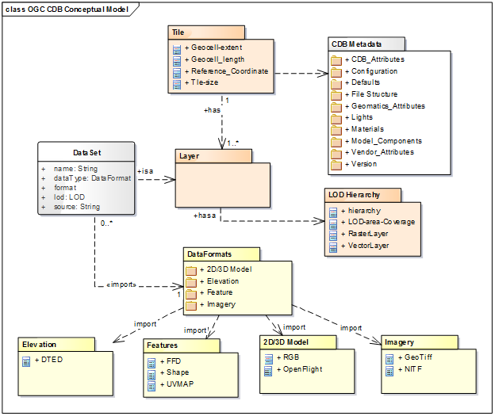
Figure 1: Package diagram of OGC CDB data store conceptual model
The CDB data store structure provides efficient access of its contents. The main properties of the CDB data store UML diagram are documented below.
Name | Definition | Data type & Value | Multiplicity
Tile | Geographically divides the world into geodetic tiles (bound by latitudes and longitudes), each containing at least a dataset | Dataset type. | One or more (mandatory)
LOD Hierarchy | Each dataset layer has a LOD hierarchy. | Hierarchy of raster, vector and models. | One (mandatory)
Dataset | It defines the basic storage unit used in a CDB data store. | Layers of data | One (mandatory)
Models | It includes 3D representations of cultural features and moving models such as buildings, pylons and posts, aircraft and other moving platforms. 3D models have various model components | Model data formats supported in CDB standard. | Zero or more (optional)
Imagery | There are various imageries in a CDB data store such as representation of geo-referenced terrain, elevation, and texture. | Image data formats supported in the CDB standard such as GeoTIFF, JPEG 2000 and etc. | Zero or more (optional)
Vector Features | This includes all the vector feature datasets in a CDB which are defined based on the FDD. | Vectors data formats supported by the CDB such as shapefile and etc. | Zero or more (optional)
Elevation | It is depicted by a grid of elevation data elements at regular geographic intervals, which include DEM, MinMaxElevation and MaxCulture. | Grid of terrain altimetry data | Zero or more (optional)
Metadata | A number of CDB XML files that include the default hierarchies, naming, values to be used by client devices. | XML association | one or more (mandatory)

As it can be seen in Figure 2, the CDB standard relies on three important concepts to organize geospatial data: Tiles, Layers (or datasets) and Levels of Detail (LOD) which are described here:
- Tiles: Tiles organize the data into zones defined by location with respect to a WGS84 reference system. The CDB storage structure allows efficient searching, retrieval and storage of any information contained within a CDB data store. The storage structure portion of the standard geographically divides the world into geodetic tiles (bound by latitudes and longitudes), each containing a specific set of features (such as terrain altimetry, vectors) and models (such as 3D and Radar Cross Sections models), which are in turn represented by their respective datasets. The datasets define the basic storage unit used in a CDB data store. The geographic granularity is at the tile level while in each tile, the information granularity is at the dataset level defined by layers.
- Layers: Layers organize different types of data in a tile. The CDB standard data store model is also logically organized as distinct layers of information. The layers are independent from each other (i.e., changes in one layer do not impose changes in other layers).
- Levels-of-Detail (LODs): LODs organize the data in each layer of each tile by its detail. The availability of LOD representations is critical to real-time performance. Most simulation client-devices can readily take advantage of an LOD structure because, in many cases, less detail/information is necessary at increasing distances from the viewpoint of a simulation rendering. The CDB standard requires that each geographic area be represented in an LOD hierarchy in accordance with the availability of source data.

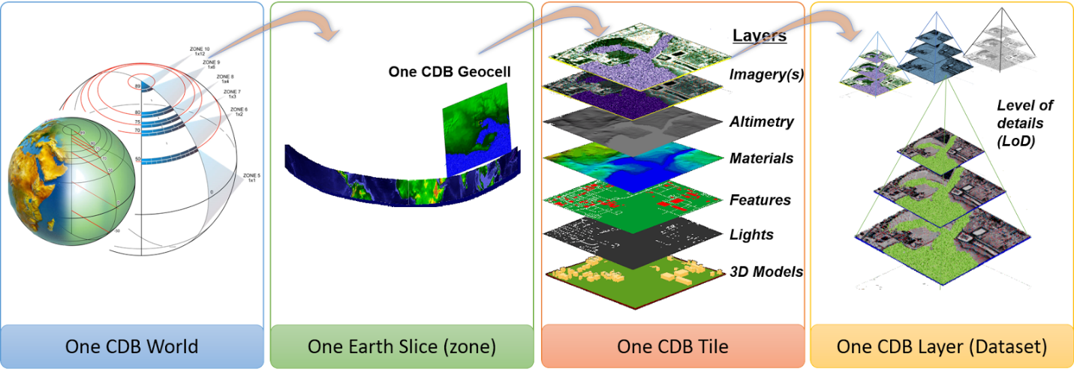
Figure 2: CDB data organization structure

2- CDB General Data Organization
The CDB is composed of several datasets that share a common structure. The following sections present the general organization and structure of all CDB datasets. The CDB standard does not define or enforce an operating system or file system. Nonetheless, the implementation of a CDB storage sub-system must conform to absolute minimum file system requirements called for by the standard. A CDB database uses existing common file formats for storing data in various formats such as TIFF/GeoTIFF (raster data), JPEG 2000 (imagery data), OpenFlight (3D models), Shape (vector data and radar cross sections), RGB (textures), XML (Metadata) and ZIP (file collection). The current version of CDB uses a consolidation of data dictionaries from DIGEST, DGIWG, SEDRIS and UHRB. In addition, it is possible to extend the CDB Feature Data Dictionary (FDD) by using the extension capabilities and adding a new FDD XML schema file to access additional feature data codes. The UML diagram in Figure 3 describes how the data is categorized in tiles, layers and LODs. This is the basis for the CDB geospatial data categorization.
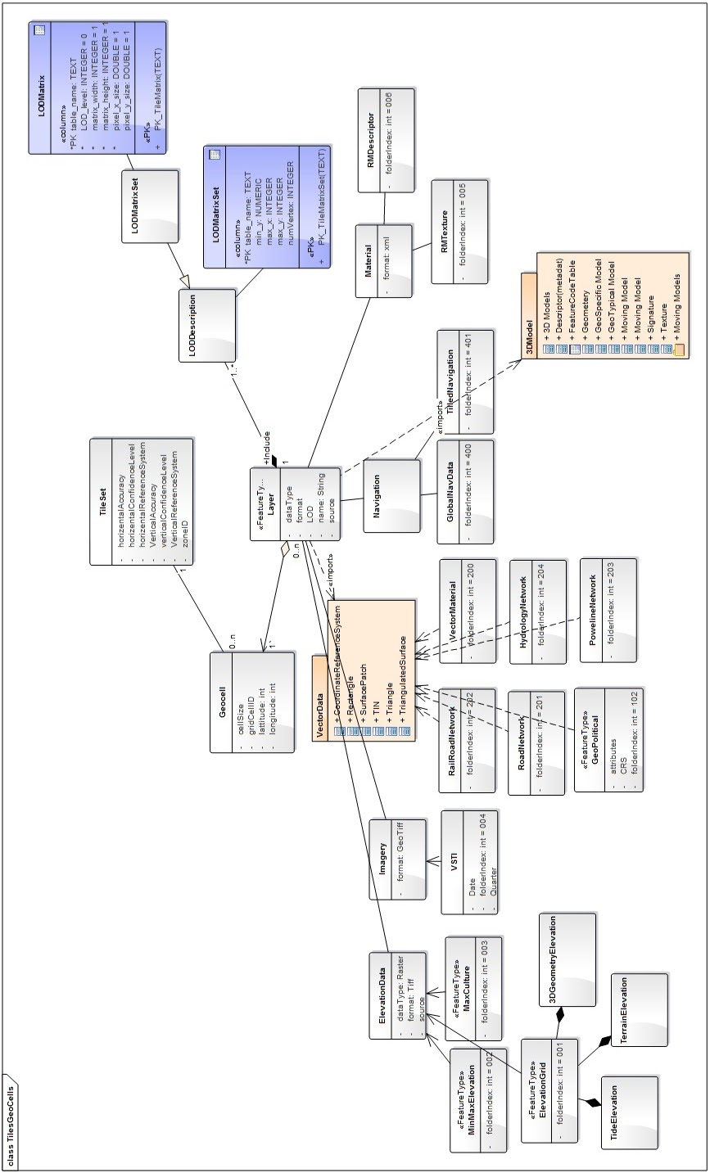
Figure 3: UML diagram of the CDB general data organization
This diagram is the general data organization for the CDB. The main properties of the CDB general data organization UML diagram are documented below.
Name | Definition | Data type & Value | Multiplicity
Raster Dataset | Data elements are organized into a regular grid evenly positioned. Raster Datasets always have a fixed number of elements corresponding to their LOD spec. | Raster data formats supported in CDB Core Standard for elevation, imageries, texture and grid data. | Zero or more (optional)
Vector  Dataset | The point features, the lineal features, and the areal features of the CDB are organized into several Vector Datasets and into LODs. For each CDB LOD, the maximum number of points allowed per Tile-LOD and the resulting average Feature Density is defined. | RMDescriptor, GSFeature, GTFeature, GeoPolitical, VectorMateria, RoadNetwork, RailRoadNetwork, PowerLineNetwork, HydrographyNetwork,  vectors(Shape) | Zero or more (optional)
Model Dataset | It includes 3D GTModel, GSModel, MModel & 2D Model or cultural feature such as air platforms, buildings and pylons and posts. 3D models have various model components. | GSModelGeometry, GSModelTexture, GSModelSignature, GSModelDescriptor, GSModelMaterial,  GSModelInteriorGeometry, GSModelInteriorTexture, GSModelInteriorDescriptor, GSModelInteriorMaterial, GSModelCMT, T2DModelGeometry,  OpenFlight models | Zero or more (optional)
Navigation | Navigation library is composed of a single dataset. | NavData | Zero or more (optional)

2-1- LOD and Geocell
This section shows the relationship between the tile structure, layers and LODs. As it can be seen in Figure 4, any TileGeoCell class may have any number of layers and each layer is associated with a LOD matrix set.
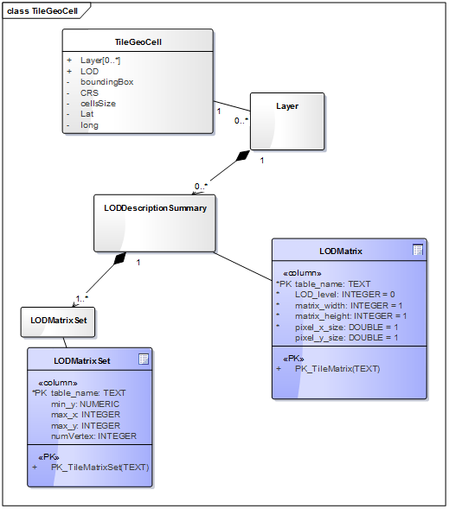
Figure 4: UML diagram of the Geocell, tile and LOD concept

2-2- CDB File System
This section describes how a current version of a CDB conformant data store uses the computer’s native file system to store data in files and directories, what the CDB versioning structure is, and how the data is categorized. Further this section defines the structure of a CDB conformant data store, i.e., the name of all directories forming the CDB hierarchy, as well as the name of all files found in the CDB hierarchy. An important feature of the CDB standard is that all CDB file names are unique and that the filename alone is sufficient to infer the path of the file.
The CDB data store is composed of several datasets that usually reside in their own directory; however some datasets share a common structure. The top-level directory of the CDB data store follows the following structures:
- \CDB\: This is the root directory and does not need to be “\CDB\” and can be any valid path name on any disk device or volume under the target file system it is stored on.
- \CDB\Metadata\: This directory contains the specific XML metadata files which are global to the CDB.
- \CDB\GTModel\: This is the entry directory that contains the Geotypical Models Datasets.
- \CDB\MModel\: This is the entry directory that contains the Moving Models Datasets.
- \CDB\Tiles\: This is the entry directory that contains all tiles within the CDB instance.
- \CDB\Navigation\: This is the entry directory that contains the global Navigation datasets.
Most of the CDB datasets are organized in a tile structure and stored under \CDB\Tiles\ directory. The tile structure facilitates access to the information in real-time by any runtime client-devices. However, for some datasets such as Moving Models or Geotypical Models that require minimal storage, there is no significant advantage to be added into such a tile structure. Such datasets are referred to as global datasets; they consist of data elements that are global to the earth.
A CDB Version is a collection of CDB and/or user-defined datasets. A CDB Version contains data belonging to a single version of a CDB conformant database. One CDB Version may refer to another one, which is the basis for the CDB File Replacement Mechanism. The concept of a CDB Version is illustrated using the following UML diagram (Figure 4).

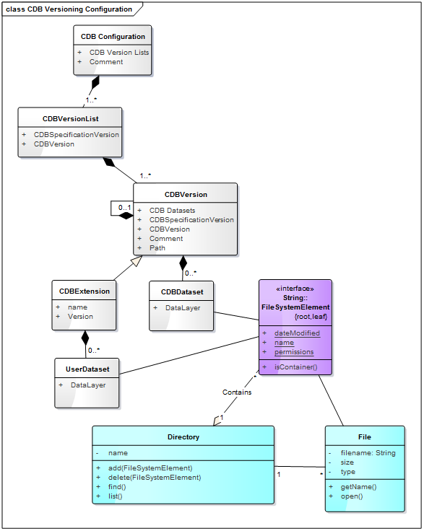
Figure 5: UML diagram of CDB version concept
The diagram shows that a CDB Version contains CDB Datasets; in addition, it states which CDB Version Number has been used to build the CDB content; finally, the CDB Version has a reference to another CDB Version. This reference allows the creation of a chain of CDB Versions. By chaining two CDB Versions together, the user can replace files in a previous CDB Version with new ones in a newer CDB Version data store. The diagram shows that a CDB Extension inherits all the attributes of a CDB Version and adds its own attributes, a name and a version number (of the extension). The client application checks the name attribute to recognize and process known CDB Extensions and unrecognized CDB Extensions are skipped.

2-3- Model Type
The term Model refers to all of the modeled representations of a cultural feature. The model type features of a CDB can be represented using the following UML diagram. 3DModel, referred to as a GSModel, is unique. In the case where the 3DModel is instanced, it is referred to as a GTModel. A 3DModel that is capable of movement is called a MModel. In the case where a MModel is positioned by the modeler, it is called a statically-positioned MModel.
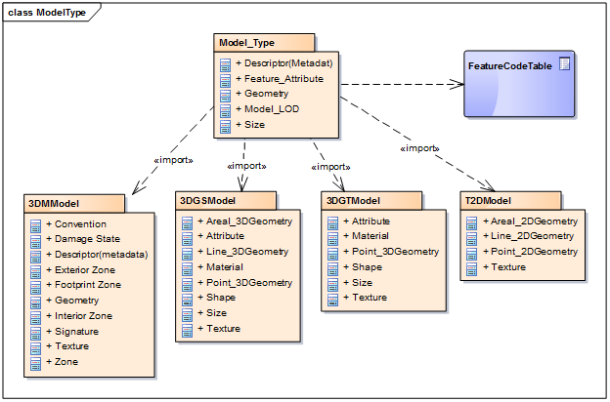
Figure 6: UML package diagram of the model type
The term Model-LOD refers to a specific level of detail of a Model. The main properties of the CDB 2D/3D model type UML diagram are listed below.
Name | Definition | Data type & Value | Multiplicity
Model_Type | The modeled representation of a feature primarily consists of its geometry and textures, and encompasses its exterior and interior. | 3D model formats supported by the CDB such as OpenFlight | Zero or more (optional)
3DGTModel | Geotypical 3D Model is a geotypical representation of a point-feature that is anchored to the ground. | 3D model formats supported by the CDB such as OpenFlight | Zero or more (optional)
3DGSModel | Geospecific 3D Model is geospecific representation of a point-, lineal- or areal feature that is anchored to the ground. | 3D model formats supported by the CDB such as OpenFlight | Zero or more (optional)
T2DModel | Tiled 2D Model is geospecific or geotypical representations of lineal and areal features that are anchored to the ground. | 2D model formats supported by the CDB such as Shapefile | Zero or more (optional)
3DMModel | 3D modeled representations of point-features that are not anchored to the ground. | 3D model formats supported by the CDB such as OpenFlight | Zero or more (optional)

2-3-1 3D Moving Model
A moving model is typically characterized as if it can move (on its own) or be moved. More specifically within the context of this standard, the model is not required to be attached to a cultural point feature (geographic location).
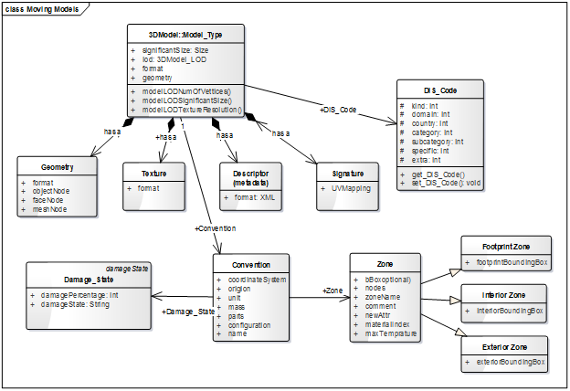
Figure 7: UML diagram of the 3D moving model
During the course of a multi-player simulation, each client-device is typically solicited to provide a modeled representation of each player. The activation of such players requires the client-device to access the appropriate modeled representation of each player. There are a large number of military simulations where the player types are characterized by their Distributed Interactive Simulation (DIS) code. To this end, the CDB data store provides a moving model library whose structure provides a convenient categorization of models by their DIS code as shown in the following diagram.
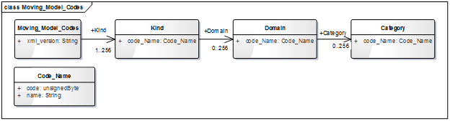
Figure 8: UML diagram of moving model codes
The “xml_vesion” attribute of a moving model code is used to indicate the version of the XML file containing the list of codes. It is independent from the version of the Standard and also the version of the Schema.

2-4- Vector Data Model
Vector tiles differ from their raster counterpart in three important ways. First of all, the vector tiles’ internal structure permits a non-uniform distribution of elements within the tile, i.e., the position of each element within the tile is explicit. Secondly, the vector tiles’ internal structure permits a variable number of elements within the tile confines. Finally, it is possible to control the distribution of the element types from a single list.
Conceptually, the LOD of a vector tile implicitly provides the average density of elements within the tile. The run-time level-of-detail behavior that controls the rendered number of data elements depends on various parameters and on the off-line filtering process.
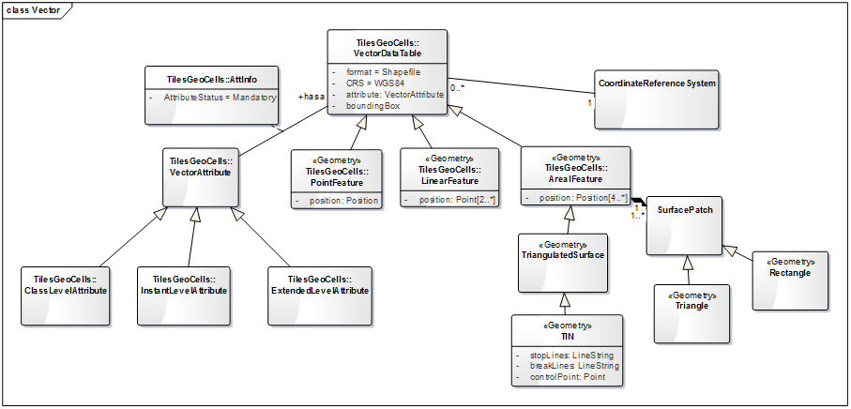
Figure 9: UML diagram of vector data model

3- Metadata Schema
Metadata datasets contain information, global to a CDB implementation, that define its structure, naming hierarchies, default values, allowable values, and status. All metadata files are formatted using XML files, and their XSD schemas can be found in the \CDB\Metadata\Schema\ folder delivered with the CDB Standard.

3-1- Light Names Hierarchy
The light name hierarchy for a CDB compliant database is described in detail within the table found in Volume 2 Annex J of the OGC CDB Core Standard. This provides a description of the entire naming hierarchy, including the hierarchical relationship of the levels with respect to each other and the position of each light type within this hierarchy. To this end, the lights hierarchy definition metadata is stored in an XML file in the metadata CDB directory. “Lights.xml” file contains the name of each light type and a unique code with each light type. Light codes have a one-to-one association with light types; consequently, the light codes are unique among all light types. For run-time access of this data, clients must be able to retrieve such information. The below diagram (figure 9) shows the UML of light data hierarchy to define and validate the content of the CDB light names hierarchy found in /CDB/Metadata/Lights.xml.
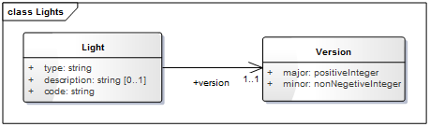
Figure 10: UML diagram of light names hierarchy
This attribute “Version” represents the version number of the Light.xml file.

3-2- Client Specific Lights Definition
Client-devices use the light type code as an index to lookup the client-specific properties and characteristics of each light type using a Lights_xxx.xml. The CDB standard offers a complementary approach to modifying the appearance of lights. This approach provides basic control over light intensity, color, lobe width and aspect, frequency and duty cycle for potential use by simulation implementations. This approach also permits a modeler to add new light types to the CDB light hierarchy. The below UML diagram (figure) presents the schema for the fields of the Lights_xxx.xml which is generated from the schema file located at \CDB\Schema\Lights_Tuning.xsd.
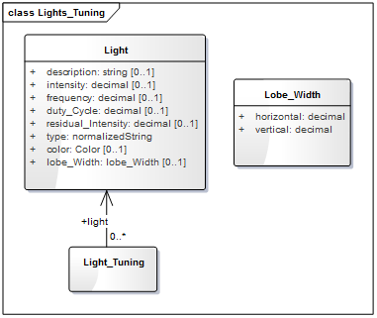
Figure 11: UML diagram of client specific lights definition

3-3- Model Components Definition
The CDB Standard provides the means to unambiguously tag any portions of a 3D model (moving model or cultural feature with a modeled representation) with a descriptive name. Component model names are stored in the model components’ definition file, at \CDB\Metadata\Model_Components.xml which is delivered with the standard distribution package.
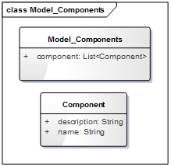
Figure 12: UML diagram of the model components definition
CDB Model Components is a list of components which are made up of the component names along with their descriptions.

3-4- Base Materials Table
A Base Material represents a basic material such as water, vegetation, concrete, glass, steel which has a unique name. The components of a Base Material are listed in Volume 1 Section 2.5.1 of the CDB Core standard in Table 2-6: Components of a Base Material. A Base Material Table (BMT) is provided for run-time access by client applications. More details on the file format can be found in Volume 1 Core Standard section 5.1.3, Base Material Table. CDB Base Materials are listed and stored in an XML file named \CDB\Metadata\Materials.xml. The format of the file is defined by the following UML diagram generated from an XML schema that is delivered with the CDB standard in the file named \CDB\Metadata\Schema\Base_Material_Table.xsd.
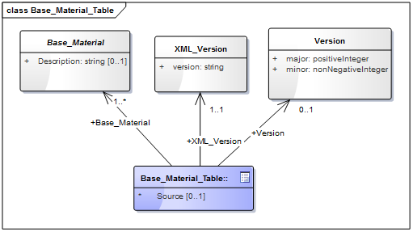
Figure 13: UML diagram of the base materials table
The main properties of the base materials table UML diagram are documented below.
Name | Definition | Data type & Value | Multiplicity
Base_Material | This element defines one CDB Base Material by giving it a unique name. It is recommended to provide a description. | XML | One or more (mandatory)
XML_Version | This element indicates the version of the XML file containing the list of CDB Default Values. It is independent from the version of the Standard. | string | One (mandatory)
Version | This attribute represents the version number of this file. | Version | One (mandatory)

3-5- Composite Material Tables
Composite Material Tables provide a structured arrangement by which Composite Materials can be defined. There are several Composite Material Tables spread across the CDB hierarchy. A CMT is a list of one or more composite materials. Note that all Composite Material Tables follow the following UML diagram.
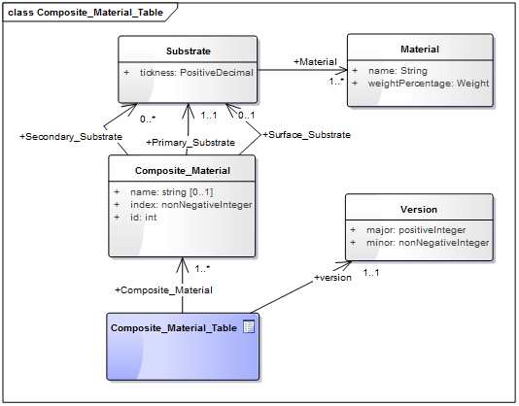
Figure 14: UML diagram of composite material tables
The main properties of the composite material tables’ UML diagram are documented below.
Name | Definition | Data type & Value | Multiplicity
Composit_Material | Each composite material has a unique identification number, a name, and one or more substrates. | XML | One or more (mandatory)
Material | Each material is identified by the name of its base material and by its proportion in the substrate. This class has a weightPercentage which is an integer in the range [1,100]. | Array of strings | One or more (mandatory)
Substrate | A substrate has a certain thickness and is composed of one or more base materials. | positive decimal | One or more (mandatory)
Version | This attribute represents the version number of this file. | Version | One (mandatory)

3-6- Default Values Definition Table
Default values for all datasets can be stored in the default values’ metadata file “\CDB\Metadata\Defaults.xml”. Default values, defined throughout the CDB standard, are listed in Volume 2 Annexes for the Core CDB Standard (normative) - Annex S and the below UML diagram indicates the schema provided in \CDB\Metadata\Schema\Defaults.xsd to define and validate the content of Defaults.xml. There are two types of default values: read and write default values (‘R’ or ‘W’.) Generally, read default values are values to be used when optional information is not available. Write default values are default values to be used by CDB creation tools to fill mandatory content when information is either missing or not available. The default value name is a unique name identifying a default value for a given dataset. Valid default value names are listed in Annex S. Each default value has a type. Valid default value data types are “float”, “integer” and “string”.
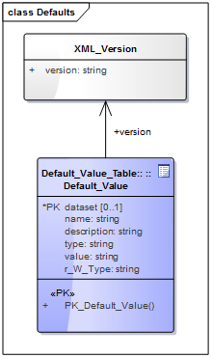
Figure 15: UML diagram of the default values definition table
The “XML_Version” attribute is used to indicate the version of the XML file containing the list of CDB Default Values. It is independent from the version of the standard.

3-7- Version
Each CDB version has a version control file that is called Version.xml. Its contents should be defined and validated by the following UML diagram which is generated from the content of Defaults.xsd in the schema folder of the CDB.
The optional <PreviousIncrementalRootDirectory> element is used to refer to another CDB Version. This is the mechanism used to chain together two CDB versions. The mandatory <Specification> element indicates the CDB standard that is used to produce the content of the CDB Version. Note that version numbers of the standard are limited to the version numbers from the legacy industry-maintained CDB specification: 3.2, 3.1, and 3.0, and OGC V1.0 from this standard; other values are not permitted. Finally, the optional <Extension> element indicates that this CDB Version is in fact a CDB Extension. A version control file that does not have a CDB Extension indicates that the CDB Version holds content that strictly follows the CDB standard.
A CDB Extension corresponds to user defined information, which is not described or supported by the CDB standard, stored within the CDB Version. As an example, such additional information could be client or vendor-specific information used to increase system performance. Any user defined information shall not replace or be used in place of existing CDB information. A CDB Extension only contains vendor or device specific information.
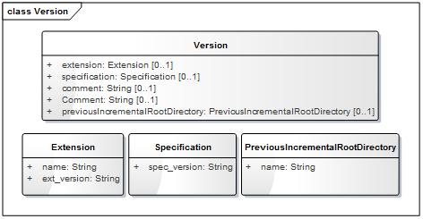
Figure 16: UML diagram of the version

3-8- Configuration
The CDB Configuration and CDB Version mechanisms allow users to manage the CDB by offering the following capabilities:
- The CDB can have multiple simultaneous independent CDB Configurations.
- Each CDB Configuration is defined by an ordered list of CDB Versions.
- A CDB Version is either a collection of CDB Datasets or a collection of user-defined datasets called a CDB Extension
The Configuration metadata file provides the means of defining CDB Configurations. The complete XML schema is provided in /CDB/Metadata/Schema/Configuration.xsd delivered with the standard and displayed below.
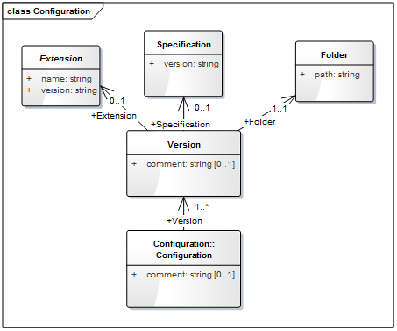
Figure 17: UML diagram of configuration metadata
A single XML file, named Configuration.xml, completely defines the configuration of a CDB. This way, the client application does not have to traverse the linked list of CDB Versions through the 'PreviousIncrementalRootDirectory' element found in Version.xml. The main properties of the configuration metadata UML diagram are documented below.
Name | Definition | Data type & Value | Multiplicity
Configuration | The CDB Configuration is a simple list of one or more CDB Versions. | XML | One or more (mandatory)
Extension | Indicates that the CDB Version contains extensions to the CDB Specification. The CDB Extension is identified by a name and a version number. | Array of strings | Zero or more (optional)
Folder | Provides a non-empty path to a folder. A relative path is prefered although an absolute path is supported. | string | One (mandatory)
Specification | Specifies the version of the CDB Specification used to generate the current CDB Version. If 'Specification' is omitted, the version number is deemed to be 3.0. | string | Zero or more (optional)
Version | A CDB Version points to the folder where the data resides. An optional comment can be used to describe the version. It is possible to indicate to which version of the CDB Specification, the CDB Version complies. Finally, the CDB Version can indicate if it contains extensions to the standard. | String | One (mandatory)

3-9- CDB Vector Attributes
The CDB attributes are listed and described in Volume 1: CDB Core section 5.7.1.3 CDB Attributes. The metadata for these attributes is stored in \CDB\Metadata\CDB_Attributes.xml and the following diagram indicates the schema file as provided in the CDB schema folder, Vector_Attributes.xsd. In essence, the file is the transposition of CDB Attributes into a format more appropriate for a computer program.
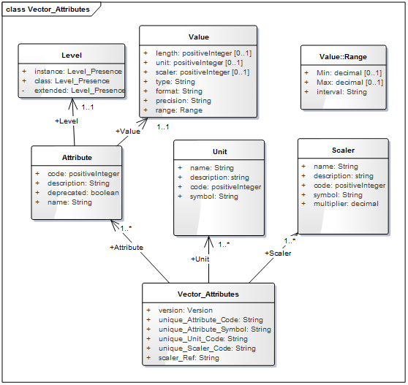
Figure 18: UML diagram of the CDB vector attributes
The UML diagram is composed of three majors sections (i.e. attributes, units and scalers), the first one being the most important. The file has a list of attributes, followed by two lists of units and scalers that are referenced by an individual attribute. The main properties of the vector attributes’ UML diagram are documented below.
Name | Definition | Data type & Value | Multiplicity
Vector_Attributes | Attributes are defined through 3 lists: 1) the attributes themselves, 2) their units, and 3) their scalers. | Vector_Attributes | One (mandatory)
Version | This represents the version number of the file which has two components: major and minor. | String | One (mandatory)

3-10- 3D Model Metadata
This following UML presents an XML schema file in the CDB schema folder which defines the metadata associated with 3D models. This is in accordance with the legacy industry-maintained version 3.0 of the CDB specification and includes name, feature data dictionary, mass, part, texture and materials.
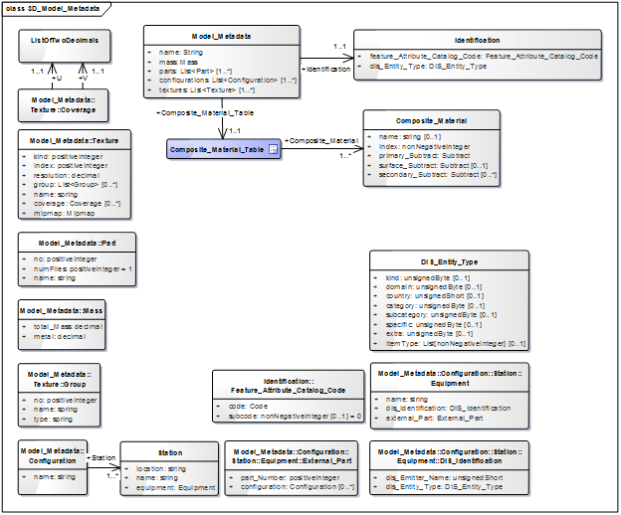
Figure 19: UML diagram of 3D model metadata
The main properties of the 3D model metadata UML diagram are documented below.
Name | Definition | Data type & Value | Multiplicity
3D_Model_Metadata | The metadata associated with a model is made of up to seven elements. | XML | One (mandatory)
Identification | A 3D model is either a moving model with a DIS Entity Type, or a cultural feature with a FACC code. | DIS or FACC | One (mandatory)
DIS_Entity_Type | It has two formats: 1) a simple list of up to 7 integers; or 2) a sequence of up to 7 elements providing the name of the fields whose values are being provided. | DIS | One (mandatory)
Feature_Attribute_Catalog_Code | FACC is composed of two elements: a code and a subcode. The code is a string of 2 letters and 3 digits. The subcode is optional and defaults to 0. | FACC | One (mandatory)
Mass | The mass is defined by 2 elements: the total mass, and its metallic portion. By default, the metallic portion is assumed to be 0. | Mass | One (mandatory)
Part | When the list of parts is supplied, it contains at least one entry. If the list is absent, a single part stored in a single file is assumed. A part has a name and is made of a part number, and the number of files associated with the part. | Part | One (mandatory)
Textures | When the list of textures is supplied, it contains at least one entry. If the list is absent, the model does not have textures. Optionally, groups of textures may be defined and listed. An individual texture may optionally belong to texture groups. | Texture | One (mandatory)
Texture group | It is identified by its group number and its group name. Later, individual texture will refer to group numbers. | Texture group | One or more (mandatory)
Texture | A texture is defined by a sequence of 5 mandatory elements and 2 optional elements. The first 4 elements (Kind, Index, Mipmap, and Name) are used to compose the file name where the texture is stored. The Resolution can be used to select which mipmap to load. The optional Coverage provides the maximum extent of U and V mapping. The optional Group refers to the Texture_Group to which the texture belongs. | Texture | One or more (mandatory)
Configurations | the list of one or more configurations is supplied, | configuration | One (mandatory)
configuration | A configuration is a named list of one or more stations. | configuration | One or more (mandatory)
Station | A Station has a name and defines exactly one equipment in one location. | Station | One (mandatory)
Equipment | An Equipment is defined by either a DIS key or an external part - and possibly both. An external part is identified by its part number. Optionally the part may have its own configuration. | Equipment | One (mandatory)
DIS identification | A DIS identification is either a DIS entity type or a DIS emitter name. A DIS emitter name is a 16-bit unsigned integer. | integer | One (mandatory)
Composite material table | A composite material table is a list of one or more composite materials. Each composite material has a unique identification number, a name, and one or more substrates. A substrate has a certain thickness and is composed of one or more base materials. Each material in a substrate is identified by the name of its base material and by its proportion in the substrate. A percentage is an integer in the range [1,100]. | integer | One (mandatory)

4- 3D Model Extensions
As an example, OpenFlight plays a significant role, since all of the statically positioned cultural features and the moving models are represented in this format. To add attributes to OpenFlight models, OpenFlight_Model_Extensions.xsd schema file can be used to verify the changes. The below diagram is generated from this schema file which is located in the CDB schema folder (/CDB/Metadata/Schema/).
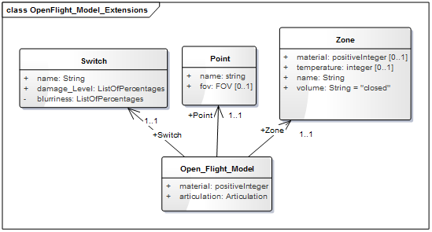
Figure 20: UML diagram of OpenFlight model extensions

5- Feature Data Dictionary
The CDB Feature Data Dictionary (FDD) is provided with the CDB standard in the form of an XML file including the complete list of the supported FACC codes. The following UML diagram is generated using the XML stylesheet which is provided to format and display the dictionary inside a standard Web browser. Furthermore, the schema can also be found in the schema subdirectory of the CDB Schema Distribution Package.
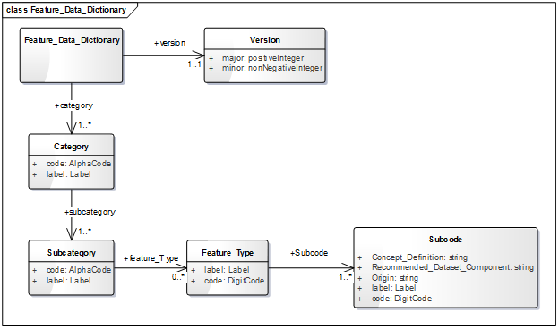
Figure 21: UML diagram of feature data dictionary
The main properties of the feature data dictionary UML diagram are documented below.
Name | Definition | Data type & Value | Multiplicity
AlphaCode | The code of the category or subcategory. | string | One (mandatory)
Feature_Data_Dictionary | This element represents the CDB Feature Data Dictionary root element. It has a version number and the list of all categories. | XML | One (mandatory)
Feature_Type | This element has a code attribute, a label and a list of subcodes. | Feature_Type | Zero or more (optional)
Label | It is a meaningful name to the code attribute. | string | One (mandatory)
Subcategory | It has a code attribute, a label and a list of feature types. | Feature_Type | One or more (mandatory)
Subcode | It has a code attribute, a label, a concept definition, a recommended dataset component and an origin. | Subcode | Zero or more (optional)
Version | This attribute represents the version number of FDD. | Array of strings | One (mandatory)

Annex A:
Conformance Class Abstract Test Suite (Normative)

This section describes conformance test for the OGC CDB Conceptual Model Standard. A CDB dataset shall satisfy the following criteria to be conformant with the OGC CDB Conceptual Model Standard.

A.1. CDB Overall Conceptual Model
The following conformance class is designed to determine if any dataset claiming conformance to the CDB Conceptual model is described based on the comprehensive set of requirements.
Conformance Class | http://opengis.net/spec/CDB/1.0//conf/core/core/OveralConceptualModel
Requirements | http://opengis.net/spec/CDB/1.0/core/OveralConceptualModel
Dependency | All of the requirements of the OGC CDB core document
Test Class 1 | Test purpose | Verify to test requirement class 1
 | Test method | Review that the CDB dataset complies with the corresponding mandatory requirements of the OGC CDB core standard.
 | Test type | Conformance

Annex B:
UML notations

B.1 Class Diagrams Notation
A diagram that shows a collection of declarative (static) model elements, such as classes, types, and their contents and relationships. Classes and relationships represent real-world concepts to describe the structure of a system. The CDB Core Standard is presented in this document in diagrams using the Unified Modeling Language (UML) class diagrams. The UML notations used in this standard are described here (see ISO TS 19103, Geographic information - Conceptual schema language for the details).
A relationship is a general term covering the specific types of logical connections found on class and object diagrams. UML shows the following relationships:
Relationships | Definition | Diagram
Association | It is semantic relationship between two or more classes that specifies links among their instances. In association, an attribute of the dependent class is an instance of the independent class.
Aggregation | Form of association that specifies a whole-part relationship between the aggregate (whole) and a component part.
Composition | It is an aggregation and stronger variant of the "has a" association relationship; if the container is destroyed, normally every instance that it contains is destroyed as well. | 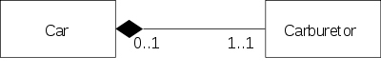
Generalization | Taxonomic relationship between a more general element and a more specific element. It is also known as the inheritance or "is a" relationship. The superclass (base class) is also known as the "parent".
Realizations | It is shown on classes, interfaces, components, and packages that connects a client element with a supplier element and shows that the class realizes the operations offered by the interface. | 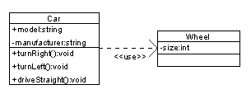

The UML representation of an association is a line with an optional arrowhead indicating the role of the object(s) in the relationship, and an optional notation at each end indicating the multiplicity (the number of objects that participate in the association) of instances of that entity as listed in the below table:
0..1 | No instances, or one instance
1, 1..1 | Exactly one instance
0..* | Zero or more instances
n | Specific number
1..* | One or more instances

In the document, UML diagrams typically identifies a stereotype with a bracketed comment for each object identifying whether it is a class, interface, etc. Additionally, the UMLs are color-coded as follow to show different stereotypes:
Elements (e.g. Class & Object) | Interface | Description
Table | Data Type | Profile

Please see CDB Spatial Reference System Guidance - Volume 8
IEEE 1278 series Distributed Interactive Simulation.

