Open Geospatial Consortium
Submission Date: 2015-09-30
Approval Date: <yyyy-dd-mm>
Publication Date: <yyyy-dd-mm>
External identifier of this OGC® document: <http://www.opengis.net/doc/IS/DGGS/1.0>
Internal reference number of this OGC® document: 15-104
Version: 1.0.0
Category: OGC® Implementation Standard
Editor: Matthew Purss

OGC Discrete Global Grid System (DGGS) Core Standard
Copyright notice
Copyright © 2015 Open Geospatial Consortium
To obtain additional rights of use, visit http://www.opengeospatial.org/legal/.

Warning
This document is not an OGC Standard. This document is distributed for review and comment. This document is subject to change without notice and may not be referred to as an OGC Standard.
Document type: OGC® Implementation Standard
Document subtype: if applicable
Document stage: Draft
Document language: English
Recipients of this document are invited to submit, with their comments, notification of any relevant patent rights of which they are aware and to provide supporting documentation.

License Agreement
Permission is hereby granted by the Open Geospatial Consortium, ("Licensor"), free of charge and subject to the terms set forth below, to any person obtaining a copy of this Intellectual Property and any associated documentation, to deal in the Intellectual Property without restriction (except as set forth below), including without limitation the rights to implement, use, copy, modify, merge, publish, distribute, and/or sublicense copies of the Intellectual Property, and to permit persons to whom the Intellectual Property is furnished to do so, provided that all copyright notices on the intellectual property are retained intact and that each person to whom the Intellectual Property is furnished agrees to the terms of this Agreement.
If you modify the Intellectual Property, all copies of the modified Intellectual Property must include, in addition to the above copyright notice, a notice that the Intellectual Property includes modifications that have not been approved or adopted by LICENSOR.
THIS LICENSE IS A COPYRIGHT LICENSE ONLY, AND DOES NOT CONVEY ANY RIGHTS UNDER ANY PATENTS THAT MAY BE IN FORCE ANYWHERE IN THE WORLD.
THE INTELLECTUAL PROPERTY IS PROVIDED "AS IS", WITHOUT WARRANTY OF ANY KIND, EXPRESS OR IMPLIED, INCLUDING BUT NOT LIMITED TO THE WARRANTIES OF MERCHANTABILITY, FITNESS FOR A PARTICULAR PURPOSE, AND NONINFRINGEMENT OF THIRD PARTY RIGHTS. THE COPYRIGHT HOLDER OR HOLDERS INCLUDED IN THIS NOTICE DO NOT WARRANT THAT THE FUNCTIONS CONTAINED IN THE INTELLECTUAL PROPERTY WILL MEET YOUR REQUIREMENTS OR THAT THE OPERATION OF THE INTELLECTUAL PROPERTY WILL BE UNINTERRUPTED OR ERROR FREE. ANY USE OF THE INTELLECTUAL PROPERTY SHALL BE MADE ENTIRELY AT THE USER’S OWN RISK. IN NO EVENT SHALL THE COPYRIGHT HOLDER OR ANY CONTRIBUTOR OF INTELLECTUAL PROPERTY RIGHTS TO THE INTELLECTUAL PROPERTY BE LIABLE FOR ANY CLAIM, OR ANY DIRECT, SPECIAL, INDIRECT OR CONSEQUENTIAL DAMAGES, OR ANY DAMAGES WHATSOEVER RESULTING FROM ANY ALLEGED INFRINGEMENT OR ANY LOSS OF USE, DATA OR PROFITS, WHETHER IN AN ACTION OF CONTRACT, NEGLIGENCE OR UNDER ANY OTHER LEGAL THEORY, ARISING OUT OF OR IN CONNECTION WITH THE IMPLEMENTATION, USE, COMMERCIALIZATION OR PERFORMANCE OF THIS INTELLECTUAL PROPERTY.
This license is effective until terminated. You may terminate it at any time by destroying the Intellectual Property together with all copies in any form. The license will also terminate if you fail to comply with any term or condition of this Agreement. Except as provided in the following sentence, no such termination of this license shall require the termination of any third party end-user sublicense to the Intellectual Property which is in force as of the date of notice of such termination. In addition, should the Intellectual Property, or the operation of the Intellectual Property, infringe, or in LICENSOR’s sole opinion be likely to infringe, any patent, copyright, trademark or other right of a third party, you agree that LICENSOR, in its sole discretion, may terminate this license without any compensation or liability to you, your licensees or any other party. You agree upon termination of any kind to destroy or cause to be destroyed the Intellectual Property together with all copies in any form, whether held by you or by any third party.
Except as contained in this notice, the name of LICENSOR or of any other holder of a copyright in all or part of the Intellectual Property shall not be used in advertising or otherwise to promote the sale, use or other dealings in this Intellectual Property without prior written authorization of LICENSOR or such copyright holder. LICENSOR is and shall at all times be the sole entity that may authorize you or any third party to use certification marks, trademarks or other special designations to indicate compliance with any LICENSOR standards or specifications. This Agreement is governed by the laws of the Commonwealth of Massachusetts. The application to this Agreement of the United Nations Convention on Contracts for the International Sale of Goods is hereby expressly excluded. In the event any provision of this Agreement shall be deemed unenforceable, void or invalid, such provision shall be modified so as to make it valid and enforceable, and as so modified the entire Agreement shall remain in full force and effect. No decision, action or inaction by LICENSOR shall be construed to be a waiver of any rights or remedies available to it.

Contents
1. Scope 8
2. Conformance 9
3. References 9
4. Terms and Definitions 10
4.1 Refinement Ratio 10
4.2 Base polyhedron 10
4.3 Cell Refinement 10
4.4 Coordinate Reference System 11
4.5 Discrete Global Grid System 11
4.6 DGGS Cell 11
4.7 DGGS Domain 11
4.8 DGGS Extent 11
4.9 DGGS Reference Frame 11
4.10 Dimensionally Extended Nine-Intersection Model (DE-9IM) 11
4.11 Earth grid system 12
4.12 Ellipsoidal polygon 12
4.13 Geo-encoding 12
4.14 Geographic Identifier 12
4.15 Hierarchy 12
4.16 Initial Discretization 12
4.17 Projected Coordinate Reference System 12
4.18 Quantization strategy 13
4.19 Spatial Reference System 13
4.20 Tessellation 13
5. Conventions 13
5.1 Identifiers 13
5.2 UML notation 13
6. Background to DGGS (Informative) 13
6.1 DGGS as a Digital Information Medium 13
6.2 History 14
6.3 Global Grid Taxonomy 14
6.4 Criterion 15
6.5 A Digital Spatial Reference System 16
6.6 Application 16
7. DGGS Core Data Model (normative) 17
7.1 DGGS Core Data Model Overview 17
7.2 DGGS Reference Frame Elements 18
7.2.1 Global Coverage 19
7.2.2 Multiple Spatial Resolutions 19
7.2.3 Area Preservation 20
7.2.4 Cell Structure 20
7.2.5 Spatial Referencing 21
7.3 DGGS Functional Algorithms 21
7.3.1 Cell Operations 22
7.3.2 Quantization Operations 25
7.3.3 Algebraic Operations 26
7.3.4 Interoperability 27
A.1 Conformance class: Core 31
A.1.1 Core Data Model 31
A.1.2 Reference Frame – Global Coverage – Surface Area Equivalence 31
A.1.3 Reference Frame – Global Coverage – Cell Boundary Overlap 32
A.1.4 Reference Frame – Multiple Spatial Resolutions 32
A.1.5 Reference Frame —Area Preservation 32
A.1.6 Reference Frame — Equal Area Cells 33
A.1.7 Reference Frame – Spatial Reference 33
A.1.8 Reference Frame – Spatial Reference – Cells Referenced at their Centroid 34
A.1.9 Functional Algorithms – Cell Operations – Initial Discretization 34
A.1.10 Functional Algorithms – Cell Operations – Cell Refinement 34
A.1.11 Functional Algorithms – Cell Operations – Cell Addressing 35
A.1.12 Functional Algorithms – Quantization Operations 35
A.1.13 Functional Algorithms – Algebraic Processes – Cell Navigation 36
A.1.14 Functional Algorithms – Algebraic Processes – Spatial Analysis 36
A.1.15 Functional Algorithms – Interoperability Query Operations 37
A.1.16 Functional Algorithms – Interoperability Broadcast Operations 37

List of Normative Requirements
Requirement 1. 18
Requirement 2. 19
Requirement 3. 19
Requirement 4. 20
Requirement 5. 20
Requirement 6. 20
Requirement 7. 21
Requirement 8. 21
Requirement 9. 23
Requirement 10. 24
Requirement 11. 25
Requirement 12. 26
Requirement 13. 27
Requirement 14. 27
Requirement 15. 29
Requirement 16. 30

Abstract
This document specifies the core standard and extension mechanisms for Discrete Global Grid Systems (DGGS). A DGGS is a spatial reference system that uses a hierarchical tessellation of cells to partition and address the globe. DGGS are characterized by the properties of their cell structure, geo-encoding, quantization strategy and associated mathematical functions. The OGC DGGS standard supports the specification of standardized DGGS infrastructures that enable the integrated analysis of very large, multi-source, multi-resolution, multi-dimensional, distributed geospatial data. Interoperability between OGC DGGS implementations is anticipated through extension interface encodings of OGC Web Services.
Keywords
The following are keywords to be used by search engines and document catalogues.
ogcdoc, OGC document, Discrete Global Grid System, DGGS, Digital Earth, DGGS-core, Spatial Reference System, Global Data Structure, Geographic Information Systems, DE-9IM
Preface
This document specifies the core of an OGC Discrete Global Grid System encoding standard.
Attention is drawn to the possibility that some of the elements of this document may be the subject of patent rights. The Open Geospatial Consortium shall not be held responsible for identifying any or all such patent rights.
Recipients of this document are requested to submit, with their comments, notification of any relevant patent claims or other intellectual property rights of which they may be aware that might be infringed by any implementation of the standard set forth in this document, and to provide supporting documentation.
Submitting organizations
The following organizations submitted this Document to the Open Geospatial Consortium (OGC):
Geoscience Australia
Landcare Research New Zealand
University of Calgary
PYXIS
SpaceCurve
Zhengzhou Institute of Surveying & Mapping

Submitters
All questions regarding this submission should be directed to the editor or the submitters:

Name | Affiliation
Matthew Purss | Geoscience Australia
Robert Gibb | Landcare Research New Zealand
Faramarz Samavati | University of Calgary
Perry Peterson | PYXIS
J Andrew Rogers | SpaceCurve
Jin Ben | Zhengzhou Institute of Surveying & Mapping

Roger Lott’s significant contribution is acknowledged for his eleventh hour assistance in working through the relationship between DGGS concepts and ISO concepts and for ensuring the document structure complies with both OGC and ISO requirements.
Scope
This OGC standard defines the DGGS core data model and the core set of requirements to which every OGC DGGS encoding must adhere. Extensions to the DGGS core standard add further functionality to the core requirements. In particular, DGGS extensions to the core will be required to support additional functional capabilities and interoperability using OGC Web Service (OWS) architectures, such as OGC Web Coverage Service (WCS) and Web Coverage Processing Service (WCPS) interfaces.
This standard defines:
- A concise definition of the term Discrete Global Grid System as a spatial reference system;
- The essential characteristics of a conformant DGGS; and,
- The core functional algorithms required to support the operation of a conformant DGGS.
This standard anticipates:
- The creation of a registration system for DGGS analogous to the registration for Coordinate Reference Systems (CRS).
- The elaboration of extensions to the core standard to define additional functional algorithms and/or schemas that will support interoperability protocols through multi-DGGS processing operations.
- Potential additions to the OGC Abstract Specification and follow-on additions to other specifications.

Conformance
This standard defines a single requirements class, core, of http://www.opengis.net/spec/dggs/1.0/req/core with a single pertaining conformance class, core, with URI http://www.opengis.net/spec/dggs/1.0/conf/core .
Conformance with this standard shall be checked using all the relevant tests specified in Annex A (normative) of this document. The framework, concepts, and methodology for testing, and the criteria to be achieved to claim conformance are specified in the OGC Compliance Testing Policies and Procedures [OGC 08-134r10] and the OGC Compliance Testing web site.
All requirements-classes and conformance-classes described in this document are owned by the standard(s) identified.

References
The OGC DGGS Core standard consists of this document.
The complete standard is identified by OGC URI http://www.opengis.net/spec/dggs/1.0.
The document has OGC URI http://www.opengis.net/doc/IS/dggs/1.0
The following normative documents contain provisions that, through reference in this text, constitute provisions of this document. For dated references, subsequent amendments to, or revisions of, any of these publications do not apply. For undated references, the latest edition of the normative document referred to applies.
ISO 19111:2007, Geographic information – Spatial referencing by coordinates. 2007
ISO 19112:2003, Geographic information – Spatial referencing by geographic identifiers. 2003
ISO 19115-1:2014, Geographic information – Metadata – Part 1: Fundamentals. 2014
OGC 06-103r4, Implementation Standard for Geographic information – Simple feature access – Part 1: Common Architecture. Version 1.2.1, 2011 (identical in normative content to ISO 19125-1).
OGC 08-015r2, Abstract Specification – Topic 2: Spatial referencing by coordinates. Version 4.0.0, 2010. (identical in normative content to ISO 19111:2007)

Terms and Definitions
For the purposes of this document, the following terms and definitions apply.

base polyhedron
polyhedron used to construct the DGGS reference frame of a DGGS implementation

cell refinement
full specification for generating child cells from their parent cell(s) including the method of subdividing parent cells into child cells using a specified refinement ratio
Note 1 to entry: Iterative application of cell refinements results in a hierarchy of cell levels.
Note 2 to entry: Cell refinement methods may result in child cells that all have unique parents or child cells that may share parents.

coordinate reference system
coordinate system that is related to an object by a datum
[SOURCE: ISO 19111:2007, definition 4.8].
Note 1 to entry: For geodetic and vertical datums, the object will be the Earth.

discrete global grid system
spatial reference system that uses a hierarchical tessellation of cells to partition and address the globe

Note1 to entry: DGGSs are characterized by the properties of their cell structure, geo-encoding, quantization strategy and associated mathematical functions.

Note 2 to entry: A DGGS represents a spatial reference system that uses the Earth as its organizing structure [1].

DGGS cell
fundamental atomic object of a DGGS Reference Frame at each cell refinement level
Note 1 to entry: A DGGS cell can be considered a container for storing and retrieving data within a DGGS implementation. A DGGS cell may be considered either as a parent cell or as a child cell of at least one parent

DGGS coordinate reference system
coordinate reference system tied to the earth by a set of datum that cover the DGGS domain
Note 1 to entry: A DGGS coordinate reference system in two-dimensions is analogous to an ISO19111 geodetic coordinate reference system tied to one horizontal datum. DGGS coordinate reference systems however may in future be extended to include other dimensions (vertical, time) each with an appropriate datum. DGGS coordinate reference systems of higher dimensionality are therefore considered to be analogous to ISO19111 single coordinate reference systems and not ISO19111compound coordinate reference systems.

DGGS domain
spatio-temporal domain defined by a DGGS implementation
Note 1 to entry: By definition the surface domain of a DGGS is the surface of the entire globe. It may be extended to include other dimensions (vertical, time).

DGGS data extent
extent of data assigned to a DGGS
Note 1 to entry: The DGGS extent may be local, regional or global and is independent of the DGGS domain.

DGGS reference frame
fixed structural elements that define the hierarchical spatial framework within which the DGGS's functional algorithms operate

dimensionally extended nine-intersection model
topological model framework used to test whether a spatial topological relationship exists between two spatial objects
Note 1 to entry: DE-9IM is a mathematical approach that defines the pair-wise spatial relationship between geometries of different types and dimensions based on intersections of their interior, boundary, and exterior. It was developed by Clementini et. al. [2-4], extending the Nine Intersection Model of Egenhofer and Herring [5].
Note 2 to entry: DE-9IM used here is its extended form defined in OGC [OGC 06-103r4] identical in normative content to ISO/TC 211 [ISO 19125-1].

Earth grid system
one or more spatial or spatio-temporal grids on the surface of the Earth

ellipsoidal polygon
polygon constituting the boundary of a DGGS cell
Note 1: DGGS are agnostic to the surface model of the Earth (e.g. spherical, ellipsoidal and geoid models of the Earth are all valid surface models to construct a DGGS Reference Frame).
Note 2: Different DGGS configurations will control the type of arcs that comprise the edges of an ellipsoidal polygon. In order of complexity, arcs may be geodesic – shortest path, circular– intersection of a plane oriented perpendicular to the ellipsoid’s axis of rotation and an ellipsoidal surface model, planar– intersection of a defined plane and the surface model, or complex. Currently known DGGS use arcs that are geodesic or circular.

geo-encoding
process of assigning a geodetic identifier to a DGGS cell
Note 1 to entry: Each cell of a DGGS is given a unique self-descriptive geodetic identifier or encoded cell address which represents a spatial reference that implicitly identifies its location and hierarchical relationship with other DGGS cells. Geometric transformation and indexing of cells can be implemented directly by address code operations alone.

geodetic identifier
spatial reference in the form of a label or code that identifies a DGGS cell in a DGGS reference frame
Note 1 to entry: By analogy to [SOURCE: ISO 19112:2003, definition 4.3] a geographic identifier is a spatial reference in the form of a label that identifies a location, whereas in a DGGS each cell is deemed to be a location in a DGGS Reference Frame.

hierarchy
organization and ranking of successive levels of cell refinement of a DGGS reference frame

inverse projected coordinate reference system
geodetic coordinate reference system derived from a planar coordinate reference system by applying an inverse projection
Note 1: By analogy to [SOURCE: ISO 19111:2007, definition 4.39] a projected coordinate reference system derived from a geodetic coordinate reference system by applying a map projection

inverse projection
projection of coordinates on a flat surface to their equivalent coordinates on an ellipsoidal surface.
Note 1 to entry: In DGGS construction, inverse projections use the same mathematics as traditional map projections but in the inverse direction.

quantization strategy
process of digital assignment of data values that have been sampled from other data sources to the cells of a DGGS implementation

refinement ratio
ratio of the number of child cells to parent cells
Note 1 to entry: A cell refinement of a layer of DGGS parent cells using a refinement ratio of 3 will result in three times as many child cells as parent cells.
Note 2 to entry: For a two dimensional DGGS this is the area ratio. For a three dimensional DGGS this is the volume ratio.
Note 3 to entry: In DGGS literature [29] the term aperture has been used instead of refinement ratio. We prefer refinement ratio because it is clearer in meaning to audiences outside the early DGGS community.

spatial reference
description of position in the real world
[SOURCE: ISO 19112:2003, definition 4.5]
Note 1 to entry: This may take the form of a label, code or set of coordinates.

spatial reference system
system for identifying position in the real world
[SOURCE: ISO 19112:2003, definition 4.6]

tessellation
partitioning of a space into a set of conterminous subspaces having the same dimension as the space being partitioned
[SOURCE: ISO 19123:2005, definition 4.1.39]
Note 1 to entry: In the context of a DGGS implementation, an initialTessellation is the process of creating an initial partition of the ellipsoid into DGGS cells, and subsequent tessellations apply cell refinement methods resulting in child DGGS cells.

Conventions
This sections provides details and examples for any conventions used in the document. Examples of conventions are symbols, abbreviations, use of XML schema, or special notes regarding how to read the document.

Identifiers
The normative provisions in this specification are denoted by the URI
http://www.opengis.net/spec/dggs/1.0
All requirements and conformance tests that appear in this document are denoted by partial URIs which are relative to this base.

UML notation
All the diagrams that appear in this specification are presented using the Unified Modeling Language (UML) static structure diagram, as described in Sub-clause 5.2 of OGC Web Service Common [OGC 06-121r9].

Abbreviated terms
CRS coordinate reference system
DE-9IM dimensionally extended nine-intersection model
DGGS discrete global grid system
OGC Open Geospatial Consortium
OWS OGC Web Service

Background to DGGS (Informative)

DGGS as a Digital Information Medium
DGGS provide a fixed geospatial reference frame for the persistent location of measured Earth observations, feature interpretations, and modelled predictions. A DGGS is designed to be an information grid not a navigation grid. Whereas conventional coordinate reference systems address the globe with a continuous field of points suitable for repeatable navigation and analytical geometry, DGGS address the entire planet by partitioning it into a discrete hierarchical tessellation of progressively finer resolution cells. The geometry and location of the cell is the principle aspect of a DGGS. Data integration, decomposition, and aggregation is optimized in the DGGS hierarchical structure and can be exploited for efficient multi-source data processing, storage, discovery, transmission, visualization, computation, analysis, and modeling.

History
Formal development of DGGS began in the 1980s with the promising value of global analysis coinciding with the increased use of geographic information systems and availability of global mapping data and positioning systems. The first formalized discrete global grid was implemented by Geoffrey Dutton in 1984 [6] at the Laboratory for Computer Graphics and Spatial Analysis at Harvard Graduate School of Design. Dutton’s global grid was designed for assembling and managing global terrain data on a triangular global grid. His global geodesic elevation model (GEM) [6, 7] started with a cuboctahedron connected into a rhombic dodecahedron (which is its dual polyhedron where the vertices of one corresponds to the center of the faces of the other) and recursively divided the initial 12 triangular faces into refinements of 9 partially nested equilateral triangles. Elevations were assigned to the faces of each successive triangle. Waldo Tobler and Zi-tan Chen [8] imagined the primary purpose for a formal discrete global grid standard would be information exchange and storage. Tobler argued that as a generalized information medium “coverage must be uniform and that every element of area must have an equal probability of entering the system. This suggests that the world should be partitioned into chunks of equal size” [8]. Tobler’s global grid started with a cube as a base polyhedron and divided into rectilinear quad-trees to create successive subdivisions with unlimited resolution. Dennis White, Scott Overton, and Jon Kimerling, driven by a need for a statistically valid sampling to integrate aquatic and terrestrial monitoring for the US-EPA, designed a global grid in 1989 using closely packed hexagonal cells that started with a truncated icosahedron as the base polyhedron [9].

Global Grid Taxonomy
There have been numerous methods proposed for achieving a tessellation of the Earth, each with varying degrees of area and/or shape distortion [10]. These tessellations can be organized into a limited set of categories that describe a hierarchical taxonomy of global grids (Figure 1) [10, 11]. In order for a global grid tessellation to be able to operate as a DGGS it must be able to produce equal area cells on the surface of the Earth [8]. Only two classes of global grid achieve this [10]: those based on equal area inverse projections of a base polyhedron (such as the Icosahedral Snyder Equal Area [ISEA] projection [12]) and those based on direct surface tessellations using Small Circle Subdivision (e.g. [13]).

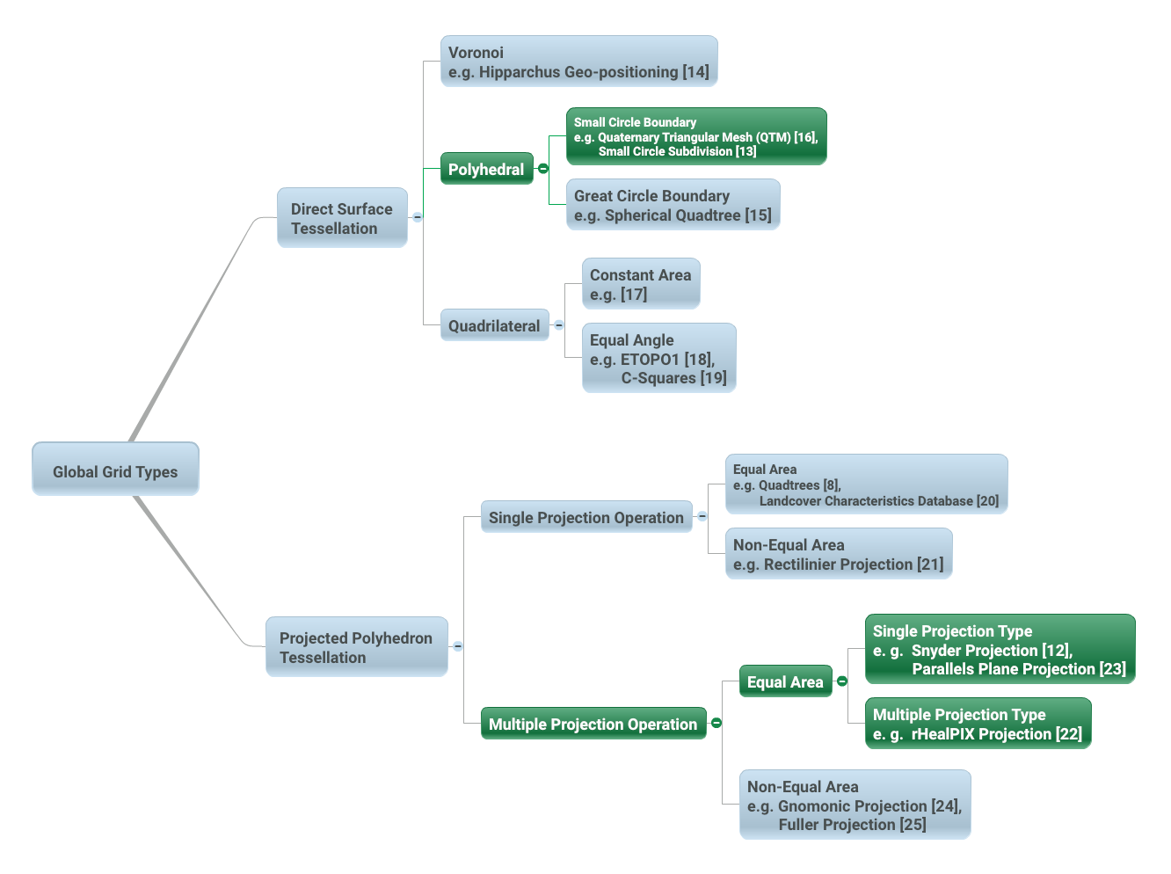
Figure 1 – Global Grid Taxonomy (after Figure 4 from [10]). Direct Surface Tessellations can be achieved using the following classes of methods: Voronoi [14]; Polyhedral-Great Circle Boundary [15]; Polyhedral-Small Circle Boundary [13, 16]; Quadrilateral-Constant Area [17]; and, Quadrilateral-Equal Angle [18, 19]. Projected Polyhedron Tessellations can be achieved using the following classes of methods: Single Projection – Equal Area [8, 20]; Single Projection-Non-Equal Area [21]; Multiple Projections – Equal Area [12, 22, 23]; and Multiple Projection – non-Equal Area [24, 25]. Suitable classes of global grid tessellations for application in DGGS under this standard are highlighted in green.

Criterion
There are many possible DGGS, each with their own advantages and disadvantages. Criterion for a discrete global grid are well developed by both Michael F. Goodchild [26] and Jon Kimerling [10]; the foremost requirements being a tessellation of cells that exhaustively cover the globe with each cell having equal area and representing a single point. The points and cells of the various resolution grids which constitute the grid system form a hierarchy which displays a high degree of regularity [27]. Choices for an appropriate tessellation include properties of shape, adjacency, connectivity, orientation, self-similarity, decomposability, and packing properties. Cell choices generally are taken from the three shapes that uniformly tile a plane – rectilinear, triangular, and hexagonal cells.
The only perfectly regular partitioning methods for the surface of a sphere (or ellipsoid) are based on the inverse projection of the following Platonic solids: the tetrahedron, cube, octahedron, dodecahedron, and icosahedron.
This method of mapping the faces of a base polyhedron to the surface model of the Earth creates an inverse projected coordinate reference system. GIS and image analysis packages that assume flat earth geometries will need to adapt to support this new construct that more closely represents the earth.
Any tessellation of the Earth does not necessarily produce a DGGS. Single resolution computational grids are not sufficient to constitute a DGGS. Spatial data structures used to organize map tiles or optimize rapid spatial search cannot be considered to qualify as a DGGS in and of themselves; although DGGS often utilize hierarchical indices to identify a cell, the primary feature of the DGGS is the cell geometry not the optimization of a spatial query. Further, DGGS have data independent geometry – their geometry is not formed to optimize a balanced search like R-Trees or maximal spacing of data as generated by Voronoi diagrams.

A Digital Spatial Reference System
One way to understand the important difference between a DGGS and a conventional spatial reference system is to consider that a DGGS provides a digital framework for geospatial information. Geospatial information is essentially a signal – that is some variable (e.g. measurement of phenomena) which changes subject to some other independent variable (e.g. spatial location). Conventional geospatial data are analog signals as they reference to a continuous space – geographic coordinates on an ellipsoidal datum. Even the discrete pixels of a satellite Earth observation image reference this continuous analog model of Earth; however, these pixels do not represent the same spatial coverage for different observations of the same location.
Sampling and quantization are necessary for a signal to be considered digital. As the name implies the DGGS provides the regular discrete intervals or cell partitioning to which location information (e.g. signal values) are sampled. A well-designed quantization strategy is also an important implementation of a DGGS so as to maintain the fidelity of the original information in the values assigned to each cell. The discrete data values can be sampled from any geospatial data source independent of the original spatial reference, scale, format, type, frequency, or time. A DGGS is a discrete “digital” model of the Earth.

Application
As each cell in a DGGS is fixed in location, and the location provides an explicit area representation, basic geospatial enquiry – “Where is it?”, “What is here?”, and “How has it changed?” - are simplified into set theory operations. As any data values referenced to a particular DGGS are, by the nature of the grid, aligned, the high costs of integrating data in traditional systems are dramatically reduced.
A DGGS can even be designed for lossless encoding of vector geometry such that cells, and their integer addressing, converge monotonically to the Real number coordinate pairs of each observation with each successive refinement – an essential property of a conventional coordinate system.
DGGS are designed to eliminate requirements for complex data fusion processes. Reducing the reliance on an intermediary integrator or analyst is a key requirement for distributed participatory digital-Earth information system. “[Digital-Earth] can clearly benefit from developments in discrete global grid, which can provide the georeferencing, the indexing, and the discretization needed for geospatial data sets. They have properties, in particular hierarchical structure, uniqueness, explicit representation of spatial resolution, and consistency, that make them superior to any single alternative.” [26].
A DGGS provides a uniform environment to integrate and visualize both vector geometry and raster-based geospatial data sources in much the same way that information within a computer graphics pipeline becomes the pixels on a computer screen. Efficiencies are gained through implementing the Dimensionally Extended nine-Intersection Model (DE-9IM) set of fundamental spatial operations [2-5] directly on the DGGS cell structure. This allows for higher order algebraic algorithms (via bindings to external analytic libraries) to be created on the DGGS structure itself, independent of the data sources.

Relationship between DGGS terms and data models and their respective ISO19111, ISO19112 and ISO 19115 terms and data models
Every endeavour has been made to use terms and data model from ISO19111, ISO19112 and ISO19115. However, DGGS are just sufficiently different to preclude use of many existing terms. ISO data model patterns are used but with redefined model classes and their associations. Some of the fundamental differences are highlighted by the need to introduce the terms inverse projection, DGGS coordinate reference system, geodetic identifier, and ellipsoidal polygons in order to distinguish them from their ISO equivalents of projection, geodetic coordinate reference system, geographic identifier, and geodesic polygons. Establishing these new terms is necessary to reinforce the fact that DGGS have a role that is most similar to that of latitude, longitude and are not planar map projections. This approach paves the way for future DGGS specification extension to support unified three and four dimensional spatio-temporal DGGS with domains encompassing the combined volume of the earth and its atmosphere, both past and future geologic time spans, and earth centred, earth fixed reference systems.

DGGS Core Data Model (normative)
This Clause specifies the underlying data model and core requirement class for a DGGS implementation.
Requirements Class - Core
http://www.opengis.net/spec/DGGS/1.0/req/core
Target type | Software Implementation

DGGS Core Data Model Overview
For an Earth grid system to be compliant with this standard it must define a hierarchical tessellation of equal area cells that both partition the entire Earth at multiple levels of granularity and provide a global spatial reference frame. The system must also include encoding methods to: address each cell; assign quantized data to cells; and perform algebraic operations on the cells and the data assigned to them.
Figure 2 shows the packages comprising a DGGS with the core elements grouped into the two (2) main components of:
- reference frame elements, and,
- functional algorithm elements
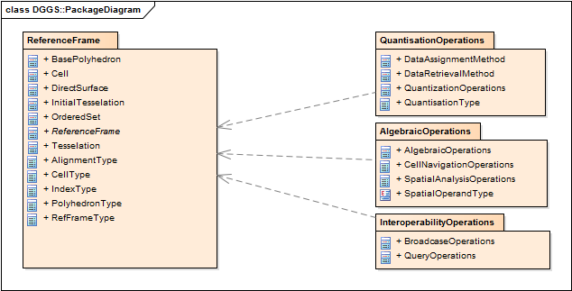
Figure 2 – DGGS Core Conceptual Data Model

http://www.opengis.net/spec/DGGS/1.0/req/core/model
A DGGS implementation SHALL include a DGGS Reference Frame and the associated Functional Algorithms as defined by the DGGS Core Conceptual Data Model.

DGGS Reference Frame Elements
The reference frame of a DGGS consists of the fixed structural elements that define the spatial framework on which the DGGS functional algorithms operate. The following sub-clauses define the core requirements for an Earth grid system to be considered a DGGS.
Figure 3 shows the class structure for the reference frame of a DGGS specification and how the classes relate to each other.
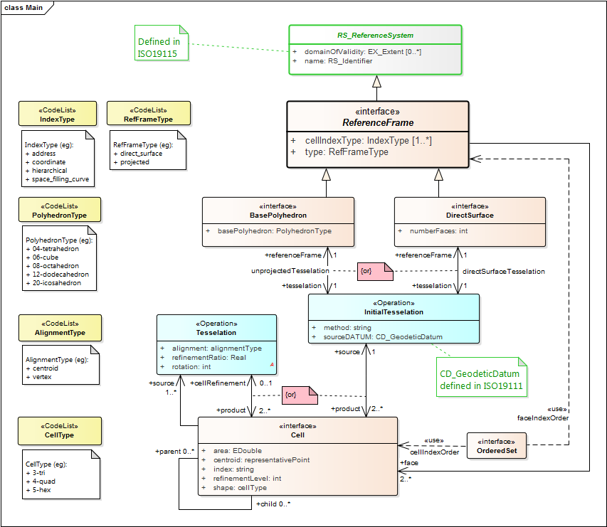
Figure 3 – DGGS Reference Frame Class diagram

Global Coverage
For an Earth grid system to be considered a DGGS implementation it must be defined over the entire surface of the Earth, representing the DGGS Domain. As defined by Goodchild [26] global coverage is achieved when the areal cells defined by the grid “exhaustively cover the globe without overlapping”.
http://www.opengis.net/spec/DGGS/1.0/req/core/reference_frame/coverage/area
A DGGS Domain SHALL cover the entire globe.

http://www.opengis.net/spec/DGGS/1.0/req/core/reference_frame/coverage/overlap
A DGGS Domain SHALL be defined without any overlapping DGGS Cells.

Tessellation Sequence
Unlike a single resolution spatial grid, a DGGS must define multiple grids forming a system of hierarchical tessellations each with progressively finer spatial resolution, each related by Cell Refinement methods.
http://www.opengis.net/spec/DGGS/1.0/req/core/reference_frame/tessellation_sequence
A DGGS implementation SHALL comprise a sequence of tessellations to represent multiple spatial resolutions

Area Preservation
Preservation of total area throughout the range of hierarchical tessellations is a necessary property of DGGS in order to represent information consistently at successive resolutions.
http://www.opengis.net/spec/DGGS/1.0/req/core/reference_frame/area_preservation
For each successive level of grid refinement of a DGGS implementation, the total area of all child cells SHALL exactly equal the total area of the area of all parent cells.

Cell Structure
Cell structure is an important aspect of any DGGS. Each cell can be considered to be an ellipsoidal polygon on the surface model of the Earth, for which several different cell shapes can be used. Each cell shape has its own advantages and disadvantages [29] and it is usually desired to have a majority of cells highly regular [28, 30]. Triangular, quadrilateral and hexagonal cells are common choices used in DGGS. These shapes provide regular tiling of the plane [28].

The cell structures in each successive level of cell refinement are constrained by the properties of the initial tessellation (i.e. direct surface tessellation or inverse projected polyhedron tessellation), but do not necessarily have the same geometry as the initial tessellation.

Equal Area Cells
Because many use cases that are of relevance to DGGS (e.g. geostatistics, global environmental monitoring, etc.…) require area based analysis, equal area cells are a critical requirement under this standard. Equal area cells help to minimize the confounding effects of area variations in analysis and provide equal probabilities for data quantization strategies.
Planar equal area cells, after transformation by an equal area inverse projection onto a DGGS Reference Frame, are deemed to be of equal area. For DGGS cells constructed to approximate equal area but derived in other ways, we require that the cell refinement method be iterative and monotonically convergent on equal area.
In any implementation of a DGGS, there will be a practical limit to the computational precision that is acceptable for that implementation. This precision is represented as the ratio of DGGS cell area uncertainty to DGGS cell area. The DGGS cell area uncertainty may arise for example from the number of iterations undertaken in any iteratively converging calculation, the rate of convergence, the number of bits in the underlying computer’s CPU or storage architecture, or the precision of critical real values such as π, and the parameters defining the DGGS reference frame.

http://www.opengis.net/spec/DGGS/1.0/req/core/reference_frame/cell/equal_area_precison
A DGGS implementation SHALL define a DGGS equal area precision that represents the maximum allowed ratio of cell area uncertainty to cell area

http://www.opengis.net/spec/DGGS/1.0/req/core/reference_frame/cell/equal_area
For each successive level of grid refinement, a DGGS implementation SHALL define DGGS Cells that are of equal area within a level of precision specified by the DGGS

Spatial Referencing
Spatial referencing (or geo-encoding) is achieved by addressing an identifier – an index or geographic identifier – to each DGGS cell. The cell address must be unique across the entire domain of hierarchical tessellations of the DGGS.

http://www.opengis.net/spec/DGGS/1.0/req/core/reference_frame/spatial_reference
A DGGS implementation SHALL assign a unique index to address each cell across all defined spatial resolutions

Cells Referenced at their Centroid
Each DGGS Cell must be referenced at its centroid. The centroid is calculated as the center of n-dimensional area of a DGGS cell. Calculated this way the centroid of a center aligned child cell will be the centroid of its parent cell, and this will be preserved through all cell refinements. Conversely for many non-aligned tessellation methods the centroid of a parent cell will be a common vertex for some of its child cells. The centroid enables a dual representation of a DGGS tessellation as both n-dimensional areal cell coverages and as point-based lattices.
http://www.opengis.net/spec/DGGS/1.0/req/core/reference_frame/spatial_reference/cell_centroid
A DGGS implementation SHALL define the location of a DGGS Cell reference to be the centroid of each cell.

Tessellations
A multiresolution hierarchy tessellation of cells is created by an initial tessellation process of inverse projection of the chosen base polyhedron onto the surface model of the Earth. This creates one DGGS cell for each of the polyhedron’s faces. These cells are then iteratively refined by application of cell refinement method(s) [29] to create finer resolution child cells. The initial tessellation, the inverse projection method, the cell shape, the refinement methods and indexing methods may all vary for different DGGS.

Initial Tessellation
The entire globe must be partitioned to a finite/discrete set of regions. Most methods initially approximate the globe using a simple polyhedron with polygonal faces and then map/transform its faces to the globe using inverse projection. The most common choices for an initial base polyhedron are discussed in sub-clause 6.4 [29].

http://www.opengis.net/spec/DGGS/1.0/req/core/methods/cell/initial_tessellation
A DGGS implementation SHALL have a method to generate an initial tessellation of the Earth.

Tessellation by Cell Refinement
To support multiple spatial resolutions, a series of increasingly finer resolution tessellations are needed [30]. Each finer resolution is generated from its parent by recursive application of one or more refinement methods. Each refinement method is categorized according to parent cell shape(s), child cell shape(s) – often the same as the parent shape, parent-child alignment, rotation and refinement ratio [29]. Theoretically there are an infinite number of cell refinements that can be implemented on a DGGS; however, in practice a DGGS implementation should specify a maximum number of refinements that considers the spatial resolution and precision of the Earth model used by the DGGS Reference Frame.

http://www.opengis.net/spec/DGGS/1.0/req/core/methods/cell/refinement
A DGGS implementation SHALL have a method to refine parent cells into finer resolution child cells.

Cell Addressing
Cell addresses, or indices, for DGGSs are derived from four general indexing methods: hierarchy-based, space-filling curve based, coordinate pairs [31] and encoded address schemas (such as those used for IP addresses [32]). The use of labels as geographic identifiers might also achieve an acceptable addressing if DGGS operations can be maintained. Under this standard each cell of a DGGS implementation must have a unique cell address assigned using one or more of these methods.
http://www.opengis.net/spec/DGGS/1.0/req/core/methods/cell/addressing
A DGGS implementation SHALL use at least one of the following spatial referencing addressing methods to address cells:
- Hierarchy;
- Space Filling Curve;
- Coordinate; or,
- Encoded Address.

DGGS Functional Algorithms
The ability to locate and perform algebraic operations on data assigned to a DGGS is critical for a DGGS implementation to function. Additionally, it should support connectivity and hierarchical operations on cells. As a minimum, a DGGS implementation must include support for:
- Quantization Operations – Assigning and retrieving data to and from cells;
- Algebraic Operations –Performing algebraic operations on cells and the data assigned to them and cell navigation; and
- Interoperability Operations – Translating cell addresses to other Coordinate Reference Systems (CRS), such as a conventional latitude-longitude.

Quantization Operations
A DGGS is defined based on the geometry of the globe in a data agnostic manner. Therefore, a DGGS implementation must have a mechanism for assigning data to cells and retrieving data from cells. Different quantization strategies may be used for sampling content into cells. For example, a single DGGS may be used as a data structure for integrating multiple datasets of different types (e.g. vector and raster datasets) [30] and in different ways (e.g. DGGS cells as data tiles, or one raster pixel per DGGS cell or DGGS cell indices as vector coordinate-pairs). Some DGGS choices are more efficient for sampling. For example, hexagonal cells are optimized for high fidelity sampling [28, 29].

The data assigned to a DGGS implementation defines the DGGS Extent and will vary as the amount of data assigned to it changes. The DGGS Domain, however, must always be fixed and be defined over the entire Earth.

Figure 4 shows the key functional algorithm elements required to perform data quantization operations on a DGGS implementation.

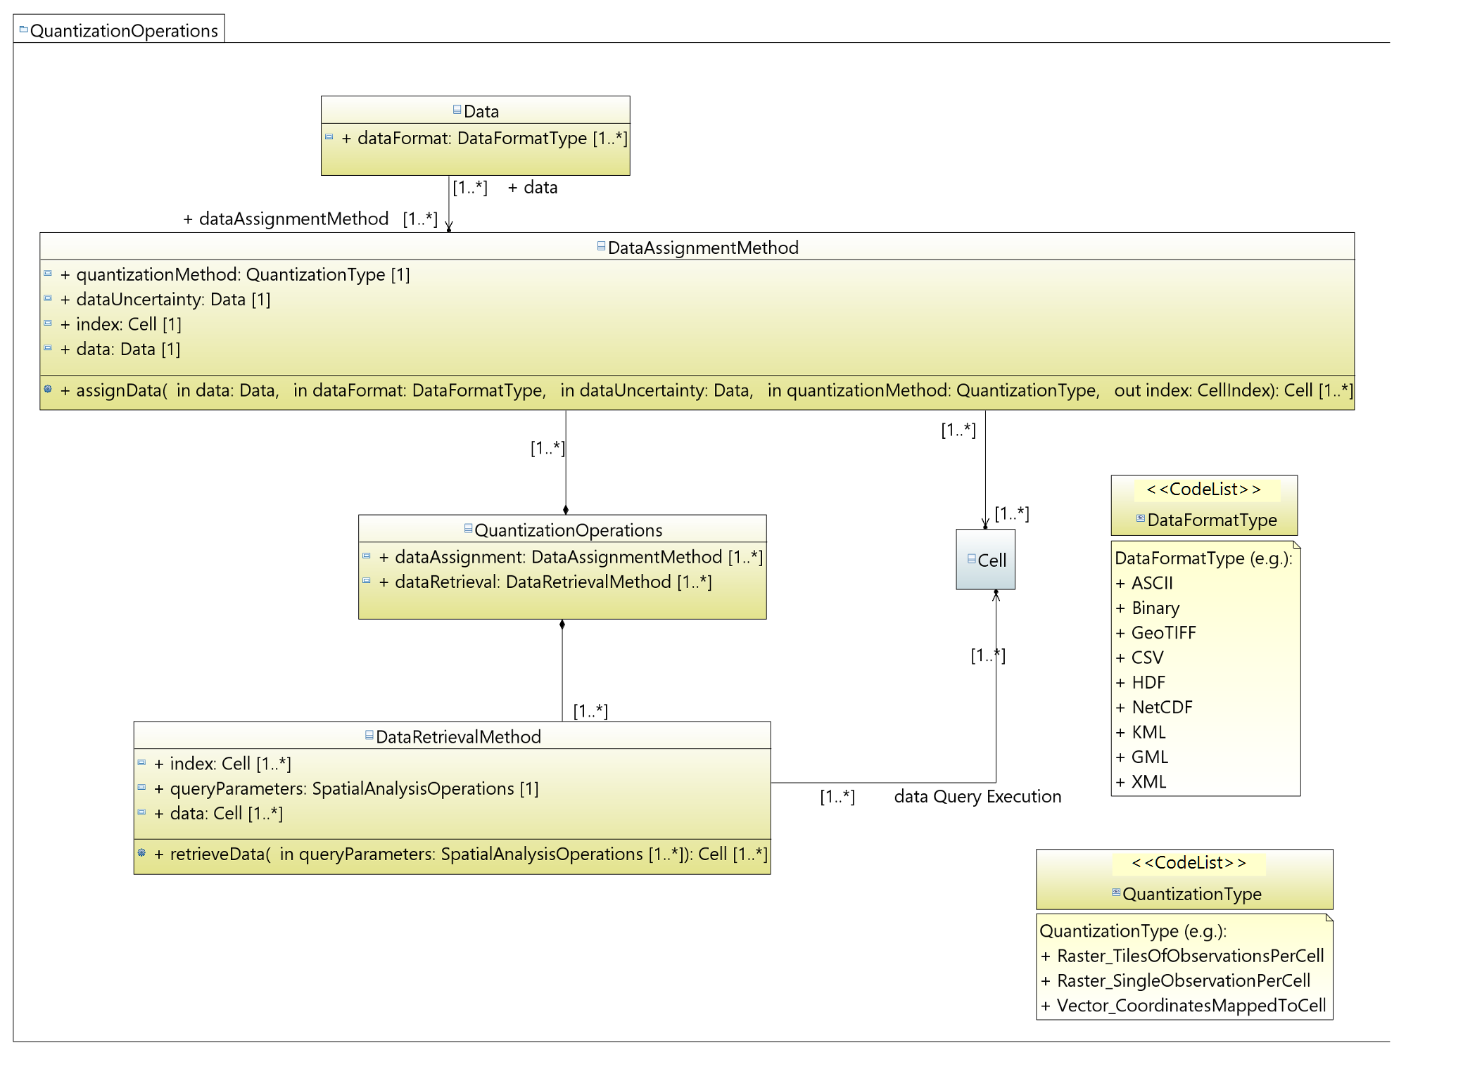
Figure 4 – DGGS Quantization functional algorithm class diagram

http://www.opengis.net/spec/DGGS/1.0/req/core/methods/quantization
A DGGS implementation SHALL have quantization methods for assigning data to DGGS cells and retrieval methods for reading data from DGGS cells.

Algebraic Operations
A DGGS implementation must include methods to support analytic and algebraic processes on the data assigned to it across its entire domain. There are two key classes of operations that support this:
- Cell Navigation Operations – supporting navigation operations through both parent-child DGGS Cell relationships and neighbourhood associations across the entire DGGS Domain; and,
- Spatial Analysis Operations – supporting spatial analysis operations using DE-9IM to determine the spatial relationships between DGGS Cells and spatial query objects.
These two classes of operators facilitate the hierarchical and spatial queries necessary to retrieve data from DGGS cell(s). Further algebraic and analytic processes may then be applied to the returned data through additional software bindings. This standard does not specify any requirements for the binding or implementation of further, extension, algebraic or analytic processes.
Figure 5 shows the key classes of algebraic operations required by a DGGS implementation.
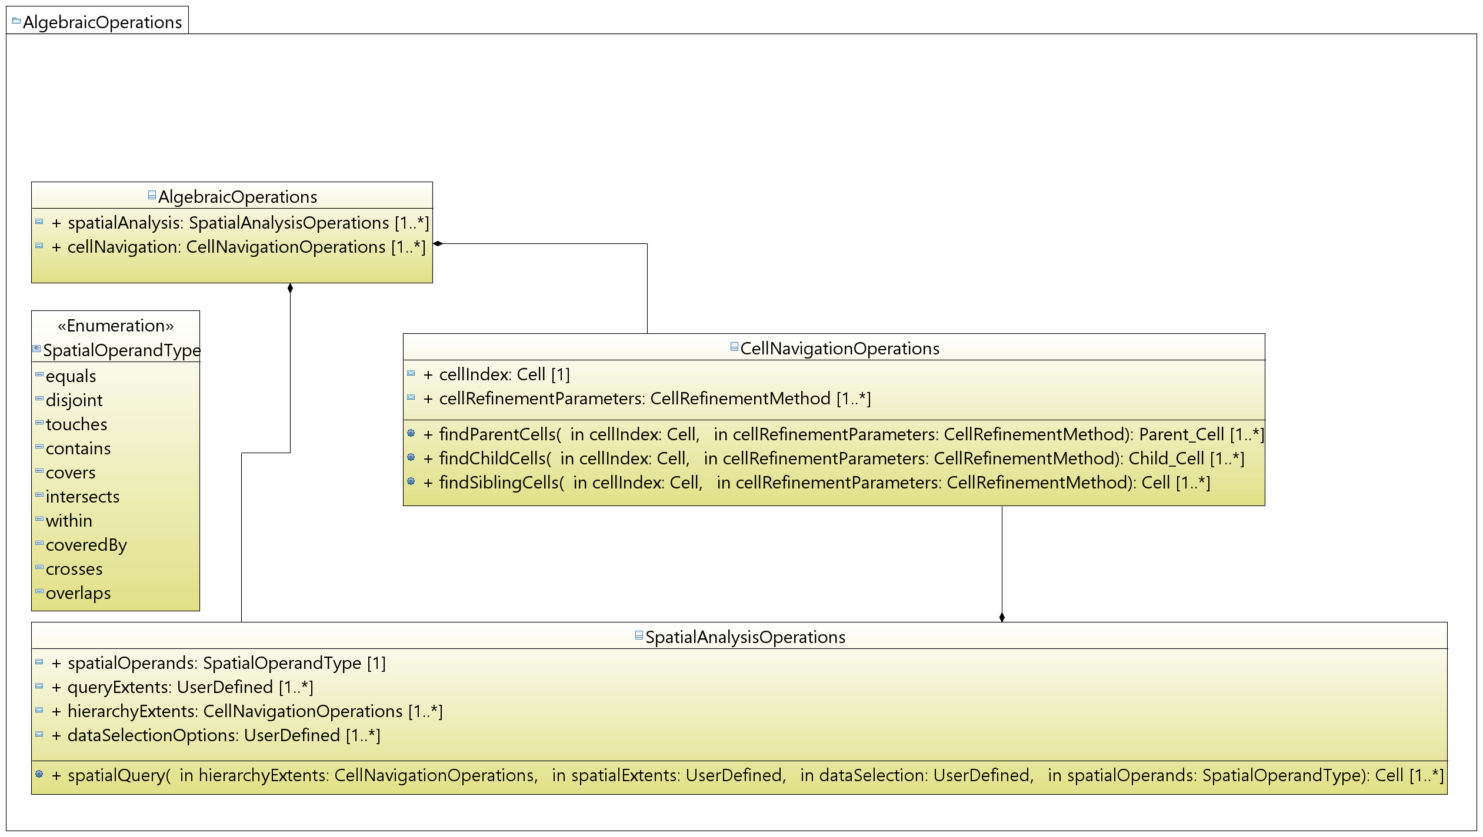
Figure 5 – DGGS Algebraic Operations functional algorithms class diagram
http://www.opengis.net/spec/DGGS/1.0/req/core/methods/algebraic_processes/cell_navigation
A DGGS implementation SHALL include functions/methods to perform both hierarchy and neighbourhood navigation operations across its entire domain.

http://www.opengis.net/spec/DGGS/1.0/req/core/methods/algebraic_processes/spatial_analysis
A DGGS implementation SHALL include functions/methods to perform simple spatial analysis operations across its entire domain. [OGC 06-103r4] SHALL be used as a basis for specifying the spatial relationship operands that support these functions.

Interoperability
While the quantization and algebraic functional algorithms enable a DGGS implementation to successfully operate internally; in order to facilitate connectivity with other spatial data infrastructures additional interoperability operations/methods are required. As a minimum these interoperability operations must include functions to:
- Interpret and translate external data queries and/or process commands sent to the DGGS implementation; and,
- Convert the result set returned from a DGGS data operation from internal data format(s) (optimized for that DGGS implementation) to format(s) suitable for external data delivery.
This document does not specify the specific interface protocol encodings required to connect a DGGS implementation to an external client and facilitate the transfer of information into and out of a DGGS. Specific interface encodings are anticipated to be elaborated as extensions to this standard.

External Query/Process Interpretation
External queries and processes may originate from an external client application and range in syntax from “natural language queries” (e.g. ‘Where are the gas pipelines in Western Canada located?’, or, ‘How has the Murray-Darling Basin in Australia changed over the past 27 years?’, or ‘Compute the watershed area of the Kawarau Catchment in New Zealand’), to an OWS ‘GetCapabilities’ or similar type of query, to an SQL (or similar) statement. To be interoperable, a DGGS implementation must be able to receive, interpret and translate an external data query (or process) request into a form that can be processed by the internal DGGS data retrieval algorithms and/or algebraic operations.
Figure 6 shows the key functional algorithm elements required for a DGGS implementation to translate and execute an external query or process operation.

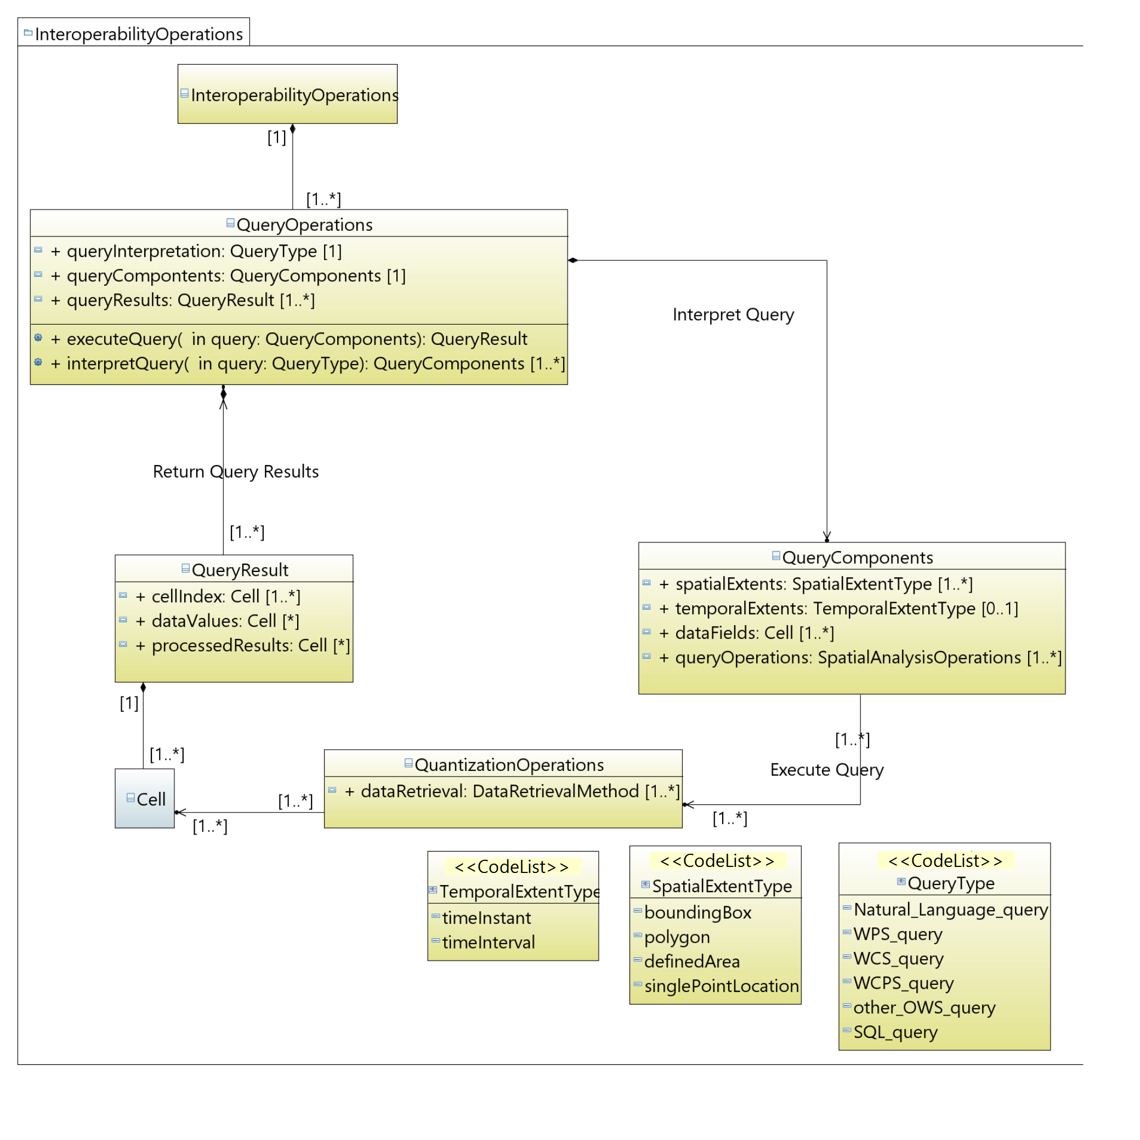
Figure 6 – DGGS Interoperability Query functional algorithm class diagram

http://www.opengis.net/spec/DGGS/1.0/req/core/methods/interoperability/query
A DGGS implementation SHALL include a method, or functional algorithm, to read, interpret and execute an external data query.

Query/Process Result Broadcasting
Just as it is necessary for a DGGS implementation encoding to be able to interpret and execute an external data query, a DGGS implementation encoding must be able to broadcast the results of a data query to an external client or data infrastructure. The external client is anticipated to be a web-based client, a software client on the same ICT infrastructure as the DGGS implementation encoding, or even another DGGS implementation encoding.
Figure 7 shows the basic elements required to translate the result set(s) returned from a DGGS data query into a suitable data format for transfer and broadcast the reformatted result set via one or a number of data/information transfer protocols.
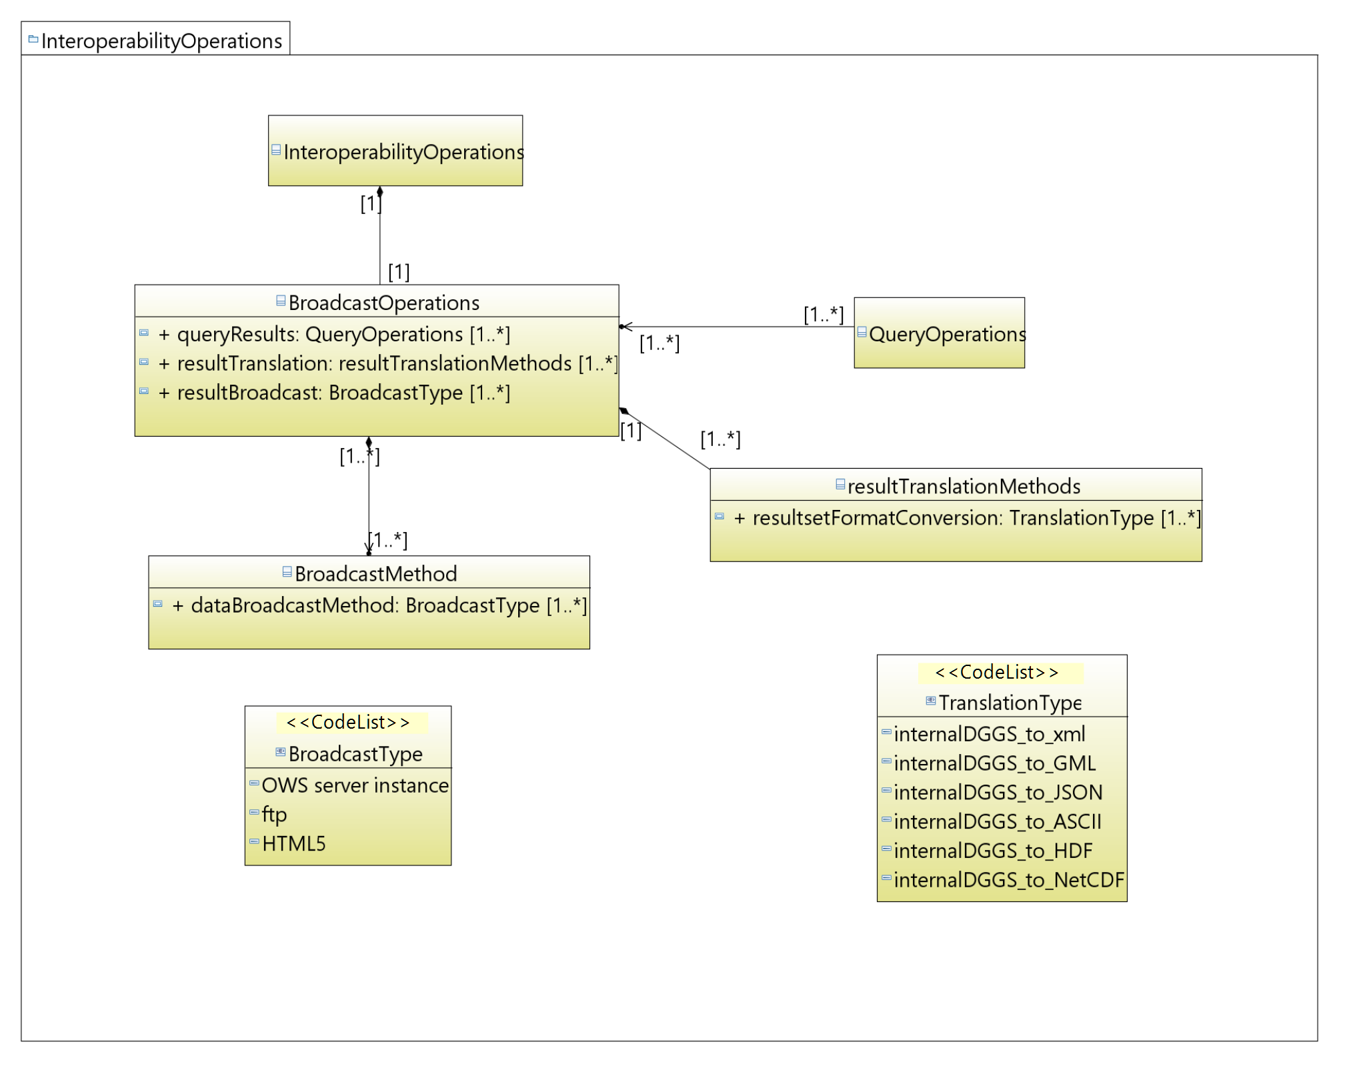
Figure 7 – DGGS Interoperability Broadcasting functional algorithm class diagram.
http://www.opengis.net/spec/DGGS/1.0/req/core/methods/interoperability/broadcast
A DGGS implementation encoding SHALL include a method, or functional algorithm, to convert data query/process results from internal DGGS data structures to standard data formats and to transmit the reformatted result set via standard data transfer protocols.

Annex A: Conformance Class Abstract Test Suite (Normative)
This Annex specifies an Abstract Test Suite which shall be passed in completeness by any implementation claiming conformance with this Implementation Standard.
Tests identifiers below are relative to http://www.opengis.net/spec/DGGS/1.0/.

Conformance class: Core
- Core Data Model
http://www.opengis.net/spec/DGGS/1.0/conf/core/model
Title | Core Data Model
Abbreviation | core/model
Type | Basic
Requirement | Requirement 1:  http://www.opengis.net/spec/DGGS/1.0/req/core/model
Reference Clause | 7.1
Test Purpose | To verify that a DGGS implementation conforms to the DGGS Core Data Model
Test Method | Verify that a DGGS implementation includes all elements of the DGGS Core Data Model

- Reference Frame – Global Coverage – Surface Area Equivalence
http://www.opengis.net/spec/DGGS/1.0/conf/core/reference_frame/coverage/area
Title | Reference Frame - Global Coverage – Surface Area Equivalence
Abbreviation | reference_frame/coverage/area
Type | Basic
Requirement | Requirement 2:  http://www.opengis.net/spec/DGGS/1.0/req/core/reference_frame/coverage/area
Reference Clause | 7.2.1
Test Purpose | To verify that the DGGS Reference Frame defined by a DGGS implementation has global coverage
Test Method | Test that for a given cell resolution refinement the DGGS implementation defines grid cells at all positions around the globe, as follows:  - Calculate the surface area of the Earth model used as the base for the DGGS Reference Frame (e.g. WGS84);  - Calculate the sum of the areas of all DGGS cells defined by the tessellation at a given level of cell refinement;  - Compare the two surface areas.  The test is passed if the two surface areas are equal.

- Reference Frame – Global Coverage – Cell Boundary Overlap
http://www.opengis.net/spec/DGGS/1.0/conf/core/reference_frame/coverage/overlap
Title | Reference Frame - Global Coverage – Cell Boundary Overlap
Abbreviation | reference_frame/coverage/overlap
Type | Basic
Requirement | Requirement 3:  http://www.opengis.net/spec/DGGS/1.0/req/core/reference_frame/coverage/overlap
Reference Clause | 7.2.1
Test Purpose | To verify that the DGGS Reference Frame defined by a DGGS implementation does not have any overlapping DGGS Cells.
Test Method | Test that for a given cell resolution refinement the DGGS implementation defines grid cells where the coordinates of all shared DGGS Cell boundaries are identical.  Test passes if all shared boundary coordinates are identical.

- Reference Frame – Tessellation Sequence
http://www.opengis.net/spec/DGGS/1.0/conf/core/reference_frame/tessellation_sequence
Title | Reference Frame – Tessellation Sequence
Abbreviation | reference_frame/tessellation_sequence
Type | Basic
Requirement | Requirement 4:  http://www.opengis.net/spec/DGGS/1.0/req/core/reference_frame/tessellation_sequence
Reference Clause | 7.2.2
Test Purpose | To verify that the reference frame of a DGGS implementation can support multiple levels of spatial resolution
Test Method | Test that the reference frame of a DGGS implementation:  - Includes more than one tessellation of the Earth, and,  - The tessellations consist of DGGS Cells that are consistent with a sequence based on cell areal extents that become finer with successive levels of cell refinement.

- Reference Frame —Area Preservation
http://www.opengis.net/spec/DGGS/1.0/conf/core/reference_frame/area_preservation
Title | Reference Frame––Area Preservation
Abbreviation | reference_frame/area_preservation
Type | Basic
Requirement | Requirement 5:  http://www.opengis.net/spec/DGGS/1.0/req/core/reference_frame/area_preservation
Reference Clause | 7.2.3
Test Purpose | To verify that the child cells of a given level of cell refinement in a DGGS implementation represent the same total surface area as represented by the parent cells (i.e. that they cover the globe).
Test Method | Test that for each level of cell refinement defined by the DGGS Reference Frame the sum of the areas of all child cells exactly equals the sum of the area of all parent cells. Test passes if child cell total area equals parent cell total area.

- Reference Frame — Equal Area Precision
http://www.opengis.net/spec/DGGS/1.0/conf/core/reference_frame/cell/equal_area_precision
Title | Reference Frame — Equal Area Precision
Abbreviation | reference_frame/cell/equal_area_precision
Type | Basic
Requirement | Requirement 6:  http://www.opengis.net/spec/DGGS/1.0/req/core/reference_frame/cell/equal_area_precision
Reference Clause | 7.2.4.1
Test Purpose | To verify that the DGGS has defined a DGGS equal area precision
Test Method | Verify that the DGGS has defined a DGGS equal area precision

- Reference Frame — Equal Area Cells
http://www.opengis.net/spec/DGGS/1.0/conf/core/reference_frame/cell/equal_area
Title | Reference Frame — Equal Area Cells
Abbreviation | reference_frame/cell/equal_area
Type | Basic
Requirement | Requirement 7:  http://www.opengis.net/spec/DGGS/1.0/req/core/reference_frame/cell/equal_area
Reference Clause | 7.2.4.1
Test Purpose | To verify that the cells at a given level of cell refinement in a DGGS implementation have equal area
Test Method | For each level of cell refinement:  - Compute the nominal cell area  Nominal Cell Area = total surface area / No. of cells.  - Compute the maximum cell area uncertainty across all cells  Maximum Uncertainty = greater of  (Maximum Cell Area - Nominal Cell Area)  (Nominal Cell Area - Minimum Cell Area)  - Compute the equal area precision  Precision = Maximum Uncertainty / Nominal Cell Area.  DGGS Equal Area Cell Test passes if the calculated Precision is less than or equal to the defined DGGS Equal Area Precision.

- Reference Frame – Spatial Reference
http://www.opengis.net/spec/DGGS/1.0/conf/core/reference_frame/spatial_reference
Title | Reference Frame – Spatial Reference
Abbreviation | reference_frame/spatial_reference
Type | Basic
Requirement | Requirement 8:  http://www.opengis.net/spec/DGGS/1.0/req/core/reference_frame/spatial_reference
Reference Clause | 7.2.5
Test Purpose | To verify that the cells defined by a DGGS Reference Frame have a unique index assigned to them.
Test Method | Search the DGGS implementation for a given cell index. Test passes if only one DGGS cell is returned.

- Reference Frame – Spatial Reference – Cells Referenced at their Centroid
http://www.opengis.net/spec/DGGS/1.0/conf/core/reference_frame/spatial_reference/cell_centroid
Title | Reference Frame – Spatial Reference – Cells Reference at their Centroid
Abbreviation | reference_frame/spatial_reference/cell_centroid
Type | Basic
Requirement | Requirement 9:  http://www.opengis.net/spec/DGGS/1.0/req/core/reference_frame/spatial_reference/cell_centroid
Reference Clause | 7.2.5.1
Test Purpose | To verify that the cells defined by a DGGS Reference Frame are referenced at the centroid of each cell
Test Method | For each DGGS Cell:  - Compute the center of n-dimensional area for the cell;  - Compare the registered location reference of the cell with the computed location of the center of n-dimensional area.  Test passes if the registered location reference of the cell equals the computed center of n-dimensional area.

- Functional Algorithms – Cell Operations – Initial Tessellation
http://www.opengis.net/spec/DGGS/1.0/conf/core/methods/cell/initial_tessellation
Title | Functional Algorithms – Cell Operations – Initial Tessellation
Abbreviation | methods/cell/initial_tessellation
Type | Basic
Requirement | Requirement 10:  http://www.opengis.net/spec/DGGS/1.0/req/core/methods/cell/initial_tessellation
Reference Clause | 7.3.1.1
Test Purpose | To verify that a DGGS implementation has a method to achieve an initial tessellation of the Earth.
Test Method | Validate that the software associated with the DGGS implementation includes a method to achieve an initial tessellation of the Earth.

- Functional Algorithms – Cell Operations – Cell Refinement
http://www.opengis.net/spec/DGGS/1.0/conf/core/methods/cell/refinement
Title | Functional Algorithms – Cell Operations – Cell Refinement
Abbreviation | methods/cell/refinement
Type | Basic
Requirement | Requirement 11:  http://www.opengis.net/spec/DGGS/1.0/req/core/methods/cell/refinement
Reference Clause | 7.3.1.2
Test Purpose | To verify that a DGGS implementation has a method to refine each cell into finer resolution child cells
Test Method | Validate that the software associated with the DGGS implementation includes a method to refine each DGGS cell into finer resolution child cells.

- Functional Algorithms – Cell Operations – Cell Addressing
http://www.opengis.net/spec/DGGS/1.0/conf/core/methods/cell/indexing
Title | Functional Algorithms – Cell Operations – Cell Addressing
Abbreviation | methods/cell/indexing
Type | Basic
Requirement | Requirement 12:  http://www.opengis.net/spec/DGGS/1.0/req/core/methods/cell/indexing
Reference Clause | 7.3.1.3
Test Purpose | To verify that a DGGS implementation has a method to assign a unique spatial reference (or index) to each DGGS cell.
Test Method | Validate that the software associated with the DGGS implementation includes a method to assign a unique spatial reference to each DGGS cell. Acceptable methods include:  - Hierarchy;  - Space Filling Curve;  - Coordinate; or,  - Encoded Address  At least one of these methods SHALL be used. More than one of these methods MAY be used to create parallel, independent or compound spatial references for each DGGS cell; so long as conformance test A.1.7 (http://www.opengis.net/spec/DGGS/1.0/conf/core/reference_frame/spatial_reference) is satisfied.

- Functional Algorithms – Quantization Operations
http://www.opengis.net/spec/DGGS/1.0/conf/core/methods/quantization
Title | Functional Algorithms – Quantization Operations
Abbreviation | methods/quantization
Type | Basic
Requirement | Requirement 13:  http://www.opengis.net/spec/DGGS/1.0/req/core/methods/quantization
Reference Clause | 7.3.2
Test Purpose | To verify that a DGGS implementation has a method to assign and retrieve data from a cell.
Test Method | Validate that the software associated with the DGGS implementation includes a method to assign and retrieve data from a DGGS cell.

- Functional Algorithms – Algebraic Processes – Cell Navigation
http://www.opengis.net/spec/DGGS/1.0/conf/core/methods/algebraic_processes/cell_navigation
Title | Functional Algorithms – Algebraic Processes – Cell Navigation
Abbreviation | methods/algebraic_processes/cell_navigation
Type | Basic
Requirement | Requirement 14:  http://www.opengis.net/spec/DGGS/1.0/req/core/methods/algebraic_processes/cell_navigation
Reference Clause | 7.3.3
Test Purpose | To verify that a DGGS implementation has a method (or methods) to perform cell hierarchy navigation operations across its entire domain.
Test Method | Validate that the software associated with the DGGS implementation includes a method (or methods) to perform cell hierarchy operations across its entire domain. As a minimum there SHALL be functions to:  - Identify and navigate to a Parent cell(s) from any DGGS Cell defined by the DGGS Reference Frame;  - Identify and navigate to Child cells from any DGGS Cell defined by the DGGS Reference Frame; and,  - Identify and navigate to Sibling cells (cells at the same level of DGGS cell refinement) from any DGGS Cell defined by the DGGS Reference Frame.  Test passes if all of these operations can be performed.

- Functional Algorithms – Algebraic Processes – Spatial Analysis
http://www.opengis.net/spec/DGGS/1.0/conf/core/methods/algebraic_processes/spatial_analysis
Title | Functional Algorithms – Algebraic Processes – Spatial Analysis
Abbreviation | methods/algebraic_processes/spatial_analysis
Type | Basic
Requirement | Requirement 15:  http://www.opengis.net/spec/DGGS/1.0/req/core/methods/algebraic_processes/spatial_analysis
Reference Clause | 7.3.3
Test Purpose | To verify that a DGGS implementation has a method (or methods) to perform simple spatial analysis operations across its entire domain.
Test Method | Validate that the software associated with the DGGS implementation includes a method (or methods) to perform simple spatial analysis operations across its entire domain.  Test that the spatial analysis operations can perform the spatial relationship operands defined by the DE-9IM framework. Test passes if the DGGS can perform these spatial query operations.

- Functional Algorithms – Interoperability Query Operations
http://www.opengis.net/spec/DGGS/1.0/conf/core/methods/interoperability/query
Title | Functional Algorithms – Interoperability Query Operations
Abbreviation | methods/interoperability/query
Type | Basic
Requirement | Requirement 16:  http://www.opengis.net/spec/DGGS/1.0/req/core/methods/interoperability/query
Reference Clause | 7.3.4.1
Test Purpose | To verify that a DGGS implementation has a method (or methods) to support the translation of an external data query into a form that can be applied to the data stored in the DGGS implementation.
Test Method | Send an external data process/query command to a DGGS implementation. Test passes if the DGGS implementation can interpret, parameterize and execute the process/query.

- Functional Algorithms – Interoperability Broadcast Operations
http://www.opengis.net/spec/DGGS/1.0/conf/core/methods/interoperability/broadcast
Title | Functional Algorithms – Interoperability Broadcast Operations
Abbreviation | methods/interoperability/broadcast
Type | Basic
Requirement | Requirement 17:  http://www.opengis.net/spec/DGGS/1.0/req/core/methods/interoperability/broadcast
Reference Clause | 7.3.4.2
Test Purpose | To verify that a DGGS implementation has a method (or methods) to support broadcasting data query results externally to the DGGS implementation. Actual broadcasting of information from a DGGS implementation is not included as part of this ‘Core’ standard; although the supporting capability to do so is;
Test Method | Apply a given data process/query (generated either internally or externally) to the DGGS implementation. Verify that the query result can be reformatted to a form that can be broadcast externally from the DGGS implementation. (NB: specific broadcast protocol interfaces do not need to be encoded in the DGGS implementation at this time – these interface protocols will be elaborated in extensions to this standand).  Test passes if the result set can be reformatted to a standard data format for transfer and dispatched to at least one broadcast medium.

Annex B: Revision history

Date | Release | Author | Paragraph modified | Description
2015-08-10 | 0.1.0 | Matthew Purss,  Robert Gibb,  Faramarz Samavati,  Perry Peterson, J Andrew Rogers,  Jin Ben | All | Initial draft created
2015-09-30 | 1.0.0 | Matthew Purss,  Robert Gibb,  Faramarz Samavati,  Perry Peterson, J Andrew Rogers,  Jin Ben | All | Draft Candidate Standard approved by SWG for release to public for 30-day Public Comment Period.
2015-11-20 | 1.1.0 | Matthew Purss | Clauses:  i;  1 - par 3;  4.1, 4.6, 4.7, 4.11, 4.15, 4.19, 4.20;  6.1, 6.2, 6.3, 6.4 - par 1&2, 6.6 - par 3-5, figure 1;  7.2.1, 7.2.4, 7.3.1, 7.3.1.1, 7.3.1.2, 7.3.2, Req 12, Req 13;  Annex C | Minor editorial changes following comments from Chris Little during OAB review.
2015-11-30 | 1.1.1 | Robert Gibb, Matthew Purss, Faramarz Smarvati, Perry Peterson | Clauses ? | Minor editorial changes following comments from John Herring during OAB review
2015-12-2 | 1.2.0 | Roger Lott,  Robert Gibb | Clause 4 (All)  Clause 5.3 (new)  Clause 6.4  Clause 7 (many) | Change Term Definitions to ISO compliance and flow-on changes to the rest of the document, introduce Equal Area Precision requirement and associated change to Equal Area requirement and conformance tests, replace Initial Discretization with Initial Tessellation throughout, replace hierarchy requirement and conformance test with tessellation sequence.
2015-12-23 | 1.3.0 | Robert Gibb | Submitters  Clause 2  Clause 4  New 5.7  Update all figures, removing old figs 4,5,6 & 7  Clause 6 | Acknowledge Roger Lott’s contribution  Remove unreferenced ISO standards  Differentiate DGGS from ISO definitions where needed  Clarify need for DGGS and ISO term differentiation  Insert ISO classes wherever possible & use ISO patterns where appropriate  Update usage to new DGGS terms, move 6.3.1 to 6.2.6 reflecting updated fig 3

Annex C: Bibliography
[1] Goodchild, M. F., 1992, “Geographical information science”, International Journal of Geographical Information Systems, 6(1): pp 31–45. DOI:10.1080/02693799208901893

[2] Clementini, E., Di Felice, P., van Oosterom, P., 1993. "A small set of formal topological relationships suitable for end-user interaction". In Abel, David; Ooi, Beng Chin. Advances in Spatial Databases: Third International Symposium, SSD '93 Singapore, June 23–25, 1993 Proceedings. Lecture Notes in Computer Science. 692/1993. Springer. pp 277–295. DOI:10.1007/3-540-56869-7_16.

[3] Clementini, E., Sharma, J., Egenhofer, M. J., 1994, "Modelling topological spatial relations: Strategies for query processing". Computers & Graphics 18 (6), pp 815–822. DOI:10.1016/0097-8493(94)90007-8.

[4] Clementini, E., and Di Felice P. A., 1996, “A Model for Representing Topological Relationships between Complex Geometric Features in Spatial Databases.” Information Sciences, 90(1), pp 121-136. DOI:10.1016/0020-0255(95)00289-8

[5] Egenhofer, M.J.; Herring, J.R., 1990, "A Mathematical Framework for the Definition of Topological Relationships". Fourth International Symposium on Spatial Data Handling Zürich, Switzerland, pp 803-813. http://www.spatial.maine.edu/~max/MJEJRH-SDH1990.pdf

[6] Dutton, G., 1984, “Part 4: Mathematical, Algorithmic and Data Structure Issues: Geodesic Modelling Of Planetary Relief”, Cartographica: The International Journal for Geographic Information and Geovisualization, 21(2-3), pp 188-207. DOI:10.3138/R613-191U-7255-082N

[7] Dutton, G., 1996, “Encoding and handling geospatial data with hierarchical triangular meshes”, In Proceeding of 7th International symposium on spatial data handling, 43, Netherlands: Talor & Francis. DOI:10.1.1.461.5603

[8] Tobler, W., & Chen, Z.-t., 1986, “A Quadtree for Global Information Storage”, Geographical Analysis, 18(4), pp 360-371. DOI:10.1111/j.1538-4632.1986.tb00108.x

[9] White, D., Kimerling, J., & Overton, W. S., 1992, “Cartographic and geometric components of a global sampling design for environmental monitoring”, Cartography and Geographic Information Systems, 19(1), pp 5-22. DOI:10.1559/152304092783786636
[10] Kimerling, A. J., Sahr, K., White, D., & Song, L., 1999, “Comparing Geometrical Properties of Global Grids“, Cartography and Geographic Information Systems vol. 26, no. 4, pp 271-88. DOI:10.1559/152304099782294186

[11] Dutton, G., 1994, “Geographical grid models for environmental monitoring and analysis across the globe (panel session)”. In: Proceedings of GIS/US’94 Conference, Phoenix, Arizona.

[12] Snyder, J. P., 1992, “An equal-area map projection for polyhedral globes”. Cartographica, 29(1), pp 10-21.

[13] Song, L., 1997, “Small circle subdivision method for development of global sampling grid”, Unpublished Masters Thesis, Oregon State University, 176pp.

[14] Lukatela, H., 1987, “Hipparchus geopositioning model: An overview”, In: Proceedings of Auto Carto 8 Symposium, Baltimore, Maryland. pp 87-96.

[15] Fekete, G., Treinish, L., 1990, “Sphere quadtree: A new data structure to support the visualization of spherically distributed data”.SPIE: Extracting Meaning from complex data: Processing, display, interaction. 1259, pp 242-253.

[16] Dutton, G., 1988, “Geodesic modelling of planetary relief”. Cartographica, 21, pp 188-207.

[17] Bjorke, J. T., Grytten, J. K., Haeger, M., Nilsen, S., 2003, “A Global Grid Model Based on ‘Constant Area’ Quadrilaterals”, ScanGIS, 3, pp 238-250. DOI: 10.1.1.105.2253

[18] Amante, C. and Eakins, B. W., 2009, “ETOPO1 1 Arc-Minute Global Relief Model: Procedures, Data Sources and Analysis”, NOAA Technical Memorandum NESDIS NGDC-24, 19 pp.

[19] Rees, T., 2002, “ ‘C-Squares’ – a new metadata element for improved spatial querying and representation of spatial dataset coverage in metadata records”, in EOGEO 2002 Proceedings, Ispra, Italy.

[20] Loveland, T. R., Merchant, J. W., Ohlen, D., O., Brown, J. F., 1991, “Development of a land-cover characteristics database for the counterminous”. U.S. Photogrammetric Engineering and Remote Sensing, 57(11), pp 1453-1463

[21] Snyder J. P., 1993, “Flattening the Earth: Two Thousand Years of Map Projections”, pp5-8. ISBN 0-226-76747-7)

[22] Gibb, R.G., (forthcoming), “The rHealPIX Discrete Global Grid System” Proceedings of the 9th Symposium of the International Society for Digital Earth (ISDE), Halifax, Nova Scotia, Canada.

[23] Ma, T., Zhou, C., Xie, Y., Qin, B., Ou, Y., 2009, “A discrete square global grid system based on the parallels plane projection”. International Journal of Geographical Information Science. 23(10), pp 1297-1313. DOI: 10.1080/13658810802344150

[24] Fisher, I., 1943, “A World Map on a Regular Icosahedron by Gnomonic Projection”, Geographical Review, 33(4), pp 605-619, DOI: 10.2307/209914

[25] Fuller, R. B., 1982, “Synergetics”, New York.

[26] Goodchild, M. F., 2000, “Discrete global grids for digital earth”, International Conference on Discrete Global Grids. Santa Barbara. http://www.ncgia.ucsb.edu/globalgrids/papers/goodchild.pdf
[27] Clarke, K. C., 2000, "Criteria and Measures for the Comparison of Global Geocoding Systems", International Conference on Discrete Global Grids. Santa Barbara: University of California, Santa Barbara. http://ncgia.ucsb.edu/globalgrids-book/comparison/
[28] Peterson, P. R., (Forthcoming), “Discrete Global Grid Systems.” In The International Encyclopedia of Geography, edited by Douglas Richardson. Malden, Oxford: John Wiley and Sons, Ltd.

[29] Mahdavi-Amiri, A., Alderson, T., & Samavati, F., 2015, “A Survey of Digital Earth Representation and Visualization”, uri: http://hdl.handle.net/1880/50407

[30] Sahr, K., White, D., Kimerling, A. J., 2003, “Geodesic discrete global grid systems”, Cartography and Geographic Information Science, 30 (2), pp 121–134. DOI:10.1559/152304003100011090

[31] Mahdavi-Amiri, A., Samavati, F. F., Peterson, P., 2015, “Categorization and conversions for indexing methods of discrete global grid systems”, ISPRS International Journal of Geo-Information, 4(1), pp 320–336. DOI:10.3390/ijgi4010320

[32] Postel, J., 1981, “RFC 791: Internet protocol”, Darpa Internet Protocol Specification (September 1981). - https://tools.ietf.org/html/rfc791

www.opengeospatial.org/compliance_cite
The OGC Abstract Specifications are available from http://www.opengeospatial.org/docs/as
Specific DGGS interoperability Interface Protocols will be elaborated in a series OGC Extension Standard documents to this standard.

