**Open Geospatial Consortium**

Submission Date: 2014-05-15

Approval Date:   2014-09-19

Publication Date:   2014-10-20

External identifier of this OGC® document: http://www.opengis.net/doc/BP/sos-hydrology/1.0

Internal reference number of this OGC® document:    14-004r1

Version: 1.0

Category: OGC® Best Practice

Editor:   Volker Andres, Simon Jirka, Michael Utech

OGC Sensor Observation Service 2.0 Hydrology Profile

**Copyright notice**

Copyright © 2014 Open Geospatial Consortium  
To obtain additional rights of use, visit <http://www.opengeospatial.org/legal/>.

**Warning**

This document is not an OGC Standard. This document is distributed for review and comment. This document is subject to change without notice and may not be referred to as an OGC Standard.

Document type:    OGC® Best Practice Paper

Document subtype:    not applicable

Document stage:    Approved for Public Release

Document language:  English

Recipients of this document are invited to submit, with their comments, notification of any relevant patent rights of which they are aware and to provide supporting documentation.

License Agreement

Permission is hereby granted by the Open Geospatial Consortium, ("Licensor"), free of charge and subject to the terms set forth below, to any person obtaining a copy of this Intellectual Property and any associated documentation, to deal in the Intellectual Property without restriction (except as set forth below), including without limitation the rights to implement, use, copy, modify, merge, publish, distribute, and/or sublicense copies of the Intellectual Property, and to permit persons to whom the Intellectual Property is furnished to do so, provided that all copyright notices on the intellectual property are retained intact and that each person to whom the Intellectual Property is furnished agrees to the terms of this Agreement.

If you modify the Intellectual Property, all copies of the modified Intellectual Property must include, in addition to the above copyright notice, a notice that the Intellectual Property includes modifications that have not been approved or adopted by LICENSOR.

THIS LICENSE IS A COPYRIGHT LICENSE ONLY, AND DOES NOT CONVEY ANY RIGHTS UNDER ANY PATENTS THAT MAY BE IN FORCE ANYWHERE IN THE WORLD.

THE INTELLECTUAL PROPERTY IS PROVIDED "AS IS", WITHOUT WARRANTY OF ANY KIND, EXPRESS OR IMPLIED, INCLUDING BUT NOT LIMITED TO THE WARRANTIES OF MERCHANTABILITY, FITNESS FOR A PARTICULAR PURPOSE, AND NONINFRINGEMENT OF THIRD PARTY RIGHTS. THE COPYRIGHT HOLDER OR HOLDERS INCLUDED IN THIS NOTICE DO NOT WARRANT THAT THE FUNCTIONS CONTAINED IN THE INTELLECTUAL PROPERTY WILL MEET YOUR REQUIREMENTS OR THAT THE OPERATION OF THE INTELLECTUAL PROPERTY WILL BE UNINTERRUPTED OR ERROR FREE. ANY USE OF THE INTELLECTUAL PROPERTY SHALL BE MADE ENTIRELY AT THE USER’S OWN RISK. IN NO EVENT SHALL THE COPYRIGHT HOLDER OR ANY CONTRIBUTOR OF INTELLECTUAL PROPERTY RIGHTS TO THE INTELLECTUAL PROPERTY BE LIABLE FOR ANY CLAIM, OR ANY DIRECT, SPECIAL, INDIRECT OR CONSEQUENTIAL DAMAGES, OR ANY DAMAGES WHATSOEVER RESULTING FROM ANY ALLEGED INFRINGEMENT OR ANY LOSS OF USE, DATA OR PROFITS, WHETHER IN AN ACTION OF CONTRACT, NEGLIGENCE OR UNDER ANY OTHER LEGAL THEORY, ARISING OUT OF OR IN CONNECTION WITH THE IMPLEMENTATION, USE, COMMERCIALIZATION OR PERFORMANCE OF THIS INTELLECTUAL PROPERTY.

This license is effective until terminated. You may terminate it at any time by destroying the Intellectual Property together with all copies in any form. The license will also terminate if you fail to comply with any term or condition of this Agreement. Except as provided in the following sentence, no such termination of this license shall require the termination of any third party end-user sublicense to the Intellectual Property which is in force as of the date of notice of such termination. In addition, should the Intellectual Property, or the operation of the Intellectual Property, infringe, or in LICENSOR’s sole opinion be likely to infringe, any patent, copyright, trademark or other right of a third party, you agree that LICENSOR, in its sole discretion, may terminate this license without any compensation or liability to you, your licensees or any other party. You agree upon termination of any kind to destroy or cause to be destroyed the Intellectual Property together with all copies in any form, whether held by you or by any third party.

Except as contained in this notice, the name of LICENSOR or of any other holder of a copyright in all or part of the Intellectual Property shall not be used in advertising or otherwise to promote the sale, use or other dealings in this Intellectual Property without prior written authorization of LICENSOR or such copyright holder. LICENSOR is and shall at all times be the sole entity that may authorize you or any third party to use certification marks, trademarks or other special designations to indicate compliance with any LICENSOR standards or specifications. This Agreement is governed by the laws of the Commonwealth of Massachusetts. The application to this Agreement of the United Nations Convention on Contracts for the International Sale of Goods is hereby expressly excluded. In the event any provision of this Agreement shall be deemed unenforceable, void or invalid, such provision shall be modified so as to make it valid and enforceable, and as so modified the entire Agreement shall remain in full force and effect. No decision, action or inaction by LICENSOR shall be construed to be a waiver of any rights or remedies available to it.

Contents

1. Scope 8

2. References 10

3. Conventions 11

4. Purpose of this Profile 12

4.1 Technical vs. semantic interoperability 12

4.2 Discovery functions and filtering 12

4.3 Profile Structure 13

5. Related Standards and Activities 14

5.1 GML, O&M and WaterML 2.0 14

5.1.1 GML 14

5.1.2 O&M 15

5.1.3 OGC WaterML 2.0 17

5.2 OGC Sensor Observation Service (SOS) 18

5.2.1 SOS 1.0 18

5.2.2 OGC SOS 2.0 19

5.3 OGC Hydrology Domain Working Group and Interoperability Experiments 21

5.3.1 OGC Hydrology Domain Working Group 21

5.3.2 Support by the OGC Hydrology DWG 21

5.3.3 GroundwaterIE 21

5.3.4 SurfaceWaterIE 22

5.3.5 ForecastingIE 22

5.3.6 GroundwaterIE2 22

6. Terms and Requirements 23

6.1 Profile Identification 23

6.2 FeatureOfInterest / WaterMonitoringPoint 23

6.3 ObservedProperty 24

6.4 Procedure / ObservationProcess 24

6.5 Identification 24

6.6 Open Points 26

7. Requests and Responses 27

7.1 GetCapabilities 27

7.1.1 Avoiding falsely indicated homogeneous distribution of time series in a SOS server instance 27

7.1.2 Listing of related features 27

7.2 GetFeatureOfInterest 28

7.2.1 Usage of GetFeatureOfInterest 28

7.2.2 GetFeatureOfInterest content 28

7.3 DescribeSensor 28

7.4 GetDataAvailability 29

7.5 GetObservation 31

7.5.1 Response structure if no values are in the time range 31

7.5.2 Handling of incomplete responses 32

7.5.3 Handling of requests without temporal filter 32

7.5.4 Handling of empty responses 32

7.6 Profile and SOS 1.0 33

8. Technical Aspects 34

8.1 Simple versus complex elements 34

8.2 Bindings 34

8.2.1 SOAP Binding 34

8.2.2 KVP Binding 34

8.3 Response limits 35

9. Outlook 37

9.1 Server Implementation 38

9.1.1 KISTERS KiWIS SOS2 38

9.1.2 52°North SOS Server 39

9.2 Client Implementation 40

9.2.1 KISTERS WISKI Client with The DataServiceConsumer 40

9.2.2 KISTERS Timeseries Widget 40

9.2.3 52°North Sensor Web Client API 41

9.2.4 52°North JavaScript SOS Client 42

9.2.5 52°North Thin SOS Client 43

Abstract

This OGC document defines an OGC Sensor Observation Service (SOS) 2.0 hydrology profile for SOS 2.0 implementations serving OGC WaterML 2.0. The development of this OGC Best Practice (BP) is based on previous activities and results (i.e. Hydrology Interoperability Experiments[1] as well as the European FP7 project GEOWOW[2]). The work is guided by the need to overcome semantic issues between different SOS instances serving hydrological data and the related client applications. Therefore, this profile focuses on how to use the entities and requests of the standards and defines the necessary technical details to implement the hydrology SOS profile.

Keywords

The following are keywords to be used by search engines and document catalogues.

ogcdoc, ogc documents, Hydrology, Sensor Web Enablement, Sensor Web, Sensor Observation Service, Profile

Preface

Within work package 5 (Water) of the GEOWOW project, a central work item was the creation of a fully interoperable hydrology profile for the usage of the OGC Sensor Observation Service (SOS) when serving WaterML 2.0 instances. Following the development of this profile, several members of the GEOWOW consortium implemented services and clients supporting this Best Practice as a proof of concept and fulfill the requirements of one or more use cases for demonstration purposes.

The work on this document was performed within the European GEOWOW (GEOSS interoperability for Weather, Ocean and Water) project. GEOWOW was co-funded by the European Community's Seventh Framework Programme FP7/2007-2013 under grant agreement no. 282915 in response to call ENV.2011.4.1.3-1 “Interoperable integration of Shared Earth Observations in the Global Context”.

Attention is drawn to the possibility that some of the elements of this document may be the subject of patent rights. The Open Geospatial Consortium shall not be held responsible for identifying any or all such patent rights.

*Recipients of this document are requested to submit, with their comments, notification of any relevant patent claims or other intellectual property rights of which they may be aware that might be infringed by any implementation of the standard set forth in this document, and to provide supporting documentation.*

Submitting organizations

The following organizations submitted this Document to the Open Geospatial Consortium (OGC):

* 52°North Initiative for Geospatial Open Source Software GmbH
* KISTERS AG

Submitters

All questions regarding this submission should be directed to the editor or the submitters:

|  |  |
| --- | --- |
| Name | Affiliation |
| Andres, Volker | German Federal Institute of Hydrology (BfG) / Global Runoff Data Centre (GRDC) |
| Bredel, Henning | 52°North Initiative for Geospatial Open Source Software GmbH |
| Fuest, Stefan | KISTERS AG |
| Hollmann, Carsten | 52°North Initiative for Geospatial Open Source Software GmbH |
| Jirka, Simon | 52°North Initiative for Geospatial Open Source Software GmbH |
| Nüst, Daniel | 52°North Initiative for Geospatial Open Source Software GmbH |
| Schlummer, Manuela | University of Bonn |
| Strauch, Adrian | University of Bonn |
| Schulte, Jan | 52°North Initiative for Geospatial Open Source Software GmbH |
| Utech, Michael | KISTERS AG |

# Scope

Based on previous projects and experiences by KISTERS and 52°North, the following requirements are seen as common cases regarding data discovery and data download functionalities in hydrological applications. Although these requirements are described from a client side perspective, the server side should allow requests in a corresponding way:

* DISCOVERY: List measuring locations by a geographical extent (bounding box).
* DISCOVERY: Provide a list of measuring locations with metadata such as station id, location, name, type and others.
* DISCOVERY: Provide information about available variables/parameters for a certain measuring location.
* DISCOVERY: Provide information about available time series for a certain measuring location and parameter including data coverage information.
* DATA DOWNLOAD: Retrieve data for certain measuring locations and parameters (or for a defined list of time-series) and a defined time-range.
* DATA DOWNLOAD: Harvest data for a set of defined measuring locations and parameters (or for a defined list of time-series) on a regular base.
* DATA DOWNLOAD: Retrieve a ‘layer’ of single values for certain measuring locations and parameters (or for a defined list of time-series) at a given date.

This document defines the SOS 2.0 Hydrology Profile. Each requirement is described accurately not only in its meaning (semantics) but also in the way it has been created and what alternatives were discussed. Where there are open points or issues, these are listed at the end of each section of this document.

As the title of this OGC Best Practice indicates it intended to offer a hydrology profile of the SOS 2.0 standard. However, this Best Practice also comprises a few additional aspects which are rather an extension (e.g. the proposed GetDataAvailability operation).

The next two sections briefly describe the current state in hydrological standards and the necessity of an interoperable SOS 2.0 profile for hydrology. A listing of relevant existing standards and experiments is provided in addition to the actual profile content. Section 6 provides the basic terms, entities, and identification mechanisms in the referenced standards while section 7 describes the actual service commands. Technical aspects for service implementation and usage are covered in section 8. The document concludes with a discussion of remaining work and future options.

In summary, this document describes a best practice for how to use the SOS 2.0 standard to serve WaterML 2.0 encoded hydrological observations in an interoperable manner.

# References

The following normative documents contain provisions that, through reference in this text, constitute provisions of this document. For dated references, subsequent amendments to, or revisions of, any of these publications do not apply. For undated references, the latest edition of the normative document referred to applies.

* ISO TC 211 (2011). ISO 19156:2011 - Geographic information -- Observations and measurements - International Standard. Geneva, Switzerland, International Organization for Standardization.
* Botts, Mike and Alexandre Robin (2007). OGC Implementation Specification: Sensor Model Language (SensorML) 1.0.0 (07-000). Wayland, MA, USA, Open Geospatial Consortium.
* Bröring, Arne, Christoph Stasch and Johannes Echterhoff (2012). OGC Implementation Standard: Sensor Observation Service (SOS) 2.0 (12-006). Wayland, MA, USA, Open Geospatial Consortium.
* Taylor, Peter (2012). OGC Implementation Standard: WaterML 2.0: Part 1 - Timeseries (0-126r3). Wayland, MA, USA, Open Geospatial Consortium.

# Conventions

Within this document, the following abbreviations are used:

GEOWOW GEOSS Interoperability for Weather, Ocean and Water

GML Geography Markup Language

Hydrology DWG Hydrology Domain Working Group

O&M Observations & Measurements

OGC Open Geospatial Consortium

SOAP Simple Object Access Protocol

SOS Sensor Observation Service

WFS Web Feature Service

WML WaterML 2.0

WSDL Web Service Description Language

# Purpose of this Profile

## Technical vs. semantic interoperability

How to achieve technical interoperability of a web service, such as OGC Web Map Service (WMS) or OGC Sensor Observation Service (SOS) is described as a set of requirements and rules in an engineering document. These documents define what protocols to use, how to name certain functions and what parameters and entities need to exist. On the other hand, these documents do not necessarily say much about how to correctly use these parameters and entities within a given context, such as a domain of use. If a standards document, such as SOS, provides a high degree of freedom on these points, it can easily lead to semantic communication problems. For a specific domain, such as hydrology, we need to ensure semantic interoperability.

Experience with the existing SOS services shows a range of ways to apply the semantics of the generic SOS terminology. Discussions have taken place in several groups and it appears that different approaches to implementing SOS are followed not just in different communities but also within similar communities. However, different SOS implementations using different semantics of the SOS concepts cause ambiguous client/server interaction with technically proper but semantically inconsistent request/response patterns. Interaction between clients and servers from different vendors and/or domains often requires an adjustment process to ensure common semantics and full compatibility and therefore interoperability.

The OGC SOS standard was developed to support a broad range of use cases ranging from fixed in-situ sensors to tracking applications or even complex remote sensing systems. Thus, semantic flexibility is absolutely necessary to meet this requirement. An information community should be responsible to define how to limit this flexibility to get a reasonable set of options (e.g. defining how the terms “feature of interest”, “offering” and “procedure” shall be used to ensure domain dependent functionality and logic).

## Discovery functions and filtering

To discover hydrological time series data the typical approach is to use appropriate listings and filtering options (e.g. locations, observed property) for drilling down to the actual time series. Previously this turned out to be difficult because the SOS does not support a time series data type. For the future however a GetDataAvailability command shall solve this problem including provision of coverage information. One of the contributions of GEOWOW is to advance the specification of a time-series extension to the SOS standard.

Basic discovery functions are available in the SOS 2.0 standard using the GetFeatureOfInterest command for retrieval of measuring locations. However, there are no similar options for procedures or observed properties. For filtering in general it may be helpful to add certain mandatory filters or requests to this profile to ensure greater usability.

## Profile Structure

This profile needs to ensure full interoperability of any hydrology SOS with a profile compliant client. Therefore it is necessary to publicly announce the profile in the GetCapabilities request which can be done with the ‘profile’ attribute in the ServiceIdentification section.

Wherever possible, technical requirements and definitions will also be expressed in a suitable format such as xsd schemas or extensions. All crucial points will be specified as mandatory requirements, while options not necessary for flawless interoperability may also be added as recommendations to this document.

# Related Standards and Activities

## GML, O&M and WaterML 2.0

### GML

The Geography Markup Language (GML) [1] is a standard of the Open Geospatial Consortium (OGC). The GML standard specifies a data model as well as an XML encoding for geographic features (= “abstractions of real world phenomena”).

GML was developed to enable the standardized and interoperable exchange of geospatial objects (features) together with their attributes, their relationships to other objects as well as their geometries.

The primary requirements driving the development of GML were the following aspects:

* Provision of a framework for describing geospatial application schemas to enable the transport and storage of geospatial information.
* Designed as an open and vendor independent standard that is based on XML
* Allow the creation of GML profiles that comprise subsets of GML
* Support the definition of application schemas that customize GML for example to a specific application domain

For the hydrology SOS profile, GML is relevant for two reasons: On the one hand, the OGC Observations and Measurements standard (which is a foundation standard for WaterML 2.0) has been defined as an application schema of GML. On the other hand, GML is the standard for modeling and encoding geometries such as the features of interest, to which hydrological observations are related.

### O&M

Observations and Measurements (O&M) defines a data model as well as an encoding for observation data (e.g. sensor data).



Figure 1: Overview of the Basic O&M Concepts (Source [7])

The figure above shows the general structure of an O&M Observation. Generally, an observation contains a set of time stamps:

* The phenomenonTime describes the time for which the result applies to the observed property of the feature-of-interest (e.g. the time at which a certain water level occurred).
* The resultTime describes the time instant at which the result of the observation became available (e.g. when the measurement process was finished; if a 10 minute average is measured the result time is the point in time at which the average was calculated). However, often, the resultTime is identical to the phenomenonTime.
* The optional validTime specifies a time period during which the result can be used (outside this period the result is considered invalid).

Furthermore, every observation contains a description of the observed property (the phenomenon that was observed), the geometric feature to which the observation belongs (feature of interest) and information about the process/sensor (procedure) which has been used for obtaining the result. Finally, an observation may contain optional information about its quality as well as parameters of the measurement process.

O&M version 2.0 is the most recent version of this standard. O&M 2.0 was published at the end of 2011. Whereas the 1.0 version of the O&M standard [2], [3] was purely an OGC standard, O&M 2.0 is jointly branded by the OGC and the International Organisation for Standardisation (ISO). The O&M 2.0 data model is published as an ISO standard [4] and an OGC Abstract Specification, while the XML encoding of this data model is available as an OGC standard [5].

Generally, the differences between O&M 1.0 and 2.0 are evolutionary in nature, so that the underlying concepts of both standard versions are the same. However, O&M 2.0 provides several advancements such as

* Better separation of conceptual model (ISO standard) and its implementation (XML encoding as an OGC standard)
* Addition of a spatial profile
* Additional observation properties (e.g. for relating observations to each other)
* Changes in terminology
* Removal of the observation collection type

As O&M 2.0 is also the basis for the specification of WaterML 2.0 (WaterML 2.0 is an application schema of O&M 2.0), O&M 1.0 has less relevance for the GEOWOW project.

### OGC WaterML 2.0

OGC WaterML 2.0 is a standard information model for the representation of in-situ water observation data. The intent of WaterML 2.0 is to enable the seamless exchange of such data sets across information systems. WaterML 2.0 is based on Observations and Measurements 2.0 (O&M) and implemented as an application schema according to the rules of the Geography Markup Language version 3.2 (GML). Through the use of existing OGC standards, it aims at being an interoperable exchange format that may be re-used to address a range of hydrological data exchange requirements.



Figure 2: WaterML 2.0 core model as provided in the specification document (Source [9])

The core aspect of the model is in the correct and precise description of hydrological time series. Interpretation of time series relies on understanding the nature of the process that generated them. Thus, WaterML 2.0 customizes the more generic O&M 2.0 standard to meet the requirements of the hydrology domain.

The information in this section is taken from the WaterML 2.0 standard document [9] which was adopted by the OGC as an official standard in 2012.

A basic element of WaterML 2.0 documents is the wml2:Collection which features one or more wml2:observationMember elements. These members each equal an actual time series and include information about the measuring site and location as well as the parameter, process, and the actual result.

The featureOfInterest is defined as a samplingFeature which is equivalent to a station or site that provides the data. Metadata include location and time zone information as well as gauge datum and monitoring type. Several other parameters are available with the specification and more can be added by self-definable optional parameters.

The observation data can be stored either as categorical or measurement time series in the om:result element. The short description here refers to the more common measurement time series. Metadata is divided into time series based metadata which is valid for the whole time series (e.g. if the series is cumulative, equidistant etc.) and metadata which is valid on a per value basis. This allows storing the unit, quality and interpolation information as well as several other fields for each value individually (or defining a default value). The last part of the result is the list of values with corresponding timestamps as sequence of wml2:point elements.

## OGC Sensor Observation Service (SOS)

The Sensor Observation Service (SOS) is an interface specification included in the Sensor Web Enablement (SWE) framework of the Open Geospatial Consortium (OGC). It defines an interface comprising operations for accessing sensor data as well as metadata.

### SOS 1.0

In the SOS 1.0 standard [7] the interface is divided into three groups:

* Core Profile: The main operations for retrieving sensor data and metadata
* Transactional Profile: Operations for inserting new sensors and observations into a SOS server
* Enhanced Profile: Additional operations for specific functionality such as requesting geometries of observed objects/features, determining the time periods for which data is available, etc.

For GEOWOW especially the following operations of SOS 1.0 were expected to be relevant:

* GetCapabilities: Accessing a description of a SOS server, its contents and the supported operations
* GetObservation: Accessing sensor data stored in a SOS server by filter criteria such as temporal extent, observed property, spatial extent, values etc.
* DescribeSensor: Accessing metadata about a sensor
* RegisterSensor: Inserting a new sensor into a SOS server
* InsertObservation: Inserting new observation data for a previously registered sensor into a SOS server
* GetFeatureOfInterest: Accessing the geometries of features of interest (e.g. sensor stations)
* GetFeatureOfInterestTime: Determining for which time periods data is available at a specific feature of interest (please note: in SOS 1.0 this operation has only a limited functionality and is usually not implemented).

However, due to the advantages of the SOS 2.0 standard, in GEOWOW the decision was taken to base the development of the SOS 2.0 Profile for Hydrology solely on the SOS 2.0 standard (see below).

### OGC SOS 2.0

The SOS 2.0 standard [8] is an evolutionary advancement of the SOS 1.0 standard. Experiences with the SOS 1.0 specification were used to improve the existing operations, to remove functionality which was not used in practice and to increase interoperability.

The main changes between SOS 1.0 and SOS 2.0 are the following:

* Restructuring of the standard by separating into core and extensions: this means that the distinction between the different profiles of SOS 1.0 is replaced by functional modules (conformance classes) that comprise certain types of functionality
* Introduction of a key value pair (KVP) binding for the SOS interface: although the SOS 1.0 standard mentions a key value pair binding it has not been included in the specification; this deficit is addressed by SOS 2.0
* Increased interoperability by a set of changes in the standard
* Definition of a mandatory set of operators and operands for temporal and spatial filters (clients can rely on the implementation of these operators and operands).
* Introduction of a Spatial Filtering Profile which defines interoperable access to spatial observations (allowing more advanced spatial queries).
* Definition of O&M as default and mandatory response format for observations. Thus, clients can rely on the availability of O&M support in SOS servers, while further data formats may be implemented in a SOS server in addition.
* Redesign of the GetCapabilities responses:
  + Limitation to one sensor per observation offering (please note: a sensor network could also be considered as one sensor). This allows determining the capabilities of a sensor directly within the Capabilities document
  + Listing of related features instead of all features of interest. This change is intended to reduce the length of GetCapabilities responses. As a replacement the functionality of the GetFeatureOfInterest operation has been extended.
* Result handling which allows to store templates for insertion as well as retrieval operations so that repetitive overhead in similar requests is avoided:
  + New operations for result insertion (InsertResult and InsertResultTemplate)
  + New operations for result retrieval (GetResult and GetResultTemplate)
* Removal of operations that were not used in practice
  + DescribeObservationType
  + DescribeResultModel
  + DescribeFeatureType

An additional extension for the retrieval of metadata about available data is in the OGC specification process. This extension defines the so called GetDataAvailability operation which provides more comprehensive functionality than the GetFeatureOfInterestTime operation in the SOS 1.0 specification.

## OGC Hydrology Domain Working Group and Interoperability Experiments

### OGC Hydrology Domain Working Group

The following text is the official description of the OGC Hydrology Domain Working Group (DWG)[3].

*“The Hydrology Domain Working Group is a domain working group in the Open Geospatial Consortium (OGC). It brings together interested parties to develop and promote the technology for greatly improving the way in which water information is described and shared. This working group is to be hosted by the OGC and co-chaired by a representative from the World Meteorological Organisation’s (WMO) Commission for Hydrology (CHy). The Hydrology Domain Working Group will coordinate efforts with other earth science DWGs (Meteorology, Oceans, etc) through the Earth System Science DWG.*

*The purpose of the Hydro DWG is to provide a venue and mechanism for seeking technical and institutional solutions to the challenge of describing and exchanging data describing the state and location of water resources, both above and below the ground surface. The path to adoption will be through OGC papers and standards, advanced to ISO where appropriate, and also through the World Meteorological Organization’s (WMO) and its Commission for Hydrology (CHy) and Information Systems (WIS) activities. While CHy has the recognized mandate to publish and promote standards in this area, OGC contributes to the process with its resources and experience in guiding collaborative development among disparate participants in a rapidly evolving technological environment. It is proposed that the OGC Hydrology DWG will provide a means of developing candidate standards for submission to ISO and for adoption by CHy as appropriate.”*

### Support by the OGC Hydrology DWG

The content of the SOS 2.0 Hydrology Profile has been developed with the invaluable help of the Hydrology Domain Working Group (DWG). Several important points were presented at meetings of the OGC Hydrology DWG in Reading in June 2012 and in Quebec City in 2013. These presentations lead to vivid discussions during which the participants confirmed the importance of this profile as well as the definitions and added ideas for further topics and solutions.

### GroundwaterIE

The Groundwater Interoperability Experiment (GroundwaterIE) was initiated in 2009 and finished in spring 2011. Main purpose was the analysis of WaterML 2.0 development and the OGC service standards in respect to their usage in groundwater scenarios and use cases. Within the scope of this experiment the first indications of technical and semantic problems with the usage of SOS 1.0 in the hydrology domain were discovered and discussed. The focus there was mainly on discovery functionality via the GetCapabilities request that was unsuitable for some of the use cases.

The final report of the GroundwaterIE [10] contains a first set of definitions for a SOS and WFS profile that is dedicated to the usage in the more specialized groundwater domain.

### SurfaceWaterIE

The Surface Water Interoperability Experiment (SurfaceWaterIE) was initiated in 2010 and finished in summer 2011. Similar to the GroundwaterIE the development of WaterML 2.0 was supported and based on some previous results and extensive analysis of problems with the SOS was performed. The experiment had three use cases, namely ‘Cross Border Data Exchange’, ‘Forecasting’ from which the current ForecastingIE was developed and ‘Global Runoff’. All use cases focused on data exchange relying on WaterML 2.0 and OGC services.

During this experiment several semantic types of SOS have been identified based on existing setups. Similar to the GroundwaterIE a set of recommendations has been created on how to use SOS and WaterML 2.0 in surface water use cases [11]. These more general findings also are the basis for the hydrology profile development on-going within the frame of GEOWOW.

### ForecastingIE

The Forecasting Interoperability Experiment (ForecastingIE) was initiated in autumn 2011. It was also planned to look again at the profiling options for SOS in respect to hydrological forecasting data. The experiment utilized previous results and was planned to possibly adjust with the GEOWOW profile to not have separate developments. However, since mid-2012 the experiment is on hold and it is unsure if it will continue.

### GroundwaterIE2

The Groundwater Interoperability Experiment 2 (GroundwaterIE2) started in September 2012 and focuses on further development of GroundWaterML2 as a dedicated language but also makes use of WaterML 2.0 for more generic purposes. Unlike previous experiments the focus is not directly on how to set up services. Therefore, no influence on the Hydrology Profile is expected. In case of a SOS 2.0 server being used within the experiment it is likely that the group will adopt the current profile version for it.

# Terms and Requirements

This document uses the terms defined in Sub-clause 5.3 of [OGC 06-121r8], which is based on the ISO/IEC Directives, Part 2, Rules for the structure and drafting of International Standards. In particular, the word “shall” (not “must”) is the verb form used to indicate a requirement to be strictly followed to conform to this standard.

For the purposes of this document, the following additional terms and definitions apply.

Terminology from other well established Glossaries such as the OGC Glossary (http://www.opengeospatial.org/ogc/glossary), the ISO TC-211 Glossary (http://www.isotc211.org/Terminology.htm), the OGSA Glossary (http://www.ogf.org/documents/GFD.120.pdf), the OASIS SAML/XACML Glossary (http://www.oasis-open.org/committees/security/docs/draft-sstc-glossary-02.pdf), have been re-used as much as possible and complemented with additional definitions when needed.

## Profile Identification

Any SOS server supporting the SOS 2.0 Hydrology Profile shall announce the availability of the profile within the GetCapabilities request for clients.

|  |
| --- |
| **Requirement 1** |
| The profile shall announce itself in the ServiceIdentification section as attribute profile with the value ‘http://www.opengis.net/spec/SOS_application-profile_hydrology/1.0/ req/hydrosos’. |

## FeatureOfInterest / WaterMonitoringPoint

The feature of interest refers to a feature that is the target of an observation. It is necessary to distinguish between sampled features and sampling features.

Within this profile sampled features shall be considered as objects of study at a domain-level (domain feature), e.g. a country, a river, a river section, a lake, etc. There are relationships between these sampled features, and the in-situ locations where observations are performed.

Sampling features in this profile refer to in-situ locations where observations are performed. While technically it is possible to develop more subtypes for sampling features, the only one currently defined (within this scope) is the wml2:MonitoringPoint for WaterML 2.0. However, for future compatibility the usage of other subtypes has to be possible which leads to a recommendation to use wml2:MonitoringPoint with the option to adopt other types later.

|  |
| --- |
| **Requirement 2** |
| All sampling features within the scope of this profile are recommended to use the type wml2:MonitoringPoint. This applies for filters and responses of the GetFeatureOfInterest and GetObservation operations and satisfies the WaterML 2.0 requirements class http://www.opengis.net/spec/waterml/2.0/req/uml-monitoring-point-feature-of-interest. Each complex wml2:MonitoringPoint element shall comprise at least the following sub elements:   * gml:identifier as an identifier for the feature * gml:name as a label for the feature |

## ObservedProperty

The observed property is the phenomenon for which an observation result provides a value. It is a property that is associated to the feature of interest of the observation. Examples for an observed property are discharge or water level.

This property is normally implemented using an identifier for the property that is being observed. If possible this identifier shall reference a controlled vocabulary. Currently, there is no agreement upon standard vocabularies for observed phenomena within the hydrology domain, but there is on-going work in the area to address this issue.

## Procedure / ObservationProcess

A procedure is defined as a measurement process, analysis, or processing algorithm that is used to obtain an observation result. Within this profile a process is considered as an algorithm, sensor type, or time series type, but not as an individual, physical device (sensor instance).

|  |
| --- |
| **Requirement 3** |
| All procedures within the scope of this profile shall be restricted to the type wml2:ObservationProcess. This applies for filters of the GetFeatureOfInterest and GetDataAvailability operations as well as all filters and responses of the GetObservation operation. This requirement shall satisfy the WaterML 2.0 requirements class http://www.opengis.net/spec/waterml/2.0/req/uml-observervation-process. |

## Identification

Identifying an object in the context of this profile means to have exactly one URI pointer for an object and to have at least one human readable/understandable name which serves for labeling that object.

Identification generally should not be achieved using xlink:href and xlink:title from gml:ReferenceType wherever explicit identification is possible. Identification is crucial and therefore shall be done explicitly by using gml:identifier and gml:name from gml:StandardObjectProperties, as well as swes:identifier and swes:name from swes:AbstractSWESType respectively.

|  |
| --- |
| **Requirement 4** |
| Identification of entities shall refer to the gml:identifier field of the entity wherever possible, while the gml:name field shall hold a label name for it. |

Where gml:ReferenceType is the only possible identification type (this refers to a ‘simple’ element), xlink:href shall be used for unique identification whereas xlink:title shall be used to declare a human readable name.

|  |
| --- |
| **Requirement 5** |
| If the entity is not listed as a complex element and therefore does not contain a gml:identifier, the xlink:href attribute shall be used as identifier, while the xlink:title field shall hold a label name for it. This makes the WML2 recommendation http://www.opengis.net/spec/waterml/2.0/req/xsd-xml-rules/rec/xsd-xml-rules/xlink-title mandatory. |

Which variant has to be used depends on the underlying standard (e.g. SOS, WaterML 2.0).

Additionally to the identification of individual elements, it also is of general interest to identify a single time series either by an ID or by metadata. Since the concepts of SOS 2.0 and WaterML 2.0 do not provide a real unique time series ID, the combination of the metadata fields feature of interest, observed property and procedure can be used. While it is technically possible to have multiple time series with the same metadata this behavior should be discouraged for obvious reasons – since the metadata fields are used to find and retrieve time series data, a client would not be able to distinguish two or more time series with identical so-called identifying fields.

|  |
| --- |
| **Requirement 6** |
| Any existing combination of the identifying metadata fields feature of interest, observed property and procedure shall be unique within the service and identify either none or only a single time series. |

## Open Points

* SOS 2.0 does not provide human readable names in the capabilities. This makes it impossible for clients displaying other than identification URIs which are generally not intended for human identification. To resolve this issue, it is planned to submit a change request to the relevant OGC Standards Working Groups.

# Requests and Responses

## GetCapabilities

The GetCapabilities request is designed to be the main discovery function that provides a rough overview of a SOS server’s functionality and content. It is not meant to expose the complete metadata structure and just leave the actual time series data out.

### Avoiding falsely indicated homogeneous distribution of time series in a SOS server instance

Based on the listings of procedures and properties in the GetCapabilities document and the similar list of sampling features in the GetFeatureOfInterest command the service suggests that any possible combination of these entities leads to exactly one time series. In a practical setup, however, databases tend to not be homogeneous, e.g. one station only measures precipitation, while another one only measures river stage.

The pattern for structuring the data offered by a SOS server in the GetCapabilities responses is the offering concept. However, the offering concept is constrained so that one offering may contain only one procedure. This way it is possible to express the relationship between procedures and observed properties. Further structuring is not offered. A filter system for further relationships is only available in the (optional) GetFeatureOfInterest request, where sampling features can be searched based on their related procedures and observed properties.

An explicit listing of existing time series is missing although it can be technically constructed with the filter mechanisms of GetFeatureOfInterest as described above (as long as the used filters are combined with the resulting feature list). However, this would require a rather high degree of complexity in the business logic of clients. To overcome this problem there is an ongoing discussion about providing a GetDataAvailability extension for the SOS standard. This approach is discussed in section 7.4. This approach was successfully implemented in the forecasting IEs and advanced in the GEOWOW project to allow granular definition of the available time extents of individual time series.

### Listing of related features

Listing all sampling features of interest (measurement stations) may lead to very large capabilities documents that can affect client performance for parsing. To avoid listing all sampling features available in a SOS server, they have to be available via the getFeatureOfInterest request only. Sampled features may be added as swes:FeatureRelationship.

|  |
| --- |
| **Requirement 7** |
| As the OGC SWE Service Model defines the default feature relationship as http://www.opengis.net/def/nil/OGC/0/unknown the sampled feature’s role shall explicitly be marked with <http://www.opengis.net/def/featureType/domainFeature>.  The GetCapabilities content section shall list sampled features only and those as related features, no sampling features shall be exposed. If no sampled features are available no features at all shall be listed. The OperationsMetadata shall not expose any features at all. |

## GetFeatureOfInterest

The GetFeatureOfInterest request is an additional operation of the SOS interface that lists and is capable of filtering features of interest. It is not specified in any more detail what subtypes of features should be contained.

### Usage of GetFeatureOfInterest

In the SOS 2.0 standard this request is optional but since it is crucial for the discovery of sampling features (unless an additional WFS server is available) it is mandatory within the SOS 2.0 Hydrology Profile.

|  |
| --- |
| **Requirement 8** |
| The GetFeatureOfInterest request shall be implemented. |

### GetFeatureOfInterest content

Additionally the generic feature of interest entity shall be limited to sampling features with recommendation for wml2:MonitoringPoint to have a direct connection with the corresponding WaterML 2.0 restriction. This way it is ensured that only monitoring points in the sense of sampling features are returned which simplifies the understanding and usability of this operation.

|  |
| --- |
| **Requirement 9** |
| The GetFeatureOfInterest request shall return sampling features only, it is additionally recommended that these be entities of the type wml2:MonitoringPoint. |

## DescribeSensor

The DescribeSensor operation is mandatory. According to the SOS standard, DescribeSensor is intended to deliver sensor/procedure descriptions, usually encoded in SensorML.

Within WaterML 2.0 the wml2:observationProcess type is used for describing procedures. Thus, it either must be used as format or it would be necessary to map the contents of a wml2:observationProcess to SensorML documents, which does not provide any additional information. Therefore the wml2:observationProcess shall be used as procedure description format with SensorML being optional.

|  |
| --- |
| **Requirement 10** |
| The procedure description format <http://www.opengis.net/waterml/2.0/observationProcess> shall be mandatory and shall be announced in the GetCapabilities response. |

|  |
| --- |
| **Requirement 11** |
| The DescribeSensor request shall return procedures as <http://www.opengis.net/waterml/2.0/observationProcess> |

## GetDataAvailability

The SOS standard does not provide standardized means for a client to construct valid parameter constellations (i.e. combinations of the query parameters “offering”, “procedure”, “feature of interest” and “observed property”) that refer to an existing time series. Even though best practices are available to let clients construct such constellations, clients still have to deal with SOS dialects to request an existing time series. Within this profile, a mandatory GetDataAvailability operation is added to the SOS 2.0 interface that provides a filterable time series list and is a result from previous understandings and results of interoperability experiments (e.g. the Groundwater Interoperability Experiment[4] and the Surface Water Interoperability Experiment[5]).

The request enables clients to filter for existing time series by their identifying metadata fields and the offering they may belong to. The resulting time series list contains all time series matching the filter criteria with their identifying metadata fields and their data coverage in form of a phenomenon time element. An optional field for the count of values in a time series is also available as well as an extension point to provide additional metadata.

|  |
| --- |
| **Requirement 12** |
| The support of the GetDataAvailability operation by servers shall be mandatory.  If the SOS server supports a SOAP binding, the SOAP action for the GetDataAvailability shall be <http://www.opengis.net/def/serviceOperation/sos/daRetrieval/2.0/GetDataAvailability> for the request and <http://www.opengis.net/def/serviceOperation/sos/daRetrieval/2.0/GetDataAvailabilityResponse> for the response.  To indicate the support of the GetDataAvailability operation, the ServiceIdentification section shall contain the profile entry http://www.opengis.net/spec/SOS/2.0/conf/gda |

The schema provided in ANNEX B describes a formal specification of this operation. Figure 3 shows an overview of the GetDataAvailability request while Figure 4 gives a summary of the response.

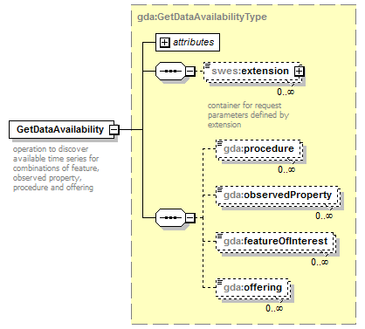

Figure 3: Overview diagram of the GetDataAvailability request

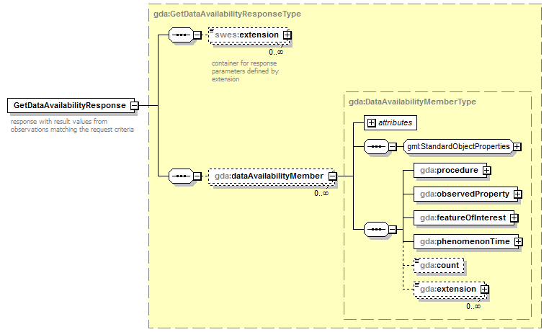

Figure 4: Overview diagram of the GetDataAvailability response

## GetObservation

The GetObservation operation is the way for data retrieval from SOS servers. It allows several types of entity based filters as well as temporal filters to limit the response.

### Response structure if no values are in the time range

Currently compliant SOS implementations do respond with different messages when no observations are present for a given request. While some services still return the metadata (like sampling feature and procedure etc.) of the time series, other services deliver either an error message or a completely empty GetObservation response. For a client however it is crucial to know that the time series exists and just does not contain data for the requested time range. Therefore it is important for the service to return the time series metadata anyway and only respond with an error message if an explicitly requested time series does not exist (e.g. a combination of feature of interest, observed property and procedure has no result).

|  |
| --- |
| **Requirement 13** |
| The GetObservation request shall return metadata of all matching timeseries in form of the OM_Observation element even if they do not contain any values for the requested time range. |

### Handling of incomplete responses

An incomplete response for example is, if the client sends the request for one procedure, one observed property and three features. Technically this would lead to a response comprising three time series. But it is relatively common that maybe only two time series exist which leaves the service with the two options to either return everything that was found or to return an error message. Since the SOS standard also allows loose requests (like observed property and procedure only) it makes the most sense to generally deliver everything that matched the criteria.

|  |
| --- |
| **Requirement 14** |
| The GetObservation request shall return all existing time series that match the request parameters. |

### Handling of requests without temporal filter

Since the GetObservation request does not define a temporal filter as mandatory, a request without this filter technically is supposed to return all data for all time series that match the query parameters. For time series with many values (e.g. 100,000 is quite common) this typically leads to the problem of overloading both the server and the communications channel. In extreme cases it might even kill the server or be falsely recognized as a denial-of-service attack. While client applications typically use well-defined requests, direct users tend to start with a simple call without limiting the time range just to ‘see what you get’.

To protect their servers and also the clients, several service providers have already changed the response behavior to return the last value of a time series if no temporal filter is specified. This not only protects the server from unintended large requests but also adds a new feature to the SOS interface. The latest value of a time series often is of special interest for a user and otherwise would have to be requested based on the data coverage of a time series which is not even available with the basic set of requests. It is obvious that this behavior is a double advantage and the full data content of a time series still can be retrieved by specifying a suitable temporal filter.

|  |
| --- |
| **Requirement 15** |
| If a GetObservation request does not contain a temporal filter the service shall only return the latest value of each time series instead of the full content. |

### Handling of empty responses

Depending on the requested entities it is possible that no time series are found to match the criteria. There are two ways to handle such a case: the service can either respond with an empty GetObservation response or return an error message stating that no results could be found. Since it is more consistent with the previous requirements and also allows easier handling in clients this is defined as an empty response.

|  |
| --- |
| **Requirement 16** |
| If the GetObservation request does not lead to any resulting time series an empty sos:GetObservationResponse document shall be returned. |

## Profile and SOS 1.0

Due to the specific requirements of the hydrology domain, which can be covered best through the enhancements offered by the SOS 2.0 standard, the SOS Hydrology Profile has only been defined for SOS 2.0.

# Technical Aspects

## Simple versus complex elements

For the basic entities the standards underlying the SOS 2.0 Hydrology Profile (in most places) allow for either using a simple element in the form of a one-line reference, e.g.

<featureOfInterest href=”http://myservice/features/WaterWell1” title=”WaterWell1”>

or to specifying a complex version that does not feature the ‘href’ and ‘title’ attributes but has more detailed information about the entity.

This means that the complex versions potentially have different information fields compared to the simple ones (if not resolved based on the reference) which can lead to problems in discovery and uniqueness.

## Bindings

### SOAP Binding

While SOS 1.0 does not define a SOAP binding at all, the SOS 2.0 standard provides a basic binding for each request. This binding is nothing more than a regular XML based POST request wrapped into a SOAP envelope. It allows usage of generic SOAP features that require SOAP headers to be existent (e.g. authentication services) but does not provide any help with building a client since the necessary complete WSDL file is missing.

With the help of a WSDL file a user could easily just use a generic SOAP client to construct a simple SOS 2.0 client and access any services. Several discussions about this issue took place. Due to the openness of the SOS schemas it is nearly impossible to provide a full WSDL description of all characteristics and details of a specific SOS server so that the practical use of a WSDL file would be very limited. Therefore the decision was taken to not publish a WSDL file together with this profile.

### KVP Binding

Neither SOAP nor KVP bindings are actually mandatory in the SOS 2.0 standard. Therefore it is essential for a client to know that at least one of the two bindings is available.

|  |
| --- |
| **Requirement 17** |
| The KVP binding in the SOS 2.0 shall be supported by all SOS servers implementing this profile. |

## Response limits

An issue with both the SOS 1.0 and 2.0 standards is the relative ‘openness’ to extensive queries either by mistake or on purpose. For instance, a request with no time range and just one observed property and offering could easily return some hundred time series with millions of values.

Requirement 15 defines limits to the response as one value per time series if no temporal filter has been set. But it is still possible to explicitly request the full range of many time series by setting a wide temporal filter in GetObservation requests.

To prevent overloading SOS servers there are two ways limits can be imposed. The first one is to make more restricted filtering mandatory. This still might be insufficient if large requests are made on purpose. The second option is to allow any request, but simply limit the response size or content. The new SOS 2.0 standard actually specifies an error message indicating that a request would lead to a too large response. The standard does not say anything about what is considered “too much” and the message also does not contain any additional information.

Since it is already agreed that a security limitation via response restrictions is needed to protect the server (as well as the client), it was decided how a response size limit can be defined. Again there are two options: The simple solution is to limit the number of overall values that the service will return before it responds with an error message that also includes this limit (so that it can be parsed by a client for instance). At the OGC Hydrology DWG meeting in Reading it was criticized that this might make it hard to harvest data from a service because the client needs to be relatively intelligent to determine how to create suitable requests after such an error message.

Due to the complex request options of the SOS interface, it is obvious that the service itself cannot deliver a ‘follow-up’ request to indicate some kind of paging mechanism. Therefore it was suggested to think about a limitation on time spans instead of values that would simplify client logic for harvesting. This however introduces new problems: For instance it makes a big difference if the requested time series contain yearly or five minute data. Also there are often time series that are not equidistant. So a time dependent limitation like 500 years of data for the whole request may be very limiting for yearly time series (500 values) while it is already large for five minute data (52560000 values). At the same time it is not possible to distinguish between those cases. Additionally, if more than one time series is requested the client still has no indication which time series are more or less problematic (this is the same as with the count limitation of course).

Because of the collected discussion points it has been decided to go with a count limitation. For facilitating the handling of limits by the client the SOS needs to announce any limit values within the AccessConstraints section of the GetCapabilities document. Additionally, it is recommended that the limit for time series values should be larger than the largest time series in the underlying database.

|  |
| --- |
| **Requirement 18** |
| If a SOS server has a limit on how many time series values can be returned within one request, this limit shall be announced in the AccessConstraints section of the GetCapabilities document. It is recommended that this limit be higher than the value count of the largest time series in the underlying database if possible.  The following string shall be included in an AccessConstraints element for indicating the limit of the number of values that can be returned (replace X with an integer value representing the limit): “maxNumberOfReturnedValues=X” |

|  |
| --- |
| **Requirement 19** |
| If a SOS server has a limit on how many time series can be returned within one request, this limit shall be announced in the AccessConstraints section of the GetCapabilities document.  The following string shall be included in an AccessConstraints element for indicating the limit of the number of time series that can be returned (replace X with an integer value representing the limit): “maxNumberOfReturnedTimeSeries=X” |

# Outlook

This version of the SOS 2.0 Hydrology Profile relies on a standalone SOS for hydrological data. For additional discovery and search options it would be very helpful to have an additional OGC WFS with basic functionality as supported by the SOS standard (i.e. for managing related sampled features). This is not a new idea and especially large (and therefore unhandy) services would profit from a combined setup.

It is intended that each SOS instance still should be able to work as standalone server and therefore provide the GetFeatureOfInterest request and the GetDataAvailability extension, but the combination with an additional WFS would no doubt be very powerful and fully in the sense of the OGC service architecture.

Annex A: Implementation Examples (informative)

The SOS 2.0 Hydrology Profile has been implemented by the companies 52°North and KISTERS. These implementations were tested with data of the Global Runoff Data Centre (GRDC). This work has been achieved in the context of the European FP7 project GEOWOW. The following subsections provide an overview of these server and client implementations.

## Server Implementation

### KISTERS KiWIS SOS2

The KISTERS Web Interoperability Solution (KiWIS) Timeseries Server application provides several service types and formats at once for one or more mainly WISKI backed data sources. The core service is the native KISTERS QueryServices (KiQS) interface that features requests, filtering and many attributes for the WISKI system. The KiQS support several data formats depending on the request including WaterML 2.0 for time series data. Further supported services are the old SOS 1.0 as well as WFS, Web Map Service (WMS) and WaterOneFlow.

The SOS 2.0 has been completely implemented with the core commands, the GetFeatureOfInterest extension and the GetDataAvailability extension. The only supported time series data format is WaterML 2.0. The SOS 2.0 module will be available from version 1.4.0 and will be updated continuously according to the profile or other new developments (e.g. an official GetDataAvailability extension).

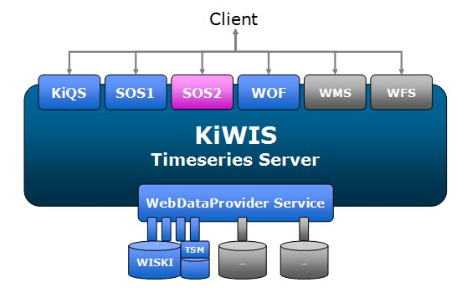

Figure 5: KISTERS KiWIS architecture schema

Like any other KiWIS service the SOS 2.0 can be used on top of any data source supported by KiWIS. Figure 5 shows the general architecture schema.

### 52°North SOS Server

Complementary to the use of KISTERS software components for making the GRDC data sets accessible, an instance of the Open Source 52°North SOS was set-up on top of the GRDC database. Within GEOWOW the new 4.0 release of the 52°North SOS implementation was developed which not only features full support of the SOS 2.0 Hydrology Profile but also advanced administration tools supporting the operators of SOS servers.

The design of the 52°North SOS is based on a 4-tier web architecture. The lowest layer encapsulates the access to databases. To enable the SOS operator to use different data sources, the data access for each operation is implemented using the Data Access Object (DAO) pattern as well as the Hibernate framework. This enables the SOS operator to easily adjust the 52°North SOS to already existing sensor databases. In this case, it adjustment to the existing GRDC Oracle database was performed. Similarly the business logic is encapsulated in a separate layer so that different SOS behaviors (e.g. the hydrology SOS profile) can be implemented without needing to change the rest of the service implementation. The decoding of incoming requests as well as the encoding of responses is covered by the presentation layer as shown in Figure 6.

Finally, the visualization of the provided sensor data can be considered as a fourth layer. However, this is not part of the SOS implementation itself but is instead covered by external web components such as the 52°North Sensor Web client.

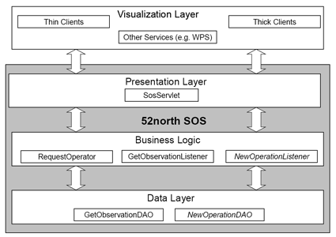

Figure 6: Architecture of the 52°North SOS

## Client Implementation

### KISTERS WISKI Client with The DataServiceConsumer

The KISTERS DataServiceConsumer (DSC) is a Java library that unites plug-ins for several service types under one common interface. The WISKI client utilizes this library to import basic data like stations as well as time series data from web services (Figure 7). With this component, WISKI will also be able to import data from hydrology profile conformal SOS 2.0 instances. A minimum amount of mapping configuration still is needed to import the data depending on the source service to fit some WISKI naming restrictions.

The DSC creates station and time series lists either for the full service or according to filters. Then these structures can be fully or selectively imported into the WISKI database. Once done, time series data can be downloaded from the service and imported into each previously created time series.

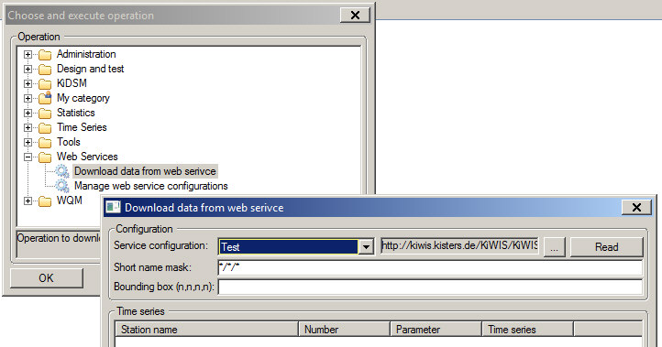

Figure 7: Importing data into WISKI from a web service

### KISTERS Timeseries Widget

The KISTERS Timeseries Widget (Figure 8) is a widget application for integration into web pages. It serves as a dynamic time series viewer on top of the DSC. Therefore time series from one or more services can be shown simultaneously. The widget is configured by the integrating web page before initialization with time series IDs, time range to show and lots of more optional features.

Technically the widget consists of a JavaScript component for the web page and a Java Servlet to retrieve data from services. The Java component also features a caching system to improve performance when accessing the same data multiple times. The actual graph images are created by a KISTERS internal graph library and dynamically used by the widget.

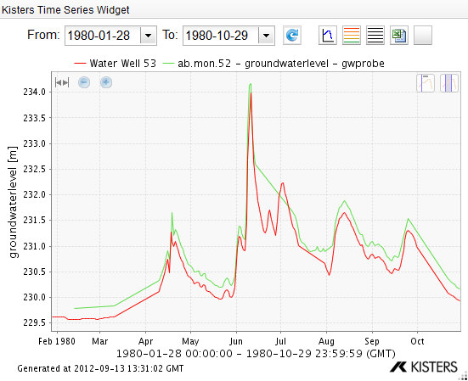

Figure 8: The KISTERS Timeseries Widget showing two time series

### 52°North Sensor Web Client API

When developing Sensor Web clients, there are common elements of business logic that are needed to interact with SOS servers. Furthermore, certain basic functionalities are required for extracting information about available sensors/procedures, offerings, observed properties, and time series from the metadata offered by a SOS server. To facilitate the work of client developers, 52°North has worked in the context of GEOWOW on an approach that encapsulates this common business logic and enables its re-use.

The result of these efforts is the 52°North Sensor Web Client API. This API offers a REST interface that can be used by any developer to create new client applications. The following list gives an overview of the core features of this API:

* Business logic for interacting with SOS servers
* Support of WaterML 2.0 as well as the SOS 2.0 Hydrology Profile
* Lightweight responses to support mobile devices
* Conversion of data types (e.g. returning CSV files)
* Comprehensive query and filtering options to determine available sensors, stations, observed properties, time series, etc.
* Optional server-side rendering of diagrams (time series charts)

The 52°North JavaScript SOS Client described in the next section relies on the benefits of the 52°North Sensor Web Client API.

### 52°North JavaScript SOS Client

The 52°North JavaScript Client is a very storage-efficient and handy client to visualize the metadata and measurements which are provided by the Sensor Web Client API. This client has been build only with the cornerstone web techniques HTML, CSS and JavaScript. The layout is based on a responsive design to support all kinds of devices and their different screen types/sizes (e.g. mobile phones, tablet computers, desktop browsers).

The map view as seen in Figure 9 provides functionality for the selection of stations and time series. A filtering mechanism regarding the observed phenomenon and data provider is available. Besides the selection of time series through this map view, there is also an option for navigating through a list of parameters to determine the time series which shall be loaded. After the selection of a time series, the series will be delegated to the chart view for the visualization.

Figure 10 shows the visualization of two time series. The legend provides metadata information (phenomenon, latest measured value, etc.) to the selected time series. There are also several interactive functionalities offered to the user for every time series. The user can hide or delete the time series, look it up on a map to know the location of the station which provides the time series, or change its styling. Highlighting of time series is possible by selecting an element in the legend or by clicking on the y-axis.

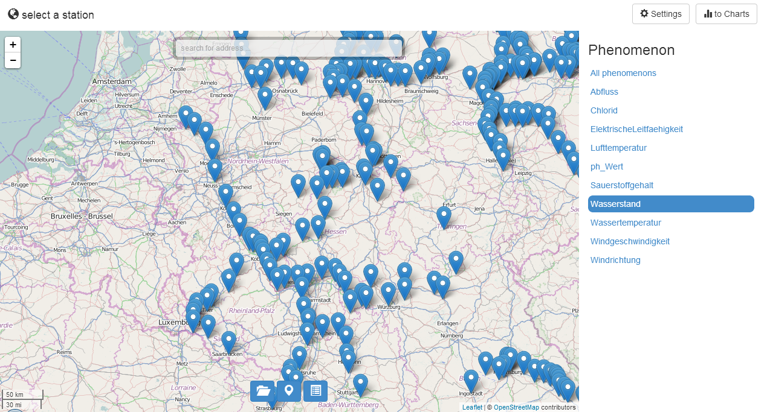

Figure 9: Map view to select a station

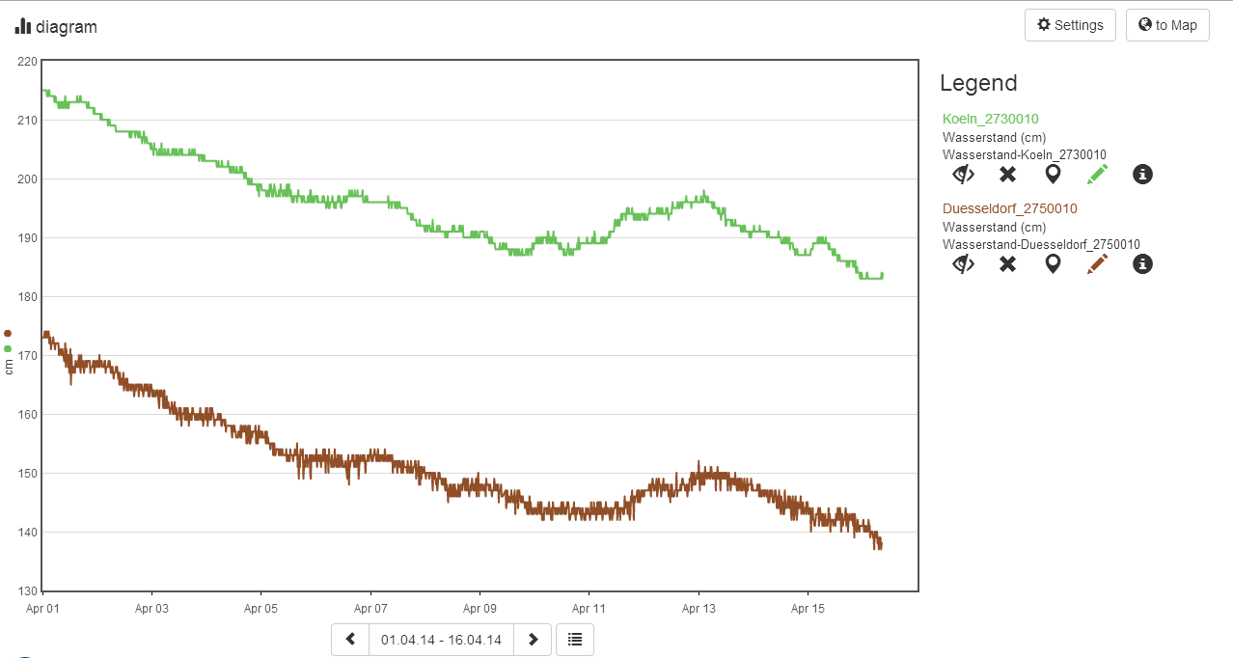

Figure 10: Chart view which visualize the selected time series

### 52°North Thin SOS Client

Complementary to the lightweight JavaScript Client, the 52°North Sensor Web Client will is used to visualize the time series data provided in the context of GEOWOW. This client is a web-based application which offers a comfortable graphical user interface for selecting time series and displaying according graphs.

During the development of the client special focus has been placed on hiding the complexity and technical details of the SWE specifications from the user. Thus, non-IT-experts become able to use the Sensor Web Client for answering their questions.

For ensuring a high degree of compatibility and to make the client platform-independent, it was developed as a web-based application relying on the Google Web Toolkit. This means that the program code of the client is written in Java while the Google Web Toolkit automatically translates it to different JavaScript styles that fit in the best possible way to the individual specifics of different browsers.

Figure 11 shows the menu for selecting a time series that shall be displayed. First, on the right hand side the user is able to select the parameter for which he/she would like to access a time series. Subsequently, on a map view all available stations providing data for this parameter are displayed. After selecting a station, the user is finally able to load the time series provided by the selected station.

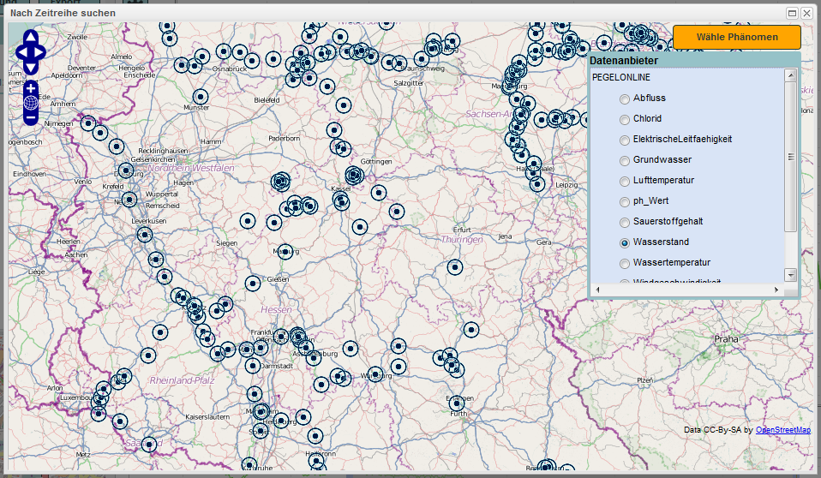

Figure 11: Menu for selecting a time series

In Figure 12 the time series view is shown. The user is able to display multiple time series (even with different parameters from different stations) within a diagram to discover correlations and compare values. In addition, a legend is provided offering information about the different time series. Finally, a map helps the user to locate the position of the stations that have measured the displayed time series.

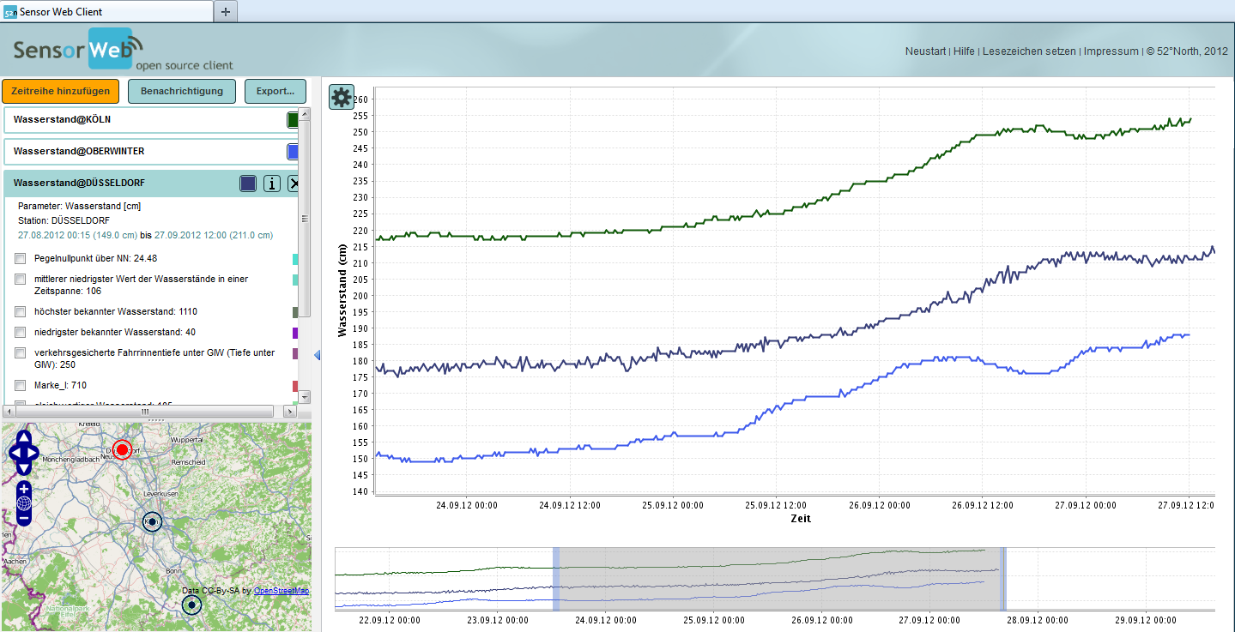

Figure 12: Time series visualization within the 52°North Sensor Web Client

Annex B: GetDataAvailability Schemas

<?xml version="1.0" encoding="UTF-8"?>

<schema xmlns="http://www.w3.org/2001/XMLSchema"

xmlns:gml="http://www.opengis.net/gml/3.2"

xmlns:gda="http://www.opengis.net/sosgda/1.0"

xmlns:swes="http://www.opengis.net/swes/2.0"

targetNamespace="http://www.opengis.net/sosgda/1.0"

elementFormDefault="qualified"

attributeFormDefault="unqualified"

version="2.0.1">

<import namespace="http://www.opengis.net/gml/3.2"

schemaLocation="http://schemas.opengis.net/gml/3.2.1

/gml.xsd"/>

<import namespace="http://www.opengis.net/swes/2.0"

schemaLocation="http://schemas.opengis.net/swes/2.0

/swes.xsd"/>

<element name="GetDataAvailability"

type="gda:GetDataAvailabilityType"

substitutionGroup="swes:ExtensibleRequest">

<annotation>

<documentation>

operation to discover available time series for

combinations of feature, observed property, procedure and

offering

</documentation>

</annotation>

</element>

<complexType name="GetDataAvailabilityType">

<complexContent>

<extension base="swes:ExtensibleRequestType">

<sequence>

<element name="procedure"

type="anyURI"

minOccurs="0"

maxOccurs="unbounded">

<annotation>

<documentation>

pointer to a procedure for which time series

shall be discovered

</documentation>

</annotation>

</element>

<element name="observedProperty"

type="anyURI"

minOccurs="0"

maxOccurs="unbounded">

<annotation>

<documentation>

pointer to an observed property for which time

series shall be discovered

</documentation>

</annotation>

</element>

<element name="featureOfInterest"

type="anyURI"

minOccurs="0"

maxOccurs="unbounded">

<annotation>

<documentation>

pointer to a feature of interest for which time

series shall be discovered

</documentation>

</annotation>

</element>

<element name="offering"

type="anyURI"

minOccurs="0"

maxOccurs="unbounded">

<annotation>

<documentation>

pointer to an offering for which time series

shall be discovered

</documentation>

</annotation>

</element>

</sequence>

</extension>

</complexContent>

</complexType>

<complexType name="GetDataAvailabilityPropertyType">

<sequence minOccurs="0">

<element ref="gda:GetDataAvailability"/>

</sequence>

<attributeGroup ref="gml:AssociationAttributeGroup"/>

</complexType>

<element name="GetDataAvailabilityResponse"

type="gda:GetDataAvailabilityResponseType"

substitutionGroup="swes:ExtensibleResponse">

<annotation>

<documentation>

response with result values from observations matching the

request criteria

</documentation>

</annotation>

</element>

<element name="DataAvailabilityMember"

type="gda:DataAvailabilityMemberType"

substitutionGroup="gml:AbstractGML">

<annotation>

<documentation>

template which contains observation metadata that is used

to form complete observation together with result values

that are inserted later on

</documentation>

</annotation>

</element>

<complexType name="GetDataAvailabilityResponseType">

<complexContent>

<extension base="swes:ExtensibleResponseType">

<sequence>

<element name="dataAvailabilityMember"

type="gda:DataAvailabilityMemberType"

minOccurs="0"

maxOccurs="unbounded">

</element>

</sequence>

</extension>

</complexContent>

</complexType>

<complexType name="DataAvailabilityMemberType">

<annotation>

<documentation>

The DataAvailabilityMemberType represents an individual

time series comprising one procedure/observed

property/feature of interest combination

</documentation>

</annotation>

<complexContent>

<extension base="gml:AbstractGMLType">

<sequence>

<element name="procedure" type="gml:ReferenceType">

<annotation>

<documentation>

the procedure of the time series

</documentation>

</annotation>

</element>

<element name="observedProperty"

type="gml:ReferenceType">

<annotation>

<documentation>

the observed property of the time series

</documentation>

</annotation>

</element>

<element name="featureOfInterest"

type="gml:ReferenceType">

<annotation>

<documentation>

the feature of interest of the time series

</documentation>

</annotation>

</element>

<element name="phenomenonTime"

type="gda:TimeObjectPropertyType">

<annotation>

<documentation>

The time for which the time series contains

data. This element has been copied from the

Observation and Measurements schema in order to

avoid the need to import the whole Observations

and Measurements schema.

</documentation>

</annotation>

</element>

<element name="count"

type="nonNegativeInteger"

minOccurs="0"

maxOccurs="1">

<annotation>

<documentation>

the number of observations contained in the

time series

</documentation>

</annotation>

</element>

<element name="extension"

type="anyType"

minOccurs="0"

maxOccurs="unbounded">

<annotation>

<documentation>

place where other specifications/profiles may

insert additional information

</documentation>

</annotation>

</element>

</sequence>

</extension>

</complexContent>

</complexType>

<complexType name="GetDataAvailabilityResponsePropertyType">

<sequence minOccurs="0">

<element ref="gda:GetDataAvailabilityResponse"/>

</sequence>

<attributeGroup ref="gml:AssociationAttributeGroup"/>

</complexType>

<complexType name="TimeObjectPropertyType">

<annotation>

<documentation>

This property type is not provided directly by GML

</documentation>

</annotation>

<sequence minOccurs="0">

<element ref="gml:AbstractTimeObject"/>

</sequence>

<attributeGroup ref="gml:AssociationAttributeGroup"/>

</complexType>

</schema>

Annex C: XML Examples

**C.1 GetCapabilities Response**

<?xml version="1.0" encoding="UTF-8"?>

<sos:Capabilities xmlns:sos="http://www.opengis.net/sos/2.0"   
 xmlns:xsi="http://www.w3.org/2001/XMLSchema-instance"   
 xmlns:ows="http://www.opengis.net/ows/1.1"   
 xmlns:xlink="http://www.w3.org/1999/xlink"   
 xmlns:fes="http://www.opengis.net/fes/2.0"   
 xmlns:swes="http://www.opengis.net/swes/2.0"   
 xmlns:gml="http://www.opengis.net/gml/3.2"   
 version="2.0.0"   
 xsi:schemaLocation="http://www.opengis.net/fes/2.0   
 http://schemas.opengis.net/filter/2.0/filterAll.xsd   
 http://www.opengis.net/swes/2.0   
 http://schemas.opengis.net/swes/2.0/swes.xsd   
 http://www.opengis.net/sos/2.0   
 http://schemas.opengis.net/sos/2.0/  
 sosGetCapabilities.xsd   
 http://www.opengis.net/gml/3.2   
 http://schemas.opengis.net/gml/3.2.1/gml.xsd   
 http://www.opengis.net/ows/1.1   
 http://schemas.opengis.net/ows/1.1.0/owsAll.xsd">

<ows:ServiceIdentification>

<ows:Title>Hydrology SOS</ows:Title>

<ows:Abstract>Hydrology SOS</ows:Abstract>

<ows:Keywords>

<ows:Keyword>DISCHARGE</ows:Keyword>

</ows:Keywords>

<ows:ServiceType>OGC:SOS</ows:ServiceType>

<ows:ServiceTypeVersion>2.0.0</ows:ServiceTypeVersion>

<ows:Profile>  
 http://www.opengis.net/spec/OMXML/2.0/conf/categoryObservation  
 </ows:Profile>

<ows:Profile>

http://www.opengis.net/spec/OMXML/2.0/conf/countObservation  
 </ows:Profile>

<ows:Profile>  
 http://www.opengis.net/spec/OMXML/2.0/conf/geometryObservation  
 </ows:Profile>

<ows:Profile>  
 http://www.opengis.net/spec/OMXML/2.0/conf/measurement  
 </ows:Profile>

<ows:Profile>  
 http://www.opengis.net/spec/OMXML/2.0/conf/samplingCurve  
 </ows:Profile>

<ows:Profile>  
 http://www.opengis.net/spec/OMXML/2.0/conf/samplingPoint  
 </ows:Profile>

<ows:Profile>  
 http://www.opengis.net/spec/OMXML/2.0/conf/samplingSurface  
 </ows:Profile>

<ows:Profile>  
 http://www.opengis.net/spec/OMXML/2.0/conf/spatialSampling  
 </ows:Profile>

<ows:Profile>  
 http://www.opengis.net/spec/OMXML/2.0/conf/textObservation  
 </ows:Profile>

<ows:Profile>  
 http://www.opengis.net/spec/OMXML/2.0/conf/truthObservation  
 </ows:Profile>

<ows:Profile>  
 http://www.opengis.net/spec/SOS/2.0/conf/core  
 </ows:Profile>

<ows:Profile>  
 http://www.opengis.net/spec/SOS/2.0/conf/daRetrieval  
 </ows:Profile>

<ows:Profile>  
 http://www.opengis.net/spec/SOS/2.0/conf/foiRetrieval  
 </ows:Profile>

<ows:Profile>  
 http://www.opengis.net/spec/SOS/2.0/conf/kvp-core  
 </ows:Profile>

<ows:Profile>  
 http://www.opengis.net/spec/SOS/2.0/conf/soap  
 </ows:Profile>

<ows:Profile>  
 http://www.opengis.net/spec/SOS_application-  
 profile_hydrology/1.0/req/hydrosos  
 </ows:Profile>

<ows:Profile>  
 http://www.opengis.net/spec/SWE/2.0/conf/core  
 </ows:Profile>

<ows:Profile>  
 http://www.opengis.net/spec/SWE/2.0/conf/general-encoding-  
 rules  
 </ows:Profile>

<ows:Profile>  
 http://www.opengis.net/spec/SWE/2.0/conf/text-encoding-rules  
 </ows:Profile>

<ows:Profile>  
 http://www.opengis.net/spec/SWE/2.0/conf/uml-block-components  
 </ows:Profile>

<ows:Profile>  
 http://www.opengis.net/spec/SWE/2.0/conf/uml-record-components  
 </ows:Profile>

<ows:Profile>  
 http://www.opengis.net/spec/SWE/2.0/conf/uml-simple-components  
 </ows:Profile>

<ows:Profile>  
 http://www.opengis.net/spec/SWE/2.0/conf/uml-simple-encodings  
 </ows:Profile>

<ows:Profile>  
 http://www.opengis.net/spec/SWE/2.0/conf/xsd-block-components  
 </ows:Profile>

<ows:Profile>  
 http://www.opengis.net/spec/SWE/2.0/conf/xsd-record-components  
 </ows:Profile>

<ows:Profile>  
 http://www.opengis.net/spec/SWE/2.0/conf/xsd-simple-components  
 </ows:Profile>

<ows:Profile>  
 http://www.opengis.net/spec/SWE/2.0/conf/xsd-simple-encodings  
 </ows:Profile>

<ows:Profile>  
 http://www.opengis.net/spec/waterml/2.0/conf/uml-measurement-  
 timeseries-tvp-observation  
 </ows:Profile>

<ows:Profile>  
 http://www.opengis.net/spec/waterml/2.0/conf/uml-timeseries-  
 tvp-observation  
 </ows:Profile>

<ows:Profile>  
 http://www.opengis.net/spec/waterml/2.0/conf/xsd-measurement-  
 timeseries-tvp  
 </ows:Profile>

<ows:Profile>  
 http://www.opengis.net/spec/waterml/2.0/conf/xsd-timeseries-  
 observation  
 </ows:Profile>

<ows:Profile>  
 http://www.opengis.net/spec/waterml/2.0/conf/xsd-timeseries-  
 tvp-observation  
 </ows:Profile>

<ows:Profile>  
 http://www.opengis.net/spec/waterml/2.0/conf/xsd-xml-rules  
 </ows:Profile>

<ows:Fees>NONE</ows:Fees>

<ows:AccessConstraints>NONE</ows:AccessConstraints>

</ows:ServiceIdentification>

<ows:ServiceProvider>

<ows:ProviderName>Data Provider XY</ows:ProviderName>

<ows:ProviderSite xlink:href="http://www.dataproviderxy.de/"/>

<ows:ServiceContact>

<ows:IndividualName>Mr. X</ows:IndividualName>

<ows:PositionName>Data Manager</ows:PositionName>

<ows:ContactInfo>

<ows:Phone>

<ows:Voice>+49 (0)000 0000 0000</ows:Voice>

</ows:Phone>

<ows:Address>

<ows:DeliveryPoint>Street Name 1</ows:DeliveryPoint>

<ows:City>City</ows:City>

<ows:AdministrativeArea>  
 Federal State  
 </ows:AdministrativeArea>

<ows:PostalCode>00000</ows:PostalCode>

<ows:Country>Germany</ows:Country>

<ows:ElectronicMailAddress>  
 x@dataproviderxy.de/  
 </ows:ElectronicMailAddress>

</ows:Address>

</ows:ContactInfo>

</ows:ServiceContact>

</ows:ServiceProvider>

<ows:OperationsMetadata>

<ows:Operation name="DescribeSensor">

<ows:DCP>

<ows:HTTP>

<ows:Get xlink:href="http://geowow.dev.52north.org:8080/  
 52n-sos-grdc-webapp/sos/kvp?">

<ows:Constraint name="Content-Type">

<ows:AllowedValues>

<ows:Value>application/x-kvp</ows:Value>

</ows:AllowedValues>

</ows:Constraint>

</ows:Get>

<ows:Post xlink:href="http://geowow.dev.52north.org:  
 8080/52n-sos-grdc-webapp/sos/soap">

<ows:Constraint name="Content-Type">

<ows:AllowedValues>

<ows:Value>application/soap+xml</ows:Value>

</ows:AllowedValues>

</ows:Constraint>

</ows:Post>

</ows:HTTP>

</ows:DCP>

<ows:Parameter name="procedure">

<ows:AllowedValues>

<ows:Value>  
 http://www.bafg.de/grdc/procedure/  
 CalculatedMonthlyMean  
 </ows:Value>

<!--... further procedures...-->

</ows:AllowedValues>

</ows:Parameter>

<ows:Parameter name="procedureDescriptionFormat">

<ows:AllowedValues>

<ows:Value>  
 http://www.opengis.net/waterml/2.0/observationProcess  
 </ows:Value>

</ows:AllowedValues>

</ows:Parameter>

</ows:Operation>

<ows:Operation name="GetCapabilities">

<ows:DCP>

<ows:HTTP>

<ows:Get xlink:href="http://geowow.dev.52north.org:8080/  
 52n-sos-grdc-webapp/sos/kvp?">

<ows:Constraint name="Content-Type">

<ows:AllowedValues>

<ows:Value>application/x-kvp</ows:Value>

</ows:AllowedValues>

</ows:Constraint>

</ows:Get>

<ows:Post xlink:href="http://geowow.dev.52north.org:  
 8080/52n-sos-grdc-webapp/sos/soap">

<ows:Constraint name="Content-Type">

<ows:AllowedValues>

<ows:Value>application/soap+xml</ows:Value>

</ows:AllowedValues>

</ows:Constraint>

</ows:Post>

</ows:HTTP>

</ows:DCP>

<ows:Parameter name="AcceptFormats">

<ows:AllowedValues>

<ows:Value>application/xml</ows:Value>

</ows:AllowedValues>

</ows:Parameter>

<ows:Parameter name="AcceptVersions">

<ows:AllowedValues>

<ows:Value>2.0.0</ows:Value>

</ows:AllowedValues>

</ows:Parameter>

<ows:Parameter name="Sections">

<ows:AllowedValues>

<ows:Value>All</ows:Value>

<ows:Value>Contents</ows:Value>

<ows:Value>FilterCapabilities</ows:Value>

<ows:Value>OperationsMetadata</ows:Value>

<ows:Value>ServiceIdentification</ows:Value>

<ows:Value>ServiceProvider</ows:Value>

</ows:AllowedValues>

</ows:Parameter>

<ows:Parameter name="updateSequence">

<ows:AnyValue/>

</ows:Parameter>

</ows:Operation>

<ows:Operation name="GetDataAvailability">

<ows:DCP>

<ows:HTTP>

<ows:Get xlink:href="http://geowow.dev.52north.org:8080/  
 52n-sos-grdc-webapp/sos/kvp?">

<ows:Constraint name="Content-Type">

<ows:AllowedValues>

<ows:Value>application/x-kvp</ows:Value>

</ows:AllowedValues>

</ows:Constraint>

</ows:Get>

<ows:Post xlink:href="http://geowow.dev.52north.org:  
 8080/52n-sos-grdc-webapp/sos/soap">

<ows:Constraint name="Content-Type">

<ows:AllowedValues>

<ows:Value>application/soap+xml</ows:Value>

</ows:AllowedValues>

</ows:Constraint>

</ows:Post>

</ows:HTTP>

</ows:DCP>

<ows:Parameter name="featureOfInterest">

<ows:AllowedValues>

<ows:Value/>

</ows:AllowedValues>

</ows:Parameter>

<ows:Parameter name="observedProperty">

<ows:AllowedValues>

<ows:Value>  
 http://sweet.jpl.nasa.gov/2.0/hydroSurface.owl  
 #Discharge  
 </ows:Value>

</ows:AllowedValues>

</ows:Parameter>

<ows:Parameter name="procedure">

<ows:AllowedValues>

<ows:Value>  
 http://www.bafg.de/grdc/procedure/  
 CalculatedMonthlyMean  
 </ows:Value>

<!--... further procedures...-->

</ows:AllowedValues>

</ows:Parameter>

</ows:Operation>

<ows:Operation name="GetFeatureOfInterest">

<ows:DCP>

<ows:HTTP>

<ows:Get xlink:href="http://geowow.dev.52north.org:8080/  
 52n-sos-grdc-webapp/sos/kvp?">

<ows:Constraint name="Content-Type">

<ows:AllowedValues>

<ows:Value>application/x-kvp</ows:Value>

</ows:AllowedValues>

</ows:Constraint>

</ows:Get>

<ows:Post xlink:href="http://geowow.dev.52north.org:  
 8080/52n-sos-grdc-webapp/sos/soap">

<ows:Constraint name="Content-Type">

<ows:AllowedValues>

<ows:Value>application/soap+xml</ows:Value>

</ows:AllowedValues>

</ows:Constraint>

</ows:Post>

</ows:HTTP>

</ows:DCP>

<ows:Parameter name="featureOfInterest">

<ows:AllowedValues>

<ows:Value/>

</ows:AllowedValues>

</ows:Parameter>

<ows:Parameter name="observedProperty">

<ows:AllowedValues>

<ows:Value>  
 http://sweet.jpl.nasa.gov/2.0/hydroSurface.owl  
 #Discharge  
 </ows:Value>

</ows:AllowedValues>

</ows:Parameter>

<ows:Parameter name="procedure">

<ows:AllowedValues>

<ows:Value>  
 http://www.bafg.de/grdc/procedure/  
 CalculatedMonthlyMean  
 </ows:Value>

<!--... further procedures...-->

</ows:AllowedValues>

</ows:Parameter>

<ows:Parameter name="spatialFilter">

<ows:AllowedValues>

<ows:Range>

<ows:MinimumValue>  
 -38.1397 -163.6774  
 </ows:MinimumValue>

<ows:MaximumValue>  
 70.070335 153.394  
 </ows:MaximumValue>

</ows:Range>

</ows:AllowedValues>

</ows:Parameter>

</ows:Operation>

<ows:Operation name="GetObservation">

<ows:DCP>

<ows:HTTP>

<ows:Get xlink:href="http://geowow.dev.52north.org:8080/  
 52n-sos-grdc-webapp/sos/kvp?">

<ows:Constraint name="Content-Type">

<ows:AllowedValues>

<ows:Value>application/x-kvp</ows:Value>

</ows:AllowedValues>

</ows:Constraint>

</ows:Get>

<ows:Post xlink:href="http://geowow.dev.52north.org:  
 8080/52n-sos-grdc-webapp/sos/soap">

<ows:Constraint name="Content-Type">

<ows:AllowedValues>

<ows:Value>application/soap+xml</ows:Value>

</ows:AllowedValues>

</ows:Constraint>

</ows:Post>

</ows:HTTP>

</ows:DCP>

<ows:Parameter name="featureOfInterest">

<ows:AllowedValues>

<ows:Value/>

</ows:AllowedValues>

</ows:Parameter>

<ows:Parameter name="observedProperty">

<ows:AllowedValues>

<ows:Value>  
 http://sweet.jpl.nasa.gov/2.0/hydroSurface.owl  
 #Discharge  
 </ows:Value>

</ows:AllowedValues>

</ows:Parameter>

<ows:Parameter name="offering">

<ows:AllowedValues>

<ows:Value>http://www.bafg.de/grdc/offering/  
 CalculatedMonthlyMean  
 </ows:Value>

<!--... further procedures...-->

</ows:AllowedValues>

</ows:Parameter>

<ows:Parameter name="procedure">

<ows:AllowedValues>

<ows:Value>  
 http://www.bafg.de/grdc/procedure/  
 CalculatedMonthlyMean  
 </ows:Value>

<!--... further procedures...-->

</ows:AllowedValues>

</ows:Parameter>

<ows:Parameter name="responseFormat">

<ows:AllowedValues>

<ows:Value>http://www.opengis.net/om/2.0</ows:Value>

<ows:Value>  
 http://www.opengis.net/waterml-dr/2.0  
 </ows:Value>

<ows:Value>  
 http://www.opengis.net/waterml/2.0  
 </ows:Value>

</ows:AllowedValues>

</ows:Parameter>

<ows:Parameter name="spatialFilter">

<ows:AllowedValues>

<ows:Range>

<ows:MinimumValue>  
 -38.1397 -163.6774  
 </ows:MinimumValue>

<ows:MaximumValue>  
 70.070335 153.394  
 </ows:MaximumValue>

</ows:Range>

</ows:AllowedValues>

</ows:Parameter>

<ows:Parameter name="temporalFilter">

<ows:NoValues/>

</ows:Parameter>

</ows:Operation>

<ows:Parameter name="service">

<ows:AllowedValues>

<ows:Value>SOS</ows:Value>

</ows:AllowedValues>

</ows:Parameter>

<ows:Parameter name="version">

<ows:AllowedValues>

<ows:Value>2.0.0</ows:Value>

</ows:AllowedValues>

</ows:Parameter>

</ows:OperationsMetadata>

<sos:filterCapabilities>

<fes:Filter_Capabilities>

<fes:Conformance>

<fes:Constraint name="ImplementsQuery">

<ows:NoValues/>

<ows:DefaultValue>false</ows:DefaultValue>

</fes:Constraint>

<fes:Constraint name="ImplementsAdHocQuery">

<ows:NoValues/>

<ows:DefaultValue>false</ows:DefaultValue>

</fes:Constraint>

<fes:Constraint name="ImplementsFunctions">

<ows:NoValues/>

<ows:DefaultValue>false</ows:DefaultValue>

</fes:Constraint>

<fes:Constraint name="ImplementsResourceld">

<ows:NoValues/>

<ows:DefaultValue>false</ows:DefaultValue>

</fes:Constraint>

<fes:Constraint name="ImplementsMinStandardFilter">

<ows:NoValues/>

<ows:DefaultValue>false</ows:DefaultValue>

</fes:Constraint>

<fes:Constraint name="ImplementsStandardFilter">

<ows:NoValues/>

<ows:DefaultValue>false</ows:DefaultValue>

</fes:Constraint>

<fes:Constraint name="ImplementsMinSpatialFilter">

<ows:NoValues/>

<ows:DefaultValue>true</ows:DefaultValue>

</fes:Constraint>

<fes:Constraint name="ImplementsSpatialFilter">

<ows:NoValues/>

<ows:DefaultValue>true</ows:DefaultValue>

</fes:Constraint>

<fes:Constraint name="ImplementsMinTemporalFilter">

<ows:NoValues/>

<ows:DefaultValue>true</ows:DefaultValue>

</fes:Constraint>

<fes:Constraint name="ImplementsTemporalFilter">

<ows:NoValues/>

<ows:DefaultValue>true</ows:DefaultValue>

</fes:Constraint>

<fes:Constraint name="ImplementsVersionNav">

<ows:NoValues/>

<ows:DefaultValue>false</ows:DefaultValue>

</fes:Constraint>

<fes:Constraint name="ImplementsSorting">

<ows:NoValues/>

<ows:DefaultValue>false</ows:DefaultValue>

</fes:Constraint>

<fes:Constraint name="ImplementsExtendedOperators">

<ows:NoValues/>

<ows:DefaultValue>false</ows:DefaultValue>

</fes:Constraint>

<fes:Constraint name="ImplementsMinimumXPath">

<ows:NoValues/>

<ows:DefaultValue>false</ows:DefaultValue>

</fes:Constraint>

<fes:Constraint name="ImplementsSchemaElementFunc">

<ows:NoValues/>

<ows:DefaultValue>false</ows:DefaultValue>

</fes:Constraint>

</fes:Conformance>

<fes:Spatial_Capabilities>

<fes:GeometryOperands>

<fes:GeometryOperand xmlns:ns="http://www.opengis.net/  
 gml/3.2"   
 name="ns:Envelope"/>

</fes:GeometryOperands>

<fes:SpatialOperators>

<fes:SpatialOperator name="BBOX">

<fes:GeometryOperands>

<fes:GeometryOperand xmlns:ns="http://www.opengis.  
 net/gml/3.2"   
 name="ns:Envelope"/>

</fes:GeometryOperands>

</fes:SpatialOperator>

</fes:SpatialOperators>

</fes:Spatial_Capabilities>

<fes:Temporal_Capabilities>

<fes:TemporalOperands>

<fes:TemporalOperand xmlns:ns="http://www.opengis.net/  
 gml/3.2"   
 name="ns:TimeInstant"/>

<fes:TemporalOperand xmlns:ns="http://www.opengis.net/  
 gml/3.2"   
 name="ns:TimePeriod"/>

</fes:TemporalOperands>

<fes:TemporalOperators>

<fes:TemporalOperator name="Before">

<fes:TemporalOperands>

<fes:TemporalOperand xmlns:ns="http://www.opengis.  
 net/gml/3.2"   
 name="ns:TimeInstant"/>

<fes:TemporalOperand xmlns:ns="http://www.opengis.  
 net/gml/3.2"   
 name="ns:TimePeriod"/>

</fes:TemporalOperands>

</fes:TemporalOperator>

<fes:TemporalOperator name="After">

<fes:TemporalOperands>

<fes:TemporalOperand xmlns:ns="http://www.opengis.  
 net/gml/3.2"   
 name="ns:TimeInstant"/>

<fes:TemporalOperand xmlns:ns="http://www.opengis.  
 net/gml/3.2"   
 name="ns:TimePeriod"/>

</fes:TemporalOperands>

</fes:TemporalOperator>

<fes:TemporalOperator name="Begins">

<fes:TemporalOperands>

<fes:TemporalOperand xmlns:ns="http://www.opengis.  
 net/gml/3.2"   
 name="ns:TimeInstant"/>

<fes:TemporalOperand xmlns:ns="http://www.opengis.  
 net/gml/3.2"   
 name="ns:TimePeriod"/>

</fes:TemporalOperands>

</fes:TemporalOperator>

<fes:TemporalOperator name="Ends">

<fes:TemporalOperands>

<fes:TemporalOperand xmlns:ns="http://www.opengis.  
 net/gml/3.2"   
 name="ns:TimeInstant"/>

<fes:TemporalOperand xmlns:ns="http://www.opengis.  
 net/gml/3.2"   
 name="ns:TimePeriod"/>

</fes:TemporalOperands>

</fes:TemporalOperator>

<fes:TemporalOperator name="EndedBy">

<fes:TemporalOperands>

<fes:TemporalOperand xmlns:ns="http://www.opengis.  
 net/gml/3.2"   
 name="ns:TimeInstant"/>

<fes:TemporalOperand xmlns:ns="http://www.opengis.  
 net/gml/3.2"   
 name="ns:TimePeriod"/>

</fes:TemporalOperands>

</fes:TemporalOperator>

<fes:TemporalOperator name="BegunBy">

<fes:TemporalOperands>

<fes:TemporalOperand xmlns:ns="http://www.opengis.  
 net/gml/3.2"   
 name="ns:TimeInstant"/>

<fes:TemporalOperand xmlns:ns="http://www.opengis.  
 net/gml/3.2"

name="ns:TimePeriod"/>

</fes:TemporalOperands>

</fes:TemporalOperator>

<fes:TemporalOperator name="During">

<fes:TemporalOperands>

<fes:TemporalOperand xmlns:ns="http://www.opengis.  
 net/gml/3.2"   
 name="ns:TimeInstant"/>

<fes:TemporalOperand xmlns:ns="http://www.opengis.  
 net/gml/3.2"   
 name="ns:TimePeriod"/>

</fes:TemporalOperands>

</fes:TemporalOperator>

<fes:TemporalOperator name="TEquals">

<fes:TemporalOperands>

<fes:TemporalOperand xmlns:ns="http://www.opengis.  
 net/gml/3.2"   
 name="ns:TimeInstant"/>

<fes:TemporalOperand xmlns:ns="http://www.opengis.  
 net/gml/3.2"   
 name="ns:TimePeriod"/>

</fes:TemporalOperands>

</fes:TemporalOperator>

<fes:TemporalOperator name="TContains">

<fes:TemporalOperands>

<fes:TemporalOperand xmlns:ns="http://www.opengis.  
 net/gml/3.2"   
 name="ns:TimeInstant"/>

<fes:TemporalOperand xmlns:ns="http://www.opengis.  
 net/gml/3.2"   
 name="ns:TimePeriod"/>

</fes:TemporalOperands>

</fes:TemporalOperator>

<fes:TemporalOperator name="TOverlaps">

<fes:TemporalOperands>

<fes:TemporalOperand xmlns:ns="http://www.opengis.  
 net/gml/3.2"   
 name="ns:TimeInstant"/>

<fes:TemporalOperand xmlns:ns="http://www.opengis.  
 net/gml/3.2"   
 name="ns:TimePeriod"/>

</fes:TemporalOperands>

</fes:TemporalOperator>

<fes:TemporalOperator name="Meets">

<fes:TemporalOperands>

<fes:TemporalOperand xmlns:ns="http://www.opengis.  
 net/gml/3.2"   
 name="ns:TimeInstant"/>

<fes:TemporalOperand xmlns:ns="http://www.opengis.  
 net/gml/3.2"   
 name="ns:TimePeriod"/>

</fes:TemporalOperands>

</fes:TemporalOperator>

<fes:TemporalOperator name="MetBy">

<fes:TemporalOperands>

<fes:TemporalOperand xmlns:ns="http://www.opengis.  
 net/gml/3.2"   
 name="ns:TimeInstant"/>

<fes:TemporalOperand xmlns:ns="http://www.opengis.  
 net/gml/3.2"   
 name="ns:TimePeriod"/>

</fes:TemporalOperands>

</fes:TemporalOperator>

<fes:TemporalOperator name="OverlappedBy">

<fes:TemporalOperands>

<fes:TemporalOperand xmlns:ns="http://www.opengis.  
 net/gml/3.2"   
 name="ns:TimeInstant"/>

<fes:TemporalOperand xmlns:ns="http://www.opengis.  
 net/gml/3.2"   
 name="ns:TimePeriod"/>

</fes:TemporalOperands>

</fes:TemporalOperator>

</fes:TemporalOperators>

</fes:Temporal_Capabilities>

</fes:Filter_Capabilities>

</sos:filterCapabilities>

<sos:contents>

<sos:Contents>

<swes:offering>

<sos:ObservationOffering xmlns:ns="http://www.opengis.net/  
 sos/2.0">

<swes:identifier>  
 http://www.bafg.de/grdc/offering/  
 CalculatedMonthlyMean  
 </swes:identifier>

<swes:name>  
 Calculated monthly mean discharge from daily values  
 </swes:name>

<swes:procedure>  
 http://www.bafg.de/grdc/procedure/  
 CalculatedMonthlyMean  
 </swes:procedure>

<swes:procedureDescriptionFormat>  
 http://www.opengis.net/sensorML/1.0.1  
 </swes:procedureDescriptionFormat>

<swes:procedureDescriptionFormat>  
 http://www.opengis.net/waterml/2.0/observationProcess  
 </swes:procedureDescriptionFormat>

<swes:observableProperty>  
 http://sweet.jpl.nasa.gov/2.0/hydroSurface.owl  
 #Discharge  
 </swes:observableProperty>

<sos:observedArea>

<gml:Envelope srsName="http://www.opengis.net/def/  
 crs/EPSG/0/4979">

<gml:lowerCorner>  
 -38.1397 -163.6774  
 </gml:lowerCorner>

<gml:upperCorner>  
 70.070335 153.394  
 </gml:upperCorner>

</gml:Envelope>

</sos:observedArea>

<sos:phenomenonTime>

<gml:TimePeriod gml:id="phenomenonTime_1">

<gml:beginPosition>  
 1814-01-01T00:00:00.000Z  
 </gml:beginPosition>

<gml:endPosition>  
 2002-12-31T00:00:00.000Z  
 </gml:endPosition>

</gml:TimePeriod>

</sos:phenomenonTime>

<sos:resultTime>

<gml:TimePeriod gml:id="resultTime_1">

<gml:beginPosition>  
 1814-01-01T00:00:00.000Z  
 </gml:beginPosition>

<gml:endPosition>  
 2002-12-31T00:00:00.000Z  
 </gml:endPosition>

</gml:TimePeriod>

</sos:resultTime>

<sos:responseFormat>  
 http://www.opengis.net/om/2.0  
 </sos:responseFormat>

<sos:responseFormat>  
 http://www.opengis.net/waterml-dr/2.0  
 </sos:responseFormat>

<sos:responseFormat>  
 http://www.opengis.net/waterml/2.0  
 </sos:responseFormat>

<sos:observationType>  
 http://www.opengis.net/def/observationType/  
 OGC-OM/2.0/OM_Measurement  
 </sos:observationType>

</sos:ObservationOffering>

</swes:offering>

<!--...further swes:offering elements...-->

</sos:Contents>

</sos:contents>

</sos:Capabilities>

**C.2 DescribeSensor Response**

<?xml version="1.0" encoding="UTF-8"?>

<soap:Envelope xmlns:soap="http://www.w3.org/2003/05/soap-envelope"   
 xmlns:xsi="http://www.w3.org/2001/XMLSchema-instance"   
 xmlns:swes="http://www.opengis.net/swes/2.0"   
 xmlns:wml2="http://www.opengis.net/waterml/2.0"   
 xmlns:gml="http://www.opengis.net/gml/3.2"   
 xmlns:xlink="http://www.w3.org/1999/xlink"   
 xmlns:om="http://www.opengis.net/om/2.0"   
 xsi:schemaLocation="  
 http://www.opengis.net/waterml-dr/2.0   
 http://schemas.opengis.net/waterml/2.0/  
 domain-range-informative/timeseries-domain-range.xsd

http://www.opengis.net/om/2.0

http://schemas.opengis.net/om/2.0/observation.xsd

http://www.opengis.net/waterml/2.0   
 http://schemas.opengis.net/waterml/2.0/waterml2.xsd   
 http://www.opengis.net/swes/2.0  
 http://schemas.opengis.net/swes/2.0/  
 swesDescribeSensor.xsd   
 http://www.opengis.net/gmlcov/1.0   
 http://schemas.opengis.net/gmlcov/1.0/gmlcovAll.xsd   
 http://www.opengis.net/gml/3.2   
 http://schemas.opengis.net/gml/3.2.1/gml.xsd   
 http://www.w3.org/2003/05/soap-envelope   
 http://www.w3.org/2003/05/soap-envelope">

<soap:Body>

<swes:DescribeSensorResponse>

<swes:procedureDescriptionFormat>  
 http://www.opengis.net/waterml/2.0/observationProcess  
 </swes:procedureDescriptionFormat>

<swes:description>

<swes:SensorDescription>

<swes:data>

<wml2:ObservationProcess gml:id="process.1B37EE2F08B9  
 A7C221863661ADEF48D074924B  
 F8">

<gml:identifier codeSpace="http://www.opengis.net/  
 def/nil/OGC/0/unknown">  
 http://www.bafg.de/grdc/procedure/  
 OriginalMonthlyMean  
 </gml:identifier>

<wml2:processType xlink:href="http://www.opengis.  
 net/def/waterml/2.0/processType/  
 Algorithm"/>

<wml2:input xlink:href="urn:ogc:def:phenomenon:  
 OGC:1.0.0:Discharge"   
 xlink:title="providerDischargeValue"/>

<wml2:parameter>

<om:NamedValue>

<om:name xlink:href="urn:ogc:def:identifier:  
 OGC:uniqueID"   
 xlink:title="uniqueID"/>

<om:value xmlns:xs="http://www.w3.org/2001/  
 XMLSchema"   
 xsi:type="xs:string">http://www.  
 bafg.de/grdc/procedure/  
 OriginalMonthlyMean</om:value>

</om:NamedValue>

</wml2:parameter>

<wml2:parameter>

<om:NamedValue>

<om:name xlink:href="output"/>

<om:value xmlns:xs="http://www.w3.org/  
 2001/XMLSchema"   
 xsi:type="xs:string">  
 urn:ogc:def:phenomenon:OGC:1.0.0:  
 Discharge  
 </om:value>

</om:NamedValue>

</wml2:parameter>

</wml2:ObservationProcess>

</swes:data>

</swes:SensorDescription>

</swes:description>

</swes:DescribeSensorResponse>

</soap:Body>

</soap:Envelope>

**C.3 GetDataAvailability Request**

<?xml version="1.0" encoding="UTF-8"?>

<soap:Envelope xmlns:soap="http://www.w3.org/2003/05/soap-envelope"   
 xmlns:wsa="http://www.w3.org/2005/08/addressing"   
 xmlns:xsi="http://www.w3.org/2001/XMLSchema-instance"   
 xsi:schemaLocation="http://www.w3.org/2003/05/soap-  
 envelope  
 http://www.w3.org/2003/05/soap-envelope/soap-  
 envelope.xsd  
 http://www.w3.org/2005/08/addressing   
 http://www.w3.org/2005/08/addressing/ws-addr.xsd">

<soap:Header>

<wsa:To>http://www.ogc.org/SOS</wsa:To>

<wsa:Action>  
 http://www.opengis.net/def/serviceOperation/sos/daRetrieval/  
 2.0/GetDataAvailability  
 </wsa:Action>

<wsa:ReplyTo>

<wsa:Address>  
 http://www.w3.org/2005/08/addressing/anonymous  
 </wsa:Address>

</wsa:ReplyTo>

<wsa:MessageID>0</wsa:MessageID>

</soap:Header>

<soap:Body>

<gda:GetDataAvailability service="SOS"  
 version="2.0.0"   
 xmlns:gda="http://www.opengis.net/  
 sosgda/1.0"   
 xsi:schemaLocation="http://www.opengis.  
 net/sosgda/1.0  
 http://waterml2.org/schemas/gda/1.0/  
 gda.xsd">

<gda:procedure>  
 http://www.bafg.de/grdc/procedure/YearlyMeanDaily  
 </gda:procedure>

<gda:observedProperty>  
 http://sweet.jpl.nasa.gov/2.0/hydroSurface.owl#Discharge  
 </gda:observedProperty>

<gda:featureOfInterest>  
 http://www.bafg.de/grdc/feature/1160500  
 </gda:featureOfInterest>

</gda:GetDataAvailability>

</soap:Body>

</soap:Envelope>

**C.4 GetDataAvailability Response**

<?xml version="1.0" encoding="UTF-8"?>

<soap:Envelope xmlns:soap="http://www.w3.org/2003/05/soap-envelope"   
 xmlns:xsi="http://www.w3.org/2001/XMLSchema-instance"   
 xsi:schemaLocation="http://www.opengis.net/sosgda/1.0   
 http://waterml2.org/schemas/gda/1.0/gda.xsd   
 http://www.opengis.net/gml/3.2   
 http://schemas.opengis.net/gml/3.2.1/gml.xsd   
 http://www.w3.org/2003/05/soap-envelope   
 http://www.w3.org/2003/05/soap-envelope">

<soap:Body>

<gda:GetDataAvailabilityResponse xmlns:gda="http://www.opengis.  
 net/sosgda/1.0"   
 xmlns:gml="http://www.opengis.  
 net/gml/3.2"   
 xmlns:swe="http://www.opengis.  
 net/swe/2.0"   
 xmlns:xlink="http://www.w3.org/  
 1999/xlink">

<gda:dataAvailabilityMember gml:id="dam_1">

<gda:procedure xlink:href="http://www.bafg.de/grdc/  
 procedure/YearlyMeanDaily"   
 xlink:title="YearlyMeanDaily"/>

<gda:observedProperty xlink:href="http://sweet.jpl.nasa.  
 gov/2.0/hydroSurface.owl#Discharge"   
 xlink:title="Discharge"/>

<gda:featureOfInterest xlink:href="http://www.bafg.de/  
 grdc/feature/1160500"   
 xlink:title="DONKER HOEK   
 ALICEDALE "/>

<gda:phenomenonTime>

<gml:TimePeriod gml:id="tp_1">

<gml:beginPosition>1957</gml:beginPosition>

<gml:endPosition>2011</gml:endPosition>

</gml:TimePeriod>

</gda:phenomenonTime>

</gda:dataAvailabilityMember>

</gda:GetDataAvailabilityResponse>

</soap:Body>

</soap:Envelope>

Annex D: Revision History

|  |  |  |  |  |
| --- | --- | --- | --- | --- |
| **Date** | **Release** | **Author** | **Paragraph modified** | **Description** |
| 03/03/2014 | 0.3 | All authors listed as contributors | All | Initial version |
| 29/04/2014 | 0.4 | All authors listed as contributors | All | Addition of formal specification for the GetDataAvailability operation and resolving of open points |
| 15/04/2014 | 0.5 | All authors listed as contributors | All | Version for upload to the OGC Portal Pending Documents area |
| 09/10/2014 | 1.0 | Carl Reed, Michael Utech, Simon Jirka | All | Editorial changes and additional annex providing XML examples |

Annex E: Bibliography

[1] Portele, Clemens (2012). OGC Implementation Specification: Geography Markup Language (GML) - Extended Schemas and Encoding Rules (OGC 10-129r1). Wayland, MA, USA, Open Geospatial Consortium Inc.

[2] Cox, Simon (2007). OGC Implementation Specification: Observations and Measurements (O&M) - Part 1 - Observation Schema 1.0.0 (07-022r1). Wayland, MA, USA, Open Geospatial Consortium Inc.

[3] Cox, Simon (2007). OGC Implementation Specification: Observations and Measurements (O&M) - Part 2 - Sampling Features 1.0.0 (07-002r3). Wayland, MA, USA, Open Geospatial Consortium Inc.

[4] ISO TC 211 (2011). ISO 19156:2011 - Geographic information -- Observations and measurements - International Standard. Geneva, Switzerland, International Organization for Standardization.

[5] Cox, Simon (2011). OGC Implementation Specification: Observations and Measurements (O&M) - XML Implementation 2.0 (10-025r1). Wayland, MA, USA, Open Geospatial Consortium Inc.

[6] Botts, Mike and Alexandre Robin (2007). OGC Implementation Specification: Sensor Model Language (SensorML) 1.0.0 (07-000). Wayland, MA, USA, Open Geospatial Consortium Inc.

[7] Na, Arthur and Mark Priest (2007). OGC Implementation Specification: Sensor Observation Service (SOS) 1.0.0 (06-009r6). Wayland, MA, USA, Open Geospatial Consortium Inc.

[8] Bröring, Arne, Christoph Stasch and Johannes Echterhoff (2012). OGC Implementation Specification: Sensor Observation Service (SOS) 2.0 (12-006). Wayland, MA, USA, Open Geospatial Consortium Inc.

[9] Taylor, Peter (2012). OGC Implementation Specification: WaterML 2.0: Part 1 - Timeseries (0-126r3). Wayland, MA, USA, Open Geospatial Consortium Inc.

[10] Brodaric, Boyan and Booth, Nate (2011). OGC Interoperability Experiment Report: OGC Groundwater Interoperability Experiment – Final Report (10-194r3). Wayland, MA, USA, Open Geospatial Consortium Inc.

[11] Fitch, Peter (2011). OGC Interoperability Experiment Report: OGC Surfacewater Interoperability Experiment – Final Report (12-018). Wayland, MA, USA, Open Geospatial Consortium Inc.

1. <http://www.opengeospatial.org/projects/initiatives/gwie>
2. http://www.geowow.eu/
3. Taken from http://external.opengis.org/twiki_public/HydrologyDWG/WebHome
4. http://external.opengeospatial.org/twiki_public/HydrologyDWG/GroundwaterInteroperabilityExperiment
5. http://external.opengeospatial.org/twiki_public/HydrologyDWG/SurfacewaterInteroperabilityExperiment