**Open Geospatial Consortium**

Submission Date: 2014-11-13

Approval Date:   2015-08-10

Publication Date:   2016-06-09

External identifier of this OGC® document: <http://www.opengis.net/doc/IS/eompom/1.1>

URL for this OGC® document: <http://docs.opengeospatial.org/is/10-157r4/10-157r4.html>

Internal reference number of this OGC® document: 10-157r4

Version: 1.1

Category: OGC® Implementation Standard

Editors:   Jerome Gasperi, Frédéric Houbie, Andrew Woolf, Steven Smolders

OGC Earth Observation Metadata profile of Observations & Measurements

* **Copyright notice**

Copyright © 2016 Open Geospatial Consortium  
To obtain additional rights of use, visit <http://www.opengeospatial.org/legal/>.

**Warning**

This formatted version of this document is not an OGC standard. The normative OGC Member approved international standard is available at:   
 http://docs.opengeospatial.org/is/10-157r4/10-157r4.html

This document is available on a royalty free, non-discriminatory basis. Recipients of this document are invited to submit, with their comments, notification of any relevant patent rights of which they are aware and to provide supporting documentation.

Document type:    OGC® Standard

Document subtype:    Implementation

Document stage:    Approved as official OGC standard

Document language:  English

License Agreement

Permission is hereby granted by the Open Geospatial Consortium, ("Licensor"), free of charge and subject to the terms set forth below, to any person obtaining a copy of this Intellectual Property and any associated documentation, to deal in the Intellectual Property without restriction (except as set forth below), including without limitation the rights to implement, use, copy, modify, merge, publish, distribute, and/or sublicense copies of the Intellectual Property, and to permit persons to whom the Intellectual Property is furnished to do so, provided that all copyright notices on the intellectual property are retained intact and that each person to whom the Intellectual Property is furnished agrees to the terms of this Agreement.

If you modify the Intellectual Property, all copies of the modified Intellectual Property must include, in addition to the above copyright notice, a notice that the Intellectual Property includes modifications that have not been approved or adopted by LICENSOR.

THIS LICENSE IS A COPYRIGHT LICENSE ONLY, AND DOES NOT CONVEY ANY RIGHTS UNDER ANY PATENTS THAT MAY BE IN FORCE ANYWHERE IN THE WORLD.

THE INTELLECTUAL PROPERTY IS PROVIDED "AS IS", WITHOUT WARRANTY OF ANY KIND, EXPRESS OR IMPLIED, INCLUDING BUT NOT LIMITED TO THE WARRANTIES OF MERCHANTABILITY, FITNESS FOR A PARTICULAR PURPOSE, AND NONINFRINGEMENT OF THIRD PARTY RIGHTS. THE COPYRIGHT HOLDER OR HOLDERS INCLUDED IN THIS NOTICE DO NOT WARRANT THAT THE FUNCTIONS CONTAINED IN THE INTELLECTUAL PROPERTY WILL MEET YOUR REQUIREMENTS OR THAT THE OPERATION OF THE INTELLECTUAL PROPERTY WILL BE UNINTERRUPTED OR ERROR FREE. ANY USE OF THE INTELLECTUAL PROPERTY SHALL BE MADE ENTIRELY AT THE USER’S OWN RISK. IN NO EVENT SHALL THE COPYRIGHT HOLDER OR ANY CONTRIBUTOR OF INTELLECTUAL PROPERTY RIGHTS TO THE INTELLECTUAL PROPERTY BE LIABLE FOR ANY CLAIM, OR ANY DIRECT, SPECIAL, INDIRECT OR CONSEQUENTIAL DAMAGES, OR ANY DAMAGES WHATSOEVER RESULTING FROM ANY ALLEGED INFRINGEMENT OR ANY LOSS OF USE, DATA OR PROFITS, WHETHER IN AN ACTION OF CONTRACT, NEGLIGENCE OR UNDER ANY OTHER LEGAL THEORY, ARISING OUT OF OR IN CONNECTION WITH THE IMPLEMENTATION, USE, COMMERCIALIZATION OR PERFORMANCE OF THIS INTELLECTUAL PROPERTY.

This license is effective until terminated. You may terminate it at any time by destroying the Intellectual Property together with all copies in any form. The license will also terminate if you fail to comply with any term or condition of this Agreement. Except as provided in the following sentence, no such termination of this license shall require the termination of any third party end-user sublicense to the Intellectual Property which is in force as of the date of notice of such termination. In addition, should the Intellectual Property, or the operation of the Intellectual Property, infringe, or in LICENSOR’s sole opinion be likely to infringe, any patent, copyright, trademark or other right of a third party, you agree that LICENSOR, in its sole discretion, may terminate this license without any compensation or liability to you, your licensees or any other party. You agree upon termination of any kind to destroy or cause to be destroyed the Intellectual Property together with all copies in any form, whether held by you or by any third party.

Except as contained in this notice, the name of LICENSOR or of any other holder of a copyright in all or part of the Intellectual Property shall not be used in advertising or otherwise to promote the sale, use or other dealings in this Intellectual Property without prior written authorization of LICENSOR or such copyright holder. LICENSOR is and shall at all times be the sole entity that may authorize you or any third party to use certification marks, trademarks or other special designations to indicate compliance with any LICENSOR standards or specifications. This Agreement is governed by the laws of the Commonwealth of Massachusetts. The application to this Agreement of the United Nations Convention on Contracts for the International Sale of Goods is hereby expressly excluded. In the event any provision of this Agreement shall be deemed unenforceable, void or invalid, such provision shall be modified so as to make it valid and enforceable, and as so modified the entire Agreement shall remain in full force and effect. No decision, action or inaction by LICENSOR shall be construed to be a waiver of any rights or remedies available to it.

Contents

1. Scope 8

2. Conformance 8

3. References 9

4. Terms and Definitions 9

5. Conventions 10

5.1 Abbreviated terms 10

5.2 Namespace prefix conventions 11

6. Conceptual Model 12

6.1 General concepts 12

6.2 Observations & Measurements 13

6.3 Earth Observation metadata mapping on Observations and Measurements 15

6.3.1 Observed property 17

6.3.2 Result time 18

6.4 General recommendations 18

6.4.1 Language recommendation 18

6.4.2 Extensions 18

6.4.2.1 Thematic extended namespace 18

6.4.2.2 Mission specific extended namespace 19

6.4.3 Units of measure 19

6.4.4 GML restrictive use 20

7. Requirements for XML Instances 20

8. EO Products schemas 22

8.1 General EO product data schema 22

8.1.1 EarthObservationMetaData 25

8.1.1.1 Resource identifiers 31

8.1.2 EarthObservationEquipment 31

8.1.3 Footprint 36

8.1.4 EarthObservationResult 38

8.2 Thematic EO product data schema 42

8.2.1 Optical EO Product data schema 42

8.2.2 Radar EO Product data schema 44

8.2.3 Atmospheric EO Product data schema 47

8.2.4 Altimetry EO Product data schema 49

8.2.5 Limb Looking EO Product data schema 53

8.2.6 Synthesis and Systematic EO Product data schema 55

**Figures**

Figure 1 : A layered view of EO O&M Products metadata. 13

Figure 2 : The basic Observation type (from OGC10-004r3) 14

Figure 3: Relationship of EarthObservation and EarthObservationEquipment to O&M 17

Figure 4: Model-driven approach of ISO TC211 68

**Tables**

Table 1 : namespace mappings 12

Table 2: Observations and Measurements properties mapping within the Earth Observation context 16

Table 3: Requirements for XML instances 22

Table 4 : <eop:EarthObservation> fields description 24

Table 5 : <eop:EarthObservationMetaData> fields description 31

Table 6 : <eop:EarthObservationEquipment> fields description 36

Table 7 : <eop:Footprint> fields description 37

Table 8 : <eop:EarthObservationResult> fields description 42

Table 9 : <opt:EarthObservationResult> extension of <eop:EarthObservationResult> 44

Table 10 : <sar:Acquisition> extension of <eop:Acquisition> 46

Table 11 : <atm:EarthObservationResult> extension of <eop:EarthObservationResult> 49

Table 12 : <alt:EarthObservationEquipment> extension of <eop:EarthObservationEquipment> 51

Table 13 : <alt:Footprint> extension of <eop:Footprint> 52

Table 14 : <alt:ProcessingInformation> extension of <eop:ProcessingInformation> 52

Table 15 : <alt:Acquisition> extension of <eop:Acquisition> 53

Table 16 : <lmb:Footprint > extension of <lmb:Footprint> 55

Table 17 : <lmb:Sensor> extension of <eop:Sensor> 55

Table 18 : <lmb:Acquisition> extension of <eop:Acquisition> 55

Table 19 : <ssp:Footprint> extension of <eop:Footprint> 58

Table 20 : <ssp: EarthObservationEquipment> extension of <eop: EarthObservationEquipment> 58

Table 21 : <ssp:EarthObservationResult > extension of <eop:EarthObservationResult> 59

Table 22 : <ssp:EarthObservationMetaData> extension of <eop:EarthObservationMetaData> 59

Table 23: Conformance class 63

Table 24: GML vs. O&M observation properties (optional properties in italics) 67

Abstract

This OGC Implementation Standard defines a profile of Observations and Measurements (ISO 19156:2010 and OGC 10-025r1) for describing Earth Observation products (EO products).

This profile is intended to provide a standard schema for encoding Earth Observation product metadata to support the description and cataloguing of products from sensors aboard EO satellites.

The metadata being defined in this document is applicable in a number of places where EO product metadata is needed.

1. In the EO Product Extension Package for ebRIM (OGC 10-189). This extension package defines how to catalog Earth Observation product metadata described by this document. Using this metadata model and the Catalogue Service defined in OGC 10-189, client applications can provide the functionality to discover EO Products. Providing an efficient encoding for EO Product metadata cataloguing and discovery is the prime purpose of this specification.
2. In the EO Application Profile of WMS (OGC 07-063r1). The GetFeatureInfo operation on the outline (footprint layer) should return metadata following the Earth Observation Metadata profile of Observation and Measurements.
3. In a coverage downloaded via an EO WCS AP (OGC 10-140). In WCS 2.0 (OGC 10-084), the GetCoverage and DescribeCoverage response contains the *metadata* element intended to store metadata information about the coverage. The Earth Observation Application profile of WCS (OGC 10-140) specifies that the metadata format preferred for Earth Observation is defined by this document.
4. Potentially enclosed within an actual product to describe georeferencing information as for instance within the JPEG2000 format using GMLJP2. GMLJP2 defines how to store GML coverage metadata inside a JP2 file.

Earth Observation data products are generally managed within logical collections that are usually structured to contain data items derived from sensors onboard a satellite or series of satellites. The key characteristics differentiating products within the collections are date of acquisition, location as well as characteristics depending on the type of sensor, For example, key characteristics for optical imagery are the possible presence of cloud, haze, smokes or other atmospheric or on ground phenomena obscuring the image.

The common metadata used to distinguish EO products types are presented in this document for generic and thematic EO products (i.e optical, radar, atmospheric, altimetry, limb-looking and synthesis and systematic products). From these metadata the encodings are derived according to standard schemas. In addition, this document describes the mechanism used to extend these schemas to specific missions and for specific purposes such as long term data preservation.

Keywords

The following are keywords to be used by search engines and document catalogues.

ogcdoc, OGC document, Observations and Measurement, Earth Observation, metadata

Preface

This OGC Implementation Standard defines a profile of Observations and Measurements (ISO 19156:2010) for describing Earth Observation (EO) product metadata.

The document was initially produced during the ESA Heterogeneous Missions Accessibility [HMA] initiative and related projects. Although this standard has been developed in the context of these HMA projects, the content is generic to Earth Observation product description. The metadata model described in this document is structured to follow the different types of products (Optical, Radar, …) which are not HMA specific.

Suggested additions, changes, and comments on this standard are welcome and encouraged. Such suggestions may be submitted by email message to the editors.

Attention is drawn to the possibility that some of the elements of this document may be the subject of patent rights. The Open Geospatial Consortium shall not be held responsible for identifying any or all such patent rights.

*Recipients of this document are requested to submit, with their comments, notification of any relevant patent claims or other intellectual property rights of which they may be aware that might be infringed by any implementation of the standard set forth in this document, and to provide supporting documentation.*

Submitting organizations

The following organizations submitted this Document to the Open Geospatial Consortium (OGC):

* ESA - European Space Agency
* CNES - French Space Agency
* Luciad
* GIM – Geographic Information Management
* STFC - Science and Technology Facilities Council

Submitters

All questions regarding this submission should be directed to the editor or the submitters:

|  |  |
| --- | --- |
| 1. Name | 1. Affiliation |
| 1. Jerome Gasperi | 1. Centre National d’Études Spatiales (CNES) |
| 1. Frederic Houbie | 1. Luciad |
| 1. Andrew Woolf | 1. Science & Technology Facilities Council (STFC) |
| 1. Steven Smolders | 1. GIM |

Other contributors:

* Jolyon Martin, ESA
* Fabian Skivee
* Dominic Lowe, STFC
* Wim De Smet, GIM

# Scope

This document describes the encodings required to describe Earth Observation (EO) products metadata from general Earth Observation Product descriptions to mission specific characteristics. The document is a profile of the Observations and Measurements 2.0 standard.

# Conformance

EO Product metadata conforming to this profile of Observations and Measurements shall be encoded as XML documents that are fully compliant with the normative XML Schema Documents associated with this standard (i.e. *eop.xsd* for general EO Products, *opt.xsd*, *sar.xsd*, *atm.xsd*, *alt.xsd*, *lmb.xsd* and *ssp.xsd* for optical, radar, atmospheric, altimetry, limb looking and “synthesis and systematic” products respectively).

In addition to validation against the aforementioned XML schema, schematron validation (i.e *schematron_rules_for_eop.sch*) shall be used to verify the compliance of an XML instance.

Conformance with this standard shall be checked using all the relevant tests specified in Annex A (normative) of this document. The framework, concepts, and methodology for testing, and the criteria to be achieved to claim conformance are specified in the OGC Compliance Testing Policies and Procedures and the OGC Compliance Testing web site[1].

All requirements-classes and conformance-classes described in this document are owned by the standard(s) identified.

# References

The following normative documents contain provisions that, through reference in this text, constitute provisions of this document. For dated references, subsequent amendments to, or revisions of, any of these publications do not apply. For undated references, the latest edition of the normative document referred to applies.

[OGC 10-004r3] *OGC Abstract Specification Topic 20 -* Observations and Measurements, Version 2.0 (also published as ISO/DIS 19156:2010, Geographic information — Observations and Measurements)

[OGC 10-025r1] *Observations and Measurements – XML Implementation*, Version 2.0

[OGC 07-036] *Geography Markup Language,* Version 3.2.1 (also published as ISO 19136:2007, Geographic information — Geography Markup Language)

[OGC 06-080r4] *GML 3.1.1 Application schema for Earth Observation products*, Version 1.0.0

[OGC 09-046r2] *OGC Naming Authority (OGC-NA) Policies & Procedures*

[OGC 06-135r11] *Policy Directives for Writing and Publishing* *OGC Standards: TC Decisions.*

In addition to this document, this standard includes several normative XML Schema files. These schemas are posted online at <http://schemas.opengis.net/eompom/1.1/> . These XML Schema files may also be bundled with the zip version of this document (informative version). In the event of a discrepancy between the bundled and online versions of the XML Schema files, the online files shall be considered authoritative.

# Terms and Definitions

This document uses the terms defined in Sub-clause 5.3 of [OGC 06-121r8], which is based on the ISO/IEC Directives, Part 2, Rules for the structure and drafting of International Standards. In particular, the word “shall” (not “must”) is the verb form used to indicate a requirement to be strictly followed to conform to this standard.

For the purposes of this document, the following additional terms and definitions apply.

client

software component that can invoke an **operation** from a **server**

datastrip

A satellite acquisition

geographic information

information concerning phenomena implicitly or explicitly associated with a location relative to the Earth [ISO 19101]

identifier

a character string that may be composed of numbers and characters that is exchanged between the client and the server with respect to a specific identity of a resource

request

invocation of an **operation** by a **client**

response

result of an **operation,** returned from a **server** to a **client**

scene

The result of cutting a datastrip into multiple parts

EXAMPLE For the PHR mission, a scene is a 20x20 km^2 square part.

schema

formal description of a model [ISO 19101, ISO 19103, ISO 19109, ISO 19118]

# Conventions

## Abbreviated terms

The abbreviated terms used in this document include:

ALT ALTimetry

ATM ATMospheric

CF Climate and Forecast

EO Earth Observation

EOP Earth Observation Product

GML Geography Markup Language

HMA Heterogeneous Missions Accessibility

LMB LiMB looking

OGC Open Geospatial Consortium

OPT OPTical

O&M Observations and Measurements

PHR Pleiades High Resolution

SAR Synthetic Aperture Radar

SSP Synthesis and Systematic Product

XML eXtensible Markup Language

## Namespace prefix conventions

The namespace prefixes used in this document are **not** normative and are merely chosen for convenience; they may appear in examples without being formally declared, and have no semantic significance. The namespaces to which the prefixes correspond are normative, however.

|  |  |  |
| --- | --- | --- |
| Prefix | Namespace URI | Description |
| eop | http://www.opengis.net/eop/2.1 | General EO product schema namespace |
| opt | http://www.opengis.net/opt/2.1 | Optical High Resolution EO product schema namespace |
| sar | http://www.opengis.net/sar/2.1 | Radar EO product schema namespace |
| atm | http://www.opengis.net/atm/2.1 | Atmospheric EO product schema namespace |
| alt | http://www.opengis.net/alt/2.1 | Altimetry EO product schema namespace |
| lmb | http://www.opengis.net/lmb/2.1 | Limb looking EO product schema namespace |
| ssp | http://www.opengis.net/ssp/2.1 | Synthesis and Systematic EO product schema namespace |

Table 1 : namespace mappings

# Conceptual Model

This section focuses on the purpose and requirements for this standard. In particular, the document describes the model of the Earth Observation Metadata defined as a profile of Observations and Measurements.

## General concepts

The approach consists in modelling EO product metadata as a profile of Observations and Measurements – XML Implementation [OGC 10-025r1]. ISO definitions are specified for attributes where available, although not the full ISO schema is used for the structural definitions, which would lead to a less efficient overall structure.

The general mechanism is to create a schema with a dedicated namespace for each level of specificity from a general description which is common to each EO Product to a restricted description for specific mission EO Products. Each level of specificity is an extension of the previous one.

The general EO product schema is the main application schema for EO Product metadata. It is associated with the “eop” namespace.

Each Thematic EO product schema extends the “eop” schema.

* The Optical EO Product schema is used to describe optical products. It is associated with the “opt” namespace.
* The SAR EO Product schema is used to describe radar products. It is associated with the “sar” namespace.
* The Atmospheric EO Product schema is used to describe atmospheric products. It is associated with the “atm” namespace.
* The Altimetry EO Product schema is used to describe altimetry products. It is associated with the “alt” namespace.
* The Limb Looking EO Product schema is used to describe limb looking products. It is associated with the “lmb” namespace.
* The Synthesis and Systematic EO Product schema is used to describe “Synthesis and Systematic” products. It is associated with the “ssp” namespace.

The idea behind this layered levels approach is to create an efficient schema set that describes EO Product metadata concentrating on the core metadata characteristics that differentiate an EO product within a collection.

The adoption of this layered schema structure is intended to facilitate the realization of clients / viewers that understand the schema at various levels. For example, since this profile extends GML and O&M, our products can be displayed by a generic GML viewer, which will see EO Products as features with a footprint and “unknown” metadata, or by an EO Product specific viewer, which will understand the semantics of these metadata (cf. Figure 1)

O&M

OPT

EOP

Generic O&M

General EO Products

Thematic EO Products

Mission Specific EO Products

*Generic, widespread community*

*Specific, tight community*

Other Thematic EO Products description

…

Specific Mission EO Products description

SAR

ATM

ALT

LMB

SSP

...

Figure 1 : A layered view of EO O&M Products metadata.

More precisely, a generic GML viewer capable of handling O&M will only understand the “O&M” vocabulary of the O&M document; a “Generic EO Products viewer” will understand the “O&M” and “eop” vocabulary of the O&M document; an “Optical EO Products viewer” will understand the “O&M”, “eop” and “opt” vocabulary of the O&M document. Mission specific vocabulary will only be understood by a “Specific Mission Viewer”.

## Observations & Measurements

In natural language, the model states:

An ***observation*** is an event that estimates an ***observed property*** of some ***feature of interest*** using a specified ***procedure*** and generates a ***result***.

The quantity to be measured can be simple (a single temperature), or it may be a complex quantity such as a coverage. Remotely sensed images in the sense of their acquisition can be viewed as observations in which the result of the observation (value of the result property) is a remotely-sensed image product.



Figure 2 : The basic Observation type (from OGC10-004r3)

The major elements of the model are indicated in bold and modelled through associations in the UML model. In addition, an observation has the following attributes and associations.

* *parameter* (optional): for arbitrary event-specific parameters, e.g. instrument settings.
* *phenomenonTime* (mandatory): the time that the result applies to the feature of interest.
* *resultQuality* (optional): the quality of the result.
* *resultTime* (mandatory): the time when the result becomes available (e.g. if postprocessing or laboratory analysis is required, it might be different to the phenomenonTime).
* *validTime* (optional): the time period during which the result is intended to be used (e.g. if a meteorological forecast is modelled as an observation, then it is intended to be used during a specific period of time).
* *relatedObservation* (optional): related observations providing important context for understanding the result.
* *metadata* (optional): descriptive metadata.
* *featureOfInterest* (mandatory)*:* The association *Domain* shall link the OM_Observation to the GFI_Feature that is the subject of the observation and carries the observed property. This feature has the role *featureOfInterest* with respect to the observation.
* *observedProperty* (mandatory): The association *Phenomenon* shall link the OM_Observation to the GFI_PropertyType for which the OM_Observation:result provides an estimate of its value. The property type has the role *observedProperty* with respect to the observation.
* *result*: The association *Range* shall link the OM_Observation to the value generated by the procedure. The value has the role *result* with respect to the observation.
* *procedure*: The association *ProcessUsed* shall link the OM_Observation to the OM_Process (6.2.3) used to generate the result. The process has the role *procedure* with respect to the observation.

## Earth Observation metadata mapping on Observations and Measurements

To represent Earth Observation metadata, this profile extends the Observations and Measurements properties with EO specific information. Table 2 defines the awaited content of each Observations and Measurements property. Figure 3 shows the relationship of EarthObservation and EarthObservationEquipment to O&M.

|  |  |  |
| --- | --- | --- |
| **Observations and Measurements property** | **Awaited Content** | **Description** |
| metadata | eop:EarthObservationMetadata | General properties such as the data identifier, the downlink and archiving information. |
| phenomenonTime | gml:TimePeriod | The acquisition duration |
| procedure | eop:EarthObservationEquipment | The Platform/Instrument/Sensor used for the acquisition and the acquisition parameters (i.e. pointing angles, etc.) |
| featureOfInterest | eop:Footprint | The observed area (or its projection) on the ground i.e. the footprint of acquisition |
| result | Eop:EarthObservationResult | The metadata describing the Earth Observation result composed of the browse, mask and product descriptions |
| observedProperty | xlink reference to eop:EarthObservationResult/eop:parameter/  eop:ParameterInformation/eop:phenomenon/  swe:Phenomenon if provided or CF Standard Name code list entry | See section 6.3.1 |
| resultTime | gml:TimeInstant | See section 6.3.2 |

Table 2: Observations and Measurements properties mapping within the Earth Observation context



Figure 3: Relationship of EarthObservation and EarthObservationEquipment to O&M

### Observed property

The ‘observed property’ is mandatory for OM_Observation.

* The standard XML encoding of observedProperty is a gml:ReferenceType.
* It may be null with a nilReason if required, e.g. <om:observedProperty nilReason="inapplicable"/>.
* If there is a parameter property present within the EarthObservationResult then the observed property should point using xlink to the Phenomenon definition that is included as part of the eop:ParameterInformation.
* If there is no parameter property present and the observedProperty is not left null, then the observedProperty should be an xlink to the observedPropery definition. The code list that is mandated is the NETCDF CF Standard names. An example of an Observed Property from this code list is:

<om:observedProperty xlink:href=“[http://cf-pcmdi.llnl.gov/documents/cf-standard-names/standard-name-table/15/cf-standard-name-table.xml#sea_surface_height_above_sea_level”/>](http://cf-pcmdi.llnl.gov/documents/cf-standard-names/standard-name-table/15/cf-standard-name-table.xml#sea_surface_height_above_sea_level).

### Result time

The OM_Observation ‘resultTime’ is the time at which the result became available. In general, this may be different to the ‘phenomenonTime’, which is the geophysically relevant time at which the final product applies. The times may be different when additional processing is performed to retrieve geophysical parameters.

## General recommendations

When creating the Earth Observation Metadata profile, a set of principles was followed. It is recommended that a mission specific extension of this profile follows these same principles.

### Language recommendation

Natural language is used as far as possible for property names. For instance, complete names for properties are preferred to abbreviations.

### Extensions

As seen in §6.3, each Earth Observation product fits exactly the structure of an *OM_Observation* element.

Thus, in the inheritance mechanism for thematic or mission specific namespaces, it is needed to extend existing properties defined in the eop namespace or create new properties that fit inside the model.

#### Thematic extended namespace

Thematic extended namespace (opt for example) contains:

* opt "words";
* an *opt:EarthObservation* element that inherits from *eop:EarthObservation.* This inheritance is an XML schema extension (to avoid restriction problems) with no elements added (because all elements fit inside one of the Observation properties *metadata*, *procedure, phenomenonTime, result or featureOfInterest*);
* one or more extensions of existing eop properties (see example below).

For example, “opt” thematic EO Products metadata include the cloud cover percentage, named “cloudCoverPercentage”. This property is described within the *opt:EarthObservationResultType* element which extends and acts as a substitution for *eop:* *EarthObservationResultType*:

<opt:EarthObservation>

[…]

<om:result>

<opt:EarthObservationResult gml:id="eop_2"> >

[…]

<opt:cloudCoverPercentage uom="%" >30</opt:cloudCoverPercentage>

[…]

</opt: EarthObservationResult >

</om:result>

[…]

</opt: EarthObservation>

#### Mission specific extended namespace

A mission specific extended namespace contains the following.

* Mission-specific "words."
* A mission specific *EarthObservation*  element that inherits from for instance sar*:EarthObservation.* This inheritance is an XML schema extension (to avoid restriction problems) with no element added (because all elements fit inside one of the Observation property *metadata*, *procedure, phenomenonTime, result or featureOfInterest* ).
* One or more extensions of existing sar properties.

These principles are close to those described for the thematic extended namespace. However, the property extension approach leads to a drawback in the mission specific case.

Indeed, from a client point of view, an “eop” enabled reader must encounter well-known structures under “eop” properties. This is not a problem for the “eop” and thematics schemas since they are completely described in this document (i.e. structure can be “hard coded” in the client). For mission specific schema however, the specific schema is not in the scope of this document.

Thus, in order for a generic “eop” enabled reader to “understand” such mission specific metadata, it should be able to process complex schema inheritance mechanisms.

To avoid this drawback, we introduce an attribute "*eop:type*" at the eop level. This attribute is required for properties that extend one of eop or its thematic properties. This attribute is expected to contain the name of the property it extends directly. This mechanism is comparable to the ISO19139 *gco:isoType*.

### Units of measure

Each non-angle property concerned by a unit of measure is recommended to use the existing GML type <gml:MeasureType>.

Example : resolution

<xs:element name="resolution" type="gml:MeasureType">

<xs:annotation>

<xs:documentation> resolution</xs:documentation>

</xs:annotation>

</xs:element>

Each angle property is recommended to use the existing GML type <gml:AngleType>.

Example : Instrument Across Track incidence angle

<xs:element name="instrumentAcrossTrackIncidenceAngle " type="gml:AngleType" minOccurs="0">

<xs:annotation>

<xs:documentation>Instrument across track Incidence angle given in degrees.</xs:documentation>

</xs:annotation>

</xs:element>

### GML restrictive use

The use of GML types is restricted to those relevant to the EO Products metadata description, i.e.:

* gml:AngleType;
* gml:CodeListType;
* gml:MeasureType;
* gml:MeasureListType;
* gml:UnitOfMeasureType;
* gml:ReferenceType;
* gml:Point (expected structure : gml:Point/gml:pos);
* gml:MultiSurface (expected structure : gml:MultiSurface/gml:surfaceMembers/gml:Polygon/gml:exterior/gml:LinearRing/gml:posList);
* gml:TimePeriod; and
* gml:TimeInstant.

# Requirements for XML Instances

To allow exchange of metadata, the conceptual model described in the previous section must be encoded in XML.

As a profile of Observations and Measurements, this document provides XML schemas that extend Observations and Measurements for XML. To generate these schemas, we adopted the model-driven approach of ISO TC211. This approach is described in Annex D.

This section constitutes the core requirements class for all XML instances of the Earth Observation Metadata profile of Observations and Measurements.

XML representations of earth observation metadata requires the use of the element eop:EarthObservation or a member of its substitution group.

There is a dependency on the requirements classes for Observations and Measurements documents, defined in Clause 7.3 of [OGC 10-025r1].

|  |  |
| --- | --- |
| **<http://www.opengis.net/spec/EOMPOM/1.1/req/earthobservation>** | |
| Target type | Data instance |
| Dependency | [**http://www.opengis.net/spec/OMXML/2.0/req/observation**](http://www.opengis.net/spec/OMXML/2.0/req/observation) |
| Requirement | **http://www.opengis.net/spec/EOMPOM/1.1/req/earthobservation/observation-valid**  Any XML element in the substitution group of eop:EarthObservation shall be well-formed and validate against the schema. |
| Requirement | **http://www.opengis.net/spec/EOMPOM/1.1/req/earthobservation/metaDataProperty**  eop:metaDataProperty shall contain eop:EarthObservationMetaData or an extension: either an alt or ssp thematic extension corresponding to the product type or a mission-specific extension with appropriate attribute eop:type. |
| Requirement | **http://www.opengis.net/spec/EOMPOM/1.1/req/earthobservation/om_procedure**  om:procedure shall contain eop:EarthObservationEquipment or an extension: either an alt, atm, lmb or ssp thematic extension corresponding to the product type or a mission-specific extension with appropriate attribute eop:type. |
| Requirement | **http://www.opengis.net/spec/EOMPOM/1.1/req/earthobservation/acquisitionParameters**  eop:acquisitionParameters shall contain eop:Acquisition or an extension: either a sar, alt, atm or lmb thematic extension corresponding to the product type or a mission-specific extension with appropriate attribute eop:type. |
| Requirement | **http://www.opengis.net/spec/EOMPOM/1.1/req/earthobservation/om_result**  om:result shall contain eop:EarthObservationResult or an extension: either an atm, opt or ssp thematic extension corresponding to the product type or a mission-specific extension with appropriate attribute eop:type. |
| Requirement | **http://www.opengis.net/spec/EOMPOM/1.1/req/earthobservation/om_featureOfInterest**  om:featureOfInterest shall contain an eop:Footprint or an extension of eop:Footprint corresponding to the product type (alt, lmb, ssp). |
| Requirement | **http://www.opengis.net/spec/EOMPOM/1.1/req/earthobservation/om_phenomenonTime**  om:phenomenonTime shall contain a gml:TimePeriod/gml:beginPosition and a gml:TimePeriod/gml:endPosition. |
| Requirement | **http://www.opengis.net/spec/EOMPOM/1.1/req/earthobservation/multiExtentOf**  Footprint eop:multiExtentOf shall contain a gml:MultiSurface/gml:surfaceMembers/gml:Polygon/gml:exterior/gml:LinearRing/gml:posList. |
| Requirement | **http://www.opengis.net/spec/EOMPOM/1.1/req/earthobservation/centerOf**  Footprint eop:centerOf shall contain a gml:Point/gml:pos. |

Table 3: Requirements for XML instances

# EO Products schemas

## General EO product data schema

The “eop” schema provides the description of metadata common to all EO Products derived from satellite based remote sensing.

The root element of the “eop” schema, named <eop:EarthObservation> extends the <om:OM_Observation> type as follows :

<element name="EarthObservation" substitutionGroup="om:OM_Observation" type="eop:EarthObservationType"/>

<complexType name="EarthObservationType">

<complexContent>

<extension base="om:OM_ObservationType">

<sequence>

<element name="metaDataProperty" type="eop:EarthObservationMetaDataPropertyType"/>

<element name="version" type="string"/>

</sequence>

</extension>

</complexContent>

</complexType>

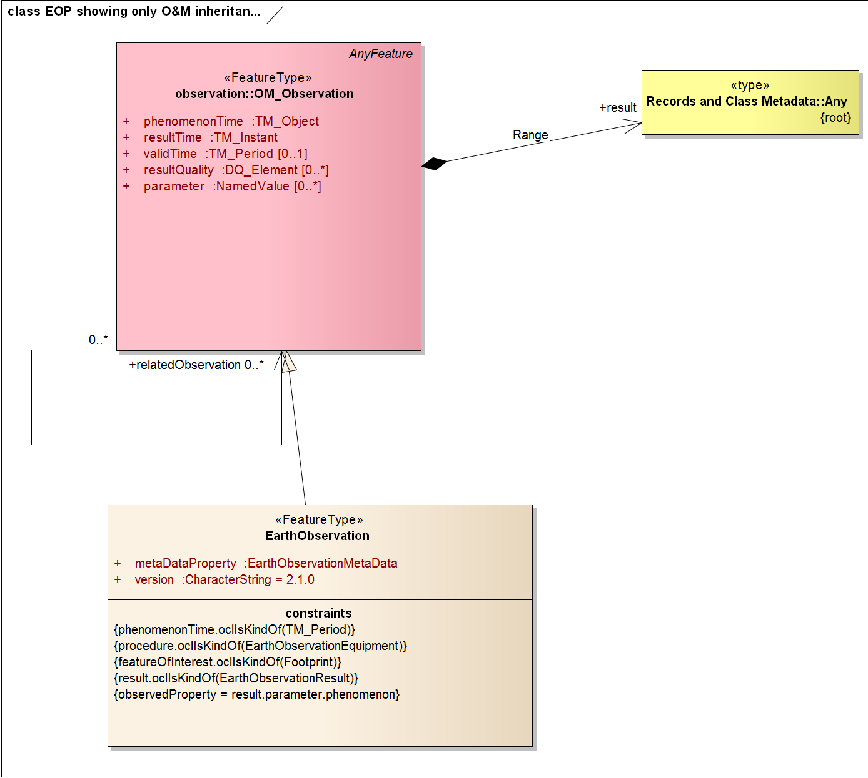

The “EarthObservation” element contains a mandatory “version” attribute that references the schema version number.

The “eop” metadata are referenced inside higher level structure (see Table 2):

* *eop:EarthObservationMetaData*;
* *eop:EarthObservationEquipment*;
* *eop:Footprint*; and
* *eop:EarthObservationResult*.

A complete description of an *EarthObservation* element is given in Table 4.

|  |  |  |
| --- | --- | --- |
| Field name | Field description | Cardinality |
| om:phenomenonTime/ gml:TimePeriod/ gml:beginPosition | Acquisition start date time dateTime in ISO 8601 format (CCYY-MM-DDThh:mm[:ss[.cc]]Z) | 1 |
| om:phenomenonTime/ gml:TimePeriod/ gml:endPosition | Acquisition end date time dateTime in ISO 8601 format (CCYY-MM-DDThh:mm[:ss[.cc]]Z) | 1 |
| om:resultTime/gml:TimeInstant/ gml:timePosition | The time when the result becomes available  dateTime in ISO 8601 format (CCYY-MM-DDThh:mm[:ss[.cc]]Z) | 1 |
| om:procedure/ eop:EarthObservationEquipment | Platform/Instrument/Sensor used for the acquisition and the acquisition parameters | 1 |
| om:observedProperty | An xlink to the observed property definition | 1..n |
| om:featureOfInterest / eop:Footprint | Observed area on the ground or its projection i.e. the footprint of acquisition | 0..1 |
| om:result/ eop:EarthObservationResult | Earth Observation result metadata composed of the browse, mask and product description | 0..1 |
| eop:metaDataProperty/eop:EarthObservationMetaData | Additional external metadata about the data acquisition | 1 |

Table 4 : <eop:EarthObservation> fields description

### EarthObservationMetaData

The *eop:EarthObservationMetaData* block contains all the metadata relative to an *eop:EarthObservation* that do not fit inside one of the other blocks, i.e. metadata that do not describe the time, the mechanism, the location or the result of the observation.

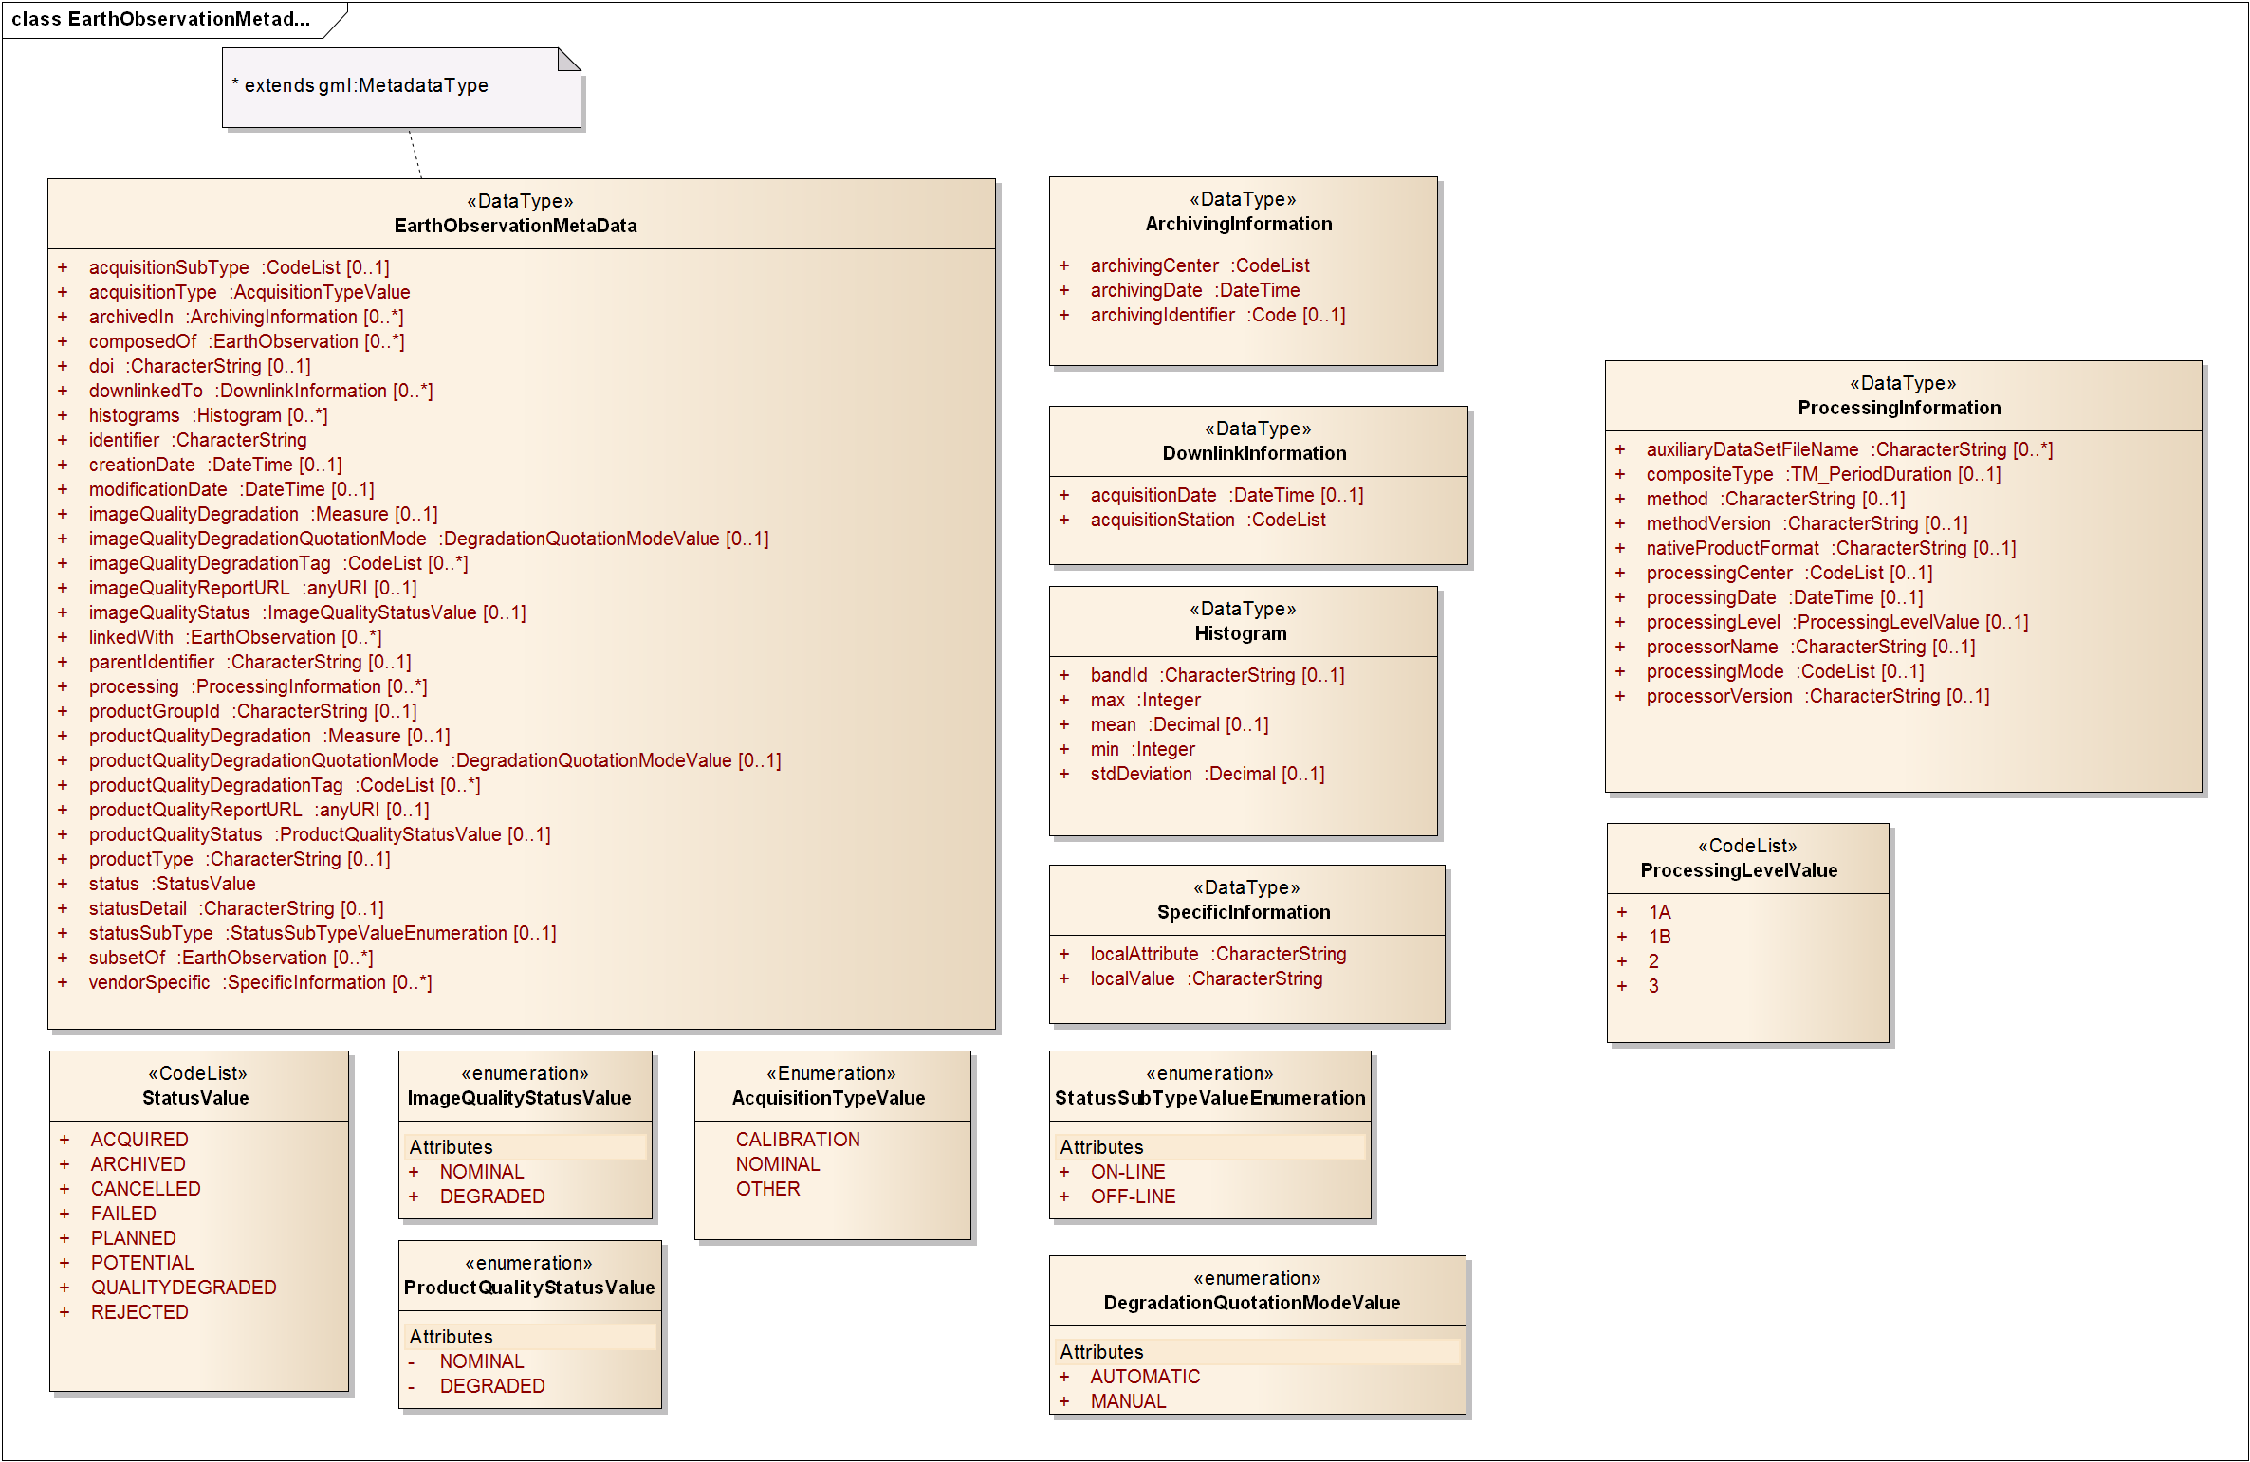



These metadata are mainly the *EarthObservation* identifier, the acquisition type and information relative to the downlink and archiving centers. The complete description of the *EarthObservationMetaData* is given in Table 5.

|  |  |  |
| --- | --- | --- |
| Field name | Field description | Cardinality |
| identifier | Identifier for metadata item | 1 |
| creationDate | creation date for the metadata item. When retrieved from a metadata catalogue, the creationDate is the date when the metadata item was ingested for the first time (i.e. inserted) in the catalogue. | 0..1 |
| modificationDate | Date of the last modification to the metadata item. When retrieved from a metadata catalogue, the modificationDate is the date when the metadata item was last modified (i.e. updated) in the catalogue. | 0..1 |
| doi | Digital Object Identifier identifying the product (see http://www.doi.org) | 0..1 |
| parentIdentifier | Collection Identifier | 0..1 |
| acquisitionType | Used to distinguish at a high level the appropriateness of the acquisition for "general" use, whether the product is a nominal acquisition, special calibration product or other.  Values:  - NOMINAL  - CALIBRATION  - OTHER | 1 |
| acquisitionSubType | The broad value defined by the acquisitionType is however too restrictive, so mission specific type definition should refer to mission/ground segment dedicated codeSpace | 0..1 |
| productType | Describes the product type in case that mixed types are available within a single collection, this is a ground segment specific definition | 0..1 |
| Status | Refers to product status.  Values :  - ARCHIVED  - ACQUIRED  - CANCELLED  - FAILED   - PLANNED  - POTENTIAL  - REJECTED  - QUALITYDEGRADED[2] | 1 |
| statusSubType | Refines the status of a product when the “status” is set to “ARCHIVED”.  Possible values:  - “ON-LINE”  - “OFF-LINE” | 0..1 |
| statusDetail | This field refers to the eop:status value. It should be used to motivate the reason of a failure, cancelation, rejection or degraded quality. | 0..1 |
| downlinkedTo/ DownlinkInformation/ acquisitionStation | Acquisition / receiving station code. Possible values are mission specific and should be retrieved using codespace. | 1  (with eop:downlinkedTo 0..n) |
| downlinkedTo/ DownlinkInformation/ acquisitionDate | Acquisition date time. | 0..1 |
| archivedIn/ ArchivingInformation/ archivingCenter | Archiving center code. Possible values are mission specific and should be retrieved using codeSpace. | 1  (with eop:ArchivingInformation 0..n) |
| archivedIn/ ArchivingInformation/ archivingDate | Archiving date time. | 1 |
| archivedIn/ ArchivingInformation/ archivingIdentifier | Local archiving id as created by the mission ground segment that may be required to allow subsequent order processing | 0..1 |
| imageQualityDegradation | Quality degradation percentage (i.e. uom=’%’)  This element is deprecated. Please use the equivalent productQualityDegradation element instead. | 0..1 |
| productQualityDegradation | Quality degradation percentage (i.e. uom=’%’) | 0..1 |
| imageQualityDegradationQuotationMode | Indicator to know how the quality degradation percentage has been calculated.  Values:  AUTOMATIC  MANUAL  This element is deprecated. Please use the equivalent productQualityDegradationQuotationMode element instead. | 0..1 |
| productQualityDegradationQuotationMode | Indicator to know how the quality degradation percentage has been calculated.  Values :  AUTOMATIC  MANUAL | 0..1 |
| imageQualityStatus | Indicator that specifies whether the product quality is degraded or not. This optional field shall be provided if the product has passed a quality check.  Values: DEGRADED,  NOMINAL  This element is deprecated. Please use the equivalent productQualityStatus element instead. | 0..1 |
| productQualityStatus | Indicator that specifies whether the product quality is degraded or not. This optional field shall be provided if the product has passed a quality check.  Values: DEGRADED,  NOMINAL | 0..1 |
| imageQualityDegradationTag | Contains further textual information concerning the quality degradation. It shall be provided if eop:imageQualityStatus value is DEGRADED. Possible values are mission specific and should refer to mission/ground segment dedicated codeSpace.  Example of values could be "RADIOMETRY" or "GEOLOCATION".  This element is deprecated. Please use the equivalent productQualityDegradationTag element instead. | 0..n |
| productQualityDegradationTag | Contains further textual information concerning the quality degradation. It shall be provided if eop:productQualityStatus value is DEGRADED. Possible values are mission specific and should refer to mission/ground segment dedicated codeSpace.  Example of values could be "RADIOMETRY" or "GEOLOCATION". | 0..n |
| imageQualityReportURL | URL reference to an external quality report file  This element is deprecated. Please use the equivalent productQualityReport element instead. | 0..1 |
| productQualityReportURL | URL reference to an external quality report file | 0..1 |
| histograms/ Histogram/ bandId | Histogram specific : identifier of the spectral band used to compute histogram values | 0.. 1  *(with eop:histograms 0..n)* |
| histograms/ Histogram/ min | Histogram specific : minimum value | 1 |
| histograms/ Histogram/ max | Histogram specific : maximum value | 1 |
| histograms/ Histogram/ mean | Histogram specific : mean value | 0..1 |
| histograms/ Histogram/ stdDeviation | Histogram specific : standard deviation value | 0..1 |
| composedOf | Link to an EO product that is part of this EO product (e.g. a phr:DataStrip is composed of one or more phr:Scene) | 0..n |
| subsetOf | Link to the “father” EO product (e.g. a phr:Scene is a subset of a phr:DataStrip) | 0..n |
| linkedWith | Specify a link to another EO product (e.g. ERS1 and ERS2 interferometric pair) | 0..n |
| processing/ ProcessingInformation/ processingCenter | Processing center code. Possible values are mission specific and should be retrieved using codeSpace. | 0..1  *(with eop:processing 0..n)* |
| processing/ ProcessingInformation/ processingDate | Processing date time | 0..1 |
| processing/ ProcessingInformation/ compositeType | Type of composite product expressed as timeperiod that the composite product covers (e.g. P10D for a 10 day composite) | 0..1 |
| processing/ ProcessingInformation/ method | Method used to compute datalayer. (e.g. Kalman filtering, ROSE) | 0..1 |
| processing/ ProcessingInformation/ methodVersion | Method version (e.g. 1.0) | 0..1 |
| processing/ ProcessingInformation/ processorName | Processor software name (e.g. FastROSE) | 0..1 |
| processing/ ProcessingInformation/ processorVersion | Processor software version (e.g. 1.0) | 0..1 |
| processing/ ProcessingInformation/ processingLevel | Processing level applied to the product | 0..1 |
| processing/ ProcessingInformation/ nativeProductFormat | Native product format | 0..1 |
| processing/ ProcessingInformation/ auxiliaryDataSetFileName | Name(s) of auxiliary dataset(s) used in the process | 0..n |
| processing/ ProcessingInformation/ processingMode | Processing mode taken from mission specific code list  Examples of values are:  NRT  NOMINAL  BACKLOGGED  REPROCESSED  VALIDATE | 0..1 |
| productGroupId | Holds the identifier of a particular group to which the product belongs to. Group members represent then "granules" or "portions" of end-user products that are eligible for specific aggregations (e.g. all Sentinel-2 granules having the same productGroupId can be assembled together to form a Sentinel-2 end-user product) | 0..1 |
| vendorSpecific/ SpecificInformation/ localAttribute | Container for ad-hoc metadata that does not merit a mission specific schema or extension, the localAttribute describes the name of the attribute | 1  (with eop:vendorSpecific 0..n) |
| vendorSpecific/ SpecificInformation/ localValue | Container for ad-hoc metadata that does not merit a mission specific schema or extension, the localAttribute describes the value of the attribute | 1 |

Table 5 : <eop:EarthObservationMetaData> fields description

#### Resource identifiers

The primary purpose of the identifier is to allow operations on a resource without ambiguities. For that reason, it is important to have a totally unique identifier that will never be generated twice by any system. This identifier will be used throughout the process of manipulating the product, from tasking to ordering.

### EarthObservationEquipment

The *eop:EarthObservationEquipment* block contains metadata relative to the mechanism used during the *EarthObservation*.

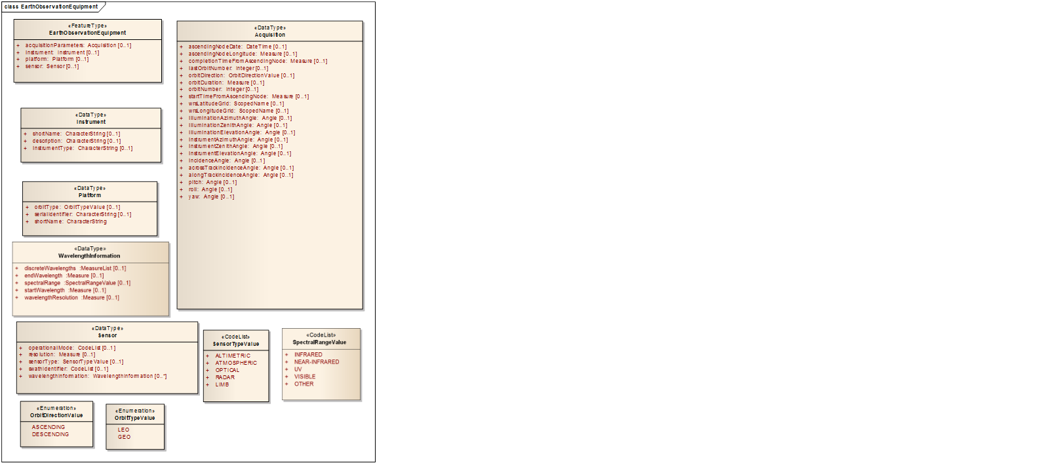

These metadata describe on one hand the platform, instrument and sensor used for the *EarthObservation*, and, on the other hand, the acquisition parameters of this observation. Complete description of the *EarthObservationEquipment* is given in Table 6.

|  |  |  |
| --- | --- | --- |
| Field name | Field description | Cardinality |
| platform/ Platform/ shortName | Platform short name (e.g. PHR) | 1  (with eop:platform 0..1) |
| platform/ Platform/ serialIdentifier | Platform serial identifier (e.g. for PHR : 1A) | 0..1 |
| platform/ Platform/ orbitType | High level characterisation of main mission types taken from a codelist  Values:  GEO  LEO | 0..1 |
| instrument/ Instrument/ shortName | Instrument (Sensor) name | 0..1  (with eop:instrument 0..1) |
| instrument/ Instrument/ description | Instrument description | 0..1 |
| instrument/ Instrument/ instrumentType | Instrument type | 0..1 |
| sensor/ Sensor/ sensorType | Sensor type based on codelist  Values:  - OPTICAL  - RADAR  - ALTIMETRIC  - ATMOSPHERIC  - LIMB | 0..1  (with eop:sensor 0..1) |
| sensor/ Sensor/ operationalMode | Sensor mode. Possible values are mission specific and should be retrieved using codeSpace. | 0..1 |
| sensor/ Sensor/ resolution | Sensor resolution. | 0..1 |
| sensor/ Sensor/ swathIdentifier | Swath identifier (e.g. Envisat ASAR has 7 distinct swaths (I1,I2,I3...I7) that correspond to precise incidence angles for the sensor). Value list can be retrieved with codeSpace. | 0..1 |
| sensor/Sensor/wavelengthInformation/WavelengthInformation/discreteWavelengths | List of discrete wavelengths observed in the product (gml:MeasureList) | 0..1  (with eop: wavelengthInformation 0..n) |
| sensor/Sensor/wavelengthInformation/WavelengthInformation/endWavelength | End of the observed wavelength range (gml:Measure) | 0..1 |
| sensor/Sensor/wavelengthInformation/WavelengthInformation/spectralRange | The observed Spectral Range:  Values:  - INFRARED - NEAR-INFRARED - UV - VISIBLE - OTHER | 0..1 |
| sensor/Sensor/wavelengthInformation/WavelengthInformation/startWavelength | Start of the observed wavelength range (gml:Measure) | 0..1 |
| sensor/Sensor/wavelengthInformation/WavelengthInformation/wavelengthResolution | Spacing between consecutive wavelengths (gml:Measure) | 0..1 |
| acquisitionParameters/ Acquisition/ orbitNumber | Acquisition orbit number | 0..1  (with eop:acquisitionParameters 0..1) |
| acquisitionParameters/ Acquisition/ lastOrbitNumber | Acquisition last orbit number | 0..1 |
| acquisitionParameters/ Acquisition/ orbitDirection | Acquisition orbit direction  Values:  ASCENDING  DESCENDING | 0..1 |
| acquisitionParameters/ Acquisition/ wrsLongitudeGrid | Neutral wrsLongitudeGrid to replace track in track/frame, K in K/J, etc.  The optional attribute "eop:codeSpace" is used to point the reference grid | 0..1 |
| acquisitionParameters/ Acquisition/ wrsLatitudeGrid | Neutral wrsLatitudeGrid to replace frame in track/frame, J in K/J, etc.  The optional attribute "eop:codeSpace" is used to point the reference grid | 0..1 |
| acquisitionParameters/ Acquisition/ ascendingNodeDate | UTC date and time at ascending node of orbit | 0..1 |
| acquisitionParameters/ Acquisition/ ascendingNodeLongitude | Longitude at ascending node of orbit. Should be expressed in degrees. | 0..1 |
| acquisitionParameters/ Acquisition/ startTimeFromAscendingNode | Start time of acquisition in milliseconds from ascending node date | 0..1 |
| acquisitionParameters/ Acquisition/ completionTimeFromAscendingNode | Stop time of acquisition in milliseconds from ascending node date | 0..1 |
| acquisitionParameters/ Acquisition/ orbitDuration | Actual orbit duration in milliseconds | 0..1 |
| acquisitionParameters/ Acquisition/ illuminationAzimuthAngle | Mean illumination/solar azimuth angle given in degrees. (i.e. uom='deg') | 0..1 |
| acquisitionParameters/ Acquisition/ illuminationZenithAngle | Mean illumination/solar zenith angle given in degrees. (i.e. uom='deg') | 0..1 |
| acquisitionParameters/ Acquisition/ illuminationElevationAngle | Mean illumination/solar elevation angle given in degrees. (i.e. uom='deg') | 0..1 |
| acquisitionParameters/ Acquisition/ instrumentAzimuthAngle | Mean instrument azimuth angle given in degrees. (i.e. uom='deg') | 0..1 |
| acquisitionParameters/ Acquisition/ instrumentZenithAngle | Mean instrument zenith angle given in degrees. (i.e. uom='deg') | 0..1 |
| acquisitionParameters/ Acquisition/ instrumentElevationAngle | Mean instrument elevation angle given in degrees. (i.e. uom='deg') | 0..1 |
| acquisitionParameters/ Acquisition/ incidenceAngle | Acquisition global incidence angle given in degrees (i.e. uom='deg') | 0..1 |
| acquisitionParameters/ Acquisition/ acrossTrackIncidenceAngle | Acquisition across track incidence angle given in degrees. (i.e. uom='deg') | 0..1 |
| acquisitionParameters/ Acquisition/ alongTrackIncidenceAngle | Acquisition along track incidence angle given in degrees. (i.e. uom='deg') | 0..1 |
| acquisitionParameters/ Acquisition/ pitch | Satellite pitch angle given in degrees (i.e. uom='deg') | 0..1 |
| acquisitionParameters/ Acquisition/ roll | Satellite roll angle given in degrees (i.e. uom='deg') | 0..1 |
| acquisitionParameters/ Acquisition/ yaw | Satellite yaw angle given in degrees (i.e. uom='deg') | 0..1 |

Table 6 : <eop:EarthObservationEquipment> fields description

### Footprint

The *eop:Footprint* block contains the description of the target location observed during the *EarthObservation*.

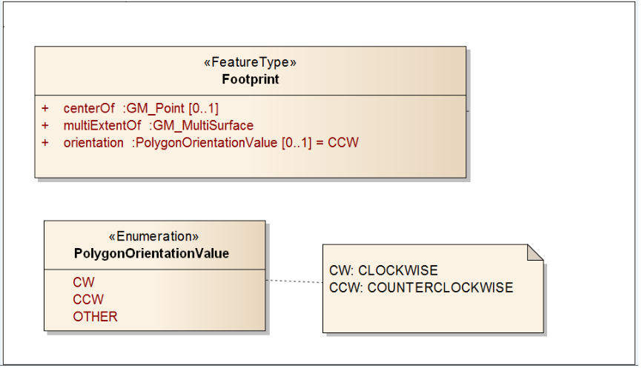

Complete description of *eop:Footprint* is given in Table 7.

|  |  |  |
| --- | --- | --- |
| Field name | Field description | Cardinality |
| multiExtentOf | Acquisition footprint coordinates, described by a closed polygon (last point=first point), using latitude, longitude pairs. Expected structure is gml:Polygon/gml:exterior/gml:LinearRing/gml:posList.[3] | 1 |
| centerOf | Acquisition center coordinates | 0..1 |
| orientation | Determines the orientation of the coordinate pairs for the exterior boundary of the footprint polygons. Possible values are CW (clockwise), counter-clockwise (CCW) or OTHER (unspecified orientation). Note that this property is only to be provided for footprints that do not follow the normal counterclockwise for exterior boundaries convention as defined in [OGC06-103r4]. If the property is not provided, a CCW orientation for the exterior boundary will be assumed. | 0..1 |

Table 7 : <eop:Footprint> fields description

### EarthObservationResult

The *eop:EarthObservationResult* block contains the description of the result of the *EarthObservation*.

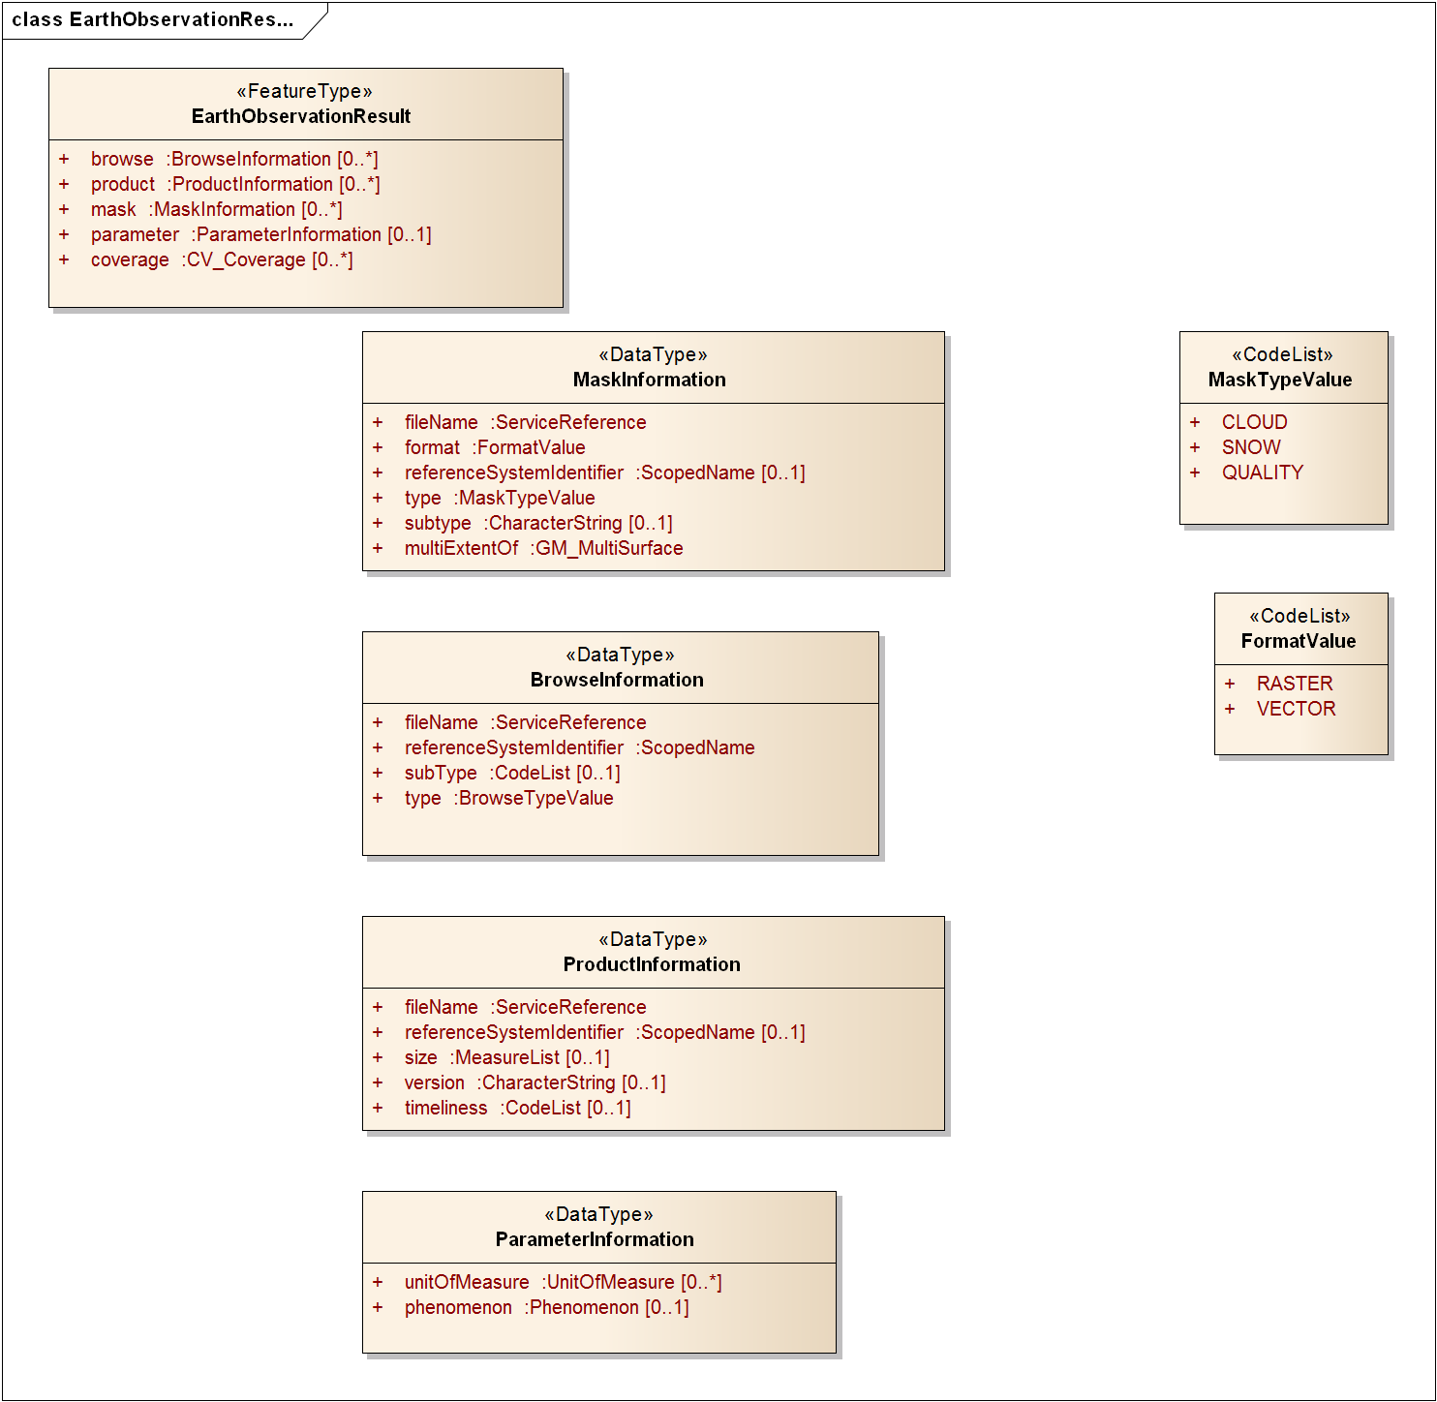

Complete description of *eop:EarthObservationResult* is given in Table 8

|  |  |  |
| --- | --- | --- |
| Field name | Field description | Cardinality |
| browse/ BrowseInformation/ type | Browse type.  Values are :  - THUMBNAIL  - QUICKLOOK  - ALBUM. | 1  (with eop:browse 0..n) |
| browse/ BrowseInformation/ subtype | Browse subType. Value is mission specific. Value list can be retrieved with codeSpace (e.g. for MODIS : OPTICAL, THERMAL) | 0..1 |
| browse/ BrowseInformation/ referenceSystemIdentifier | Indicates if browse is geo-referenced, and thus can be assumed to be displayed directly on a map (in which case it should point to a code space for the CRS), when not supplied it is assumed that the browse is provided in "raw" satellite frame of reference | 1 |
| browse/ BrowseInformation/ filename | Reference to File or OGC Web Service   * In case the browse products are offered from FTP or HTTP URLS, the xlink:href attribute is used to encode the full URL to the product and the ows:RequestMessage element is left blank. * In case the browse products are offered through WMS or WCS using HTTP GET with KeyValuePair encoding, the xlink:href attribute is used to encode the full URL including the KVP and the ows:RequestMessage element is left blank. * In case the browse products are offered through a service supporting HTTP POST or SOAP the xlink:href attribute is used to encode the service endpoint (online resource and the ows:RequestMessage shall contain the XML encoded message (including the SOAP Header in case of SOAP messaging). | 1 |
| product/ ProductInformation/ referenceSystemIdentifier | Indicates if product is geo-referenced, (in which case should point to a code space for the CRS), when not supplied it is assumed that the browse is provided in "raw" satellite frame of reference | 0..1 |
| product/ ProductInformation/ filename | Reference to File or OGC Web Service   * In case the products are offered from FTP or HTTP URLS, the xlink:href attribute is used to encode the full URL to the product and the ows:RequestMessage element is left blank. * In case the products are offered through WMS or WCS using HTTP GET with KeyValuePair encoding, the xlink:href attribute is used to encode the full URL including the KVP and the ows:RequestMessage element is left blank. * In case the products are offered through a service supporting HTTP POST or SOAP the xlink:href attribute is used to encode the service endpoint (online resource and the ows:RequestMessage shall contain the XML encoded message (including the SOAP Header in case of SOAP messaging). | 1  (with eop:product 0..n) |
| product/ ProductInformation/ version | Product version | 0..1 |
| product/ ProductInformation/ size | Product size (bytes) allowing the user to realise how long a download is likely to take | 0..1 |
| product/ ProductInformation/timeliness | Timeliness of the product, such as "near real time", "rush". Possible values are mission specific and shall refer to mission/ground segment dedicated codeSpace.  Example of values could be "NRT", "NOMINAL", “NTC” or “STC” | 0..1 |
| mask/ MaskInformation/ type | Mask type. Possible values are : SNOW, CLOUD and QUALITY | 1  (with eop:mask 0..n) |
| mask/ MaskInformation/ subType | Allows to further specify the type of mask | 0..1 |
| mask/ MaskInformation/ format | Mask format. Possible values are: RASTER or VECTOR | 1 |
| mask/ MaskInformation/ referenceSystemIdentifier | Indicates if mask is geo-referenced, and thus can be assumed to be displayed directly on a map (in which case should point to a code space for the CRS), when not supplied it is assumed that the mask is provided in "raw" satellite frame of reference | 0..1 |
| mask/ MaskInformation/ fileName | Reference to File or OGC Web Service   * In case the masks are offered from FTP or HTTP URLS, the xlink:href attribute is used to encode the full URL to the product and the ows:RequestMessage element is left blank. * In case the masks are offered through WMS or WCS using HTTP GET with KeyValuePair encoding, the xlink:href attribute is used to encode the full URL including the KVP and the ows:RequestMessage element is left blank. Preferably the masks are encoded using GML 3.2.1 following the model that is specified in Annex F. * In case the masks are offered through a service supporting HTTP POST or SOAP the xlink:href attribute is used to encode the service endpoint (online resource and the ows:RequestMessage shall contain the XML encoded message (including the SOAP Header in case of SOAP messaging). | 0..1  (either fileName or multiExtentOf shall be provided) |
| mask/MaskInformation/ multiExtentOf | Contains inline encoded mask polygon geometries using the gml:MultiSurface/gml:surfaceMembers/gml:Polygon constructs. | 0..1  (either fileName or multiExtentOf shall be provided) |
| parameter/ParameterInformation/unitOfMeasure | Units of measure for the observed phenomenon.  Note that for a multi-faceted Constrained or Composite Phenomenon multiple unitOfMeasure attributes must be present and the unitOfMeasure element order must correspond to the order of the phenomenon descriptions. | 0..n  (with eop: parameter 0..1) |
| parameter/ParameterInformation/phenomenon | A SWE 1.0 Phenomenon. Could be a single SWE Phenomenon (such as Sea Surface Height) or a SWE ConstrainedPhenomenon, such as a list of particular radiance bands, or a SWECompositePhenomeon which groups several discrete phenomena | 0..1 |
| coverage | Reference to coverage exploitation metadata (domainSet, RangeType, ...) as offered by a corresponding WCS using a HTTP GET encoded DescribeCoverage Request. | 0..n |

Table 8 : <eop:EarthObservationResult> fields description

The coverage element is foreseen in order to have the possibility to reference additional "exploitation" metadata of the EO Product.   
This exploitation metadata consists of detailed information on the spatial domain of the EO product (origin, offset vectors, grid envelope, axis labels) and the Range Structure (information on the available bands with their names, units of measure, data type and nill value list). As this type of metadata is already defined by the GML 3.2 Application Schema for WCS 2.0 (OGC09-146) that is used within the wcs:CoverageDescriptions Element, it is proposed to let the coverage element defined in this specification refer to a wcs:CoverageDescriptions element that is returned in response to a WCS DescribeCoverage Request. In case the EO Product is offered by a WCS service, this proves a convenient manner to offer this type of metadata without duplicating the information. In case the product isn't offered by a WCS Service, an alternative HTTP GET URL could be used.  
  
An example of the use of the coverage element is:  
  
<eop:coverage xlink:href="[http://hma.xxx.xx/wcseoserver/ows?Service=WCS&amp;Version=2.0.0&amp;Request=DescribeCoverage&amp;coverageId=](http://hma.xxx.xx/wcseoserver/ows?Service=WCS&Version=2.0.0&Request=DescribeCoverage&coverageId=)coverageId"/>

## Thematic EO product data schema

The Thematic EO Product schemas provide the description of metadata common to a specific thematic category of EO Products. Thematic EO Products schemas extend the “eop” schema.

### Optical EO Product data schema

The “opt” schema provides the description of metadata common to all EO Products derived from optical satellite based remote sensing. It describes the same fields as the “eop” schema plus specific fields for optical products.

As described in §6.4.2.1, the root element of the “opt” schema, named <opt:EarthObservation> simply extends the <eop:EarthObservationType> type (with no element added) :

<xs:element name="EarthObservation" type="opt:EarthObservationType"

substitutionGroup="eop:EarthObservation"/>

<xs:complexType name="EarthObservationType">

<xs:complexContent>

<xs:extension base="eop:EarthObservationType">

<xs:sequence/>

</xs:extension>

</xs:complexContent>

</xs:complexType>

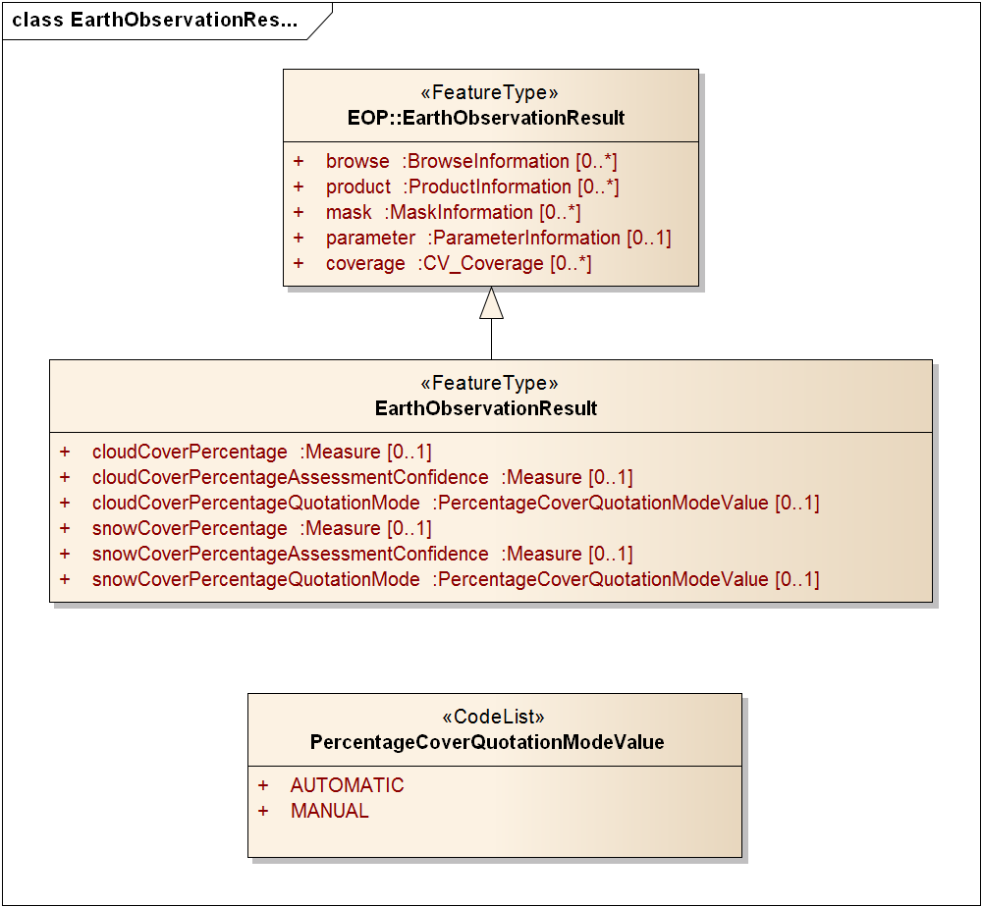

One property is extended from the eop schema :

* *opt:EarthObservationResult* extends *eop:EarthObservationResult*

|  |  |  |
| --- | --- | --- |
| Field name | Field description | Cardinality |
| opt:EarthObservationResult/ opt:cloudCoverPercentage | Cloud cover percentage (i.e. uom=’%’) | 0..1 |
| opt:EarthObservationResult/ opt:cloudCoverPercentageAssessmentConfidence | Cloud cover assessment confidence. Expressed in percents. | 0..1 |
| opt:EarthObservationResult/ opt:cloudCoverPercentageQuotationMode | Indicator to know how the cloud cover percentage has been calculated  Values :  AUTOMATIC  MANUAL | 0..1 |
| opt:EarthObservationResult/ opt:snowCoverPercentage | Snow cover percentage (i.e. uom=’%’) | 0..1 |
| opt:EarthObservationResult/ opt:snowCoverPercentageAssessmentConfidence | Snow cover assessment confidence. Expressed in percents. | 0..1 |
| opt:EarthObservationResult/ opt:snowCoverPercentageQuotationMode | Indicator to know how the snow cover percentage has been calculated  Values :  AUTOMATIC  MANUAL | 0..1 |

Table 9 : <opt:EarthObservationResult> extension of <eop:EarthObservationResult>

### Radar EO Product data schema

The “sar” schema provides the description of metadata common to all EO Products derived from radar satellite based remote sensing. It describes the same fields as the “eop” schema plus radar specific fields.

As described in §6.4.2.1, the root element of the “sar” schema, named <sar:EarthObservation> simply extends the <eop:EarthObservationType> type (with no element added) :

<xs:element name="EarthObservation" type="sar:EarthObservationType"

substitutionGroup="eop:EarthObservation"/>

<xs:complexType name="EarthObservationType">

<xs:complexContent>

<xs:extension base="eop:EarthObservationType">

<xs:sequence/>

</xs:extension>

</xs:complexContent>

</xs:complexType>

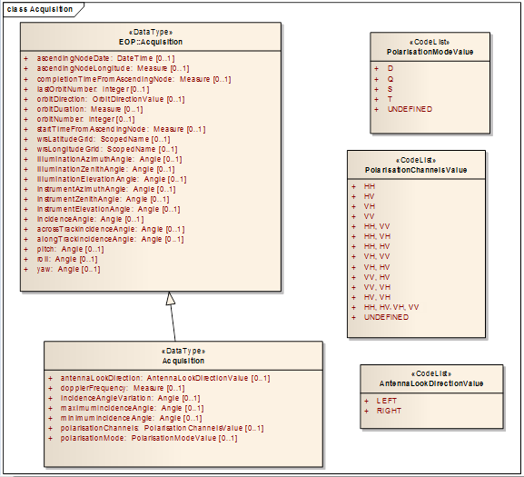

One property is extended from the eop schema :

* *sar:Acquisition* extends *eop:Acquisition* (Table 10).

|  |  |  |
| --- | --- | --- |
| Field name | Field description | Cardinality |
| eop:EarthObservationEquipment/ eop:acquisitionParameters/ sar:Acquisition/ sar:polarisationMode | Polarisation mode taken from codelist:  S (for single),  D (for dual),  T (for twin),  Q (for quad),  UNDEFINED | 0..1 |
| eop:EarthObservationEquipment/ eop:acquisitionParameters/ sar:Acquisition/ sar:polarisationChannels | polarisation channel transmit/receive configuration: horizontal, vertical.  Values:  - HH  - HV  - VH - VV  - HH, VV - HH, VH - HH, HV - VH, VV - VH, HV - VV, HV  - VV, VH  - HV, VH  - HH, HV, VH, VV - UNDEFINED | 0..1 |
| eop:EarthObservationEquipment/ eop:acquisitionParameters/ sar:Acquisition/ sar:antennaLookDirection | Look direction of antenna taken from codelist  Values:  - LEFT  - RIGHT | 0..1 |
| eop:EarthObservationEquipment/ eop:acquisitionParameters/ sar:Acquisition/ sar:minimumIncidenceAngle | Minimum incidence angle | 0..1 |
| eop:EarthObservationEquipment/ eop:acquisitionParameters/ sar:Acquisition/ sar:maximumIncidenceAngle | Maximum incidence angle | 0..1 |
| eop:EarthObservationEquipment/ eop:acquisitionParameters/ sar:Acquisition/ sar:incidenceAngleVariation | Incidence angle variation | 0..1 |
| eop:EarthObservationEquipment/ eop:acquisitionParameters/ sar:Acquisition/ sar:dopplerFrequency | Doppler Frequency of acquisition | 0..1 |

Table 10 : <sar:Acquisition> extension of <eop:Acquisition>

### Atmospheric EO Product data schema

The “atm” schema provides the description of metadata common to all EO Products derived from atmospheric based remote sensing. It describes the same fields as the “eop” schema plus atmospheric specific fields.

As described in §6.4.2.1, the root element of the “atm” schema, named <atm:EarthObservation> simply extends the <eop:EarthObservationType> type (with no element added) :

<xs:element name="EarthObservation" type="atm:EarthObservationType"

substitutionGroup="eop:EarthObservation"/>

<xs:complexType name="EarthObservationType">

<xs:complexContent>

<xs:extension base="eop:EarthObservationType">

<xs:sequence/>

</xs:extension>

</xs:complexContent>

</xs:complexType>



One property is extended from the eop schema :

* *atm:EarthObservationResult* extends *eop:EarthObservationResult* (Table 11).

|  |  |  |
| --- | --- | --- |
| Field name | Field description | Cardinality |
| atm:EarthObservationResult/ atm:dataLayers/ atm:DataLayer/ atm:speciesError | Error on species contained in DataLayer | 0..1 |
| atm:EarthObservationResult/ atm:dataLayers/ atm:DataLayer/ atm:unit | Unit of species in DataLayer | 0..1 |
| atm:EarthObservationResult/ atm:dataLayers/ atm:DataLayer/ atm:verticalRange | Top height of DataLayer. May be expressed in meters or other units such as pressure. | 0..1 |
| atm:EarthObservationResult/ atm:dataLayers/ atm:DataLayer/ atm:species | Species contained in DataLayer | 0..1 |
| atm:EarthObservationResult/ atm:dataLayers/ atm:DataLayer/ atm:algorithmName | Name of algorithm used to compute DataLayer | 0..1 |
| atm:EarthObservationResult/ atm:dataLayers/ atm:DataLayer/ atm:algorithmVersion | Algorithm version used to compute DataLayer | 0..1 |
| atm:EarthObservationResult/ atm:dataLayers/ atm:DataLayer/ atm:verticalResolution | Full width at half maximum of the rows of the vertical averaging kernel matrix | 0..1 |
| atm:EarthObservationResult/atm:cloudCoverPercentage | Cloud cover percentage (i.e. uom=’%’) | 0..1 |
| atm:EarthObservationResult/atm:cloudCoverPercentageAssessmentConfidence | Cloud cover assessment confidence. Expressed in percents. | 0..1 |
| atm:EarthObservationResult/atm:cloudCoverPercentageQuotationMode | Indicator to know how the cloud cover percentage has been calculated  Values :  AUTOMATIC  MANUAL | 0..1 |
| atm:EarthObservationResult/atm:snowCoverPercentage | Snow cover percentage (i.e. uom=’%’) | 0..1 |
| atm:EarthObservationResult/atm:snowCoverPercentageAssessmentConfidence | Snow cover assessment confidence. Expressed in percents. | 0..1 |
| atm:EarthObservationResult/atm:snowCoverPercentageQuotationMode | Indicator to know how the snow cover percentage has been calculated  Values :  AUTOMATIC  MANUAL | 0..1 |

Table 11 : <atm:EarthObservationResult> extension of <eop:EarthObservationResult>

### Altimetry EO Product data schema

The “alt” schema provides the description of metadata common to all EO Products derived from radar altimeter based remote sensing. It describes the same fields as the “eop” schema plus altimetry specific fields.

As described in §6.4.2.1, the root element of the “alt” schema, named <alt:EarthObservation> simply extends the <eop:EarthObservationType> type (with no element added) :

<xs:element name="EarthObservation" type="alt:EarthObservationType"

substitutionGroup="eop:EarthObservation"/>

<xs:complexType name="EarthObservationType">

<xs:complexContent>

<xs:extension base="eop:EarthObservationType">

<xs:sequence/>

</xs:extension>

</xs:complexContent>

</xs:complexType>

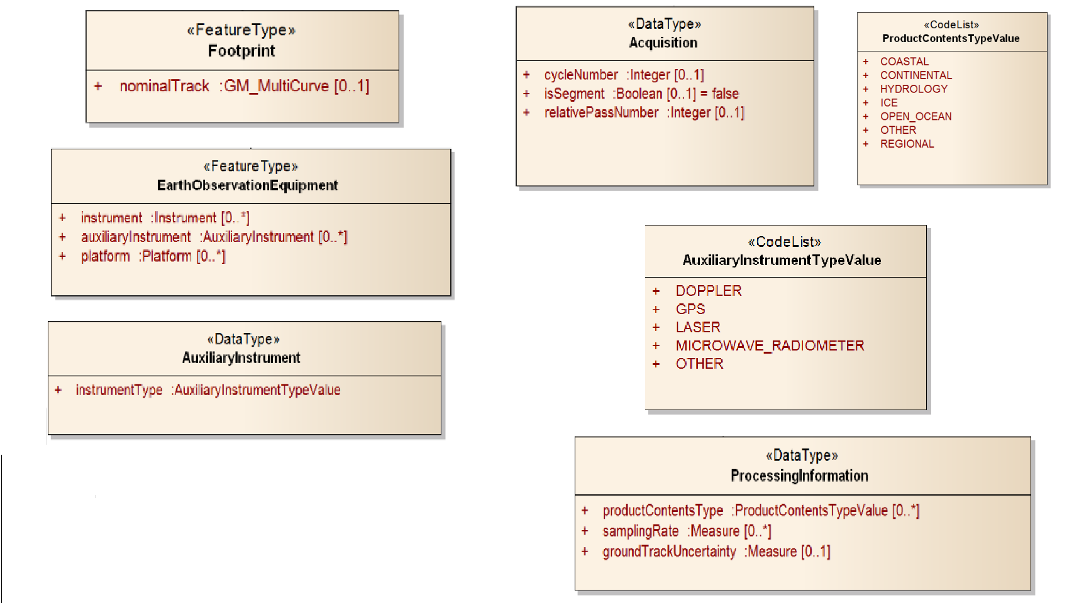

Four properties are extended from the eop schema:

* *alt:EarthObservationEquipment* extends *eop:EarthObservationEquipment* ([Table 12]);
* *alt:Footprint* extends *eop:Footprint* ([Table 13]).
* *alt:ProcessingInformation* extends *eop:ProcessingInformation* ([Table 14]).
* *alt:Acquisition* extends *eop:Acquisition* ([Table 15]).

| Field name | Field description | Cardinality |
| --- | --- | --- |
| alt:EarthObservationEquipment/ alt:instrument | Cardinality of the instrument attribute in base schema is 0..1  For combined products (made with multiple altimeters) there may be more than one primary instrument.  Cardinality is therefore modified to 0..n  (Note this is separate from the requirement for Auxiliary Instruments).  This requirement is for the case when a gridded product for example is the result of more than one instrument. | 0..n |
| alt:EarthObservationEquipment/ alt:auxiliaryInstrument | Must be of type AuxiliaryInstrument  Auxiliary instruments are a class of instruments that are not the primary instrument. It is desirable to identify them for discovery purposes.  e.g. DORIS-DIODE is an auxiliary instrument used in altimetry. | 0..n |
| alt:EarthObservationEquipment/ alt:auxiliaryInstrument/alt:instrumentType | The type of the auxiliary instrument.  Allowed Values are:   * DOPPLER * GPS * LASER * MICROWAVE_RADIOMETER * OTHER | 1 |
| alt:EarthObservationEquipment/ alt:platform | Cardinality of the platform attribute in base schema is 0..1  For combined products (made with multiple altimeters) there may be more than one primary platform.  Cardinality is therefore modified to 0..n | 0..n |

Table 12 : <alt:EarthObservationEquipment> extension of <eop:EarthObservationEquipment>

|  |  |  |
| --- | --- | --- |
| Field name | Field description | Cardinality |
| alt:Footprint/ alt:nominalTrack | A geometry of type GM_Multicurve used to define the nominal track on the earths surface. This track is essentially a line that is representative of the product but does not include points for every value.  The use of GM_MultiCurve allows for multiple lines and breaks in lines. | 0..1 |

Table 13 : <alt:Footprint> extension of <eop:Footprint>

|  |  |  |
| --- | --- | --- |
| Field name | Field description | Cardinality |
| alt:ProcessingInformation/alt:groundTrackUncertainty | Measure of the uncertainty of the ground track. Sometimes known as deadband e.g. 1Km deadband. | 0..1 |
| alt:ProcessingInformation/alt:productContentsType | Classification of product according to ground type covered. Note cardinality allows for multiple instances of this property.  Allowed Values:   * COASTAL * CONTINENTAL * HYDROLOGY * ICE * OPEN_OCEAN * OTHER * REGIONAL | 0..n |
| alt:ProcessingInformation/alt: samplingRate | Rate at which samples are provided in product. Some products may contain more than one sampling rate, e.g. 1kHz and 20kHz. Cardinality is therefore zero to many.  Must be gml:Measure | 0..n |

Table 14 : <alt:ProcessingInformation> extension of <eop:ProcessingInformation>

|  |  |  |
| --- | --- | --- |
| Field name | Field description | Cardinality |
| alt:Acquisition/ alt:cycleNumber | Number of Cycles | 0..1 |
| alt:Acquisition/ alt:isSegment | Acquisition may not be a pass but may be a segment characterised by a start and end time.  In this case the isSegment flag should be set to "True"  The default value (or the assumed value if not present) is "False" | 0..1 |
| alt:Acquisition/ alt:relativePassNumber | Pass number since start of cycle. | 0..1 |

Table 15 : <alt:Acquisition> extension of <eop:Acquisition>

### Limb Looking EO Product data schema

The “lmb” schema provides the description of metadata common to all EO Products derived from limb looking based remote sensing. It describes the same fields as the “eop” schema plus limb looking specific fields.

As described in §6.4.2.1, the root element of the “lmb” schema, named <lmb:EarthObservation> simply extends the <eop:EarthObservationType> type (with no element added) :

<xs:element name="EarthObservation" type="lmb:EarthObservationType"

substitutionGroup="eop:EarthObservation"/>

<xs:complexType name="EarthObservationType">

<xs:complexContent>

<xs:extension base="eop:EarthObservationType">

<xs:sequence/>

</xs:extension>

</xs:complexContent>

</xs:complexType>

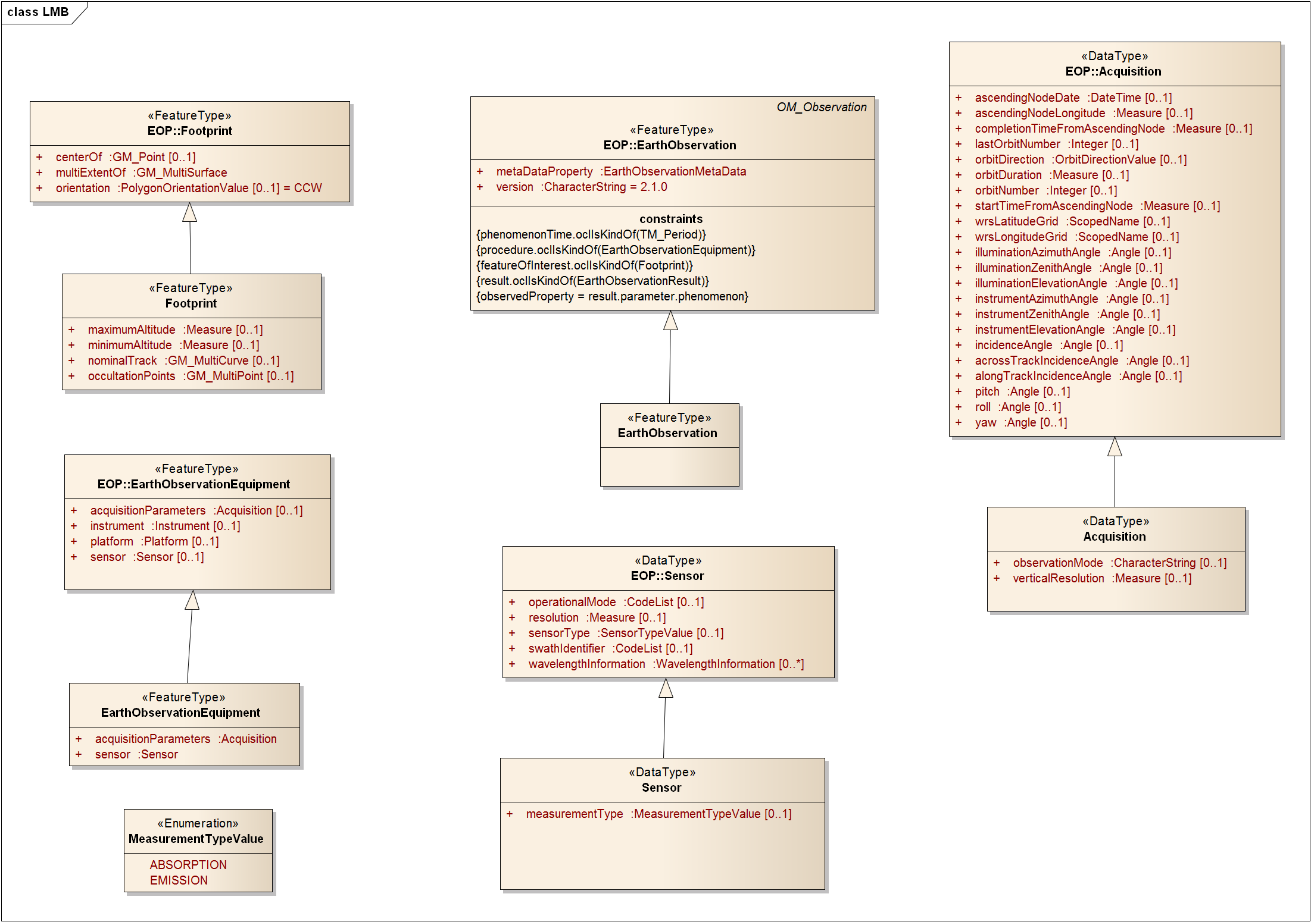

Three properties are extended from the eop schema:

* *lmb:Footprint* extends *eop:Footprint* ([Table 16]).
* *lmb:Sensor* extends *eop:Sensor* ([Table 17]).
* *lmb:Acquisition* extends *eop:Acquisition* ([Table 18]).

|  |  |  |
| --- | --- | --- |
| Field name | Field description | Cardinality |
| lmb:Footprint/ lmb:maximumAltitude | Upper bound of measurements in vertical dimension. Must be of gml:MeasureType | 0..1 |
| lmb:Footprint/ lmb:minimumAltitude | Lower bound of measurements in vertical dimension. Must be of gml:MeasureType | 0..1 |
| lmb:Footprint/ lmb:nominalTrack | A geometry of type GM_Multicurve is used to define the nominal track on the earths surface (projection of the measured volume). This track is essentially a line that is representative of the product but does not include points for every value.  The use of GM_MultiCurve allows for multiple lines and breaks in lines. | 0..1 |
| lmb:Footprint/ lmb:occultationPoints | A set of unstructured occultation points (e.g. with non-astronomical bodies like GPS satellites) at which atmospheric profiles are available within the product. | 0..1 |

Table 16 : <lmb:Footprint > extension of <lmb:Footprint>

|  |  |  |
| --- | --- | --- |
| Field name | Field description | Cardinality |
| lmb:Sensor/ lmb:measurementType | Measurement type taken from codelist:  Values:  - ABSORPTION  - EMISSION | 0..1 |

Table 17 : <lmb:Sensor> extension of <eop:Sensor>

|  |  |  |
| --- | --- | --- |
| Field name | Field description | Cardinality |
| lmb:Acquisition/ lmb:observationMode | Observation mode used in acquisition. e.g 'UTLS-1' is one of the seven MIPAS observation modes which determine the sampling regime. Not constrained to codelist at the limb-looking level as these modes are instrument specific. | 0..1 |
| lmb:Acquisition/ lmb: verticalResolution | Vertical spacing of data (if regular) | 0..1 |

Table 18 : <lmb:Acquisition> extension of <eop:Acquisition>

### Synthesis and Systematic EO Product data schema

Synthesis (or composite) products are products that are generated by combining information from multiple EO Products that are acquired over a certain period of time.

Examples of synthesis products are

* SPOT VGT derived products as 10-Daily Mean Value Composite synthesis (VGT S10) or 10-Daily BiDirectional Composite synthesis (VGT D10)
* MODIS/Terra 16 day Maximum Value Composite

The “ssp” schema provides the description of metadata common to all EO Products derived from Synthesis and Systematic products. It describes the same fields as the “eop” schema plus Synthesis and Systematic specific fields.

As described in §6.4.2.1, the root element of the “ssp” schema, named <ssp:EarthObservation> simply extends the <eop:EarthObservationType> type (with no element added) :

<xs:element name="EarthObservation" type="ssp:EarthObservationType"

substitutionGroup="eop:EarthObservation"/>

<xs:complexType name="EarthObservationType">

<xs:complexContent>

<xs:extension base="eop:EarthObservationType">

<xs:sequence/>

</xs:extension>

</xs:complexContent>

</xs:complexType>

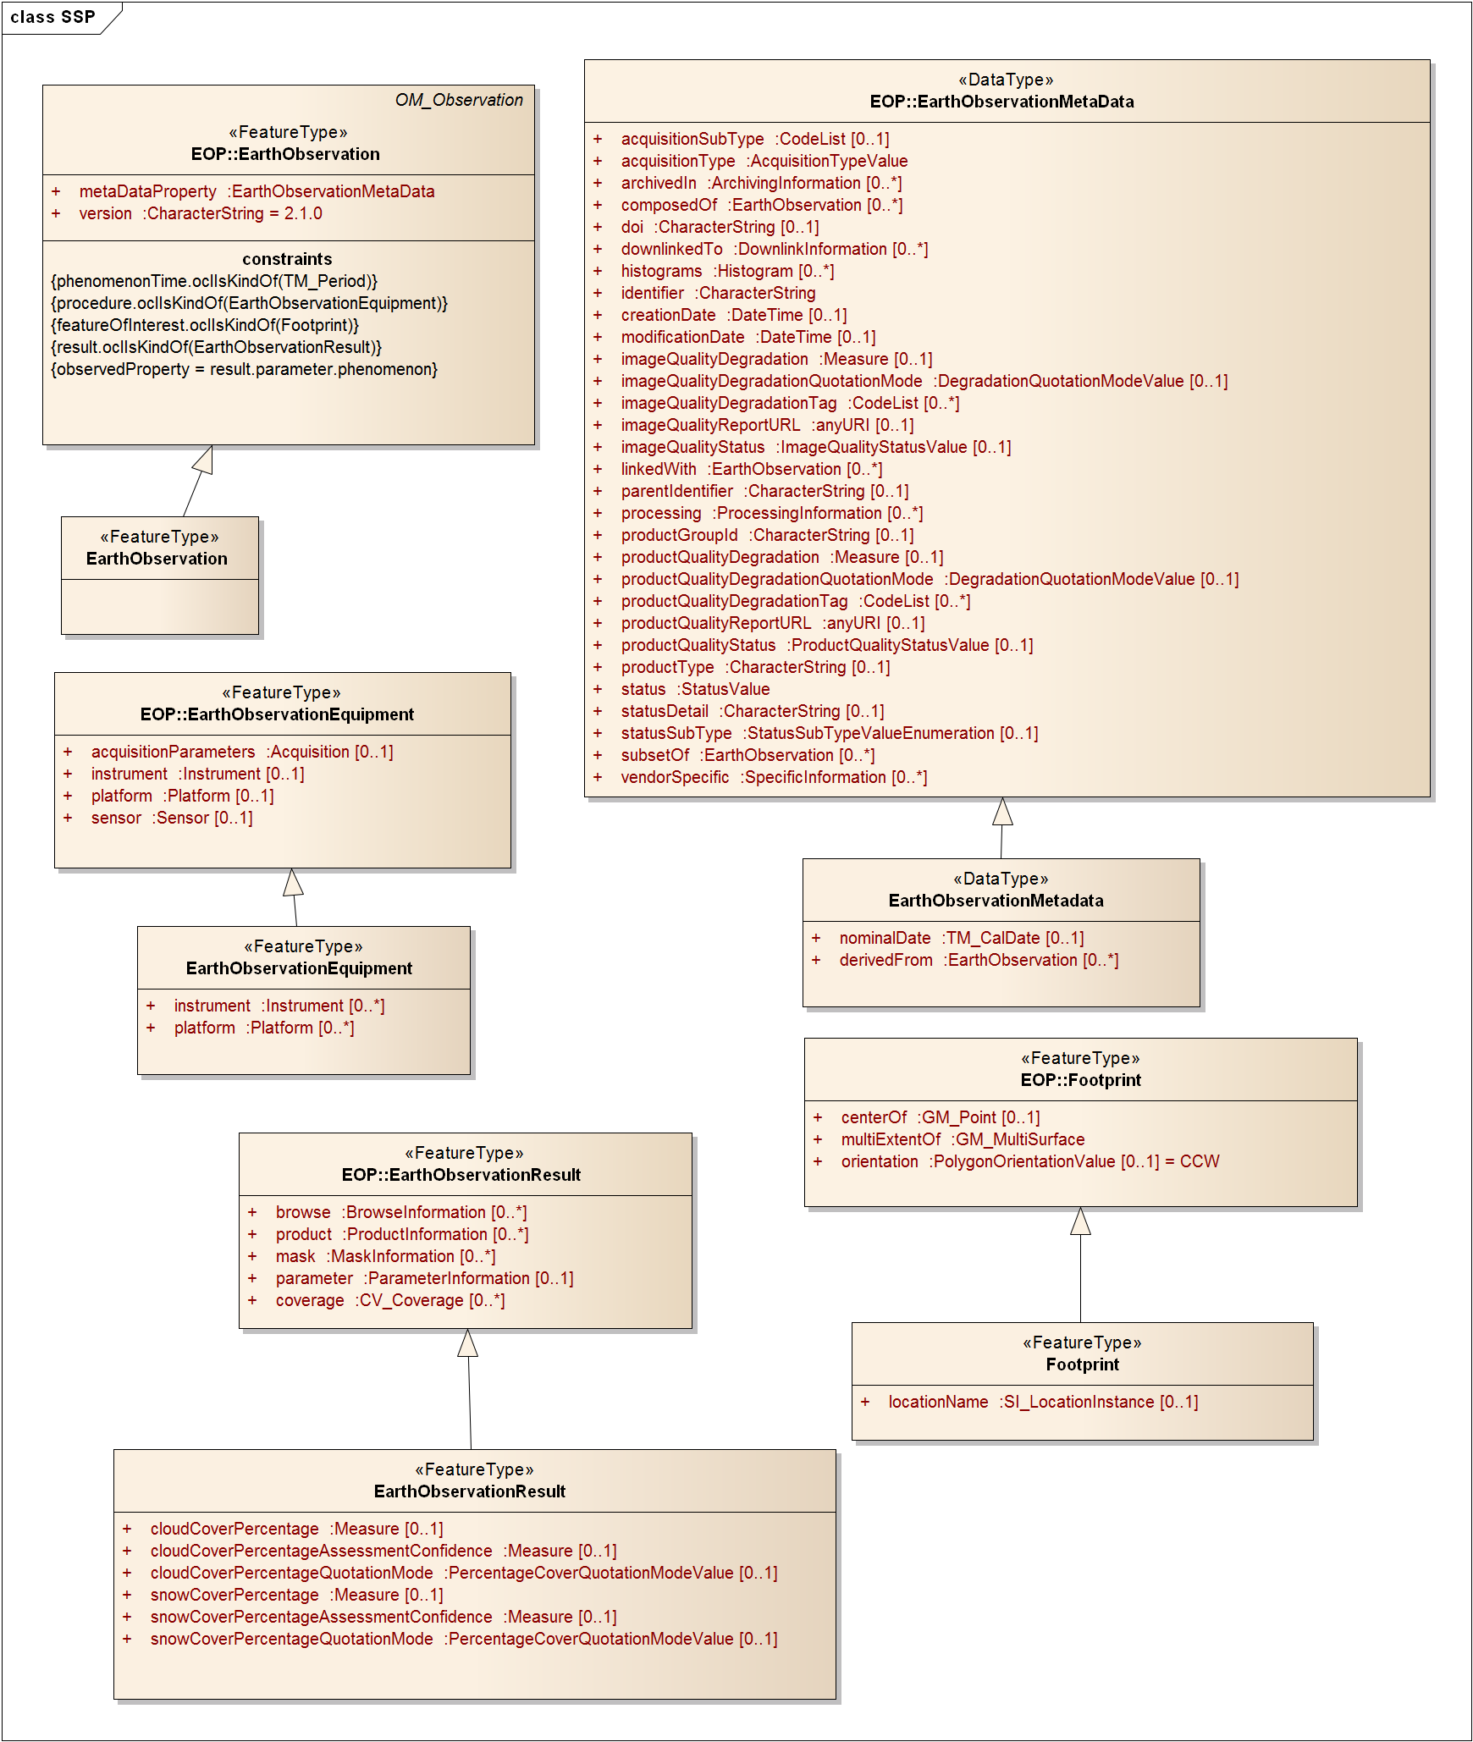

Four properties are extended from the eop schema:

* *ssp:Footprint* extends *eop:Footprint* ([Table 19]);
* *ssp:EarthObservationEquipment* extends *eop:EarthObservationEquipment* ([Table 20]);
* *ssp:EarthObservationResult* extends *eop:EarthObservationResult* ([Table 21]); and
* *ssp*:E*arthObservationMetaData* extends *eop:EarthObservationMetaData* ([Table 22]).

|  |  |  |
| --- | --- | --- |
| Field name | Field description | Cardinality |
| ssp:Footprint/ gml:locationName | Name to indicate the area that is covered e.g. "World", "Africa". Modelled as gml:locationName:a convenience property where the text value describes the location of the feature. If the location names are selected from a controlled list, then the list shall be identified in the codeSpace attribute. | 1 |

Table 19 : <ssp:Footprint> extension of <eop:Footprint>

|  |  |  |
| --- | --- | --- |
| Field name | Field description | Cardinality |
| ssp:EarthObservationEquipment/ ssp:instrument | ssp could be generated on the basis of products resulting from one or more instruments.  Cardinality is modified to 0..n | 0..n |
| ssp:EarthObservationEquipment/ ssp:platform | ssp could be generated on the basis of products resulting from instruments onboard more than one satellite.  Cardinality is modified to 0..n | 0..n |

Table 20 : <ssp: EarthObservationEquipment> extension of <eop: EarthObservationEquipment>

|  |  |  |
| --- | --- | --- |
| Field name | Field description | Cardinality |
| ssp:EarthObservationResult / ssp:cloudCoverPercentage | Cloud Cover Percentage (cfr optical products) | 0..1 |
| ssp:EarthObservationResult / ssp:cloudCoverPercentageAssessmentConfidence | Cloud Cover Percentage Assesment Confidence (cfr optical products) | 0..1 |
| ssp:EarthObservationResult / ssp:cloudCoverPercentageQuotationMode | Cloud Cover Percentage Quotation Mode (cfr optical products) | 0..1 |
| ssp:EarthObservationResult / ssp:snowCoverPercentage | Snow Cover Percentage (cfr optical products) | 0..1 |
| ssp:EarthObservationResult / ssp:snowCoverPercentageAssessmentConfidence | Snow Cover Percentage Assesment Confidence (cfr optical products) | 0..1 |
| ssp:EarthObservationResult / ssp:snowCoverPercentageQuotationMode | Snow Cover Percentage Quotation Mode (cfr optical products) | 0..1 |

Table 21 : <ssp:EarthObservationResult > extension of <eop:EarthObservationResult>

|  |  |  |
| --- | --- | --- |
| Field name | Field description | Cardinality |
| ssp:EarthObservationMetaData/ ssp:derivedFrom | Link to the EO Product(s) that were used in the generation of the ssp product | 0..n |
| ssp:EarthObservationMetaData/ ssp: nominalDate | Nominal date assigned to the synthesis product | 0..1 |

Table 22 : <ssp:EarthObservationMetaData> extension of <eop:EarthObservationMetaData>

Annex A: Conformance Class Abstract Test Suite (Normative)

Conformance class: Generic observation data

This is the core conformance class for all XML metadata instances compliant with the Earth Observation Metadata profile of Observations and Measurements.

There is a dependency on the conformance class for Observations and Measurements documents, defined in Clause 7.3 and Annex A.1 of [OGC 10-025r1].

|  |  |  |
| --- | --- | --- |
| **Conformance class** | | |
| **http://www.opengis.net/spec/EOMPOM/1.1/conf/earthobservation** | | |
| Requirements | **http://www.opengis.net/spec/EOMPOM/1.1/req/earthobservation** | |
| Dependency | **http://www.opengis.net/spec/OMXML/2.0/req/observation/observation-valid**  NOTE: The EOP schema imports the XML Schema for Observation and Measurements. However Observation and Measurements conformance includes additional tests that are not enforced by schema validation. | |
| Test | **http://www.opengis.net/spec/EOMPOM/1.1/conf/earthobservation /observation-valid** | |
| Requirement | **http://www.opengis.net/spec/EOMPOM/1.1/req/earthobservation/observation-valid** |
| Test purpose | Verify that any XML element in the substitution group of eop:EarthObservation is well-formed and valid |
| Test method | Validate the XML document using the XML Schema document (eop.xsd, opt.xsd, sar.xsd, atm.xsd, alt.xsd, lmb.xsd, ssp.xsd) that describes the appropriate namespace (EOP, OPT, SAR, ATM, ALT, LMB, SSP). Pass if no errors reported. Fail otherwise. |
| Test type | Basic |
| Test | **http://www.opengis.net/spec/EOMPOM/1.1/conf/earthobservation /metaDataProperty**  eop:metaDataProperty : expected content is eop:EarthObservationMetaData or an extension | |
| Requirement | **http://www.opengis.net/spec/EOMPOM/1.1/req/earthobservation/metaDataProperty** |
| Test purpose | Verify that the content model of any eop:metaDataProperty element is an eop:EarthObservationMetaData element or an extension (alt or ssp thematic extension corresponding to the product type or mission-specific extension with appropriate attribute eop:type) |
| Test method | Validate the XML document using the rule *metaDataProperty_strict* and *metaDataProperty_extended* per product type of the Schematron document schematron_rules_for_eop.sch. Pass if no errors reported. Fail otherwise. |
| Test type | Capability |
| Test | **http://www.opengis.net/spec/EOMPOM/1.1/conf/earthobservation/om_procedure**  om:procedure: expected contents is eop:EarthObservationEquipment or an extension. | |
| Requirement | **http://www.opengis.net/spec/EOMPOM/1.1/req/earthobservation/om_procedure** |
| Test purpose | Verify that the content model of any om:procedure element is an eop:EarthObservationEquipment element or an extension (alt, atm, lmb or ssp corresponding to the product type or mission-specific extension with appropriate attribute eop:type) |
| Test method | Validate the XML document using the rule *using_strict* and *using_extended per productType* of the Schematron document schematron_rules_for_eop.sch. Pass if no errors reported. Fail otherwise. |
| Test type | Capability |
| Test | **http://www.opengis.net/spec/EOMPOM/1.1/conf/earthobservation/acquisitionParameters**  eop:acquisitionParameters: expected contents is eop:Acquisition or an extension | |
| Requirement | **http://www.opengis.net/spec/EOMPOM/1.1/req/earthobservation/acquisitionParameters** |
| Test purpose | Verify that the content model of any eop:acquisitionParameters element is an eop:Acquisition element or an extension (sar, alt, atm, lmb corresponding to the product type or mission-specific extension with appropriate attribute eop:type). |
| Test method | Validate the XML document using the rules *acquisition_strict* and *acquisition_extended per product type,* of the Schematron document schematron_rules_for_eop.sch. Pass if no errors reported. Fail otherwise. |
| Test type | Capability |
| Test | **http://www.opengis.net/spec/EOMPOM/1.1/conf/earthobservation om_result**  om:result : expected contents is eop:EarthObservationResult or an extension | |
| Requirement | **http://www.opengis.net/spec/EOMPOM/1.1/req/earthobservation/om_result** |
| Test purpose | Verify that the content model of any om:result element is an eop:EarthObservationResult element or an extension (opt, atm, ssp corresponding to the product type or mission-specific extension with appropriate attribute eop:type) |
| Test method | Validate the XML document using the rule *result_strict,* and *result_extended per product Type* of the Schematron document schematron_rules_for_eop.sch. Pass if no errors reported. Fail otherwise. |
| Test type | Capability |
| Test | **http://www.opengis.net/spec/EOMPOM/1.1/conf/earthobservation /om_featureOfInterest**  om:featureOfInterest: expected contents is eop:Footprint or an extension corresponding to the product type (alt, lmb, ssp) | |
| Requirement | **http://www.opengis.net/spec/EOMPOM/1.1/req/earthobservation/om_result/om_featureOfInterest** |
| Test purpose | Verify that the content model of any om:featureOfInterest element is an eop:Footprint element or an extension corresponding to the product type (alt, lmb, ssp). |
| Test method | Validate the XML document using the rule *eop_featureOfInterest, alt_featureOfInterest, lmb_featureOfInterest* and *ssp_featureOfInterest* of the Schematron document schematron_rules_for_eop.sch. Pass if no errors reported. Fail otherwise. |
| Test type | Capability |
| Test | **http://www.opengis.net/spec/EOMPOM/1.1/conf/earthobservation /om_phenomenonTime**  om:phenomenonTime : expected contents is gml:TimePeriod/gml:beginPosition and gml:TimePeriod/gml:endPosition | |
| Requirement | **http://www.opengis.net/spec/EOMPOM/1.1/req/earthobservation/om_phenomenonTime** |
| Test purpose | Verify that the content model of any om:phenomenonTime element is an gml:TimePeriod/gml:beginPosition and gml:TimePeriod/gml:endPosition |
| Test method | Validate the XML document using the rule *validTime_beginPosition*  and *validTime_endPosition* of the Schematron document schematron_rules_for_eop.sch. Pass if no errors reported. Fail otherwise. |
| Test type | Capability |
| Test | **http://www.opengis.net/spec/EOMPOM/1.1/conf/earthobservation /multiExtentOf**  Footprint eop:multiExtentOf : expected contents is gml:MultiSurface/gml:surfaceMembers/gml:Polygon/gml:exterior/gml:LinearRing/gml:posList. | |
| Requirement | **http://www.opengis.net/spec/EOMPOM/1.1/req/earthobservation/multiExtentOf** |
| Test purpose | Verify that the content model of any eop:multiExtentOf element is an gml:MultiSurface/gml:surfaceMembers/gml:Polygon/gml:exterior/gml:LinearRing/gml:posLis element |
| Test method | Validate the XML document using the rule *footprint_extentOf* of the Schematron document schematron_rules_for_eop.sch. Pass if no errors reported. Fail otherwise. |
| Test type | Capability |
| Test | **http://www.opengis.net/spec/EOMPOM/1.1/conf/earthobservation/centerOf**  Footprint eop:centerOf : expected contents is gml:Point/gml:pos. | |
| Requirement | **http://www.opengis.net/spec/EOMPOM/1.1/req/earthobservation/centerOf** |
| Test purpose | Verify that the content model of any eop:centerOf element is an gml:Point/gml:pos element. |
| Test method | Validate the XML document using the rule *footprint_centerOf* of the Schematron document schematron_rules_for_eop.sch. Pass if no errors reported. Fail otherwise. |
| Test type | Capability |

**Table 23: Conformance class**

Annex B: Examples (informative)

The associated “XML Examples” contains six example XML documents:

* eop_example.xml
* opt_example.xml
* alt_example.xml
* lmb_example.xml
* ssp_example.xml
* sar_example.xml

They are available at <http://schemas.opengis.net/eompom/1.1/>.

Annex C: Background to Standardisation of EO product metadata (informative)

This annex contains background information related to the development of this specification. It explains the past approach based on gml:observations and the evolution to Observations and Measurements.

Past approach

In the frame of the initial Heterogeneous Missions Accessibility -Interoperability (HMA-I) project, ESA together with other GMES participating agencies as ASI, CNES, CSA-MDA, and DLR decided to model the metadata of Earth Observation products as geographic features encoded in the OGC Geographic Markup Language.

The reasoning for adopting gml instead of a more traditional approach using the ISO19115 Geographic Information Metadata model was the fact that the ISO 19115 elements are more suited for describing the metadata of collections of EO Products rather than for describing individual EO products themselves:

* Typical mandatory ISO 19115 metadata elements like contactInformation (gmd:Contact), citation and abstract (MD_dataIdentication) constitute information that will be identical for each individual product in the collection. It does not make a lot of sense to repeat these elements in every product metadata record. The complexity of the overall ISO19115 model with deep nesting of elements leads to a less efficient data structure for web access.
* On the other hand specific metadata elements like for instance cloud cover are required to allow for efficient discovery of EO products. In case ISO19115 would have been selected, such elements would have needed to be added to a non-comprehensive profile extension of ISO19115 which would anyway have been specific to the HMA community.

Instead of choosing this clearly sub-optimal ISO19115 approach, it was agreed to model EO Product metadata as a geographic feature characterised by a footprint and a set of attributes. As the specification document [OGC 06-080r4] states:” From an end user point of view, an EO data product can be naturally described by a spatial extent (e.g. the geographic footprint of a satellite acquisition) and several attributes describing the metadata (e.g. date of acquisition, etc.)”. The encoding language for describing geographic features is the Geography Markup Language as standardised by the OGC and further adopted as ISO19136.

The GML application schema for Earth Observation Products was developed during a consensus process in which a mapping was done between metadata elements from the different partners on to a harmonised set of elements. Where possible, the element names were taken from corresponding element names within the ISO19115 [ISO 19115:2003] and ISO19115 Part 2 [ISO 19115-2:2009] standards.

The metadata was initially modelled as features (extending <gml:AbstractFeature>) and later on refined as gml:observations.

All metadata elements common to all Earth Observation products were defined within an Earth Observation Product (eop) GML application schema (formerly known as hma schema). Specific metadata elements for optical radar and atmospheric products, were assigned to three specific application schemas deriving (respectively opt, sar and atm) from the base eop schema. For products of specific missions requiring further metadata elements for their descriptions, it is possible to define a specific application schema deriving from one of the thematic application schemas.

Evolutions of the Standards baseline

In the continuation of the Heterogeneous Missions Accessibility (HMA) project, the HMA Follow on (HMA-FO) project proposed to extend the EO product metadata to address radar altimeter, limb looking and synthesis/systematic products and some minor improvements to the base schema.

Besides the schema extensions for the new product types, it is beneficial to evaluate the underlying standards baseline.

Adoption of GML 3.2.1

Since the initial work on the GML Application Schema for EO Products in 2006, the base GML 3.1.1 specification of which [OGC 06-080r4] is an application schema has been superseded by a newer version. GML 3.2.1 [OGC 07-036] is now the official OGC GML Implementation Specification since July 2007. It was therefore logical to align this new version of the specification with GML 3.2.1 which is also used within O&M and WCS 2.0.

Observations and Measurements

Over almost ten years, OGC has been developing a richer conceptual model for observations and measurements within the ISO standard 19156 “Geographic Information – Observations and Measurements” [OGC 10-004r3].

In view of this the existing gml:Observation will be deprecated and replaced by the ISO model.

The differences between the two models are not major, with the ISO model adding the following mandatory properties to the GML model:

* the observed property and
* the result time (which in general may be different to the phenomenonTime).

To adopt the standard OM_Observation (ISO 19156), minimal refactoring is required by replacing the GML observation properties with their equivalent.

|  |  |
| --- | --- |
| **GML** | **O&M** |
| validTime | phenomenonTime |
| *using* | procedure |
| *target* | featureOfInterest |
| resultOf | result |
| - | observedProperty |
| - | *parameter* |
| - | *resultQuality* |
| - | resultTime |
| - | *validTime* |
| - | *relatedObservation* |
| - | *metadata* |

**Table 24: GML vs. O&M observation properties (optional properties in italics)**

Annex D: Model Driven Approach (informative)

It was proposed, for extending the ‘GML Application Schema for EO Products’ to adopt the model-driven approach of ISO TC211, illustrated in Figure 4 below.

In this approach, a *universe of discourse* is modelled formally as a *conceptual model* in a *UML application schema* using the General Feature Model of ISO 19109 [ISO 19109:2005]. *Feature types* may be registered in a *feature catalogue* specified within ISO 19110 [ISO 19110:2005] for re-use (e.g. as part of other application schemas, through association or generalisation), thus aiding interoperability.

From the UML model, a canonical XML *encoding* may be generated automatically, providing a *GML application schema* as per OGC 07-036/ISO 19136 [OGC 07-036]. Exchange datasets containing feature instances may then be transformed from existing (legacy) database or other storage into an XML document conforming to the GML application schema.

Usually these GML instances are accessed through a Web Feature Service as specified in ISO 19142 [ISO 19142].

In the case of the ‘GML Application Schema for EO Products’, the GML dataset contains product-level metadata and is instead accessed through the CSW ebRIM profile (OGC 07-110r2) using the EO Products ebRIM Extension Package (OGC 10-189r2).



Figure 4: Model-driven approach of ISO TC211

The term ‘model-driven’ refers to the fact that the primary artefact is the UML conceptual model – the GML application schema (and other artefacts, e.g. model documentation) are generated automatically from the UML model.

The motivation for a model-driven approach follows naturally from the theoretical principles underlying the conceptual modelling framework adopted by ISO TC211, the Conceptual Schema Modelling Facilities (CSMF) [ISO 14481].

Without dwelling on the details of this, CSMF defines a number of important principles for conceptual modelling. Chief among them are:

* the “100% principle”: everything significant in the universe of discourse should be described in the conceptual model;
* the “conceptualization principle”: the conceptual model should contain only aspects of the universe of discourse (it should not include aspects related to implementation details, e.g. data representation or storage); and
* the “Helsinki principle”: any meaningful exchange should follow agreed syntax and semantics related to the conceptual model.

In particular, the Helsinki principle implies a direct relationship between the UML conceptual model and the GML application schema, and that the latter should in principle be generated from the former.

Annex E: Revision history

|  |  |  |  |  |
| --- | --- | --- | --- | --- |
| 1. **Date** | 1. **Release** | 1. **Author** | 1. **Paragraph modified** | 1. **Description** |
| 1. 12 July 2010 | 1. 0.1.0 | 1. Frederic Houbie & Fabian Skivee | 1. N/A | 1. Initial document |
| 1. 11 January 2011 | 1. 0.2.0 | 1. Fabian Skivée |  | 1. Integrate comments from Steven Smolders and Jolyon Martin |
| 16 May 2011 | 1.0.0 | F. Houbie |  | 1. OAB comments   ESA comments |
| 19 June 2013 | 1.0.1 | 1. S. Smolders   W. De Smet | 8 | Update taking into account the first set of Change Requests |
| 27 November 2013 | 1.0.2 | S. Smolders | 1. 7.5 | Update to ATS following ETS implementation |
| 06 January 2014 | 1.0.3 | W. De Smet | 1. 6.2 | Update of namespaces to version 2.1 |
| 18 February 2014 | 1.0.4 | S. Smolders | 8.1.1 | Update taking into account the change request related to creation and modification date |
| 22 October 2014 | 1.1.0 | S. Smolders |  | Update following approval of all change requests and incorporation of OAB comments |
| 23 March 2016 | 1.1.0 | S. Simmons |  | Convert document to updated OGC template for publishing, minor text edits throughout document |

Annex F: Bibliography

[HMA] Heterogeneous Missions Accessibility - Design Methodology, Architecture and Use of Geospatial Standards for the Ground Segment Support of Earth Observation missions ESA TM-21 http://www.esa.int/About_Us/ESA_Publications/ESA_TM-21_Heterogeneous_Missions_Accessibility

[ISO 19115:2003] *Geographic information -- Metadata*

[ISO 19115-2:2009] *Geographic information -- Metadata -- Part 2: Extensions for imagery and gridded data*

[ISO 19109:2005] *ISO 19109:2005 Geographic information -- Rules for application schema*

[ISO 19110:2005] *ISO 19110:2005: Geographic information -- Methodology for feature cataloguing*

[ISO 19142] *ISO/DIS 19142: Geographic information -- Web Feature Service*

[ISO 14481] *ISO/IEC 14481: Conceptual Schema Modeling Facilities (CSMF)*

[OGC 06-103r4] OpenGIS Implementation Specification for Geographic information - Simple feature access - Part 1: Common architecture, Version 1.2.1, 2011-05-28

[OGC 07-110r2] OGC CSW-ebRIM Registry Service - Part 1: ebRIM profile of CSW, version 1.0.0, 2008/02/29.

[OGC 10-189r2] Cataloguing Earth Observation Products for ebXML Registry Information Model 3.0 based Catalogues

W3C, *Extensible Markup Language (XML) 1.0* (Second Edition), W3C Recommendation, 6 October 2000, <http://www.w3.org/TR/REC-xml>

W3C, *XML Schema Part 1: Structures*, <http://www.w3.org/TR/xmlschema-1>

W3C, *XML Schema Part 2: Datatypes*, <http://www.w3.org/TR/xmlschema-2>

1. W3C, *Namespaces in XML*, http://www.w3.org/TR/1999/REC-xml-names-19990114

1. [www.opengeospatial.org/cite](http://www.opengeospatial.org/cite)
2. The value qualityDegraded is deprecated. Please use the productQualityStatus element instead.
3. The Polygon geometry shall be encoded in WGS:84 geographic coordinates .

   The coordinate pairs shall be ordered as lat, long following the official axis ordering convention.