Open Geospatial Consortium
Publication Date: 2014-08-18
Approval Date: 2014-08-18
Submission Date: 2014-06-30
External identifier of this OGC® document: http://www.opengis.net/doc/IS/fes/2.0.3
URL for this OGC® document: http://docs.opengeospatial.org/is/09-026r2/09-026r2.html
Reference number of this OGC® Project Document: OGC 09-026r2
Version: 2.0.3
Category: OGC® Implementation Standard
Editor: Panagiotis (Peter) A. Vretanos
OGC Filter Encoding 2.0 Encoding Standard – With Corrigendum

Copyright © 2014 Open Geospatial Consortium
To obtain additional rights of use, visit http://www.opengeospatial.org/legal/.

Warning
This document is an OGC Member approved international standard. This document is available on a royalty free, non-discriminatory basis. Recipients of this document are invited to submit, with their comments, notification of any relevant patent rights of which they are aware and to provide supporting documentation. This is a corrigendum for the joint OGC-ISO document 19143.

Document type: OGC® Implementation Standard
Document subtype: Encoding
Document stage: Approved version 2.0.3
Document language: English
License Agreement
Permission is hereby granted by the Open Geospatial Consortium, ("Licensor"), free of charge and subject to the terms set forth below, to any person obtaining a copy of this Intellectual Property and any associated documentation, to deal in the Intellectual Property without restriction (except as set forth below), including without limitation the rights to implement, use, copy, modify, merge, publish, distribute, and/or sublicense copies of the Intellectual Property, and to permit persons to whom the Intellectual Property is furnished to do so, provided that all copyright notices on the intellectual property are retained intact and that each person to whom the Intellectual Property is furnished agrees to the terms of this Agreement.
If you modify the Intellectual Property, all copies of the modified Intellectual Property must include, in addition to the above copyright notice, a notice that the Intellectual Property includes modifications that have not been approved or adopted by LICENSOR.
THIS LICENSE IS A COPYRIGHT LICENSE ONLY, AND DOES NOT CONVEY ANY RIGHTS UNDER ANY PATENTS THAT MAY BE IN FORCE ANYWHERE IN THE WORLD.
THE INTELLECTUAL PROPERTY IS PROVIDED "AS IS", WITHOUT WARRANTY OF ANY KIND, EXPRESS OR IMPLIED, INCLUDING BUT NOT LIMITED TO THE WARRANTIES OF MERCHANTABILITY, FITNESS FOR A PARTICULAR PURPOSE, AND NONINFRINGEMENT OF THIRD PARTY RIGHTS. THE COPYRIGHT HOLDER OR HOLDERS INCLUDED IN THIS NOTICE DO NOT WARRANT THAT THE FUNCTIONS CONTAINED IN THE INTELLECTUAL PROPERTY WILL MEET YOUR REQUIREMENTS OR THAT THE OPERATION OF THE INTELLECTUAL PROPERTY WILL BE UNINTERRUPTED OR ERROR FREE. ANY USE OF THE INTELLECTUAL PROPERTY SHALL BE MADE ENTIRELY AT THE USER’S OWN RISK. IN NO EVENT SHALL THE COPYRIGHT HOLDER OR ANY CONTRIBUTOR OF INTELLECTUAL PROPERTY RIGHTS TO THE INTELLECTUAL PROPERTY BE LIABLE FOR ANY CLAIM, OR ANY DIRECT, SPECIAL, INDIRECT OR CONSEQUENTIAL DAMAGES, OR ANY DAMAGES WHATSOEVER RESULTING FROM ANY ALLEGED INFRINGEMENT OR ANY LOSS OF USE, DATA OR PROFITS, WHETHER IN AN ACTION OF CONTRACT, NEGLIGENCE OR UNDER ANY OTHER LEGAL THEORY, ARISING OUT OF OR IN CONNECTION WITH THE IMPLEMENTATION, USE, COMMERCIALIZATION OR PERFORMANCE OF THIS INTELLECTUAL PROPERTY.
This license is effective until terminated. You may terminate it at any time by destroying the Intellectual Property together with all copies in any form. The license will also terminate if you fail to comply with any term or condition of this Agreement. Except as provided in the following sentence, no such termination of this license shall require the termination of any third party end-user sublicense to the Intellectual Property which is in force as of the date of notice of such termination. In addition, should the Intellectual Property, or the operation of the Intellectual Property, infringe, or in LICENSOR’s sole opinion be likely to infringe, any patent, copyright, trademark or other right of a third party, you agree that LICENSOR, in its sole discretion, may terminate this license without any compensation or liability to you, your licensees or any other party. You agree upon termination of any kind to destroy or cause to be destroyed the Intellectual Property together with all copies in any form, whether held by you or by any third party.
Except as contained in this notice, the name of LICENSOR or of any other holder of a copyright in all or part of the Intellectual Property shall not be used in advertising or otherwise to promote the sale, use or other dealings in this Intellectual Property without prior written authorization of LICENSOR or such copyright holder. LICENSOR is and shall at all times be the sole entity that may authorize you or any third party to use certification marks, trademarks or other special designations to indicate compliance with any LICENSOR standards or specifications. This Agreement is governed by the laws of the Commonwealth of Massachusetts. The application to this Agreement of the United Nations Convention on Contracts for the International Sale of Goods is hereby expressly excluded. In the event any provision of this Agreement shall be deemed unenforceable, void or invalid, such provision shall be modified so as to make it valid and enforceable, and as so modified the entire Agreement shall remain in full force and effect. No decision, action or inaction by LICENSOR shall be construed to be a waiver of any rights or remedies available to it.

with Corrigendum
Information géographique — Codage de filtres

Contents Page
Foreword v
Introduction vi
1 Scope 1
2 Conformance 2
3 Normative references 3
4 Terms and definitions 3
5 Conventions 6
5.1 Abbreviated terms 6
5.2 UML notation 7
5.3 Use of examples 8
5.4 Namespaces 8
5.5 KVP-encoded parameter lists 8
5.6 XML Schema fragments 9
6 Query expressions 9
6.1 General 9
6.2 Abstract query expressions 9
6.3 Ad hoc query expression 10
7 Filter 13
7.1 General considerations 13
7.2 Encoding 14
7.3 Expressions 15
7.4 Value references 16
7.5 Literals 18
7.6 Functions 18
7.7 Comparison operators 19
7.8 Spatial operators 23
7.9 Temporal operators 27
7.10 Logical operators 29
7.11 Object identifiers 31
7.12 Extensions 32
7.13 Filter capabilities 34
7.14 Encoding 37
8 Sorting 43
8.1 General considerations 43
8.2 Encoding 44
8.3 Exceptions 44
Annex A (normative) Conformance testing 46
Annex B (informative) Filter schema definitions 50
Annex C (informative) Examples 62
Annex D (informative) EBNF for XPath subset 82
Annex E (informative) Abstract model 83
Bibliography 84

Foreword
OGC Declarations
Attention is drawn to the possibility that some of the elements of this document may be the subject of patent rights. The Open Geospatial Consortium Inc. shall not be held responsible for identifying any or all such patent rights.
Recipients of this document are requested to submit, with their comments, notification of any relevant patent claims or other intellectual property rights of which they may be aware that might be infringed by any implementation of the standard set forth in this document, and to provide supporting documentation.
ISO Declarations
ISO (the International Organization for Standardization) is a worldwide federation of national standards bodies (ISO member bodies). The work of preparing International Standards is normally carried out through ISO technical committees. Each member body interested in a subject for which a technical committee has been established has the right to be represented on that committee. International organizations, governmental and non-governmental, in liaison with ISO, also take part in the work. ISO collaborates closely with the International Electrotechnical Commission (IEC) on all matters of electrotechnical standardization.
International Standards are drafted in accordance with the rules given in the ISO/IEC Directives, Part 2.
The main task of technical committees is to prepare International Standards. Draft International Standards adopted by the technical committees are circulated to the member bodies for voting. Publication as an International Standard requires approval by at least 75 % of the member bodies casting a vote.
Attention is drawn to the possibility that some of the elements of this document may be the subject of patent rights. ISO shall not be held responsible for identifying any or all such patent rights.

Introduction
The Filter Encoding standard originated in the OGC.
A fundamental operation performed on a set of data or resources is that of querying in order to obtain a subset of the data which contains certain desired information that satisfies some query criteria and which is also, perhaps, sorted in some specified manner.
The term “projection clause” is used to describe an encoding for specifying which subset of resource properties are presented in the response to a query.
The term “filter or selection clause” is used to describe an encoding of predicates which are typically used in query operations to specify how data instances in a source dataset should be filtered to produce a result set. Each data instance in the source set is evaluated using the filter expression. The overall filter expression always evaluates to true or false. If the expression evaluates to true, the data instance satisfies the expression and is marked as being in the result set. If the overall filter expression evaluates to false, the data instance is not in the result set. Thus, the net effect of evaluating a filter expression is a set of data or resource identifiers which satisfy the predicates in the expression.
The term “sorting clause” is used to describe an encoding for specifying how the data in a response is ordered prior to being presented.
Such encodings are considered system neutral because using the numerous XML tools available today, XML encoded projection, selection and sorting clauses can be easily validated, parsed and then transformed into whatever target query language is required to retrieve or modify resources stored in some persistent object store. For example an XML encoded query composed of a projection, selection and sorting clauses can be transformed into a SQL “SELECT … FROM … WHERE … ORDER BY …” statement to fetch data stored in a SQL-based relational database. Similarly, the same XML encoded query expression can just as easily be transformed into an XQuery expression in order to retrieve data from XML document.
The XML and KVP encodings of projection, selection and sorting clauses described in this International Standard are common components which can be used together or as individually by a number of web services. Any service that requires the ability to query objects from a web-accessible repository can make use of the XML and KVP encodings of a query expression described in this International Standard. For example the GetFeature operation, defined in OGC 09-025r2, uses the elements derived from definitions in this International Standard to encode query expressions.

Scope
This International Standard describes an XML and KVP encoding of a system neutral syntax for expressing projections, selection and sorting clauses collectively called a query expression.
These components are modular and intended to be used together or individually by other standards which reference this International Standard.
EXAMPLE 1 OGC 09-025r2 makes use of some or all of these components.
This International Standard defines an abstract component, named AbstractQueryExpression, from which other specifications can subclass concrete query elements to implement query operations.
This International Standard also defines an additional abstract query component, named AbstractAdhocQueryExpresison, which is derived from AbstractQueryExpression and from which other specifications can subclass concrete query elements which follow the following query pattern:
An abstract query element from which service specifications can subclass a concrete query element that implements a query operation that allows a client to specify a list of resource types, an optional projection clause, an optional selection clause, and an optional sorting clause to query a subset of resources that satisfy the selection clause.
This pattern is referred to as an ad hoc query pattern since the server is not aware of the query until it is submitted for processing. This is in contrast to a stored query expression, which is stored and can be invoked by name or identifier.
This International Standard also describes an XML and KVP encoding of a system-neutral representation of a select clause. The XML representation is easily validated, parsed and transformed into a server-specific language required to retrieve or modify object instances stored in some persistent object store.
EXAMPLE 2 An XML encoded filter can be transformed into a WHERE clause for a SQL SELECT statement to fetch data stored in a SQL-based relational database. Similarly, and XML encoded filter expression can be transformed into an XPath or XPointer expression for fetching data from XML documents.
This International Standard defines the XML encoding for the following predicates.
- A standard set of logical predicates: and, or and not.
- A standard set of comparison predicates: equal to, not equal to, less than, less than or equal to, greater than, greater than or equal to, like, is null and between.
- A standard set of spatial predicates: equal, disjoint, touches, within, overlaps, crosses, intersects, contains, within a specified distance, beyond a specified distance and BBOX.
- A standard set of temporal predicates: after, before, begins, begun by, contains, during, ends, equals, meets, met by, overlaps and overlapped by.
- A predicate to test whether the identifier of an object matches the specified value.
This International Standard defines the XML encoding of metadata that allows a service to declare which conformance classes, predicates, operators, operands and functions it supports. This metadata is referred to as Filter Capabilities.

Conformance
Few usage scenarios require the full implementation of this International Standard to work. Therefore, service providers may want to specify requirements for only the subset needed to fulfil their service. Or system developers may want to document which subset of this International Standard it is that that they have implemented and conform to. These named conformance classes help in specifying such subsets.
This International Standard defines conformance classes based on the operations and behaviour that a filter encoding service claims to implement. Table 1 indicates which behaviour shall be implemented for each of the conformance classes. The described behaviour shall be implemented for the corresponding conformance class, and the name of the paragraph of the actual detailed abstract test suite in Annex A.
Table 1 — FE conformance classes
Conformance class name | Operation or behaviour | Subclause of the abstract test suite
Query | Service that references this International Standard materializes a concrete query element that is substitutable for fes:AbstractQueryElement. | A.1
Ad hoc Query | Service that references this International Standard materializes a concrete query element that is substitutable for fes:AbstractAdhocQueryElement and materializes a concrete selection clause element that is substitutable for fes:AbstractSelectionClause and materializes a concrete projection clause element that is substitutable for fes:AbstractProjectionClause and materializes a concrete sorting clause element that is substitutable for fes:AbstractSortingClause. | A.2
Functions | Implements functions that are in addition to the operators defined in this International Standard. | A.3
Resource Identification | Implements the ResourceId operator with the rid parameter to allow predicates to be written that allow a specific resource to be queried. | A.4
Minimum Standard Filter | Implements the comparison operators: PropertyIsEqualTo, PropertyIsNotEqualTo, PropertyIsLessThan, PropertyIsGreaterThan, PropertyIsLessThanOrEqualTo, PropertyIsGreaterThanOrEqualTo. Implements the logical operators. Does not implement any additional functions. | A.5
Standard Filter | Implements all the comparison and logical operators and may implement one or more additional functions. | A.6
Minimum Spatial Filter | Implements only the BBOX spatial operator. | A.7
Spatial Filter | Implements the BBOX spatial operator and one or more of the other spatial operators. | A.8
Minimum Temporal Filter | Implements only the During temporal operator. | A.9
Temporal Filter | Implements the During temporal operator and one or more of the other temporal operators. | A.10
Version navigation | Implements ResourceId operator with the parameters that allow versions of resources to be queried (version, startTime, endTime). | A.11
Sorting | Implements sorting of the resources in a response. | A.12
Extended Operators | Implements additional operators not defined in this International Standard. | A.13
Minimum XPath | Implements the minimum required set of XPath capabilities. | A.14
Schema Element Function | Implements the schema-element() XPath function. | A.15
Other standards that include this International Standard shall declare what constitutes a “minimum” filter by declaring the minimum set of conformance classes from Table 1 that shall be implemented.

Normative references
The following referenced documents are indispensable for the application of this document. For dated references, only the edition cited applies. For undated references, the latest edition of the referenced document (including any amendments) applies.
ISO 19108:2002, Geographic information — Temporal schema
ISO 19125-1:2004, Geographic information — Simple feature access — Part 1: Common architecture
ISO 19136:2007, Geographic information — Geography Markup Language (GML)
IETF RFC 2396, Uniform Resource Identifiers (URN): Generic Syntax (August 1998)
OGC 06-121r3, OGC Web Services Common Specification, OGC® Implementation Specification (9 February 2009)
W3C XML, Extensible Markup Language (XML) 1.0 (Third edition), W3C Recommendation (4 February 2004)
W3C XML, Namespaces, Namespaces in XML, W3C Recommendation (14 January 1999)
W3C XML, Path Language, XML Path Language (XPath) 2.0, W3C Recommendation (23 January 2007)
W3C XML, Schema Part 1, XML Schema Part 1: Structures, W3C Recommendation (2 May 2001)
W3C XML, Schema Part 2, XML Schema Part 2: Datatypes, W3C Recommendation (2 May 2001)

Terms and definitions
For the purposes of this document, the following terms and definitions apply.
4.1
attribute
⟨XML⟩ name-value pair contained in an element
[ISO 19136:2007, definition 4.1.3]
NOTE In this International Standard, an attribute is an XML attribute unless otherwise specified.
4.2
client
software component that can invoke an operation from a server
[ISO 19128:2005, definition 4.1]
4.3
coordinate
one of a sequence of n numbers designating the position of a point in n-dimensional space
[ISO 19111:2007, definition 4.5]
4.4
coordinate reference system
coordinate system that is related to an object by a datum
[ISO 19111:2007, definition 4.8]
4.5
coordinate system
set of mathematical rules for specifying how coordinates are to be assigned to points
[ISO 19111:2007, definition 4.10]
4.6
element
⟨XML⟩ basic information item of an XML document containing child elements, attributes and character data
[ISO 19136:2007, definition 4.1.23]
4.7
feature
abstraction of real world phenomena
[ISO 19101:2002, definition 4.11]
NOTE A feature can occur as a type or an instance. It is intended that the term “feature type” or “feature instance” be used when only one is meant.
4.8
feature identifier
identifier that uniquely designates a feature instance
[OGC 09-025r2, definition 4.8]
4.9
feature reference
Uniform Resource Identifier that identifies a feature
4.10
filter capabilities XML
metadata, encoded in XML, that describes which predicates defined in this International Standard a system implements
4.11
filter expression
predicate expression encoded using XML
4.12
filter expression processor
component of a system that processes a filter expression
4.13
function
rule that associates each element from a domain (source, or domain of the function) to a unique element in another domain (target, co-domain, or range)
[ISO 19107:2003, definition 4.41]
4.14
interface
named set of operations that characterize the behaviour of an entity
[ISO 19119:2005, definition 4.2]
4.15
literal value
constant, explicitly specified value
NOTE This contrasts with a value that is determined by resolving a chain of substitution (e.g. a variable).
4.16
join predicate
filter expression that includes one or more clauses that constrain properties from two different entity types
NOTE In this International Standard, the entity types are resource types.
4.17
namespace
⟨XML⟩ collection of names, identified by a URI reference which are used in XML documents as element names and attribute names
[W3C XML Namespaces]
4.18
operation
specification of a transformation or query that an object may be called to execute
[ISO 19119:2005, definition 4.3]
4.19
predicate
set of computational operations applied to a data instance which evaluate to true or false
4.20
predicate expression
formal syntax for describing a predicate
4.21
property
facet or attribute of an object referenced by a name
4.22
request
invocation of an operation by a client
[ISO 19128:2005, definition 4.10]
4.23
resource
asset or means that fulfils a requirement
[ISO 19115:2003, definition 4.10]
NOTE In this International Standard, a resource is assumed to have identity.
4.24
response
result of an operation returned from a server to a client
[ISO 19128:2005, definition 4.11]
4.25
service
distinct part of the functionality that is provided by an entity through interfaces
[ISO 19119:2005, definition 4.1]
4.26
server
particular instance of a service
[ISO 19128:2005, definition 4.12]
4.27
tuple
ordered list of values
[ISO 19136:2007, definition 4.1.63]
NOTE In this International Standard, the ordered list is generally a finite sequence of resources.
4.28
Uniform Resource Identifier
URI
unique identifier for a resource, structured in conformance with IETF RFC 2396
[ISO 19136:2007, definition 4.1.65]
NOTE The general syntax is <scheme>::<scheme-specified-part>. The hierarchical syntax with a namespace is <scheme>://<authority><path>?<query>.

Conventions

Abbreviated terms
BBOX Bounding Box
CRS Coordinate Reference System
EBNF Extended Backus-Naur Form
EPSG European Petroleum Survey Group
GML Geography Markup Language
HTTP Hypertext Transfer Protocol
HTTPS Secure Hypertext Transfer Protocol
IETF Internet Engineering Task Force
KVP Keyword-value Pair
OGC Open Geospatial Consortium
SRS Spatial Reference System
URI Uniform Resource Identifier
URL Uniform Resource Locator
URN Uniform Resource Name
UTC Coordinated Universal Time
W3C World Wide Web Consortium
WFS Web Feature Service
XML Extensible Markup Language

UML notation
5.2.1 Figure 1 describes the Unified Modelling Language (UML) notations used in this International Standard for UML class diagrams.
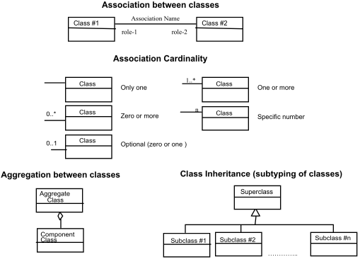
Figure 1 — UML notation in class diagrams
5.2.2 In these class diagrams, the following stereotypes of UML classes are used:
- <<DataType>> is a descriptor of a set of values that lack identity (independent existence and the possibility of side effects). A DataType is a class with no operations, whose primary purpose is to hold the information.
- <<Enumeration>> is a data type whose instances form a list of alternative literal values. Enumeration means a short list of well-understood potential values within a class.
- <<CodeList>> is a flexible enumeration for expressing a long list of potential alternative values. If the list alternatives are completely known, an enumeration shall be used; if the only likely alternatives are known, a code list shall be used.
- <<Interface>> is a definition of a set of operations that is supported by objects having this interface. An Interface class cannot contain any attributes.
- <<Type>> is a stereotyped class used for specification of a domain of instances (objects), together with the operations applicable to the objects. A Type class may have attributes and associations.
- <<Union>> is a list of alternate attributes where only one of those attributes may be present at any time.
See also ISO/TS 19103:2005, 6.8.2 and D.8.3.
5.2.3 In this International Standard, the following standard data types are used:
- CharacterString is a sequence of characters;
- LocalisedCharacterString is a CharacterString associated with a locale;
- Boolean is a value specifying TRUE or FALSE;
- URI is an identifier of a resource that provides more information;
- Integer is an integer number.

Use of examples
This International Standard makes use of XML examples. They are meant to illustrate the various aspects of filters discussed in this International Standard. While every effort has been made to ensure that the examples are well formed and valid, this goal may be sacrificed for the sake of clarity. For instance, many examples are formatted in a specific way to highlight a particular aspect that would render the example invalid from the perspective of an XML validation tool. Furthermore, most examples reference fictitious servers and data.
Thus, this International Standard does not assert that any XML encoded example, copied from this International Standard, would necessarily execute correctly or validate using a particular XML validation tool.

Namespaces
Namespaces (a specified in W3C XML Namespaces) are used to discriminate XML vocabularies from one another. The following namespaces are normatively used in this International Standard:
- (http://www.opengis.net/fes/2.0): for the Filter vocabulary;
- (http://www.opengis.net/gml/3.2): for the GML vocabulary.

KVP-encoded parameter lists
This International Standard defines both XML and KVP encodings for query and filter expressions. Several of the parameters in the KVP-encoding consist of lists of values (see Table 2) and possibly lists of lists of values. This subclause defines how to encode lists of values as the value of a parameter.
Parameters consisting of lists shall use the comma (“,”) as the delimiter between items in the list. In addition, multiple lists may be specified as the value of a parameter by enclosing each list in parentheses; “(“, ”)”.
EXAMPLE 1 This example shows a list of items.
PARAMETER=item1,item2,item3,item4a%2Citem4b
This list consists of four values: item1, item2, item3 and the value “item4a,item4b”.
NOTE In this example, the embedded comma in the last item has been encoded as per IETF RFC 2396 in order to distinguish it from the commas used in the list of delimit list entries.
EXAMPLE 2 This example shows multiple lists of items assigned to a single parameter.
PARAMETER=(item11,item12,item13)(item21,item22,item23)

XML Schema fragments
This International Standard makes use of XML Schema (as given in W3C XML Schema Part 1 and W3C XML Schema Part 2) fragments to define the XML encoding of the components of a filter expression. These XML Schema fragments are collected into a set of consolidated schema files in Annex B.

Query expressions

General
A query expression (see Figure 2) is an action that performs a search over some set of resources and returns a subset of those resources. Other standards that reference this International Standard shall assert what a resource is.
EXAMPLE A WFS would assert that a resource is a feature.
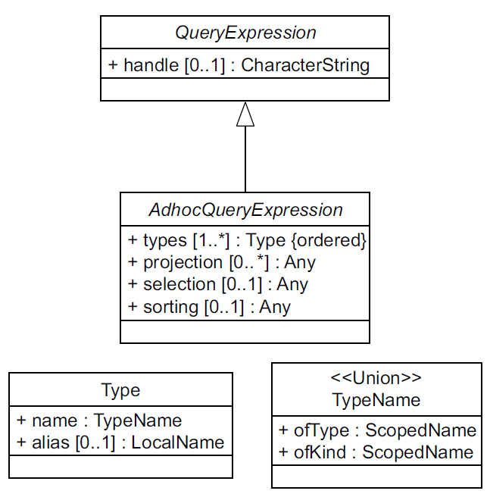
Figure 2 — Query expressions

Abstract query expressions
This International Standard defines the abstract element fes:AbstractQueryExpression as the head of a substitution group of query expressions. The element fes:AbstractQueryExpression is defined by the following XML Schema fragment:
<xsd:element name="AbstractQueryExpression"
type="fes:AbstractQueryExpressionType" abstract="true"/>
<xsd:complexType name="AbstractQueryExpressionType" abstract="true">
<xsd:attribute name="handle" type="xsd:string"/>
</xsd:complexType>
The fes:AbstractQueryExpression element defines the handle attribute which can be used to assign user-defined identifier to the query expression for the purpose of error handling or correlating the response to a query, from within a series of queries, with the source query expression.
International Standards that reference this International Standard shall declare the types(s) of resources that can be queried and shall derive query expressions from fes:AbstractQueryExpression.

Ad hoc query expression

General considerations
A fundamental type of query expression is the ad hoc query expression. It is ad hoc in the sense that the query is not known before the time it is being executed as, for example, a stored query would be.
An ad hoc query expression is a query expression that contains the names of one or more resource types to query, an optional projection clause enumerating the properties of the resource to present in the response, an option selection clause that constraints the properties of those resources types in order to define a result set and an optional sorting clause specifying the order in which the result set is presented.
This subclause defines the head of an substitution group called fes:AbstractAdhocQueryExpression from which standards that reference this International Standard can derive concrete ad hoc query expressions.

XML encoding
The following XML Schema fragment define the abstract element fes:AbstractAdhocQueryExpression
<xsd:element name="AbstractAdhocQueryExpression"
type="fes:AbstractAdhocQueryExpressionType"
substitutionGroup="fes:AbstractQueryExpression"
abstract="true"/>
<xsd:complexType name="AbstractAdhocQueryExpressionType" abstract="true">
<xsd:complexContent>
<xsd:extension base="fes:AbstractQueryExpressionType">
<xsd:sequence>
<xsd:element ref="fes:AbstractProjectionClause"
minOccurs="0" maxOccurs="unbounded"/>
<xsd:element ref="fes:AbstractSelectionClause" minOccurs="0"/>
<xsd:element ref="fes:AbstractSortingClause" minOccurs="0"/>
</xsd:sequence>
<xsd:attribute name="typeNames"
type="fes:TypeNamesListType" use="required"/>
<xsd:attribute name="aliases"
type="fes:AliasesType"/>
</xsd:extension>
</xsd:complexContent>
</xsd:complexType>
<xsd:simpleType name="TypeNamesListType">
<xsd:list itemType="fes:TypeNamesType"/>
</xsd:simpleType>
<xsd:simpleType name="TypeNamesType">
<xsd:union memberTypes="fes:SchemaElement xsd:QName"/>
</xsd:simpleType>
<xsd:simpleType name="SchemaElement">
<xsd:restriction base="xsd:string">
<xsd:pattern value="schema\-element\(.+\)"/>
</xsd:restriction>
</xsd:simpleType>
<xsd:simpleType name="AliasesType">
<xsd:list itemType="xsd:NCName"/>
</xsd:simpleType>
<xsd:element name="AbstractProjectionClause" abstract="true"/>
<xsd:complexType name="AbstractProjectionClauseType" abstract="true"/>
<xsd:element name="AbstractSelectionClause" abstract="true"/>
<xsd:complexType name="AbstractSelectionClauseType" abstract="true"/>
<xsd:element name="AbstractSortingClause" abstract="true"/>
<xsd:complexType name="AbstractSortingClauseType" abstract="true"/>

KVP-encoding
Table 2 defines the KVP-encoding for an ad hoc query expression.
Table 2 — KVP-encoding for ad hoc query expression
URL Component | O/Ma | Description
TYPENAMES | Mb | A comma-separated list of resource types to query. Specifying more that one name indicates that a join is being performed.
ALIASES | O | A comma-separated list of aliases for the resource types listed as the value of the TYPENAMES parameter.
Projection clause
PROPERTYNAME | O | If more that one feature type name is specified as the value of the TYPENAMES keyword, a list of parameter lists shall be specified (see 5.5.). Each sublist shall correspond 1:1 with each feature type name listed as the value of the TYPENAMES parameter.
Selection clause
FILTER  (Mutually exclusive with RESOURCEID and BBOX) | O | The value of the parameter shall be a filter expression encoded using the language specified by the FILTER_LANGUAGE parameter.
FILTER_LANGUAGE | O | Indicates the predicate language used to encode the filter expression that is the value of the FILTER parameter.  The default value urn:ogc:def:query Language:OGC-FES:Filter shall be used to indicate that the value of FILTER parameter is a string encoding the filter using an XML fragment as defined in this International Standard.
RESOURCEID  (Mutually exclusive with FILTER and BBOX) | O | A comma-separated list of resource identifiers to retrieve from some data store.
BBOX^{c}  (Mutually exclusive with FILTER and RESOURCEID) | O | A bounding box, encoded as specified in OGC 06-121r3, Clause 10.2.3, indicating that all resources not disjoint with that BBOX shall be retrieved from some data store.
Sorting clause
SORTBY | O | The SORTBY parameter is used to specify a list of value references that should be used to order (upon presentation) the set of resource instances that satisfy the query. The value of the SORTBY parameter shall have the form “PropertyName [ASC|DESC][,PropertyName [ASC|DESC],…]” where the letters ASC are used to indicate an ascending sort and the letters DESC are used to indicate a descending sort. If neither ASC nor DESC are specified, the default sort order shall be ascending. An example value might be: “SORTBY=Field1 DESC,Field2 DESC,Field3”. In this case the results are sorted by Field 1 descending, Field2 descending and Field3 ascending.
a O = Optional, M = Mandatory.
b Standards that reference this International Standard may change the requirement for the TYPENAME parameter. In such cases, the referencing standard shall document whether the TYPENAME parameter is mandatory, optional or mandatory in some cases and optional in others.
c As per OGC 06-121r3, a referencing standard must indicate what the default CRS value for a KVP-encoded BBOX operator should be if one is not specified.

Parameter discussion

typeNames parameter
The mandatory typeNames parameter shall be used within an ad hoc query expression to encode the names of one or more correlated resource types to be queried. Individual resource type names shall be encoded as QName (as given in W3C XML Schema Part 2).
NOTE For the KVP-encoding of the typeNames parameter, see 5.5 for encoding lists of values.
International Standards that derive query expressions from fes:AbstractQueryExpression shall declare the resource type(s) that can be queried.

aliases parameter
The optional aliases parameter may be used within an ad hoc query expression to specify alternate names for the resource type names specified as the value of the typeNames parameter. A resource type alias may be used anywhere; the resource type name may be used within the context of the query expression.
The number of list elements in the value of the aliases parameter shall match the number of corresponding resource type names in the value of the typeNames parameter and shall be correlated 1:1.
EXAMPLE 1 < … typeNames=“ns1:ResourceType1, ns2:ResourceType2” aliases=“A B” …>
This example encodes an ad hoc query expression fragment that queries the resource types ns1:ResourceType1 and ns2:ResourceType2 which are aliased to A and B. Thus, the tokens A or B can be used within the filter expression of the query expression as alternate names for the resource types ns1:ResourceType1 and ns2:ResourceType2.
Each alias specified in the value of aliases attribute shall be unique within the context of a single query expression.
If the aliases attribute is used, an alias shall be specified for each resource type name listed as the value of typeNames attribute.
Aliases are typically used in query expressions that perform a join operation to support self-joins. That is a join of one resource type back to itself.
EXAMPLE 2 typeNames=“myns:ResType1 myns:ResType1” aliases=“a b”
In this example, the first resource type, myns:ResType1, is aliased to the name “a” and the second resource type, myns:Feat1, is aliased to the name “b”. Thus properties from the first instance of myns:ResType1 can be referenced in a request as “/a/myns:property_name” and properties from the second instance of myns:ResType2 can be referenced in a request as “/b/myns:property_name” where the token “myns:property_name” is used as a place holder for the name of any property of the resource type myns:ResType1.

Projection clause
A projection clause encodes a list of optional resource properties that shall be available in a query response.
For XML-encoded requests, specifications which implement the projection clause of an ad hoc query expression shall define a concrete element derived from fes:AbstractAdhocProjectionClause.
For KVP-encoded requests, the PROPERTYNAME keyword shall be used to encode the projection clause. The value of the PROPERTYNAME keyword shall be a comma-separated list of property names.

Selection clause
The selection clause defines a set of query predicates that shall be applied to a dataset in order to define a subset of data to be operated upon.
Services that implement this International Standard shall use the fes:Filter element, which is substitutable for fes:AbstractSelectionClause, to encode the selection clause of a query expression.
For XML-encoded requests, the selection clauses shall be encoded using the fes:Filter element.
For KVP-encoded requests, the select clause shall be encoded using the keywords FILTER, FILTER_LANGUAGE, RESOURCEID, BBOX (see Table 2). The parameters FILTER, RESOURCEID and BBOX are mutually exclusive. In the event that a selection clause specifies more than one of these parameters, an OperationNotSupported (as given in OGC 06-121r3, Table 25) exception shall be raised.

Join queries
A join query finds tuples (i.e. pairs, triples, etc.) of resources, among a list of resource types, that satisfy a filter expression which includes join predicates. If the filter expression is satisfied, that tuple of resources is considered to be in the result set of the query expression.
A join query is encoded by:
- listing the resource types to join using the typeNames parameter (see 6.3.3.1.1);
- specifying join predicates in the selection clause that reference properties of the resource types listed as the values of the typeNames parameter (see 6.3.3.1.1).
Services that implement join queries shall implement an inner join meaning that only resource tuples which match the join conditions shall be returned in the result set.

schema-element() function
If the list of values for the typeNames parameters contains a single QName then the schema-element() function can be used to trigger a sequence of queries on the specified resource type and any resource type whose object elements are in the substitution group of the specified resource type.
EXAMPLE typeNames=“schema-element(ns1:Vehicles)” might, along with ns1:Vehicle, query the resource types ns1:Cars, ns1:Boats, etc …
The schema-element() function shall not be used if a join operation (see 6.3.3.1.5) is being performed.

Sorting clause
A sorting clause can be used to assert the order in which resources shall appear in response to an ad hoc query expression.
For XML-encoded requests, standards that reference this International Standard shall use the fes:SortBy element (see Clause 9), which is substitutable for fes:AbstractSortingClause, to encode the sorting clause of an ad hoc query expression.
For KVP-encoded requests, the keyword SORTBY shall be used to encode a sorting clause (see Table 2).

Filter

General considerations
A filter (see Figure 3) is used to identify a subset of resources from a collection of resources whose property values satisfy a set of logically connected predicates. If the property values of a resource satisfy all the predicates in a filter then that resource is considered to be part of the resulting subset.
This clause defines the XML encoding of a filter as a set of predicate expressions, contained within the root element fes:Filter, encoded using the elements defined herein.
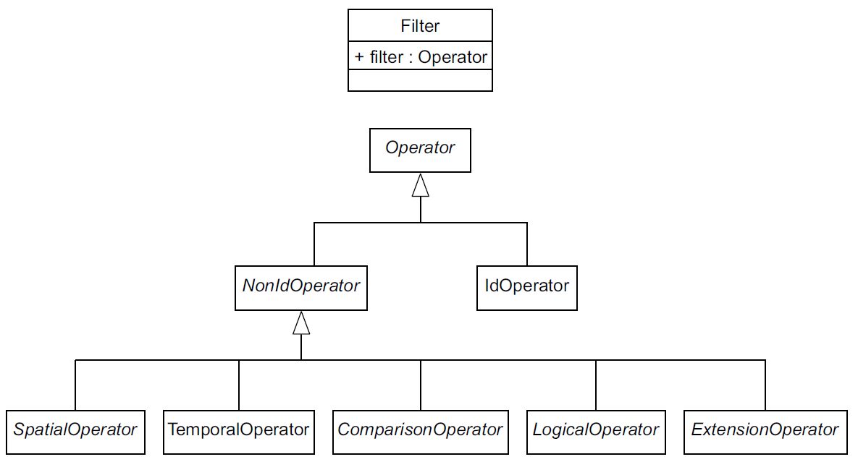
Figure 3 — Filter

Encoding
The root element of a filter expression, fes:Filter, is defined by the following XML Schema fragment:
<xsd:element name="Filter"
type="fes:FilterType"
substitutionGroup="fes:AbstractSelectionClause"/>
<xsd:complexType name="FilterType">
<xsd:complexContent>
<xsd:extension base="fes:AbstractSelectionClauseType">
<xsd:sequence>
<xsd:group ref="fes:FilterPredicates"/>
</xsd:sequence>
</xsd:extension>
</xsd:complexContent>
</xsd:complexType>
<xsd:group name="FilterPredicates">
<xsd:choice>
<xsd:element ref="fes:comparisonOps"/>
<xsd:element ref="fes:spatialOps"/>
<xsd:element ref="fes:temporalOps"/>
<xsd:element ref="fes:logicOps"/>
<xsd:element ref="fes:extensionOps"/>
<xsd:element ref="fes:Function"/>
<xsd:element ref="fes:_Id" maxOccurs="unbounded"/>
</xsd:choice>
</xsd:group>

<xsd:element name="extensionOps"
type="fes:ExtensionOpsType"
abstract="true"/>
<xsd:complexType name="ExtensionOpsType" abstract="true"/>
The elements contained within the fes:Filter element are discussed in detail in subsequent clauses.

Expressions

General considerations
An expression (see Figure 4) is a combination of one or more symbols that form part of a predicate. In this International Standard, valid symbols shall be encoded using the XML elements defined in this International Standard. Expressions are encoded by nesting these elements to form XML fragments that validate against the schemas in Annex C.
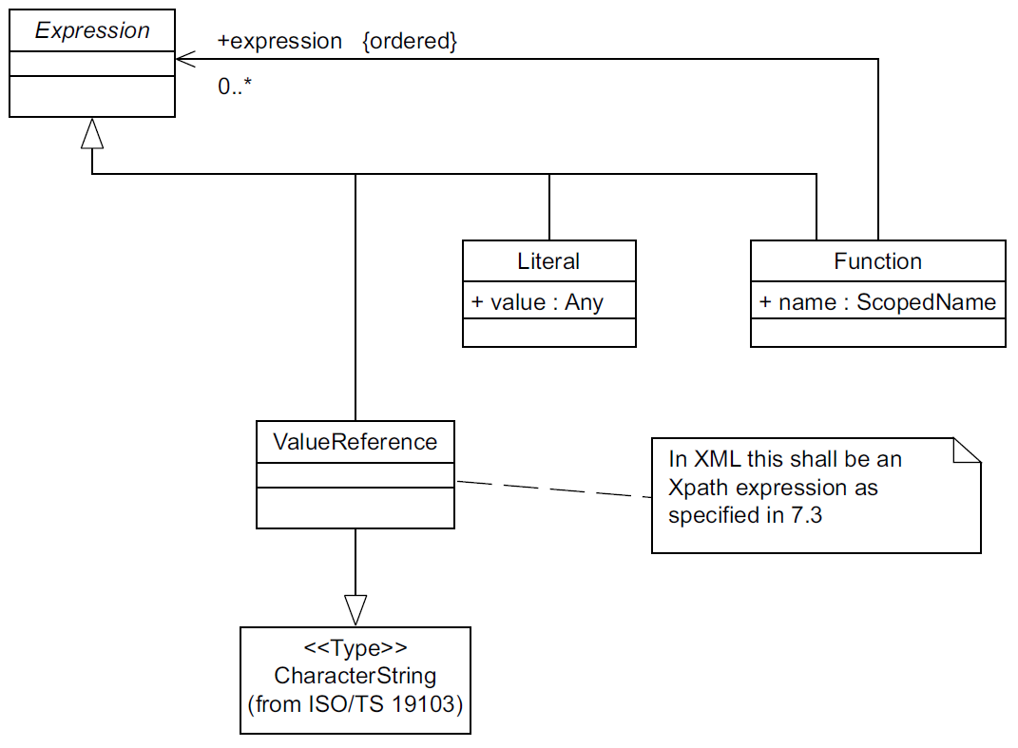
Figure 4 — Expression

Encoding
An expression can be formed using the following XML elements:
• fes:ValueReference
• fes:Literal
• fes:Function
These elements all belong to the substitution group expression and can be used wherever an expression is called for. In addition, the XML fragments formed by combining these elements are themselves expressions and can be used wherever an expression is called for.
The fes:expression element is an abstract element and its only purpose is to act as a placeholder for the elements and combinations of elements that can be used to form expressions.
The XML Schema fragment that defines the abstract fes:expression element is:
<xsd:element name="expression" abstract="true"/>

Value references

General considerations
A value reference is a string that represents a value that is to be evaluated by a predicate. The string can, for example, be the name of a property of a resource or a path expression that represents some value that is part of the property of a resource. At runtime, a predicate is evaluated by replacing the value reference by the value it refers to and then executing whatever test is encoded by the predicate.

Encoding
The following fragment defines the XML encoding for the fes:ValueReference element:
<xsd:element name="ValueReference" type="xsd:string" substitutionGroup="fes:expression"/>

Property names in GML
The fes:ValueReference element can used to specify the name of any property of an object whose value shall be tested by a predicate in a filter expression. For services that implement this International Standard and use GML (see ISO 19136), property names shall be encoded using XML elements as described in the Extensible Markup Language (XML) 1.0 (see W3C XML) specification. In addition, GML property names may be qualified with a namespace, in which case the name shall conform to the Namespaces in XML (as given in W3C XML Namespaces) specification. The following definition is taken from Clauses 2 and 3 of W3C XML Namespaces:
Names and Tokens
[4] NCName ::= (Letter | '_') (NCNameChar)*
/* An XML Name, minus the ":" */
[5] NCNameChar ::= Letter | Digit | '.' | '-' | '_' | CombiningChar | Extender
[6] QName ::= (Prefix ':')? LocalPart
[7] Prefix ::= NCName
[8] LocalPart ::= NCName
The definitions of the components Letter, Digit, CombiningChar and Extender are given in Annex B of Namespaces in XML (W3C XML Namespaces).
EXAMPLE 1 Examples of valid property names are: age, temperature, _KHz, INWATERA_1M.WKB_GEOM
EXAMPLE 2 Examples of invalid property names are: +Domain, 123_SomeName

XPath expressions
In cases where the data model of the service that implements this International Standard is represented as XML, as is the case with OGC 09-025r2 where GML (see ISO 19136) is used, value references can refer to parts of a complex property and shall be encoded using the XML Path Language (given in W3C XML Path Language).
The XML Path Language (as given in W3C XML Path Language) specification is a language for addressing parts of an XML document, or in the case of this International Standard, for referencing XML elements and attributes that represent the properties of an object encoded in XML.
This International Standard does not require that a filter expression processor support the full XPath language. In order to keep the implementation entry cost as low as possible, services that implement this specification and require the use of XPath, shall support a subset of the XPath language. The following set of rules defines this subset of the XPath language.
- The abbreviated form of the child and attribute axis specifier (see W3C XML Path Language) shall be supported.
- The context node shall be the resource element, except in the case of a join operation, in which case the context node shall be the parent of the resource element.
- Each step in the path may include an XPath predicate.
- At least the following predicate expression items shall be supported:
  - a positive non-zero integer may be used to indicate which child of the context node should be selected (i.e. an index). This allows ordered properties with repeatable values to be specifically referenced;
  - an equality predicate for the form “=value” may be used to indicate which child of the context node should be selected based on its value. This allows properties with repeatable value to be specifically referenced by value;
  - equality tests of the form “child=value” may be used to identify a specific object property by constraining the child elements of the property. Equality tests can be logically combined using the “and” or “or” operators.
NOTE Consider the following example:
<Building>
<name>City hall</name>
<addresses>
<Address>
<city>Bonn</city>
<street>Oxfordstrasse</street>
<number>1</number>
</Address>
<Address>
<city>Bonn</city>
<street>Breitestrasse</street>
<number>5</number>
</Address>
</addresses>
</Building>

<Filter>
<PropertyIsEqualTo>
<ValueReference>addresses/Address/city</ValueReference>
<Literal>Bonn</Literal>
</PropertyIsEqualTo>
</Filter>

In this example “City hall” has two address values. The following XPath expression can be used to reference the number of the first Address value:
addresses/Address[street="Oxfordstrasse"]/number
- The last step of the XPath expression shall be a resource property or sub-component of a resource property.
- The function schema-element() may be supported.
Other standards that reference this International Standard shall declare whether implementing the schema-element() function is mandatory or optional.
EXAMPLE 1 The WFS standard (see OGC 09-025r2) declares that implementing the schema-element() function is optional and defines a conformance class to test whether a WFS implementation supports that method or not.
Other standards that reference this International Standard may extend this XPath subset as required.
EXAMPLE 2 The WFS standard (see OGC 09-025r2) extends this subset by allowing the use of an accessor function called wfs:valueOf().
Annex D defines the subset of the XPath grammar for the path expressions used in this International Standard. It follows the EBNF (see ISO/IEC 14977) notation defined in the XPath 2.0 specification, Appendix A “XPath grammar” (see http://www.w3.org/TR/xpath20/#nt-bnf).

Literals

General considerations
This subclause defines how the XML encoding of a filter expression defined in this International Standard encodes literal values. A literal value is any part of a statement or expression which should be used as provided.

Encoding
The following XML Schema fragment defines the fes:Literal element:
<xsd:element name="Literal" type="fes:LiteralType"
substitutionGroup="fes:expression"/>
<xsd:complexType name="LiteralType" mixed="true">
<xsd:sequence>
<xsd:any minOccurs="0"/>
</xsd:sequence>
<xsd:attribute name="type" type="xsd:QName"/>
</xsd:complexType>
The fes:Literal element is used to encode any explicitly stated value. If the literal value is a geometric value, the value shall be encoded following the rules of GML (defined in ISO 19136).
Literals can, optionally, be typed using the type attribute. The value of the attribute type is the name of type from some type system.
EXAMPLE The following XML fragment: <Literal type=“xs:date”>1963-10-13</Literal> encodes a date value. The type of the value is xs:date as defined in (see W3C XML Schema Part 2).

Functions

General considerations
This section defines the encoding of single valued functions using the fes:Function element. A function is a named procedure that performs a distinct computation. A function can accept zero or more arguments as input and generates a single result.
Functions may be used to extend the filter syntax with additional operators that can be used in filter expressions.
If a standard that references this International Standard extends the filter syntax using the fes:Function element, any additional functions shall be documented in the referencing standard. An implementation of the referencing standard shall, in its filter capabilities (see 7.14.6), declare these additional functions.

Encoding
The following XML Schema fragment declares the fes:Function element:
<xsd:element name="Function" type="fes:FunctionType"
substitutionGroup="fes:expression"/>
<xsd:complexType name="FunctionType">
<xsd:sequence>
<xsd:element ref="fes:expression"
minOccurs="0" maxOccurs="unbounded"/>
</xsd:sequence>
<xsd:attribute name="name" type="xsd:string" use="required"/>
</xsd:complexType>
A function is composed of the name of the function, encoded using the attribute “name”, and zero or more arguments contained within the fes:Function element. The arguments themselves are in-turn expressions (see 7.3) and shall appear in the order in which they are defined in the filter capabilities document (see 7.14.6).
Functions that can be used as filter operators and can thus be combined using logical operations (see 7.10) shall return a boolean result.
EXAMPLE The following XML fragment uses a function to invoke an operator named “ClassifiedAs” to find roads classified as major highways within some area of interest. The function accepts two arguments; the name of a classification scheme, and the name of a node within that classification scheme.
<fes:Filter>
<fes:And>
<fes:Function name="ClassifiedAs">
<fes:Literal>RoadTaxonomy</fes:Literal>
<fes:Literal>Major Highway</fes:Literal>
</fes:Function>
<fes:BBOX>
<fes:ValueReference>/RS1/geometry</fes:ValueReference>
<gml:Envelope srsName=" http://www.opengis.net/def/crs/epsg/0/1234">
<gml:lowerCorner>10 10</gml:lowerCorner>
<gml:upperCorner>20 20</gml:upperCorner>
</gml:Envelope>
</fes:BBOX>
</fes:And>
</fes:Filter>

Comparison operators

General considerations
A comparison operator (see Figure 5) is used to form expressions that evaluate the mathematical comparison between two arguments. If the arguments satisfy the comparison then the expression evaluates to true. Otherwise the expression evaluates to false.
A service that implements this International Standard shall, in its filter capabilities (see 7.14.3), declare which comparison operators it supports.
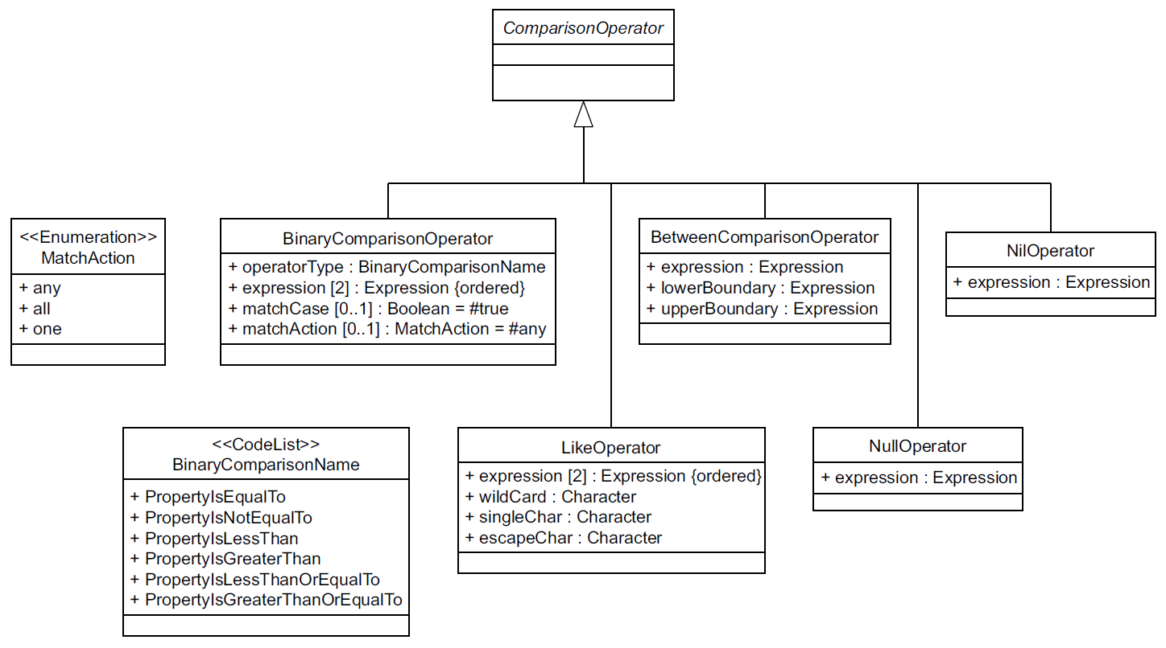
Figure 5 — ComparisonOperator

Encoding
The following XML Schema fragment defines the XML encoding for comparison operators:
<xsd:element name="comparisonOps"
type="fes:ComparisonOpsType"
abstract="true"/>
<xsd:complexType name="ComparisonOpsType" abstract="true"/>
<xsd:element name="PropertyIsEqualTo"
type="fes:BinaryComparisonOpType"
substitutionGroup="fes:comparisonOps"/>
<xsd:element name="PropertyIsNotEqualTo"
type="fes:BinaryComparisonOpType"
substitutionGroup="fes:comparisonOps"/>
<xsd:element name="PropertyIsLessThan"
type="fes:BinaryComparisonOpType"
substitutionGroup="fes:comparisonOps"/>
<xsd:element name="PropertyIsGreaterThan"
type="fes:BinaryComparisonOpType"
substitutionGroup="fes:comparisonOps"/>
<xsd:element name="PropertyIsLessThanOrEqualTo"
type="fes:BinaryComparisonOpType"
substitutionGroup="fes:comparisonOps"/>
<xsd:element name="PropertyIsGreaterThanOrEqualTo"
type="fes:BinaryComparisonOpType"
substitutionGroup="fes:comparisonOps"/>
<xsd:element name="PropertyIsLike"
type="fes:PropertyIsLikeType"
substitutionGroup="fes:comparisonOps"/>
<xsd:element name="PropertyIsNull"
type="fes:PropertyIsNullType"
substitutionGroup="fes:comparisonOps"/>
<xsd:element name="PropertyIsNil"
type="fes:PropertyIsNilType"
substitutionGroup="fes:comparisonOps"/>
<xsd:element name="PropertyIsBetween"
type="fes:PropertyIsBetweenType"
substitutionGroup="fes:comparisonOps"/>
<xsd:complexType name="BinaryComparisonOpType">
<xsd:complexContent>
<xsd:extension base="fes:ComparisonOpsType">
<xsd:sequence>
<xsd:element ref="fes:expression" minOccurs="2" maxOccurs="2"/>
</xsd:sequence>
<xsd:attribute name="matchCase" type="xsd:boolean"
use="optional" default="true"/>
<xsd:attribute name="matchAction" type="fes:MatchActionType"
use="optional" default="Any"/>
</xsd:extension>
</xsd:complexContent>
</xsd:complexType>
<xsd:simpleType name="MatchActionType">
<xsd:restriction base="xsd:string">
<xsd:enumeration value="All"/>
<xsd:enumeration value="Any"/>
<xsd:enumeration value="One"/>
</xsd:restriction>
</xsd:simpleType>
<xsd:complexType name="PropertyIsLikeType">
<xsd:complexContent>
<xsd:extension base="fes:ComparisonOpsType">
<xsd:sequence>
<xsd:element ref="fes:expression" minOccurs="2" maxOccurs="2"/>
</xsd:sequence>
<xsd:attribute name="wildCard" type="xsd:string" use="required"/>
<xsd:attribute name="singleChar" type="xsd:string" use="required"/>
<xsd:attribute name="escapeChar" type="xsd:string" use="required"/>
<xsd:attribute name="matchCase" type="xsd:boolean" use="optional" default="true"/>
</xsd:extension>
</xsd:complexContent>
</xsd:complexType>
<xsd:complexType name="PropertyIsNullType">
<xsd:complexContent>
<xsd:extension base="fes:ComparisonOpsType">
<xsd:sequence>
<xsd:element ref="fes:expression"/>
</xsd:sequence>
</xsd:extension>
</xsd:complexContent>
</xsd:complexType>
<xsd:complexType name="PropertyIsNilType">
<xsd:complexContent>
<xsd:extension base="fes:ComparisonOpsType">
<xsd:sequence>
<xsd:element ref="fes:expression"/>
</xsd:sequence>
<xsd:attribute name="nilReason" type="xsd:string"/>
</xsd:extension>
</xsd:complexContent>
</xsd:complexType>
<xsd:complexType name="PropertyIsBetweenType">
<xsd:complexContent>
<xsd:extension base="fes:ComparisonOpsType">
<xsd:sequence>
<xsd:element ref="fes:expression"/>
<xsd:element name="LowerBoundary" type="fes:LowerBoundaryType"/>
<xsd:element name="UpperBoundary" type="fes:UpperBoundaryType"/>
</xsd:sequence>
</xsd:extension>
</xsd:complexContent>
</xsd:complexType>
<xsd:complexType name="LowerBoundaryType">
<xsd:choice>
<xsd:element ref="fes:expression"/>
</xsd:choice>
</xsd:complexType>
<xsd:complexType name="UpperBoundaryType">
<xsd:sequence>
<xsd:element ref="fes:expression"/>
</xsd:sequence>
</xsd:complexType>

Prameter discussion

Binary comparisons
This International Standard defines a standard set of comparison operators (=,<,>,>=,<=,<>): equal to, less than, greater than, less than or equal to, greater than or equal to and not equal to. These comparison operators are encoded using the complex type BinaryComparisonOpType.

matchCase parameter
The matchCase attribute, which is of type Boolean, shall be used to specify how a filter expression processor should perform string comparisons. A value of true means that string comparisons shall match case. This shall be the default value. The value false means that string comparisons are performed caselessly.

matchAction parameter
The matchAction attribute can be used to specify how the comparison predicate shall be evaluated for a collection of values (e.g. in XML, properties having maxOccurs > 1) and not including some additional context to identify a specific value from the collection to be tested. Possible values for the attribute are: All, Any or One. A value of All means that all values in the collection shall satisfy the predicate. A value of Any means that any of the value in the collection can satisfy the predicate. Finally, a value of One means that only one of the values in the collection shall satisfy the predicate.
If the value of the matchAction attribute is One, additional context (e.g. XPath index) can be included to indicate which value in the collection should satisfy the predicate.
EXAMPLE The following example illustrates the use of the matchAction attribute. Consider the following XML fragment, which is an instance of a GML (see ISO 19136) feature:
<ex:Building gml:id="b123">
<gml:name>175 Fifth Ave.</gml:name>
<gml:name>Flatiron</gml:name>
<gml:name>Acme Building</gml:name>
<!-- ... -->
</ex:Building>

and consider the following filter expression:
<fes:Filter>
<fes:PropertyIsEqualTo matchAction="...">
<fes:ValueReference>gml:name</fes:ValueReference>
<fes:Literal>Flatiron</fes:Literal>
</fes:PropertyIsEqualTo>
</fes:Filter>
If the value of the matchAction attribute is set to Any, this predicate will evaluate to true since there is at least one gml:name value that satisfied the predicate. If the value of the matchAction attribute is All, this predicate will evaluate to false since not all gml:name values are Flatiron. Finally, if the matchAction attribute is set to One then the expression will evaluate to true since only one gml:name value is Flatiron.
If the value of the matchAction attribute is Any or All, the ValueReference XPath expression shall not include an index predicate. If the matchAction attribute is One an XPath index predicate may be specified and the predicate shall only evaluate to true if not only one value matches the predicate but the specific value indicates by the index matches the value.

PropertyIsLike operator
The PropertyIsLike element is intended to encode a character string comparison operator with pattern matching. A combination of regular characters, the wildCard character, the singleChar character, and the escapeChar character define the pattern. The wildCard character matches zero or more characters. The singleChar character matches exactly one character. The escapeChar character is used to escape the meaning of the wildCard, singleChar and escapeChar itself.

PropertyIsNull operator
The PropertyIsNull operator tests the specified property to see if it exists in the resource being evaluated. This corresponds to checking whether the property exists in the real-world.

PropertyIsNil operator
The PropertyIsNil operator tests the content of the specified property and evaluates if it is nil. The operator can also evaluate the nil reason using the nilReason parameter. The implied operator for evaluating the nil reason is “equals”.

PropertyIsBetween operator
The PropertyIsBetween element is defined as a compact way of encoding a range check. The lower and upper boundary values are inclusive.

Spatial operators

General considerations
A spatial operator (see Figure 6) shall determine whether its geometric arguments satisfy the stated spatial relationship. The operator shall evaluate to true if the spatial relationship is satisfied. Otherwise, the operator shall evaluate to false.
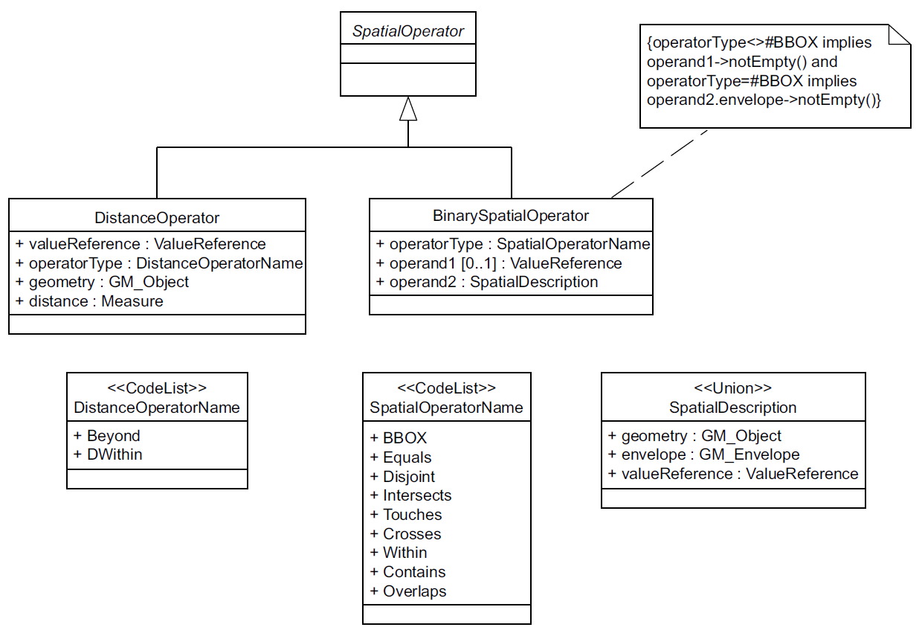
Figure 6 — SpatialOperator
Table 3 maps the spatial operators described in this International Standard to the set of spatial operators defined in ISO 19125-1.
Table 3 — Mapping of OGC 09-026R1 spatial operators to ISO 19125-1 spatial operators
OGC 09-026R1 spatial operator | ISO 19125-1 spatial operator
Equals | Equals
Disjoint | Disjoint
Touches | Touches
Withina | Within
Overlaps | Overlaps
Crosses | Crosses
Intersects | Intersects
Containsa | Contains
DWithin | N/A
Beyond | N/A
BBOX | equivalent to NOT Disjoint with gml:Envelope
a (A Within B) implies that (B Contains A) (see ISO 19125-1:2004, 6.1.14.3)

A service that implements this International Standard shall, in its filter capabilities (see 7.14.4), declare which spatial operators it supports.

Encoding
The following XML Schema fragment defines the XML encoding for spatial operators:
<xsd:element name="spatialOps" type="fes:SpatialOpsType" abstract="true"/>
<xsd:complexType name="SpatialOpsType" abstract="true"/>
<xsd:element name="Equals"
type="fes:BinarySpatialOpType"
substitutionGroup="fes:spatialOps"/>
<xsd:element name="Disjoint"
type="fes:BinarySpatialOpType"
substitutionGroup="fes:spatialOps"/>
<xsd:element name="Touches"
type="fes:BinarySpatialOpType"
substitutionGroup="fes:spatialOps"/>
<xsd:element name="Within"
type="fes:BinarySpatialOpType"
substitutionGroup="fes:spatialOps"/>
<xsd:element name="Overlaps"
type="fes:BinarySpatialOpType"
substitutionGroup="fes:spatialOps"/>
<xsd:element name="Crosses"
type="fes:BinarySpatialOpType"
substitutionGroup="fes:spatialOps"/>
<xsd:element name="Intersects"
type="fes:BinarySpatialOpType"
substitutionGroup="fes:spatialOps"/>
<xsd:element name="Contains"
type="fes:BinarySpatialOpType"
substitutionGroup="fes:spatialOps"/>
<xsd:element name="DWithin"
type="fes:DistanceBufferType"
substitutionGroup="fes:spatialOps"/>
<xsd:element name="Beyond"
type="fes:DistanceBufferType"
substitutionGroup="fes:spatialOps"/>
<xsd:element name="BBOX"
type="fes:BBOXType"
substitutionGroup="fes:spatialOps"/>
<xsd:complexType name="BinarySpatialOpType">
<xsd:complexContent>
<xsd:extension base="fes:SpatialOpsType">
<xsd:choice maxOccurs="2">

<xsd:element ref="fes:expression"/>
<xsd:any namespace="##other"/>

</xsd:choice>
</xsd:extension>
</xsd:complexContent>
</xsd:complexType>
<xsd:complexType name="BBOXType">
<xsd:complexContent>
<xsd:extension base="fes:SpatialOpsType">
<xsd:choice maxOccurs="2">

<xsd:element ref="fes:expression"/>
<xsd:any namespace="##other"/>

</xsd:choice>
</xsd:extension>
</xsd:complexContent>
</xsd:complexType>
<xsd:complexType name="DistanceBufferType">
<xsd:complexContent>
<xsd:extension base="fes:SpatialOpsType">
<xsd:sequence>
<xsd:choice maxOccurs="2">

<xsd:element ref="fes:expression"/>
<xsd:any namespace="##other"/>
</xsd:choice>
<xsd:element name="Distance" type="fes:MeasureType"/>
</xsd:sequence>
</xsd:extension>
</xsd:complexContent>
</xsd:complexType>
<xsd:complexType name="MeasureType">
<xsd:simpleContent>
<xsd:extension base="xsd:double">
<xsd:attribute name="uom" type="fes:UomIdentifier" use="required"/>
</xsd:extension>
</xsd:simpleContent>
</xsd:complexType>
<xsd:simpleType name="UomIdentifier">
<xsd:union memberTypes="fes:UomSymbol fes:UomURI"/>
</xsd:simpleType>
<xsd:simpleType name="UomSymbol">
<xsd:restriction base="xsd:string">
<xsd:pattern value="[^: \n\r\t]+"/>
</xsd:restriction>
</xsd:simpleType>
<xsd:simpleType name="UomURI">
<xsd:restriction base="xsd:anyURI">
<xsd:pattern value="([a-zA-Z][a-zA-Z0-9\-\+\.]*:|\.\./|\./|#).*"/>
</xsd:restriction>
</xsd:simpleType>
Spatial operators shall be used to test whether the value of a geometric property, referenced using the name of the property, and a literal geometric value or the value of another geometric property satisfy the spatial relationship implied by the operator.
EXAMPLE The fes:Overlaps operator evaluates whether the value of the specified geometric property and the specified literal geometric value or value of another geometric property spatially overlap.
Literal geometric values shall be expressed using GML (as defined in ISO 19136).
NOTE Although the canonical version of GML supported by this International Standard is GML 3.2 (see ISO 19136), the filter schemas have been crafted in such a way as to allow valid filter expressions to be encoded that use other versions of GML (see C.5, Example 11).

Operator semantics

Spatial operators
The semantics of the other operators Equals, Disjoint, Touches, Within, Overlaps, Crosses, Intersects, and Contains are defined in ISO 19125-1:2004, 6.1.14.

BBOX operator
The fes:BBOX element is defined as a convenient and more compact way of encoding the very common bounding box constraint based on the gml:Envelope geometry. It is equivalent to the spatial operation <fes:Not><fes:Disjoint> … </fes:Disjoint></fes:Not> meaning that the fes:BBOX operator shall identify all geometries that spatially interact with the box. If the optional fes:PropertyName element is not specified, the calling service shall apply the BBOX operator to all the spatial properties of the resource.

DWithin and Beyond operators
The spatial operators DWithin and Beyond shall test whether the value of a geometric property A is within or beyond a specified distance d of the specified literal geometric value B. More specifically:
DWithin(A,B,d) = Distance(A,B) < d
Beyond(A,B,d) = Distance(A,B) > d
Distance values shall be expressed using the fes:Distance element. The content of the fes:Distance element shall represent the magnitude of the distance and the uom attribute shall be used to specify the units of measure. Units of measure can be expressed as symbols or as a URI that links to a definition of a unit of measure that may not have a conventional symbol or when it is desired to indicate a precise or variant definition.
EXAMPLE The following XML fragment:
<Distance unit="m">10</Distance>
encodes a distance value of 10 m.
If the optional fes:expression element is not specified, the service shall apply the operator to all the spatial properties of the resource.

NULL geometries
For all spatial operators in a filter expression, except Disjoint and Beyond, testing a pair of geometric values where one of the values evaluates to NULL, shall result in the expression evaluating to FALSE indicating that the two geometries are disjoint. In the case of the Disjoint and Beyond operators, which test for disjointness, the expression shall evaluate to TRUE.

Coordinate reference system handling
In filter expressions, geometric values shall be encoded using GML, as given in ISO 19136. In GML, the optional srsName attribute is used to specify the coordinate reference system for the coordinates of geometry. Attention is drawn to the fact that specifications that reference this International Standard shall specify how to handle the following cases that can arise where two expressions that resolve to geometric values are compared:
- the two geometry values have different srsName values;
- one or both of the geometry values do not have an srsName value specified.
Although this International Standard does not mandate what actions to take to resolve these situations, it is clear that some strategies for resolving these issues can require coordinate transformations to be applied to one or both of the geometries.

Temporal operators

General considerations
A temporal operator (see Figure 7) determines whether its time arguments satisfy the stated temporal relationship. The operator evaluates to true if the temporal relationship is satisfied. Otherwise, the operator evaluates to false.
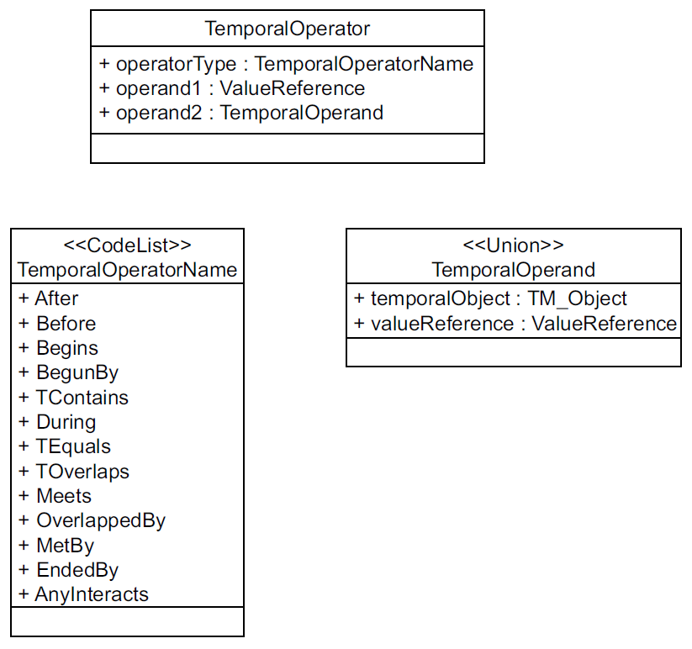
Figure 7 — TemporalOperator
Table 4 maps the temporal operators described in this International Standard to the set of temporal operators defined in ISO 19108.
Table 4 — Mapping of OGC 09-026R1 temporal operators to ISO 19108 temporal operators
OGC 09-026R1 temporal operator | ISO 19108 temporal operatora
After | After
Before | Before
Begins | Begins
BegunBy | Begun
TContains | Contains
During | During
TEquals | Equals
TOverlaps | Overlaps
Meets | Meets
OverlappedBy | OverlappedBy
MetBy | MetBy
EndedBy | EndedBy
AnyInteracts | N/A
a The values in this column are enumerates of TM_RelativePosition used in the relativePosition operation from ISO 19108.

A service that implements this International Standard shall, in its filter capabilities (see 7.14.5), declare which temporal operators it supports.

Encoding
The XML encoding for temporal operators is defined by the following XML Schema fragment:
<xsd:element name="temporalOps" type="fes:TemporalOpsType" abstract="true"/>
<xsd:complexType name="TemporalOpsType" abstract="true"/>
<xsd:element name="After"
type="fes:BinaryTemporalOpType"
substitutionGroup="fes:temporalOps"/>
<xsd:element name="Before"
type="fes:BinaryTemporalOpType"
substitutionGroup="fes:temporalOps"/>
<xsd:element name="Begins"
type="fes:BinaryTemporalOpType"
substitutionGroup="fes:temporalOps"/>
<xsd:element name="BegunBy"
type="fes:BinaryTemporalOpType"
substitutionGroup="fes:temporalOps"/>
<xsd:element name="TContains"
type="fes:BinaryTemporalOpType"
substitutionGroup="fes:temporalOps"/>
<xsd:element name="During"
type="fes:BinaryTemporalOpType"
substitutionGroup="fes:temporalOps"/>
<xsd:element name="EndedBy"
type="fes:BinaryTemporalOpType"
substitutionGroup="fes:temporalOps"/>
<xsd:element name="Ends"
type="fes:BinaryTemporalOpType"
substitutionGroup="fes:temporalOps"/>
<xsd:element name="TEquals"
type="fes:BinaryTemporalOpType"
substitutionGroup="fes:temporalOps"/>
<xsd:element name="Meets"
type="fes:BinaryTemporalOpType"
substitutionGroup="fes:temporalOps"/>
<xsd:element name="MetBy"
type="fes:BinaryTemporalOpType"
substitutionGroup="fes:temporalOps"/>
<xsd:element name="TOverlaps"
type="fes:BinaryTemporalOpType"
substitutionGroup="fes:temporalOps"/>
<xsd:element name="OverlappedBy"
type="fes:BinaryTemporalOpType"
substitutionGroup="fes:temporalOps"/>
<xsd:element name="AnyInteracts"
type="fes:BinaryTemporalOpType"
substitutionGroup="fes:temporalOps"/>
<xsd:complexType name="BinaryTemporalOpType">
<xsd:complexContent>
<xsd:extension base="fes:TemporalOpsType">
<xsd:choice maxOccurs="2">

<xsd:element ref="fes:expression"/>
<xsd:any namespace="##other"/>

</xsd:choice>
</xsd:extension>
</xsd:complexContent>
</xsd:complexType>
As defined in this International Standard, temporal operators are used to test whether a value reference and a filter expression, that evaluates to a temporal value, satisfy the temporal relationship implied by the operator.
EXAMPLE The fes:TOverlaps operator evaluates whether the value of the specified temporal property and the specified literal temporal value temporally overlap.
Literal temporal values are expressed using GML (as defined in ISO 19136).
The semantics of all the temporal operators except fes:AnyInteracts are defined in ISO 19108:2002, 5.2.3.5.
Applicable to TM_Period only, the temporal operator fes:AnyInteracts is a shortcut operator semantically equivalent to NOT (Before OR Meets OR MetBy OR After).
If any input value of TM_TemporalPosition is indeterminate, an exception shall be raised.

Time zone handling
When temporal operators are used to compare time instants or periods, the time offset for local time zone shall be handled as described in XML Schema Part 2, 3.2.7: Datatypes (see W3C XML Schema Part 2).

Logical operators

General considerations
A logical operator (see Figure 8) can be used to combine one or more conditional expressions. The logical operator AND evaluates to true if all the combined expressions evaluate to true. The operator OR operator evaluates to true is any of the combined expressions evaluate to true. The NOT operator reverses the logical value of an expression.
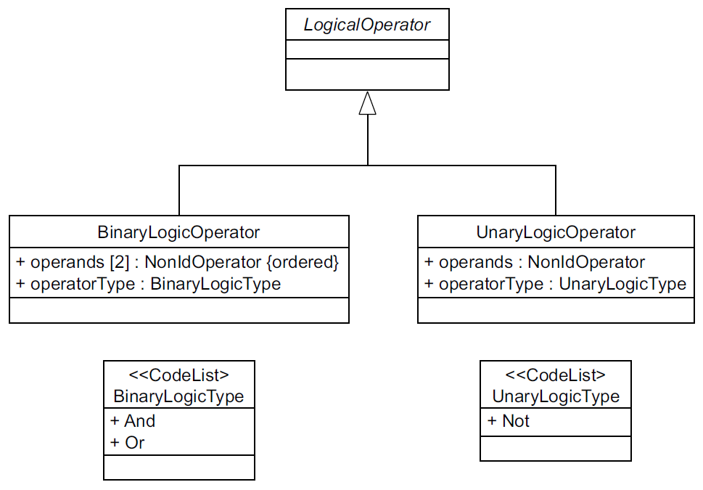
Figure 8 — LogicalOperator

Encoding
The XML encoding for the logical operators AND, OR and NOT is defined by the following XML Schema fragment:
<xsd:element name="logicOps" type="fes:LogicOpsType" abstract="true"/>
<xsd:complexType name="LogicOpsType" abstract="true"/>
<xsd:element name="And"
type="fes:BinaryLogicOpType"
substitutionGroup="fes:logicOps"/>
<xsd:element name="Or"
type="fes:BinaryLogicOpType"
substitutionGroup="fes:logicOps"/>
<xsd:element name="Not"
type="fes:UnaryLogicOpType"
substitutionGroup="fes:logicOps"/>
<xsd:complexType name="BinaryLogicOpType">
<xsd:complexContent>
<xsd:extension base="fes:LogicOpsType">
<xsd:choice minOccurs="2" maxOccurs="unbounded">
<xsd:group ref="fes:FilterPredicates"/>
</xsd:choice>
</xsd:extension>
</xsd:complexContent>
</xsd:complexType>
<xsd:complexType name="UnaryLogicOpType">
<xsd:complexContent>
<xsd:extension base="fes:LogicOpsType">
<xsd:sequence>
<xsd:choice>
<xsd:group ref="fes:FilterPredicates"/>
</xsd:choice>
</xsd:sequence>
</xsd:extension>
</xsd:complexContent>
</xsd:complexType>
The fes:And, fes:Or and fes:Not elements can be used to combine elements, that are substitutable for the abstract fes:expression element, to form more complex compound expressions.

Object identifiers

General considerations
An object identifier is meant to represent a unique identifier for an instance of a resource within the context of the web service that is serving the resource. This International Standard defines the abstract element fes:AbstractId (see Figure 9) as the head of an XML substitution group that can be used to define a resource identifier element that can be used as a predicate within a filter expressions for specific resource types.
This International Standard defines the element fes:ResourceId (see Figure 9) that can be used as a predicate to identify any identifiable resource within a filter expression.
Specifications that reference this International Standard can also define their own element for identifying resources, if the fes:ResourceId element is deemed unsuitable, and add it to the fes:AbstractId substitution group.
Which resource identifier elements can be used predicates in a filter expression shall be advertized in the filter capabilities document (see 7.14.2).
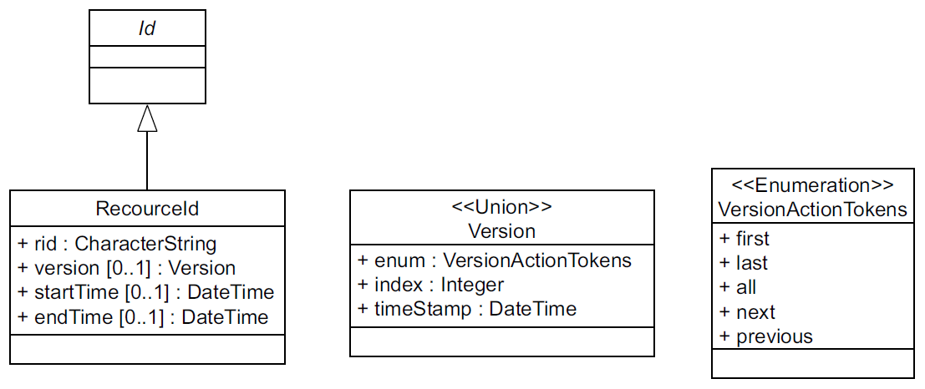
Figure 9 — ResourceId

Encoding
The following XML schema fragment declares the abstract element fes:AbstractId as well as the concrete element fes:ResourceId:
<xsd:element name="_Id" type="fes:AbstractIdType" abstract="true"/>
<xsd:complexType name="AbstractIdType" abstract="true"/>
<xsd:element name="ResourceId"
type="fes:ResourceIdType"
substitutionGroup="fes:_Id"/>
<xsd:complexType name="ResourceIdType">
<xsd:complexContent>
<xsd:extension base="fes:AbstractIdType">
<xsd:attribute name="rid" type="xsd:string" use="required"/>
<xsd:attribute name="previousRid" type="xsd:string"/>
<xsd:attribute name="version" type="fes:VersionType"/>
<xsd:attribute name="startDate" type="xsd:dateTime"/>
<xsd:attribute name="endDate" type="xsd:dateTime"/>
</xsd:extension>
</xsd:complexContent>
</xsd:complexType>
<xsd:simpleType name="VersionType">
<xsd:union memberTypes="fes:VersionActionTokens
xsd:positiveInteger
xsd:dateTime"/>
</xsd:simpleType>
<xsd:simpleType name="VersionActionTokens">
<xsd:restriction base="xsd:string">
<xsd:enumeration value="FIRST"/>
<xsd:enumeration value="LAST"/>
<xsd:enumeration value="PREVIOUS"/>
<xsd:enumeration value="NEXT"/>
<xsd:enumeration value="ALL"/>
</xsd:restriction>
</xsd:simpleType>
Within filter expressions, specific resource instances can be identified using the fes:ResourceId element.
The rid attribute specifies the id of the resource that shall be selected by the predicate.
The previousRid attribute may be used, in implementations that support versioning, to report the previous identifier of a resource.
For attributes version, startTime and endTime are used to navigate versions of a resource if an implementation that references this International Standard supports versioning.
If an implementation that references this International Standard does not support versioning, any value specified for these attributes shall be ignored and the predicate shall always select the single version that is available.
If an implementation that references this International Standard supports versioning, the rid shall be a system generated hash containing a logical resource identifier and a version number. The specific details of the hash are implementation dependant and shall be opaque to a client.
The version attribute may then be used to navigate the various versions of a resource.
The version attribute may be an integer N indicating that the Nth version of the resource shall be selected. The first version of a resource shall be numbered 1. If N exceeds the number of versions available, the latest version of the resource shall be selected.
The version attribute may also be date indicating that the version of the resource closest to the specified date shall be selected.
The versionAction attribute may also be the strings FIRST, LATEST, PREVIOUS, NEXT and ALL. The token FIRST shall select the first version of a resource. The token LATEST shall select the most recent version of a resource. The PREVIOUS and NEXT tokens shall select the previous or next version of a resource relative to the version specified using the rid attribute. The token ALL shall select all available version of a resource.
The attributes startTime and endTime may be used to specify a predicate that selects all versions of a resource between the specified start date and end date. The startTime and endTime attributes shall always be specified together. If the startTime and endTime are specified, the version attribute shall not be specified.

Extensions

General considerations
Standards that reference this International Standard may extend the filter syntax by:
- adding functions using the fes:Function element (see 7.6);
- adding new operators by defining new elements in the filter syntax.
Each of these methods can be used to extend the filter syntax, as described in 7.12.2 and 7.12.3.
Ad hoc extensions to the filter syntax are strongly discouraged because such extensions are not interoperable. Instead, extensions should be made within the context of a standard that references this International Standard.

Extending filter using the fes:Function element
Filter may be extended by adding new functions to the syntax that are invoked using the fes:Function element (see 7.6). Any functions added to the filter syntax shall be listed in the filter capabilities document using the fes:Function element (see 7.14.6). It is strongly recommended that additional functions be fully documented in the filter capabilities document using comments or the ows:Metadata element (see 7.14.6).

Extending filter by adding new elements
The filter syntax may also be extended by adding new elements that represent new operators. This may be accomplished by adding new elements that are substitutable for one of fes:comparisonOps, fes:spatialOps, fes:temporalOps, or fes:extensionOps (see 7.2).
Any new operators that are added to the filter syntax shall be defined in a namespace other than the filter namespace (see 5.4).
Any new operators that are substitutable for fes:comparisonOps, fes:spatialOps or fes:temporalOps shall be listed in the capabilities document using the pattern “extension:Name_of_new_Operator” (see 7.7, 7.8, 7.9) where the token “Name_of_new_Operator” is a placeholder for the name of the new operator.
Any new operators that are substitutable for fes:extensionOps shall be listed in the fes:Extended_Capabilities section of the filter capabilities document (see 7.14.7).
EXAMPLE The following XML Schema illustrates how to add a new comparison operator named “myops:PropertyExists” to the filter syntax.
<?xml version="1.0" encoding="UTF-8"?>
<xsd:schema
targetNamespace="http://www.someserver.com/myops/1.0"
xmlns:myops="http://www.someserver.com/myops/1.0"
xmlns:fes="http://www.opengis.net/fes/2.0"
xmlns:gml="http://www.opengis.net/gml/3.2"
xmlns:xsd="http://www.w3.org/2001/XMLSchema"
elementFormDefault="qualified"
version="2.0.2">

<xsd:import namespace="http://www.opengis.net/fes/2.0"
schemaLocation="http://schemas.opengis.net/filter/2.0/filterAll.xsd"/>

<xsd:element name="PropertyExists"
type="myops:PropertyExistsType"
substitutionGroup="fes:comparisonOps"/>
<xsd:complexType name="PropertyExistsType">
<xsd:complexContent>
<xsd:extension base="fes:ComparisonOpsType">
<xsd:sequence>
<xsd:element ref="fes:ValueReference"/>
</xsd:sequence>
</xsd:extension>
</xsd:complexContent>
</xsd:complexType>
</xsd:schema>

The following XML fragment illustrates how the myops:PropertyExists operator might be used:
<?xml version="1.0"?>
<fes:Filter
xmlns:fes="http://www.opengis.net/fes/2.0"
xmlns:myops="http://www.someserver.com/myops/1.0"
xmlns:xsi="http://www.w3.org/2001/XMLSchema-instance"
xsi:schemaLocation="http://www.opengis.net/fes/2.0
http://schemas.opengis.net/filter/2.0/filterAll.xsd
http://www.someserver.com/myops/1.0 ./filter23.xsd">
<fes:And>
<myops:PropertyExists>
<fes:ValueReference>Person/age</fes:ValueReference>
</myops:PropertyExists>
<fes:PropertyIsBetween>
<fes:ValueReference>Person/age</fes:ValueReference>
<fes:LowerBoundary>
<fes:Literal>18</fes:Literal>
</fes:LowerBoundary>
<fes:UpperBoundary>
<fes:Literal>200</fes:Literal>
</fes:UpperBoundary>
</fes:PropertyIsBetween>
</fes:And>
</fes:Filter>

Filter capabilities
The filterCapabilities.xsd schema defines metadata that is used to describe the specific elements that a particular implementation of this International Standard supports. A client application can inspect the filter capabilities metadata (Figures 10 to 17) and be able to determine which operators and types a filter expression processor supports.
The filter capabilities metadata can be embedded in a larger metadata document describing a system of which a filter expression processor is one component. For example a web feature service (see OGC 09-025r2) that uses the XML encoding of a filter expression would include a filter capabilities fragment in its capabilities document to advertize what filter capabilities the service supports.
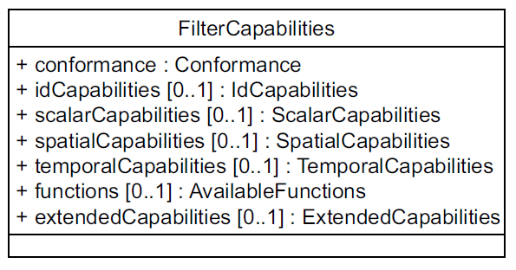
Figure 10 — FilterCapabilities
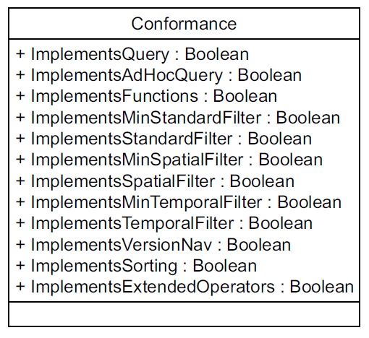
Figure 11 — Conformance
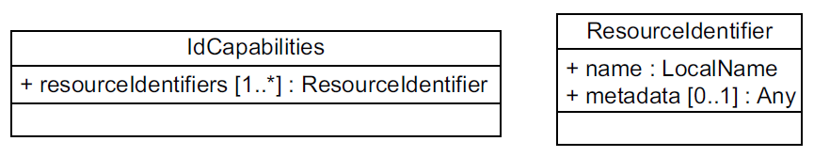
Figure 12 — IdCapabilities
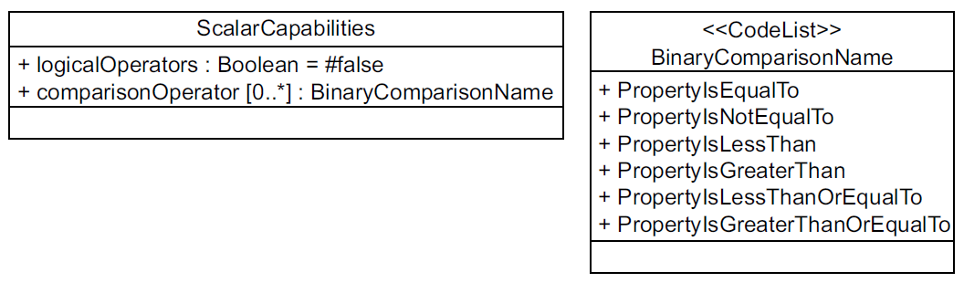
Figure 13 — ScalarCapabilities
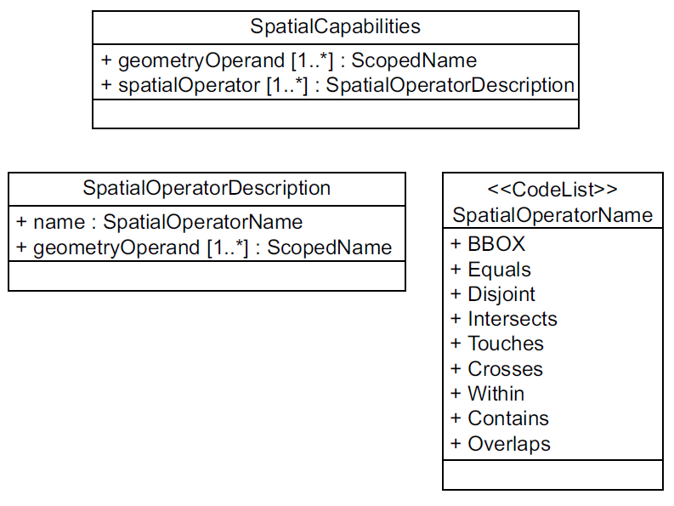
Figure 14 — SpatialCapabilities
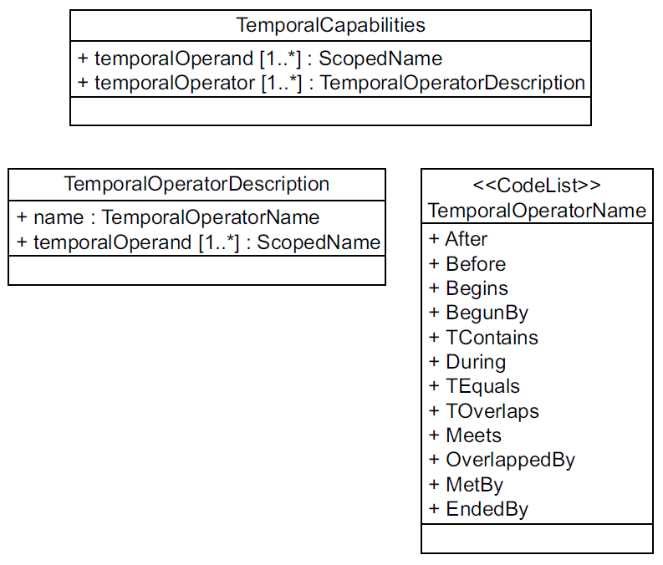
Figure 15 — TemporalCapabilities
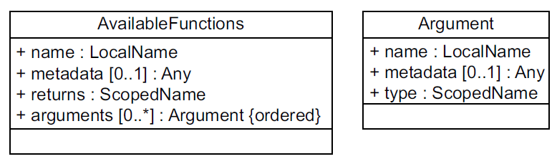
Figure 16 — AvailableFunction
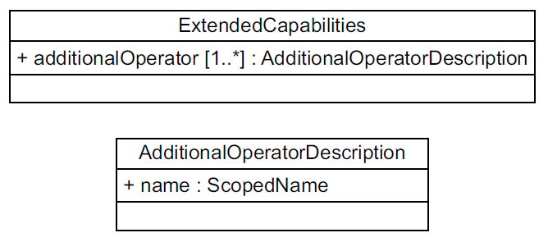
Figure 17 — ExtendedCapabilities

Encoding

Capability categories
Filter capabilities are divided into five categories: id capabilities, scalar capabilities, spatial capabilities, temporal capabilities and the ability to test the schema of a resource for the existence or absence of a named property. The following XML Schema fragment defines the root element of the filter capabilities:
<xsd:element name="Filter_Capabilities">
<xsd:complexType>
<xsd:sequence>
<xsd:element name="Conformance"
Type="fes:ConformanceType"/>
<xsd:element name="Id_Capabilities"
type="fes:Id_CapabilitiesType"
minOccurs="0"/>
<xsd:element name="Scalar_Capabilities"
type="fes:Scalar_CapabilitiesType"
minOccurs="0"/>
<xsd:element name="Spatial_Capabilities"
type="fes:Spatial_CapabilitiesType"
minOccurs="0"/>
<xsd:element name="Temporal_Capabilities"
type="fes:Temporal_CapabilitiesType"
minOccurs="0"/>
<xsd:element name="Functions"
type="fes:AvailableFunctionsType"
minOccurs="0"/>
<xsd:element name="Extended_Capabilities"
type="fes:Extended_CapabilitiesType"
minOccurs="0"/>
</xsd:sequence>
</xsd:complexType>
</xsd:element>

Conformance clause
The conformance clauses/subclauses shall be used to declare which conformance classes a particular implementation of this International Standard implements.
The following XML Schema fragment declares the schema of the fes:Conformance clause:
<xsd:complexType name="ConformanceType">
<xsd:sequence>
<xsd:element name="Constraint" type="ows:DomainType" maxOccurs="unbounded"/>
</xsd:sequence>
</xsd:complexType>
It is a list of ows:Constraint elements whose value is either “TRUE” or “FALSE”.
Table 5 — Names of conformance class constraints
Conformance class name (see Table 1) | Constraint name
Query | ImplementsQuery
Ad hoc query | ImplementsAdHocQuery
Functions | ImplementsFunctions
Resource Identification | ImplementsResourceld
Minimum Standard Filter | ImplementsMinStandardFilter
Standard Filter | ImplementsStandardFilter
Minimum Spatial Filter | ImplementsMinSpatialFilter
Spatial Filter | ImplementsSpatialFilter
Minimum Temporal Filter | ImplementsMinTemporalFilter
Temporal Filter | ImplementsTemporalFilter
Version navigation | ImplementsVersionNav
Sorting | ImplementsSorting
Extended Operators | ImplementsExtendedOperators
Minimum XPath | ImplementsMinimumXPath
Schema Element Function | ImplementsSchemaElementFunc

Implementations of this International Standard shall include each of the constraints listed in Table 5 settings its value to “TRUE” to indicate that the implementation implements the corresponding conformance class or “FALSE” to indicate that the implementation does not implement the conformance class.
EXAMPLE The following XML fragment illustrates a conformance section:
<fes:Conformance>
<fes:Constraint name="ImplementsQuery">
<ows:NoValues/>
<ows:DefaultValue>TRUE</ows:DefaultValue>
</fes:Constraint>
<fes:Constraint name="ImplementsAdHocQuery">
<ows:NoValues/>
<ows:DefaultValue>TRUE</ows:DefaultValue>
</fes:Constraint>
<fes:Constraint name="ImplementsMinStandardFilter">
<ows:NoValues/>
<ows:DefaultValue>TRUE</ows:DefaultValue>
</fes:Constraint>
<fes:Constraint name="ImplementsStandardFilter">
<ows:NoValues/>
<ows:DefaultValue>FALSE</ows:DefaultValue>
</fes:Constraint>
<fes:Constraint name="ImplementsMinSpatialFilter">
<ows:NoValues/>
<ows:DefaultValue>TRUE</ows:DefaultValue>
</fes:Constraint>
<fes:Constraint name="ImplementsSpatialFilter">
<ows:NoValues/>
<ows:DefaultValue>FALSE</ows:DefaultValue>
</fes:Constraint>
<fes:Constraint name="ImplementsMinTemporalFilter">
<ows:NoValues/>
<ows:DefaultValue>FALSE</ows:DefaultValue>
</fes:Constraint>
<fes:Constraint name="ImplementsVersionNav">
<ows:NoValues/>
<ows:DefaultValue>FALSE</ows:DefaultValue>
</fes:Constraint>
<fes:Constraint name="ImplementsSorting">
<ows:NoValues/>
<ows:DefaultValue>FALSE</ows:DefaultValue>
</fes:Constraint>
</fes:Conformance>

Id capabilities
This International Standard defines the element fes:ResourceId as a generic element for referencing resources by id. Implementations that reference this International Standard, however, may define their own elements for resource identifications. The resource identifiers section of the filter capabilities document allows such implementations to declare the name or names of the elements it uses for resource identifiers.
The following XML Schema fragment declares the schema of the fes:ResourceIdentifiers section:
<xsd:complexType name="Id_CapabilitiesType">
<xsd:sequence>
<xsd:element name="ResourceIdentifier"
type="fes:ResourceIdentifierType" maxOccurs="unbounded"/>
</xsd:sequence>
</xsd:complexType>
<xsd:complexType name="ResourceIdentifierType">
<xsd:sequence>
<xsd:element ref="ows:Metadata" minOccurs="0"/>
</xsd:sequence>
<xsd:attribute name="name" type="xsd:QName" use="required"/>
</xsd:complexType>
It is a list of element names that represent the resource identifier elements that the service supports. These element names shall be considered synonyms.
EXAMPLE A catalogue that implements this International Standard may include the following Id_Capabilities element within its filter capabilities document:
<fes:Id_Capabilities>
<fes:Id_Element>cat:RecordId</fes:Id_Element>
<fes:Id_Element>fes:ResourceId</fes:Id_Element>
</fes:Id_capabilities>
indicating that the service can accept the cat:RecordId or fes:ResourceId element as predicates in a filter expression.

Scalar capabilities
The fes:Scalar_Capabilities element can be specified by a service to advertise which logical, comparison and arithmetic operators the service supports. If the fes:Scalar_Capabilities element is not specified then a client shall assume that the service does not support any logical or comparison operators and does not implement any additional functions.
Scalar capabilities include the ability to process logical expressions and comparisons. The following XML Schema defines how scalar capabilities are encoded:
<xsd:complexType name="Scalar_CapabilitiesType">
<xsd:sequence>
<xsd:element ref="fes:LogicalOperators" minOccurs="0"/>
<xsd:element name="ComparisonOperators"
type="fes:ComparisonOperatorsType" minOccurs="0"/>
</xsd:sequence>
</xsd:complexType>
<xsd:complexType name="ComparisonOperatorsType">
<xsd:sequence maxOccurs="unbounded">
<xsd:element name="ComparisonOperator"
type="fes:ComparisonOperatorType"/>
</xsd:sequence>
</xsd:complexType>
The fes:LogicalOperators element is used to indicate that the filter can process And, Or and Not operators. The XML encoding for the fes:LogicalOperators element is declared by the following XML schema fragment:
<xsd:element name="LogicalOperators">
<xsd:complexType/>
</xsd:element>
The fes:ComparisonOperators element is used to indicate which comparison operators are supported by a service. The XML encoding of the fes:ComparisonOperators element is declared by the following XML Schema fragment:
<xsd:complexType name="ComparisonOperatorsType">
<xsd:sequence maxOccurs="unbounded">
<xsd:element name="ComparisonOperator"
type="fes:ComparisonOperatorType"/>
</xsd:sequence>
</xsd:complexType>
<xsd:complexType name="ComparisonOperatorType">
<xsd:attribute name="name"
type="fes:ComparisonOperatorNameType" use="required"/>
</xsd:complexType>
<xsd:simpleType name="ComparisonOperatorNameType">
<xsd:union>
<xsd:simpleType>
<xsd:restriction base="xsd:string">
<xsd:enumeration value="PropertyIsEqualTo"/>
<xsd:enumeration value="PropertyIsNotEqualTo"/>
<xsd:enumeration value="PropertyIsLessThan"/>
<xsd:enumeration value="PropertyIsGreaterThan"/>
<xsd:enumeration value="PropertyIsLessThanOrEqualTo"/>
<xsd:enumeration value="PropertyIsGreaterThanOrEqualTo"/>
<xsd:enumeration value="PropertyIsLike"/>
<xsd:enumeration value="PropertyIsNull"/>
<xsd:enumeration value="PropertyIsNil"/>
<xsd:enumeration value="PropertyIsBetween"/>
</xsd:restriction>
</xsd:simpleType>
<xsd:simpleType>
<xsd:restriction base="xsd:string">
<xsd:pattern value="extension:\w{2,}"/>
</xsd:restriction>
</xsd:simpleType>
</xsd:union>
</xsd:simpleType>
The pattern “extension:OperatorName” shall be used to list any additional comparison operators that may be added to the filter syntax (see 7.12). The token “OperatorName” is a placeholder for the actual name of the additional operator.

Spatial capabilities
The fes:Spatial_Capabilities element can be specified by a service to advertise which spatial operators and geometric operands the service supports. If the fes:Spatial_Capabilities element is not specified, a client shall assume that the service does not support any spatial operators.
A service that supports spatial filtering shall include a spatial capabilities section in its capabilities document. Spatial capabilities include the ability to filter spatial data of specified geometry types based on the definition of a bounding box (BBOX) as well as the ability to process the spatial operators declared in this International Standard: Equals, Disjoint, Touches, Within, Overlaps, Crosses, Intersects, Contains, DWithin and Beyond. Spatial capabilities are encoded according to the following XML Schema fragments:
<xsd:complexType name="Spatial_CapabilitiesType">
<xsd:sequence>
<xsd:element name="GeometryOperands"
type="fes:GeometryOperandsType"/>
<xsd:element name="SpatialOperators"
type="fes:SpatialOperatorsType"/>
</xsd:sequence>
</xsd:complexType>
<xsd:complexType name="GeometryOperandsType">
<xsd:sequence>
<xsd:element name="GeometryOperand" maxOccurs="unbounded">
<xsd:complexType>
<xsd:attribute name="name" type="xsd:QName" use="required"/>
</xsd:complexType>
</xsd:element>
</xsd:sequence>
</xsd:complexType>
<xsd:complexType name="SpatialOperatorsType">
<xsd:sequence>
<xsd:element name="SpatialOperator"
type="fes:SpatialOperatorType"
maxOccurs="unbounded"/>
</xsd:sequence>
</xsd:complexType>
<xsd:complexType name="SpatialOperatorType">
<xsd:sequence>
<xsd:element name="GeometryOperands"
type="fes:GeometryOperandsType"
minOccurs="0"/>
</xsd:sequence>
<xsd:attribute name="name" type="fes:SpatialOperatorNameType"/>
</xsd:complexType>
<xsd:simpleType name="SpatialOperatorNameType">
<xsd:union>
<xsd:simpleType>
<xsd:restriction base="xsd:string">
<xsd:enumeration value="BBOX"/>
<xsd:enumeration value="Equals"/>
<xsd:enumeration value="Disjoint"/>
<xsd:enumeration value="Intersects"/>
<xsd:enumeration value="Touches"/>
<xsd:enumeration value="Crosses"/>
<xsd:enumeration value="Within"/>
<xsd:enumeration value="Contains"/>
<xsd:enumeration value="Overlaps"/>
<xsd:enumeration value="Beyond"/>
<xsd:enumeration value="DWithin"/>
</xsd:restriction>
</xsd:simpleType>
<xsd:simpleType>
<xsd:restriction base="xsd:string">
<xsd:pattern value="extension:\w{2,}"/>
</xsd:restriction>
</xsd:simpleType>
</xsd:union>
</xsd:simpleType>
A service that implements this International Standard shall list the spatial operators and geometry operand types that it supports as the content of the fes:SpatialCapabilities element of its filter capabilities document. Geometry operands are listed using the fes:GeometryOperands element. Geometry operands can be defined globally (as the first child of the fes:Spatial_Capabilities element) indicating that all spatial operators know how to process the specified operands or locally for each spatial operator (as the content of the fes:SpatialOperator element) indicating that the specific operator knows how to process the specified operands.
The pattern “extension:OperatorName” shall be used to list any additional spatial operators that may be added to the filter syntax (see 7.12). The token “OperatorName” is a placeholder for the actual name of the additional operator.

Temporal capabilities
The fes:Temporal_Capabilities element can be specified by a service to advertise which temporal operators and temporal operands the service supports. If the fes:Temporal_Capabilities element is not specified then a client shall assume that the service does not support any temporal operators.
A service that supports temporal filtering shall include a temporal capabilities section in its capabilities document. Temporal capabilities include the ability to filter temporal data of specified temporal types based on the spatial operators declared in this International Standard: After, Before, Begins, BegunBy, TContains, During, TEquals, TOverlaps, Meets, OverlappedBy, MetBy and EndedBy.
Temporal capabilities are encoded according to the following XML Schema fragments:
<xsd:complexType name="Temporal_CapabilitiesType">
<xsd:sequence>
<xsd:element name="TemporalOperands"
type="fes:TemporalOperandsType"/>
<xsd:element name="TemporalOperators"
type="fes:TemporalOperatorsType"/>
</xsd:sequence>
</xsd:complexType>
<xsd:complexType name="TemporalOperandsType">
<xsd:sequence>
<xsd:element name="TemporalOperand" maxOccurs="unbounded">
<xsd:complexType>
<xsd:attribute name="name" type="xsd:QName" use="required"/>
</xsd:complexType>
</xsd:element>
</xsd:sequence>
</xsd:complexType>
<xsd:complexType name="TemporalOperatorsType">
<xsd:sequence>
<xsd:element name="TemporalOperator"
type="fes:TemporalOperatorType"
maxOccurs="unbounded"/>
</xsd:sequence>
</xsd:complexType>
<xsd:complexType name="TemporalOperatorType">
<xsd:sequence>
<xsd:element name="TemporalOperands"
type="fes:TemporalOperandsType"
minOccurs="0"/>
</xsd:sequence>
<xsd:attribute name="name"
type="fes:TemporalOperatorNameType" use="required"/>
</xsd:complexType>
<xsd:simpleType name="TemporalOperatorNameType">
<xsd:union>
<xsd:simpleType>
<xsd:restriction base="xsd:string">
<xsd:enumeration value="After"/>
<xsd:enumeration value="Before"/>
<xsd:enumeration value="Begins"/>
<xsd:enumeration value="BegunBy"/>
<xsd:enumeration value="TContains"/>
<xsd:enumeration value="During"/>
<xsd:enumeration value="TEquals"/>
<xsd:enumeration value="TOverlaps"/>
<xsd:enumeration value="Meets"/>
<xsd:enumeration value="OverlappedBy"/>
<xsd:enumeration value="MetBy"/>
<xsd:enumeration value="Ends"/>
<xsd:enumeration value="EndedBy"/>
</xsd:restriction>
</xsd:simpleType>
<xsd:simpleType>
<xsd:restriction base="xsd:string">
<xsd:pattern value="extension:\w{2,}"/>
</xsd:restriction>
</xsd:simpleType>
</xsd:union>
</xsd:simpleType>
An implementation of this International Standard shall list the temporal operators and temporal operand types that it supports as the content of the fes:TemporalCapabilities element of its filter capabilities document. Temporal operands are listed using the fes:TemporalOperands element. Temporal operands can be defined globally (as the first child of the fes:Temporal_Capabilities element) indicating that all temporal operators know how to process the specified operands or locally for each temporal operator (as the content of the fes:TemporalOperator element) indicating that the specific operator knows how to process the specified operands.
The pattern “extension:OperatorName” shall be used to list any additional temporal operators that may be added to the filter syntax (see 7.12). The token “OperatorName” is a placeholder for the actual name of the additional operator.

Functions
The fes:Functions element shall be used in a filter capabilities document to enumerate the function that may be used in filter expressions.
The description of each function shall include a declaration of the return type, the list of arguments with optional names and expected types. The ows:Metadata element may be used to reference detailed metadata about the function or its arguments. The following fragment defines the schema of fes:Functions element.
<xsd:complexType name="AvailableFunctionsType">
<xsd:sequence>
<xsd:element name="Function"
type="fes:AvailableFunctionType" maxOccurs="unbounded"/>
</xsd:sequence>
</xsd:complexType>
<xsd:complexType name="AvailableFunctionType">
<xsd:sequence>
<xsd:element ref="ows:Metadata" minOccurs="0"/>
<xsd:element name="Returns" type="xsd:QName"/>
<xsd:element name="Arguments"
type="fes:ArgumentsType" minOccurs="0"/>
</xsd:sequence>
<xsd:attribute name="name" type="xsd:string" use="required"/>
</xsd:complexType>
<xsd:complexType name="ArgumentsType">
<xsd:sequence>
<xsd:element name="Argument"
type="fes:ArgumentType" maxOccurs="unbounded"/>
</xsd:sequence>
</xsd:complexType>
<xsd:complexType name="ArgumentType">
<xsd:sequence>
<xsd:element ref="ows:Metadata" minOccurs="0"/>
<xsd:element name="Type" type="xsd:QName"/>
</xsd:sequence>
<xsd:attribute name="name" type="xsd:string" use="required"/>
</xsd:complexType>

Extended capabilities
The fes:Extended_Capabilities element may be specified within a service's filter capabilities document to advertise any additional operators that standards that reference this International Standard might add to the filter syntax.
The following XML Schema fragment defines the schema of the fes:Extended_Capabilities element:
<xsd:complexType name="Extended_CapabilitiesType">
<xsd:sequence>
<xsd:element name="AdditionalOperators"
type="fes:AdditionalOperatorsType" minOccurs="0"/>
</xsd:sequence>
</xsd:complexType>
<xsd:complexType name="AdditionalOperatorsType">
<xsd:sequence>
<xsd:element name="Operator"
type="fes:ExtensionOperatorType"
minOccurs="0" maxOccurs="unbounded"/>
</xsd:sequence>
</xsd:complexType>
<xsd:complexType name="ExtensionOperatorType">
<xsd:attribute name="name" type="xsd:QName" use="required"/>
</xsd:complexType>
Any additional operators added to the filter syntax shall be advertised in the extended capabilities section of the filter capabilities document. This extended capabilities section contains a list of additional operator names. How new operators can be added to the filter syntax is described in 7.12.3.

Sorting

General considerations
The fes:SortBy element (see Figure 18) is an optional part of a service-specific query and is included in the normative set of Filter schema files (i.e. “sort.xsd”).
The fes:SortBy element is used to specify property names whose values shall be used to order
(upon presentation) the set of resources that satisfy a filter expression.
The fes:SortBy element is provided as an entry point to invoke the sorting mechanism of the filter expression processor. The sorting mechanism is not specified in this International Standard. The only requirement is that the sort sequence shall be consistent, given the same data set and sort request, between consecutive invocations of the sort.
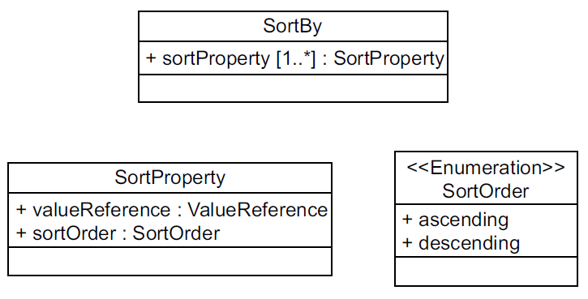
Figure 18 — SortBy

Encoding
The XML encoding for sorting is defined by the following XML Schema fragment:
<xsd:element name="SortBy"
type="fes:SortByType"/>
<xsd:complexType name="SortByType">
<xsd:sequence>
<xsd:element name="SortProperty"
type="fes:SortPropertyType" maxOccurs="unbounded"/>
</xsd:sequence>
</xsd:complexType>
<xsd:complexType name="SortPropertyType">
<xsd:sequence>
<xsd:element ref="fes:ValueReference"/>
<xsd:element name="SortOrder" type="fes:SortOrderType" minOccurs="0"/>
</xsd:sequence>
</xsd:complexType>
<xsd:simpleType name="SortOrderType">
<xsd:restriction base="xsd:string">
<xsd:enumeration value="DESC"/>
<xsd:enumeration value="ASC"/>
</xsd:restriction>
</xsd:simpleType>
The fes:SortBy element shall have a minimum of one and an unbounded number of fes:SortProperty child elements. In the event that multiple fes:SortProperty elements exist, the sequence of the fes:SortProperty elements shall determine the order of ordering. The fes:SortProperty element shall have a single fes:PropertyName child element and an optional fes:SortOrder child element. The fes:SortOrder element shall have a value of either “ASC” or “DESC”. The value “ASC” shall indicate that an ascending sort, in the collation sequence of the underlying data store, be performed. The value “DESC” shall indicate that a descending sort, in the collation sequence of the filter expression processor, be performed. In the event that fes:SortOrder is not included within the fes:SortProperty element of a request, the service shall assume a sort order of ASC.

Exceptions
In the event that the fes:ValueReference element contains a reference to a value of an unknown resource type, the service shall raise an InvalidParameterValue (as given in OGC 06-121r3, Table 25) exception.
In the event that the fes:ValueReference element contains a reference to a value of a known resource type but that value if not defined for the resource type being queried, the service shall raise an InvalidParameterValue (as given in OGC 06-121r3, Table 25) exception.
In the event that multiple fes:SortProperty elements are specified whose fes:ValueReference elements reference the same value, the service shall raise a DuplicateSortKey exception with the exception locator (as given in OGC 06-121r3, 8.4) indicating the duplicate value reference.

- (normative)
Conformance testing
  - Test cases for query
- Test purpose: verify the correct use of query elements.
- Test method: verify that a concrete element is materialized that is substitutable for fes:AbstractQueryElement. Use that element to submit query requests and check that the query operation works according to its description.
- Reference: 6.2.
- Test type: basic test.
  - Test cases for ad hoc query
- Test purpose: verify the correct use of XML-encoded and KVP-encoded ad hoc query elements.
- Test method: verify that concrete elements are materialized that are substitutable for fes:AbstractAdhocQuery, fes:AbstractSelectionClause, fes:AbstractProjectionClause and fes:AbstractSortingClause. Use those concrete elements to formulate and submit ad hoc query requests and check that that ad hoc query requests work according to their description. Verify that the server implements KVP-encoded ad hoc queries. Submit KVP-encoded ad hoc query requests and check that the ad hoc query operations work according to their description.
- Reference: 6.3.2, 6.3.3.
- Test type: basic test.
  - Test cases for functions
- Test purpose: verify that additional functions are defined and verify their correct use.
- Test method: verify that one or more functions are listed in the filter capabilities document. Submit requests and check that the additional filter functions operate according to their description.
- Reference: 7.6, 7.14.7.
- Test type: basic Test.
  - Test cases for resource identification
- Test purpose: verify the correct use of the resource identification operator.
- Test method: submit requests that query specific instances of resource and check that the ResourceId operator operates according to its description.
- Reference: 7.11.
- Test type: basic test.
  - Test cases for minimum standard filter
- Test purpose: verify the correct use of comparison and logical operators.
- Test method: verify that the operators PropertyIsEqualTo, PropertyIsNotEqualTo, PropertyIsLessThan, PropertyIsGreaterThan, PropertyIsLessThanOrEqualTo, PropertyIsGreaterThanOrEqualTo are listed in the filter capabilities document. Verify that all the logical operators are listed in the filter capabilities document. Submit requests and check that the implemented comparison and logical operators work according to their description.
- Reference: 7.7.3, 7.7.3.2, 7.7.3.3, 7.10, 7.14.4.
- Test type: basic test.
  - Test cases for standard filter
- Test purpose: verify the correct use of additional comparison operators.
- Test method: verify that the Minimum Standard Filter conformance class (see A.4) is satisfied. Verify that the operators PropertyIsNull, PropertyIsNil, PropertyIsLike and PropertyIsBetween are listed in the filter capabilities document. Submit requests and check that the operators work according to their description.
- Reference: 7.7.3.4, 7.7.3.5, 7.7.3.6, 7.7.3.7, 7.14.4.
- Test type: basic test.
  - Test cases for minimum spatial filter
- Test purpose: verify the correct use of the BBOX operator.
- Test method: verify that the BBOX operator is listed in the filter capabilities document. Submit requests and check that the BBOX operator works according to its description.
- Reference: 7.8.3.2.
- Test type: basic test.
  - Test cases for spatial filter
- Test purpose: verify the correct use of additional spatial operators.
- Test method: verify that the Minimum Spatial Filter conformance class is satisfied. Verify that one or more additional spatial operators are listed in the filter capabilities document. Submit requests and check that the additional spatial operators work according to their description.
- Reference: 7.8.2, 7.8.3, 7.8.3.3, 7.8.4, 7.14.5.
- Test type: basic test.
  - Test cases for minimum temporal filter
- Test purpose: verify the correct use of the During operator.
- Test method: verify that the During operator is listed in the filter capabilities document. Submit requests and check that the During operator works according to its description.
- Reference: 7.9.2, 7.9.3, 7.14.6.
- Test type: basic test.
  - Test cases for temporal filter
- Test purpose: verify the correct use of additional temporal operators.
- Test method: verify that the Minimum Temporal Filter conformance class is satisfied. Verify that one or more additional temporal operators are listed in the filter capabilities document. Submit requests and check that the additional temporal operators work according to their description.
- Reference: 7.9.2, 7.9.3, 7.14.6.
- Test type: basic test.
  - Test cases for version navigation
- Test purpose: verify the ability to navigate feature versions using the fes:ResourceId version navigation capability.
- Test method: submit requests and check that the operations work according to their description.
- Reference: 7.11.
- Test type: basic test.
  - Test cases for sorting
- Test purpose: verify the correct use of sorting.
- Test method: submit requests and check that the operations work according to their description.
- Reference: OGC 09-026R1, Clause 8.
- Test type: basic test.
  - Test cases for extended operators
- Test purpose: verify the correct use of extended operators.
- Test method: verify that a list of extended operators in presented in the filter capabilities document. Submit requests to check that the extended operators work according to their description.
- Reference: 7.12.3,7.14.8.
- Test type: basic test.
  - Test cases for XPath
- Test purpose: verify that the correct use of the minimum set of XPath capabilities.
- Test method: submit requests to check that XPath processing operates according to its description.
- Reference: 7.4.4.
- Test type: basic test.
  - Test cases for schema-element() function
- Test purpose: verify the correct use of the schema-element() XPath function.
- Test method: verify that the Minimum XPath conformance class is satisfied. Submit requests that use the schema-element() function and check that the function operates according to its description.
- Reference: 7.4.4, A.14.
- Test type: basic test.

- (informative)
Filter schema definitions
  - General considerations
The XML schema fragments presented in this International Standard are gathered in this annex and factored into files that may be used to validate XML-encoded query and filter expressions.
  - Schema files
    - expr.xsd
<?xml version="1.0" encoding="UTF-8"?>
<xsd:schema
targetNamespace="http://www.opengis.net/fes/2.0"
xmlns:fes="http://www.opengis.net/fes/2.0"
xmlns:xsd="http://www.w3.org/2001/XMLSchema"
elementFormDefault="qualified"
version="2.0.2">

<xsd:element name="expression" abstract="true"/>

<xsd:element name="ValueReference" type="xsd:string"
substitutionGroup="fes:expression"/>

<xsd:element name="Function" type="fes:FunctionType"
substitutionGroup="fes:expression"/>
<xsd:complexType name="FunctionType">
<xsd:sequence>
<xsd:element ref="fes:expression"
minOccurs="0" maxOccurs="unbounded"/>
</xsd:sequence>
<xsd:attribute name="name" type="xsd:string" use="required"/>
</xsd:complexType>

<xsd:element name="Literal" type="fes:LiteralType"
substitutionGroup="fes:expression"/>
<xsd:complexType name="LiteralType" mixed="true">
<xsd:sequence>
<xsd:any minOccurs="0"/>
</xsd:sequence>
<xsd:attribute name="type" type="xsd:QName"/>
</xsd:complexType>
</xsd:schema>
    - filter.xsd
<?xml version="1.0" encoding="UTF-8"?>
<xsd:schema
targetNamespace="http://www.opengis.net/fes/2.0"
xmlns:fes="http://www.opengis.net/fes/2.0"
xmlns:xsd="http://www.w3.org/2001/XMLSchema"
elementFormDefault="qualified"
version="2.0.2">

<xsd:include schemaLocation="expr.xsd"/>
<xsd:include schemaLocation="query.xsd"/>
<xsd:include schemaLocation="filterCapabilities.xsd"/>

<xsd:element name="Filter"
type="fes:FilterType"
substitutionGroup="fes:AbstractSelectionClause"/>
<xsd:complexType name="FilterType">
<xsd:complexContent>
<xsd:extension base="fes:AbstractSelectionClauseType">
<xsd:sequence>
<xsd:group ref="fes:FilterPredicates"/>
</xsd:sequence>
</xsd:extension>
</xsd:complexContent>
</xsd:complexType>

<!-- =================================================================== -->
<!-- FILTER PREDICATES -->
<!-- =================================================================== -->
<xsd:group name="FilterPredicates">
<xsd:choice>
<xsd:element ref="fes:comparisonOps"/>
<xsd:element ref="fes:spatialOps"/>
<xsd:element ref="fes:temporalOps"/>
<xsd:element ref="fes:logicOps"/>
<xsd:element ref="fes:extensionOps"/>
<xsd:element ref="fes:Function"/>
<xsd:element ref="fes:_Id" maxOccurs="unbounded"/>
</xsd:choice>
</xsd:group>

<!-- =================================================================== -->
<!-- COMPARISON OPERATORS -->
<!-- =================================================================== -->
<xsd:element name="comparisonOps"
type="fes:ComparisonOpsType"
abstract="true"/>
<xsd:complexType name="ComparisonOpsType" abstract="true"/>
<xsd:element name="PropertyIsEqualTo"
type="fes:BinaryComparisonOpType"
substitutionGroup="fes:comparisonOps"/>
<xsd:element name="PropertyIsNotEqualTo"
type="fes:BinaryComparisonOpType"
substitutionGroup="fes:comparisonOps"/>
<xsd:element name="PropertyIsLessThan"
type="fes:BinaryComparisonOpType"
substitutionGroup="fes:comparisonOps"/>
<xsd:element name="PropertyIsGreaterThan"
type="fes:BinaryComparisonOpType"
substitutionGroup="fes:comparisonOps"/>
<xsd:element name="PropertyIsLessThanOrEqualTo"
type="fes:BinaryComparisonOpType"
substitutionGroup="fes:comparisonOps"/>
<xsd:element name="PropertyIsGreaterThanOrEqualTo"
type="fes:BinaryComparisonOpType"
substitutionGroup="fes:comparisonOps"/>
<xsd:element name="PropertyIsLike"
type="fes:PropertyIsLikeType"
substitutionGroup="fes:comparisonOps"/>
<xsd:element name="PropertyIsNull"
type="fes:PropertyIsNullType"
substitutionGroup="fes:comparisonOps"/>
<xsd:element name="PropertyIsNil"
type="fes:PropertyIsNilType"
substitutionGroup="fes:comparisonOps"/>
<xsd:element name="PropertyIsBetween"
type="fes:PropertyIsBetweenType"
substitutionGroup="fes:comparisonOps"/>

<!-- =================================================================== -->
<!-- SPATIAL OPERATORS -->
<!-- =================================================================== -->
<xsd:element name="spatialOps" type="fes:SpatialOpsType" abstract="true"/>
<xsd:complexType name="SpatialOpsType" abstract="true"/>
<xsd:element name="Equals"
type="fes:BinarySpatialOpType"
substitutionGroup="fes:spatialOps"/>
<xsd:element name="Disjoint"
type="fes:BinarySpatialOpType"
substitutionGroup="fes:spatialOps"/>
<xsd:element name="Touches"
type="fes:BinarySpatialOpType"
substitutionGroup="fes:spatialOps"/>
<xsd:element name="Within"
type="fes:BinarySpatialOpType"
substitutionGroup="fes:spatialOps"/>
<xsd:element name="Overlaps"
type="fes:BinarySpatialOpType"
substitutionGroup="fes:spatialOps"/>
<xsd:element name="Crosses"
type="fes:BinarySpatialOpType"
substitutionGroup="fes:spatialOps"/>
<xsd:element name="Intersects"
type="fes:BinarySpatialOpType"
substitutionGroup="fes:spatialOps"/>
<xsd:element name="Contains"
type="fes:BinarySpatialOpType"
substitutionGroup="fes:spatialOps"/>
<xsd:element name="DWithin"
type="fes:DistanceBufferType"
substitutionGroup="fes:spatialOps"/>
<xsd:element name="Beyond"
type="fes:DistanceBufferType"
substitutionGroup="fes:spatialOps"/>
<xsd:element name="BBOX"
type="fes:BBOXType"
substitutionGroup="fes:spatialOps"/>

<!-- =================================================================== -->
<!-- TEMPORAL OPERATORS -->
<!-- =================================================================== -->
<xsd:element name="temporalOps" type="fes:TemporalOpsType" abstract="true"/>
<xsd:complexType name="TemporalOpsType" abstract="true"/>
<xsd:element name="After"
type="fes:BinaryTemporalOpType"
substitutionGroup="fes:temporalOps"/>
<xsd:element name="Before"
type="fes:BinaryTemporalOpType"
substitutionGroup="fes:temporalOps"/>
<xsd:element name="Begins"
type="fes:BinaryTemporalOpType"
substitutionGroup="fes:temporalOps"/>
<xsd:element name="BegunBy"
type="fes:BinaryTemporalOpType"
substitutionGroup="fes:temporalOps"/>
<xsd:element name="TContains"
type="fes:BinaryTemporalOpType"
substitutionGroup="fes:temporalOps"/>
<xsd:element name="During"
type="fes:BinaryTemporalOpType"
substitutionGroup="fes:temporalOps"/>
<xsd:element name="EndedBy"
type="fes:BinaryTemporalOpType"
substitutionGroup="fes:temporalOps"/>
<xsd:element name="Ends"
type="fes:BinaryTemporalOpType"
substitutionGroup="fes:temporalOps"/>
<xsd:element name="TEquals"
type="fes:BinaryTemporalOpType"
substitutionGroup="fes:temporalOps"/>
<xsd:element name="Meets"
type="fes:BinaryTemporalOpType"
substitutionGroup="fes:temporalOps"/>
<xsd:element name="MetBy"
type="fes:BinaryTemporalOpType"
substitutionGroup="fes:temporalOps"/>
<xsd:element name="TOverlaps"
type="fes:BinaryTemporalOpType"
substitutionGroup="fes:temporalOps"/>
<xsd:element name="OverlappedBy"
type="fes:BinaryTemporalOpType"
substitutionGroup="fes:temporalOps"/>
<xsd:element name="AnyInteracts"
type="fes:BinaryTemporalOpType"
substitutionGroup="fes:temporalOps"/>

<!-- =================================================================== -->
<!-- LOGICAL OPERATORS -->
<!-- =================================================================== -->
<xsd:element name="logicOps" type="fes:LogicOpsType" abstract="true"/>
<xsd:complexType name="LogicOpsType" abstract="true"/>
<xsd:element name="And"
type="fes:BinaryLogicOpType"
substitutionGroup="fes:logicOps"/>
<xsd:element name="Or"
type="fes:BinaryLogicOpType"
substitutionGroup="fes:logicOps"/>
<xsd:element name="Not"
type="fes:UnaryLogicOpType"
substitutionGroup="fes:logicOps"/>

<!-- =================================================================== -->
<!-- EXTENSION OPERATORS -->
<!-- =================================================================== -->
<xsd:element name="extensionOps"
type="fes:ExtensionOpsType"
abstract="true"/>
<xsd:complexType name="ExtensionOpsType" abstract="true"/>

<!-- =================================================================== -->
<!-- OBJECT/RECORDS IDENTIFIERS -->
<!-- =================================================================== -->
<xsd:element name="_Id" type="fes:AbstractIdType" abstract="true"/>
<xsd:complexType name="AbstractIdType" abstract="true"/>

<!-- =================================================================== -->
<!-- CONCRETE OBJECT IDENTIFIERS -->
<!-- =================================================================== -->
<xsd:element name="ResourceId"
type="fes:ResourceIdType"
substitutionGroup="fes:_Id"/>
<xsd:complexType name="ResourceIdType">
<xsd:complexContent>
<xsd:extension base="fes:AbstractIdType">
<xsd:attribute name="rid" type="xsd:string" use="required"/>
<xsd:attribute name="previousRid" type="xsd:string"/>
<xsd:attribute name="version" type="fes:VersionType"/>
<xsd:attribute name="startDate" type="xsd:dateTime"/>
<xsd:attribute name="endDate" type="xsd:dateTime"/>
</xsd:extension>
</xsd:complexContent>
</xsd:complexType>
<xsd:simpleType name="VersionType">
<xsd:union memberTypes="fes:VersionActionTokens
xsd:positiveInteger
xsd:dateTime">
<xsd:annotation>
<xsd:documentation>
Allows navigation of versioned resources.
Can be the tokens FIRST,LAST,PREVIOUS,NEXT,ALL relative
to the specified rid. It is up to the WFS to arrange
for the version id to be hashed into the RID.
Can be an integer indicating which version of a
feature to fetch. 1=first, 2=second, etc...
Can be a
</xsd:documentation>
</xsd:annotation>
</xsd:union>
</xsd:simpleType>
<xsd:simpleType name="VersionActionTokens">
<xsd:restriction base="xsd:string">
<xsd:enumeration value="FIRST"/>
<xsd:enumeration value="LAST"/>
<xsd:enumeration value="PREVIOUS"/>
<xsd:enumeration value="NEXT"/>
<xsd:enumeration value="ALL"/>
</xsd:restriction>
</xsd:simpleType>

<!-- =================================================================== -->
<!-- TYPE DECLARATIONS -->
<!-- =================================================================== -->
<xsd:complexType name="BinaryComparisonOpType">
<xsd:complexContent>
<xsd:extension base="fes:ComparisonOpsType">
<xsd:sequence>
<xsd:element ref="fes:expression" minOccurs="2" maxOccurs="2"/>
</xsd:sequence>
<xsd:attribute name="matchCase" type="xsd:boolean"
use="optional" default="true"/>
<xsd:attribute name="matchAction" type="fes:MatchActionType"
use="optional" default="Any"/>
</xsd:extension>
</xsd:complexContent>
</xsd:complexType>
<xsd:simpleType name="MatchActionType">
<xsd:restriction base="xsd:string">
<xsd:enumeration value="All"/>
<xsd:enumeration value="Any"/>
<xsd:enumeration value="One"/>
</xsd:restriction>
</xsd:simpleType>
<xsd:complexType name="PropertyIsLikeType">
<xsd:complexContent>
<xsd:extension base="fes:ComparisonOpsType">
<xsd:sequence>
<xsd:element ref="fes:expression" minOccurs="2" maxOccurs="2"/>
</xsd:sequence>
<xsd:attribute name="wildCard" type="xsd:string" use="required"/>
<xsd:attribute name="singleChar" type="xsd:string" use="required"/>
<xsd:attribute name="escapeChar" type="xsd:string" use="required"/>
</xsd:extension>
</xsd:complexContent>
</xsd:complexType>
<xsd:complexType name="PropertyIsNullType">
<xsd:complexContent>
<xsd:extension base="fes:ComparisonOpsType">
<xsd:sequence>
<xsd:element ref="fes:expression" minOccurs="0"/>
</xsd:sequence>
</xsd:extension>
</xsd:complexContent>
</xsd:complexType>
<xsd:complexType name="PropertyIsNilType">
<xsd:complexContent>
<xsd:extension base="fes:ComparisonOpsType">
<xsd:sequence>
<xsd:element ref="fes:expression" minOccurs="0"/>
</xsd:sequence>
<xsd:attribute name="nilReason" type="xsd:string"/>
</xsd:extension>
</xsd:complexContent>
</xsd:complexType>
<xsd:complexType name="PropertyIsBetweenType">
<xsd:complexContent>
<xsd:extension base="fes:ComparisonOpsType">
<xsd:sequence>
<xsd:element ref="fes:expression"/>
<xsd:element name="LowerBoundary" type="fes:LowerBoundaryType"/>
<xsd:element name="UpperBoundary" type="fes:UpperBoundaryType"/>
</xsd:sequence>
</xsd:extension>
</xsd:complexContent>
</xsd:complexType>
<xsd:complexType name="LowerBoundaryType">
<xsd:choice>
<xsd:element ref="fes:expression"/>
</xsd:choice>
</xsd:complexType>
<xsd:complexType name="UpperBoundaryType">
<xsd:sequence>
<xsd:element ref="fes:expression"/>
</xsd:sequence>
</xsd:complexType>
<xsd:complexType name="BinarySpatialOpType">
<xsd:complexContent>
<xsd:extension base="fes:SpatialOpsType">
<xsd:choice maxOccurs="2">

<xsd:element ref="fes:expression"/>
<xsd:any namespace="##other"/>

</xsd:choice>
</xsd:extension>
</xsd:complexContent>
</xsd:complexType>
<xsd:complexType name="BinaryTemporalOpType">
<xsd:complexContent>
<xsd:extension base="fes:TemporalOpsType">
<xsd:choice maxOccurs="2">

<xsd:element ref="fes:expression"/>
<xsd:any namespace="##other"/>

</xsd:choice>
</xsd:extension>
</xsd:complexContent>
</xsd:complexType>
<xsd:complexType name="BBOXType">
<xsd:complexContent>
<xsd:extension base="fes:SpatialOpsType">
<xsd:choice maxOccurs="2">

<xsd:element ref="fes:expression"/>
<xsd:any namespace="##other"/>

</xsd:choice>
</xsd:extension>
</xsd:complexContent>
</xsd:complexType>
<xsd:complexType name="DistanceBufferType">
<xsd:complexContent>
<xsd:extension base="fes:SpatialOpsType">
<xsd:sequence>
<xsd:choice maxOccurs="2">

<xsd:element ref="fes:expression">
<xsd:any namespace="##other"/>

<xsd:choice>
<xsd:element name="Distance" type="fes:MeasureType"/>
</xsd:sequence>
</xsd:extension>
</xsd:complexContent>
</xsd:complexType>
<xsd:complexType name="BinaryLogicOpType">
<xsd:complexContent>
<xsd:extension base="fes:LogicOpsType">
<xsd:choice minOccurs="2" maxOccurs="unbounded">
<xsd:group ref="fes:FilterPredicates"/>
</xsd:choice>
</xsd:extension>
</xsd:complexContent>
</xsd:complexType>
<xsd:complexType name="UnaryLogicOpType">
<xsd:complexContent>
<xsd:extension base="fes:LogicOpsType">
<xsd:sequence>
<xsd:choice>
<xsd:group ref="fes:FilterPredicates"/>
</xsd:choice>
</xsd:sequence>
</xsd:extension>
</xsd:complexContent>
</xsd:complexType>
<xsd:complexType name="MeasureType">
<xsd:simpleContent>
<xsd:extension base="xsd:double">
<xsd:attribute name="uom" type="fes:UomIdentifier" use="required"/>
</xsd:extension>
</xsd:simpleContent>
</xsd:complexType>
<xsd:simpleType name="UomIdentifier">
<xsd:union memberTypes="fes:UomSymbol fes:UomURI"/>
</xsd:simpleType>
<xsd:simpleType name="UomSymbol">
</xsd:annotation>
<xsd:restriction base="xsd:string">
<xsd:pattern value="[^: \n\r\t]+"/>
</xsd:restriction>
</xsd:simpleType>
<xsd:simpleType name="UomURI">
</xsd:annotation>
<xsd:restriction base="xsd:anyURI">
<xsd:pattern value="([a-zA-Z][a-zA-Z0-9\-\+\.]*:|\.\./|\./|#).*"/>
</xsd:restriction>
</xsd:simpleType>
</xsd:schema>
    - query.xsd
<?xml version="1.0" encoding="UTF-8"?>
<xsd:schema
targetNamespace="http://www.opengis.net/fes/2.0"
xmlns:fes="http://www.opengis.net/fes/2.0"
xmlns:xsd="http://www.w3.org/2001/XMLSchema"
elementFormDefault="qualified"
version="2.0.2">

<xsd:element name="AbstractQueryExpression"
type="fes:AbstractQueryExpressionType" abstract="true"/>
<xsd:complexType name="AbstractQueryExpressionType" abstract="true">
<xsd:attribute name="handle" type="xsd:string"/>
</xsd:complexType>

<xsd:element name="AbstractAdhocQueryExpression"
type="fes:AbstractAdhocQueryExpressionType"
substitutionGroup="fes:AbstractQueryExpression"
abstract="true"/>
<xsd:complexType name="AbstractAdhocQueryExpressionType" abstract="true">
<xsd:complexContent>
<xsd:extension base="fes:AbstractQueryExpressionType">
<xsd:sequence>
<xsd:element ref="fes:AbstractProjectionClause"
minOccurs="0" maxOccurs="unbounded"/>
<xsd:element ref="fes:AbstractSelectionClause" minOccurs="0"/>
<xsd:element ref="fes:AbstractSortingClause" minOccurs="0"/>
</xsd:sequence>
<xsd:attribute name="typeNames"
type="fes:TypeNamesListType" use="required"/>
<xsd:attribute name="aliases"
type="fes:AliasesType"/>
</xsd:extension>
</xsd:complexContent>
</xsd:complexType>

<xsd:simpleType name="TypeNamesListType">
<xsd:list itemType="fes:TypeNamesType"/>
</xsd:simpleType>
<xsd:simpleType name="TypeNamesType">
<xsd:union memberTypes="fes:SchemaElement xsd:QName"/>
</xsd:simpleType>
<xsd:simpleType name="SchemaElement">
<xsd:restriction base="xsd:string">
<xsd:pattern value="schema\-element\(.+\)"/>
</xsd:restriction>
</xsd:simpleType>
<xsd:simpleType name="AliasesType">
<xsd:list itemType="xsd:NCName"/>
</xsd:simpleType>

<xsd:element name="AbstractProjectionClause" abstract="true"/>
<xsd:complexType name="AbstractProjectionClauseType" abstract="true"/>

<xsd:element name="AbstractSelectionClause" abstract="true"/>
<xsd:complexType name="AbstractSelectionClauseType" abstract="true"/>

<xsd:element name="AbstractSortingClause" abstract="true"/>
<xsd:complexType name="AbstractSortingClauseType" abstract="true"/>

</xsd:schema>
    - sort.xsd
<?xml version="1.0" encoding="UTF-8"?>
<xsd:schema
targetNamespace="http://www.opengis.net/fes/2.0"
xmlns:fes="http://www.opengis.net/fes/2.0"
xmlns:xsd="http://www.w3.org/2001/XMLSchema"
elementFormDefault="qualified"
version="2.0.2">

<xsd:include schemaLocation="query.xsd"/>
<xsd:include schemaLocation="expr.xsd"/>

<!-- ============================================= -->
<!-- SORTBY EXPRESSION -->
<!-- ============================================= -->
<xsd:element name="SortBy"
type="fes:SortByType"
substitutionGroup="fes:AbstractSortingClause"/>

<!-- ============================================= -->
<!-- COMPLEX TYPES -->
<!-- ============================================= -->
<xsd:complexType name="SortByType">
<xsd:sequence>
<xsd:element name="SortProperty"
type="fes:SortPropertyType" maxOccurs="unbounded"/>
</xsd:sequence>
</xsd:complexType>
<xsd:complexType name="SortPropertyType">
<xsd:sequence>
<xsd:element ref="fes:ValueReference"/>
<xsd:element name="SortOrder" type="fes:SortOrderType" minOccurs="0"/>
</xsd:sequence>
</xsd:complexType>
<xsd:simpleType name="SortOrderType">
<xsd:restriction base="xsd:string">
<xsd:enumeration value="DESC"/>
<xsd:enumeration value="ASC"/>
</xsd:restriction>
</xsd:simpleType>
</xsd:schema>
    - filterCapabilities.xsd
<?xml version="1.0" encoding="UTF-8"?>
<xsd:schema
targetNamespace="http://www.opengis.net/fes/2.0"
xmlns:fes="http://www.opengis.net/fes/2.0"
xmlns:ows="http://www.opengis.net/ows/1.1"
xmlns:xsd="http://www.w3.org/2001/XMLSchema"
xmlns:xml="http://www.w3.org/XML/1998/namespace"
elementFormDefault="qualified"
version="2.0.2">

<xsd:import namespace="http://www.w3.org/XML/1998/namespace"
schemaLocation="http://www.w3.org/2001/xml.xsd"/>

<xsd:import namespace="http://www.opengis.net/ows/1.1"
schemaLocation="../../ows/1.1.0/owsAll.xsd"/>

<xsd:element name="Filter_Capabilities">
<xsd:complexType>
<xsd:sequence>
<xsd:element name="Conformance"
type="fes:ConformanceType"/>
<xsd:element name="Id_Capabilities"
type="fes:Id_CapabilitiesType"/>
<xsd:element name="Scalar_Capabilities"
type="fes:Scalar_CapabilitiesType"
minOccurs="0"/>
<xsd:element name="Spatial_Capabilities"
type="fes:Spatial_CapabilitiesType"
minOccurs="0"/>
<xsd:element name="Temporal_Capabilities"
type="fes:Temporal_CapabilitiesType"
minOccurs="0"/>
<xsd:element name="Functions"
type="fes:AvailableFunctionsType" minOccurs="0"/>
<xsd:element name="Extended_Capabilities"
type="fes:Extended_CapabilitiesType"
minOccurs="0"/>
</xsd:sequence>
</xsd:complexType>
</xsd:element>

<!-- CONFORMANCE -->
<xsd:complexType name="ConformanceType">
<xsd:sequence>
<xsd:element name="Constraint" type="ows:DomainType" maxOccurs="unbounded"/>
</xsd:sequence>
</xsd:complexType>

<!-- RESOURCE IDENTIFIERS -->
<xsd:complexType name="Id_CapabilitiesType">
<xsd:sequence>
<xsd:element name="ResourceIdentifier"
type="fes:ResourceIdentifierType" maxOccurs="unbounded"/>
</xsd:sequence>
</xsd:complexType>
<xsd:complexType name="ResourceIdentifierType">
<xsd:sequence>
<xsd:element ref="ows:Metadata" minOccurs="0"/>
</xsd:sequence>
<xsd:attribute name="name" type="xsd:QName" use="required"/>
</xsd:complexType>

<!-- SCALAR CAPABILITIES -->
<xsd:complexType name="Scalar_CapabilitiesType">
<xsd:sequence>
<xsd:element ref="fes:LogicalOperators" minOccurs="0"/>
<xsd:element name="ComparisonOperators"
type="fes:ComparisonOperatorsType" minOccurs="0"/>
</xsd:sequence>
</xsd:complexType>
<xsd:element name="LogicalOperators">
<xsd:complexType/>
</xsd:element>
<xsd:complexType name="ComparisonOperatorsType">
<xsd:sequence maxOccurs="unbounded">
<xsd:element name="ComparisonOperator"
type="fes:ComparisonOperatorType"/>
</xsd:sequence>
</xsd:complexType>
<xsd:complexType name="ComparisonOperatorType">
<xsd:attribute name="name"
type="fes:ComparisonOperatorNameType" use="required"/>
</xsd:complexType>
<xsd:simpleType name="ComparisonOperatorNameType">
<xsd:union>
<xsd:simpleType>
<xsd:restriction base="xsd:string">
<xsd:enumeration value="PropertyIsEqualTo"/>
<xsd:enumeration value="PropertyIsNotEqualTo"/>
<xsd:enumeration value="PropertyIsLessThan"/>
<xsd:enumeration value="PropertyIsGreaterThan"/>
<xsd:enumeration value="PropertyIsLessThanOrEqualTo"/>
<xsd:enumeration value="PropertyIsGreaterThanOrEqualTo"/>
<xsd:enumeration value="PropertyIsLike"/>
<xsd:enumeration value="PropertyIsNull"/>
<xsd:enumeration value="PropertyIsNil"/>
<xsd:enumeration value="PropertyIsBetween"/>
</xsd:restriction>
</xsd:simpleType>
<xsd:simpleType>
<xsd:restriction base="xsd:string">
<xsd:pattern value="extension:\w{2,}"/>
</xsd:restriction>
</xsd:simpleType>
</xsd:union>
</xsd:simpleType>
<xsd:complexType name="AvailableFunctionsType">
<xsd:sequence>
<xsd:element name="Function"
type="fes:AvailableFunctionType" maxOccurs="unbounded"/>
</xsd:sequence>
</xsd:complexType>
<xsd:complexType name="AvailableFunctionType">
<xsd:sequence>
<xsd:element ref="ows:Metadata" minOccurs="0"/>
<xsd:element name="Returns" type="xsd:QName"/>
<xsd:element name="Arguments"
type="fes:ArgumentsType" minOccurs="0"/>
</xsd:sequence>
<xsd:attribute name="name" type="xsd:string" use="required"/>
</xsd:complexType>
<xsd:complexType name="ArgumentsType">
<xsd:sequence>
<xsd:element name="Argument"
type="fes:ArgumentType" maxOccurs="unbounded"/>
</xsd:sequence>
</xsd:complexType>
<xsd:complexType name="ArgumentType">
<xsd:sequence>
<xsd:element ref="ows:Metadata" minOccurs="0"/>
<xsd:element name="Type" type="xsd:QName"/>
</xsd:sequence>
<xsd:attribute name="name" type="xsd:string" use="required"/>
</xsd:complexType>

<!-- SPATIAL CAPABILITIES -->
<xsd:complexType name="Spatial_CapabilitiesType">
<xsd:sequence>
<xsd:element name="GeometryOperands"
type="fes:GeometryOperandsType"/>
<xsd:element name="SpatialOperators"
type="fes:SpatialOperatorsType"/>
</xsd:sequence>
</xsd:complexType>
<xsd:complexType name="GeometryOperandsType">
<xsd:sequence>
<xsd:element name="GeometryOperand" maxOccurs="unbounded">
<xsd:complexType>
<xsd:attribute name="name" type="xsd:QName" use="required"/>
</xsd:complexType>
</xsd:element>
</xsd:sequence>
</xsd:complexType>
<xsd:complexType name="SpatialOperatorsType">
<xsd:sequence>
<xsd:element name="SpatialOperator"
type="fes:SpatialOperatorType"
maxOccurs="unbounded"/>
</xsd:sequence>
</xsd:complexType>
<xsd:complexType name="SpatialOperatorType">
<xsd:sequence>
<xsd:element name="GeometryOperands"
type="fes:GeometryOperandsType"
minOccurs="0"/>
</xsd:sequence>
<xsd:attribute name="name" type="fes:SpatialOperatorNameType"/>
</xsd:complexType>
<xsd:simpleType name="SpatialOperatorNameType">
<xsd:union>
<xsd:simpleType>
<xsd:restriction base="xsd:string">
<xsd:enumeration value="BBOX"/>
<xsd:enumeration value="Equals"/>
<xsd:enumeration value="Disjoint"/>
<xsd:enumeration value="Intersects"/>
<xsd:enumeration value="Touches"/>
<xsd:enumeration value="Crosses"/>
<xsd:enumeration value="Within"/>
<xsd:enumeration value="Contains"/>
<xsd:enumeration value="Overlaps"/>
<xsd:enumeration value="Beyond"/>
<xsd:enumeration value="DWithin"/>
</xsd:restriction>
</xsd:simpleType>
<xsd:simpleType>
<xsd:restriction base="xsd:string">
<xsd:pattern value="extension:\w{2,}"/>
</xsd:restriction>
</xsd:simpleType>
</xsd:union>
</xsd:simpleType>

<!-- TEMPORAL CAPABILITIES -->
<xsd:complexType name="Temporal_CapabilitiesType">
<xsd:sequence>
<xsd:element name="TemporalOperands"
type="fes:TemporalOperandsType"/>
<xsd:element name="TemporalOperators"
type="fes:TemporalOperatorsType"/>
</xsd:sequence>
</xsd:complexType>
<xsd:complexType name="TemporalOperandsType">
<xsd:sequence>
<xsd:element name="TemporalOperand" maxOccurs="unbounded">
<xsd:complexType>
<xsd:attribute name="name" type="xsd:QName" use="required"/>
</xsd:complexType>
</xsd:element>
</xsd:sequence>
</xsd:complexType>
<xsd:complexType name="TemporalOperatorsType">
<xsd:sequence>
<xsd:element name="TemporalOperator"
type="fes:TemporalOperatorType"
maxOccurs="unbounded"/>
</xsd:sequence>
</xsd:complexType>
<xsd:complexType name="TemporalOperatorType">
<xsd:sequence>
<xsd:element name="TemporalOperands"
type="fes:TemporalOperandsType"
minOccurs="0"/>
</xsd:sequence>
<xsd:attribute name="name"
type="fes:TemporalOperatorNameType" use="required"/>
</xsd:complexType>
<xsd:simpleType name="TemporalOperatorNameType">
<xsd:union>
<xsd:simpleType>
<xsd:restriction base="xsd:string">
<xsd:enumeration value="After"/>
<xsd:enumeration value="Before"/>
<xsd:enumeration value="Begins"/>
<xsd:enumeration value="BegunBy"/>
<xsd:enumeration value="TContains"/>
<xsd:enumeration value="During"/>
<xsd:enumeration value="TEquals"/>
<xsd:enumeration value="TOverlaps"/>
<xsd:enumeration value="Meets"/>
<xsd:enumeration value="OverlappedBy"/>
<xsd:enumeration value="MetBy"/>
<xsd:enumeration value="Ends"/>
<xsd:enumeration value="EndedBy"/>
</xsd:restriction>
</xsd:simpleType>
<xsd:simpleType>
<xsd:restriction base="xsd:string">
<xsd:pattern value="extension:\w{2,}"/>
</xsd:restriction>
</xsd:simpleType>
</xsd:union>
</xsd:simpleType>

<!-- EXTENSION CAPABILITIES -->
<xsd:complexType name="Extended_CapabilitiesType">
<xsd:sequence>
<xsd:element name="AdditionalOperators"
type="fes:AdditionalOperatorsType" minOccurs="0"/>
</xsd:sequence>
</xsd:complexType>
<xsd:complexType name="AdditionalOperatorsType">
<xsd:sequence>
<xsd:element name="Operator"
type="fes:ExtensionOperatorType"
minOccurs="0" maxOccurs="unbounded"/>
</xsd:sequence>
</xsd:complexType>
<xsd:complexType name="ExtensionOperatorType">
<xsd:attribute name="name" type="xsd:QName" use="required"/>
</xsd:complexType>

</xsd:schema>
    - filterAll.xsd
<?xml version="1.0" encoding="UTF-8"?>
<xsd:schema
targetNamespace="http://www.opengis.net/fes/2.0"
xmlns:fes="http://www.opengis.net/fes/2.0"
xmlns:xsd="http://www.w3.org/2001/XMLSchema"
elementFormDefault="qualified"
version="2.0.2">

<xsd:include schemaLocation="query.xsd"/>
<xsd:include schemaLocation="filter.xsd"/>
<xsd:include schemaLocation="sort.xsd"/>
</xsd:schema>

- (informative)
Examples
  - General considerations
This annex contains a number of examples of filters. Since filters are meant to be part of larger schemas, these examples represent XML fragments that would likely be embedded in another XML document, such as web feature service request.
  - XPath example
To practically illustrate the use of XPath expressions for referencing the XML elements and attributes within the description of an XML encoded object consider the fictitious feature Person defined by the following XML Schema document:
<?xml version="1.0" ?>
<schema
targetNamespace="http://www.someserver.com/myns"
xmlns:myns="http://www.someserver.com/myns"
xmlns:gml="http://www.opengis.net/gml/3.2"
xmlns:xsd="http://www.w3.org/2001/XMLSchema"
xmlns="http://www.w3.org/2001/XMLSchema"
elementFormDefault="qualified"
version="1.0">

<import namespace="http://www.opengis.net/gml/3.2"
schemaLocation="http://schemas.opengis.net/gml/3.2.1/gml.xsd"/>

<complexType name="PersonPropertyType">
<sequence>
<element ref="myns:Person"/>
</sequence>
<attributeGroup ref="gml:AssociationAttributeGroup"/>
</complexType>
<element name="Person" type="myns:PersonType"
substitutionGroup="gml:AbstractFeature"/>
<complexType name="PersonType">
<complexContent>
<extension base="gml:AbstractFeatureType">
<sequence>
<element name="insuranceNumber" type="xsd:string"/>
<element name="lastName">
<simpleType>
<restriction base="string">
<maxLength value="30"/>
</restriction>
</simpleType>
</element>
<element name="firstName">
<simpleType>
<restriction base="string">
<maxLength value="10"/>
</restriction>
</simpleType>
</element>
<element name="age" type="gml:MeasureType" nillable="true"/>
<element name="sex" type="string"/>
<element name="spouse" type="myns:PersonPropertyType"
minOccurs="0"/>
<element name="location"
type="gml:PointPropertyType" minOccurs="0"/>
<element name="mailAddress"
type="myns:AddressPropertyType" minOccurs="0"/>
<element name="phone" type="xsd:string"
minOccurs="0" maxOccurs="unbounded"/>
</sequence>
</extension>
</complexContent>
</complexType>
<complexType name="AddressPropertyType">
<sequence>
<element name="Address" type="myns:AddressType"/>
</sequence>
</complexType>
<complexType name="AddressType">
<sequence>
<element name="streetName">
<simpleType>
<restriction base="string">
<maxLength value="30"/>
</restriction>
</simpleType>
</element>
<element name="streetNumber">
<simpleType>
<restriction base="string">
<maxLength value="10"/>
</restriction>
</simpleType>
</element>
<element name="city">
<simpleType>
<restriction base="string">
<maxLength value="30"/>
</restriction>
</simpleType>
</element>
<element name="province">
<simpleType>
<restriction base="string">
<maxLength value="30"/>
</restriction>
</simpleType>
</element>
<element name="postalCode">
<simpleType>
<restriction base="string">
<maxLength value="15"/>
</restriction>
</simpleType>
</element>
<element name="country">
<simpleType>
<restriction base="string">
<maxLength value="30"/>
</restriction>
</simpleType>
</element>
</sequence>
</complexType>
</schema>
Example instances of the feature type “Person” might be:
<Person
xmlns="http://www.someserver.com/myns"
xmlns:gml="http://www.opengis.net/gml/3.2"
xmlns:xsi="http://www.w3.org/2001/XMLSchema-instance"
xsi:schemaLocation="http://www.someserver.com/myns
http://www.pvretano.com/Test/Person.xsd"
gml:id="P1">
<insuranceNumber>345678345</insuranceNumber>
<lastName>Smith</lastName>
<firstName>John</firstName>
<age uom="years">35</age>
<sex>male</sex>
<spouse xlink:href="P2"/>
<location>
<gml:Point gml:id="PT1" srsName="urn:ogc:crs:EPSG::4326">
<gml:pos>10 10</gml:pos>
</gml:Point>
</location>
<mailAddress>
<Address>
<streetName>Main</streetName>
<streetNumber>10</streetNumber>
<city>SomeTown</city>
<province>Ontario</province>
<postalCode>M1R1K9</postalCode>
<country>Canada</country>
</Address>
</mailAddress>
<phone>4161234567</phone>
<phone>4168901234</phone>
</Person>

<Person
xmlns="http://www.someserver.com/myns"
xmlns:gml="http://www.opengis.net/gml/3.2"
xmlns:xsi="http://www.w3.org/2001/XMLSchema-instance"
xsi:schemaLocation="http://www.someserver.com/myns
http://www.pvretano.com/Test/Person.xsd"
gml:id="P2">
<insuranceNumber>111222333</insuranceNumber>
<lastName>Smith</lastName>
<firstName>Jane</firstName>
<age uom="years">32</age>
<sex>female</sex>
<spouse xlink:href="#P1"/>
<location>
<gml:Point gml:id="PT1" srsName="urn:ogc:crs:EPSG::4326">
<gml:pos>15 31</gml:pos>
</gml:Point>
</location>
<mailAddress>
<Address>
<streetName>Main</streetName>
<streetNumber>10</streetNumber>
<city>SomeTown</city>
<province>Ontario</province>
<postalCode>M1R1K9</postalCode>
<country>Canada</country>
</Address>
</mailAddress>
<phone>4161234567</phone>
<phone>4165678901</phone>
</Person>
Using XPath (as defined in W3C XML Path Language) expressions, each XML element within the description of a Person feature that is the root element of an XML document can be referenced as shown in Table C.1 (omitting the namespace qualifiers for the sake of clarity).
Table 6 — XPath expressions and property values for Person example
XPath Expression in Person element context | Alternate XPath Expression in XML document context | Example Property Value
insuranceNumber | Person/insuranceNumber | 111222333
lastName | Person/lastName | Smith
firstName | Person/firstName | Jane
age | Person/age | 32
sex | Person/sex | female
spouse | Person/spouse | #P1
location | Person/location | <gml:Point>  <gml:pos>15 31</gml:pos>  </gml:Point>
mailAddress/Address/streetNumber | Person/mailAddress/Address/streetNumber | 10
mailAddress/Address/streetName | Person/mailAddress/Address/streetName | Main St.
mailAddress/Address/city | Person/mailAddress/Address/city | SomeTown
mailAddress/Address/province | Person/mailAddress/Address/province | Ontario
mailAddress/Address/postalCode | Person/mailAddress/Address/postalCode | M1R1K9
mailAddress/Address/country | Person/mailAddress/Address/country | Canada
phone[1] | Person/phone[1] | 416-123-4567
phone[2] | Person/phone[2] | 416-567-8901

In this instance, each relative location path begins with the root element of the feature property being referenced. This simply corresponds to the name of the feature property. Optionally, each XML element within the description can be referenced with the relative location path beginning with root element of the feature (i.e. the name of the feature type). Thus the lastName property could be reference as Person/lastName, the City element could be referenced as Person/mailAddress/Address/city and so on.
Each step of the path is composed of the abbreviated child:: axis specifier (i.e. the axis specifier child:: is omitted) and the name of the specified XML element within the description which is of node type element.
The cardinality of the phone element is greater than 1 and phone property values appear multiple times. The specific element being referenced is indicated using the predicates [1] and [2]. The predicate [1] is used to indicate the first occurrence of the Phone element. The predicate [2] is used to indicate the second occurrence of the phone element.
  - XPath predicate example
The purpose of this example is to illustrate the use of XPath predicates to identify specific data elements to test if a Filter expression.
Consider the following sample dataset:
<?xml version="1.0" ?>
<wfs:FeatureCollection
timeStamp="2008-09-07T19:00:00"
numberReturned="2"
numberMatched="unknown"
xmlns="http://www.someserver.com/myns"
xmlns:myns="http://www.someserver.com/myns"
xmlns:wfs="http://www.opengis.net/wfs/2.0"
xmlns:gml="http://www.opengis.net/gml/3.2"
xmlns:xsi="http://www.w3.org/2001/XMLSchema-instance"
xsi:schemaLocation="http://www.opengis.net/wfs/2.0
http://schemas.opengis.net/wfs/2.0/wfs.xsd
http://www.someserver.com/myns
http://www.someserver.com/schemas/BuildingSchema.xsd">

<wfs:member>
<Building gml:id="B1">
<name>City hall</name>
<addresses>
<Address>
<city>Bonn</city>
<street>Oxfordstrasse</street>
<number>1</number>
</Address>
<Address>
<city>Bonn</city>
<street>Breitestrasse</street>
<number>5</number>
</Address>
</addresses>
</Building>
</wfs:member>
</wfs:FeatureCollection>
The following filter expression can be used to select all Building features in “Oxfordstrasse 1”:
<fes:Filter>
<fes:PropertyIsEqualTo>
<fes:ValueReference>/Building/addresses/Address[street='Oxfordstrasse']/number</fes:ValueReference>
<fes:Literal>1</fes:Literal>
</fes:PropertyIsEqualTo>
</fes:Filter>

  - XPath schema-element() example
The schema-element() function is a built-in XPath function (see W3C XML Path Language) that test an element to see if it is the same substitution group as the function argument.
Consider the examples XPath expression:
/Person/mailAddress/USAddress/streetName
Person is the feature type name, mailAddress is a property of the type Person, USAddress is the property type of the mailAddress, streetName is a property of the Address type. Now consider the XPath expression:
/Person/mailAddress/schema-element(Address)/streetName
In this case, the WFS shall consider the property streetName of all subtypes of Address, i.e. USAddress, EUAddress, AUAddress and Address itself.
  - Filter examples
EXAMPLE 1
A simple non-spatial filter checking to see if SomeProperty is equal to 100.
<fes:Filter
xmlns:fes="http://www.opengis.net/fes/2.0"
xmlns:xsi="http://www.w3.org/2001/XMLSchema-instance"
xsi:schemaLocation="http://www.opengis.net/fes/2.0
http://schemas.opengis.net/filter/2.0/filterAll.xsd">
<fes:PropertyIsEqualTo>
<fes:ValueReference>SomeProperty</fes:ValueReference>
<fes:Literal>100</fes:Literal>
</fes:PropertyIsEqualTo>
</fes:Filter>
EXAMPLE 2
A simple non-spatial filter comparing a property value to a literal. In this case, the DEPTH is checked to find instances where it is less than 30 - possibly to identify areas that need dredging.
<fes:Filter
xmlns:fes="http://www.opengis.net/fes/2.0"
xmlns:xsi="http://www.w3.org/2001/XMLSchema-instance"
xsi:schemaLocation="http://www.opengis.net/fes/2.0
http://schemas.opengis.net/filter/2.0/filterAll.xsd">
<fes:PropertyIsLessThan>
<fes:ValueReference>DEPTH</fes:ValueReference>
<fes:Literal>30</fes:Literal>
</fes:PropertyIsLessThan>
</fes:Filter>
EXAMPLE 3
This example encodes a simple spatial filter. In this case, one is finding all features that have a geometry that spatially interacts with the specified bounding box. The expression NOT DISJOINT is used to exclude all features that do not interact with the bounding box; in other words identify all the features that interact with the bounding box in some way.
<fes:Filter
xmlns:fes="http://www.opengis.net/fes/2.0"
xmlns:gml="http://www.opengis.net/gml/3.2"
xmlns:xsi="http://www.w3.org/2001/XMLSchema-instance"
xsi:schemaLocation="http://www.opengis.net/fes/2.0
http://schemas.opengis.net/filter/2.0/filterAll.xsd
http://www.opengis.net/gml/3.2
http://schemas.opengis.net/gml/3.2.1/gml.xsd">
<fes:Not>
<fes:Disjoint>
<fes:ValueReference>Geometry</fes:ValueReference>
<gml:Envelope srsName="http://www.opengis.net/def/crs/epsg/0/4326">
<gml:lowerCorner>13.0983 31.5899</gml:lowerCorner>
<gml:upperCorner>35.5472 42.8143</gml:upperCorner>
</gml:Envelope>
</fes:Disjoint>
</fes:Not>
</fes:Filter>
An alternative encoding of this filter could have used to fes:BBOX element:
<fes:Filter
xmlns:fes="http://www.opengis.net/fes/2.0"
xmlns:gml="http://www.opengis.net/gml/3.2"
xmlns:xsi="http://www.w3.org/2001/XMLSchema-instance"
xsi:schemaLocation="http://www.opengis.net/fes/2.0
http://schemas.opengis.net/filter/2.0/filterAll.xsd
http://www.opengis.net/gml/3.2
http://schemas.opengis.net/gml/3.2.1/gml.xsd">
<fes:BBOX>
<fes:ValueReference>Geometry</fes:ValueReference>
<gml:Envelope srsName="http://www.opengis.net/def/crs/epsg/0/4326">
<gml:lowerCorner>13.0983 31.5899</gml:lowerCorner>
<gml:upperCorner>35.5472 42.8143</gml:upperCorner>
</gml:Envelope>
</fes:BBOX>
</fes:Filter>
EXAMPLE 4
In this example, Examples 2 and 3 are combined with the logical operator AND. The predicate is thus interpreted as seeking all features that interact with the specified bounding box and have a DEPTH value of less than 30 m.
<fes:Filter
xmlns:fes="http://www.opengis.net/fes/2.0"
xmlns:gml="http://www.opengis.net/gml/3.2"
xmlns:xsi="http://www.w3.org/2001/XMLSchema-instance"
xsi:schemaLocation="http://www.opengis.net/fes/2.0
http://schemas.opengis.net/filter/2.0/filterAll.xsd
http://www.opengis.net/gml/3.2
http://schemas.opengis.net/gml/3.2.1/gml.xsd">
<fes:And>
<fes:PropertyIsLessThan>
<fes:ValueReference>DEPTH</fes:ValueReference>
<fes:Literal>30</fes:Literal>
</fes:PropertyIsLessThan>
<fes:Not>
<fes:Disjoint>
<fes:ValueReference>Geometry</fes:ValueReference>
<gml:Envelope srsName="http://www.opengis.net/def/crs/epsg/0/4326">
<gml:lowerCorner>13.0983 31.5899</gml:lowerCorner>
<gml:upperCorner>35.5472 42.8143</gml:upperCorner>
</gml:Envelope>
</fes:Disjoint>
</fes:Not>
</fes:And>
</fes:Filter>
EXAMPLE 5
A fes:Filter element can also be used to identify an enumerated set of feature instances or feature components. In this case, any operation that included this filter block would be limited to the feature instances or feature components listed within the fes:Filter element.
A filter applied to a GML version 3 data store:
<fes:Filter
xmlns:fes="http://www.opengis.net/fes/2.0"
xmlns:xsi="http://www.w3.org/2001/XMLSchema-instance"
xsi:schemaLocation="http://www.opengis.net/fes/2.0
http://schemas.opengis.net/filter/2.0/filterAll.xsd">
<fes:ResourceId rid="TREESA_1M.1234"/>
<fes:ResourceId rid="TREESA_1M.5678"/>
<fes:ResourceId rid="TREESA_1M.9012"/>
<fes:ResourceId rid="INWATERA_1M.3456"/>
<fes:ResourceId rid="INWATERA_1M.7890"/>
<fes:ResourceId rid="BUILTUPA_1M.4321"/>
</fes:Filter>
EXAMPLE 6
The following filter includes the encoding of a function. This filter identifies all features where the sine() of the property named DISPERSION_ANGLE is 1.
<fes:Filter
xmlns:fes="http://www.opengis.net/fes/2.0"
xmlns:xsi="http://www.w3.org/2001/XMLSchema-instance"
xsi:schemaLocation="http://www.opengis.net/fes/2.0
http://schemas.opengis.net/filter/2.0/filterAll.xsd">
<fes:PropertyIsEqualTo>
<fes:Function name="SIN">
<fes:ValueReference>DISPERSION_ANGLE</fes:ValueReference>
</fes:Function>
<fes:Literal>1</fes:Literal>
</fes:PropertyIsEqualTo>
</fes:Filter>
EXAMPLE 7
This example assumes that the server advertises support for a function called “Add” in its filter capabilities document. The example encodes a filter that includes an arithmetic expression. This filter is equivalent to the expression PROPA = PROPB + 100.
<fes:Filter
xmlns:fes="http://www.opengis.net/fes/2.0"
xmlns:xsi="http://www.w3.org/2001/XMLSchema-instance"
xsi:schemaLocation="http://www.opengis.net/fes/2.0
http://schemas.opengis.net/filter/2.0/filterAll.xsd">
<fes:PropertyIsEqualTo>
<fes:ValueReference>PROPA</fes:ValueReference>
<fes:Function name="Add">
<fes:ValueReference>PROPB</fes:ValueReference>
<fes:Literal>100</fes:Literal>
</fes:Function>
</fes:PropertyIsEqualTo>
</fes:Filter>
EXAMPLE 8
This example encodes a filter using the BETWEEN operator. The filter identifies all features where the DEPTH is between 100 m and 200 m.
<fes:Filter
xmlns:fes="http://www.opengis.net/fes/2.0"
xmlns:xsi="http://www.w3.org/2001/XMLSchema-instance"
xsi:schemaLocation="http://www.opengis.net/fes/2.0
http://schemas.opengis.net/filter/2.0/filterAll.xsd">
<fes:PropertyIsBetween>
<fes:ValueReference>DEPTH</fes:ValueReference>
<fes:LowerBoundary>
<fes:Literal>100</fes:Literal>
</fes:LowerBoundary>
<fes:UpperBoundary>
<fes:Literal>200</fes:Literal>
</fes:UpperBoundary>
</fes:PropertyIsBetween>
</fes:Filter>
EXAMPLE 9
This example is similar to Example 8, except that in this case, the filter is checking to see if the SAMPLE_DATE property is within a specified date range.
<fes:Filter
xmlns:fes="http://www.opengis.net/fes/2.0"
xmlns:xsi="http://www.w3.org/2001/XMLSchema-instance"
xsi:schemaLocation="http://www.opengis.net/fes/2.0
http://schemas.opengis.net/filter/2.0/filterAll.xsd">
<fes:PropertyIsBetween>
<fes:ValueReference>SAMPLE_DATE</fes:ValueReference>
<fes:LowerBoundary>
<fes:Literal>2001-01-15T20:07:48.11</fes:Literal>
</fes:LowerBoundary>
<fes:UpperBoundary>
<fes:Literal>2001-03-06T12:00:00.00</fes:Literal>
</fes:UpperBoundary>
</fes:PropertyIsBetween>
</fes:Filter>
EXAMPLE 10
This example encodes a filter using the LIKE operation to perform a pattern matching comparison. In this case, the filter identifies all features where the value of the property named LAST_NAME begins with the letters “JOHN”.
<fes:Filter
xmlns:fes="http://www.opengis.net/fes/2.0"
xmlns:xsi="http://www.w3.org/2001/XMLSchema-instance"
xsi:schemaLocation="http://www.opengis.net/fes/2.0
http://schemas.opengis.net/filter/2.0/filterAll.xsd">
<fes:PropertyIsLike wildCard="*" singleChar="#" escapeChar="!">
<fes:ValueReference>LAST_NAME</fes:ValueReference>
<fes:Literal>JOHN*</fes:Literal>
</fes:PropertyIsLike>
</fes:Filter>
EXAMPLE 11
This example encodes a spatial filter that identifies all features whose geometry property, named Geometry in this example, overlap a polygonal area of interest.
<fes:Filter
xmlns:fes="http://www.opengis.net/fes/2.0"
xmlns:gml="http://www.opengis.net/gml/3.2"
xmlns:xsi="http://www.w3.org/2001/XMLSchema-instance"
xsi:schemaLocation="http://www.opengis.net/fes/2.0
http://schemas.opengis.net/filter/2.0/filterAll.xsd
http://www.opengis.net/gml/3.2
http://schemas.opengis.net/gml/3.2.1/gml.xsd">
<fes:Overlaps>
<fes:ValueReference>Geometry</fes:ValueReference>
<gml:Polygon gml:id="P1" srsName="http://www.opengis.net/def/crs/epsg/0/4326">
<gml:exterior>
<gml:LinearRing>
<gml:posList>10 10 20 20 30 30 40 40 10 10</gml:posList>
</gml:LinearRing>
</gml:exterior>
</gml:Polygon>
</fes:Overlaps>
</fes:Filter>
Although GML 3.2 is the canonical GML version supported by this International Standard, the filter schemas have been crafted is such a way as to support any version of GML. For example, here is the same filter expression expect that it GML 2.1.2 to encoding the geometry rather than GML 3.2:
<?xml version="1.0"?>
<fes:Filter
xmlns:fes="http://www.opengis.net/fes/2.0"
xmlns:gml="http://www.opengis.net/gml"
xmlns:xsi="http://www.w3.org/2001/XMLSchema-instance"
xsi:schemaLocation="http://www.opengis.net/fes/2.0
http://www.pvretano.com/schemas/filter/2.0/filterAll.xsd
http://www.opengis.net/gml
http://www.pvretano.com/schemas/gml/2.1.2/geometry.xsd">
<fes:Overlaps>
<fes:ValueReference>Geometry</fes:ValueReference>
<gml:Polygon srsName="urn:fes:def:crs:EPSG::4326">
<gml:outerBoundaryIs>
<gml:LinearRing>
<gml:coordinates>10,10 20,20 30,30 40,40 10,10</gml:coordinates>
</gml:LinearRing>
</gml:outerBoundaryIs>
</gml:Polygon>
</fes:Overlaps>
</fes:Filter>
EXAMPLE 12
In this example, a more complex scalar predicate is encoded using the logical operators AND and OR. The example is equivalent to the expression:
((FIELD1=10 OR FIELD1=20) AND (STATUS="VALID"))
<fes:Filter
xmlns:fes="http://www.opengis.net/fes/2.0"
xmlns:xsi="http://www.w3.org/2001/XMLSchema-instance"
xsi:schemaLocation="http://www.opengis.net/fes/2.0
http://schemas.opengis.net/filter/2.0/filterAll.xsd">
<fes:And>
<fes:Or>
<fes:PropertyIsEqualTo>
<fes:ValueReference>FIELD1</fes:ValueReference>
<fes:Literal>10</fes:Literal>
</fes:PropertyIsEqualTo>
<fes:PropertyIsEqualTo>
<fes:ValueReference>FIELD1</fes:ValueReference>
<fes:Literal>20</fes:Literal>
</fes:PropertyIsEqualTo>
</fes:Or>
<fes:PropertyIsEqualTo>
<fes:ValueReference>STATUS</fes:ValueReference>
<fes:Literal>VALID</fes:Literal>
</fes:PropertyIsEqualTo>
</fes:And>
</fes:Filter>

EXAMPLE 13
Spatial and non-spatial predicates can be encoded in a single filter expression. In this example, a spatial predicate checks to see if the geometric property WKB_GEOM lies within a region of interest defined by a polygon and a scalar predicate check to see if the scalar property DEPTH lies within a specified range. This example encoding is equivalent to the expression:
(wkb_geom WITHIN "some polygon") AND (depth BETWEEN 400 AND 800)
<fes:Filter
xmlns:fes="http://www.opengis.net/fes/2.0"
xmlns:gml="http://www.opengis.net/gml/3.2"
xmlns:xsi="http://www.w3.org/2001/XMLSchema-instance"
xsi:schemaLocation="http://www.opengis.net/fes/2.0
http://schemas.opengis.net/filter/2.0/filterAll.xsd
http://www.opengis.net/gml/3.2
http://schemas.opengis.net/gml/3.2.1/gml.xsd">
<fes:And>
<fes:Within>
<fes:ValueReference>WKB_GEOM</fes:ValueReference>
<gml:Polygon gml:id="P1" srsName="http://www.opengis.net/def/crs/epsg/0/4326">
<gml:exterior>
<gml:LinearRing>
<gml:posList>10 10 20 20 30 30 40 40 10 10</gml:posList>
</gml:LinearRing>
</gml:exterior>
</gml:Polygon>
</fes:Within>
<fes:PropertyIsBetween>
<fes:ValueReference>DEPTH</fes:ValueReference>
<fes:LowerBoundary>
<fes:Literal>400</fes:Literal>
</fes:LowerBoundary>
<fes:UpperBoundary>
<fes:Literal>800</fes:Literal>
</fes:UpperBoundary>
</fes:PropertyIsBetween>
</fes:And>
</fes:Filter>
EXAMPLE 14
This example restricts the active set of objects to those instances of the Person type that are older than 50 years old and live in Toronto. This filter expression uses an XPath (as given in W3C XML Path Language) expression to reference the complex attributes of the Person type.
<fes:Filter
xmlns:fes="http://www.opengis.net/fes/2.0"
xmlns:xsi="http://www.w3.org/2001/XMLSchema-instance"
xsi:schemaLocation="http://www.opengis.net/fes/2.0
http://schemas.opengis.net/filter/2.0/filterAll.xsd">
<fes:And>
<fes:PropertyIsGreaterThan>
<fes:ValueReference>Person/age</fes:ValueReference>
<fes:Literal>50</fes:Literal>
</fes:PropertyIsGreaterThan>
<fes:PropertyIsEqualTo>
<fes:ValueReference>Person/mailAddress/Address/city</fes:ValueReference>
<fes:Literal>Toronto</fes:Literal>
</fes:PropertyIsEqualTo>
</fes:And>
</fes:Filter>
EXAMPLE 15
This example finds features within a specified distance of a geometry.
<?xml version="1.0"?>
<fes:Filter
xmlns:fes="http://www.opengis.net/fes/2.0"
xmlns:gml="http://www.opengis.net/gml/3.2"
xmlns:xsi="http://www.w3.org/2001/XMLSchema-instance"
xsi:schemaLocation="http://www.opengis.net/fes/2.0
http://schemas.opengis.net/filter/2.0/filterAll.xsd
http://www.opengis.net/gml/3.2
http://schemas.opengis.net/gml/3.2.1/gml.xsd">
<fes:DWithin>
<fes:ValueReference>geometry</fes:ValueReference>
<gml:Point gml:id="P1" srsName="http://www.opengis.net/def/crs/epsg/0/4326">
<gml:pos>43.716589 -79.340686</gml:pos>
</gml:Point>
<fes:Distance uom="m">10</fes:Distance>
</fes:DWithin>
</fes:Filter>

  - SortBy example
WFS GetFeature operation with SortBy clause:
<?xml version="1.0" ?>
<GetFeature
version="2.0.2"
service="WFS"
handle="Query01"
xmlns="http://www.opengis.net/wfs/2.0"
xmlns:fes="http://www.opengis.net/fes/2.0"
xmlns:gml="http://www.opengis.net/gml/3.2"
xmlns:myns="http://www.someserver.com/myns"
xmlns:xsi="http://www.w3.org/2001/XMLSchema-instance"
xsi:schemaLocation="http://www.opengis.net/wfs/2.0
http://schemas.opengis.net/wfs/2.0/wfs.xsd
http://www.opengis.net/gml/3.2
http://schemas.opengis.net/gml/3.2.1/gml.xsd">
<Query typeNames="myns:Hydrography">
<PropertyName>myns:geoTemp</PropertyName>
<PropertyName>myns:depth</PropertyName>
<PropertyName>myns:temperature</PropertyName>
<fes:Filter>
<fes:Not>
<fes:Disjoint>
<fes:ValueReference>myns:geoTemp</fes:ValueReference>
<gml:Envelope srsName="urn:ogc;def:crs:EPSG::4326">
<gml:lowerCorner>-57.9118 46.2023</gml:lowerCorner>
<gml:upperCorner>-46.6873 51.8145</gml:upperCorner>
</gml:Envelope>
</fes:Disjoint>
</fes:Not>
</fes:Filter>
<fes:SortBy>
<fes:SortProperty>
<fes:ValueReference>myns:depth</fes:ValueReference>
</fes:SortProperty>
<fes:SortProperty>
<fes:ValueReference>myns:temperature</fes:ValueReference>
<fes:SortOrder>DESC</fes:SortOrder>
</fes:SortProperty>
</fes:SortBy>
</Query>
</GetFeature>

Response
<?xml version="1.0" ?>
<wfs:FeatureCollection
xmlns="http://www.someserver.com/myns"
xmlns:wfs="http://www.opengis.net/wfs/2.0"
xmlns:gml="http://www.opengis.net/gml/3.2"
xmlns:xsi="http://www.w3.org/2001/XMLSchema-instance"
xsi:schemaLocation="http://www.someserver.com/myns
http://www.someserver.com/Schemas/Hydrography.xsd
http://www.opengis.net/wfs/2.0
http://schemas.opengis.net/wfs/2.0/wfs.xsd">
<gml:boundedBy>
<gml:Envelope srsName="http://www.opengis.net/def/crs/epsg/0/4326">
<gml:lowerCorner>10 10</gml:lowerCorner>
<gml:upperCorner>20 20</gml:upperCorner>
</gml:Envelope>
</gml:boundedBy>
<gml:featureMember>
<HydrographyHydrography gml:id="HydrographyHydrography.450">
<geoTemp>
<gml:Point srsName="http://www.opengis.net/def/crs/epsg/0/4326">
<gml:pos>10 10</gml:pos>
</gml:Point>
</geoTemp>
<depth>561</depth>
<temperature>12</temperature>
</HydrographyHydrography>
</gml:featureMember>
<gml:featureMember>
<HydrographyHydrography gml:id="HydrographyHydrography.451">
<geoTemp>
<gml:Point srsName="http://www.opengis.net/def/crs/epsg/0/4326">
<gml:pos>10 11</gml:pos>
</gml:Point>
</geoTemp>
<depth>565</depth>
<temperature>15</temperature>
</HydrographyHydrography>
</gml:featureMember>
<gml:featureMember>
<HydrographyHydrography gml:id="HydrographyHydrography.450">
<geoTemp>
<gml:Point srsName="http://www.opengis.net/def/crs/epsg/0/4326">
<gml:pos>11 12</gml:pos>
</gml:Point>
</geoTemp>
<depth>565</depth>
<temperature>13</temperature>
</HydrographyHydrography>
</gml:featureMember>
<gml:featureMember>
<HydrographyHydrography gml:id="HydrographyHydrography.451">
<geoTemp>
<gml:Point srsName="http://www.opengis.net/def/crs/epsg/0/4326">
<gml:pos>11 13</gml:pos>
</gml:Point>
</geoTemp>
<depth>565</depth>
<temperature>11</temperature>
</HydrographyHydrography>
</gml:featureMember>
<!—
.
. … more HydrographyHydrography instances …
.
-->
</wfs:FeatureCollection>
In the previous example, the response is returned with instances in ascending order first by the “myns:wkbGeom” property and then, in the event of a tie between retrieved instances, by the “myns:tileId” property in descending order… (and so forth until either a tie between instances is no longer found or the execution of fes:SortProperty elements is exhausted).
  - Temporal filter example
EXAMPLE 1 The following examples for temporal comparisons are provided to illustrate the proper use of the temporal operators. The examples are based on the following sample GML:
<fes:SimpleTrajectory>
<gml:TimePeriod>
<gml:begin>
<gml:TimeInstant>
<gml:timePosition>2005-05-19T09:28:40Z</gml:timePosition>
</gml:TimeInstant>
</gml:begin>
<gml:end>
<gml:TimeInstant>
<gml:timePosition>2005-05-21T09:36:50Z</gml:timePosition>
</gml:TimeInstant>
</gml:end>
</gml:TimePeriod>
<pathGeometry>
<gml:MovingObjectStatus gml:id="GML_MS_100010">
<gml:validTime>
<gml:TimeInstant frame="#ISO-8601">
<gml:timePosition frame="#ISO-8601">2005-05-19T09:28:40Z</gml:timePosition>
</gml:TimeInstant>
</gml:validTime>
<gml:location>
<gml:Point srsName="EPSG:4326">
<gml:pos>-89.0979727 42.1953272</gml:pos>
</gml:Point>
</gml:location>
</gml:MovingObjectStatus>
<gml:MovingObjectStatus gml:id="GML_MS_100011">
<gml:validTime>
<gml:TimeInstant frame="#ISO-8601">
<gml:timePosition frame="#ISO-8601">2005-05-21T09:36:50Z</gml:timePosition>
</gml:TimeInstant>
</gml:validTime>
<gml:location>
<gml:Point srsName="EPSG:4326">
<gml:pos>-88.9897097 42.2219765</gml:pos>
</gml:Point>
</gml:location>
</gml:MovingObjectStatus>
</pathGeometry>
</fes:SimpleTrajectory>
EXAMPLE 2 Time instant to time instant:
<fes:Filter
xmlns:fes="http://www.opengis.net/fes/2.0"
xmlns:gml="http://www.opengis.net/gml/3.2"
xmlns:xsi="http://www.w3.org/2001/XMLSchema-instance"
xsi:schemaLocation="http://www.opengis.net/fes/2.0
http://schemas.opengis.net/filter/2.0/filterAll.xsd
http://www.opengis.net/gml/3.2
http://schemas.opengis.net/gml/3.2.1/gml.xsd">
<fes:TEquals>
<fes:ValueReference>SimpleTrajectory/pathGeometry/gml:MovingObjectStatus[1]/ gml:validTime/gml:TimeInstant</fes:ValueReference>
<gml:TimeInstant gml:id="TI1">
<gml:timePosition>2005-05-19T09:28:40Z</gml:timePosition>
</gml:TimeInstant>
</fes:TEquals>
</fes:Filter>
EXAMPLE 3 Time period to time instant:
<fes:Filter
xmlns:fes="http://www.opengis.net/fes/2.0"
xmlns:gml="http://www.opengis.net/gml/3.2"
xmlns:xsi="http://www.w3.org/2001/XMLSchema-instance"
xsi:schemaLocation="http://www.opengis.net/fes/2.0
http://schemas.opengis.net/filter/2.0/filterAll.xsd
http://www.opengis.net/gml/3.2
http://schemas.opengis.net/gml/3.2.1/gml.xsd">
<fes:TContains>
<fes:ValueReference>SimpleTrajectory/gml:TimePeriod</fes:ValueReference>
<gml:TimeInstant gml:id="TI1">
<gml:timePosition>2005-05-20T02:45:00-05:00</gml:timePosition>
</gml:TimeInstant>
</fes:TContains>
</fes:Filter>
EXAMPLE 4 Time instant to time period:
<fes:Filter
xmlns:fes="http://www.opengis.net/fes/2.0"
xmlns:gml="http://www.opengis.net/gml/3.2"
xmlns:xsi="http://www.w3.org/2001/XMLSchema-instance"
xsi:schemaLocation="http://www.opengis.net/fes/2.0
http://schemas.opengis.net/filter/2.0/filterAll.xsd
http://www.opengis.net/gml/3.2
http://schemas.opengis.net/gml/3.2.1/gml.xsd">
<fes:During>
<fes:ValueReference>SimpleTrajectory/pathGeometry/gml:MovingObjectStatus[1]/gml:validTime/gml:TimeInstant</fes:ValueReference>
<gml:TimePeriod gml:id="TP1">
<gml:begin>
<gml:TimeInstant gml:id="TI1">
<gml:timePosition>2005-05-17T00:00:00Z</gml:timePosition>
</gml:TimeInstant>
</gml:begin>
<gml:end>
<gml:TimeInstant gml:id="TI2">
<gml:timePosition>2005-05-23T00:00:00Z</gml:timePosition>
</gml:TimeInstant>
</gml:end>
</gml:TimePeriod>
</fes:During>
</fes:Filter>
EXAMPLE 5 Time period to time period:
<fes:Filter
xmlns:fes="http://www.opengis.net/fes/2.0"
xmlns:gml="http://www.opengis.net/gml/3.2"
xmlns:xsi="http://www.w3.org/2001/XMLSchema-instance"
xsi:schemaLocation="http://www.opengis.net/fes/2.0
http://schemas.opengis.net/filter/2.0/filterAll.xsd
http://www.opengis.net/gml/3.2
http://schemas.opengis.net/gml/3.2.1/gml.xsd">
<fes:TOverlaps>
<fes:ValueReference>SimpleTrajectory/gml:TimePeriod</fes:ValueReference>
<gml:TimePeriod gml:id="TP1">
<gml:begin>
<gml:TimeInstant gml:id="TI1">
<gml:timePosition>2005-05-17T08:00:00Z</gml:timePosition>
</gml:TimeInstant>
</gml:begin>
<gml:end>
<gml:TimeInstant gml:id="TI2">
<gml:timePosition>2005-05-23T11:00:00Z</gml:timePosition>
</gml:TimeInstant>
</gml:end>
</gml:TimePeriod>
</fes:TOverlaps>
</fes:Filter>

  - Filter capabilities examples
EXAMPLE 1
The following example shows a capabilities fragment from a web feature service that supports all filtering capabilities defined in this International Standard, including a list of named functions:
<?xml version="1.0"?>
<fes:Filter_Capabilities
xmlns:ows="http://www.opengis.net/ows/1.1"
xmlns:fes="http://www.opengis.net/fes/2.0"
xmlns:gml="http://www.opengis.net/gml/3.2"
xmlns:xsd="http://www.w3.org/2001/XMLSchema"
xmlns:xsi="http://www.w3.org/2001/XMLSchema-instance"
xsi:schemaLocation="http://www.opengis.net/fes/2.0
http://schemas.opengis.net/filter/2.0/filterAll.xsd">
<fes:Conformance>
<fes:Constraint name="ImplementsQuery">
<ows:NoValues/>
<ows:DefaultValue>TRUE</ows:DefaultValue>
</fes:Constraint>
<fes:Constraint name="ImplementsAdHocQuery">
<ows:NoValues/>
<ows:DefaultValue>TRUE</ows:DefaultValue>
</fes:Constraint>
<fes:Constraint name="ImplementsFunctions">
<ows:NoValues/>
<ows:DefaultValue>TRUE</ows:DefaultValue>
</fes:Constraint>
<fes:Constraint name="ImplementsResourceId>
<ows:NoValues/>
<ows:DefaultValue>TRUE</ows:DefaultValue>
</fes:Constraint>
<fes:Constraint name="ImplementsMinStandardFilter">
<ows:NoValues/>
<ows:DefaultValue>TRUE</ows:DefaultValue>
</fes:Constraint>
<fes:Constraint name="ImplementsStandardFilter">
<ows:NoValues/>
<ows:DefaultValue>TRUE</ows:DefaultValue>
</fes:Constraint>
<fes:Constraint name="ImplementsMinSpatialFilter">
<ows:NoValues/>
<ows:DefaultValue>TRUE</ows:DefaultValue>
</fes:Constraint>
<fes:Constraint name="ImplementsSpatialFilter">
<ows:NoValues/>
<ows:DefaultValue>TRUE</ows:DefaultValue>
</fes:Constraint>
<fes:Constraint name="ImplementsMinTemporalFilter">
<ows:NoValues/>
<ows:DefaultValue>TRUE</ows:DefaultValue>
</fes:Constraint>
<fes:Constraint name="ImplementsTemporalFilter">
<ows:NoValues/>
<ows:DefaultValue>TRUE</ows:DefaultValue>
</fes:Constraint>
<fes:Constraint name="ImplementsVersionNav">
<ows:NoValues/>
<ows:DefaultValue>TRUE</ows:DefaultValue>
</fes:Constraint>
<fes:Constraint name="ImplementsSorting">
<ows:NoValues/>
<ows:DefaultValue>TRUE</ows:DefaultValue>
</fes:Constraint>
<fes:Constraint name="ImplementsExtendedOperators">
<ows:NoValues/>
<ows:DefaultValue>TRUE</ows:DefaultValue>
</fes:Constraint>
<fes:Constraint name="ImplementsMinimumXPath>
<ows:NoValues/>
<ows:DefaultValue>TRUE</ows:DefaultValue>
</fes:Constraint>
<fes:Constraint name="ImplementsSchemaElementFunc>
<ows:NoValues/>
<ows:DefaultValue>TRUE</ows:DefaultValue>
</fes:Constraint>
</fes:Conformance>
<fes:Id_Capabilities>
<fes:ResourceIdentifier name="fes:ResourceId"/>
</fes:Id_Capabilities>
<fes:Scalar_Capabilities>
<fes:LogicalOperators/>
<fes:ComparisonOperators>
<fes:ComparisonOperator name="PropertyIsLessThan"/>
<fes:ComparisonOperator name="PropertyIsGreaterThan"/>
<fes:ComparisonOperator name="PropertyIsLessThanOrEqualTo"/>
<fes:ComparisonOperator name="PropertyIsGreaterThanOrEqualTo"/>
<fes:ComparisonOperator name="PropertyIsEqualTo"/>
<fes:ComparisonOperator name="PropertyIsNotEqualTo"/>
<fes:ComparisonOperator name="PropertyIsLike"/>
<fes:ComparisonOperator name="PropertyIsBetween"/>
<fes:ComparisonOperator name="PropertyIsNull"/>
<fes:ComparisonOperator name="PropertyIsNil"/>
</fes:ComparisonOperators>
</fes:Scalar_Capabilities>
<fes:Spatial_Capabilities>
<fes:GeometryOperands>
<fes:GeometryOperand name="gml:Point"/>
<fes:GeometryOperand name="gml:MultiPoint"/>
<fes:GeometryOperand name="gml:LineString"/>
<fes:GeometryOperand name="gml:MultiLineString"/>
<fes:GeometryOperand name="gml:Curve"/>
<fes:GeometryOperand name="gml:MultiCurve"/>
<fes:GeometryOperand name="gml:Polygon"/>
<fes:GeometryOperand name="gml:MultiPolygon"/>
<fes:GeometryOperand name="gml:Surface"/>
<fes:GeometryOperand name="gml:MultiSurface"/>
<fes:GeometryOperand name="gml:MultiGeometry"/>
<fes:GeometryOperand name="gml:Box"/>
<fes:GeometryOperand name="gml:Envelope"/>
</fes:GeometryOperands>
<fes:SpatialOperators>
<fes:SpatialOperator name="BBOX"/>
<fes:SpatialOperator name="Equals"/>
<fes:SpatialOperator name="Disjoint"/>
<fes:SpatialOperator name="Intersects"/>
<fes:SpatialOperator name="Touches"/>
<fes:SpatialOperator name="Crosses"/>
<fes:SpatialOperator name="Within"/>
<fes:SpatialOperator name="Contains"/>
<fes:SpatialOperator name="Overlaps"/>
<fes:SpatialOperator name="Beyond"/>
<fes:SpatialOperator name="DWithin"/>
</fes:SpatialOperators>
</fes:Spatial_Capabilities>
<fes:Temporal_Capabilities>
<fes:TemporalOperands>
<fes:TemporalOperand name="gml:validTime"/>
<fes:TemporalOperand name="gml:TimeInstant"/>
<fes:TemporalOperand name="gml:TimePeriod"/>
<fes:TemporalOperand name="gml:timePosition"/>
<fes:TemporalOperand name="gml:timeInterval"/>
<fes:TemporalOperand name="gml:duration"/>
</fes:TemporalOperands>
<fes:TemporalOperators>
<fes:TemporalOperator name="After"/>
<fes:TemporalOperator name="Before"/>
<fes:TemporalOperator name="Begins"/>
<fes:TemporalOperator name="BegunBy"/>
<fes:TemporalOperator name="TContains"/>
<fes:TemporalOperator name="During"/>
<fes:TemporalOperator name="TEquals"/>
<fes:TemporalOperator name="TOverlaps"/>
<fes:TemporalOperator name="Meets"/>
<fes:TemporalOperator name="OverlappedBy"/>
<fes:TemporalOperator name="MetBy"/>
<fes:TemporalOperator name="EndedBy"/>
</fes:TemporalOperators>
</fes:Temporal_Capabilities>
<fes:Functions>
<fes:Function name="min">
<fes:Returns>xsd:double</fes:Returns>
<fes:Arguments>
<fes:Argument name="value1">
<fes:Type>xsd:double</fes:Type>
</fes:Argument>
<fes:Argument name="value2">
<fes:Type>xsd:double</fes:Type>
</fes:Argument>
</fes:Arguments>
</fes:Function>
<fes:Function name="max">
<fes:Returns>xsd:double</fes:Returns>
<fes:Arguments>
<fes:Argument name="value1">
<fes:Type>xsd:double</fes:Type>
</fes:Argument>
<fes:Argument name="value2">
<fes:Type>xsd:double</fes:Type>
</fes:Argument>
</fes:Arguments>
</fes:Function>
</fes:Functions>
</fes:Filter_Capabilities>
EXAMPLE 2
The following example shows a capabilities fragment from a catalogue service that supports a large number of filtering capabilities defined in this International Standard, including a list of named functions and an extended operator:
<?xml version="1.0"?>
<fes:Filter_Capabilities
xmlns:ows="http://www.opengis.net/ows/1.1"
xmlns:fes="http://www.opengis.net/fes/2.0"
xmlns:gml="http://www.opengis.net/gml/3.2"
xmlns:myops="http://www.someserver.com/myops/1.0"
xmlns:xsd="http://www.w3.org/2001/XMLSchema"
xmlns:xsi="http://www.w3.org/2001/XMLSchema-instance"
xsi:schemaLocation="http://www.opengis.net/fes/2.0
http://schemas.opengis.net/filter/2.0/filterAll.xsd
http://www.someserver.com/myops/1.0 ./myOps.xsd">
<fes:Conformance>
<fes:Constraint name="ImplementsQuery">
<ows:NoValues/>
<ows:DefaultValue>TRUE</ows:DefaultValue>
</fes:Constraint>
<fes:Constraint name="ImplementsAdHocQuery">
<ows:NoValues/>
<ows:DefaultValue>TRUE</ows:DefaultValue>
</fes:Constraint>
<fes:Constraint name="ImplementsFunctions">
<ows:NoValues/>
<ows:DefaultValue>TRUE</ows:DefaultValue>
</fes:Constraint>
<fes:Constraint name="ImplementsResourceId>
<ows:NoValues/>
<ows:DefaultValue>TRUE</ows:DefaultValue>
</fes:Constraint>
<fes:Constraint name="ImplementsMinStandardFilter">
<ows:NoValues/>
<ows:DefaultValue>TRUE</ows:DefaultValue>
</fes:Constraint>
<fes:Constraint name="ImplementsStandardFilter">
<ows:NoValues/>
<ows:DefaultValue>TRUE</ows:DefaultValue>
</fes:Constraint>
<fes:Constraint name="ImplementsMinSpatialFilter">
<ows:NoValues/>
<ows:DefaultValue>TRUE</ows:DefaultValue>
</fes:Constraint>
<fes:Constraint name="ImplementsSpatialFilter">
<ows:NoValues/>
<ows:DefaultValue>FALSE</ows:DefaultValue>
</fes:Constraint>
<fes:Constraint name="ImplementsMinTemporalFilter">
<ows:NoValues/>
<ows:DefaultValue>TRUE</ows:DefaultValue>
</fes:Constraint>
<fes:Constraint name="ImplementsTemporalFilter">
<ows:NoValues/>
<ows:DefaultValue>TRUE</ows:DefaultValue>
</fes:Constraint>
<fes:Constraint name="ImplementsVersionNav">
<ows:NoValues/>
<ows:DefaultValue>FALSE</ows:DefaultValue>
</fes:Constraint>
<fes:Constraint name="ImplementsSorting">
<ows:NoValues/>
<ows:DefaultValue>FALSE</ows:DefaultValue>
</fes:Constraint>
<fes:Constraint name="ImplementsExtendedOperators">
<ows:NoValues/>
<ows:DefaultValue>TRUE</ows:DefaultValue>
</fes:Constraint>
<fes:Constraint name="ImplementsMinimumXPath>
<ows:NoValues/>
<ows:DefaultValue>TRUE</ows:DefaultValue>
</fes:Constraint>
<fes:Constraint name="ImplementsSchemaElementFunc>
<ows:NoValues/>
<ows:DefaultValue>FALSE</ows:DefaultValue>
</fes:Constraint>
</fes:Conformance>
<fes:Id_Capabilities>
<fes:ResourceIdentifier name="fes:ResourceId"/>
</fes:Id_Capabilities>
<fes:Scalar_Capabilities>
<fes:LogicalOperators/>
<fes:ComparisonOperators>
<fes:ComparisonOperator name="PropertyIsLessThan"/>
<fes:ComparisonOperator name="PropertyIsGreaterThan"/>
<fes:ComparisonOperator name="PropertyIsLessThanOrEqualTo"/>
<fes:ComparisonOperator name="PropertyIsGreaterThanOrEqualTo"/>
<fes:ComparisonOperator name="PropertyIsEqualTo"/>
<fes:ComparisonOperator name="PropertyIsNotEqualTo"/>
<fes:ComparisonOperator name="PropertyIsLike"/>
<fes:ComparisonOperator name="PropertyIsBetween"/>
<fes:ComparisonOperator name="PropertyIsNull"/>
</fes:ComparisonOperators>
</fes:Scalar_Capabilities>
<fes:Spatial_Capabilities>
<fes:GeometryOperands>
<fes:GeometryOperand name="gml:Envelope"/>
</fes:GeometryOperands>
<fes:SpatialOperators>
<fes:SpatialOperator name="BBOX"/>
</fes:SpatialOperators>
</fes:Spatial_Capabilities>
<fes:Temporal_Capabilities>
<fes:TemporalOperands>
<fes:TemporalOperand name="gml:validTime"/>
<fes:TemporalOperand name="gml:TimeInstant"/>
<fes:TemporalOperand name="gml:TimePeriod"/>
<fes:TemporalOperand name="gml:timePosition"/>
<fes:TemporalOperand name="gml:timeInterval"/>
<fes:TemporalOperand name="gml:duration"/>
</fes:TemporalOperands>
<fes:TemporalOperators>
<fes:TemporalOperator name="After"/>
<fes:TemporalOperator name="Before"/>
<fes:TemporalOperator name="Begins"/>
<fes:TemporalOperator name="BegunBy"/>
<fes:TemporalOperator name="TContains"/>
<fes:TemporalOperator name="During"/>
<fes:TemporalOperator name="TEquals"/>
<fes:TemporalOperator name="TOverlaps"/>
<fes:TemporalOperator name="Meets"/>
<fes:TemporalOperator name="OverlappedBy"/>
<fes:TemporalOperator name="MetBy"/>
<fes:TemporalOperator name="EndedBy"/>
</fes:TemporalOperators>
</fes:Temporal_Capabilities>
<fes:Functions>
<fes:Function name="ClassifiedAs">
<fes:Returns>xsd:boolean</fes:Returns>
<fes:Arguments>
<fes:Argument name="ClassificationScheme">
<fes:Type>xsd:anyUri</fes:Type>
</fes:Argument>
<fes:Argument name="ClassificationNode">
<fes:Type>xsd:anyUri</fes:Type>
</fes:Argument>
</fes:Arguments>
</fes:Function>
</fes:Functions>
<fes:Extended_Capabilities>
<fes:AdditionalOperators>
<fes:Operator name="myops:MyNewOperator"/>
</fes:AdditionalOperators>
</fes:Extended_Capabilities>
</fes:Filter_Capabilities>
NOTE This example needs the following additional schema file in order to validate:
<?xml version="1.0"?>
<xsd:schema
targetNamespace="http://www.someserver.com/myops/1.0"
xmlns:myops="http://www.someserver.com/myops/1.0"
xmlns:fes="http://www.opengis.net/fes/2.0"
xmlns:xsd="http://www.w3.org/2001/XMLSchema"
elementFormDefault="qualified"
version="2.0.2">
<xsd:import namespace="http://www.opengis.net/fes/2.0"
schemaLocation="http://schemas.opengis.net/filter/2.0/filterAll.xsd"/>
<!-- =================================================================== -->
<!-- MY NEW OPERATOR -->
<!-- =================================================================== -->
<xsd:element name="MyNewOperator"
type="myops:MyNewOperatorType"
substitutionGroup="fes:extensionOps"/>
<!-- =================================================================== -->
<!-- TYPE DECLARATIONS -->
<!-- =================================================================== -->
<xsd:complexType name="MyNewOperatorType">
<xsd:complexContent>
<xsd:extension base="fes:ExtensionOpsType">
<xsd:sequence>
<xsd:element name="Arg1" type="xsd:string"/>
<xsd:element name="Arg2" type="xsd:string"/>
<xsd:element name="Arg3" type="xsd:string"/>
</xsd:sequence>
</xsd:extension>
</xsd:complexContent>
</xsd:complexType>
</xsd:schema>
EXAMPLE 3
The following example is a filter capabilities document for a web feature service that only supports the ability to reference GML objects by id and the BBOX operator:
<fes:Filter_Capabilities
xmlns:ows="http://www.opengis.net/ows/1.1"
xmlns:fes="http://www.opengis.net/fes/2.0"
xmlns:gml="http://www.opengis.net/gml/3.2"
xmlns:xsd="http://www.w3.org/2001/XMLSchema"
xmlns:xsi="http://www.w3.org/2001/XMLSchema-instance"
xsi:schemaLocation="http://www.opengis.net/fes/2.0
http://schemas.opengis.net/filter/2.0/filterAll.xsd">
<fes:Conformance>
<fes:Constraint name="ImplementsQuery">
<ows:NoValues/>
<ows:DefaultValue>TRUE</ows:DefaultValue>
</fes:Constraint>
<fes:Constraint name="ImplementsAdHocQuery">
<ows:NoValues/>
<ows:DefaultValue>TRUE</ows:DefaultValue>
</fes:Constraint>
<fes:Constraint name="ImplementsFunctions">
<ows:NoValues/>
<ows:DefaultValue>FALSE</ows:DefaultValue>
</fes:Constraint>
<fes:Constraint name="ImplementsResourceId>
<ows:NoValues/>
<ows:DefaultValue>TRUE</ows:DefaultValue>
</fes:Constraint>
<fes:Constraint name="ImplementsMinStandardFilter">
<ows:NoValues/>
<ows:DefaultValue>FALSE</ows:DefaultValue>
</fes:Constraint>
<fes:Constraint name="ImplementsStandardFilter">
<ows:NoValues/>
<ows:DefaultValue>FALSE</ows:DefaultValue>
</fes:Constraint>
<fes:Constraint name="ImplementsMinSpatialFilter">
<ows:NoValues/>
<ows:DefaultValue>TRUE</ows:DefaultValue>
</fes:Constraint>
<fes:Constraint name="ImplementsSpatialFilter">
<ows:NoValues/>
<ows:DefaultValue>FALSE</ows:DefaultValue>
</fes:Constraint>
<fes:Constraint name="ImplementsMinTemporalFilter">
<ows:NoValues/>
<ows:DefaultValue>FALSE</ows:DefaultValue>
</fes:Constraint>
<fes:Constraint name="ImplementsTemporalFilter">
<ows:NoValues/>
<ows:DefaultValue>FALSE</ows:DefaultValue>
</fes:Constraint>
<fes:Constraint name="ImplementsVersionNav">
<ows:NoValues/>
<ows:DefaultValue>FALSE</ows:DefaultValue>
</fes:Constraint>
<fes:Constraint name="ImplementsSorting">
<ows:NoValues/>
<ows:DefaultValue>FALSE</ows:DefaultValue>
</fes:Constraint>
<fes:Constraint name="ImplementsExtendedOperators">
<ows:NoValues/>
<ows:DefaultValue>FALSE</ows:DefaultValue>
</fes:Constraint>
<fes:Constraint name="ImplementsMinimumXPath>
<ows:NoValues/>
<ows:DefaultValue>FALSE</ows:DefaultValue>
</fes:Constraint>
<fes:Constraint name="ImplementsSchemaElementFunc>
<ows:NoValues/>
<ows:DefaultValue>FALSE</ows:DefaultValue>
</fes:Constraint>
</fes:Conformance>
<fes:Id_Capabilities>
<fes:ResourceIdentifier name="fes:ResourceId"/>
</fes:Id_Capabilities>
<fes:Spatial_Capabilities>
<fes:GeometryOperands>
<fes:GeometryOperand name="gml:Envelope"/>
</fes:GeometryOperands>
<fes:SpatialOperators>
<fes:SpatialOperator name="BBOX"/>
</fes:SpatialOperators>
</fes:Spatial_Capabilities>
</fes:Filter_Capabilities>

- (informative)
EBNF for XPath subset
AbbreviatedRelativePath ::= StepExpr (“/” StepExpr)*
StepExpr ::= “@” AttributeName | (FunctionCall |AbbrevChildStep) Predicate?
FunctionCall ::= QName “(“ ContextItemExpr “)”
ContextItemExpr ::= “.”
AttributeName ::= QName
AbbrevChildStep ::= NodeTest
NodeTest ::= KindTest | NameTest
KindTest ::= SchemaElementTest
SchemaElementTest ::= “schema-element” “(“ ElementDeclaration “)”
ElementDeclaration ::= ElementName
ElementName ::= QName
NameTest ::= QName
Predicate ::= “[“ Expr “]”
Expr ::= NumbericExpr | OrExpr
NumbericExpr ::= [1-9]+
OrExpr ::= AndExpr ( “or” AndExpr )
AndExpr ::= ComparisonExpr ( “and” ComparisonExpr )
ComparisonExpr ::= ChildOrContextExpr GeneralComp Literal
GeneralComp ::= “=”
ChildOrContextExpr ::= ContextItemExpr | ElementName
Literal ::= NumbericLiteral | StringLiteral
NumbericLiteral ::= IntegerLiteral | DecimalLiteral | DoubleLiteral
IntegerLiteral ::= Digits
Digits ::= [0-9]+

DecimalLiteral ::= (“.” Digits) | (Digites “.” [0-9]*)
DoubleLiteral ::= (( “.” Digits) | (Digits (“.” [0-9\*)?)) [eE] [+-}? Digits
StringLiteral ::= ('"' (EscapeQuot | [^"])* '"') | ("'" (EscapeApos | [^'])* "'")
ExcapeQuote ::= ’””’
EscapeApos ::= “’’”

- (informative)
Abstract model
  - Prerequisites
Let H be some collection of resources.
Consider further the case where H is given as a cross product of sets Hk (the idea here is that each Hk for fixed k are all instances of a feature type).
H = π Hk : k = 1, …l
  - Predicate
Define a predicate as a function f:H → {0,1} , i.e. for each h in H, f(h) = 0 or 1.
A predicate may be a spatial predicate, comparison predicate or a predicate that determines whether a set of resources falls into a given set of resource ids.
predicate ::= SpatialPredicate | ComparisonPredicate | IdPredicate
  - Filter
A filter is then defined as the map g:{0,1} → H. We are interested only in g(1) = ф-1(1)(f1, f2, …, fn), where fi is a predicate and ф() represents a finite number of combinations of predicates with logical connectives, such as AND, OR and Negative. The returned set g(1) is the set of resource that is said to satisfy the filter.
  - Query
A query is then a map q = g. A query is said to return the resource instances that satisfy the associated filter, i.e. g(1).
Let Hk for some fixed k be one of the sets in the product H. Each element hk of Hk is characterized by a set of functions pk1,… pkmk called the properties of h. pki:Hk→ Ri,k (Ri,k is a set).
We define the predicate f in terms of the property functions.
pki(hjk) = rki , where hjk = is an instance of type k, rki is a set of values.
Define f(x) = f(pk1(x), pk2(x),… pknk(x) ) which is a predicate (see E.2).

Bibliography
- ISO 19101:2002, Geographic information — Reference model
- ISO/TS 19103:2005, Geographic information — Conceptual schema language
- ISO 19107:2003, Geographic information — Spatial schema
- ISO 19111:2007, Geographic information — Spatial referencing by coordinates
- ISO 19115:2003, Geographic information — Metadata
- ISO 19119:2005, Geographic information — Services
- ISO 19128:2005, Geographic information — Web map server interface
- OGC 09-025r2, Geographic information — Web Feature Service with Corrigendum
- ISO/IEC 13249-3, Information technology — Database languages — SQL multimedia and application packages — Part 3: Spatial
- ISO/IEC 14651, Information technology — International string ordering and comparison — Method for comparing character strings and description of the common template tailorable ordering
- ISO/IEC 14977, Information technology — Syntactic metalanguage — Extended BNF
- OGC 06-131r3, EO Products Extension Package for ebRIM Profile of CSW 0.1.8

CR 12-172 cardinality of projection should be [0..unlimited] not [0..1].
Change Request -12-099
This is added to remind referencing standard to specify what the default CRS should be.
Change request 12-172
Issue 897
Changes to this scheme example are related to CR 12-172
Change Request 11-057
Change Request 12-171
Change Request 12-203
Change Request 13-048r1
Changes to this schema based on CR 12-172
Changes to schema on this page related to change request 11-077.
Change requests 11-077

