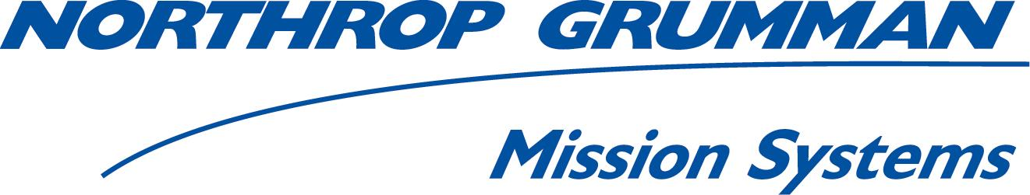

**Response to**

**Call for Participation (CFP)**

on

**GEOSS Architecture Implementation Pilot – Phase III (AIP-III)**

Response Date: 9 April 2010

provider

**Northrop Grumman Corporation**

**Health Scenario Climate Impacts &**

**Disaster Response Scenario**

**Lead Engineer** **Lead Engineer**

Stefan Falke Morris Brill

314-259-7908 310-813-2638

[Stefan.Falke@ngc.com](mailto:Stefan.Falke@ngc.com) [Morris.Brill@ngc.com](mailto:Morris.Brill@ngc.com)

Contents

1 Overview and Approach 1

2 Contribution Part I: Air Quality & Health Scenario 2

2.1 Societal Benefit Area Alignment and Support 2

2.1.1 Health SBA Architecture 2

2.2 Component and Service Contributions 4

2.2.1 Services 4

2.2.2 Clients 4

2.2.3 Performance and Availability of Components 7

3 Contribution Part II – Climate Impacts & Disaster Response Scenario 8

3.1 Societal Benefit Area Alignment and Support 8

3.1.1 Climate Impacts & Disaster Response Scenario 8

3.1.2 Enterprise Model 10

3.1.3 Participation in Climate and Disaster Response SBA Activities 13

3.2 Component and Service Contributions 14

3.3 Architecture and Interoperability Arrangement Development 14

3.3.1 Performance and Availability of Components 15

4 Description of Responding Organization 15

Appendices

Appendix 1 - List of Acronyms 16

**Appendix 2** **-** **Hurricane Disaster Response Activities………………………………….. …….**17

**Northrop Grumman Response to the GEOSS AIP-III CFP**

# Overview and Approach

Northrop Grumman Corporation is pleased to take this opportunity to respond to the GEOSS Architecture Implementation Pilot (AIP) Phase III Call for Participation (CFP). Northrop Grumman is responding to implement two scenario-based use cases on Health and Climate Impacts & Disaster Response. NGC seeks to participate in the GEOSS AIP by collaborating with the Group on Earth Observations (GEO) Societal Benefit Areas (SBAs) working groups and external agencies. Northrop Grumman will apply open standards for interoperability to achieve user objectives in environments of operational use for GEOSS.

Our interest in GEOSS and the AIP is to advance the state of technology and architecture and to evaluate standards to meet use-case driven requirements. We intend to add persistent GEOSS components, data, and product providers to the GEOSS Common Infrastructure established during Phases I and II. Northrop Grumman will use its experience working with customers in applying web services to application development and integration; using our leadership in compliance testing of Open Geospatial Consortium specifications to enhance use of these specifications with the scenario communities; using our experience in Service Oriented Architectures (SOA) to contribute to the OGC GEOSS AIP objectives; and sharing our experience as integrators, architects, providers, and operators of enterprise-class environmental systems. Our contributions in AIP-Phase III will focus on three out of the nine SBAs, leverage the SBA focus used in Phase II, and contribute to the overall AIP architecture development.

Northrop Grumman will contribute services, components, and data from our collaborative network of United States Group on Earth Observation (USGEO) agencies in the health and climate impacts & disaster response SBA scenarios. Northrop Grumman also plans to participate in the review of the AIP process. Northrop Grumman is uniquely qualified to participate because of our experience and expertise that spans sensor collection, processing of data and information, and development of decision support systems. We will work with Pilot participants in examining the suitability and performance of OGC service implementations in AIP-III.

The approach Northrop Grumman proposes is to contribute in the development and implementation of two SBA scenarios: Health and Climate Impacts & Disaster Response. Northrop Grumman will reference multiple parties that are collaborating on this CFP to provide persistent data and product exemplars, services, and applications that benefit multiple GEO SBAs. Northrop Grumman will build upon and augment the GEOSS Initial Operating Capability (IOC) previously established in Phase II by collaborating to develop scenarios with realistic features and events that include persistent data, products, and service providers. These are described in the health and climate impacts and disaster response scenarios outlined in Sections 2 and 3, respectively.

# Contribution Part I: Air Quality & Health Scenario

Northrop Grumman’s contributions to the Air Quality & Health Scenario are proposed to include

* Evaluation and enhancement to Air Quality Community Infrastructure (AQCI)
* Development of web application thin clients for GCI and AQCI testing and demonstration
* Registration and testing of data access web services as leveraged through US Government agency sponsored projects

## Societal Benefit Area Alignment and Support

The air quality scenario as outlined in the OGC GEOSS AIP CFP identifies 3 types of decision makers:

1. A policy-maker, needing synthesized information on the importance of intercontinental pollutant transport
2. An air quality manager, who needs to assess whether a regional pollution event was caused by an “exceptional event"
3. The public, needing information about air quality now and in the near future to make activity decisions

Each of these users has unique data and analysis requirements but the underlying data and analysis services are shared and available through the GEOSS Common Architecture. The unique needs are addressed through the configuration and execution of distributed web services that access, process and visualize information suitable for the user’s particular decision support activity. In many cases, standards-based interfaces for air quality data access are available, such as through DataFed and Giovanni, and activities within the air quality community, such as the EPA Air Quality Data Summit and ESIP Air Quality Working Group, are working collaboratively to develop standard interfaces more comprehensively across the air quality community. Efforts are underway in user-driven workflows for assembling customized series of access, processing and visualization services for particular uses and applications. It is anticipated that the OGC GEOSS AIP, Phase III will increase the number of data access services available in GEOSS and the Air Quality Community as well as advance the ability of air quality analysts and managers to analyze and compare multi-source observations and prediction models. Northrop Grumman’s contributions in the air quality scenario will involve evaluating the AQ Community Infrastructure through the registration of data access web services and providing web clients that access data web services available through the GCI.

### Health SBA Architecture

The OGC GEOSS AIP, Phase III Call for Participation (CFP) outlines a desire for the implementation of an architecture that supports multiple data sources undergoing multiple data processing and analysis steps that support multiple decision support needs across the information value chain. Along this sensor-to-decision information flow, Northrop Grumman is proposing to provide registration of metadata records for data access web services and testing search and use of data web services (Figure 2-1).

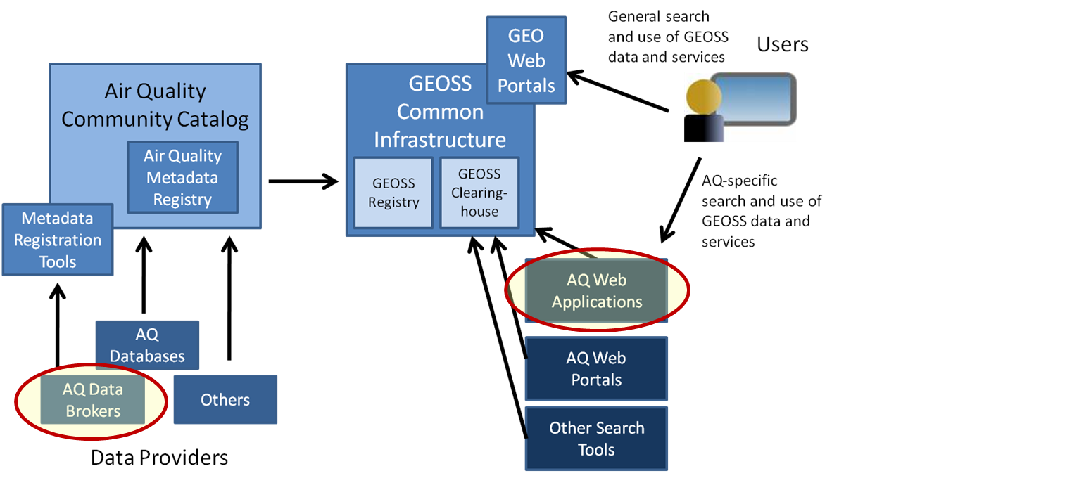

Figure 2-1. Air quality community infrastructure and areas of proposed Northrop Grumman contribution (red outlined ovals)

We plan to work with the rest of the air quality scenario group along with the GEOSS Pilot engineering teams to refine and develop architecture models that capture the air quality interoperability processes and relationships among GGI, Community components, services, and workflows.

Northrop Grumman is already actively involved within in air quality and health societal benefit area activities

* Participation in ESIP Air Quality Workgroup and emerging GEOSS Air Quality Community of Practice for Air Quality, including support for the coordination of the AIP air quality scenario
* Participation in AIP-2
* NASA ESTO project that includes co-development of the CEOS Atmospheric Composition Portal as well as its contributions to AIP-3
* EPA Office of Air & Radiation Air Quality Cyber infrastructure project, including its contributions to AIP-3
* Internal R&D investment in interoperable frameworks for geospatial information and health and environment science and applications

Northrop Grumman plans active participation in the AI Pilot in refining the air quality scenario and implementing and demonstrating web service and client components of the scenario as they related to the GCI and Air Quality Community Infrastructure. Northrop Grumman will

* Help coordinate the AIP-3 AQ&H Working Group
* Work to attain cross-project/program/pilot participant interoperability coordination through the ESIP Air Quality Workgroup and GEOSS CoP for AQ
* Coordinate with NASA, EPA, NOAA and other agencies on ensuring Pilot components and demonstration align with their needs

## Component and Service Contributions

During AIP-2, Northrop Grumman contributed smoke forecast output as OGC WMS and WCS services and used those services to test and evaluate the air quality community infrastructure and GCI. These services are available for use in AIP-3. Northrop Grumman also proposes to contribute addition data access web services for air emissions data in collaboration with EPA, the use of two thin-client web applications for evaluation and demonstration during AIP-3, and an implementation of the GCI-compatible uFind search tool.

### Services

Northrop Grumman is a participant in the EPA CyAir effort (www.cyair.net). As part of this effort, we are working with the CIERA in advancing cyber infrastructure for air emissions, including the implementation of OGC WMS, WFS, and WCS interfaces to air emissions data. We will leverage this work and the development of ISO 19115/19139 metadata records and register those in the Air Quality Community Catalog.

We also collaborate with NASA in the CEOS Atmospheric Composition Portal () where we are working with collaborators from NASA, DLR, and Washington University to identify best practices for metadata records for remotely sensed atmospheric composition data . We will coordinate with the rest of the AC Portal team to make those best practices and implementations of metadata records available to AIP-3.

### Clients

#### 2.2.2.1 Instance of uFind

uFind, as described in Washington University in St. Louis AIP-3 CFP response, is a user-oriented web application that interfaces with the GEOSS Clearinghouse. It searches and filters the Clearinghouse for air quality related metadata records and provides a GUI for browsing and further filtering the records. As part of CyAir, we anticipate implementing an instance of uFind filtered for emissions data. This implementation will be available for use in the AQ&H scenario.

#### 2.2.2.2 Visualization and Analysis Client

We have developed prototype clients for accessing, visualizing and analyzing air quality and health related data available through standard web service interfaces. Those prototypes have been developed using Adobe Flex and the ESRI Flex API to work with data in maps, tables and charts. Our prototypes will be available to help test the Air Quality Community Infrastructure and support the AIP-3 AQ&H scenario.

#### 2.2.2.3 PULSENet Client

As part of its PULSENetTM project and investment, Northrop Grumman has developed a OGC SWE client. The client will be available for AIP-3 to evaluate and demonstrate the GCI and Air Quality Community Infrastructure. The client allows a user to:

* Discover sensors within a specified area of interest by retrieving sensor location information directly from SOS and SPS instances, as well as from CS-W instances.
* Subscribe to (by automated polling of SOS instances) and retrieve observations from discovered sensors through SOS instances
* Task sensors through SPS instances (with advanced functionality provided for video sensors)
* Subscribe to and be notified of sensor alerts from SAS instances using CAP over XMPP.
* Create Event Initiated Procedures (EIPs) that automatically task a particular sensor when an observation or alert from a particular sensor is encountered (i.e. task a camera to point at an UGS sensor when that sensor generates an alert).

The PULSENet™ client runs on the Windows operating systems and currently supports interacting with many of the SWE services and encodings as well as other OGC services and external standard encodings (summarized in the table below).

| **Service/Encoding** | **Version** | **Notes** |
| --- | --- | --- |
| SOS | 1.00.0.31 | Supports SOS instances that serve SensorML/O & M or TML data |
| SPS | 1.0, 0.0.30 | Full support |
| SAS | 0.2.0 | Some support |
| WNS | 0.1.1 | Support for reading and displaying capabilities and users and adding/removing users |
| WMS | 1.1.1 | Provided natively by Skyline TerraExplorer Pro |
| WFS | 1.0.0 | Provided natively by Skyline TerraExplorer Pro |
| WCS | 1.1 | Supports translation between SOS GetObservation and WCS GetCoverage requests |
| CS-W | 2.0.1 | Support for viewing entries in a catalog |
| SensorML | 1.0.30 | Support for System and Sensor, reading location and orientation, identification, classification, contact, and several other major elements |
| O & M | 1.0, 0.11.0 | Support for CommonObservation, CategoryObservation, Observation, and several other observation types |
| TML | 1.0 | Support for some TML streams |
| CAP | 1.1, 1.0 | Full support |
| Cursor on Target (CoT) | 2.0 | Full support for main schema and support for several sub-schemas |
| GML | 3.11 | Provided natively by Skyline TerraExplorer Pro through WFS support. Support for GML embedded in SensorML and O & M |

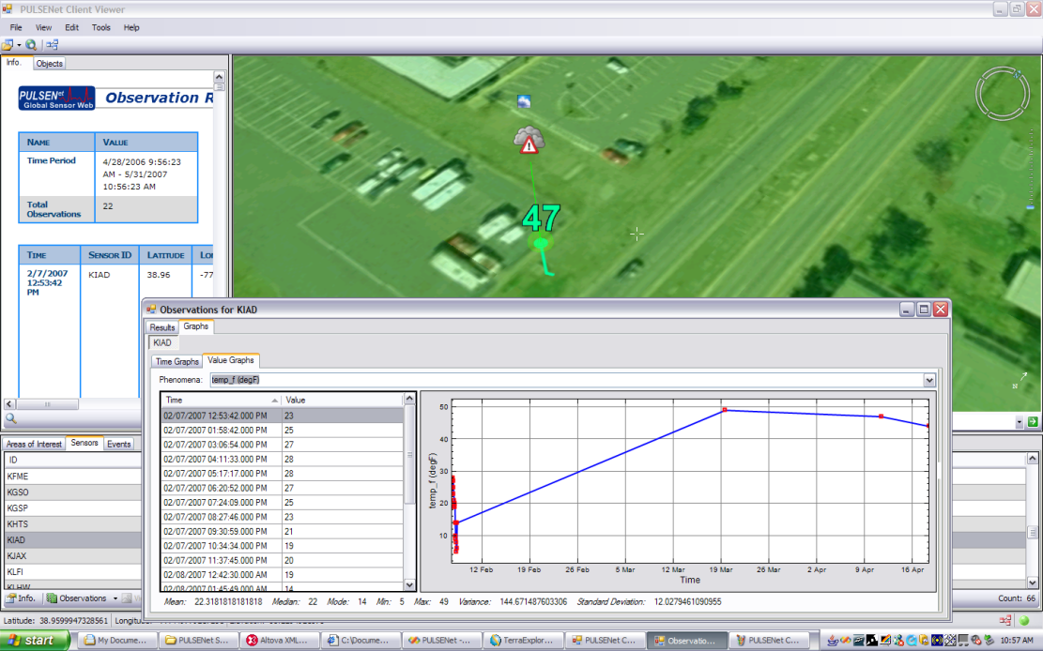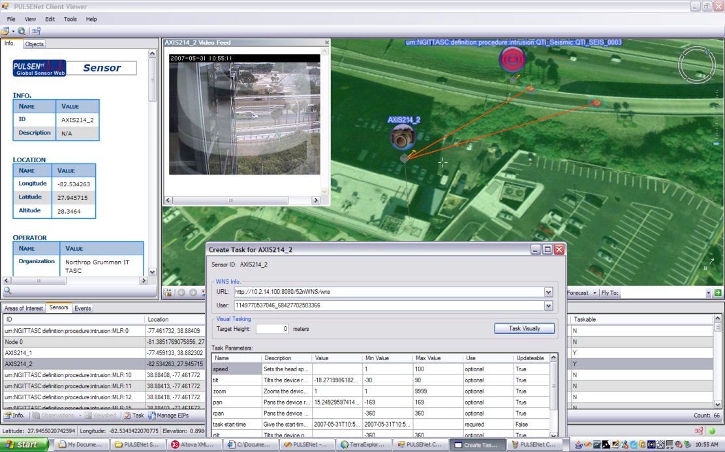

Figure 2-4. PULSENet™ Client - Retrieving Observations and Tasking a Video Camera

Northrop Grumman has utilized the following SWE service implementations as part of the the PULSENet development:

SOS - based on 52North's open source Java implementation utilizing PostgreSQL as the backend database platform. The PULSENetTM team updated 52North's implementation to include support for O & M CommonObservation format and SOS-T methods (RegisterSensor and InsertObservation). The PULSENetTM IRAD team is currently in the process of rewriting the SOS in .NET using Oracle 10g as the backend database platform.

SPS - 52North's open source Java implementation. The PULSENetTM team has two Axis 214 PTZ network cameras to which the SPS provides a tasking interface.

WNS - 52North's open source Java implementation.

SAS - custom implementation developed in .NET to work in conjunction with the SOS, allowing users to define alert conditions for incoming SOS data. The Northrop Grumman SAS generates alerts in CAP (published over XMPP) or CoT formats (published over TCP).

### Performance and Availability of Components

Our OGC services for the air quality scenario, including the Web Coverage Service and OGC SWE services, will be hosted on Northrop Grumman servers within our virtual machines environment in St. Louis, MO and Chantilly, VA. We expect the services to be available and persistent during the through at least September of 2011 but plan on their longer term availability pending available funding.

# Contribution Part II – Climate Impacts & Disaster Response Scenario

## Societal Benefit Area Alignment and Support

Northrop Grumman proposes to execute the Disaster Cycle, depicted in the GEOSS AIP-II CFP and shown in Figure 3-1. Northrop Grumman proposes to apply this cycle for a hurricane and flooding scenario that incorporates multiple user communities and demonstrates how communities of practice (COP) may use satellite constellations as identified in GEO task DI-06-09 and address uncertainties associated with climate variability and change, and related societal impacts, as identified in GEO task CL-07-01.

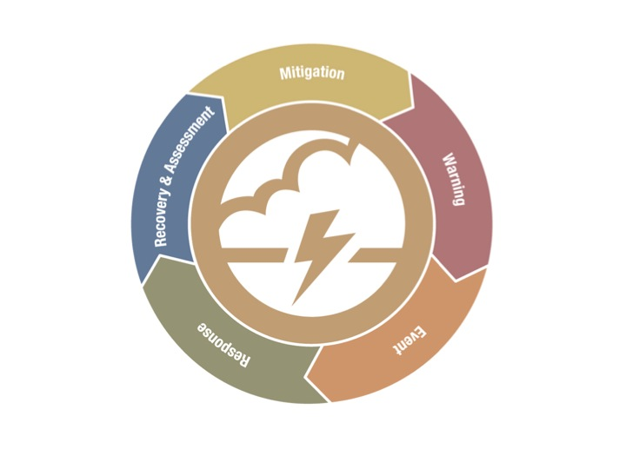

Figure 3‑1. Disaster Cycle (from GEOSS AIP Phase III CFP, Issuance 26 March 2010)

### Climate Impacts & Disaster Response Scenario

The climate impacts & disaster response scenario will be user driven and will use data and products derived from:

* Existing earth observable systems
* Other existing sensor systems as applicable to the scenario
* Existing data and service providers
* Climate data model runs and simulations

Northrop Grumman will execute on interoperability agreements and data and product provider arrangements, as well as maintain existing agreements continued from AIP-II participation. These data and product providers are the persistent exemplars that comprise the operational building blocks necessary for the system-of-systems GEOSS objectives. These objectives have been established for Phase III to augment previous GEOSS phases.

The table in Appendix 2 aligns with the Disaster Cycle depicted in Figure 3-1. Northrop Grumman has aligned the activities of the cycle with the events, users, data, products, and services that will be demonstrated in a major hurricane and flooding disaster response scenario. Northrop Grumman is coordinating its efforts with the Climate and Disaster Response SBA working groups (particularly those of GEO task CL-07-01 and DI-06-09) on the development of user needs and coordination of demonstrations to ensure interoperability. Furthermore, we propose to:

1. Enhance the climate scenario by reusing major components of the disaster response scenario presented in AIP II to step through the events of a future hurricane strike (as well as the storm and flooding events left in the wake of the storm) while factoring in climate change impacts as well

2. Demonstrate the central role the Climate Impact and Disaster Response SBA Community Portal plays in facilitating information sharing among scenario players

3. Integrate the contributions of our NOAA and NASA data and product providers into the Climate Impacts & Disaster Response scenario, and demonstrate them as persistent exemplars

4. Provide and highlight the integration required between the GEOSS Common Infrastructure (GCI) and external data and service providers through community portals

The users or actors participating in the climate impacts & disaster response scenario include the following identified users:

* Decision Makers
* Regional Civil Protectors
* Subject Matter Experts from multiple scientific disciplines
* Public Users
* Atmospheric scientist/climatologists
* Community of Practice Data Providers

The roles played by these actors are described in the scenario outlined in Appendix 2, and the specific roles are described in Table 3-1. Each actor will be able to access data unique to its role through the common and standard interfaces and services provided through the GCI as well as the SBA services that will be registered through the GEOSS Registry for access by the GEOSS Clearinghouse and Portal.

|  |  |
| --- | --- |
| Actor / User | Description |
| Community of Practice Data Providers | * Provides raw data and products necessary for the execution of the scenario * Includes weather and climate data providers * May include regional, national, and commercial providers |
| Decision Makers | * Act as emergency manager * Coordinate and manage resources necessary for disaster response * Task the sensor web * Coordinate and ensure the delivery of data to requesters * Determine any impact to operations due to space weather (jointly w/ forecaster) * Includes roles played by emergency managers and decision makers |
| Atmospheric Scientist / Climatologist | * Simulate probable storm path and intensity * Determine flood locations * Includes actors from NCDC, RCC, SWPC, NDMC, and regional/commercial weather concerns |
| Public Users | * Desire information on climate impacts * Desire information on response activities |
| Regional Civil Protectors | * Plan first response strategies * Determine assistance locations * Includes actors from FEMA, Red Cross, National Guard, and other civil protection agencies |
| Subject Matter Experts | * Provide expertise in their discipline areas * Provide collaboration from multiple disciplines for holistic scenario solutions * Includes government agency input for legislative and policy guidance |

Table 3-1 Climate Impacts & Disaster Response Scenario Actors

In keeping with the regional nature of the scenario, we introduce the concept of a regionally focused Decision Maker by locating the Decision Maker at a Regional Decision Support Center (RDSC). The RDSC is included in the scenario outline shown in Appendix 2. This center can be envisioned as a virtual concept, as enforced by a Community of Practice (COP) set up by the Decision Maker to respond to an impending disaster. The concept works equally as well as a physical construct.

### Enterprise Model

The enterprise model for our proposed hurricane and flooding scenario depicts an holistic approach to executing a climate impact & disaster response. We use the following context diagram as the model for the Climate Impacts & Disaster Response context diagram of Figure 3-3. The centrality of the Community Portal in creating a coordinated response to a disaster cannot be overstated and is depicted as such in the context diagram shown in Figure 3-3. Our proposed Climate Impacts & Disaster Response SBA Community Portal will be provided for accessing the services and information required for the implementation of the scenario.



Figure 3‑3: Disaster Response Scenario Context Diagram

The context diagram forms the framework for the sub-scenarios depicted by the activity diagrams illustrated by Figures 3-4 through 3-6. The mitigation activities depicted by the activity diagram of Figure 3-4 are focused on determining areas susceptible to flooding triggered by the impact of hurricanes. This includes flooding due to precipitation, storm surges, and failure of man-made structures (levees, dams, etc.). Such information can be made available to Regional Civil Protectors (first responders) to facilitate emergency planning.



Figure 3‑4: Disaster Cycle Mitigation Phase Activity Diagram

The Warning and Events activities of the Disaster Cycle include detecting the formation of storms and the tracking of storms. This ongoing activity is depicted by the activity diagram shown in Figure 3-5. The key actor executing this activity is the Forecaster. The products generated by the Forecaster are used by Civil Protectors and the Public Users to be able to formulate response strategies. Much of the data used by the Forecaster is provided by the Community Data Providers.



Figure 3-5: Detection and Tracking of Storms Activity Diagram

A key activity of the Forecaster is to be able to predict the landfall of a storm. This important role is critical for the timely and directed response by Civil Protection agencies. This is an ongoing activity and is depicted by Figure 3-6. This figure is focused on a hypothetical situation of the Louisiana and Texas regions of the United States. The Forecaster generates the prediction and it is the Decision Maker, in this scenario, then who coordinates the resources and response.



Figure 3‑6: Storm Prediction Activity Diagram

### Participation in Climate and Disaster Response SBA Activities

Northrop Grumman proposes to actively participate in the Climate and Disaster Response SBA activities to develop scenarios and to facilitate component integration for USGEO to include NOAA data and service providers and demonstrations. Northrop Grumman proposes to:

* Develop Interoperability Agreements with other Disaster Response Pilot participants
* Participate with other disaster response scenario developers, especially those involved with GEO tasks DI-06-09 “Use of Satellites for Risk management”. As a result of our coordination with these groups, our disaster scenario follows the Disaster Cycle activities and uses the corresponding commonly developed user needs of other scenario participants
* Participate in the development of the RM-ODP viewpoints
* Participate in the generation of Climate Impacts & Disaster Response user scenarios
* Leverage our arrangements with data providers to broaden the reach of information necessary for the benefit of the Climate Impacts & Disaster Response SBAs
* Register services and components in the GEOSS Registry that support the climate impacts and disaster response scenario
* Support the reporting of status of the Pilot Disaster Response SBA activities
* Coordinate with data and service providers to ensure data access in support of the scenario and plans to become persistent exemplars
* Participate in professional conferences to discuss our GEOSS activities
* Participate in the Final Results of AIP Phase III

## Component and Service Contributions

Northrop Grumman proposes to register services and components as part of GEOSS Common Infrastructure. These may include:

* Data access services using OGC WMS, WCS, WFS, and others
* Data processing services using OGC WPS and SOAP/WSDL
* Data comparison services using OGC WPS and SOAP/WSDL
* Clients executing service requests to visualize and manipulate results

The services and components will be implemented into the climate impacts and disaster response scenario(s) and are intended to be applicable to future uses of the services within GEOSS applications.

## Architecture and Interoperability Arrangement Development

Northrop Grumman also proposes to provide a Community of Practice Portal that will access the information and services necessary for the implementation of the Climate Impacts and Disaster Response Scenario.

The services of our USGEO government collaborators will be made available once services and the community portal have been integrated and deployed. The services and data will persist in the GEOSS operational environment and be made available to GEOSS Web Portal and Clearinghouse users no later than the end of the Phase III Pilot.

Northrop Grumman has entered into arrangements with governmental organizations for the successful implementation of the disaster response scenario outlined in Table 3-1. Northrop Grumman has reached agreements with the following data and product providers:

* NOAA Regional Climate Centers (RCC)
* National Drought Mitigation Center (NDMC)
* NASA Goddard Space Flight Center (GSFC)
* Space Weather Prediction Center (SWPC)

These organizations will be working with Northrop Grumman to make accessible the data and products necessary for successful execution of the disaster response scenario. Northrop Grumman will be providing the integration and services necessary to make data provided for the scenario compliant with GEOSS open standards.

### Performance and Availability of Components

Our OGC services for the climate impacts & disaster response scenario, including the Community of Practice Portal, will be hosted on Northrop Grumman servers in Omaha, NE. Northrop Grumman has designed the Community of Practice Portal and services to support an average of 1,000 hits per hour, at a minimum, and that will have an availability of at least 99%. We expect our participating data and product providers, along with the services and components we offer for their integration, to become persistent exemplars within GEOSS and transition to operational GEOSS status.

# Description of Responding Organization

Northrop Grumman Corporation is a trusted provider of solutions to the environmental community and particularly, agencies of the USGEO component of GEO. Northrop Grumman has a multi-decadal history of deploying and transitioning mission critical solutions through programmatic discipline and engineering rigor. Northrop Grumman’s experience with space and surface based sensors, large-scale information management and storage systems; architectures, services, and interfaces; mapping, charting, and geodesy products; space weather domain knowledge, tactical products and systems; and SOA architectures are representative of the breadth and depth of experience, knowledge, and resources that Northrop Grumman is able to place at the GEO community’s disposal.

Northrop Grumman is offering integrated, interdisciplinary teams in both scenarios for this year’s AIP with experience in GEOSS, environmental systems, meteorology, climatology, global change, sensing systems, software development, integration, systems architecture, systems engineering, and GIS services. This broad expertise is spread across the Northrop Grumman team participating in this year’s AIP and is located in St. Louis, MO; Omaha, NE; Redondo Beach, CA; and Chantilly, VA USA.

Northrop Grumman’s Information Systems sector (NGIS) is a trusted IT leader and premier provider of advanced IT solutions, engineering and business services for government and commercial clients. The company’s technological leadership spans such areas as homeland security solutions, secure wireless, cyber and physical assurance, IT and network infrastructure, managed services, knowledge management, modeling and simulation, and geospatial intelligence solutions. NGIS’s GeoEnterprise architecture is a standards-based framework for access, processing, and application of heterogeneous sensor and data sources. Included in the GeoEnterprise Architecture is the sensor web framework, PULSENet, which connects sensors to the other data, processing and visualization services.

Northrop Grumman Information Systems (NGIS) is a leading global integrator of complex, mission-critical systems. The sector's technology leadership spans command, control, communications, and computers, intelligence, surveillance and reconnaissance, and missile systems. The sector differentiates itself from others in the corporation by developing systems that enable its customers to execute their missions. From designing system architectures to developing and sustaining mission-critical systems, NGIS’ technological solutions span an entire program life-cycle and bring a wealth of expertise from the systems engineering perspective to its customers.

Northrop Grumman is a strategic member of the OGC and has been a key sponsor and participant in OGC test beds and the evolution of OGC standards. Northrop Grumman is also active in other standards bodies and works with defense and civilian government agencies to integrate standards architectures into their operations. Northrop Grumman is participating with several Federal organizations in the GEOSS AIP with the goal of transitioning them to GEOSS operational status as persistent data and product providers. **Appendix 1 - List of Acronyms**

AIP Architecture Implementation Pilot

CAP Common Alert Protocol

CAT Category

CFP Call for Participation

COP Communities of Practice

FEMA Federal Emergency Management Agency

GCI GEOSS Common Infrastructure

GCI GEOSS Common Infrastructure

GEO Group on Earth Observations

GEOSS Global Earth Observing Systems of Systems

GIS Geographical Information System

NASA National Aeronautics and Space Administration

NDMC National Drought Mitigation Center

NGIS Northrop Grumman Information Systems

NGAS Northrop Grumman Aerospace Systems

NHC National Hurricane Center

NOAA National Oceanic and Atmospheric Administration

RCC Regional Climate Center

RDSC Regional Decision Support Center

SAS Sensor Alerting Service

SBA Societal Benefit Areas

SOA System Oriented Architecture

SOS Sensor Observing Service

SPS Sensor Planning Service

SWPC Space Weather Prediction Center

UAS Unmanned Aerial Systems

USGEO United States Group on Earth Observations

WCS Web Coverage Service

WFS Web Feature Service

WMS Web Map Service

WNS Web Notification Service

**Appendix 2 – Hurricane Disaster Response Activities**



