Article published 31 March 2011 in the spring 2011 issue of LBx Journal

Title: The OGC’s Role in LBS Interoperability

Author: Steven Ramage
Executive Director, Marketing and Communications
Open Geospatial Consortium (OGC)

Business presentations about the Open Geospatial Consortium (OGC) sometimes include this quote from David Schell, the OGC’s Chairman and Founder: “Interoperability seems to be about the integration of information. What it’s really about is the coordination of organizational behavior.”

As a global non-profit standards development organization, the OGC’s membership consists of businesses, government agencies, non-governmental organizations and research institutes. Beginning in 1994, the OGC has evolved and used a successful international consensus process to define and document international standards. The standards work is focused on the geoprocessing interface and encoding standards that meet the business needs of not just member organizations but also the larger IT community. Most of the major vendors of GIS and Earth imaging software and geospatial services participate and all of them implement OGC standards in their products. OGC standards have eliminated many of the technical silos that previously isolated different organizations’ geospatial data and processing resources, resulting in well-documented and dramatic improvements in organizations’ returns on their investments in such technology. In a sense, a number of OGC consensus standards are so broadly implemented that they may be thought of as de-facto standards in the business, government and research application domains that use geospatial technologies.
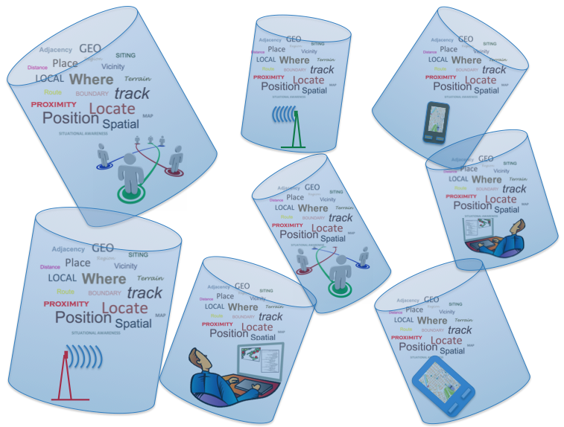
Figure: Only one Earth, but many stovepipes in the LBS value chain.
So what is happening with location services interoperability? Why don’t wireless carriers, portable device makers, app developers, social network companies and others in the LBS value chain work together as GIS and Earth imaging companies did – in “coopetition” – to make location information as open as the underlying World Wide Web? Lack of interoperability reduces customer choice, reduces options for developers, reduces available ad markets, reduces opportunities for technology convergence and generally retards market growth. As in Figure 1, various platforms, devices and applications provide and accept location data, but each implements – and is isolated by – proprietary “standards”. It may be due partly to the size of the market and the size of the players, who are used to dealing with millions of users, so there is a perceived competitive disadvantage in standards, but there’s much more to the problem.

This article is the first in a series of LBx Journal articles from the OGC and LBS industry leaders exploring this question, showing what is being done to improve and promote interoperability, and showing how stakeholders can work together to evolve LBS interoperability to meet their needs.

We will consider questions like these:

- Is location interoperability for a mass market of individual users an inherently different problem from geospatial interoperability for organizations?
- Did social networking and associated location services companies simply grow too fast and compete too furiously to be concerned with standards at the outset?
- Where – and how – does location services interoperability figure in the bigger picture? For example, in business intelligence, cloud computing, smart grid, sensor webs and the Internet of Things?
- Are OGC Web Services and other service oriented architectures (SOA – think Web services, cloud computing, service chaining etc.) passé? We will review the business implications of the debate in the OGC between advocates of SOA and advocates of a competing approach, representational state transfer (REST).
- In the context of LBS and the SOA/REST debate, what are the roles – and strengths and weaknesses – of relevant OGC standards that are already in use in many market domains:
  - OGC Sensor Web Enablement standards – interface and encoding standards that enable developers to make all types of sensors, transducers and sensor data repositories discoverable, accessible and useable via the Web.
  - Geography Markup Language Encoding Standard (GML) – an XML grammar for expressing geographical features
  - CityGML Encoding Standard –a GML-based encoding standard for the representation, storage and exchange of virtual 3D city and landscape models
  - Open Location Services Interface Standard (OpenLS) – an interface standard that enables companies in the LBS value chain to “hook up” and provide their pieces of applications such as emergency response, personal navigator, traffic information service, proximity service, location recall, mobile field service, travel directions, restaurant finder, corporate asset locator, concierge, routing, vector map portrayal and interaction, friend finder, and geography voice-graphics. These applications are enabled by interfaces that implement OpenLS services such as a Directory Service, Gateway Service, Geocoder Service, Presentation (Map Portrayal) Service and others.
- What are the implications for LBS of the lightweight GML location encodings that are mandatory elements or options in standards from other organizations, such as GeoRSS (RSS with location) and IETF’s GeoPRIV standard for Internet location privacy?
- What role does open source software play in the location standards world? Reference implementations of OGC standards are typically developed by open source software developers, and OSGeo (the Open Source Geospatial Foundation) has strong ties to the OGC. What can be said about other open source and crowd-sourcing projects in this domain that may have little connection to the OGC?

We will report on what the OGC is doing to help location services stakeholders improve information sharing and gain a more stable open standards platform for innovation and business development. We’ll discuss the OGC’s policies for fast-track adoption of contributed standards. Examples include
- KML, the application programming interface for Google Maps and Google Earth, contributed to the OGC by Google
- netCDF, an important science data encoding, contributed by the Unidata Program Center at the University Corporation for Atmospheric Research (UCAR)
- The candidate standard Open GeoSMS, contributed by ITRI from Taiwan, where Open GeoSMS is already widely used. The OGC will issue a public request for comment on Open GeoSMS in a few weeks. The June 2011 Technical Committee meeting will be held in Taiwan.
We’ll also report on the OGC’s activities in business-critical areas such as security, uncertainty encodings, workflow, and standards specifically for commercial transactions in geospatial data and services.

The March 2011 OGC Meetings in Bonn, Germany

Organizations have cultures and agendas, and the OGC is no exception. We think it might be helpful to begin by providing a sample of the proceedings of the 28 February – 4 March 2011 76th OGC Technical Committee and Planning Committee meetings.

The meetings in Bonn were hosted by UN-SPIDER (the United Nations Platform for Space-based Information for Disaster Management and Emergency Response), a unit within UNOOSA (the UN Office for Outer Space Affairs). The Bonn meeting had the highest attendance of any OGC meetings. Technical Committee meeting attendance has been roughly proportional to OGC membership, which has grown each year since 1994. Membership is now at 416 organizations with a phenomenal global reach through the members’ market reach.

The closing plenary sessions are getting to be all-day affairs – there were 37 Working Group meetings, most of which included multiple reports and discussions of multiple topics (see sidebar). Special meetings were held to report on interoperability initiatives such as the multi-threaded OWS-8 Testbed, aviation information pilot projects and several interoperability experiments. The Europe Forum and various committees met, such as the Architecture Board, the Business Value Committee and the Compliance and Interoperability Testing Initiative (CITE).

-------------------Begin sidebar--------------------
Below are a few LBS-related highlights from the agenda for the recent 78th OGC Technical Committee Meeting

CityGML Domain Working Group:
- Integration of CityGML models into simulation environments
- Indoor navigation and indoor map demonstration experiments at a commerce facility in Japan
- Hitachi's strategy for Smart City using spatial information infrastructure encoded using CityGML
- Indoor Maps for Robotics and IndoorML update. (IndoorML is a data exchange format based on CityGML, being developed by members of the Indoor Spatial Awareness (ISA) project http://u-indoor.org/)
- 3D cadaster and ISO Land Administration Domain Model (The International Organisation for Standardization (ISO) publishes a number of standards relevant to location. Some OGC standards become ISO standards.)
- Update on 3D Portrayal Interoperability Experiment

Mass Market Domain Working Group:
- Open GeoSMS Update
- Update on OpenSearch - GeoSpatial and Temporal Extensions. (OpenSearch http://www.opensearch.org/ is a collection of simple formats for the sharing of search results)
- CityGML Outreach Events and Progress

Sensor Web Enablement (SWE) Common Standards Working Group
- Profiles for structuring simple in-situ sensor data
- Profiles for structuring remote sensing data (imagery, video, radar)
- Phenomenon/Property model and encoding

Decision support Domain Working Group
- Decision Making in A Commercial Fleet Company for Green Transportation
- Advancement of client testing at the OGC TEAM Engine (compliance testing facility)
- (Spatial) Decision Support Systems Infrastructure

There were similar plenary reports from working groups focused on a number of topics such as Emergency and Disaster Management, Earth Systems Science, Geosemantics, Security, Workflow and Defense and Intelligence.

-------------------End sidebar--------------------

Such meetings have been held at least quarterly since the OGC began in 1994. Each week of meetings is a busy time for the member representatives, as they present their work, listen to others, discuss business requirements, socialize, debate technical issues, and plan to sponsor or participate in testbeds, pilot projects, interoperability experiments and plugfests. Having the opportunity to advance and influence industry standards is one important benefit of membership, but understanding the use of standards, business networking and market intelligence are key aspects of the value of membership.

Overall, it’s a bright and lively international society of people dedicated to a shared vision and mission. LBS interoperability and the “mass market” are hot topics and important business issues for many of the members. There is a general sense of confidence that the inclusive and constantly adapting OGC consensus process will ultimately be a market enabler for the LBS domain as it has been for many other domains. In coming issues of the LBx Journal, you will have an opportunity to watch this unfold.

